INTRODUCTION
In the lab work, we looked at parallelizing the Mandelbrot set because its an easy to paralyze, we call this kind of set an “embarrassing parallel problem” because it’s a problem that can be split into many completely individual task


A MANDELBROT SET

In parallelizing the Mandelbrot set using 2 threads, we tried to divide the i-loop (horizontal) which lead to a poor load balancing, but dividing the j-loop (vertical) will yield better balance due to symmetry

Figure: Mandelbrot using 2-thread parallel programming divided horizontally

Figure: Mandelbrot using 2-thread parallel programming divided vertically

 | Sequential programming |  | Two threads dividing the horizontal i range | Two threads dividing the vertical j range
1st | 613 |  | 476 | 483
2nd | 869 |  | 322 | 616
3rd | 672 |  | 448 | 615
4th | 624 |  | 325 | 613
5th | 883 |  | 322 | 622
Average | 636 |  | 323 | 616
Parallel speedup | 1 |  | 1.96 | 1.03

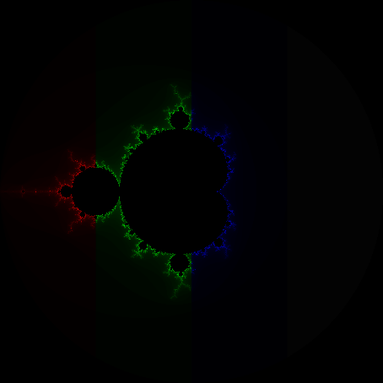
Figure: Mandelbrot using 4-thread parallel programming divided vertically

Figure: Mandelbrot using 4-thread parallel programming divided into 4 squares

 | Sequential programming | Divide the j range into 4 (vertically) | Divide i and j range
1st | 613 | 549 | 318
2nd | 869 | 519 | 311
3rd | 672 | 510 | 316
4th | 624 | 522 | 307
5th | 883 | 515 | 230
Average | 636 | 523 | 313
Parallel speedup | 1 | 1.21 | 2.03

CONCLUSION
This lecture emphasizes the importance of understanding memory architecture and selecting the right decomposing strategies for efficient parallel performance.

