Parallel Programming Lab Book

UP2154598
UP2540661
UP2543144

Table of Content
1. Lab 01 4
1.1 Introduction 5
1.2 Approaches and Result 5
1.2.1 Methodology 5
1.2.2 Results and Analysis 6
1.2.3 Increase Time Precision 7
1.2.4 The Impact of Workload Size on Parallel Efficiency 9
1.3 Conclusion 10
2. Lab02 10
2.1 Introduction 11
2.2 Approaches and Analysis 11
2.2.1 Methodology 11
2.2.2 Results and Analysis 12
2.3 Conclusion 16
3. Lab 03 17
3.1 Introduction 18
3.2 Approaches and Analysis 18
3.2.1 Methodology 18
3.2.2 Results and Analysis 19
3.3 Conclusion 20
4. Lab 04 21
4.1 Introduction 22
4.2 Approaches and Analysis 22
4.2.1 Methodology 22
4.2.2 Result and Analysis 24
4.3 Conclusion 26
5. Lab 05 27
5.1 Introduction 28
5.2 Approaches and Analysis 28
5.2.1 Methodology 28
5.2.2 Result and Analysis 29
5.3 Conclusion 31
6 Lab 06 32
6.1 Introduction 33
6.2 Methodology and Analysis 33
6.2.1 Methodology 33
6.2.2 Result and Analysis 34
6.3 Conclusion 37
7 Lab 07 38
7.1 Introduction 39
7.2 Approaches and Analysis 39
7.2.1 Methodology 40
7.2.2 Results and Analysis 40
7.3 Conclusion 45
8 Lab 09 46
8.1 Introduction 47
8.2 Approaches and Analysis 47
8.2.1 Methodology 47
8.2.2 Results and Analysis 47
8.3 Conclusion 50

List of Tables

Lists of Figures

1. Lab 01

1.1 Introduction
In this session we will be looking at a mathematical function to approximate π using multiple thread to accelerate a calculation task as an introduction to reveal the true power of the parallel programming. The formula to approximate π is listed below:
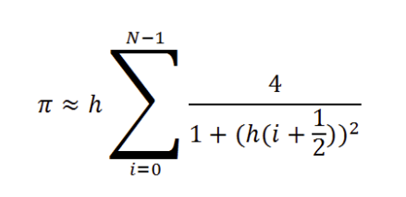
Where N is the number of integration steps and h = 1/N is the step size. The computational workload is inherently parallelisable, as the summation consists of independent terms that can be distributed across multiple threads.

1.2 Approaches and Result

1.2.1 Methodology
Firstly, we need to establish a baseline for the task, using Java codes to implement the mathematical function and run the programme sequentially to get the baseline running time.
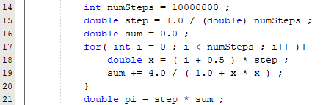
Subsequently, a parallel version is used with multi-thread coding. This divides the total number of steps, numSteps, into contiguous ranges, assigning each range to a separate thread instance of a class extending Thread. Each thread will calculate a partial sum of the π and used the join() method to synchronise and aggregate the results. A sum will be added to obtain the final value of π. During this lab session, we will be looking at the performance of parallel programming with 2, 4, and 8 threads.
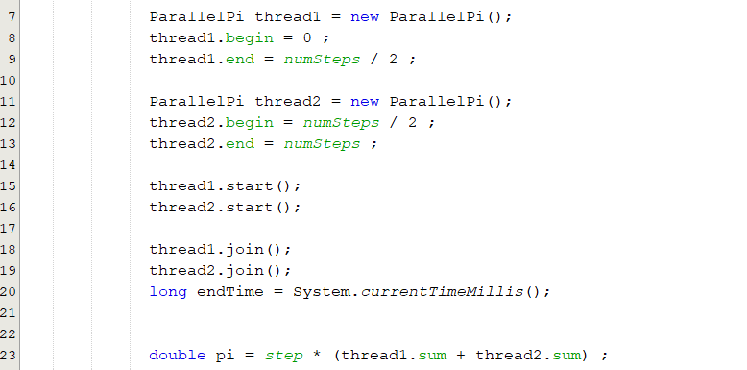
The performance measurements are taken using currentTimeMillis() functions in JAVA. A starting time, Ts, will be recorded when the programme starts and another time, Te, will be recorded when the threads finish its calculation and sum up the value of π using currentTimeMillis(). The total time consume, T, will be time difference between Te and Ts. To obtain more precise timings, the experiment was repeated using nanoTime() function, which provides nanosecond resolution. All benchmarks were conducted on a system with a multi-core processor.
A new parameter, parallel speedup, is calculated by using the sequential time and the parallel time under different core numbers to evaluate the ability of parallel programming.
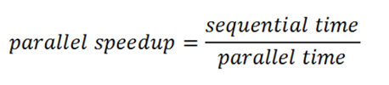

1.2.2 Results and Analysis
The initial benchmarking was performed with numSteps = 10,000,000 using currentTimeMillis() function.
Nodes | 1st Time （ms) | 2nd Time （ms) | 3rd Time （ms) | 4th Time （ms) | 5th Time （ms) | Average Time （ms) | Parallel Speedup | Efficiency (%)
Sequential | 51 | 50 | 51 | 50 | 50 | 50.40 | 1 | 100
2 | 31 | 30 | 30 | 29 | 31 | 30.20 | 1.67 | 83.5
4 | 23 | 22 | 21 | 21 | 20 | 21.40 | 2.36 | 59
8 | 19 | 20 | 19 | 20 | 17 | 19.00 | 2.65 | 33.12
Table1.2.2.1: The Relation of Parallel Speedup with Different number of Threads in Millisecond.
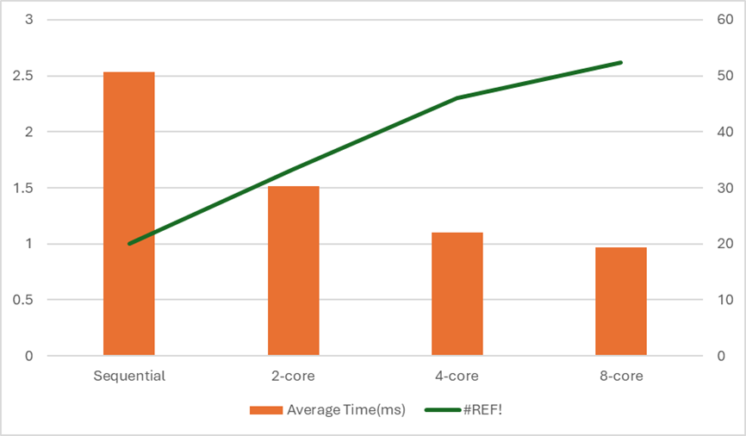
Figure1.2.2.1: Total Time (ms) under Different Core Numbers and Parallel Speedup
The results demonstrate a clear benefit from parallelisation. The 2-thread implementation achieves a 1.67 speedup. The 4-thread version shows a more substantial speedup of 2.36, shows nearly a linear increase of parallel speedup as the thread number increases. However, the progression from 4 to 8 threads yields a diminished return, with a speedup of only 2.65. The increases are no longer linear.

1.2.3 Increase Time Precision
To achieve a more accurate measurement, the experiment was repeated using nanoTime(). The results, displayed below, corroborate the trends observed with millisecond timings but provide a more granular and reliable dataset.
Nodes | 1st Time （ns) | 2nd Time （ns) | 3rd Time （ns) | 4th Time （ns) | 5th Time （ns) | Average Time （ns) | Parallel Speedup | Efficiency (%)
Sequential | 53176600 | 49276000 | 50155900 | 50968700 | 50770300 | 50869500 | 1 | 100
2 | 31033000 | 28903500 | 28813300 | 29313200 | 29853300 | 29583260 | 1.72 | 86
4 | 22,784100 | 21838199 | 21191000 | 22037700 | 21837800 | 21937760 | 2.32 | 58
8 | 21337900 | 18998200 | 21126700 | 20189500 | 21792400 | 20490940 | 2.48 | 31
Table1.2.3.1: The Relation of Parallel Speedup with Different number of Threads in Nanoseconds.

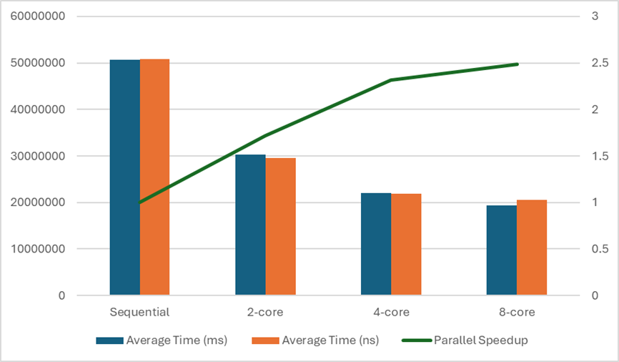
Figure1.2.3.1: Total Time (ns) of Different Core Numbers and Parallel Speedup
The use of nanoTime() is unequivocally superior for micro-benchmarking. The nanosecond resolution captures the true execution time more accurately than millisecond timings, which can be subject to rounding errors for short-duration computations. This is evident in the more consistent speedup ratios calculated from the nanosecond data. The observed speedups (1.72, 2.32, 2.48) provide a more precise measure of the parallel efficiency. Despite the time precision, both graphs of parallel speedup show the same trend in parallel speedup decrease when we increase to 8-core.

1.2.4 The Impact of Workload Size on Parallel Efficiency
The experiment compared the execution time of a sequential and a two-threaded parallel implementation of π (pi) computation using different iteration counts.

Nodes | Sequential Speed (ms) |  |  |  |  | Sequential Average (ms) | Parallel 2 Core Speed (ms) |  |  |  |  | Parallel Average  (ms) | Parallel Speedup | Efficiency (%)
1,000,000 | 10 | 10 | 11 | 12 | 11 | 10.8 | 16 | 15 | 19 | 12 | 15 | 15.4 | 0.71 | 35.5
10,000,000 | 37 | 30 | 25 | 32 | 39 | 32.6 | 29 | 26 | 22 | 29 | 27 | 26.6 | 1.23 | 61.5
1,000,000,000 | 1930 | 2000 | 2285 | 2108 | 1979 | 2160.4 | 1272 | 1362 | 1271 | 1233 | 1283 | 1284 | 1.62 | 81.5
Table1.2.4.1: The Relation of Parallel Speedup with Different number of Steps in Sequential and 2-Threads in Microsecond.

The data clearly shows that the performance benefit of parallelisation depends heavily on the problem size. For the smallest workload (1,000,000 iterations), the parallel version was slower than the sequential one, giving a speedup of 0.71. This happened because the computation time was too short to offset the overhead of thread creation, context switching, and memory synchronisation.
When the workload increased to 10,000,000 iterations, the parallel implementation began to outperform the sequential version, achieving a modest speedup of 1.23. This indicates that as the number of computations grows, the cost of thread management becomes relatively smaller compared to the total computation time.
At the highest workload of 1,000,000,000 iterations, the performance gain became much more pronounced, reaching a speedup of 1.63. This demonstrates that parallelisation becomes increasingly effective as the workload grows, since both threads can remain busy performing useful calculations for longer periods, reducing the impact of overhead and improving CPU utilisation across cores.
Overall, the trend suggests that for compute-intensive tasks, parallel execution can substantially reduce total computation time, but for smaller problems, it may degrade performance due to fixed overheads and timing limitations.

1.3 Conclusion
In summary, this lab successfully demonstrated the principles and practical challenges of parallel programming using Java Threads. The implementation of a parallel π calculation resulted in significant performance improvements, with a parallel speedup of up to 2.483 observed on a multi-core system.
However, the experiment also showed that performance gains are not strictly proportional to the number of threads used. While increasing parallelism from one to four threads yielded substantial benefits, further increasing eight threads provided only marginal gains. The exercise underscored the necessity of using high-precision timing functions like nanoTime() for accurate performance analysis. This foundational understanding of performance scaling and measurement is crucial for developing efficient parallel applications in more complex scenarios.
In addition, it was observed that smaller workloads sometimes performed worse in the parallel version. This can be because of the time limitation of the thread creation, context switching and memory synchronization.

2. Lab02

2.1 Introduction
In this session, we used the Mandelbrot set as a case study in investigating the role of problem decomposition in parallel programming. The Mandelbrot set is a classic example of an “embarrassingly parallel” problem because the value of the output image can be calculated independently. However, in this session the workload is not uniform; pixels inside the set require more iterations (up to CUTOFF) than those far outside.
Primarily while data parallelism is straight forward to implement, we need to understand the importance of memory architecture and selecting the right decomposing strategies for efficient parallel performance. The report benchmarks the different decomposition strategies for 2 and 4 threads, analyzing the resulting parallel speedup and parallel efficiency.

2.2 Approaches and Analysis

2.2.1 Methodology
A Java-based Mandelbrot set calculator with an image size of 4096x4096 and a computational cutoff of 100 iterations. This image size was chosen to provide high visual resolution while maintaining a tractable computation time for benchmarking. The baseline performance in sequential time will be implemented first. The result will be colored and saved in a png file as illustrated below in Figure 2.1.

Figure2.2.1.1: The Mandelbrot Set

Using Java, we can compute parallel programming at the next step. Initially, we will be using 2-thread and divide the image into two sections. We will be testing the implementation with a horizontal division and a vertical division. Then, we will run parallel programming using four threads. This time, the process will be divided horizontally into four horizontal strips, and another way is divided into four squares (2x2).
After running each program multiple times to get an average running time in milliseconds, we can use benchmark running time when we run the process sequentially and obtain the Parallel Speedup to provide a representative performance measure.

2.2.2 Results and Analysis
The performance of the 2-thread implementations varied based on the decomposition strategy. The results are listed in Table2.1 below.
Nodes | 1st Time （ms) | 2nd Time （ms) | 3rd Time （ms) | 4th Time （ms) | 5th Time （ms) | Average Time （ms) | Parallel Speedup | Efficiency (%)
Sequential | 613 | 869 | 672 | 624 | 883 | 636 | 1 | 100
Horizontal Cut | 476 | 322 | 448 | 325 | 322 | 323 | 1.96 | 98
Vertical Cut | 483 | 616 | 615 | 613 | 622 | 616 | 1.03 | 51.5
Table2.2.1: Performance of Two-Thread Decomposition Strategies in milliseconds.


Figure2.2.2.1: Horizontal (i-loop) Decomposition with 2 Threads

Figure2.2.2.2: Vertical (j-loop) Decomposition with 2 Threads
The horizontal cut method achieved a significantly higher speedup (1.96) than the vertical cut. This result indicates that the distribution of computational workload is not symmetric about the vertical axis, which matched graph produced by the program after colouring different processed regions. It also shows the effect of the decomposition method on efficiency.
The drastically lower speedup of the vertical division (1.03) suggests a severe load imbalance. This implies that the computationally expensive regions of the Mandelbrot set are not distributed evenly across the left and right halves of the image in this specific implementation.
The result when using 4-thread is illustrated in Table2.2 below.

Nodes | 1st Time （ms) | 2nd Time （ms) | 3rd Time （ms) | 4th Time （ms) | 5th Time （ms) | Average Time （ms) | Parallel Speedup | Efficiency (%)
Sequential | 613 | 869 | 672 | 624 | 883 | 636 | 1 | 100
4 Horizontal Strip | 549 | 519 | 510 | 522 | 515 | 523 | 1.21 | 30.3
Squares (2x2) | 318 | 311 | 316 | 307 | 230 | 313 | 2.03 | 50.8
Table 2.2.2.2: Performance of Four-Thread Decomposition Strategies in milliseconds.


Figure2.2.2.3: Horizontal Strip Decomposition with 4 Threads

Figure2.2.2.4: 4 Squares Decomposition (2x2) with 4 Threads

The parallel speedup of decomposing area into 2x2 squares using 4-thread is 2.03. This method significantly outperformed the performance of divided the graph into 4 horizontal strips, which only achieved 1.21 in the Parallel Speedup. The parallel speedup of four horizontal strips using 4-thread (1.21) is even lower than the parallel speedup of one horizontal cut using 2-thread (1.96). Splitting into four horizontal strips likely exacerbates the imbalance of the computational workload.
The process of 2x2 squares using 4-thread is by far one of the most efficient decomposing methods that we have tested as it creates smaller work units. This method allows for a much better distribution in the computational workload across all 4 threads and has a parallel speedup of 2.03.
These results conclusively demonstrate that the optimal decomposition strategy is highly dependent on the problem's data domain and memory structure. On the other hand, increasing the number of threads using the same cutting methods does not guarantee an increase in parallel speedup.

2.3 Conclusion
This Lab provided a practical demonstration of the concepts of problem decomposition and load balancing. It clearly showed achieving higher parallel speed is not just based on the dividing data among threads;
The results illustrate that the decomposition strategy must match the problem's structure. For irregular workloads like the Mandelbrot set, careful work distribution is essential to maximize processor utilization and achieve significant performance gains from parallel processing.

3. Lab 03

3.1 Introduction
Conway's Game of Life represents a class of simulation problems that are not embarrassingly parallel. Unlike the Mandelbrot Set (previous week's exercise), each cell's future state depends on its neighbors' current states, requiring careful synchronization between threads to ensure correctness. In this session, we focus on workload decomposition strategies and parallelizing simulation types using blockwise decomposition.

3.2 Approaches and Analysis

3.2.1 Methodology
This program simulates Conway's Game of Life a cellular automaton where cells on a grid live, die, or reproduce based on simple rules. It is like watching a colony of organisms evolve over time. In the sequential code we tried experimenting on different values like the constant “N, CELL-SIZE and DELAY” to see how it affects the display of the code.
For parallelization, we moved the main update loop into the “run method” of the ParallelLife class extending Thread, we then decomposed both computational loops (neighbor sum calculation and state update) using block wise decomposition we also made sure to keep I/O operations (printing and display) on thread 0 only, and lastly we Implemented barrier synchronization between computational phases using the “java.util.concurrent.CyclicBarrier” .
The parallel game of life employs a block decomposition strategy were the 256*256 grid is divided into horizontal strips, with each of the P threads assigned B=N/P consecutive rows to process. Each threads calculates neighbour sums independently and update cell states for its assigned rows.
In the program we used a two-barrier synchronization pattern implemented with “Java’s CyclicBarrier to prevent race conditions. The first barrier prevents reading partially updated neighbour sums, while the second barrier prevents mixing data from different iterations. Without the barriers you’d get race conditions where threads read inconsistent data, producing an incorrect game of life evolution
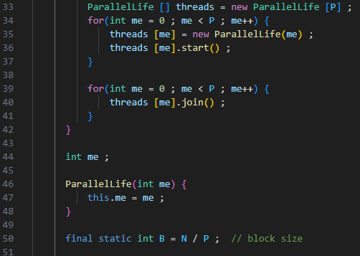

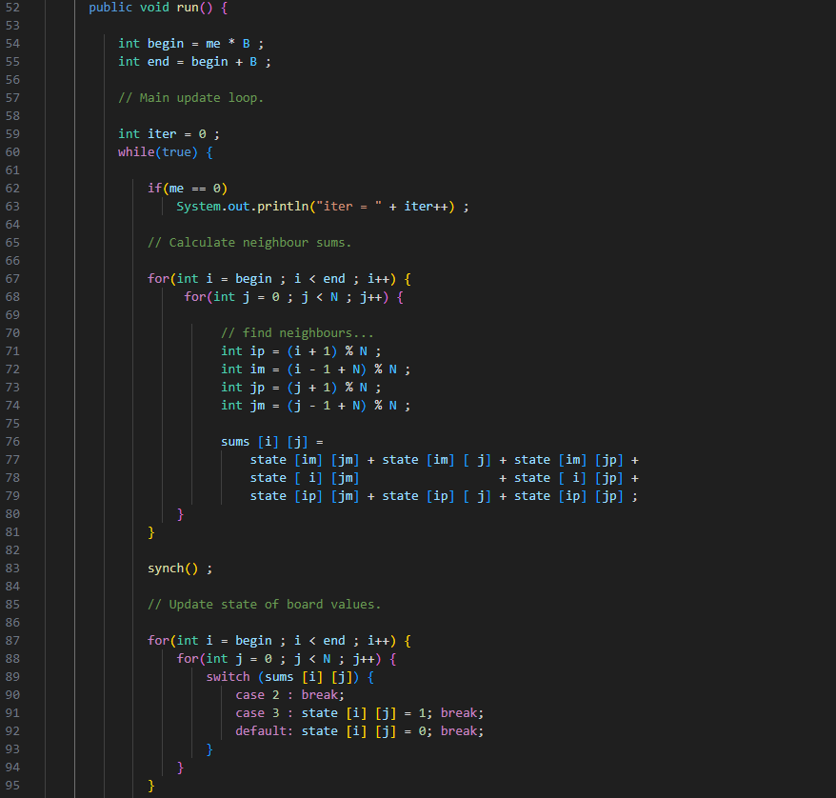

3.2.2 Results and Analysis
The performance and behavioural characteristics of the parallel Game of Life implementation were systematically evaluated through controlled experiments varying the grid dimension (N) and thread count (P). Experimental observations indicate that the number of iterations required to reach stable configurations exhibits a positive correlation with grid size. For instance, configurations with N = 128 and P = 128 typically achieved stability around 2000 iterations, whereas larger grids of N = 256 required approximately 3000 iterations to reach analogous stable states. And when the N = 256, P = 128, it takes about 4800 iterations to reach a stable state.

Figure3.2.2.1: The Game of Life Reached a Stable State

This indicates that despite the computational force increasing with the grid size, the number of iterations will also increase with the size. The parameter DELAY will force the display to freeze for a given time, and the parameter CELL_SIZE only affects the display's cell size. The rough number of iterations to reach a stable state remains unchanged.
A fundamental constraint emerged during experimentation: the implementation requires N ≥ P to function correctly. When P exceeds N, the block decomposition calculation B = N / P produces zero due to the nature of Java. Consequently, all threads received empty work ranges, resulting in a dead-lock situation where the initial random state persists indefinitely without evolution.
This condition arises because the block decomposition strategy assigns each thread a contiguous row block of size B. When P > N, B becomes zero, leaving no row for processing. We can modify the block to ensure that when it happens, we reassigned the block size to 1. However, this would leave excess threads idled.

3.3 Conclusion
This lab showed how Conway’s Game of Life can be parallelised using blockwise decomposition while still requiring careful coordination between threads to keep the simulation accurate. Splitting the grid into horizontal sections and synchronising them with a dual barrier approach allowed the program to run correctly on multiple threads, though performance depended heavily on the balance between grid size and the number of threads. Larger grids took longer to stabilise and ensuring that the grid size was at least as large as the thread count was crucial to avoid invalid partitions and deadlocks. Overall, the exercise demonstrated that although the Game of Life can benefit from parallelism, it is not naturally parallel, and effective results rely on proper synchronisation, thoughtful workload division, and matching the problem size to the available parallel resources.

4. Lab 04

4.1 Introduction
This lab explores the numerical solution of the two-dimensional Laplace equation using the relaxation method, implemented both sequentially and in parallel using Java threads. The Laplace equation is a fundamental partial differential equation that appears in various fields of physics and engineering, the sequential relaxation method involves iteratively updating each grid point based on the average neighbours, this algorithm presents significant opportunities for parallel execution. The aim of this experiment is to parallelize the Laplace solver using a multi-threaded approach with barrier synchronization, benchmark its performance under thread counts, and critically evaluate the impact of synchronization on parallel efficiency.

4.2 Approaches and Analysis

4.2.1 Methodology
The sequential Laplace equation solver was initially executed to establish a performance baseline. Rendering the graphical output is computationally expensive. Therefore, to minimise this overhead, visualisation was limited to every 1,000 iterations rather than each individual iteration. This speed up the process by reducing the number of times we need for illustration while shows the process of our simulation.

Figure4.2.1.1: The Initial State of the Simulation
The boundary conditions for Laplace's equation were defined as follows: the left and right edges were maintained at a fixed voltage of 1.0, while the top and bottom edges were held at 0.0. This configuration models a hollow conductive box with prescribed potentials on opposing faces. The maximum value is displayed in red, and 0 values are displayed in blue. That is the reason why both left and right edges in the picture above are red, while the rest of the area are in blue.

Figure4.2.1.2: The Simulation After 100,000 Iterations
The simulation after 100,000 iterations is illustrating above. The result fit with the expectation. The sequential Laplace solver was parallelised adopting the methodology demonstrated in the Game of Life case study from Chapter 3. The computational domain was decomposed using a block partitioning strategy, wherein the two-dimensional grid was divided into horizontal strips allocated to individual threads. Each Thread is responsible for updating a contagious block of rows.
Two CyclicBarrier synchronisation points were implemented to ensure computational correctness, following the principles established in Chapter 3. The first barrier guarantees that all threads complete the calculation phase before any thread proceeds to update shared state variables, thereby preventing race conditions where threads might access inconsistent generations of data. The code has two barrier synchronisations. The first barrier ensures all threads complete the calculation of the new values (new phi). The second barrier ensure all threads finish the updating new values before proceeding to the next iteration.
Furthermore, to quantify the overhead attributable specifically to synchronisation, a modified version of the parallel implementation was executed with both barrier calls removed. While this unsynchronised variant produces numerically incorrect results due to race conditions, this data allows us to analyse the performance impact of synchronisation mechanisms.
All experiments employed a fixed grid size of N = 256 across 100,000 iterations. To ensure that performance measurements reflected computational workload rather than graphical rendering overhead, visualisation was triggered only every 1,000 iterations. Each configuration was expected five times, and average execution time was used for analysis.

4.2.2 Result and Analysis
With Barrier synchronization
Threads | 1st(ms) | 2nd (ms) | 3rd (ms) | 4th (ms) | 5th (ms) | Mean (ms)
Sequential | 5076 | 5089 | 5000 | 5119 | 5140 | 5084.8
2 | 3877 | 3838 | 3831 | 3854 | 3915 | 3863.0
4 | 5125 | 5377 | 5551 | 6237 | 5761 | 5610.2
8 | 10547 | 10751 | 11438 | 11374 | 11039 | 11029.8
Table 4.2.2.1: Barrier synchronization

Without Barrier synchronization:
Threads | 1st (ms) | 2nd (ms) | 3rd (ms) | 4th (ms) | 5th (ms) | Mean (ms)
2 | 2670 | 2625 | 2772 | 2673 | 2725 | 2693
4 | 1705 | 1751 | 1735 | 1729 | 1686 | 1721
8 | 1434 | 1425 | 1679 | 1429 | 1432 | 1479
Table 4.2.2.2: Without Barrier synchronization

Threads (P) | Mean Time (ms) | Parallel Speedup | Efficiency (%)
Sequential | 5084.8 | 1.00 | 100
2 | 3863 | 1.32 | 65.9
4 | 5610.2 | 0.91 | 22.7
8 | 11029.8 | 0.46 | 5.7
Table 4.2.2.3: Performance Analysis (with Barrier)
With the barrier enabled, the performance degrades as threads increase beyond 2, indicating significant synchronisation and cache contention overhead. The 4-thread and 8-thread versions performed slower than sequential due to excessive barrier waits and thread management costs.

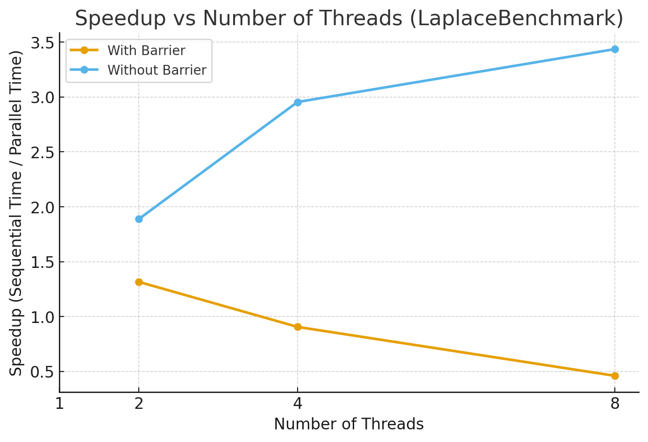
Figure4.2.2.1: Speedup vs Number of Threads
Threads (P) | Mean Time (ms) | Parallel Speedup | Efficiency (%)
2 | 2693.0 | 1.89 | 94.4
4 | 1721.2 | 2.95 | 73.7
8 | 1479.8 | 3.43 | 42.9
Table 4.2.2.4: Performance Analysis (without Barrier)

When synchronisation barriers were disabled, execution time decreased dramatically and speedup increased close to ideal between 2 to 4 threads. However, correctness was not guaranteed, since threads were not synchronized between iterations. This clearly quantifies the barrier synchronization overhead.

Threads | With Barrier (ms) | Without Barrier (ms) | Overhead (ms) | Overhead %
2 | 3863.0 | 2693.0 | 1170.0 | 43.4
4 | 5610.2 | 1721.2 | 3889.0 | 226.0
8 | 11029.8 | 1479.8 | 9550.0 | 645.0
Table 4.2.2.5: Barrier Overhead Estimation

The barrier overhead grows rapidly with thread count. At 8 threads, synchronization consumes the majority of runtime, making parallel execution slower than sequential.

4.3 Conclusion
In conclusion, this investigation into solving the Laplace equation demonstrates the effectiveness of parallel programming techniques for numerical computation in scientific and engineering applications. The relaxation method, which iteratively updates each grid point to be the average of its four neighbours, proved to be well-suited for parallelization due to its regular computational structure and clear data dependencies. Through the implementation of a parallel solver using barrier synchronisation, we successfully distributed the computational workload across multiple threads while maintaining the correctness of the numerical solution. The use of CyclicBarrier synchronization ensured that all threads completed their calculations before proceeding to the next iteration, preventing race conditions that could compromise the accuracy of the voltage field solution.

The benchmarking exercises revealed measurable performance improvements when distributing the work across multiple threads, with speedup and efficiency metrics demonstrating the practical benefits of parallelization for this type of iterative numerical problem. However, it was also evident that synchronization overhead represents a real cost in parallel computing, highlighting the importance of balancing parallelism with the computational granularity of the problem. This exercise not only provided insight into solving partial differential equations numerically but also reinforced fundamental concepts in parallel programming including thread management, data partitioning, and synchronization mechanisms. The techniques explored here from Java's concurrent utilities to OpenMP pragmas present practical approaches that extend to a wide range of computational problems in science and engineering.

5. Lab 05

5.1 Introduction
This report focuses on running MPJ (Message Passing Java) programs in a distributed computing environment. This laboratory session marks a significant transition from previous weeks, as we move beyond single-workstation parallel programming to explore distributed memory parallel computing across multiple networked computers. The primary objective of this lab was to gain hands-on experience with MPJ Express, a software framework that provides MPI-like (Message Passing Interface) functionality for Java applications. Unlike earlier labs where parallel programs executed within the multiple cores of a single workstation using shared memory, this week introduced the more challenging concept of distributed memory programming, where separate computers collaborate on solving parts of a single computational problem.

Throughout this session, we explored two operational modes of MPJ Express: multicore mode for initial testing on a single processor's cores, and cluster mode for true distributed computing across multiple nodes. A key practical component involved implementing a parallel version of the π (pi) calculation algorithm, which served as a benchmark to measure and analyze parallel speedup across different configurations. This report documents the setup process, implementation challenges, experimental results, and performance analysis of running MPJ programs in both multicore and cluster modes.

5.2 Approaches and Analysis

5.2.1 Methodology
Initially, a sequential Java program calculating π through numerical integration was implemented in without using the MPI functionality. The sequential method was executed to establish a baseline performance measurement. The computational workload was significant, with the number of integration steps (N) set to 1,000,000,000 to ensure the difference between is measurable.
After that, the parallel version of the function, MPJPi.java, was developed. The work decomposition strategy involved a block-wise distribution of the integration intervals among the available processes. A main host was responsible for aggregating partial sums from all other worker processes using MPI.COMM_WORLD.Send() and MPI.COMM_WORLD.Recv() functions for sending the requests to the nodes for calculation process and receiving the patrial sum and sum up at the main host.
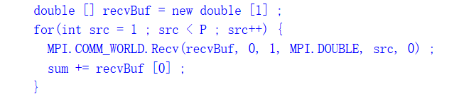
The parallel version was tested in two primary configurations:
- Multicore Mode: The MPJ processes (MPI-like functions in Java) were executed as threads on the cores of a single node within the cluster.
- Cluster Mode: MPJ daemons were initiated on multiple nodes of the cluster. A machines file was created listing the hostnames of these nodes. The node would also have a machines file listing the main hostname. The mpjrun.sh command was then used with the -dev niodev -headnodeip mn01.soc MPJPi to luanch th eapplication across these distributed nodes.
Performance was evaluated by measuring the execution time for varying numbers of processes (P). Each configuration was run five times to account for system variablity, and the average execution time was calculated. The parallel speedup was computed as the ratio of the sequential execution time to the parallel execution time for a given configuration.

5.2.2 Result and Analysis
The performance for the parallel π calculator as well as the sequential benchmark calculation with N = 1,000,000,000 are systematically presented in the table below.

Nodes | 1st (ms) | 2nd (ms) | 3rd (ms) | 4th (ms) | 5th (ms) | Average (ms) | Parallel Speedup | Efficiency (%)
Sequential Benchmark | 6244 | 6214 | 6168 | 6239 | 6234 | 6216 | 1 | 100
2-Threads (Multicore) | 3284 | 3287 | 3279 | 3274 | 3278 | 3280 | 1.90 | 95
2 Nodes (Cluster) | 3510 | 3538 | 3488 | 3491 | 3574 | 3520 | 1.77 | 88.5
3 Nodes (Cluster) | 2650 | 2565 | 2582 | 2586 | 2598 | 2596 | 2.39 | 80.0
4 Nodes (Cluster) | 2193 | 1939 | 2125 | 2107 | 2047 | 2082 | 2.99 | 74.8
4-Threads with 2 Nodes (Multicore & Cluster) | 2113 | 2155 | 2055 | 2067 | 2099 | 2098 | 2.96 | 74
Table 5.2.2.1: Benchmarking Results for Parallel π Calculation (N = 1,000,000,000)
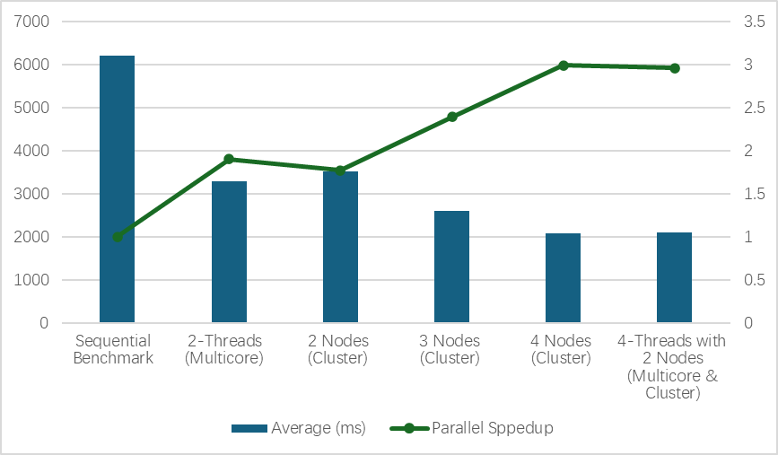
Figure5.2.2.1: Result of Parallel Programming with Cluster Mode and Multicore Mode with Sequential Benchmarking.
The trend of the parallel speedup is shown in the figure above. All parallel configurations achieved a reduction in execution time compared to the sequential baseline, confirming the effectiveness of the parallelisation strategy in both multicore mode and cluster mode. The speedup increased with the number of processes, demonstrating the scalability of the application for this problem size. The performance of 2 threads in multicore mode was very close to that of 2 processes distributed across 2 nodes in cluster mode (with parallel speedup of 1.90 and 1.77 respectively). This indicates that for compute-bound tasks like this, the overhead of inter-node communication via the network in cluster mode was not significantly detrimental compared to the lower-latency shared-memory communication in multicore mode at this scale.
The speedup improved notably when moving from 2 to 3 and then to 4 nodes, reaching a maximum speedup of approximately 3.0, although this is less than the ideal linear speedup of 4. The result for 4 threads distributed across 2 nodes also yielded a speedup of 2.96, showing that the efficiency is nearly as effective as using 4 nodes in the cluster mode.

5.3 Conclusion
This laboratory session successfully demonstrated the transition from shared-memory parallel programming to distributed-memory computing using MPJ Express. Through the implementation and benchmarking of a parallel π calculation algorithm, we gained practical experience with message-passing paradigms that form the foundation of large-scale distributed computing systems.
The experimental work revealed important insights into the performance characteristics of distributed computing. Operating MPJ Express in multicore mode provided an accessible testing environment that facilitated debugging and initial performance analysis on a single machine. The subsequent deployment in cluster mode across multiple networked computers illustrated both the potential and challenges of true distributed computing, where communication overhead between nodes becomes a critical factor affecting overall performance.
The π calculation benchmark effectively highlighted the trade-offs inherent in distributed programming. While parallelizing the computational workload across multiple processes demonstrated measurable speedup, the performance gains were inevitably constrained by the communication costs associated with distributing work segments and aggregating partial results. The use of MPI.COMM_WORLD.Send() and MPI.COMM_WORLD.Recv() functions for inter-process communication emphasized the importance of minimizing data transfer and optimizing communication patterns in distributed applications.

6 Lab 06

6.1 Introduction
This report investigates distributed memory parallel programming using MPJ Express through the implementation of a parallel Laplace Equation solver. Building on previous work with sequential and shared-memory computing, this lab explores the challenges of parallelizing problems across a cluster where processes communicate via message passing.
The primary objective was to examine how inter-process communication overhead, data decomposition strategies affect parallel efficiency. The implementation uses ghost regions and edge swap communications to maintain data consistency across distributed processes, following patterns like other distributed applications but with added complexity from fixed boundary conditions.
Experiments were conducted in both multicore mode and cluster mode to evaluate performance. Various optimizations were explored, including eliminating redundant boundary communications and investigating the relationship between problem size and scalability. The results provide insights into practical considerations for effective distributed memory parallel computing.

6.2 Methodology and Analysis

6.2.1 Methodology
The 2D Laplace domain of size N × N was divided among P processes along the i direction, so that each process handled a contiguous block of B = N/P rows. To allow stencil computations near block boundaries, two additional ghost rows were added to each block. These ghost rows stored boundary values exchanged with neighbouring processes, resulting in local arrays of size (B + 2) × N.

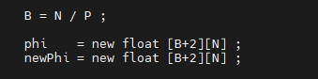

During each iteration, nearby processes exchanged their boundary rows using MPI Sendrecv calls in order to update the ghost regions. Once this exchange was complete, interior grid points were updated using the standard five-point stencil. Fixed boundary conditions were maintained at the global edges, and for this reason process 0 and process P−1 restricted their update ranges to avoid altering boundary values.

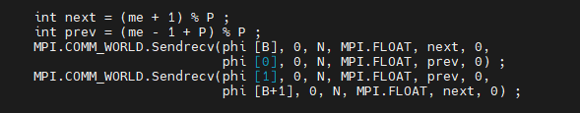

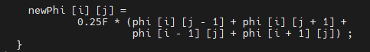

For visualisation purposes, each process transmitted its computed block, excluding ghost rows, to process 0. The root process assembled these blocks into a single global array and displayed the solution using a Swing based graphical interface.
Execution time was measured using wall clock timing around the main iteration loop. To minimise the impact of input/output overhead on performance measurements, the frequency of graphical updates was reduced once after 1000 iterations during timing experiments.

6.2.2 Result and Analysis
The benchmarking results reveals a stark contrast between multicore and cluster mode performance, underscoring the dominance of communication costs in distributed environments.

Node | 1st (ms) | 2nd (ms) | 3rd (ms) | 4th (ms) | 5th (ms) | Ave (ms) | Parallel Speedup | Efficiency (%)
1 | 9938 | 9186 | 9804 | 9619 | 9738 | 9656 | 1 | 100
2 | 8250 | 8365 | 7639 | 7963 | 8644 | 8172 | 1.18 | 59
3 | 7061 | 6331 | 7430 | 6842 | 7033 | 6939 | 1.39 | 46.3
4 | 7054 | 6966 | 7346 | 7789 | 7680 | 7367 | 1.31 | 32.8
8 | 14126 | 13947 | 14826 | 14362 | 13175 | 14087 | 0.69 | 8.6
Table6.2.2.1 Performance of MPJLaplace (N=256) in Multicore Mode
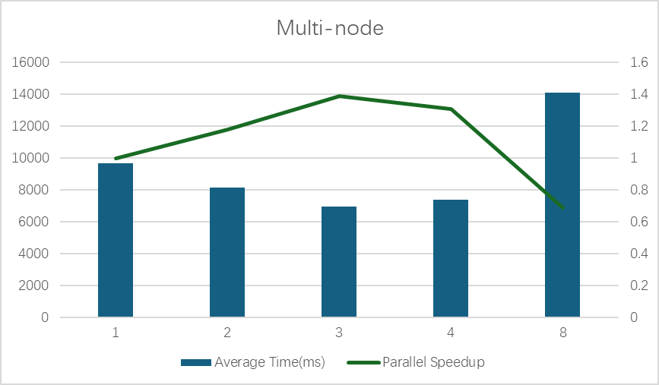
Figure6.2.2.1 Performance of MPJLaplace (N=256) in Multicore Mode and Trend of Parallel Speedup.

In multicore mode, linear speedups were partially achieved for P=2 and 3. Efficiency declined significantly as P increased, indicating growing overheads from thread management and memory contention. The severe slowdown at P=8 suggests resource oversubscription on the node’s 12-core processor, leading to cache thrashing and scheduling contention.

Node | 1st (ms) | 2nd (ms) | 3rd (ms) | 4th (ms) | 5th (ms) | Ave (ms) | Parallel Speedup | Efficiency (%)
1 | 9938 | 9186 | 9804 | 9619 | 9738 | 9656 | 1 | 100
2 | 44735 | 44825 | 44972 | 45037 | 44516 | 44817 | 0.22 | 11
3 | 43947 | 44024 | 43475 | 43869 | 43759 | 43815 | 0.22 | 7.3
4 | 41942 | 41812 | 41626 | 41482 | 41734 | 41719 | 0.23 | 5.8
8 | 38646 | 38398 | 38461 | 38426 | 38345 | 38455 | 0.25 | 3.1
Table6.2.2.2 Performance of MPJLaplace (N=256) in Cluster Mode.
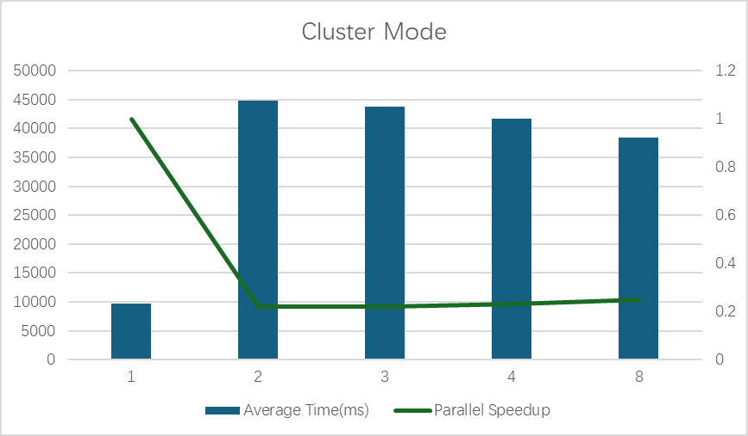
Figure6.2.2.2 Performance of MPJLaplace (N=256) in Cluster Mode and Trend in Parallel Speedup.

The cluster mode results are illuminating. A parallel slowdown was observed, with the 2-process configuration begin approximately 4.6 times slower than the sequential version. This is a direct result of high communication latency. For N=256, the local sub-grid per process is only 64x256 elements. The computation per iteration for this small domain is minimal, but the cost of performing two Sendecv operations (for the ghost regions) in every iteration across the network is exceedingly high. The total communication volume is substantial: for P=2 and NITER=100,000, there are 200,000 point-to-point messages. This results in a very low computation-to-computation ratio, causing communication costs to utterly dominate the total runtime.

Node | 1st (ms) | 2nd (ms) | 3rd (ms) | 4th (ms) | 5th (ms) | Ave (ms) | Parallel Speedup | Efficiency (%)
1 | 8766 | 8729 | 8571 | 8597 | 8483 | 8629 | 1 | 100
2 | 4710 | 4944 | 5134 | 4663 | 4804 | 4851 | 1.78 | 89
3 | 3038 | 3094 | 3057 | 3169 | 3107 | 3093 | 2.79 | 93
4 | 2216 | 2192 | 2334 | 2237 | 2344 | 2264 | 3.81 | 95.3
Table6.2.2.3 Cluster Mode Performance with Communication Overhead Removed.
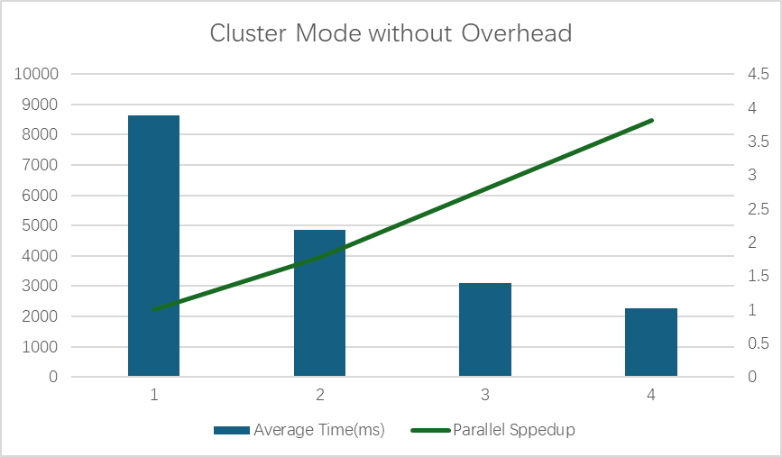
Figure6.2.2.3 Cluster Mode Performance with Communication Overhead Removed and Trend of Parallel Speedup

If we remove the edge-swap code validates this hypothesis, as shown in the Table 6.2.2.3, when communication is removed, a linear speedups and high efficiencies are achieved. This demonstrates that the data decomposition strategy is correctly implemented and that the computational load is well-balanced across nodes. The results in Table6.2.2.2 and Table6.2.2.3 show that the communication function is the main reason for the significant slowdown in cluster mode.

6.3 Conclusion
This lab discusses how static decomposition can lead to load imbalance when different parts of a problem require different amounts of computation and explains that dynamic scheduling is better suited to irregular workloads. The results from this lab directly contrast the limitations of static approaches by showing how a task farm (master–worker) model overcomes these issues in practice.
With small task sizes, the task farm dynamically redistributes work so that faster workers receive more tasks, significantly reducing idle time. This leads to strong scaling and consistently high efficiency as the number of processes increases. These results highlight a clear advantage over the static partitioning strategies outlined in this lab, where uneven workloads would cause processors to wait for the slowest task to finish.
However, the lab also demonstrates that dynamic scheduling is not automatically optimal. When task granularity is too large, the benefits of dynamic load balancing are reduced, and performance degrades due to imbalance and overhead with the communication function. One valuable lesson in this lab is that effective parallel performance depends on choosing an appropriate decomposition strategy and task size, particularly for problems with non-uniform computational cost.

7 Lab 07

7.1 Introduction
This lab focuses on the task farm model in parallel programming using MPJ Express. In earlier labs, parallelism was achieved by dividing a problem into fixed regions that were assigned to processes at the start of execution. While effective for some applications, this static approach can lead to load imbalance when different parts of the problem require different amounts of computation.
The task farm model addresses this issue by distributing work dynamically. A central master process assigns small units of work to worker processes as they become available. Once a worker finishes its task, it returns the result and immediately requests more work. This approach is particularly appropriate for embarrassingly parallel problems.
To demonstrate this model, the Mandelbrot set computation is used. Although the problem is inherently parallel, the workload is artificially increased by using a very large iteration cut-off value, making it suitable for evaluating parallel performance on multicore systems and distributed clusters.

7.2 Approaches and Analysis

7.2.1 Methodology
The experimental methodology was based on the implementation and execution of a master-worker task farm from the Mandelbrot set calculation. In this model, process 0 acts as the master, responsible for distributing tasks and collating results, while other processes act as workers. Therefore, for np processes, there are np-1 workers.
In this model, we will be using a few advanced features from MPI to help the implementation of the Mandelbrot set calculation. TAG_HELLO, TAG_TASK, TAG_RESULT, TAG_GOODBYE were used to differentiate between message types, enabling a single communication channel to handle multiple purposes. The master process used MPI.ANY_SOURCE and MPI.ANY_TAG in its Recv call to accept the next available message from any worker, whether a request for work or a completed result. The Status object returned by Recv was interrogated to determine the actual source (status.source) and message tag (status.tag), allowing the master to respond appropriately.
This lab will also test two different decompose strategies:
- Vertical Strips: This will be tested first, where each task comprised a contiguous block of BLOCK_SIZE rows of the image.
- Square Blocks: An alternative strategy where tasks were defined as square sub-regions of the image with block_edge = 64.
Benchmarking was conducted. The problem size was fixed at N=1024 and the CUTOFF=100,000. Each configuration was run five times to get an average execution time. Parallel speedup (Sp) and efficiency were calculated. The master process will also be calculated in the efficiency as part of the overall system overhead.

7.2.2 Results and Analysis
The benchmarking results provide a comprehensive view of the task farm's performance characteristics, revealing strengths and a critical performance pathology.

Nodes | 1st (ms) | 2nd (ms) | 3rd (ms) | 4th (ms) | 5th (ms) | Ave (ms) | Parallel Speedup | Efficiency (%)
2 | 27881 | 28120 | 28921 | 28121 | 28581 | 28325 | 1 | 50
3 | 14353 | 14374 | 14531 | 14461 | 14407 | 14425 | 1.96 | 65.3
4 | 9925 | 9716 | 9910 | 9696 | 9800 | 9809 | 2.89 | 72.3
5 | 7502 | 7368 | 7369 | 7364 | 7386 | 7398 | 3.83 | 76.6
6 | 6065 | 6314 | 6069 | 6053 | 5982 | 6097 | 4.65 | 77.5
7 | 5118 | 5155 | 5040 | 5123 | 5043 | 5096 | 5.56 | 79.4
8 | 4425 | 4477 | 4437 | 4394 | 4408 | 4428 | 6.40 | 80.0
9 | 3869 | 3937 | 3919 | 4018 | 3967 | 3942 | 7.19 | 79.9
10 | 3660 | 3675 | 3611 | 3559 | 3557 | 3612 | 7.84 | 78.4
11 | 3453 | 3372 | 3234 | 3406 | 3247 | 3342 | 8.47 | 77.0
12 | 3076 | 3164 | 2952 | 3015 | 3150 | 3071 | 9.22 | 76.8
Table7.2.2.1: Multicore Performance Results for Mandelbrot Set Calculation (N=1024, CUTOFF=100000, Block Size=4)

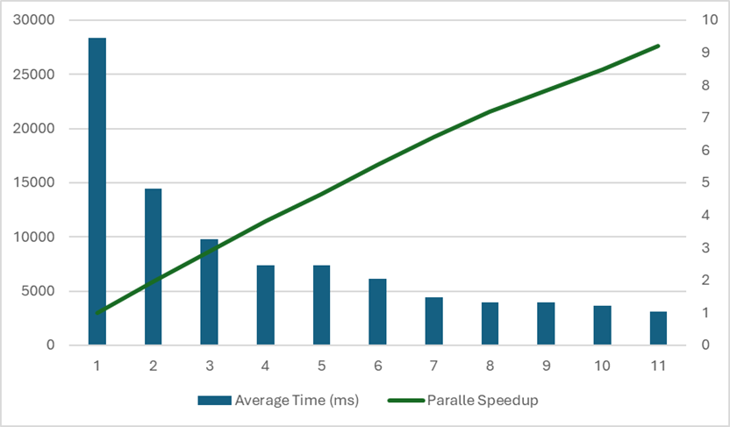
Figure7.2.2.1: Multicore Trend for Mandelbrot Set Calculation (N=1024, CUTOFF=100000, Block Size=4)

The multicore results show strong scaling as workers(np) increase. Average runtime drops from 28325ms (np=2) down to 3071ms (np=12), with speedup rising to 9.22 and efficiency staying roughly at 77% to 80% across larger process counts.
The task farm model is doing its job, dynamic scheduling keeps workers busy, so efficiency remains relatively high even as P grows. Speedup becomes less-than-ideal at higher P due to unavoidable overheads (master coordination, communication, contention), but the overall trend is still strongly positive.

Nodes | 1st (ms) | 2nd (ms) | 3rd (ms) | 4th (ms) | 5th (ms) | Ave (ms) | Parallel Speedup | Efficiency (%)
2 | 26721 | 26732 | 26692 | 26676 | 26646 | 26693 | 1 | 50.0
3 | 13645 | 13693 | 13739 | 13955 | 13660 | 13738 | 1.94 | 64.7
4 | 9293 | 9322 | 9302 | 9660 | 9293 | 9374 | 2.85 | 71.3
5 | 7172 | 7245 | 7299 | 7144 | 7147 | 7201 | 3.71 | 74.2
6 | 5802 | 5840 | 5882 | 5857 | 5814 | 5832 | 4.58 | 76.3
Table 7.2.2.2: Cluster Performance Results for Mandelbrot Set Calculation (N=1024, CUTOFF=100000, Block Size=4)

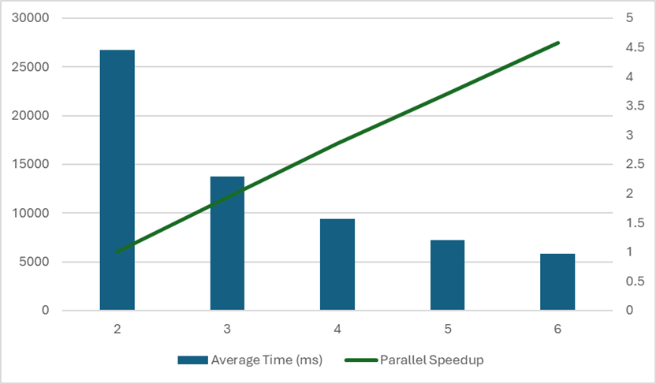
Figure 7.2.2.2: Cluster Trend Performance Results for Mandelbrot Set Calculation (N=1024, CUTOFF=100000, Block Size=4)

The vertical strip farm performed effectively in cluster mode, as shown in Table 2. While efficiencies were slightly lower than in multicore mode indicating the added latency of network communication, they remained above 71% for up to 6 total processes. This confirms that for problems with a very high computation-to-communication ratio, the task farm paradigm can leverage distributed resources efficiently, as the time spent computing dwarfs the time spent communicating tasks and results.

Nodes | 1st (ms) | 2nd (ms) | 3rd (ms) | 4th (ms) | 5th (ms) | Ave (ms) | Parallel Speedup | Efficiency (%)
2 | 26721 | 26732 | 26692 | 26676 | 26646 | 26693 | 1 | 50.0
3 | 14398 | 14178 | 14339 | 14102 | 14171 | 14238 | 1.87 | 62.3
4 | 9357 | 9497 | 9487 | 9510 | 9537 | 9478 | 2.82 | 70.5
5 | 7345 | 7635 | 7213 | 7415 | 7481 | 7424 | 3.60 | 72.0
6 | 6045 | 6012 | 5998 | 5943 | 5968 | 5993 | 4.45 | 74.2
Table 7.2.2.3: Multicore-Cluster Hybrid Performance Results for Mandelbrot Set Calculation (N=1024, CUTOFF=100000, Block Size=4)

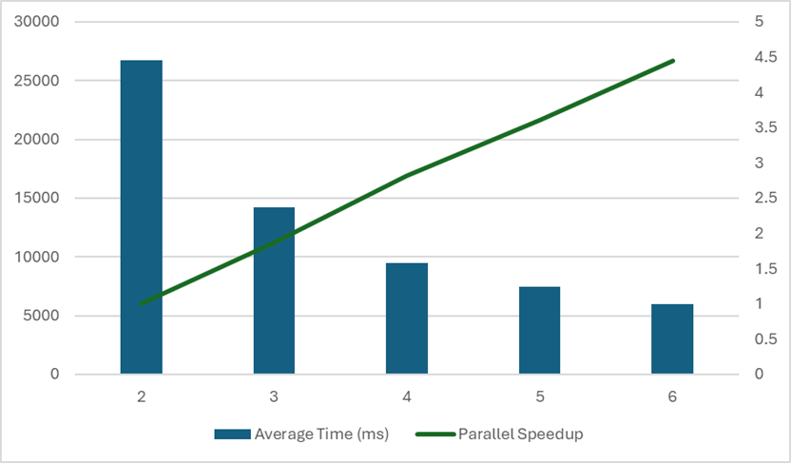
Figure 7.2.2.3: Multicore-Cluster Hybrid Trend Performance Results for Mandelbrot Set Calculation (N=1024, CUTOFF=100000, Block Size=4)

For the same block size and comparable process counts, cluster mode (np=2-6) and the multicore–cluster setup achieve similar scaling trends, Cluster mode reaches speedup 4.58 at np=6 (avg 5832ms), while Multicore-cluster reaches speedup 4.45 at np=6 (avg 5993ms). With sufficiently compute-heavy tasks (high CUTOFF) and small blocks, the farm can scale well even when workers are distributed, because computation per task helps amortize message overhead.

Nodes | 1st (ms) | 2nd (ms) | 3rd (ms) | 4th (ms) | 5th (ms) | Ave (ms) | Parallel Speedup | Efficiency (%)
2 | 34161 | 32682 | 32054 | 32624 | 32512 | 32807 | 1 | 50.0
3 | 17056 | 16970 | 16859 | 17148 | 17159 | 17038 | 1.93 | 64.3
4 | 11798 | 12349 | 12215 | 11935 | 11703 | 12000 | 2.73 | 68.3
5 | 9483 | 9343 | 9269 | 9186 | 9367 | 9330 | 3.52 | 70.4
6 | 7655 | 7565 | 7806 | 7758 | 8021 | 7761 | 4.23 | 70.5
Table7.2.2.4: Multicore Performance Results for Mandelbrot Set Calculation (N=1024, CUTOFF=100000, Block Size=64)

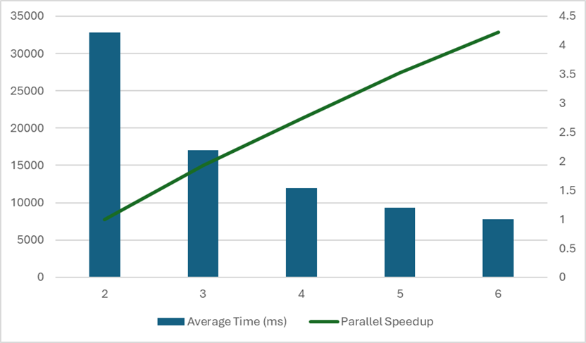
FIGURE 7.2.2.4: Multicore Trend Performance Results for Mandelbrot Set Calculation (N=1024, CUTOFF=100000, Block Size=64)

Nodes | 1st (ms) | 2nd (ms) | 3rd (ms) | 4th (ms) | 5th (ms) | Ave (ms) | Parallel Speedup | Efficiency (%)
2 | 71283 | 71460 | 72024 | 71409 | 72095 | 71654 | 1 | 50.0
3 | 52680 | 52778 | 52821 | 52930 | 52473 | 52736 | 1.36 | 45.3
4 | 46652 | 46874 | 46919 | 46942 | 46813 | 46840 | 1.53 | 38.2
5 | 43958 | 44080 | 44102 | 44010 | 44081 | 44046 | 1.63 | 32.5
6 | 42352 | 42305 | 42118 | 42092 | 42329 | 42239 | 1.70 | 28.3
Table 7.2.2.5: Cluster Performance Results for Mandelbrot Set Calculation (N=1024, CUTOFF=100000, Block Size=64)

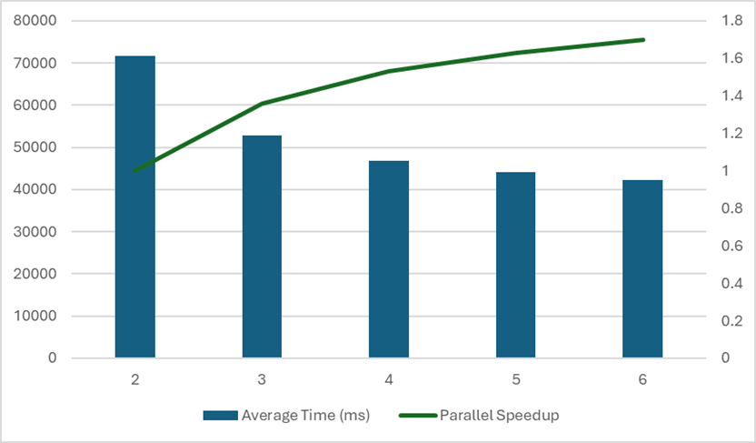
Figure 7.2.2.5: Cluster Performance Results for Mandelbrot Set Calculation (N=1024, CUTOFF=100000, Block Size=64)

Changing block size had a noticeable impact, Multicore block size = 64 is consistently slower than block size = 4 at the same np (e.g., at np=6: 7761ms vs 6097ms).
This suggests that larger blocks reduce the scheduler’s ability to “smooth out” uneven work across the fractal (i.e., less effective load balancing), which is exactly what task farming is meant to solve. Cluster block size = 64 performs dramatically worse (e.g., np=2 average 71,654ms, and only 1.70 speedup at np=6).
This indicates large blocks were not suitable for the cluster setup in this dataset.

7.3 Conclusion

8 Lab 09

8.1 Introduction

8.2 Approaches and Analysis

8.2.1 Methodology
A standard sequential matrix multiplication algorithm was implemented in Java using three nested loops. Two matrices, a and b, were initialised with deterministic values and multiplied to produce matrix c. Execution time was measured using system clock values, and performance was calculated using:
GFLOPS = $\frac{2×N^{3}}{{10}^{6} × time\left(ms\right)}$
The experiment was first conducted with N = 1024 and then repeated with larger matrix sizes to observe performance behaviour.
To experiment the effect of cache utilisation, matrix b was transposed into a temporary array bt. The modified algorithm was executed with larger matrix sizes (e.g. N=2048) and performance results were recorded for comparison with the naive sequential approach.
GPU acceleration was experimented using Aparapi. A Maven Java project was created and the Aparapi dependency was added. The matrix multiplication was expressed as a kernel where each work item computed one element of the output matrix. The kernel was executed over a two-dimensional range, and Aparapi automatically selected the most suitable available device. Execution time and performance were recorded for larger matrix sizes.

8.2.2 Results and Analysis
The performance results for all three implementations are presented in the following tables. The performance of the sequential CPU implementation serves as the benchmark for the experiment. The results in Table8.2.2.1 reveals a significant performance degradation as the problem size increases. The data of the performance results for all three implementations are presented in the following tables. The performance of the sequential CPU implementation serves as the benchmark for the experiment. The results in Table8.2.2.1 reveals a significant performance degradation as the problem size increases. The data shows that there is a considerable variable in execution time for N=1024, with the first run being slowest (4859 ms). This is very likely due to just-in-time compilation overhead in the Java runtime environment. As size increases to N=2048, the performance dropped significantly, to only one third of GFLOPS than only half of the size ones. This confirms that there is a performance drop as the problem size increases. One of the reasons is the overused CPU’s memory as the problem size increases. The storage size for N=2048 is approximately 4 times more than storage size for N=1024 for the calculation of the three matrices with the storage size at O(N³). This would overwhelm the CPU’s memory, could result in a high-rate cache missed and forced CPU to read and use the slower main memory.

Matrix Size (N) | 1st (ms) | 2nd (ms) | 3rd (ms) | 4th (ms) | 5th (ms) | Average (ms) | GFLOPS
1024 | 4859 | 2629 | 2995 | 2735 | 2584 | 3160 | 0.68
2048 | 76268 | 60611 | 62177 | 62819 | 62845 | 64944 | 0.26
Table8.2.2.1: Performance of the Sequential CPU (Baseline) Implementation.

The optimised version, which pre-computes the transpose of matrix B to enable contiguous memory accesses, demonstrates a different trend as shown in Table8.2.2.2. The results shown the consistency and efficiency. This implementation maintains a nearly constant 1.97 GFLOPS for both problem sizes N=1024 and N=2048. The optimisation successfully neutralises the memory bottleneck. The improvement for N=2024 is 7.4 times faster than the benchmark version.

Matrix Size (N) | 1st (ms) | 2nd (ms) | 3rd (ms) | 4th (ms) | 5th (ms) | Average (ms) | GFLOPS
1024 | 1088 | 1110 | 1100 | 1088 | 1074 | 1092 | 1.97
2048 | 8955 | 8672 | 8653 | 8735 | 8676 | 8738 | 1.97
Table8.2.2.2: Performance of the CPU Implementation with Modified Algorithm.

The implementation of GPU execution with the Aparapi-based approach did not go as planned. Firstly, the experiment output was significantly lower than the optimised algorithm on the CPU code. The device type, ALT, indicates that the framework did not execute the kernel on the GPU. Instead, it fell back to a secondary mode, which is typically a Java thread pool running on the CPU cores. Therefore, this performance data does not represent GPU capability but rather the performance of a multi-threaded CPU execution. The results are displayed in Table 8.2.2.3. Although this failure does not relate to the GPU, it revealed that the performance of the multi-threaded CPU’s performance. The Aparapi fallback mechanism incurs overhead from managing Java threads, and the kernel abstraction could also incur some extra time during the experiments. Although the GFLOPS values are smaller compared to the modified algorithm’s version at both N=1024 and N=2048, the performance of N=1024 with GFLOPS at 1.14, and N=2048 with GFLOPS at 0.78 shows that multi-threaded CPU performance still outperforms the single-threaded CPU performance with GFLOPS values of 0.68 and 0.26, respectively, in the benchmark.

Matrix Size (N) | 1st (ms) | 2nd (ms) | 3rd (ms) | 4th (ms) | 5th (ms) | Average (ms) | GFLOPS
1024 | 1969 | 1892 | 1673 | 1948 | 1919 | 1880 | 1.14
2048 | 23412 | 21960 | 19945 | 22489 | 21837 | 21929 | 0.78
4096 | 303474 | 286133 | 291677 | 294683 | 277978 | 290789 | 0.47
Table8.2.2.3: Performance of the Multi-Threaded CPU Implementation.

After the correction to the environment, the Apirapi kernel successfully executed on the GPU, as confirmed by the terminal output: Device type = GPU. The performance results for this successful GPU execution are summarised in Table 8.2.2.4. The data shows the definitive performance advantage of the GPU for this type of parallel task, especially when the problem scale is sufficiently large. For N=1024, THE GPU’s performance is only faster than the single-threaded benchmark, and the performance of the modified algorithm is slightly faster than GPU implementations. This could be due to the fixed overhead of launching a GPU kernel and transferring data.
However, for N=2048 and N=4096, the GPU demonstrates its capability in parallel programming. The GFLOPS jumped to 9.22 and 40.89, respectively. This is about 4 times and 21 times faster than the modified algorithm implementation for the same problem sizes. This is mainly due to the kernel launches N2 concurrent threads (over 16 million for N=4096), which are scheduled across hundreds of processing elements within the GPU’s streaming Multiprocessors (SMs). The ability of GPU GDDR memory in high memory bandwidth and rapidly switching between thousands of active threads also contributes to the GPU’s higher computational throughput than a CPU for compute-intensive parallel programming operations.

Matrix Size (N) | 1st (ms) | 2nd (ms) | 3rd (ms) | 4th (ms) | 5th (ms) | Average (ms) | GFLOPS
1024 | 1651 | 1579 | 1741 | 1775 | 1723 | 1694 | 1.27
2048 | 1746 | 1812 | 1715 | 2141 | 1899 | 1863 | 9.22
4096 | 3430 | 3368 | 3208 | 3340 | 3461 | 3361 | 40.89
Table8.2.2.4: Performance of the GPU Implementation.

8.3 Conclusion

