Heap Data Structures: Implementation, Analysis, and Applications

Frenie Labrador
University of the Cumberlands
MSCS 532: Algorithms and Data Structures
Dr. Michael Solomon
July 12, 2026
GitHub repository: https://github.com/flab21/MSCS532_Assignment4

1. Heapsort Implementation
My Heapsort lives in heapsort.py and is split into three functions: max_heapify, build_max_heap, and heapsort itself. The heap is stored directly in the input list, no separate tree structure. For a 0-based array, the children of index i sit at 2i+1 and 2i+2 and the parent sits at (i-1)//2. That index math is the whole trick behind array-based heaps, since it lets you treat a flat list as a complete binary tree without storing a single pointer.
max_heapify takes an index and sifts the value down, swapping it with its larger child until neither child beats it. I wrote it as a loop instead of recursion, mostly because Python's recursion overhead already bit me in Assignment 2 with quicksort on sorted data, and there was no reason to risk it again. build_max_heap starts at the last non-leaf node (n//2 - 1) and heapifies backwards toward the root. The sort itself then repeatedly swaps the root (the max) with the last element of the heap region, shrinks the region by one, and heapifies the new root back down. When the region hits size one, the array is sorted in ascending order.
2. Time and Space Complexity Analysis
Building the heap is O(n), which surprised me the first time I saw it because it looks like n calls to an O(log n) function. The reason it's tighter than O(n log n) is that the cost of heapify depends on the height of the node you start from, not the height of the whole tree. Roughly half the nodes are leaves and cost nothing, a quarter sit at height 1, an eighth at height 2, and so on. Summing n/2^(h+1) nodes times O(h) work over all heights gives a series that converges to O(n). The intuition is that almost all the nodes are near the bottom where there's barely anything to do.
The sorting phase does n-1 extractions, and each one runs max_heapify from the root, which is O(log n) since the swapped-in element can fall at most the height of the tree, floor(log2 n). So the second phase is O(n log n) and it dominates the O(n) build. Total: O(n log n).
What makes Heapsort a bit unusual is that this bound holds in the best, average, and worst case. There's no input that saves it work in any meaningful way. Even if the array arrives already sorted, build_max_heap has to rearrange it into a max-heap first (a sorted ascending array is basically the opposite of a max-heap), and then every extraction still sifts an element down from the root. Compare that to insertion sort, which finishes sorted input in O(n), or naive quicksort, which collapses to O(n^2) on it. Heapsort just does the same amount of structural work regardless. The extraction loop always runs n-1 times and the sift-down distance is tied to the tree height, not to how ordered the data was.
Space is the strong point. Everything happens in place through swaps, so the extra memory is O(1): a few loop variables and that's it. My iterative heapify means there isn't even recursion stack to count. Merge sort needs O(n) auxiliary space for merging and quicksort carries an O(log n) expected stack. The overheads Heapsort does carry aren't about memory, they're about memory access patterns, which showed up clearly in the benchmarks below.
3. Empirical Comparison
benchmark.py times Heapsort against merge sort and randomized quicksort on three input shapes (random, sorted, reverse-sorted) at five sizes from 1,000 up to 100,000 elements. Each number is the average of three runs on fresh copies of the same input. I used randomized quicksort rather than the last-element-pivot version because I already know from Assignments 2 and 3 what the deterministic one does to sorted input, it hits O(n^2) and blows the recursion limit. Times below are in seconds.
Table 1. Random input.
n | Heapsort (s) | Merge Sort (s) | Quicksort (s)
1000 | 0.0019 | 0.0019 | 0.0015
5000 | 0.0119 | 0.0112 | 0.0096
10000 | 0.0294 | 0.0255 | 0.0194
50000 | 0.1966 | 0.1483 | 0.1105
100000 | 0.4355 | 0.3178 | 0.2574

Table 2. Sorted input.
n | Heapsort (s) | Merge Sort (s) | Quicksort (s)
1000 | 0.0020 | 0.0013 | 0.0014
5000 | 0.0116 | 0.0071 | 0.0087
10000 | 0.0260 | 0.0148 | 0.0247
50000 | 0.1672 | 0.0866 | 0.1078
100000 | 0.3543 | 0.1860 | 0.2119

Table 3. Reverse-sorted input.
n | Heapsort (s) | Merge Sort (s) | Quicksort (s)
1000 | 0.0015 | 0.0013 | 0.0014
5000 | 0.0103 | 0.0073 | 0.0093
10000 | 0.0231 | 0.0151 | 0.0194
50000 | 0.1527 | 0.0898 | 0.1029
100000 | 0.3405 | 0.1829 | 0.2219

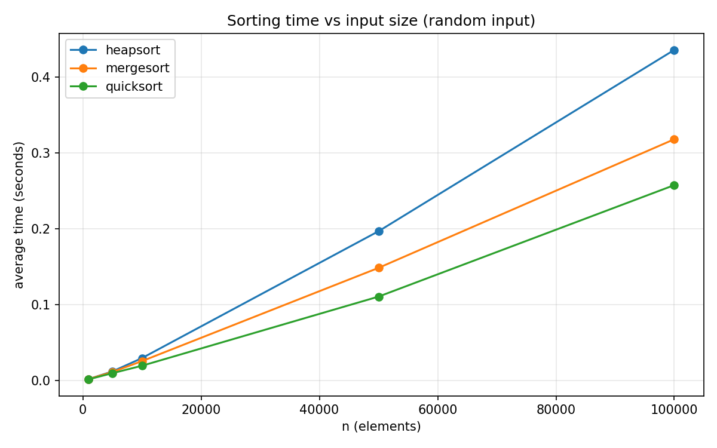
Figure 1. Running time on random input.
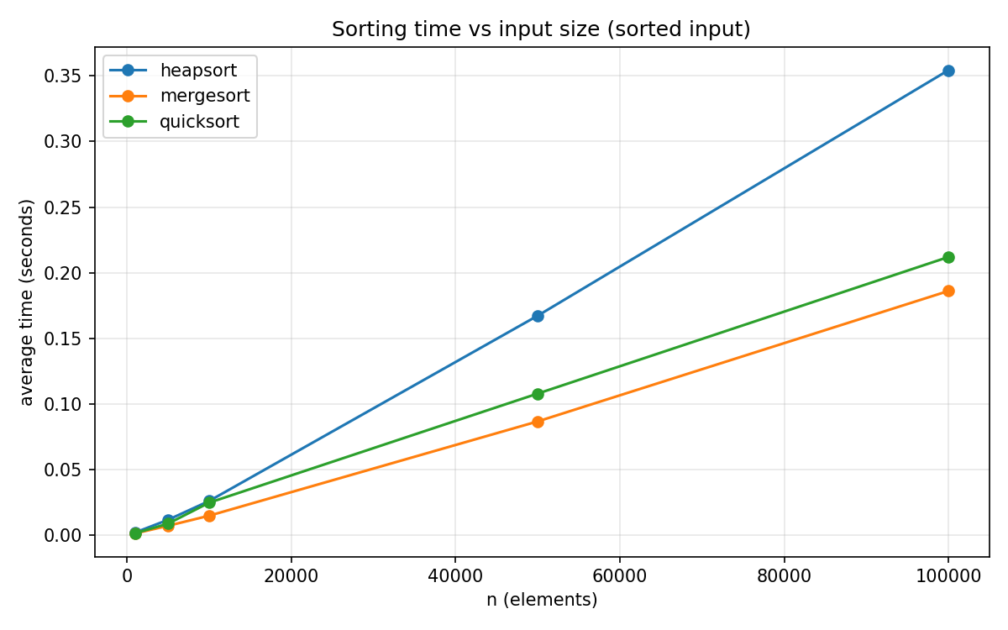
Figure 2. Running time on sorted input.
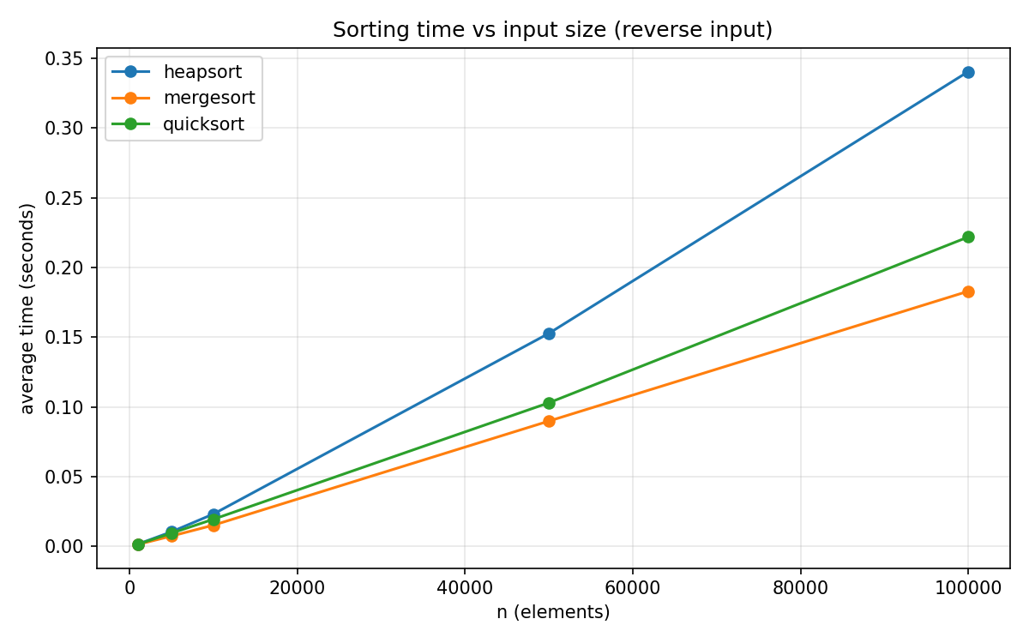
Figure 3. Running time on reverse-sorted input.
The theory says all three algorithms should scale as n log n here, and they do. Going from n = 10,000 to n = 100,000 is a 10x size increase, and every algorithm's time grew by roughly 12x to 15x, which is right in line with the extra log factor. What the theory doesn't predict is the constant factors, and that's where it got interesting.
Heapsort was the slowest of the three on every single distribution. On random input at n = 100,000 it took 0.4355s against quicksort's 0.2574s, about 1.7x slower. The usual explanation, and I think it holds up here, is cache behavior. Quicksort's partition scans the array left to right, and merge sort's merge does the same, so the CPU prefetcher can keep feeding them data. Heapsort's sift-down jumps from index i to 2i+1 to roughly 4i+3, and those jumps get wider as the heap gets bigger, so it keeps missing cache. Same O(n log n) comparisons, worse locality, bigger constant.
The other thing worth noting is that Heapsort was the most consistent. Its times barely moved across distributions (0.4355s random, 0.3543s sorted, 0.3405s reverse at n = 100,000, with the small gap likely coming from cheaper integer comparisons on the range-based inputs), which backs up the claim from section 2 that its work doesn't depend on the input order. Merge sort actually got noticeably faster on sorted and reverse input, roughly 0.19s vs 0.32s at the top size, which I believe comes from the merge step's comparisons becoming completely predictable so the branch predictor stops missing. Randomized quicksort stayed steady across all three shapes, which is exactly what the randomized pivot is supposed to buy you. So the ranking on random data was quicksort, then merge sort, then Heapsort, but on sorted and reverse data merge sort took the lead. Heapsort never won a single race, and honestly that matches its reputation: you don't pick it for raw speed, you pick it for the guaranteed worst case plus O(1) space, a combination neither of the other two offers.
4. Priority Queue: Data Structure and Design Choices
The priority queue in priority_queue.py uses a plain Python list as the backing store for the binary heap. I considered an explicit node-and-pointer tree and rejected it fast. The array version gives parent and child positions through arithmetic, keeps the whole structure contiguous in memory, and gets appends and pops at the end in O(1). A pointer-based tree would need parent references to sift up, more code, more memory per element, and no operation would actually get faster. For a complete binary tree, which a heap always is, the array is just the better representation.
Tasks are represented by a Task class holding task_id, priority, arrival_time, and an optional deadline. I kept it as a plain class rather than something fancier because the heap only ever compares priorities; the other fields are along for the ride so the scheduler has something to report on.
I went with a max-heap, meaning highest priority number runs first. That matches the scheduling model I wanted to simulate, where urgent work preempts the queue position of everything else, and it also mirrors the Heapsort code from Part 1, so both halves of the assignment share the same mental model. A min-heap would be the natural pick for deadline-driven scheduling (earliest deadline first), but for a priority-driven scheduler the max-heap reads more naturally. One extra design decision: the queue keeps a dictionary mapping task_id to its current index in the list. Without it, increase_key and decrease_key would have to linearly scan the heap to even find the task, turning an O(log n) operation into O(n). The dictionary gets updated inside every swap, which costs a constant amount per swap and keeps lookups O(1) on average.
5. Core Operations and Their Complexity
insert(task) appends the task at the end of the list and sifts it up, swapping with its parent while it has a higher priority. The append is amortized O(1) and the sift-up does at most one swap per level, so insert is O(log n).
extract_max() saves the root, moves the last element into the root slot, pops the tail, and sifts the new root down. The sift-down is again bounded by the tree height, so O(log n). peek_max() just reads index 0, O(1).
increase_key(task_id, new_priority) finds the task through the index dictionary in O(1), raises its priority, and sifts up: O(log n) total. decrease_key is the mirror image with a sift-down, also O(log n). Both raise an error if you pass a priority change in the wrong direction, which caught a bug in my own demo script before it caught anything else. is_empty() checks the list length, O(1).
6. Scheduler Simulation
scheduler_demo.py runs a small non-preemptive priority scheduler on six tasks with staggered arrival times and different service times. At each step it admits any tasks that have arrived, then extracts the max and runs it to completion. To exercise increase_key with something real, the simulation boosts task 3 (which arrived with the lowest priority, 1) up to priority 10 at time 4, and the trace shows it jumping the entire queue and running next. The run finished with an average wait of 3.67 ticks, and the two lowest-priority tasks that never got boosted (tasks 2 and 5) absorbed the longest waits at 8 ticks each. That's the known fairness problem with pure priority scheduling: low-priority work can starve while high-priority work keeps cutting the line, which is exactly why real operating systems layer aging or priority boosts on top, and the increase_key operation is the mechanism that makes those fixes possible.
7. Conclusion
The results lined up with the theory almost everywhere. Heapsort held its O(n log n) shape on every input distribution, which none of my earlier sorting assignments could say, but it paid for that consistency with the worst constant factor of the three algorithms, most likely due to cache-unfriendly access patterns. The priority queue side reinforced how much one small design choice matters: the index dictionary is maybe five lines of code, but it's the difference between O(log n) and O(n) key updates. If I extended this, I'd want to test the scheduler with preemption and an aging policy, since the starvation the simulation showed is the obvious next problem to solve.
References
Cormen, T. H., Leiserson, C. E., Rivest, R. L., & Stein, C. (2022). Introduction to algorithms (4th ed.). MIT Press.
Python Software Foundation. (2026). heapq: Heap queue algorithm. Python 3 documentation. https://docs.python.org/3/library/heapq.html

