Choosing the right LLM to use

Start with the basic/obvious questions then look at benchmarks.

Basics:
Development:
- Open source or closed
- Release date and knowledge cut-off
- Nb of Parameters.
- Training tokens. Size of the dataset is important especially if you have to fine tune.
- Context length. If you use multi-shot prompting you might need a bigger context length

Operation:
- Inference cost (Frontier: API charge, subscription), ( Open source: runtime compute).
- Training cost
- Build cost. Very low for Frontier models.
- Time to Market. Very low for Frontier models.
- Rate limits. With Frontier models you can have a limit of how many time you can call the model per hour.
- Speed. Throughput
- Latency. Request Response time.
- License. Open source of close source you need to be aware of their license. Example of license “stable diffusion” it is free to use up to a certain nb of revenues that you generate with the model.

Chinchilla scaling Law
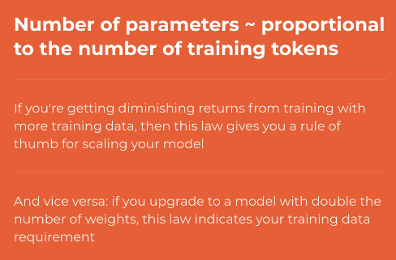

Benchmarks
Benchmarks are metrics that you use to rank LLMs in a leaderboard.
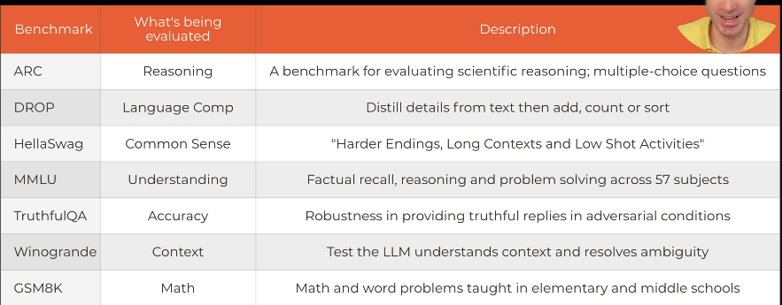
Figure 1: General Benchmark.
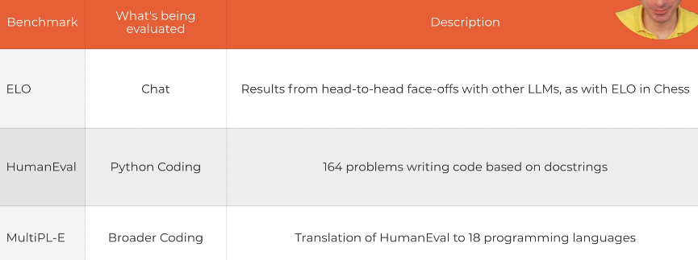
Figure 2: More specific Benchmarks
Limitation of Benchmarks:
- Not consistently applied.
- Too narrow in scope.
- Hard to measure nuanced reasoning.
- Training data leakage. (Some answers to the benchmark could be found in the training data.)
- Overfitting the evaluation set. You tune the model to fit the benchmark itself.
- (A new concern, not yet proven) Frontier LLM may be aware that they are being evaluated. This might distort some answers, example if you are trying to assess ThthfulQA it might result to wrong evaluation.
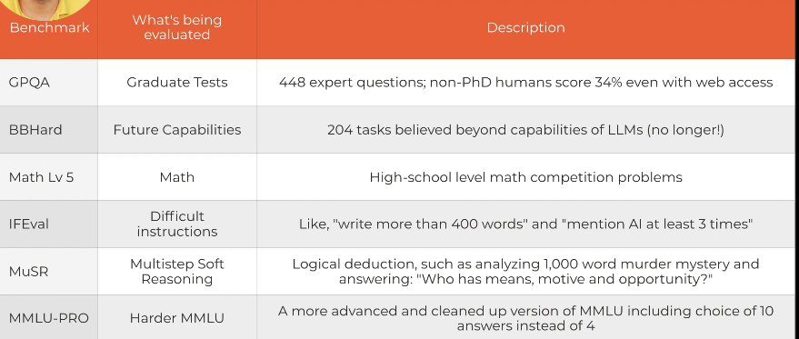
Figure 3: Harder benchmark
GPQA are PhD level questions where you cannot find a good answer on google. PhD people score 65% in this test. Leading model “Claude 3.5 sonnet” score 59%.

LeaderBoards

HuggingFace Opensource LLM
Leaderboard link: Open LLM Leaderboard - a Hugging Face Space by open-llm-leaderboard
Filter by type of model. Also by the nb of parameter.
In the table you can select the col to display. They are only the hard metrics.

HuggingFace BigCode:
For code generation LLM. Big Code Models Leaderboard - a Hugging Face Space by bigcode

HuggingFace LLM Perf:
For other telemetrics like Accuracy and speed and cost. LLM-Perf Leaderboard - a Hugging Face Space by optimum
It has a great visualisation. Each tab gives results for different GPU in growing order.
Top left are best models with low response time and high accuracy. The size of the circle represent the GPU memory needed (hoover to see exact nb)
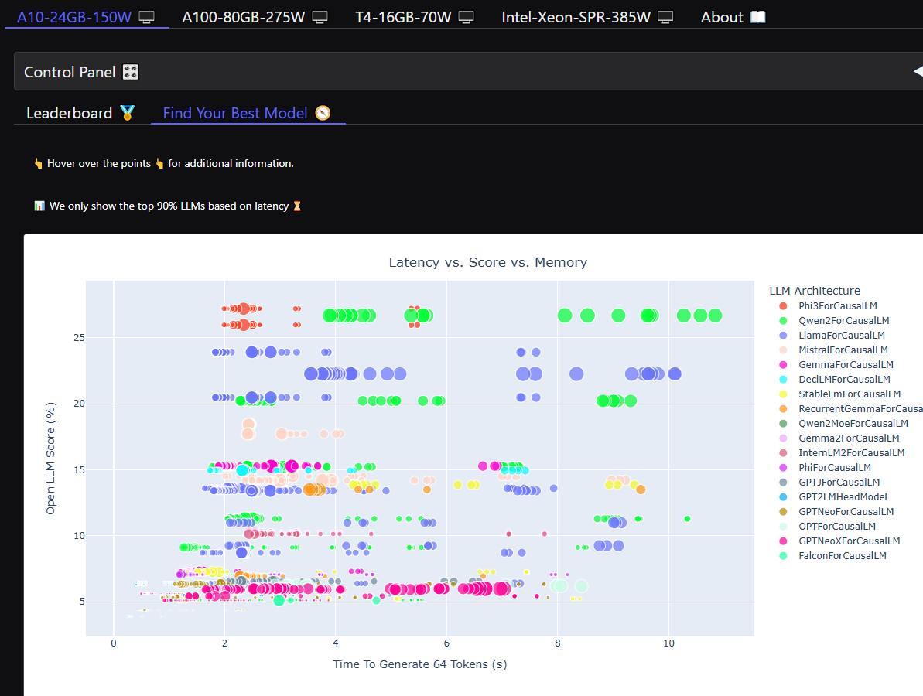

HuggingFace Others:
For specific use-case like Medical: Open Medical-LLM Leaderboard - a Hugging Face Space by openlifescienceai
French specific …etc

Vellum:
More for Close source LLM. Link: LLM Leaderboard 2025
There is a nice model comparison”duel” section. And below a table comparing the models on various metrics.
It also have a convenient cost table.

SEAL (scale)
Combine closed and open source. Link: SEAL LLM Leaderboards: Expert-Driven Private Evaluations

LMSYS Chatbot Arena
The Arena score models by relying on Human rating, accessing chat ability. Link: Chatbot Arena (formerly LMSYS): Free AI Chat to Compare & Test Best AI Chatbots
The way the scoring works is you go to Arena, and appears 2 models. You don’t know who is who. Start chating with them and you choose which is better.

Commercial Applications
Field of Law: example “Harvey”
Field of HR recruitment: Example “Nebula”.
Field of coding: example “bloop” port legacy code (COBOL, etc…) into java.
Field of healthcare: example “salesforce einstein copilot”.
Field of education: “khanmigo” is an assistant for teachers.

Model Evaluation
Model Centric or Technical metrics, are traditional ways to measure model performance:
- Loss
- accuracy
- precision
- F1 …etc
Business centric or Outcome Metrics. Measure the problem that you are trying to solve, the most tangible impact:
- ROI
- Improvement in time*customer satisfaction

