Coursera : Generative AI with Large Language Models
Table of Contents
Week1 2
Intro to LLMs and generative AI project Lifecycle 2
Transformers architecture 3
Generating Text with Transformers 5
Prompt engineering 6
Generative configuration 7
Project lifecycle 8
LLM pre-training and scaling laws 8
Parallel Training 10
Pre-training for domain adaptation 11
Week 2 11
Fine-tuning LLM with instruction 11
Instruction fine tuning 12
Single task & Catastrophic forgetting 12
Multi task fine tuning 13
Model Evaluation 13
Benchmarks 14
Parameter efficient fine-tuning 15
LORA: Low rank adaptation 16
Prompt Tuning 17

Course url: Generative AI with Large Language Models - Week 2 - Week 2 | Coursera

Week1

Intro to LLMs and generative AI project Lifecycle
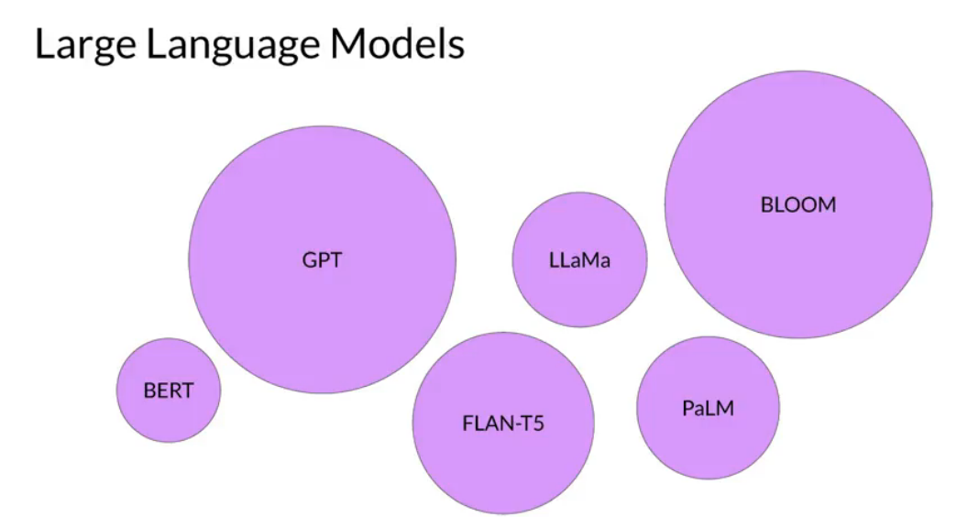
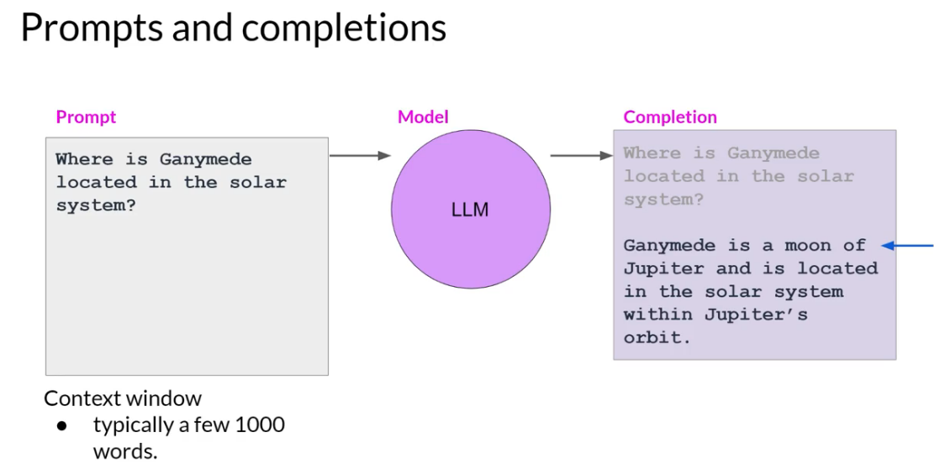

Typical LLM tasks:
- Chatbot
- Generate text (prompt “writte an essay about x”)
- Summarize a document
- Translation between languages
- Translate natural language to python code
- Entity Extraction (extract all Names from this text: X)
- Extending LLM with external data sources (“Is flight AF8005 landing on time”).

“Attention is all you need” is the foundational paper for transformer, that introduce self attention to the ML model.

Transformers architecture
Transformers are integral to LLM.
They use self attention to learn context around words. It creates an attention map. Where the relationship of each word to it’s neighbour is weighted in a vector.

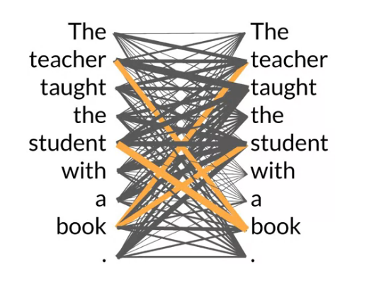
Figure 1: book has high attention to student and teacher.
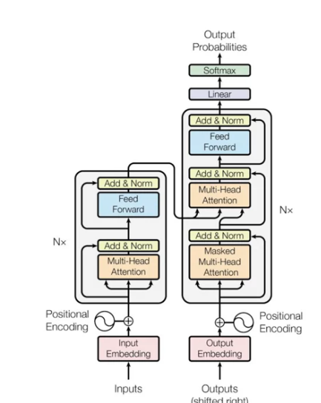
Figure 2: Original aper architecture
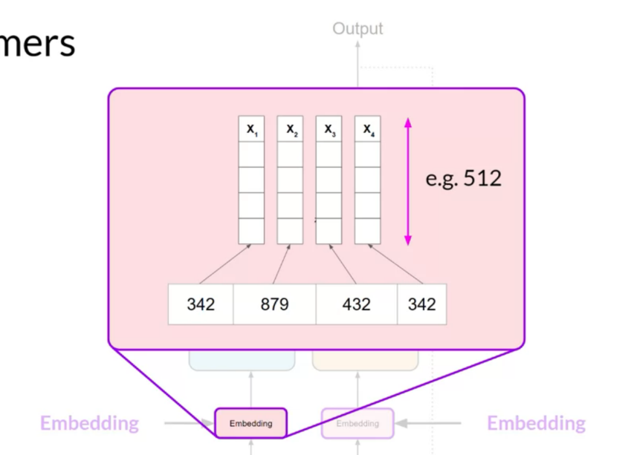
Figure 3: Original Embeding of length512 per word tokenized.
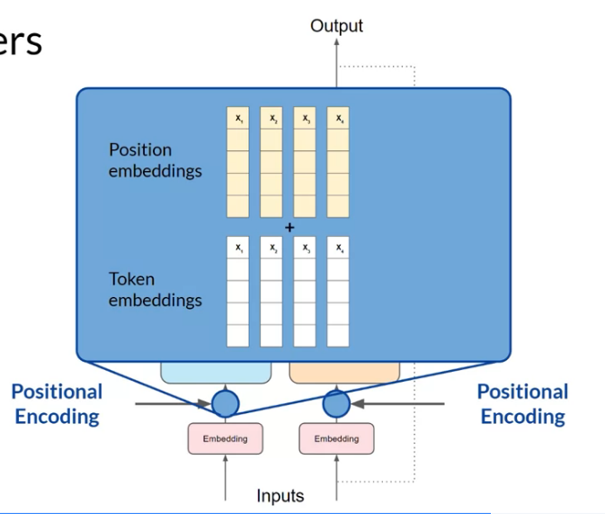
Figure 4: Positional encoding add info about the position of the word in the sentence
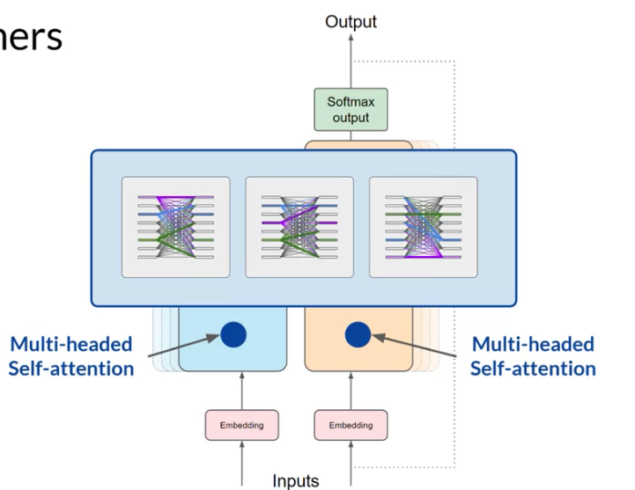
Figure 5: Self-attention heads then learn about the language context and meaning. There is around 50 to 100 independant heads. They are like filters in CNN.
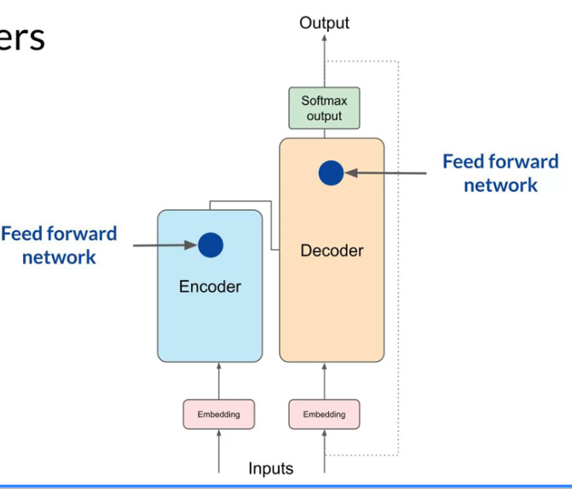
Figure 6: Finally fully connected layers (Feed-forward network) produce probability for all the words in the vocabulary. The word with highest probability is selected as an output.

Generating Text with Transformers
Let see an example task of translating French sentence to English (original task of transformer archi):
- Tokenize French sentence.
- Input in the embedding and encoder.
- The output (a meaningful representation of the sentence is input in the middle of the Decoder.
- A “start of sequence” token is input in the Decoder.
- This is added with the output of the decoder, pass several attention heads and output a token (word).
- This token is then input into the decoder.
- Repeat until an “end of sequence” token is output. You have the final translation sentence.

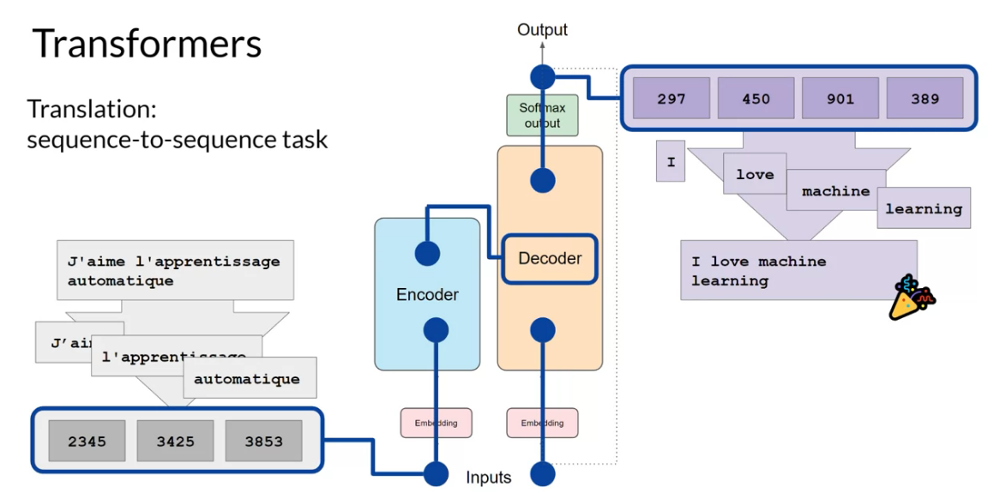
Figure 7: example of translation of a sentence.
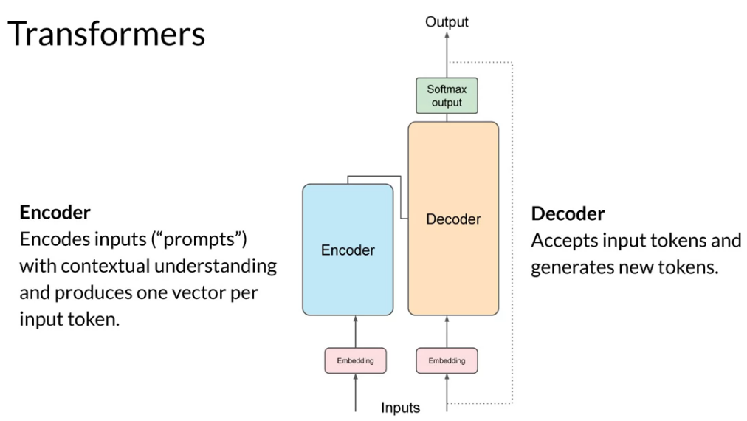
Figure 8: summary.

Encoder and decoder can be decoupled for different tasks. The encoder alone can create an output:
- It can also be used as sequence to sequence model, but output sequence will be of same length of the input sequence.
- It can be used as classifier by adding additional layers. Like for sentiment analysis.
Encoder-Decoder Models work well for:
- Sequence to sequence taks with different sequence length.
- Text Generation task.
Decoder only Models. The most used type:
- Llama, ChatGPT etc…
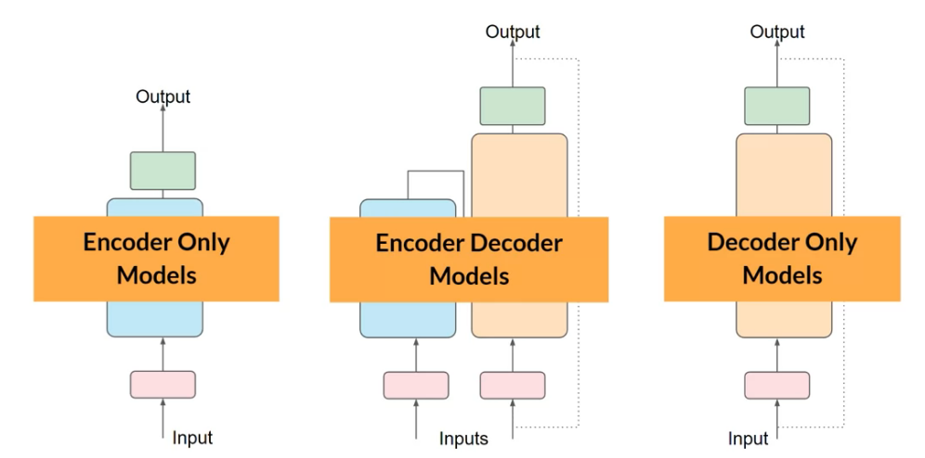

Prompt engineering
In the prompt you can include example of what you want to help the model make a good prediction. It is called “in context learning”.
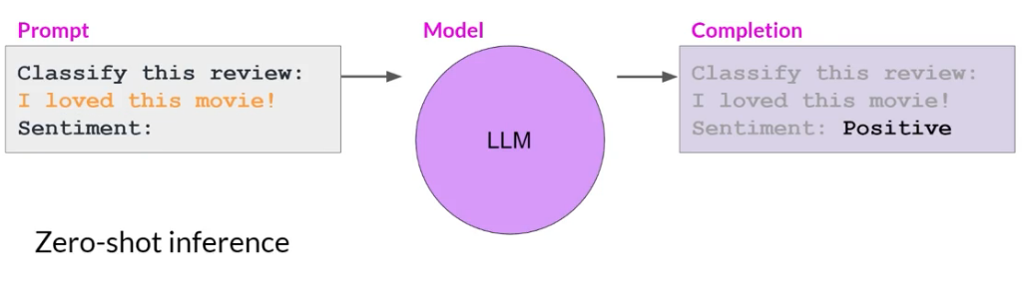
Figure 9: Zero sho inference. A big model perform well without help.
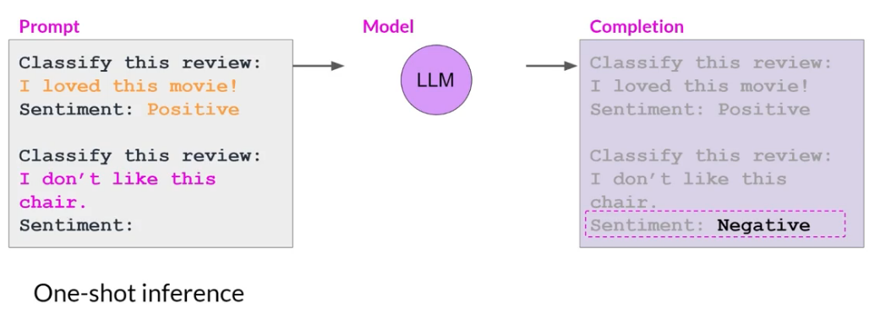
Figure 10: One Shot inference. A small model need example in the prompt to perform well.
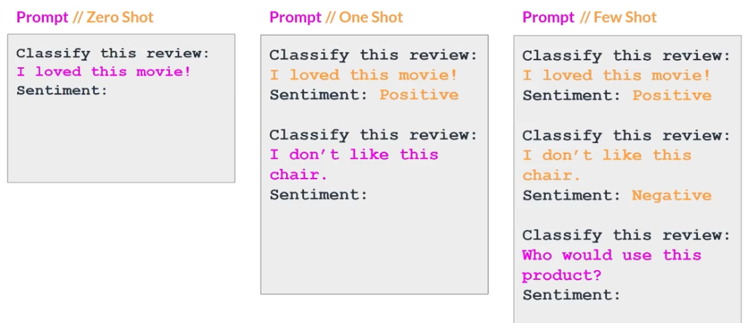
When prompt engineering doesn’t improve anymore it is time to fine tune your model.
You can also try various model, some can work better than others.
Finally a model can have configurations that will make a difference.

Generative configuration
This parameters are only used during inference time, NOT training.
- “Max new token” control the max length of the output.
- “Greedy” or “random sampling”. Greedy the token with highest proba in the output is selected. Random sampling the token is chosen with the proba distribution of the softmax output. Greedy is the default for most models.
  - Top k: sampling technique to reduce randomness. Choose token from only the top K tokens in the proba distribution.
  - Top P: reduce randomness. Choose from the top ranked token which cumulative proba is <= p
  - Temperature. Influence the shape of the proba distribution. Low temperature increase proba of high token. High temperature does the opposite giving a higher degree of randomness giving text more creative. Temperatur = 1 doesn’t change anything.
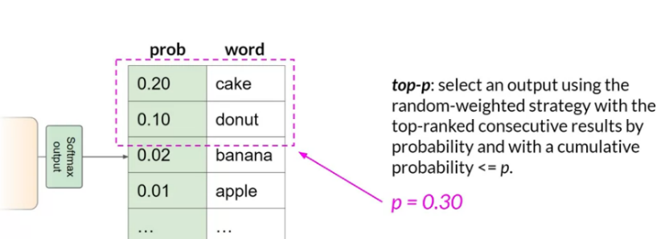
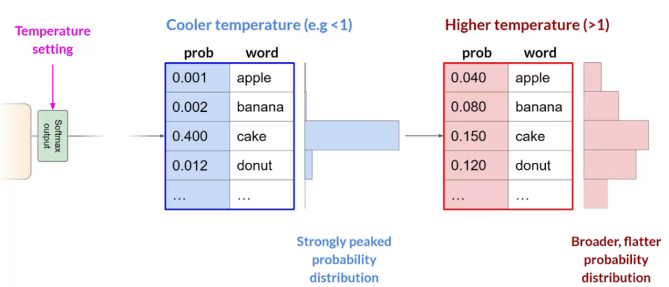

Project lifecycle
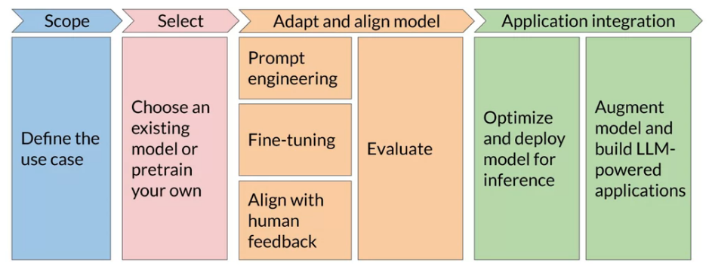

LLM pre-training and scaling laws
Many pre-trained models (foundation models) are available open-source. Often we start with them instead of training your own model.
Only 3% of original corpus remain after Data Quality filter (remove bad data and sensitive content)

Encoder only models, also called Autoencoder are trained to reconstruct the input, where some tokens are randomly masked.
Encoder are good for tasks like:
- Sentiment analysis
- Named entity recognition
- Word classification
Examples are BERT, ROBERTA
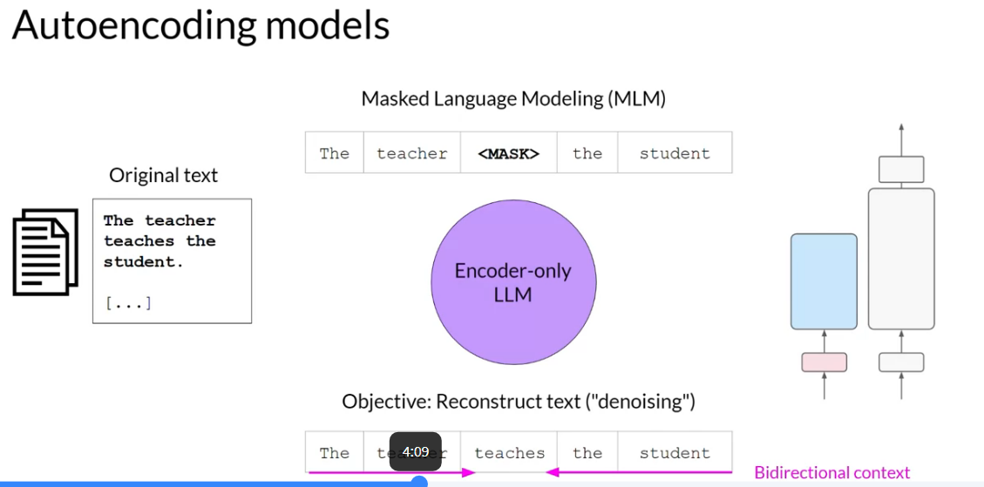

Decoder only models. Also called Autoregressive models
There are trained to continue the sentence after one word is input, iteratively until EOS token.
Good use case:
- Text generation
- Other emergent behavior
Example GPT, BLOOM.
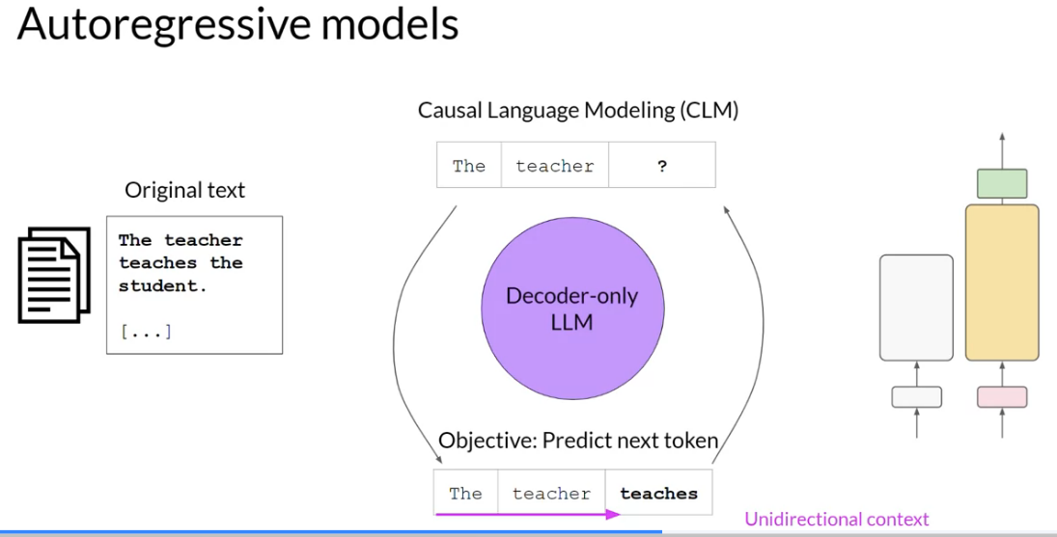

Encoder-Decoder models. Also called sequence to sequence models. Are trained by masking some words in a sequence, and have to output the words that where masked.
Good use case:
- Translation
- Text summarization
- Question answering
- Example T5, BART

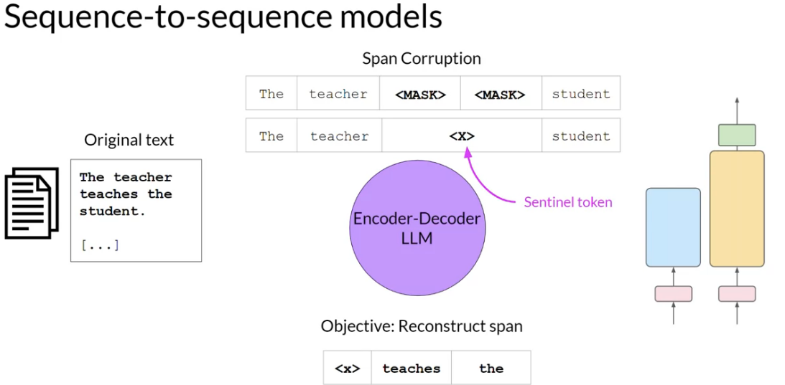
To train from scratch these big models of more than a Billion parameter, you need multiple GPU in parallel. If not there is not enough memory available.

Parallel Training
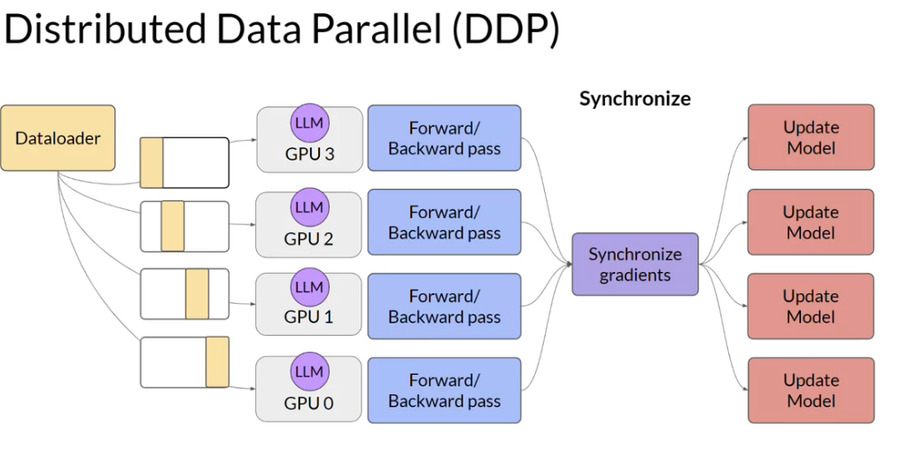
Figure 11: Distributed data training. Only work if the model is small enough to fit in memory. The dataset is split into several GPU, and the gradients are aggregated by average. So the model is the same in each GPU
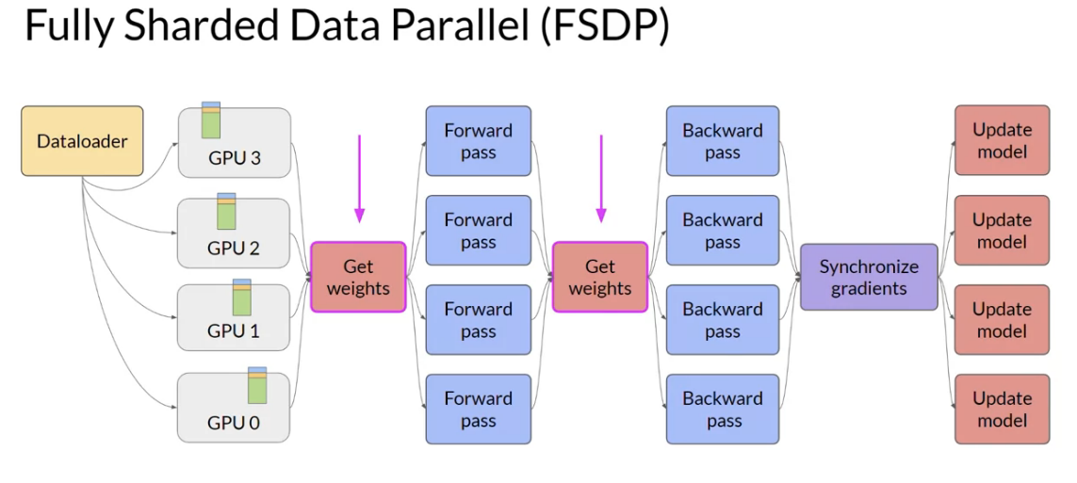
Figure 12: Sharding also split the model in shards in various GPU.

Training bigger model perform better but also need more compute budget, this is really something to take into consideration when training these transformers models.

A hypothesis is that many Transformer models could be trained with less parameter but can achieve same performance if trained on bigger dataset. This is the conclusion of the Chinchilla paper. And now company start to train smaller models (still around 50B parameters) with bigger dataset.

Pre-training for domain adaptation
If you task is in a very specific language domain that varies too much from regular vocabulary, you’ll need to train your own model from scratch.
For example for Legal application or Medical application.
Example BloombergGPT was trained with 50% Financial data and 50% regular.
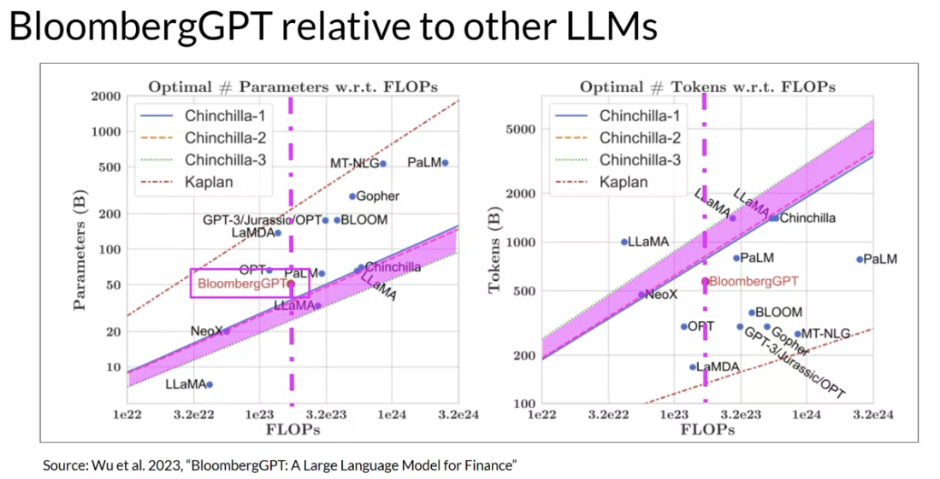
Figure 13: Bloomberg was trained following the Chinchilla rules for parameter size and Dataset size.

Week 2

Fine-tuning LLM with instruction
When in context prompt learning (single-shot) doesn’t work any you can try to fine-tune a model.
Full fine-tuning updates all the parameter of the model, so you will need parallel training most of the time.
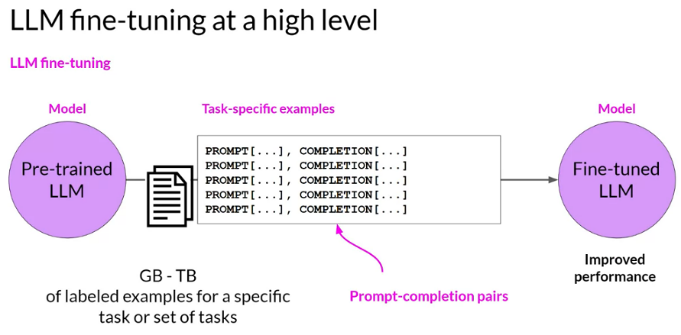
Figure 14: Fine tuning use small dataset of LABELED data to train a specific task.

Instruction fine tuning
With this method you create a dataset of body of text (input) plus completion (output). But you actually put all of that into a prompt with the instructions specific to your task. This is the most common way to fine tune LLM these days.
Some templates exist for various tasks to create your own dataset.
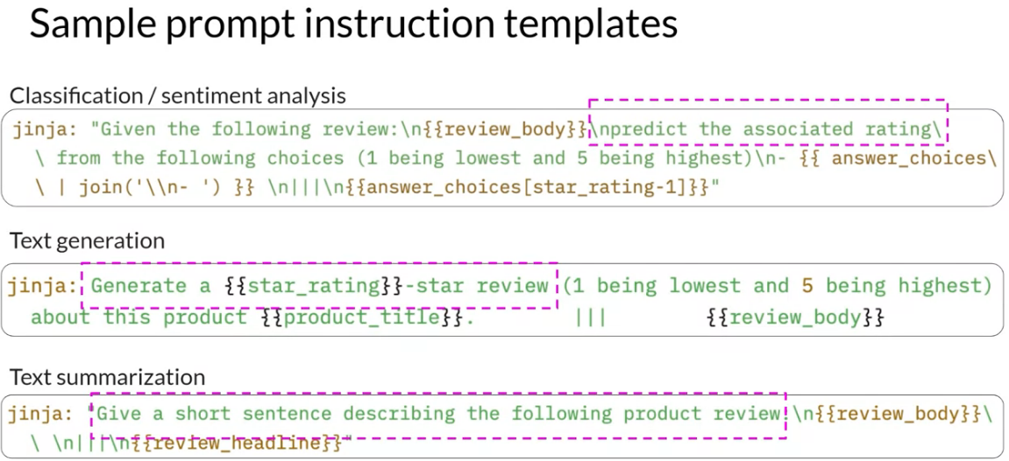
Figure 15: Example of instruction prompt. In green are the instructions. In gold are the input and output you will paste.
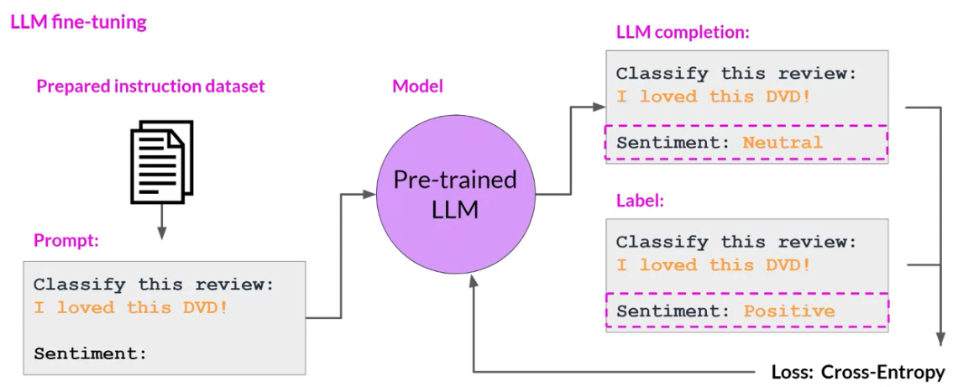

Single task & Catastrophic forgetting
Fine tuning LLM for a s ingle task can be achieved with a small dataset 500-1000 examples.
BUT this can lead to an issue of “catastrophic forgetting”: the performances of the single task increase but it degrades the performances of the other tasks.
How to avoid it:
- This may actually not be a problem for your use case!
- But if you want the model to perform other task you will need to perform fine-tuning on multiple tasks.
- Parameter Efficient Fine-tuning (PEFT). This preserve the weight of most layers by freezing, and perform training on only adaptive layers.

Multi task fine tuning
This require much more data for training
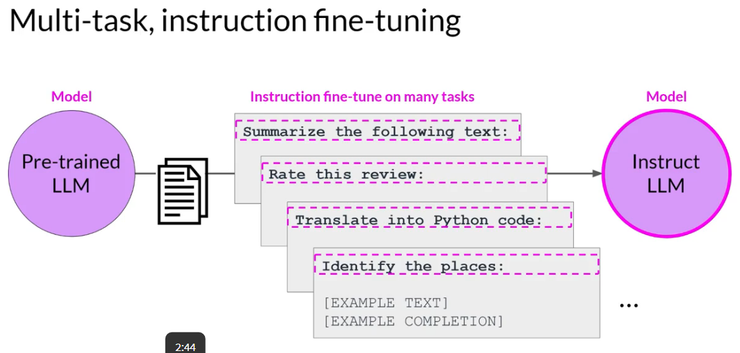

FLAN is a family of model design to be fine tunes with instruction.

Model Evaluation
Typical accuracy TP/total example cannot be applied to language output. Example “Mike really loves drinking tea” vs “Mike adores sipping tea” is this a TP or not.

Common NLP metrics are:
- ROUGE: used for text summarization. Compares to one or more ref summaries.
- BLEU: used for text translation. Compares to human generated translation.
Unigram is one word, bigram is 2 words, n-gram is multiple words.
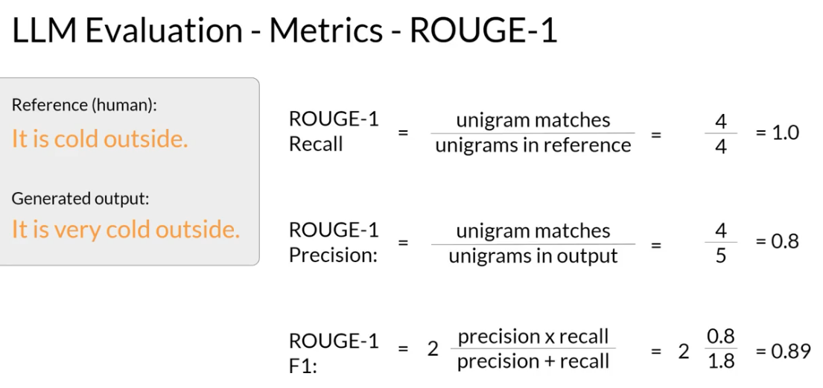
Figure 16: Rouge1 is a simple metric focusing on presence of words. But doesn't look at the ordering of words.
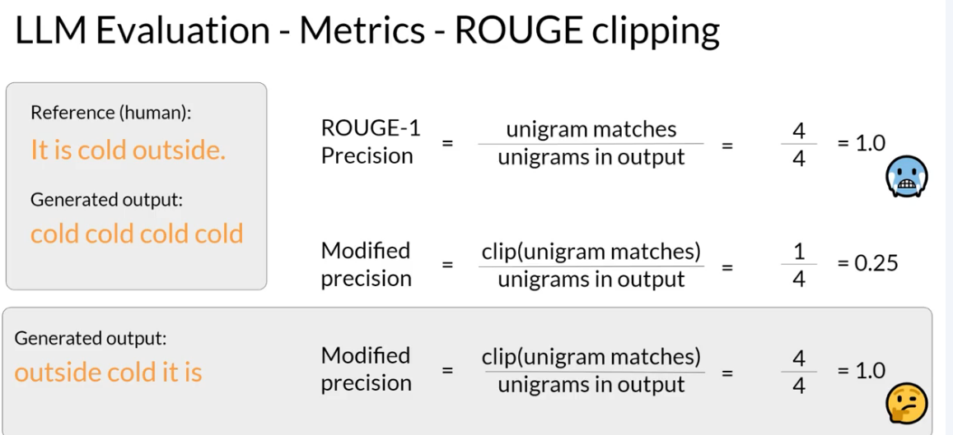
Figure 17: ROUGE score can still give good results for a bad output. Clip can reduce that by limiting the nb of matches to nb of token present in the ref.
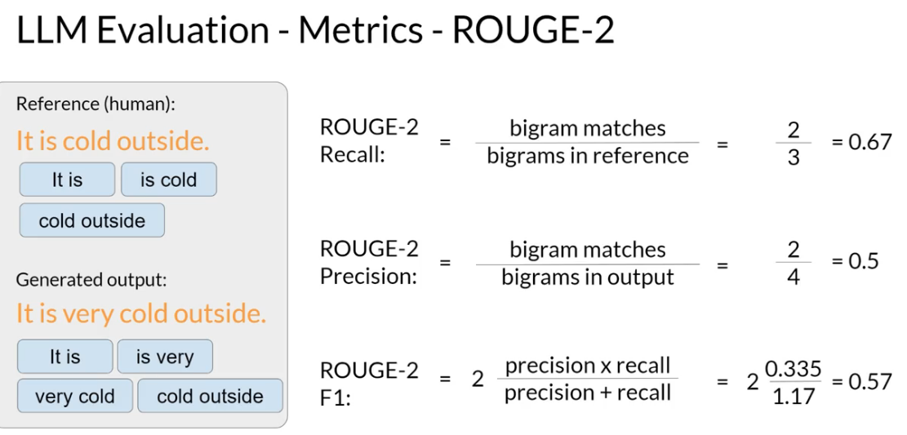
Figure 18: You can add a sense of word order by comparing bigrams.
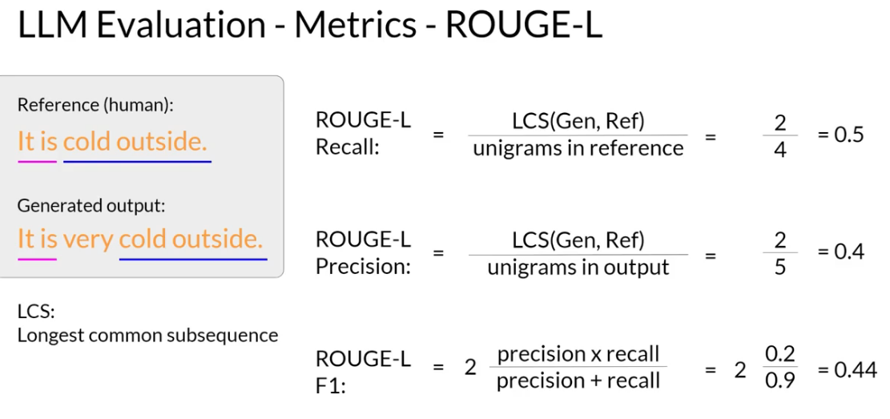
Figure 19: ROUGE-L look at Longest common sub sequence.

BLEU metric = Avg(precision across range of n-gram sizes)

Benchmarks
ROUGE and BLEU are too simple to evaluate alone your model.
To do a better evaluation of complex models researchers have established some Dataset and test to evaluate certain aspects of LLM.
Examples of benchmark:
- Glue
- Superglue
- Helm
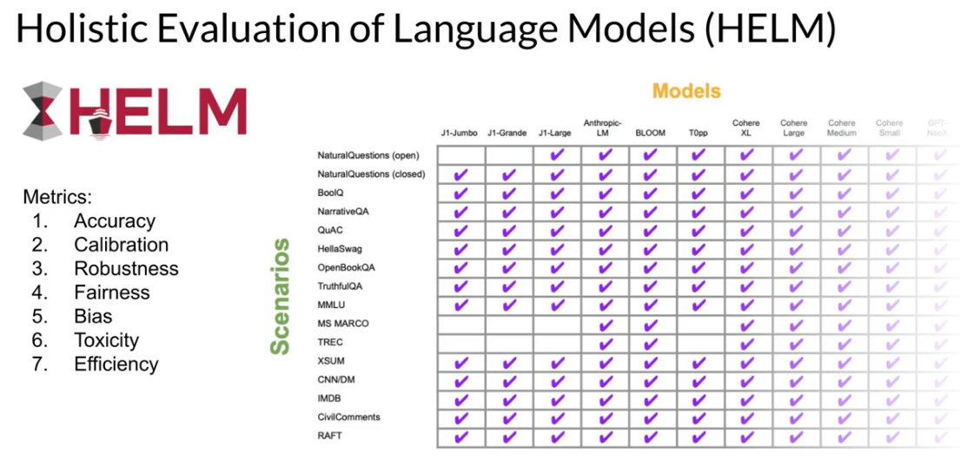

Parameter efficient fine-tuning
With PEFT you can reduce the nb of trainable parameters in two ways:
- Freeze most layers, and leave only a few layers trainable.
- Freeze all the model and add extra trainable layer.
  - Add layers at the end of encoder/decoder.
  - Or add layer in the embedding of the prompt (Prompt tuning)
- Reparametrize model weights using a low rank representation (LoRA)
PEFT can often be done on a SINGLE gpu, and it’s less prone to catastrophic forgetting.
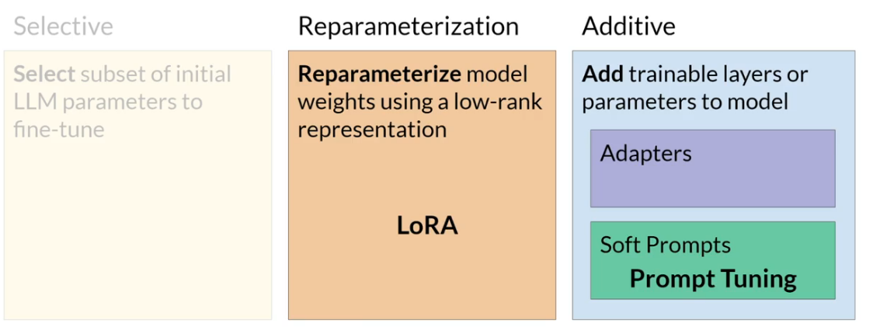
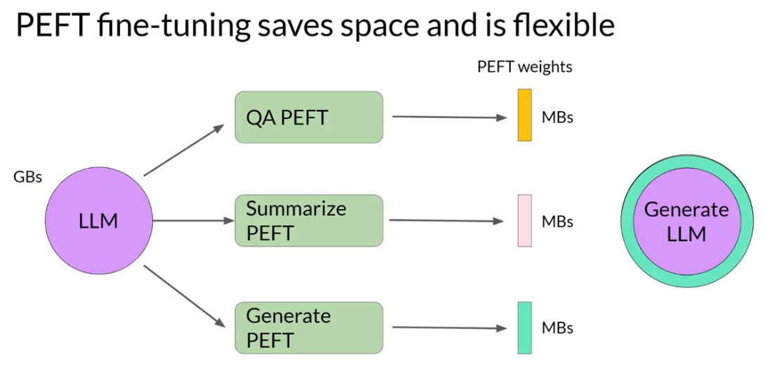
Figure 20: You can do 3 PERF for 3 different task and then just swap the PEFT layers for one or another task.

LORA: Low rank adaptation
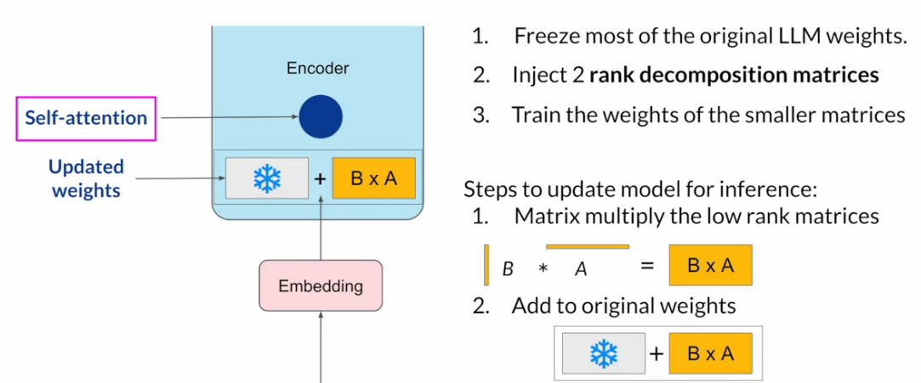
Figure 21: LORA freeze the weights of all self-attention layers, and add small trainable matrices that will be added to the frozen weights at inference time.
You can train LORA for various task and then swap the LORA small matrices when needed.
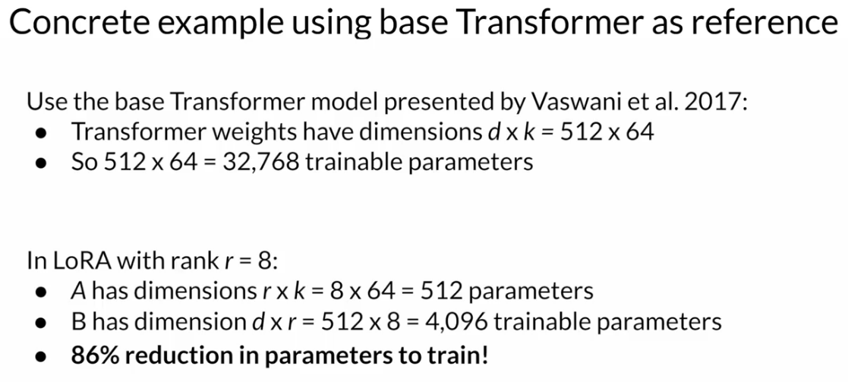
Figure 22: LORA significantly reduce the nb of parameters.
The rank of the LORA matrices is the only parameter to choose. Lower rank means less memory but maybe not as good results. Typically rank of 4 or 8 is the best.

Performance of LORA is really good, almost as good as full fine tuning the entire model.
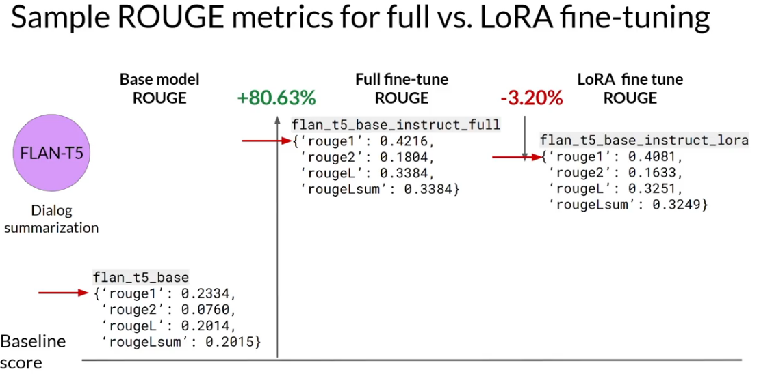

Prompt Tuning
It’s different from prompt engineering.
In prompt tuning you had some extra embedded tokens to your prompt, but these tokens do not represent words. There embedding values are learnable.
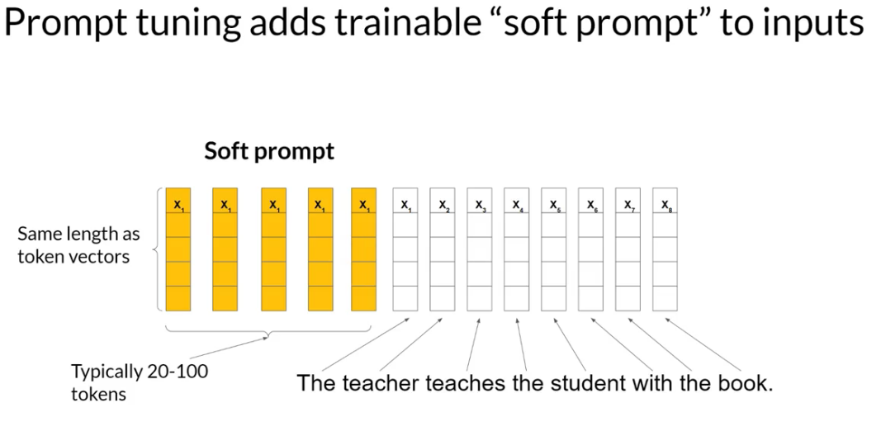
Figure 23: Soft tokens as embedded vectors added to the prompt.
The models parameters are frozen. Resulting in very little nb of learnable parameters.
Just like with LORA you can learn different Soft token for different tasks, and just swap them at inference time.
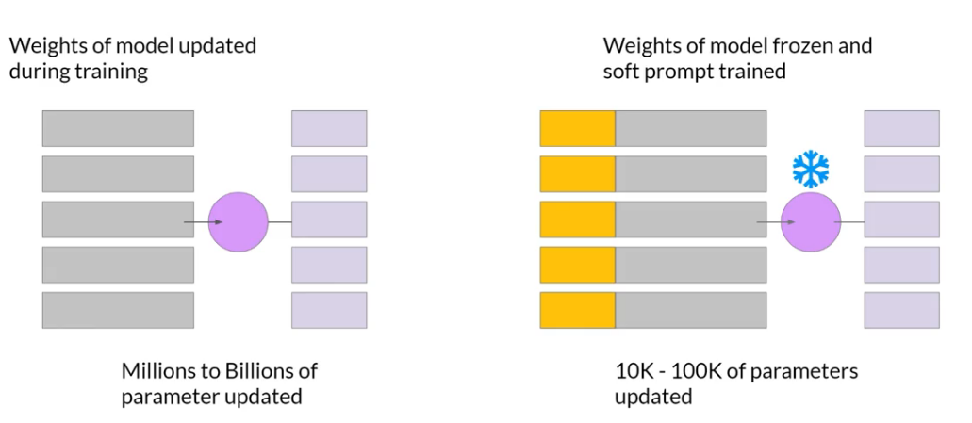
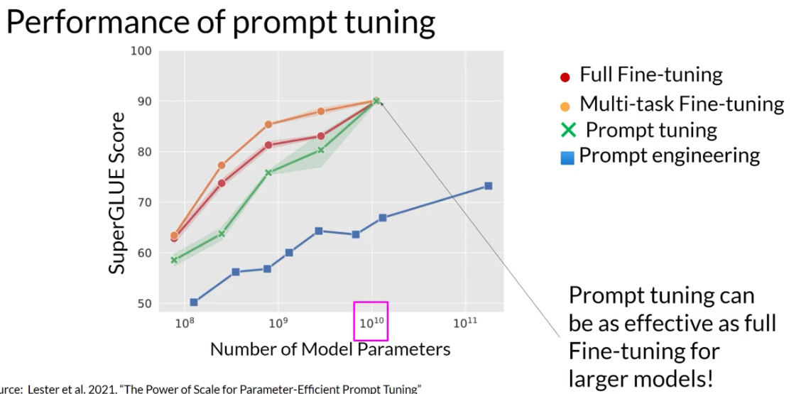
Figure 24: As the model size increase prompt tuning can perform as well as full fine tuning.
Prompt tuning can perform very well.
A drawback is the interpretability of the tuning. The soft token don’t correspond to real words. But a nearest neighbours analysis can show that they belong to a certain semantic group.

Week 3

Reinforcement learning from human feedback
LLM can output toxic, aggressive or dangerous answer, we want to avoid that.
So we need to align with human feedback.
Here are values that should be reflected in a Model output: Helpfulness, Honesty, Harmlessness.

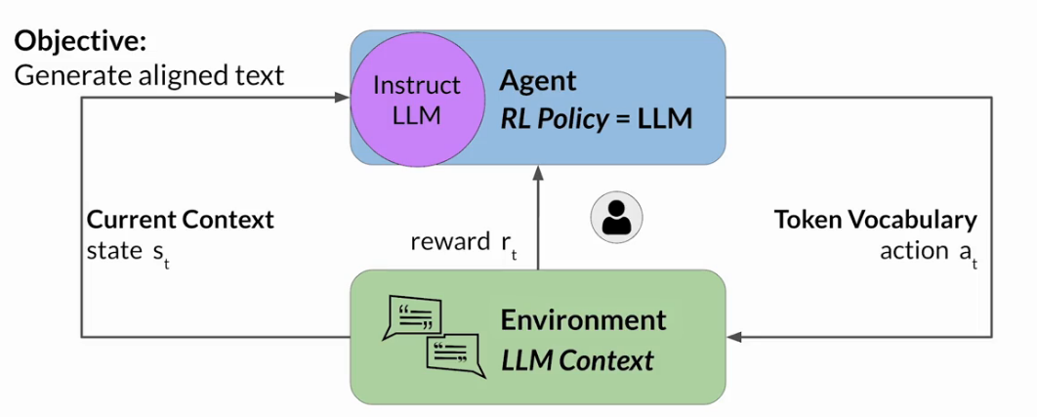
Figure 25: Reinforcement learning human fine tuning. In this case a human evaluate the completion output to determine the reward.
If it’s too expensive to get a human looking at all output to give a reward. You can create a reward model that will classify the output into a reward value. The weight of the LLM are then updated based on the reward.

RLHF: Obtain feedback from human
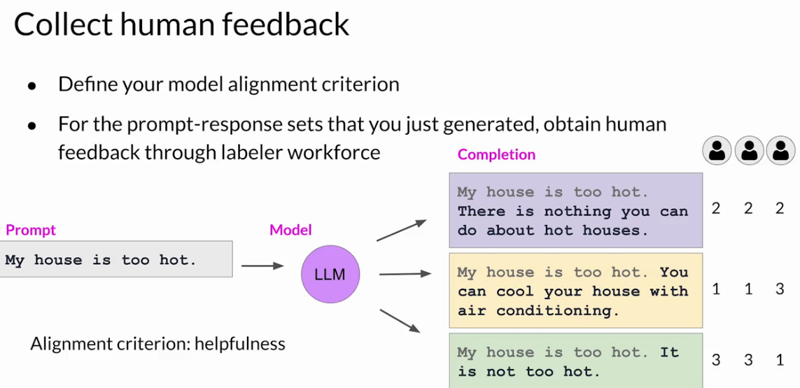
Figure 26: Generate several completion for same prompt. Then score them 1 2 3, 1 being the most Helpful.
Assign the same labelling to several person to mitigate subjectivity. That’s how you build a dataset.
You need to give good instruction to the labelers so they understand well the task.
In case of a non sensical answer by the LLM you usually don’t score but put an F as in Fail.
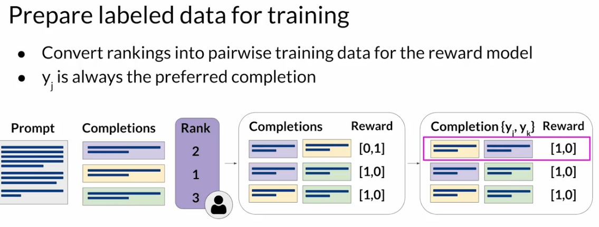
Figure 27: To prepare your dataset, create combinaison pair for each 3 completion in an example. Create associated Reward: [0,1] 1 being the prefered output. Reorganize it to have always [1,0].

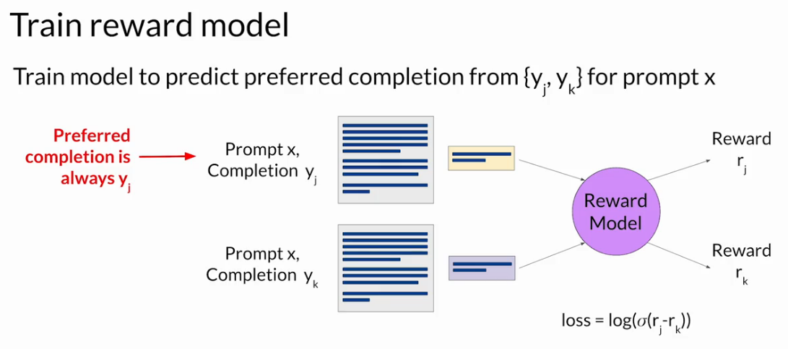
Figure 28: Training the Reward model.

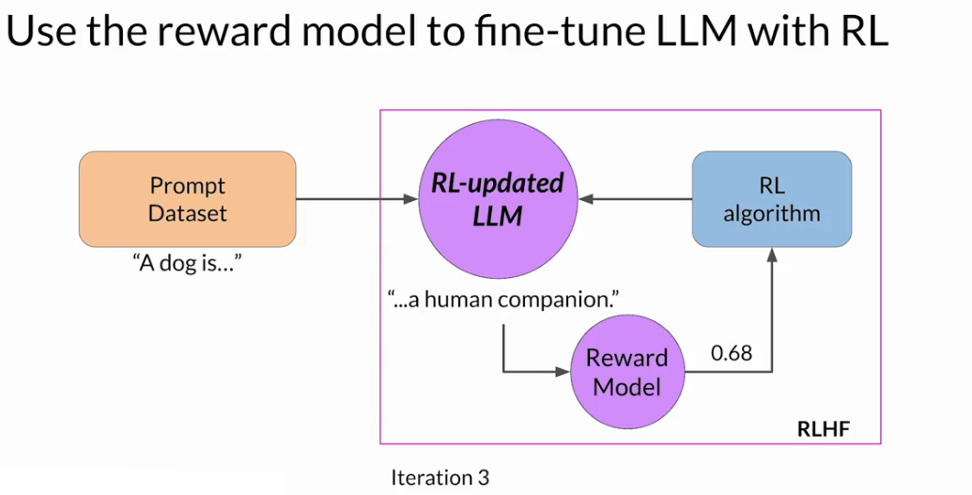
Figure 29: Overview of the LLM update process.

Proximal policy optimization
The RL algorithm to update LLM is complicated. Here we describe it more PPO proximal policy optimization.
There is 2 phases in PPO
Phase 1: Create completion
- Create completions
- Calculate reward
- Calculate Value Loss
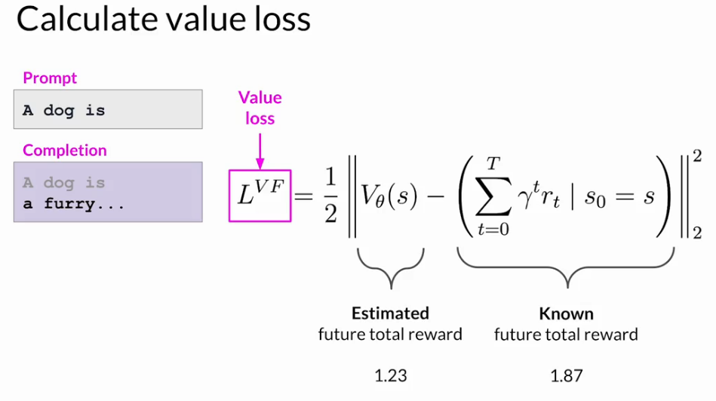
Phase 2: Model Update
If current token gives high A value, this is good the probability of this token is increased.
If current token given low A value, this is bad the probability of this token is decreased
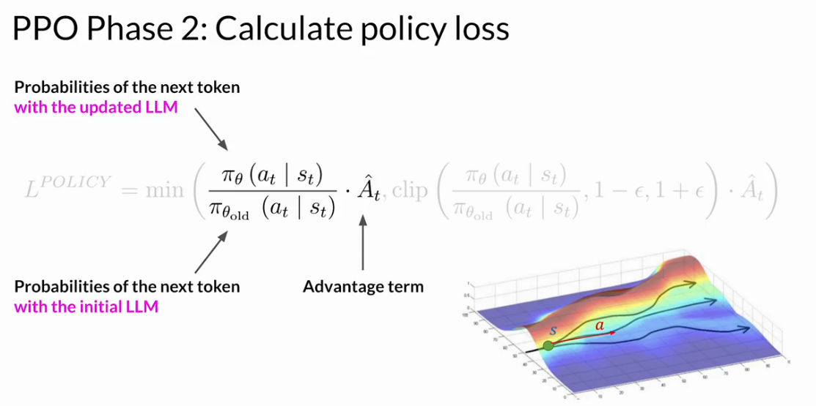
Figure 30: Try to maximize this expression for better LLM.
Proximal means the update of weight should be close to previous weight, to not change them too much.
This is the second term of the equation.
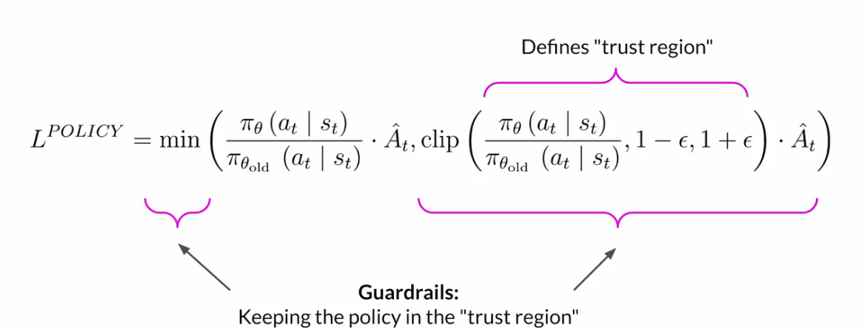

You do this cycle of phase 1/ 2 the LLM is updated many time over this process.
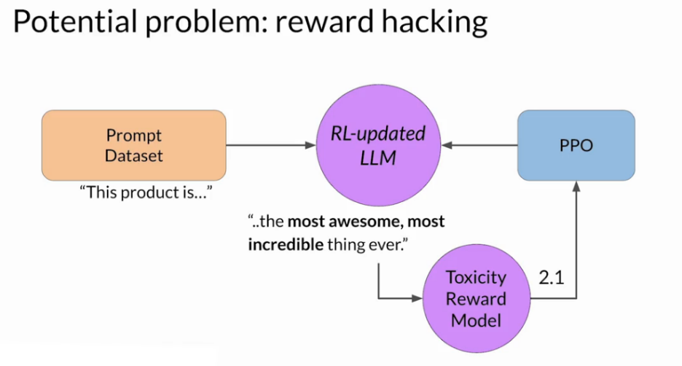
Figure 31: A problem that can happen is the LLM just predict words that are positive without making sense.
Thos solve reward hacking, you can compare the RL-updated LLM with the original model (ref model). Compare the outputs with “KL Divergence Shift Penalty”.
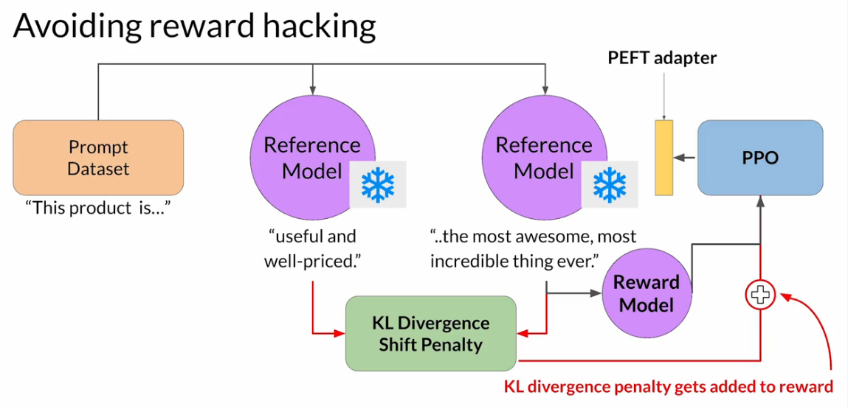

LLM-powered application
When you are ready to deploy your model for inference, there is several challenges due to model size and compute limitation.
Technique to reduce the memory size of LLM:
- Distillation
- Quantization
- Pruning
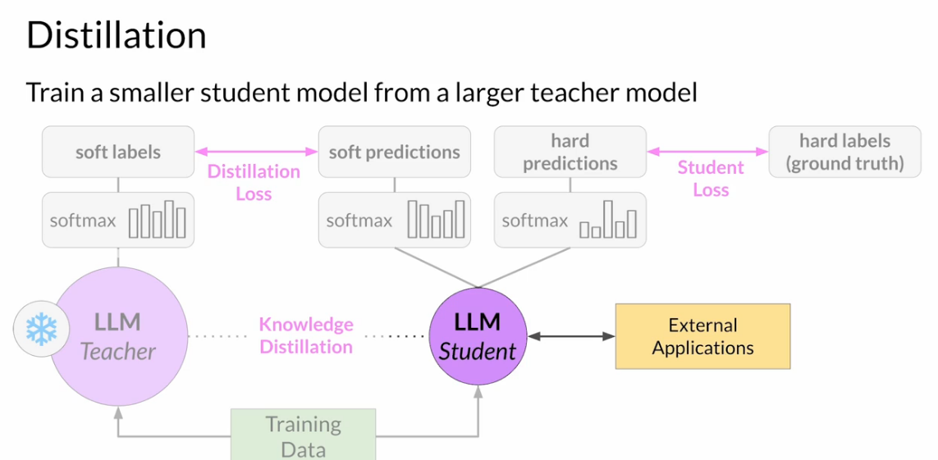
Figure 32: Distillation is a complex method where you train a new small model base on a bigger Teacher model.
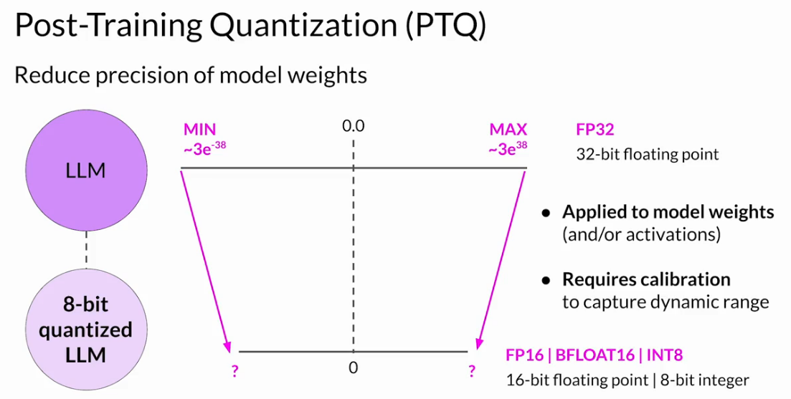
Figure 33: Quantization for prediction also reduce the model size but can also affect the performance.
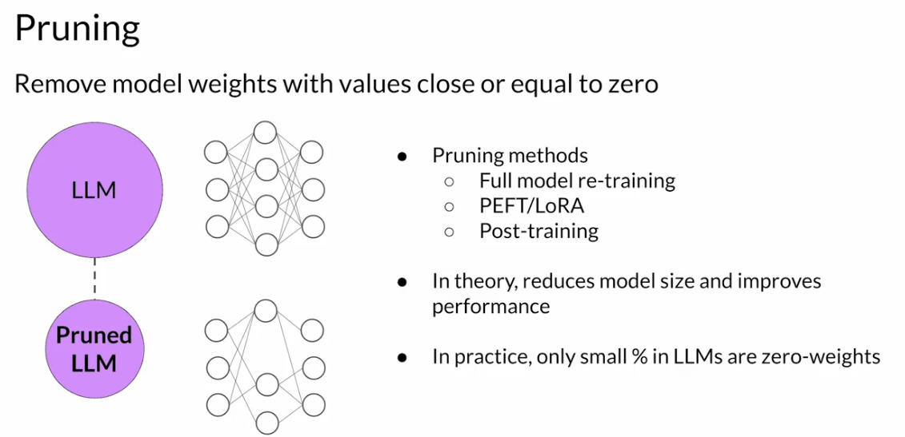
Figure 34: Pruning aim at removing weight that are not participating in the prediction. But in practice it doesn't reduce the size very much.

Generative AI Project Lifecycle
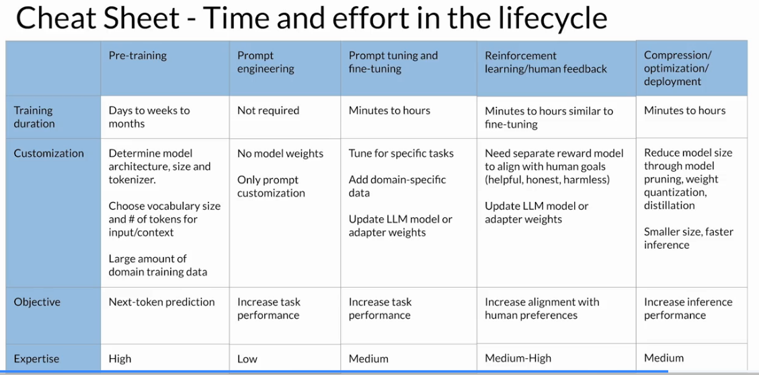

Using LLM application
LLM can have completion issues:
- Inventing a response when they don’t know the answer.
- Making math calculation (they don’t have a calculator included, they just select a token from proba).
- Answering out-of-date information (what is the president of France=Chirac)
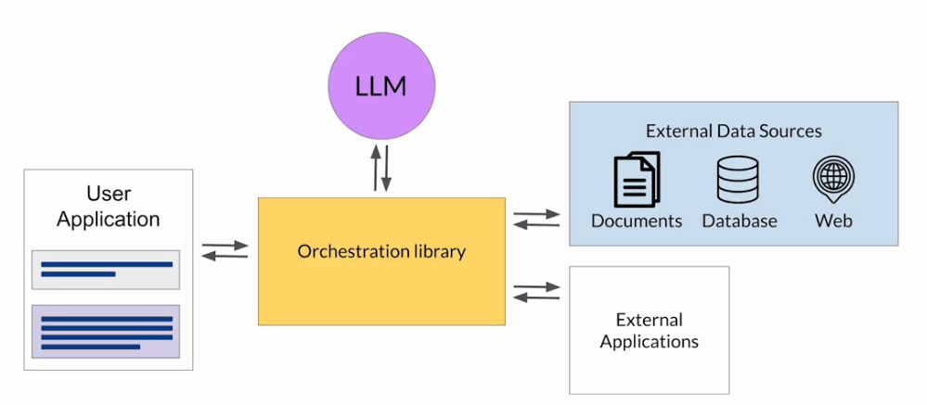
Figure 35: Orchestration library can connect to external application to help the LLM overcome these difficulties.
Retrieval augmented generation (RAG) : is a technique to make use of external applications, or external data, like documents not included in the original training.
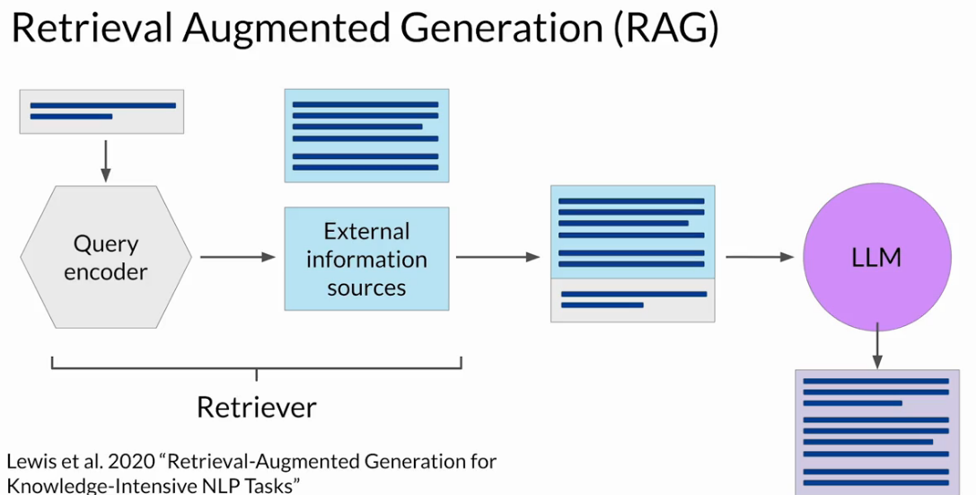
Figure 36: Original implementation of RAG query the prompt to an external information source (postgres DB, csv file, ...etc) and add the document returned to the prompt.
External Sources can be:
- Documents
- Wikis
- Expert Systems*Web pages
- Databases
- Vector Store (vector representation of text)
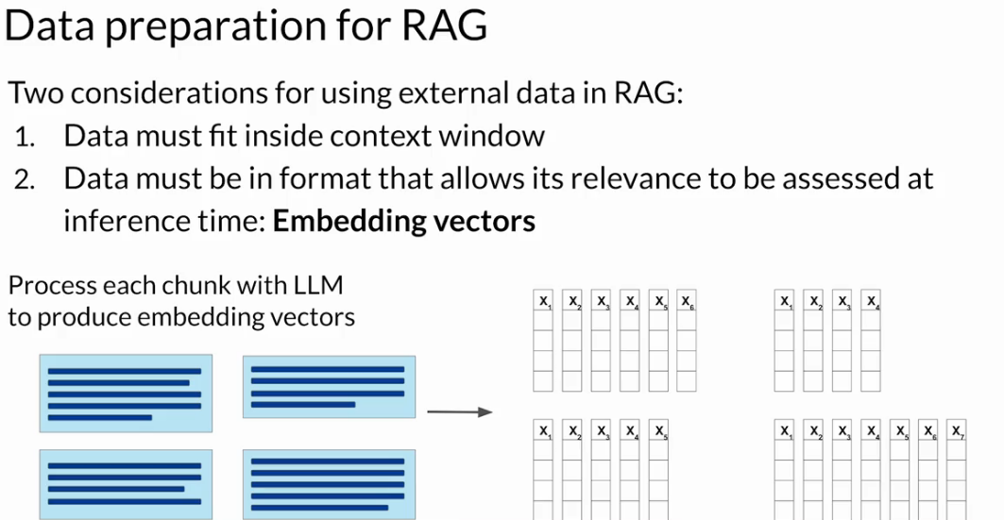
Figure 37: Things to consider when using RAG.

Using External Applications
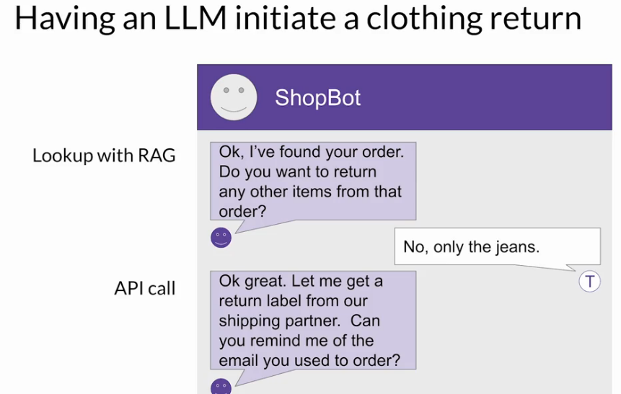
Figure 38: In this example the Bot found the order by a RAG query to a purchase DB. Then it get a return label by making an API call to an application.
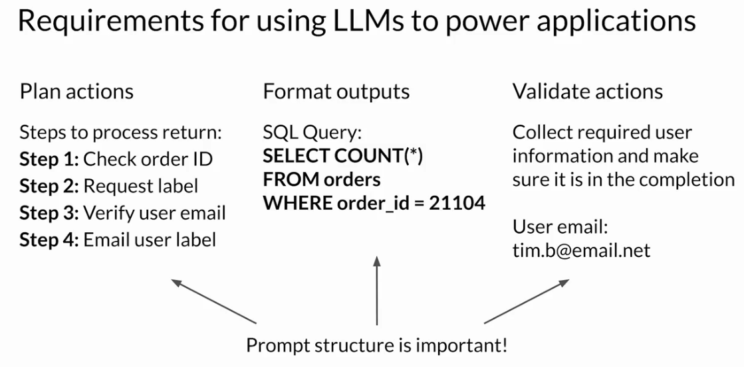
Figure 39: LLM need a way to reason to execute these plan actions.

Helping LLM with Chain of thought
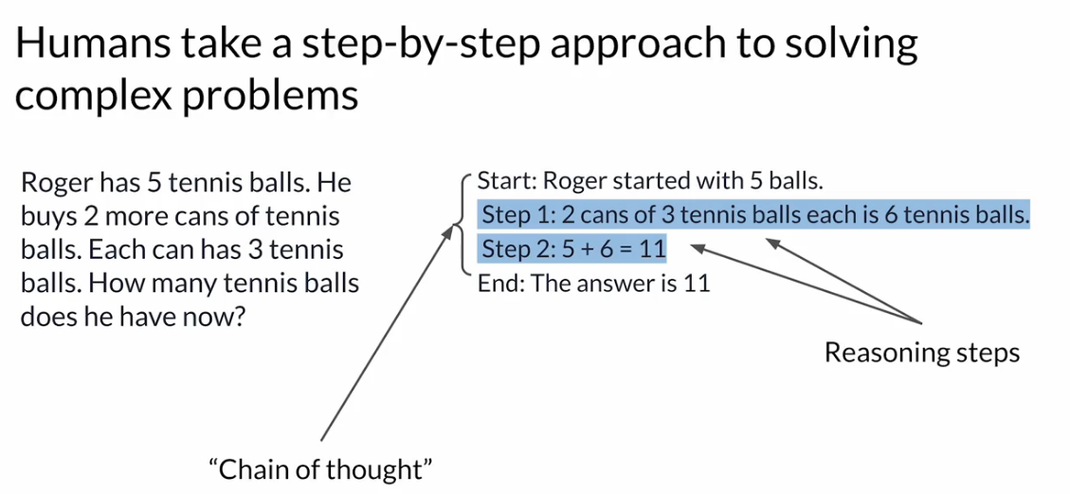
Figure 40: Example of chain of though.
You can help LLM with Chain of Thought prompting. Including a serie of intermediate steps in the One-shot inference.
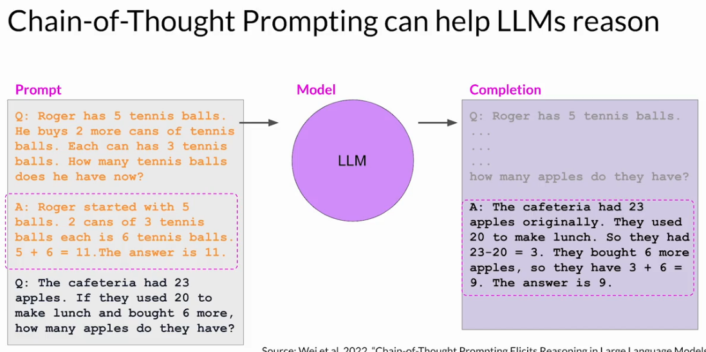
Figure 41: Example of train of Thought prompting.

Program aided language models (PAL)
LLM can struggle with mathematics, because it doesn’t know how to do math, it just predict a token probability.
PAL allow LLM to use a program interpreter like python interpreter to carry out math expressions.
The Orchestration library is the one managing exchange of information between LLM and the Python Interpreter. The LLM define plan of action and the Orchestration execute it.
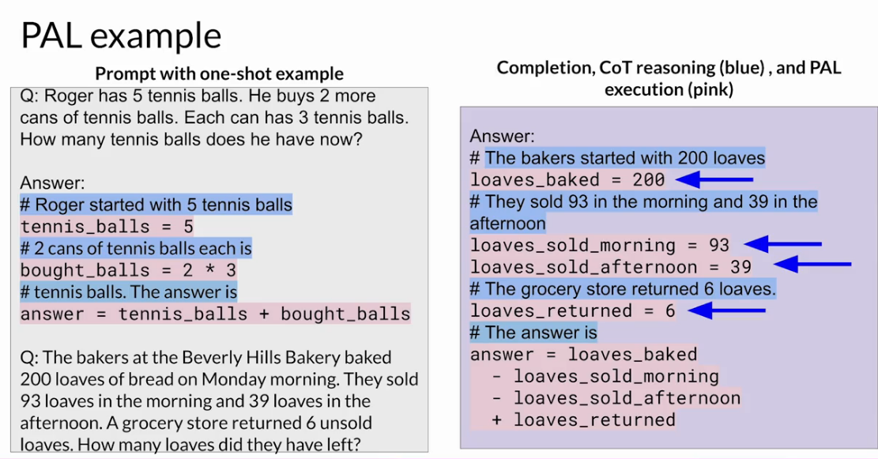
Figure 42: In Shot promt show example of Python code to resolve the answer. There is even comments with # to help.

ReAct: Combining reasoning and action.
It is another prompt engineering.
LangChain is a framework containing modular pieces that you can work to work with LLM for a complex application.
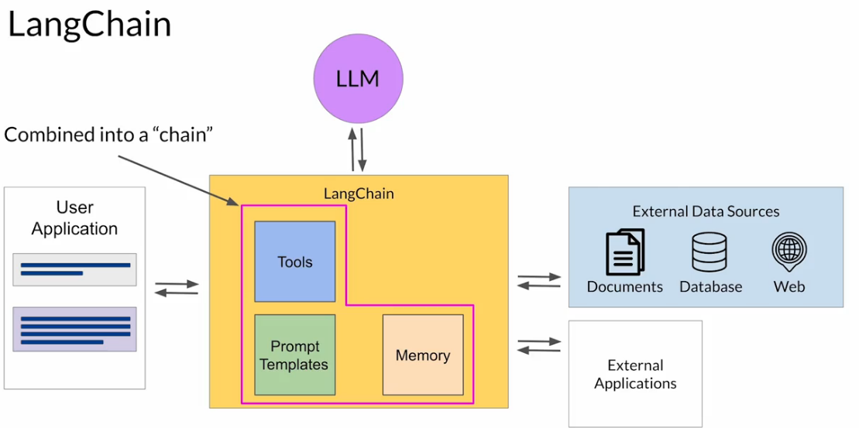
Figure 43: LangChain contains predefine Chains of Prompts memory and tool, to accomplish certain tasks.
LangChain also include Agents, when what you want to accomplish is not predefined but depend on the User instruction. Agent can be applied for Pal or ReAct.

