So far we've focuses on INFERENCE
Techniques to improve results at run-time:
- Multi shot prompting
- Promt chaining
- Tool/Function calls
- RAG/ knowledge base

Now TRAINING LLMS
- Training a multi-billion parameter model cost tens of hundred of millions $
- Instead we take advantage of Transfer Learning
- We take a pretrain model as base, and use additional training data to fine tune it for our task.

Use Case
We will predict price of things, based on their text description. Typically this is a regression problem, but it turns out LLM are also very good at this.

Regression is easy to measure, evaluate by metrics.
Here we will use RMSLE: Root Mean Squared Log Error. This metric is less affected by difference in big prices, so it's a more relative metric, small difference for small prices, will have same error as big differences in big prices.

Evaluation
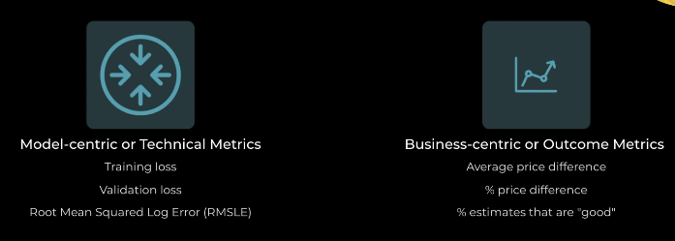
Tradeoff between metrics:
- Item at 1000 estimate 1050. Is well represented by 0.5 % "% price difference". But not well by 50 dollars "average price diff"
- Item at 10 estimate 12. Is not well represented by 20 % "% price difference". But well by 2 $ "average price diff"

To balance this we can create a %estimates that are good. For example we can establish that Good is if the difference is less than 30$ OR less than 10%.

5 steps strategy
To selecting and applying an LLM to a commercial problem.
- Understand the problem
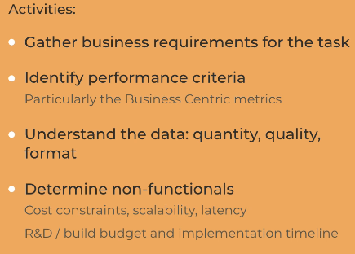
- Prepare
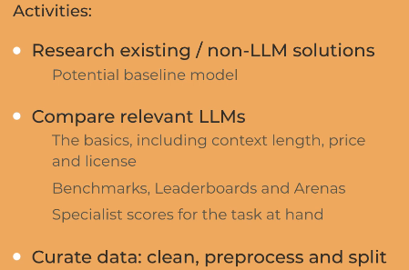
- Select
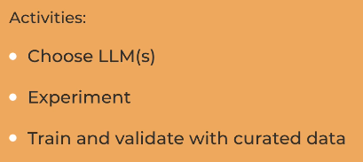
- Customize. Three techniques to optimize the performance of the model:
PROS
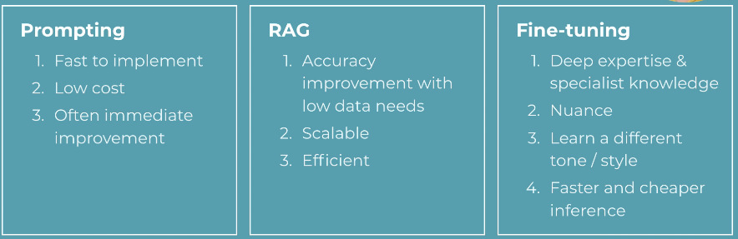
CONS
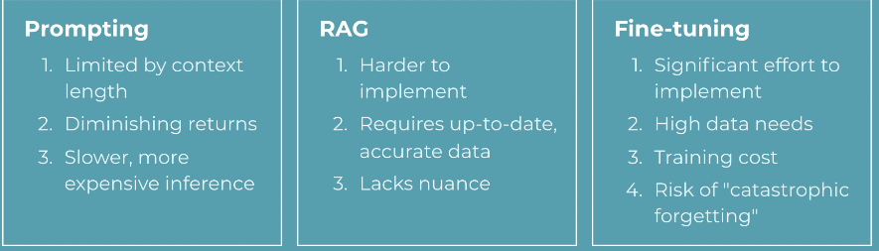

- Productionize.
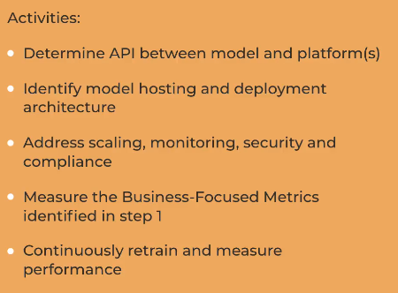

Baselines for our models
We can get a baseline result with other simple ML techniques.
It is even important to get this baseline for several reasons:
- Start cheap and simple
- Gives benchmark to improve on
- An LLM might not be the right solution
Here are some traditional NLP techniques to try:
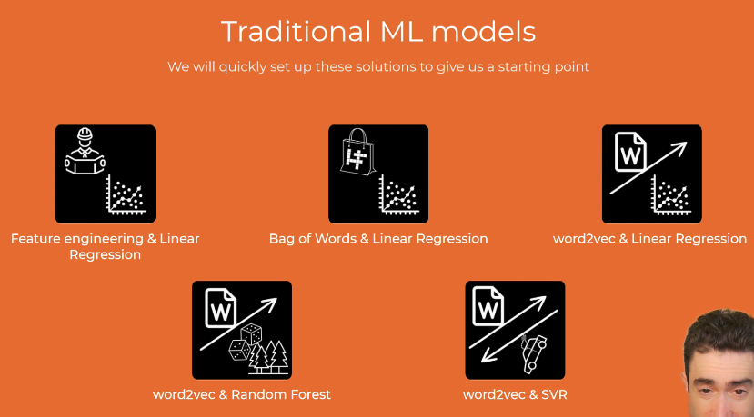

Fine-tune Frontier Models
Three stages:
- Create Training Dataset in JSONL format and upload it to OpenAI.
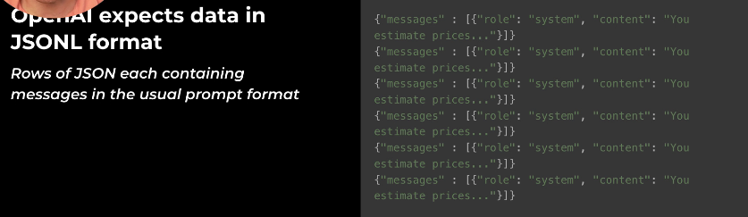
- Run training. Training and validation loss should decrease.
- Evaluate results, tweak, repeat.

Sometimes Fine-tuning Frontier model doesn’t improve it. Like in our Pricer example. Also consider that catastrophic forgetting can make things worst.
Here is the case where Finetuning Frontier LLM might be worth it:
