LoRA

Intro
Low Rank Adaptation
The smaller version of Llama3.1 is 8B. This is already too big for most of GPU we can access (32GB minimum of GPU RAM needed).

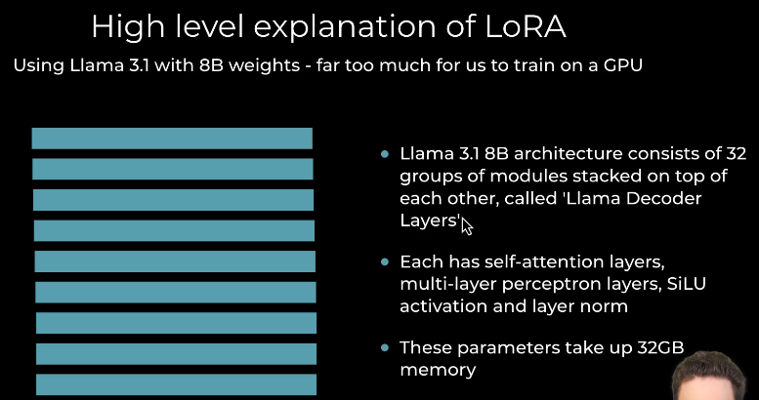
Figure 1: LLama architecture.
LORA idea:
- Freeze the weights of Llama.
- Select Target layers
- Create new matrices of lower size (rank). Matrix A & B
- Add the low rank adaptor into the target layers
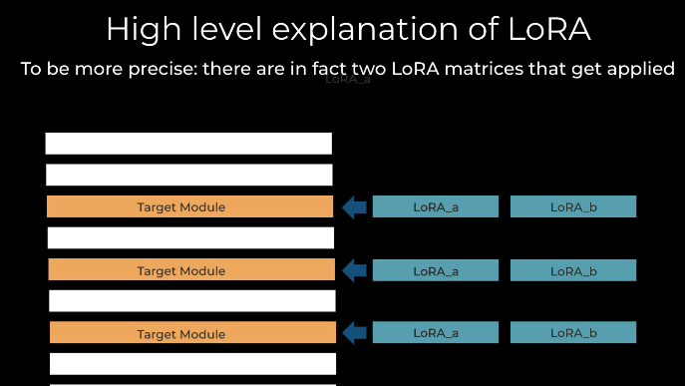

QLoRA
Even if LoRA reduce the weights to optimize, you still need to fit the entire model in memory.
That’s when QLoRA comes to the rescue.
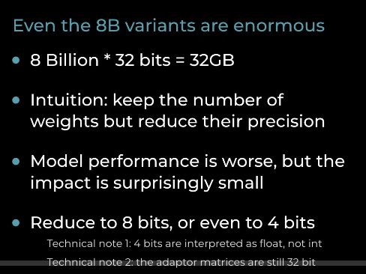

Example quantization of Llama 3.1:
- Original model 32GB
- Quantized to 8bits: 9GB
- Quantized to 4bits: 5.6GB + QLora layers 109MB

Hyperparameters of LoRA
3 essential hyperparameters:
- R: rank of the LoRA matrices.
- Alpha: it is multiplied to the weights in the Lora matrices to augment their influence.
- Target Modules: The target layers that will be added to LoRA
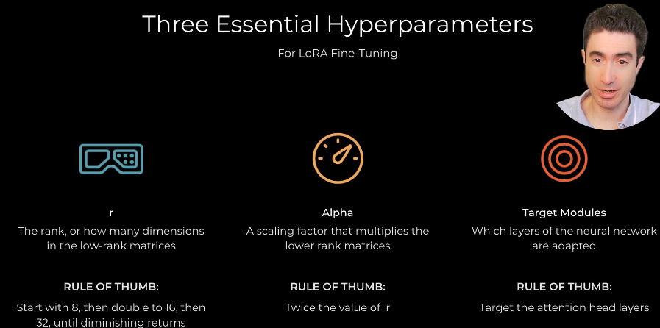

Selecting a LLM

Basics
BASE MODEL: The basically trained model.
INSTRUCT MODEL: The model design for Chat. It accept the History of messages (user, system, assistant) as input.
Decisions to select our base model:
- Number of parameters: the more is better, but we are constrain by the GPU memory of the machine we are using. In our example 7-8B is OKAY.
- Llama vs Qwen vs Phi vs Gemma.
- Base or Instruct variant. If fine tuning for one single problem start with the BASE model (even if you have a system prompt and user prompt).

LeaderBoard
In huggingface leaderboard: Open LLM Leaderboard - a Hugging Face Space by open-llm-leaderboard
Filter by parameter up to 9B
If you want to see the Instruct model click on Chat “model type”. But In our case we choose the Base model.

We choose Llama for our project although it’s not at the top of the list. The reason is because the Tokenizer of Llama numbers from 0 to 999 get mapped to a single token (other tokenizer map only 0 to 9 to a single token). It makes it easy for our problem.

Hyperparameter.

For QLORA
- Target Modules: The layers we choose to train. The rest is frozen.
- R : : how many dimensions of the LoRA matrices.
- Alpha: scaling factor multiplied to the weights in the Lora matrices to augment their influence.
- Quantization: the reduction of base model size.
- Dropout: Regularization to avoid overfitting.

For General ML
- Epochs
- Batch Size
- Learning rate
- Gradient accumulation: Instead of forward and backward with the gradient. Do Several forward pass, calculate the gradients for each forward pass and accumulate them, finally take 1 backward step.
- Optimizer: formula used to update the weight of the model with the gradients.

