Introduction
We will build a system that scrape the internet for Deals (item in sale for a good price). These deals description will be “price estimate” by several LLM to finally notify us if it’s really a good offer.

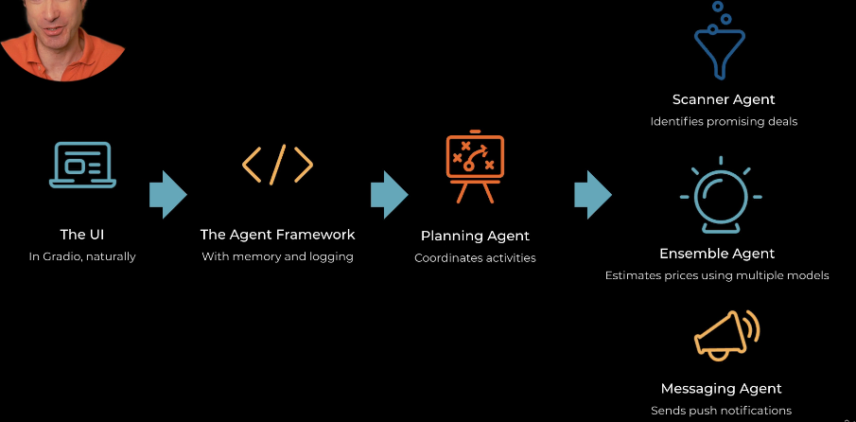
Figure 1: Multi Agent Architecture.

As we head toward prod, we will use:
- Type hint
- Comments
- Logging
- (Unit test): not in this project.

Modal

