Open Government Platform
Catalog Management System
Functional Requirements Document


Version 0.2
November 1, 2011
Revision History

Version | Description of Change | Author | Date
0.1 | Initial draft | REI Systems, Inc. | 2011-10-05
0.2 | Updated sections which were marked TBD | REI Systems, Inc. | 2011-11-01
0.3 | Updated unfinished sections | Data.gov PMO | 2011-11-18

Table of Contents
1 Introduction 1
1.1 Purpose 1
1.2 Scope 1
1.3 Background 1
1.4 References 2
1.5 Assumptions and Constraints 2
1.5.1 Assumptions 2
1.5.2 Constraints 2
2 Methodology 2
2.1 System Analysis 2
2.2 Business Analysis 2
3 Functional Requirements 3
3.1 Contexts 3
3.2 User Requirements 4
3.2.1 System Administrator 4
3.2.2 Program Management Office 4
3.2.3 Organization Point of Contact 5
3.2.4 Data Steward 5
3.2.5 Manager 6
3.3 Data Flow Diagram 6
3.4 Logical Data Model 6
3.5 Functional Requirements 6
3.5.1 System Access 7
3.5.2 User Registration and Management 7
3.5.3 User Authentication 8
3.5.4 Data Submission 8
3.5.5 Approval Workflow 9
3.5.6 General Display and Reports 9
3.5.7 System Help 10
4 Other Requirements 10
4.1 Interface Requirements 10
4.2 Hardware/Software Requirements 11
4.2.1 Hardware Requirements 11
4.2.2 Software Requirements 11
4.3 Web Accessibility Requirements 11
4.4 Operational Requirements 11
4.4.1 Security and Privacy 11
4.4.2 Audit Trail 12
4.4.3 Reliability 12
4.4.4 Disaster Recovery 12
4.4.5 System Availability 12
4.4.6 System Performance 12
4.4.7 Capacity 12
4.4.8 Data Retention Policy 12
4.4.9 Validation Rules 13
Appendix A. U.S. DGIB Requirements 14

List of Tables

Table 1: User Requirements for System Administrators 4
Table 2: User Requirements for Program Management Office 5
Table 3: User Requirements for Organization Points of Contact 5
Table 4: User Requirements for Data Stewards 6
Table 5: User Requirements for Managers 6
Table 6: System Access Requirements 7
Table 7: User Registration and Management Requirements 7
Table 8: User Authentication Requirements 8
Table 9: Data Submission Requirements 8
Table 10: Approval Workflow Requirements 9
Table 11: General Display and Reports Requirements 9
Table 12: System Help Requirements 10
Table 13: U.S. DGIB Requirements 14

List of Figures

Figure 1: Data.gov in a Box Conceptual Architecture 3

Introduction

Purpose

This functional requirements document (FRD) provides functional requirements and design for the Data Management System (DMS), which is a module of the Open Government Platform (OGPL), the open source product developed jointly by India and the United States that is being made available so that governments around the world can create their own open data sites.

For each instantiation of the OGPL, it is envisioned that there will be a coordinating group (herein called aProgram Management Office, PMO) that is responsible for the development and implementation of DMS to include the process of coordinating, reviewing, analyzing, and publishing all data in the OGPL. (While the term “data” is used in this FRD for the sake of simplicity, the DMS can be used for objects beyond data (documents, tools, etc.)

The requirements described in this FRD shall support the PMO by providing from start to finish the necessary tools and capabilities to provide an automated, manageable process for publishing data in the Open Government Platform catalogue. DMS will be available to anyone who has the URL and password.

A successful implementation of the DMS would be achieved when the PMO, governmental organization managers, and data stewards can submit, approve, and update data electronically and view management metric reports.

DMS will support management and decision-making through any web browser. DMS will help organizations rapidly provide their data through on-line entry or upload of their metadata tools from multiple on-line environments.

Scope

This FRD describes the functional characteristics of DMS. This document is prepared in support of the OGPL project to document functions and operational procedures for data submissions and changes.

Background

During the U.S.-India Open Government Dialogue, Secretary of State Hillary Rodham Clinton and Minister of External Affairs S. M. Krishna announced the U.S.-India Innovation Exchange.

The two countries have partnered to release “Data.gov-in-a-Box,” an open source version of the United States’ Data.gov data portal and India’s India.gov.in document portal. It will be available for implementation by countries globally, encouraging governments around the world to stand up open data sites. As the U.S. and India began collaborating on “Data.gov-in-a-Box,” it became clear that the resulting product would be more than a data catalog and site, and as a result, the project name was changed to Open Government Platform (OGPL). Documents and statements earlier in the project will contain references to “Data.gov-in-a-Box” or “DGIB” for short.

References

- India National Portal – http://india.gov.in/
- U.S. Data.gov – http://www.data.gov/
- U.S. Data.gov Data Management System (DMS) – https://dms.data.gov/ (requires user authentication)
- U.S. Data.gov DMS Training Site – http://dms-training.data.gov/ (requires user authentication)

Assumptions and Constraints

Assumptions

Assumptions associated with DMS are listed below:

- All OGPL components are available without restriction, fee, or license and open source.
- In any implementation, there is a central PMO responsible for management of the OGPL website.
- DMS supports two-tier hierarchical organizational structures for managing data submissions.
- Data stewards may submit metadata along with a URL of the data source, or submit metadata with a data source attached.
- DMS is a separate and isolated system from the main OGPL application that serves public-facing website contents.
- Operational requirements vary based on the specifications of the infrastructure on which OGPL is deployed.

Constraints

Constraints imposed on DMS are listed below:

- DMS has the same system requirements as Drupal 6.x. (see Drupal’s System Requirements)
- An SSL certificate must be installed on web servers.
- Operational requirements are dependent on the actual infrastructure on which the application is deployed.

Methodology

System Analysis

This Functional Requirements Document has been formulated to blueprint the functional and system requirements to upgrade the current Dataset Management System (DMS) used by the U.S. to automate and simplify the data publication process to provide users the ability to electronically submit, track, and manage data for OGPL to promote data usage, usability, and availability to the public and the government agencies.

Business Analysis

During the week of August 29 – September 2, 2011, a delegation of representatives from the Indian National Informatics Centre (NIC) visited Washington, DC, for a knowledge sharing and technical exchange session with the Data.gov team about the Data.gov-in-a-Box initiative.

Knowledge Sharing and Technical Exchange

The five-day exchange began with demonstrations of the existing United States Data.gov website, the communities, catalogs, and Dataset Management System (DMS). Valuable discussions and questions and answers took place and the group reached a shared understanding of the current capabilities, architecture, and underlying technology of both Data.gov and India’s India.gov.in document portal. A series of assumptions about the nature of the project were captured and agreed-upon, including the idea that the DGIB (now OGPL) would be open-source, modular, and customizable to any potential installation. The group outlined the desired characteristics and specifications of the various components of the proposed OGPL product.

Early on it was agreed that version 1.0 of OGPL will focus on data discovery and data access, with any type of data presentation or visualization beyond simple downloading to be incorporated in later versions. Visualization tools would be an ideal candidate for an open-source community developer challenge. Discussions centered around the basic architecture of the “minimum viable product” at the initial launch – two instantiations of Drupal, one for the website and one for the DMS. A significant agreement was reached that the U.S. Data.gov would also migrate to the same open-source architecture, thereby keeping both Data.gov and OGPL in synch. The group also held lengthy discussions about the metadata template to be the standard for OGPL. The intent is to enable any adopting country to customize the look and feel of the website, the functionality, the workflow for approving data within the DMS, and the metadata. The group agreed that a well-defined, modular standard metadata template would promote wide adoption and enable future international data sharing.

Functional Requirements

Context

System interfaces are depicted below in Figure 1.

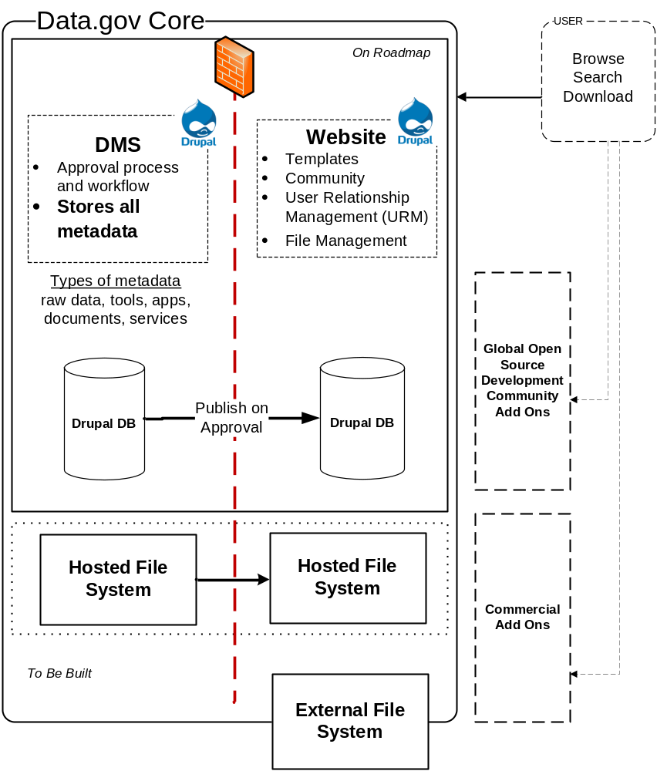
Figure 1: Open Government Platform Conceptual Architecture

User Requirements

The following basic categories of users are defined as functional, business user roles of DMS.

- PMO
- Organization Point of Contact (POC)
- Data Steward
- Manager

DMS shall allow administrators to customize user role hierarchy by creating more than one level of basic category of user roles. Each user role, except for Manager, shall have a dedicated workflow step assigned. User roles and workflow shall be customizable by system administrators.

A special system user role called System Administrator shall be available in DMS to administer the site. System Administrator shall not have a functional role within the data approval workflow. Detailed user requirements per each user role are defined below.

It is understood that as a government creates the instance of the OGPL for their own use, these roles may be modified as appropriate. This document outlines the basic functions of the software baseline to be made available.

System Administrator

System Administrator is an individual who maintains and administrates the OGPL and DMS websites, software, and possibly hardware. The System Administrator’s primary responsibility is to support operation of the website, and the System Administrator is not directly involved in the DMS data approval workflow.

Table 1: User Requirements for System Administrator
Req. ID | Requirement Definition
U1.1 | System Administrator shall have access to all records.
U1.2 | System Administrator shall have functionalities to add, update, or disable all user accounts.
U1.3 | System Administrator shall have functionalities to add, update, or disable all organizations.
U1.4 | System Administrator shall have access to function as any other user, including all other roles.
U1.5 | System Administrator shall have access to configure and customize the application as needed, via an administration interface.

Program Management Office

The PMO is a group of individuals who collectively manage OGPL and DMS. Members of PMO validate and approve submissions from the Organization POCs before data are published on the website.

Table 2: User Requirements for Program Management Office
Req. ID | Requirement Definition
U2.1 | PMO shall review records that have been approved by POCs.
U2.2 | PMO shall be able to approve records to be published on the public website, or reject records to send back to POCs.
U2.3 | PMO shall have functionalities to start the new submission of records.
U2.4 | PMO shall have access to all records.
U2.5 | PMO shall have functionalities to add, update, or disable all user accounts, including other PMO accounts, except for the System Administrator account.
U2.6 | PMO shall have functionalities to add, update, or disable all organizations.
U2.7 | PMO shall have access to generate all metric reports.
U2.8 | PMO shall have access to function as any POC or Data Steward.

Organization Point of Contact

An Organization Point of Contact (POC) is a representative from an organization who identifies, describes, and submits data for inclusion in OGPL. The POC is also responsible for ensuring data submitted meet the data policy standards for OGPL as defined by that government.

Table 3: User Requirements for Organization Points of Contact
Req. ID | Requirement Definition
U3.1 | POC shall review records that have been submitted by Data Stewards in their organization.
U3.2 | POC shall be able to approve records up to the PMO, or reject records to send back to Data Stewards.
U3.3 | POC shall have functionalities to start the new submission of records.
U3.4 | POC shall have access to all records for the organization associated to the POC’s user account.
U3.5 | POC shall have functionalities to add, update, or disable Data Stewards and other POC user accounts for the organization associated to the POC’s user account.
U3.7 | POC shall have access to generate all metric reports for the organization associated to POC’s user account.
U3.8 | POC shall be assigned to one and only one organization.

Data Steward

A Data Steward is a representative from an organization, and could be a data owner and internal reviewer in the data submission process, who accesses DMS and creates new submission records for OGPL.

Table 4: User Requirements for Data Stewards
Req. ID | Requirement Definition
U4.1 | Data Steward shall be able to submit records up to the POC for the organization associated to Data Steward’s user account.
U4.2 | Data Steward shall have functionalities to start the new submission of records.
U4.3 | Data Steward shall have access to all records initiated by the user.
U4.4 | Data Steward shall have access to all published records for the organization associated to POC’s user account.
U4.5 | Data Steward shall be assigned to one and only one organization.

Manager

A Manager is an individual affiliated with OGPL who has read-only access to view DMS and metric reports.

Table 5: User Requirements for Managers
Req. ID | Requirement Definition
U5.1 | Manager shall have access to all records.
U5.2 | Manager shall have access to generate all metric reports, as identified by FR6.10 and FR6.11.

Data Flow Diagram

The following diagram illustrates the basic approval workflow that a data record must go through in DMS before it is published on the website.

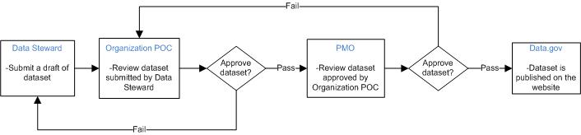

Figure 2: Data Flow Diagram (the last step above should say OGPL not Data.gov)

Logical Data Model

The metadata model for the data in the DMS is logically separated into four sections: core, access type extensions, data-specific extensions, and administrative extensions. Core is required for all data submissions, and appropriate extensions will be required as users identify what type of data is being submitted. All extensions shall be customizable by the System Administrator.

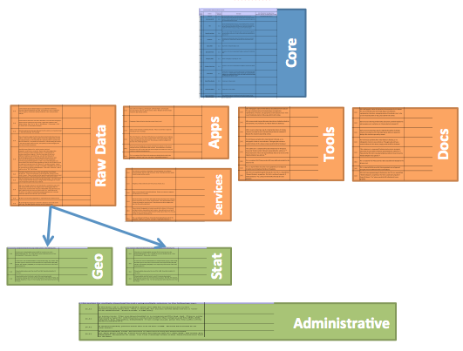
Figure 3: OGPL Metadata Logical Data Model

Functional Requirements

Functional requirements are categorized as follows:

- System access
- User registration and management
- User authentication
- Data submission
- Approval workflow
- General display and reports
- System help

System Access

The system is accessible via any web browser via a URL using HTTPS to promote collaboration across multiple organizations (which may be located in various geographic locations), while ensuring security and validity of the data submitted. A simple Internet connection is all that is necessary to access the system to encourage rapid growth of data.

Table 6: System Access Requirements
Req. ID | Requirement Definition
FR1.1 | DMS shall be accessible via a URL using any generic web browser.
FR1.2 | DMS shall be accessible via HTTPS only.

User Registration and Management

User registration needs to be configured in a way to strengthen security and validate the authoritative source of data. With a unique account and a strong password policy, hacking or breaching can be prevented with a strong audit trail.

Table 7: User Registration and Management Requirements
Req. ID | Requirement Definition
FR2.1 | DMS shall create one System Administrator account upon installation.
FR2.2 | DMS shall not allow users to self-register.
FR2.3 | DMS shall enforce an arbitrary password policy, configurable by the System Administrator.
FR2.4 | DMS shall enforce an arbitrary password expiration policy, configurable by the System Administrator.
FR2.5 | DMS shall enforce an arbitrary password reuse policy, configurable by the System Administrator.
FR2.6 | DMS shall allow the System Administrator to add, edit, or disable users of all roles.
FR2.7 | DMS shall allow the PMO to add, edit, or disable users of all roles for any organization, except for the System Administrator.
FR2.8 | DMS shall allow a POC to add, edit, or disable users of POC or Data Steward roles, for the organization associated to the POC’s user account.
FR2.9 | DMS shall allow a POC to add, edit, or disable organizations and their hierarchy for the organization associated to the POC’s user account.
FR2.10 | DMS shall allow the PMO to add, edit, or disable organizations and their hierarchy.
FR2.11 | DMS shall require the following information to create a user account: email address, name, phone number, organization, and user role.
FR2.12 | DMS shall send a temporary one-time password via email when a new user is created. This temporary password should expire within 24 hours.
FR2.13 | DMS shall force users to update their password when logging into the DMS using a temporary password.
FR2.14 | DMS shall allow users to reset passwords with email validations.
FR2.15 | DMS shall store user passwords using a one-way encryption, and shall not allow users to retrieve a lost or forgotten password.

User Authentication

Users must authenticate themselves using a unique User ID (email address) and password before performing any actions in DMS. A session expiration policy is necessary to prevent unintended use of the system by unauthorized users. DMS shall not use any persistent cookies to prevent potential unwanted saving of user credentials and to comply with generic privacy policies.

Table 8: User Authentication Requirements
Req. ID | Requirement Definition
FR3.1 | DMS shall allow users to log in to the system using their email addresses and passwords.
FR3.2 | DMS shall allow users to log out and invalidate their sessions by clicking the “Log out” link.
FR3.3 | DMS shall not allow users the option to save user credentials using persistent cookies.
FR3.4 | DMS shall automatically log out the user when the user’s session is inactive for 30 minutes with a warning at 20 minutes.

Data Submission

Users must provide a wide range of information, as identified by the OGPLmetadata model, to submit data in order to measure the usability and to gather enough searchable information to allow the public to find data.

Table 9: Data Submission Requirements
Req. ID | Requirement Definition
FR4.1 | DMS shall allow users to start a new data submission record, in the workflow step for which the individual user is responsible.
FR4.2 | DMS shall allow users to enter complete metadata using a web interface.
FR4.3 | DMS shall allow users to upload CSV and XML files to enter one or more data submission records.
FR4.4 | DMS shall allow users to save a record without submitting or approving it. Data shall not be validated while saving.
FR4.5 | DMS shall allow users to edit, submit, approve, reject, or delete records that are in the workflow step users are responsible for, as appropriately filtered by data access control based on users’ roles.
FR4.6 | DMS shall allow users to enter all metadata fields in the core template.
FR4.7 | DMS shall allow users to enter type-based metadata extension fields, based on the type of data selected.
FR4.8 | DMS shall allow users to enter category-based metadata extension fields, based on the category of data selected.
FR4.9 | DMS shall allow users to enter administrative metadata extension fields.
FR4.10 | DMS shall validate data entered, as set by administrators, while submitting or approving records. Data validation rules shall be defined by the metadata model.
FR4.11 | DMS shall allow the System Administrator to create, edit, or delete data types and categories on which extensions are based.
FR4.12 | DMS shall allow the System Administrator to create, edit, or delete type- and category-based metadata extension fields.
FR4.13 | DMS shall allow the System Administrator to group metadata fields into logical groups.
FR4.14 | DMS shall display data entry forms grouped by logical groups.

Approval Workflow

An approval workflow is necessary to ensure that each organization has completed its due diligence to ensure data meets the publishing organization’s standards.

Table 10: Approval Workflow Requirements
Req. ID | Requirement Definition
FR5.1 | DMS shall facilitate a linear data approval workflow process, as defined in Section 3.3.
FR5.2 | DMS shall allow the System Administrator to define an arbitrary number of workflow steps. Each step must have a user role responsible for the step assigned.
FR5.3 | DMS shall allow users to complete a workflow step and advance the record to the next workflow step, unless the record is published.
FR5.4 | DMS shall allow users to reject a record and send the record back to the previous workflow step, unless the record is already at the at which step it started.
FR5.5 | DMS shall allow users to create requests to update or delete already published records. DMS shall keep the original record intact until the update or delete request has gone through the approval workflow. When an update or delete request has completed the workflow, the original record shall be archived and the new record shall replace it.
FR5.6 | DMS shall send email notifications to the new workflow owner(s) when data transitions between steps.
FR5.7 | DMS shall send email notifications to all involved users when a record is published.
FR5.8 | DMS shall allow users to approve or reject multiple records at once.
FR5.9 | DMS shall allow users to provide comments while approving or rejecting a record.

General Display and Reports

The system provides several built-in reports to show statistics on the data approval workflow process, where the comprehensive status of data submissions is easily accessible. DMS shall also provide a facility for the PMO and System Administrator to communicate to all users via notifications on the home page or a repository of documents.

Table 11: General Display and Reports Requirements
Req. ID | Requirement Definition
FR6.1 | DMS shall display, upon log in, all records in the user’s workflow step, appropriately filtered by access control rules enforced by the user’s roles.
FR6.2 | DMS shall allow users to preview records in the same format as the OGPL website template.
FR6.3 | DMS shall allow users to download existing records as CSV or XML.
FR6.4 | DMS shall allow users to perform keyword searches to filter records.
FR6.5 | DMS shall allow users to filter all records viewed by workflow step or request type.
FR6.6 | DMS shall allow users to sort all records viewed by title or date last updated.
FR6.7 | DMS shall provide a document library where the System Administrator or PMO can upload any documents.
FR6.8 | DMS shall display “What’s New” notifications on the home screen, prior to user authentication. Notifications shall be added, edited, or deleted by the System Administrator or PMO.
FR6.9 | DMS shall provide a summary table to all users upon log in, which displays number of records in each workflow step, as filtered appropriately by access control defined by the user roles.
FR6.10 | DMS shall provide a detailed summary report, which displays number of records in each workflow step by each organization to the System Administrator, PMO, and Managers.
FR6.11 | DMS shall provide a summary statistics report on the average time data stays in each workflow step, by each organization to the System Administrator, PMO, and Managers.

System Help

MS’s help system, which consists of the User Guide and the help messages, promotes growth and improvement through user feedback and creates a user-friendly environment for the system.

Table 12: System Help Requirements
Req. ID | Requirement Definition
FR7.1 | DMS shall displaya help message assigned to each metadata field while users are trying to input data.
FR7.2 | DMS shall display context-based help messages, when requested, on each functional page.
FR7.3 | DMS shall allow users to download the User Guide.

Other Requirements

Interface Requirements

DMS shall push published metadata to the OGPL website software via HTTPS protocol. [Actual protocol to be used to be determined.]

DMS shall push published data source files using SCP protocol. [TBD]

On the web/application server, ports 22 and 443 must be open. On the database server, orts 22 and 3306 must be open. [Show in diagram once finalized.]

Hardware/Software Requirements

Hardware Requirements

There are no specific hardware requirements for DMS. DMS may be deployed on physical servers or virtual servers. For security, it is recommended web and database servers are separated.

Software Requirements

DMS is built using an open-source content management software called Drupal, version 6.x. As such, the same system requirements for Drupal 6.x apply to DMS. Notably, the following software packages listed are required:

- Linux
- Apache webserver 2.x
- MySQL 5.x
- PHP 5.x
- Apache Solr

Web Accessibility Requirements

DMS shall be accessible by any generic web browsers such as Internet Explorer, Firefox, or Chrome. [Note that IE 6 will not be supported.] DMS shall conform to guidelines provided by the Web Content Accessibility Guidelines 2.0.

Operational Requirements

The following sections are provided for illustrative purposes, but the specific operational requirements will be dependent on each organization that chooses to deploy OGPL.

Security and Privacy

DMS shall not rely on collecting any personally identifiable information.

DMS shall not rely on the use of any persistent cookies stored in browsers.

Audit Trail

DMS shall track the user’s system ID, workflow step, and date and time whenever a record is created or updated.

DMS shall maintain an audit trail of the user’s system ID and date and time whenever a record is approved or rejected in the workflow.

Reliability

System failure shall be defined as critical bugs in the DMS that would prevent users from submitting data. Impact of a system failure is minimal and does not involve loss of human life, complete or partial loss of the ability to perform a mission critical function, or loss of revenue. System failure may result in minor loss of productivity.

Disaster Recovery

Disaster recovery shall be implemented at the operating system level, following policies of the organization deploying the OGPL application.

System Availability

System availability is dependent on the infrastructure on which the OGPLapplication is deployed.

System Performance

System performance is dependent on the infrastructure on which the OGPL application is deployed.

Capacity

Capacity requirement is dependent on use cases created by the organization deploying the OGPL application.

Data Retention Policy

DMS shall retain application information until the system is retired. CMS is not designed to enforce any specific data retention policy.

Validation Rules

Following validation rules, based on version 3.01 OGPL metadata template, are applied when records are submitted for approval, not while saving data.

Table 13: Validation Rules

Element | Data Type | Max./Min. | Occurrence | Required
--Core--
Unique ID | Text, System Generated | N/A | 1 | Y
Date Submitted | Timestamp, System Generated | N/A | 1 | Y
Agency Generated ID | Text | N/A | 1 | N
Title | Text | N/A | 1 | Y
Description | Text | N/A | 1 | Y
Agency Name | Text, Pick List | N/A | 1 | Y
Agency Short Name | Text, Auto-filled | N/A | 1 | N
Sub-Agency Name | Text, Pick List | N/A | 1 | N
Sub-Agency Short Name | Text, Auto-filled | N/A | 1 | N
Contact Person (Name) | Text | N/A | 1 | Y
Contact Person Title | Text | N/A | 1 | Y
Contact Person Office Address | Text | N/A | 1 | Y
Contact Person Phone Number | Text | N/A | 1 | Y
Contact Person Email Address | Email | N/A | 1 | Y
Contact Person FAX Number | Text | N/A | 1 | N
Sector | Text, Pick List | N/A | n | Y
Sub-Sector | Text, Pick List | N/A | n | Y
Keywords | Text | N/A | n | Y
Date Released | Date | N/A | 1 | Y
Access URL | URL | N/A | 1 | N
Access Method | Text, Pick List | N/A | 1 | Y
Reference URL | URL | N/A | n | Y
Catalog Type | Text, Pick List | N/A | 1 | Y
Policy/Program Goal | Text, Pick List | N/A | n | Y
Data Asset Requires a License Agreement | Boolean | N/A | 1 | N
Data Asset License Agreement URL | URL | N/A | 1 | N
--Downloadable--
Access Point | URL | N/A | 1 | Y
Compressed Format | Boolean | N/A | 1 | N
File Size | Number, Float | N/A | 1 | Y
File Format | Text, Pick List | N/A | 1 | Y
--Execute upon access--
Access Point | URL | N/A | 1 | Y
--Embed/Link--
Access Point | URL | N/A | 1 | Y
--Raw Data--
Catalog Location | Text, Pick List | N/A | 1 | Y
Dataset Group Name | Text | N/A | 1 | N
Specialized Data Category Designation | Text, Pick List | N/A | 1 | N
Frequency | Text | N/A | 1 | Y
Bibliographic Citation | Text | N/A | 1 | N
--Document--
Catalog Location | Text, Pick List | N/A | 1 | Y
Document Classification | Text, Pick List | N/A | 1 | Y
Target Audience | Text | N/A | n | Y
Validity Date | Date | N/A | 1 | Y
Frequency | Text | N/A | 1 | N
Language | Text | N/A | n | Y
--Data Service--
Service Maturity | Text | N/A | 1 | Y
Service Category | Text | N/A | 1 | Y
Dataset(s) Used | Text | N/A | n | Y
Target Audience | Text | N/A | n | Y
Language | Text | N/A | n | Y
Access Type | Text | N/A | 1 | N
--Apps--
App Type | Text | N/A | 1 | Y
Dataset(s) Used | Text | N/A | n | Y
Catalog Location | Text, Pick List | N/A | 1 | Y
Language | Text | N/A | n | Y
--Tools--
Tool Type | Text | N/A | 1 | Y
Dataset(s) Used | Text | N/A | n | Y
Tool Location | Text, Pick List | N/A | 1 | Y
Extraction Format | Text | N/A | n | Y
Language | Text | N/A | n | Y
--Statistical--
Statistical Methodology | Text | N/A | n | N
Sampling | Text | N/A | 1 | N
Estimation | Text | N/A | 1 | N
Weighting | Text | N/A | 1 | N
Disclosure Avoidance | Text | N/A | 1 | N
Questionnaire Design | Text | N/A | 1 | N
Series Breaks | Text | N/A | 1 | N
Non-response Adjustment | Text | N/A | 1 | N
Seasonal Adjustment | Text | N/A | 1 | N
Data Quality | Text | N/A | 1 | N
--U.S. Open Government Directive--
Policy/Goal ID | Text | N/A | 1 | Y
Policy/Goal Title | Text | N/A | 1 | Y
Is this record a part of OGPL submissions? | Boolean | N/A | 1 | Y
Is this record listed in your agency open government plan? | Boolean | N/A | 1 | Y
Is this a high-value dataset? | Boolean | N/A | 1 | Y
What makes this a high-value dataset? | Text | N/A | 1 | Y if marked high-value
How is this new? | Text | N/A | 1 | Y if marked high-value
--U.S. Data Quality Act--
Policy/Goal ID | Text | N/A | 1 | Y
Policy/Goal Title | Text | N/A | 1 | Y
Agency Responsible for Information Quality | Text, Pick List | N/A | 1 | Y
--U.S. Privacy Protection--
Policy/Goal ID | Text | N/A | 1 | Y
Policy/Goal Title | Text | N/A | 1 | Y
Agency Responsible for PII | Text, Pick List | N/A | 1 | Y

U.S. OGPL Requirements

Table 14: U.S. OGPL Requirements
Req. ID | Requirement Definition
US1.1 | DMS shall allow users to authenticate to a remote system user account using standard protocol such as CAS or OpenID. .
US2.1 | DMS shall allow originators to self-register, if agency password is provided
US 2.2 | DMS shall allow POCs and PMO users to manage respective agency password.
US3.1 | DMS shall require approval from security and privacy liaison before data is published.
US3.2 | DMS shall allow update and delte requests to bypass the security and privacy review step.

