Express Powerr
Smart Fleet Management System
User Manual
Version 1.0

1. Login
The Login page provides secure authentication for users. Enter your username and password to access the Smart Fleet Management system.

Features:
- Username and password authentication
- Remember me option for 30 days
- Password visibility toggle
- Demo credentials displayed for testing

Demo Accounts:
- admin / password123
- dispatcher / password123
- finance / password123
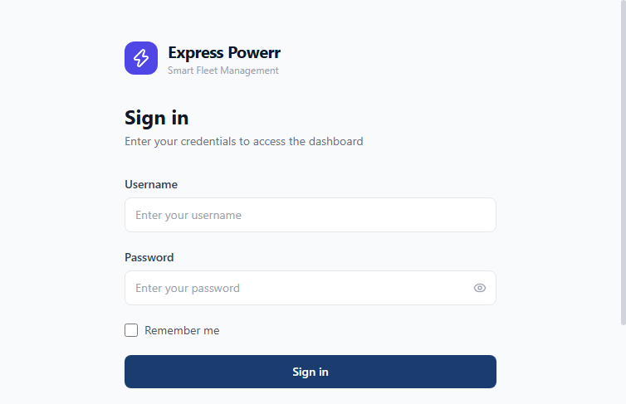

2. Dashboard
The Dashboard is the main landing page after login. It provides a high-level overview of fleet operations.

Key Features:
- Active Vehicles count and total
- Generator Fleet status and deployments
- Active Jobs with pending count
- SLA Compliance percentage
- SLA Compliance table by client
- Fuel Anomaly alerts
- Recent Jobs list
- Download Report button for CSV export
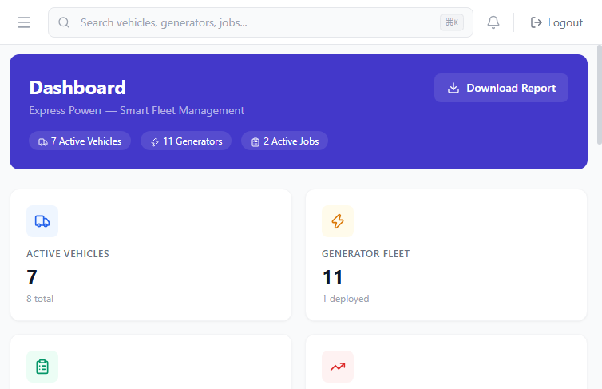

3. Fleet Management
The Fleet module manages all vehicles in the fleet.

Features:
- Vehicle list with status, plate number, and details
- Add new vehicles with full details
- Edit existing vehicle information
- Remove vehicles from fleet
- Search and filter capabilities
- Vehicle status tracking (active, maintenance, idle)
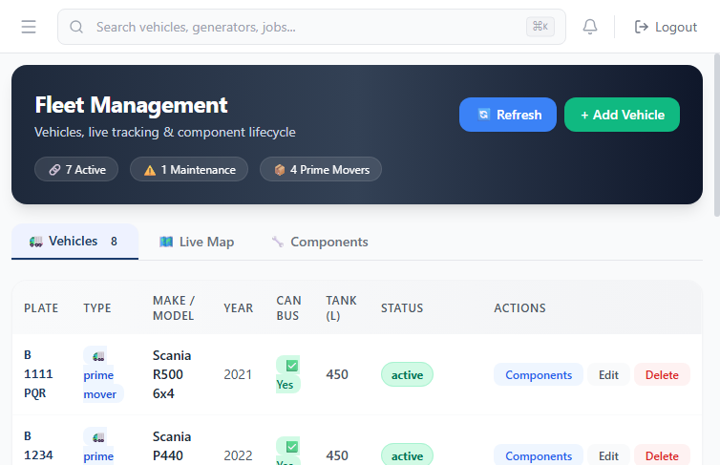

4. Generators
The Generators module manages the generator fleet.

Features:
- Generator list with status and hours
- Track hours of operation
- Deployment location management
- Add new generators
- Update generator hours
- Maintenance scheduling
- Status tracking (deployed, idle, maintenance)
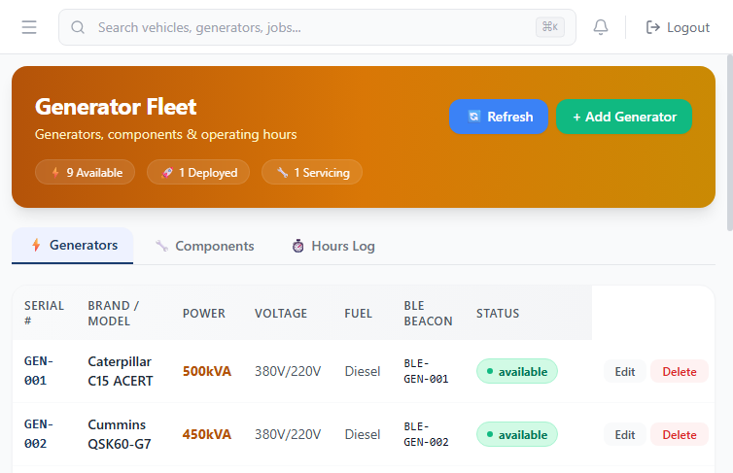

5. Dispatch
The Dispatch module handles job assignments and tracking.

Features:
- Job list with status filtering
- Status options: pending, dispatched, en_route, on_site, completed, cancelled
- Assign vehicles and drivers to jobs
- Track real-time job progress
- Mark jobs as complete
- Job number tracking
- Client assignment
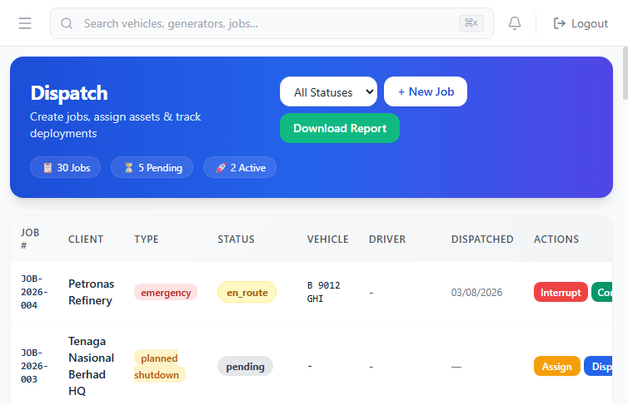

6. Assets
The Assets module provides asset traceability across the fleet.

Features:
- Track equipment, tools, and assets
- Asset condition monitoring
- Location tracking
- Assignment to vehicles or generators
- Add new assets
- Condition reports
- Accountability tracking
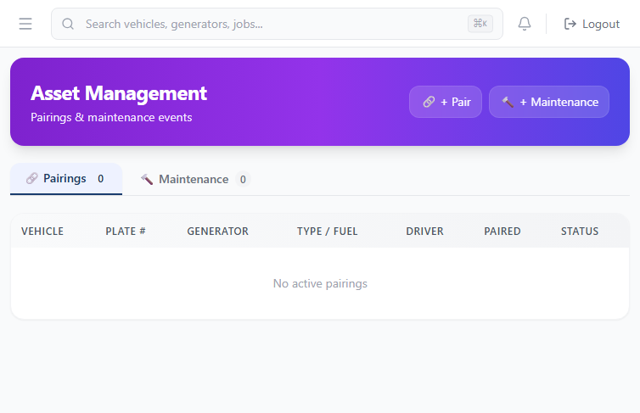

7. Sales
The Sales module manages the sales pipeline and quotation system.

Features:
- Create quotes for vehicle and generator rentals
- Track quote statuses (draft, sent, accepted, rejected)
- Pipeline view of all active quotes
- Client relationship management
- Quote generation with copy-to-clipboard
- Deposit and payment terms
- RM (Malaysian Ringgit) pricing
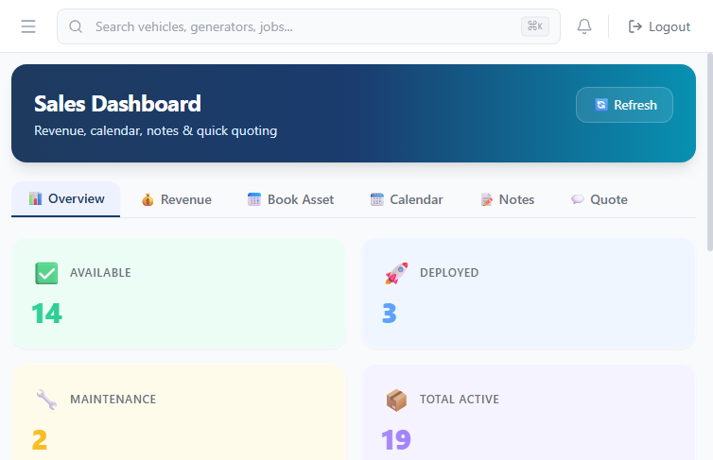

8. Fuel Management
The Fuel module tracks fuel consumption across the fleet.

Features:
- Fuel level monitoring
- Anomaly detection (high volume refills)
- Fuel consumption reports
- Vehicle-level fuel tracking
- Anomaly alerts for potential issues
- Historical fuel data
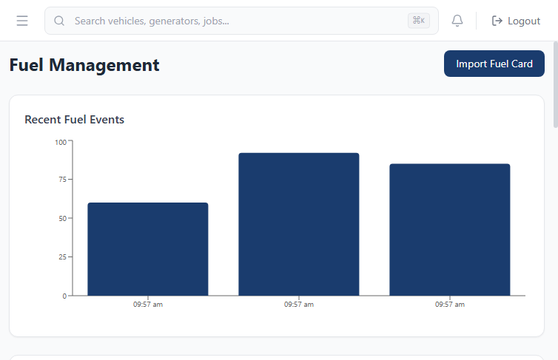

9. Clients
The Clients module manages the customer database.

Features:
- Client information management
- Contact details storage
- Associated jobs tracking
- Add new clients
- Update existing records
- Client history
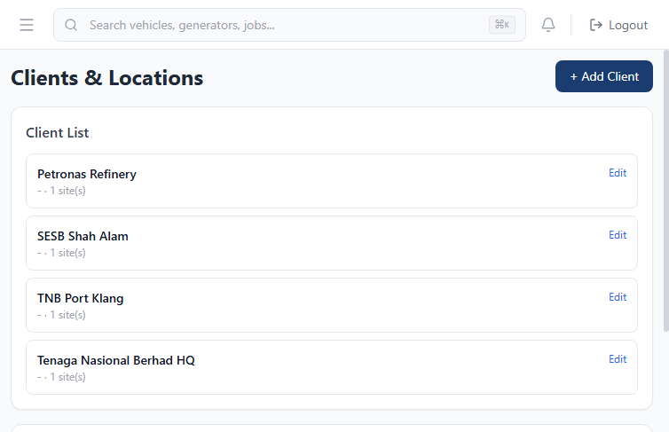

10. Driver Calendar
The Driver Calendar provides a visual calendar view of driver assignments.

Features:
- Calendar view of driver schedules
- Job assignments by date
- Driver availability tracking
- Schedule conflict detection
- Visual job status indicators
- Date range navigation
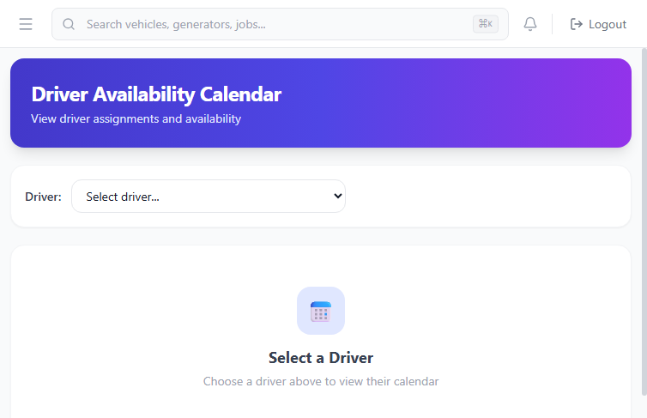

11. GPS Playback
The GPS Playback module allows you to review historical vehicle movements.

Features:
- Select vehicle from dropdown
- Choose date range for playback
- Map visualization of GPS tracks
- Speed and fuel level telemetry
- Track point details
- Route replay for incident investigation
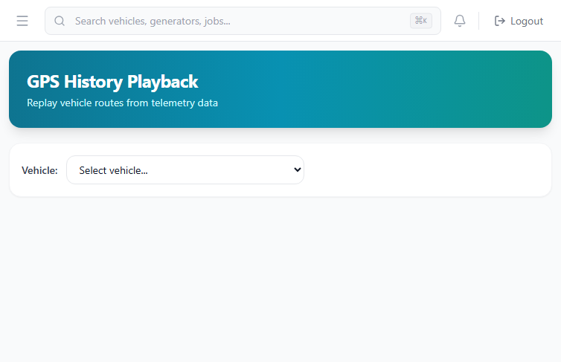

12. ERP Sync
The ERP Sync module manages integration with external ERP systems.

Features:
- Sync vehicle data with ERP
- Job record synchronization
- Fuel log integration
- Configure sync schedules
- Monitor sync status
- External system connectivity
