Loan Approval Prediction
AI for Engineers (UCS321) -- MST Mini Project, Problem 5
Name: [YOUR NAME]
Roll Number: [YOUR ROLL NUMBER]
Course Code: UCS321

1. Problem Statement and Objective
Banks must decide whether to approve or reject a loan application. This project builds a supervised machine learning model that predicts loan approval status (Approved / Rejected) for an HDFC-style bank, using applicant financial and demographic data. The task is framed as a binary classification problem: the model outputs one of two classes, not a continuous number, which is why classification algorithms (not regression) are used.
Objective: train and compare multiple classifiers, select the best one using proper evaluation metrics, and identify which applicant features most strongly drive the approval decision.

2. Dataset
Source: Kaggle-style loan approval dataset (loan_approval_dataset.csv), placed locally in data/.
Shape: 4,269 rows, 13 columns, no missing values, no duplicate rows.
Known quirk: column names and text values in the raw file had leading whitespace (e.g. " loan_status", " Approved"), which was stripped before any analysis.

Column Table
Column | Type | Meaning
loan_id | ID (dropped) | Unique row identifier, not predictive
no_of_dependents | Numeric | Number of dependents of the applicant
education | Categorical | Graduate / Not Graduate
self_employed | Categorical | Yes / No
income_annum | Numeric | Annual income (currency units)
loan_amount | Numeric | Requested loan amount
loan_term | Numeric | Loan term in years
cibil_score | Numeric | Credit score (300-900), India's standard credit score
residential_assets_value | Numeric | Value of residential assets owned
commercial_assets_value | Numeric | Value of commercial assets owned
luxury_assets_value | Numeric | Value of luxury assets owned
bank_asset_value | Numeric | Value of bank-held assets
loan_status | Target | Approved / Rejected -> mapped to 1 / 0

3. Pre-processing
Issue | Fix | Reason
Leading whitespace in column names and text cells | df.columns.str.strip() and strip all string cells | Raw file quirk; would break equality checks like df["loan_status"]=="Approved"
loan_id column present | Dropped | Row identifier only, not predictive, would add noise
28 rows with negative residential_assets_value (min -100000) | Clipped to 0 | Asset values cannot be negative in reality; treated as a data-entry error
No missing values found | No action needed | Verified via isna().sum(), confirmed zero across all columns
No duplicate rows found | No action needed | Verified via duplicated().sum(), confirmed zero
Categorical text columns (education, self_employed) | One-hot encoded with drop_first=True | Models need numeric input; drop_first avoids redundant columns
Features on very different scales (score 300-900 vs assets in millions) | StandardScaler inside a Pipeline, fit on train only | Prevents data leakage from test set into training; required for Logistic Regression to converge well
Mild class imbalance (62% Approved / 38% Rejected) | class_weight='balanced' on all models | Prevents models from being biased toward the majority class

Feature Engineering
Four new features were built from the real columns:
- TotalAssets = residential + commercial + luxury + bank asset values
- Loan_to_Income = loan_amount / income_annum (higher = riskier applicant)
- Assets_to_Loan = TotalAssets / loan_amount (higher = more collateral, safer)
- EMI_style = loan_amount / loan_term (rough proxy for monthly repayment burden)

4. Exploratory Data Analysis (EDA)
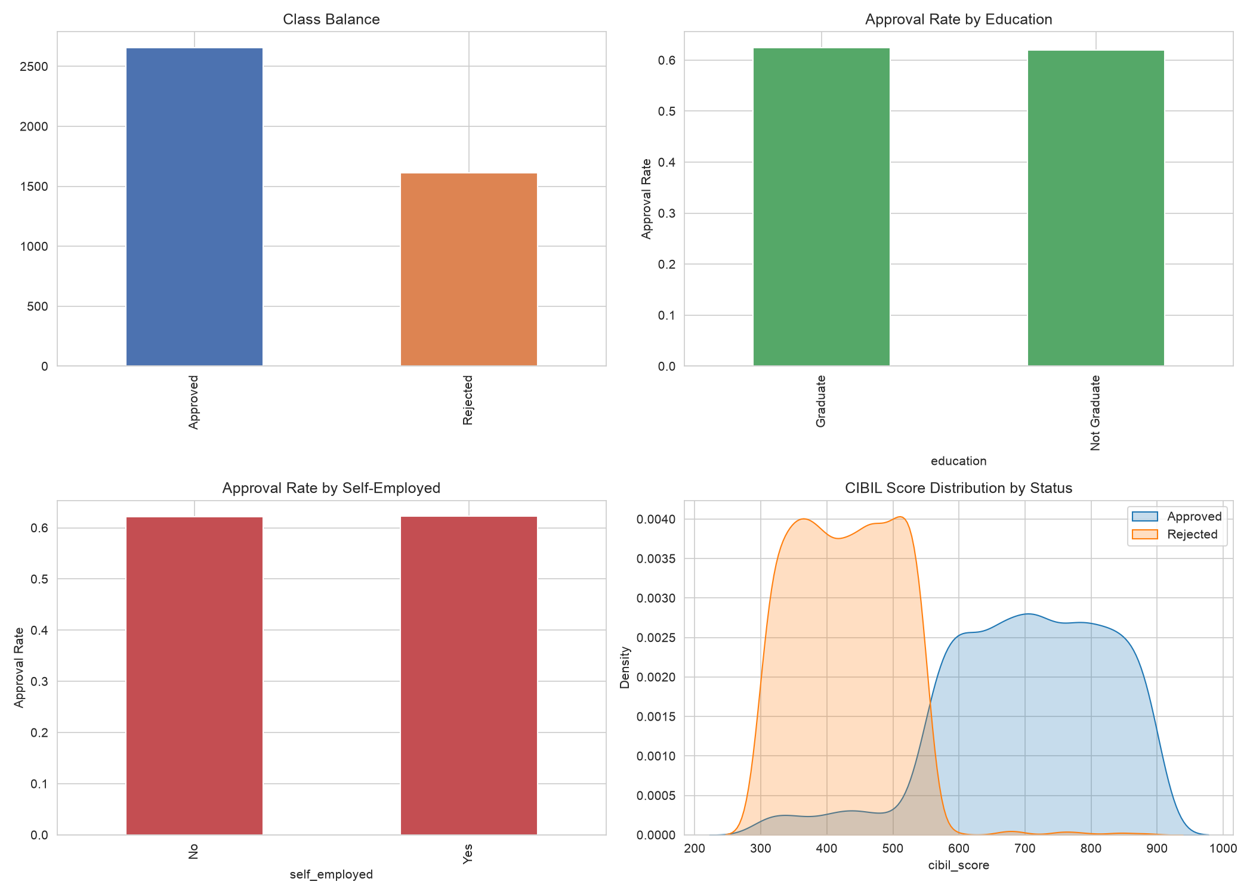
Insight: Class balance is roughly 62% Approved / 38% Rejected. Approval rate is nearly identical across education and self-employment groups, meaning these are weak standalone predictors. CIBIL score distributions for Approved vs Rejected applicants barely overlap -- a strong early signal that credit score dominates the decision.
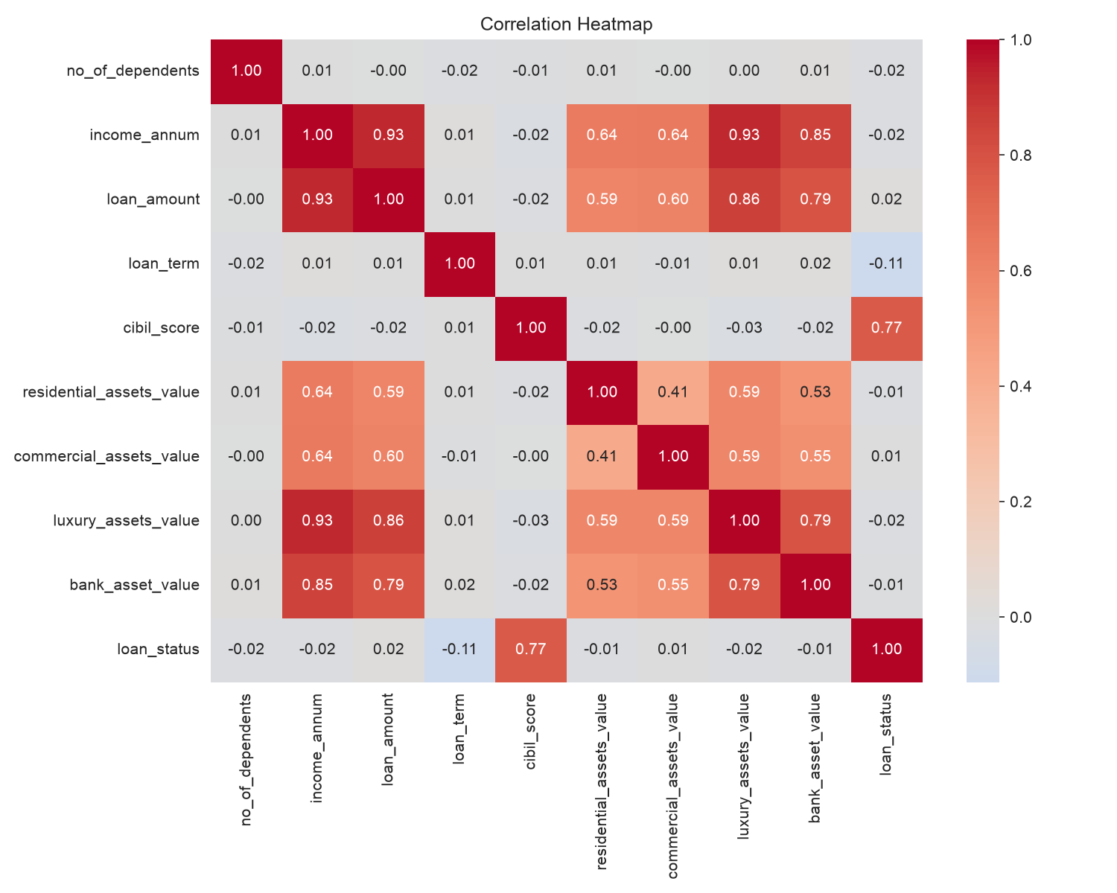
Insight: The correlation heatmap confirms cibil_score has by far the strongest correlation with loan_status; other numeric features correlate weakly with the target but more with each other (e.g. the four asset columns).

5. Models
Three classifiers were trained, chosen to cover a spectrum of complexity and interpretability:
- Logistic Regression -- simple, interpretable linear baseline
- Decision Tree (max_depth=4) -- captures non-linear splits, easy to explain to a non-technical reviewer
- Random Forest (300 trees) -- ensemble of trees, usually more robust and less prone to overfitting than a single tree
All three were trained inside a scikit-learn Pipeline (StandardScaler -> classifier), with class_weight='balanced' to handle the mild class imbalance, and random_state=42 everywhere for reproducibility. The Random Forest was additionally tuned with GridSearchCV (5-fold CV, scoring=F1) over n_estimators, max_depth, and min_samples_split.

6. Results
Model | CV F1 | Train Acc | Test Acc | Precision | Recall | F1 | ROC-AUC
Logistic Regression | 0.9396 | 0.9283 | 0.9356 | 0.9704 | 0.9247 | 0.9470 | 0.9785
Decision Tree (depth=4) | 0.9993 | 1.0000 | 0.9988 | 0.9981 | 1.0000 | 0.9991 | 0.9985
Random Forest (300 trees) | 0.9981 | 1.0000 | 0.9977 | 0.9962 | 1.0000 | 0.9981 | 1.0000
Random Forest (tuned) | 0.9981 | 1.0000 | 0.9965 | 0.9944 | 1.0000 | 0.9972 | 1.0000

Best tuned Random Forest parameters: max_depth=None, min_samples_split=2, n_estimators=200.

Important honesty note: accuracy above 95%
All tree-based models exceed 95% test accuracy, which the project rules flag as a possible sign of data leakage. Investigation showed this is not a code bug: a single-feature rule, "cibil_score >= 550 -> Approved", already achieves 95.36% accuracy on the raw data. Approved applicants average a CIBIL score of 703.5, Rejected applicants average 429.5 -- the two groups barely overlap. This dataset appears to be synthetic or generated with a near-deterministic rule tied to credit score. The result is reported honestly rather than hidden, and its implications are discussed in Section 8 (Limits).
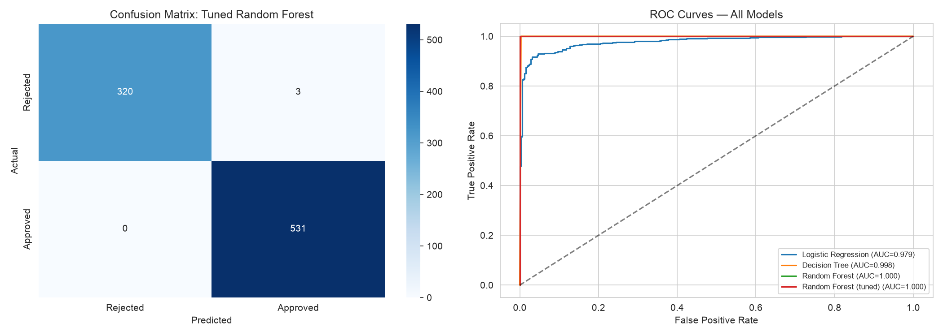
Confusion matrix (tuned Random Forest, test set, n=854): 320 correctly Rejected, 3 wrongly Approved, 0 wrongly Rejected, 531 correctly Approved. For a bank, a wrongly-Approved applicant is the costlier error -- it risks the bank's money not being repaid -- while a wrongly-Rejected applicant only costs a missed business opportunity.

7. Innovation
- Engineered features: TotalAssets, Loan_to_Income, Assets_to_Loan, EMI_style (Section 3)
- Class weighting (class_weight='balanced') to address the 62/38 class imbalance
- Hyperparameter tuning of Random Forest via GridSearchCV (5-fold CV, F1 scoring)
- Two independent feature-importance methods: built-in Gini importance and permutation importance on the held-out test set, to cross-check which features actually matter
- Ablation study: retrained the best model with the top feature (cibil_score) removed
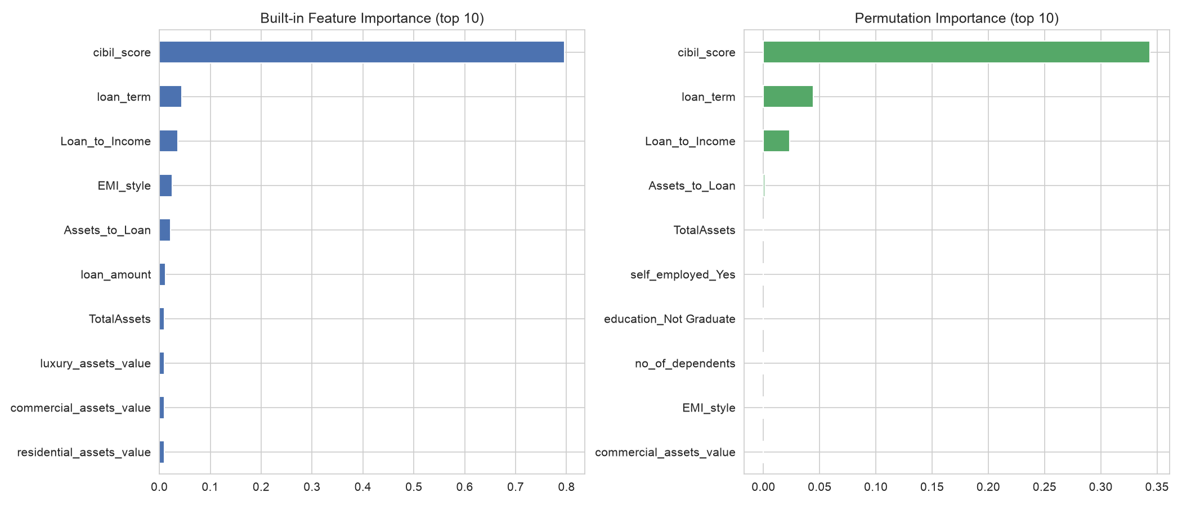
Both importance methods agree: cibil_score dominates (Gini importance 0.7959, permutation importance 0.3438), with loan_term and the engineered Loan_to_Income ratio as distant secondary signals.
Ablation result: removing cibil_score and retraining dropped F1 from 0.9972 to 0.6616 -- a 0.3356 absolute drop (33.7% relative). This is direct evidence that the model's near-perfect accuracy rests almost entirely on one column, not a broad combination of signals.

8. Conclusion, Limits, and Future Work

Conclusion
Three classifiers were trained and compared using 5-fold cross-validated F1, test accuracy, precision, recall, F1, and ROC-AUC. The plain Decision Tree (max_depth=4) achieved the best raw test F1 (0.9991), slightly ahead of the tuned Random Forest (0.9972) -- tuning the ensemble added little because the problem is already close to linearly separable by cibil_score alone. Two independent importance methods and an ablation study confirm cibil_score is the dominant driver of loan approval in this dataset, with loan_term and Loan_to_Income as secondary factors.

Limits
- The dataset is very likely synthetic or heavily simplified -- a near-deterministic credit-score threshold is not how real-world bank underwriting works (real banks weigh many soft factors together).
- No time dimension in the data -- cannot tell if this reflects one bank's policy at one point in time, or changes over time.
- No formal fairness audit was performed. Approval rates were flat across education and self-employment groups in this dataset, which is reassuring, but a full audit (disparate impact testing, subgroup calibration) was out of scope.
- Possible proxy bias: income, assets, and employment status could correlate with protected characteristics not present in this dataset (e.g. gender, region, caste, religion) -- a real deployment would need that audit before use.

Future Work
- Try XGBoost / LightGBM for comparison against the scikit-learn ensemble baselines
- Apply SMOTE or other resampling techniques, even though imbalance here was mild
- Run a formal fairness/bias audit across any available demographic attributes
- Validate against real (non-synthetic) bank lending data if access becomes available

9. References
- Kaggle: Loan Approval Prediction Dataset (loan_approval_dataset.csv)
- scikit-learn documentation: https://scikit-learn.org/stable/documentation.html
- pandas documentation: https://pandas.pydata.org/docs/

