C Sc 335 Analysis and Design Artifacts for the Final Project, Spring 2014
Due: 11:00pm Friday 11-April to the common repository in BitBucket as part of your Java project
1. Team Name: Cheezit Mountain
2. Team Members: Tyler Nienhouse Trevor Woodhouse
Jacob Rochester
3. Project Chosen: Circle your team's choice of final project
TRPG MUD Tower Defense Settlement Management

4. Candidate Objects or Class Hierarchies

List the seven most important objects, or the name of a hierarchy, and the main responsibility of each

Candidate Object | Single Responsibility in 1 or 2 sentences
1 World | Keeping track of the main game parts and progressing the game. Contains the terrain, agents, buildings, and projectiles
2 Terrain | Generates and stores an array list of the terrain. Will use perlin noise-like algorithm to generate a random terrain based on a given seed.
3 Agent | The individual characters in the game. Keep track of their location, hunger, fatigue, and personal traits (strength, motivation, etc.)
4 Building | Buildings for doing things in/with as well as storing stuff. These will act as drop-off and pick-up points for raw materials.
5 WorldView | The main GUI view. This will render the players, buildings, and terrain separately as they update.
6 Observer/ Observable | The main way that the GUI will know when items have updated – it will be the observer of all of the observable classes.
7 Command | Allows objects to send complex actions through a simple object, keep them organized, and allow them to be modular.

These Class and Sequence Diagrams may be written by hand and scanned or drawn with a UML editor such as Violet http://sourceforge.net/projects/violet/files/violetumleditor/

5. Class Diagram: Your team UML Class Diagram must show at least all of your candidate objects from above. Show any relationships between them the classes such as inheritance or interface implementation. Draw general associations such as dependency or aggregation. Label some to help explain things. Add any multiplicity adornments that seem appropriate. Use notes to explain things if you feel it will help. Each UML class must show the class name. For full credit, each class must have an average of at least one attribute per class. There must be an average of at least 2.0 methods per class, which may be implicit (no need to repeat methods) if the class implements a Java interface with methods shown there.
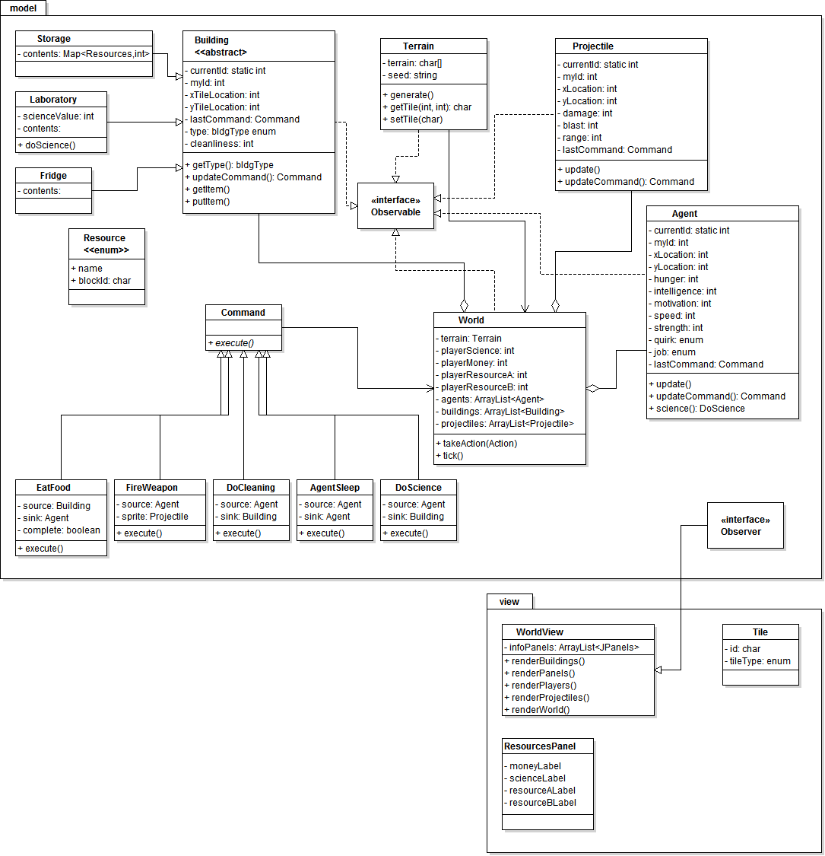

6. Sequence Diagram: Your team UML Sequence Diagram should show the most important scenario you can think of. Your sequence diagram should show most of your objects from above and how they communicate with each other.
