Laboratory Work №2
Topic:
Implementing Mandatory Access Control (MAC) and Discretionary Access Control (DAC) in Linux

Purpose of the laboratory work
The purpose of this laboratory work is to study and compare two fundamental access control models — Discretionary Access Control (DAC) and Mandatory Access Control (MAC) — through practical implementation in a Linux operating system. Students will configure file permissions, users, groups, and security policies to understand how access rights are enforced and restricted.

Learning outcomes
After completing this laboratory work, students will be able to:
- Explain the differences between DAC and MAC models
- Configure users, groups, and file permissions in Linux
- Apply DAC using traditional Linux permission mechanisms
- Understand the role of SELinux or AppArmor as MAC mechanisms
- Analyze access control effectiveness from a security perspective
- Relate access control mechanisms to the CIA triad

Prerequisites
- Basic Linux command-line skills
- Understanding of users, groups, and file systems
- Completed Laboratory Work №1

Tools and environment
- Linux OS (Ubuntu 20.04+ recommended)
- Virtual machine (VMware / VirtualBox) or physical Linux system
- Terminal access
- Root or sudo privileges

Theoretical background (brief)
Discretionary Access Control (DAC) allows the owner of a resource to define who can access it. Linux file permissions (rwx) and Access Control Lists (ACLs) are examples of DAC.
Mandatory Access Control (MAC) enforces system-wide security policies that cannot be overridden by users. Examples include SELinux and AppArmor, which define strict rules governing access to system resources.

Laboratory tasks

Task 1. DAC implementation
- Create two users:
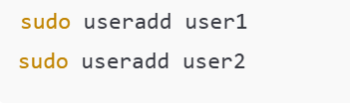
2.Create a test file:
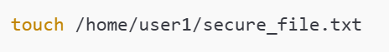
3. Set file ownership and permissions:
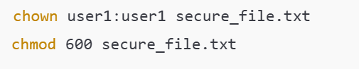
- Verify access:
- Confirm that user1 can read/write the file
- Confirm that user2 cannot access the file

Explain why access is denied for user2.

Task 2. DAC using Access Control Lists (ACL)
- Enable ACL support (if not enabled):
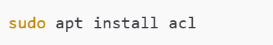

2. Grant read access to user2:

3.Verify permissions:


Explain how ACL extends standard DAC permissions.

Task 3. MAC implementation (AppArmor or SELinux)

Choose one MAC system depending on your Linux distribution.
Option A: AppArmor (Ubuntu)
- Check AppArmor status:

2. Put a profile into enforce mode:
3. Attempt restricted access and observe behavior.

Option B: SELinux (CentOS/RHEL)
- Check SELinux mode:

2. Switch to enforcing mode:

- Observe access restrictions using audit logs.

Explain how MAC restrictions apply even to root.

Task 4. Comparative analysis
Complete the following table in your report:

Feature | DAC | MAC
Controlled by user | + / - | + / -
Centralized policy | + / - | + / -
Flexibility | High / Low | High / Low
Security level | Basic / High | Basic / High

Report requirements
The report must include:
- Title page
- Purpose of the laboratory work
- Short theoretical overview (DAC vs MAC)
- Step-by-step screenshots or command outputs
- Comparative analysis table
- Conclusion
Language: English
Format: PDF / DOCX
Length: 2- 3 pages
Assessment criteria (100 points)

Criterion | Points
Correct DAC configuration | 25
Correct MAC configuration | 25
Comparative analysis quality | 25
Oral defense & report clarity | 25

