File System Using FUSE

About FUSE

FUSE (Filesystem in Userspace) is an interface for userspace programs to export a filesystem to the Linux kernel. The FUSE project consists of two components: the fuse kernel module (maintained in the regular kernel repositories) and the libfuse userspace library (maintained in this repository). libfuse provides the reference implementation for communicating with the FUSE kernel module.
A FUSE file system is typically implemented as a standalone application that links with libfuse. libfuse provides functions to mount the file system, unmount it, read requests from the kernel, and send responses back. libfuse offers two APIs: a "high-level", synchronous API, and a "low-level" asynchronous API. In both cases, incoming requests from the kernel are passed to the main program using callbacks. When using the high-level API, the callbacks may work with file names and paths instead of inodes, and processing of a request finishes when the callback function returns. When using the low-level API, the callbacks must work with inodes and responses must be sent explicitly using a separate set of API functions.

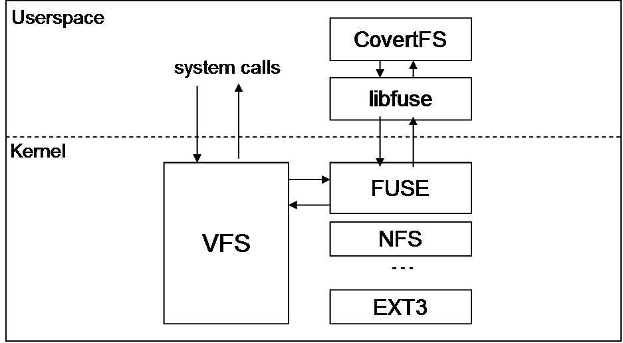

What is File System?
In computing, a file system or filesystem controls how data is stored and retrieved. Without a file system, information placed in a storage medium would be one large body of data with no way to tell where one piece of information stops and the next begins. By separating the data into pieces and giving each piece a name, the information is easily isolated and identified. Taking its name from the way paper-based information systems are named, each group of data is called a "file". The structure and logic rules used to manage the groups of information and their names is called a "file system".

There are many different kinds of file systems. Each one has different structure and logic, properties of speed, flexibility, security, size and more. Some file systems have been designed to be used for specific applications. For example, the ISO 9660 file system is designed specifically for optical discs.

File systems can be used on numerous different types of storage devices that use different kinds of media. The most common storage device in use today[when?] is a hard disk drive. Other kinds of media that are used include flash memory, magnetic tapes, and optical discs. In some cases, such as with tmpfs, the computer's main memory (random-access memory, RAM) is used to create a temporary file system for short-term use.

Some file systems are used on local data storage devices;[1] others provide file access via a network protocol (for example, NFS,[2] SMB, or 9P clients). Some file systems are "virtual", meaning that the supplied "files" (called virtual files) are computed on request (such as procfs and sysfs) or are merely a mapping into a different file system used as a backing store. The file system manages access to both the content of files and the metadata about those files. It is responsible for arranging storage space; reliability, efficiency, and tuning with regard to the physical storage medium are important design considerations.

Implemented the system calls:
-> get_attribute
-> read_directory
-> read
-> write
-> do_mkdir

The filesystem is mainly divided into six main componenets:
-> I-node bitmap
-> Data block bitmap
-> Node bitmap
-> I-nodes
-> Data blocks
-> Nodes

The bitmaps are being used to check whether a given index is occupied or empty.
The I-nodes are the stat structures for our filesystem. They store basic information about the file/directory.
Data-blocks are the region where the actual data is being stored. They are assigned only for files and not for directries.
Node is the datastructure used to implement Tree structure.

TREE structure:
The filesystem traversal structure is being implemented using a N-ary Tree.
The root node is the root directory.
Each Node can have more than 2 children and each being a file or a directory.
All the children of a node is a linked list and the head being the first child. The parent points only to its first child.

PICTURE TO BE PUT

WORKING:
The filesystem is initially empty. Once the filesystem is mounted the root directory is being created. Everytime we need to create a file/directory a node is being created in the tree and that node is appended to the appropriate parent.

For creating either a file or a directory first the availability of the node is checked, followed by the creationof Node and I-node. In case of directories no data-blocks are allocated. In case of files again the availability of data-blocks is checked and recquired number of data-blocks are being allocated.
After the successful creation of data-blocks the data is being written onto the blocks.

When a file/directory is to be deleted , the file is searched in the filesystem and in case it is present, the respective bitmaps are set to empty.

PERSISTENCE:
On unmounting the filesystem, the data (metedata + actual data) is being written to an external binary file. On remounting the filesystem the contents are being read from the external binary file and the filesystem structures are being updated accordingly. The tree structure is regenerated.

