William Alspaugh

Celine Del Mundo

Daniel Kissner

Dylan Rule

Module 9 & 10

**Case Study: Outland Adventures**

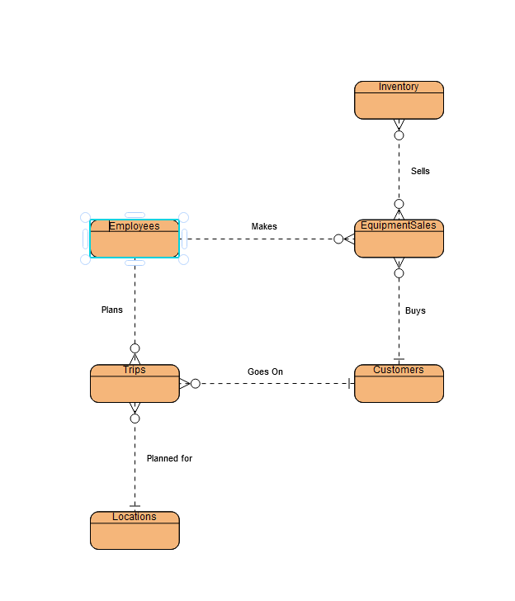

**Business Rules**

Employees

EmplyeeID – Primary - INT

FirstName - VARCHAR

LastName - VARCHAR

JobTitle – VARCHAR

Department - VARCHAR

Customers

CustomerID – Primary -INT

FirstName - VARCHAR

LastName - VARCHAR

Innoculations - BOOL

TravelVisas - BOOL

Inventory

ItemID - Primary

Description – VARCHAR

UnitPrice - DOUBLE

Quantity - INT

IntakeDate - DATE

EquipmentSales

SalesID – Primary

ItemID - Foreign/Primary -INT

Category – (“Sale”, “Rental”) - VARCHAR

Quantity - INT

Price - DOUBLE

EmployeeID - Foreign

CustomerID - Foreign

SaleDate - DATE

Locations

LocationID – Primary - INT

LocationName – VARCHAR

Trip

TripID - Primary

CustomerID – Foreign - INT

EmployeedID – Foreign - INT

LocationID – Foreign - INT

Price – DOUBLE

TripDate - DATE