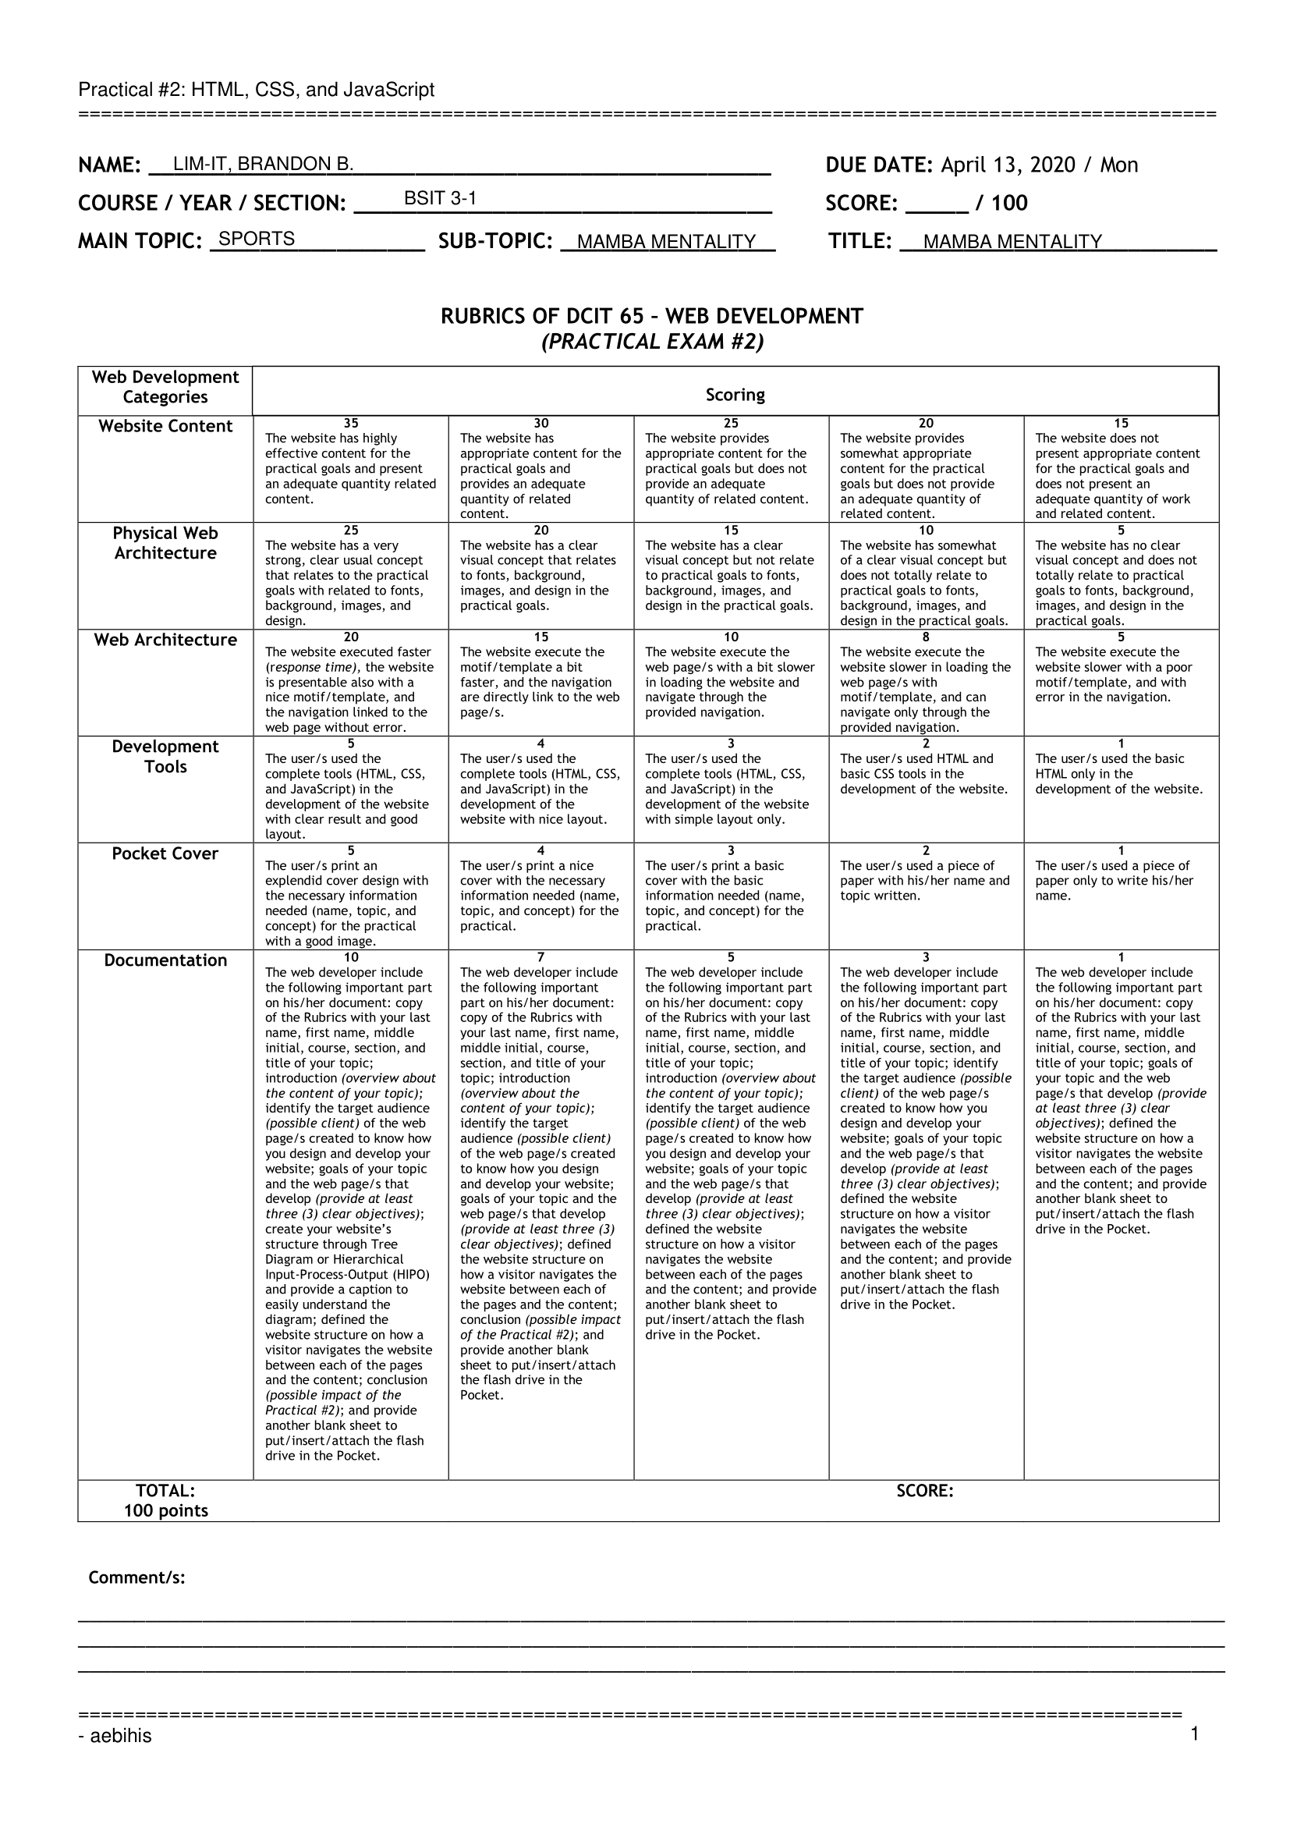**INTRODUCTION**

Basketball is one of the most known kind of sport and is played all throughout the world. With its basic premise of making the basketball ball pass through the hoop to score, it has indeed been a form of not only a competitive sport but also as recreation and entertainment as well. It has been adapted by educational institutions as a mean of physical and fitness training, and even if one is not a player of the sport, one can still enjoy it watching and feel the intensity and heat of the game.

Perhaps the most known basketball association is the National Basketball Association (NBA). It is universally agreed and cultured into the thinking of everyone that the NBA is in top of the basketball field. The players that play for the league and its team franchises are of the most athletic, skilled, and competitive players around the world. There are moments from the NBA that have been engraved not only in history but in hearts and minds as well, but most notable of them are the players.

Who nowadays does not know of the name Lebron James, Michael Jordan, Kobe Bryant, Kevin Durant, Stephen Curry, Magic Johnson, Larry Bird, and more just to name a few? Every player fashion and imitate their favourite players, from the dribbling to the shooting and even the clothes. These players have dominated their competitions and the courts they play in.

Among all these players of greatness in their respective field is one that is special, his competitiveness, dedication to win, love for the sport, and extreme workout routine has given him the assassin-like traits, persona, and fierceness when he is on the court. The player who is called the “Black Mamba”, Kobe Bryant has left such an impactful legacy behind him that future generations aspire and trains to have the “Mamba Mentality”. Not only is it applicable in the field of basketball, but it is suited as well to any fields in extent. It is a lifestyle, a mentality, a motivation, and a discipline.

The Mamba Mentality is pioneered by the Black Mamba himself, he used the term to refer to his extreme dedication in doing the thing he loves the most. It is the reason why he became so good at basketball. The Mamba Mentality in a figurative point of view frees the person from any physical limitation by pushing the mental and emotion to the highest peak and capability.

The website will give a general view, familiarization, and an in-depth background knowledge about the Mamba Mentality; a take a look at the life and legacy of the Black Mamba; and a tribute to the life of Kobe Bryant.

**Target Audience:**

1. Kobe Bryant fans
2. Los Angeles Lakers fans
3. Basketball fans
4. Sports fans
5. Athletes

**Goals and Objectives:**

1. Topic

* Sports – to promote sports as a form of recreation, physical exercise, discipline, and entertainment.
* Mamba Mentality – to promote a solid and critical core of dedication and lifestyle towards achieving any desired goal.

1. Webpages

* Home/Main – an overview to the whole goal of the website, this will serve as an attraction and impression to the viewers
* Story – display an interactive timeline of the important years in the life of Kobe Bryant, from birth to death.
* Training
  + Mamba Academy – provides a simple and quick introduction for the official academy pioneered by Kobe Bryant himself
  + TedX Talk – video interview to understand the Mamba Mentality directly from the Black Mamba himself
  + Fadeaway – a simple guide to how Kobe does his signature fadeaway
  + Workout Routine – lists the strict and extreme workout routine and daily schedule Kobe Bryant did as training.
  + Principles – The three (3) core principles that serve as the foundation of the Mamba Mentality
* Merchandise – a list of the items and equipments related to Kobe Bryant including his own authored book, official jersey, video game, and all of his signature shoes.
* Quiz – a randomly generated question with choices to test the knowledge of the user regarding the Black Mamba.
* About – shows information about the developer of the website as well as the hardware and softwares used in the development of the project.

**TREE DIAGRAM**

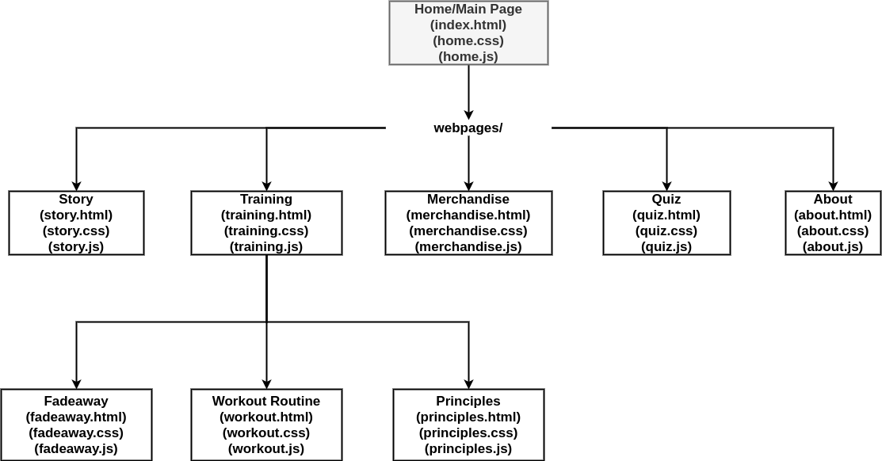

**WEBSITE STRUCTURE**

(All webpages except the “index.htm” is inside the folder “webpages/”)

1. Everytime a webpage is visited, the Navbar is automatically and dynamically generated using the navbar.js and navbar.css template

* If user click in the Story in the navbar, the user will be redirected to the Story page (story.html)
* IIf user click in the Training in the navbar, the user will be redirected to the Training page (training.html)
* If user click in the Merchandise in the navbar, the user will be redirected to the Merchandise page (merchanise.html)
* If user click in the Quiz in the navbar, the user will be redirected to the Quiz page (quiz.html)
* If user click in the About in the navbar, the user will be redirected to the About page (about.html)

1. Everytime a webpage is visited, the Footer is automatically and dynamically generated using the footer.js and footer.css template

* If user click in the Story in the footer, the user will be redirected to the Story page (story.html)
* IIf user click in the Training in the footer, the user will be redirected to the Training page (training.html)
* If user click in the Merchandise in the footer, the user will be redirected to the Merchandise page (merchanise.html)
* If user click in the Quiz in the footer, the user will be redirected to the Quiz page (quiz .html)
* If user click in the About in the footer, the user will be redirected to the About page (about .html)
* If user click in the Website icon in the footer, the user will be redirected to the personal website page of the developer (flamendless.github.io)
* If user click in the Twitter icon in the footer, the user will be redirected to the Twitter account page of the developer (twitter.com/flamendless)
* If user click in the E-Mail icon in the footer, the user will be able to send an E-Mail to the developer (mailto:flamendless8@gmail.com)

1. Everytime a webpage is loaded, it will automatically use the stylesheet found in the css/ folder with the same name of the webpage (e.g story.html will load css/story.css; except for index.html where it will use the “home” keyword)
2. Everytime a webpage is loaded, it will automatically use the Javascript file found in the js/ folder with the same name of the webpage (e.g story.html will load css/story.css; except for index.html where it will use the “home” keyword)
3. Users are first shown the Home/Main page (index.html)

* If user click in the link in the Mosaic Tile for Fadeaway, the user will be redirected to Fadeaway page (fadeaway.html)
* If user click in the story row card, the user will be redirected to the Story page (story.html)
* If user click in the training row card, the user will be redirected to the Training page (training.html)
* If user click in the merchandise row card, the user will be redirected to the Merchandise page (merchanise.html)
* If user click in the quiz row card, the user will be redirected to the Quiz page (quiz.html)
* If user click in the about row card, the user will be redirected to the About page (about.html)

1. If users are in the Training page (training.html)

* If user click in the Mamba Academy row card, the user will be shown a modal about the Mamba Academy, further clicking in the modal will redirect user to the offical Mamba Academy website (mambasportsacademy.com)
* If user click in the Listen row card, the user will be shown a modal and a video of the TedX talk.
* If user click in the Fadeaway row card, the user will be redirected to the Fadeaway webpage (fadeaway.html)
* If user click in the Workout Routine row card, the user will be redirected to the Workout Routine webpage (workout.html)
* If user click in the Principles row card, the user will be redirected to the Principles webpage (principles.html)

1. If users are in the Merchandise page (merchandise.html)

* If user click in an item card with the Buy icon, the user will be redirected to a seller page (from amazon, ebay, or offical NBA, or Steam page)
* If user click in an item card with the Watch icon, the user will be redirected to the accompanying YouTube video page
* If user click in an item card with the Detail icon, the user will be redirected to the external article webpage.

1. If users are in the Quiz page (quiz.html)

* User can click one of the different radio buttons in each question that will serve as their answer
* If user click in the submit button, their answers will be checked and a result be generated and shown
* If user click in the retry button, the quiz webpage will shuffle the questions and the choices per each question.

1. If users are in the About page (about.html)

* If user click in the name of one of the softwares used, the user will be redirected to that software’s homepage (e.g clicking on Inkscape will redirect to inkscape.org)

**CONCLUSION**

The development of a frontend website is helpful for introducing and sharing information about any topic. The technology in today’s modern era has allowed designers and developers to make astonishing and beautiful content with ease. Not only is a website appeals aesthetically, it also allows for dynamic interaction and real-time updates which add to the power and capabilities of using websites as a medium for reaching audience and other people.

Particularly, the possible impact of this website about Mamba Mentality and the Black Mamba himself is to have a reminiscent and nostalgic look back at the legacy and life of Kobe Bryant, while his death is fresh and just recent with the time of writing this section, it is an awe and tribute to such a person who left us with not only the determination to pursue our dreams and goals, but also with the discipline and inspiration that it is possible to be achieved.