CST1510
Multi-Domain Intelligence Platform
Coursework 2 — Technical Report

Student Name | Shihad Shibchurn
Student ID | M01132797
Programme | BSc Computer Science
Module | CST1510 — Multi-Domain Intelligence Platform
Academic Year | 2026
GitHub Repository | https://github.com/flamingdemon1/CW2_M01132797_CST1510
Submission version: CST1510 Coursework Two technical report

Table of Contents
1. Introduction
2. System Architecture & Design
2.1 Security — Password Hashing & Authentication
2.2 Database Design & CRUD Operations
2.3 Application Architecture
2.4 Web Interface — Streamlit
2.5 AI Integration
3. Key Features & Implementation
3.1 User Authentication System
3.2 Cybersecurity Domain Dashboard
3.3 Data Science Domain
3.4 IT Operations Domain
3.5 SmartBoyAI Assistant
3.6 Additional Extensions
4. Testing & Validation
5. Reflection & Conclusion
5.1 What I Learned
5.2 Challenges Faced
5.3 Future Improvements
5.4 Conclusion
6. AI Assistance Declaration
7. References

1. Introduction
This project acts like a multi-domain intelligence platform created in Python for the CST1510 Coursework Two. The application includes both combines a command-line interface and a Streamlit web application with a shared SQLite database. The application is intended to demonstrate how the implementation of authentication, structured data storage, data visualisation, role-based access and artificial intelligence can be integrated in a single application.
The application covers three related areas: cybersecurity incident monitoring, dataset metadata and IT support tickets. Users can create accounts, log in securely, view confidential information and access SmartBoyAI(The project’s AI assistant). In addition, the application provides administrators with additional monitoring and user-management capabilities. CSV data is migrated into SQLite so that the dashboards and AI assistant work from a consistent local data source rather than disconnected files.
The report explains the system architecture, password security, database design, Streamlit interface and Groq-based AI integration. Furthermore, it then describes the main features, records the testing performed and the learning experiences learnt along the way.

2. System Architecture & Design

2.1 Security — Password Hashing & Authentication
Passwords are protected using the bcrypt library rather than being stored as plain text. The generate_hash() function converts a password to bytes, creates a unique salt and produces a bcrypt hash. Because the salt is incorporated into the resulting hash, two users who choose the same password still receive different stored values.
When a user tries to log in, is_valid_hash() uses bcrypt.checkpw() to compare the entered password with the stored hash. The original password is never recovered or displayed(to prevent things like shouldering). This is safer than directly storing a simple MD5 or SHA-256 digest, because bcrypt was designed to be intentionally slow, which adds computational complexity to any brute-force attacks, and also incorporates salting to prevent rainbow table attacks.
The registration process also validates required fields, rejects duplicate usernames and compares entered passwords with pre-set validation rules. After successful authentication, Streamlit session state stores the logged-in username and role. Protected pages verify this state before displaying content. Administrative functions are also restricted to certain users(admins) for safety, and password hashes are not shown in user-management tables.

2.2 Database Design & CRUD Operations
SQLite was selected because it is lightweight, included with Python and suitable for a self-contained coursework application. The database is shared by the Rich CLI and the Streamlit interface. Parameterised queries use ? placeholders so user input is supplied separately from the SQL statement. This reduces the risk of SQL injection because input is treated as data rather than executable SQL.
Table | Purpose | Key fields
users | Registered accounts and access roles | id (PK), username (UNIQUE), password_hash, role, email, phone_number, two_factor_enabled
cyber_incidents | 115 migrated cybersecurity incident records | incident_id, timestamp, severity, category, status, description
datasets_metadata | Metadata for analytical datasets | dataset_id, name, rows, columns, uploaded_by, upload_date
it_tickets | 150 migrated IT-support tickets | ticket_id, priority, description, status, assigned_to, created_at, resolution_time_hours
saved_results | Saved dashboard or CLI summaries | id, username, result_type, title, content, save_source, created_at
cisa_known_exploited_vulnerabilities | Extension data from the CISA KEV catalogue | Vulnerability identifiers and catalogue fields
Core CRUD operations include account creation and reading user records, administrator-led user management, loading and querying migrated datasets, and creating, listing and opening saved results. CSV migration creates or populates the required domain tables. Repeated application startup does not intentionally destroy existing data.

2.3 Application Architecture
The application follows a modular structure so that user-interface code is separated from reusable data and service logic. main.py provides the Rich command-line interface, while home.py launches the Streamlit application. Individual Streamlit pages are stored in pages/, and reusable functions are organised in app_model/.
CW2_M01132797_CST1510/
|-- home.py Streamlit entry point
|-- main.py Rich command-line interface
|-- pages/
| |-- 1_dashboard.py Protected dashboard and saved results
| |-- 2_SmartBoyAI.py Streaming AI assistant
| |-- 3_Profile.py Account, recovery and SMS 2FA features
| `-- 4_Admin.py Role-protected administration
|-- app_model/
| |-- database and account modules
| |-- CSV migration/query modules
| |-- export_service.py Text, CSV and SQLite result saving
| `-- shared UI/service helpers
|-- DATA/ SQLite database and source datasets
|-- assets/ Logos and visual assets
|-- .streamlit/ config.toml and secrets.toml.example
|-- requirements.txt
`-- README.md
This separation makes the project easier to test and maintain. For example, the dashboard calls export_service functions instead of implementing file and database export logic directly. The same principle allows the CLI and web interface to share database behaviour.

2.4 Web Interface — Streamlit
Streamlit was chosen because it allows an interactive Python web interface to be created without a separate JavaScript frontend. This makes building a website-like app much easier compared to using html/css/javascript. Additionally, the platform uses a multi-page layout, session-state authentication, forms, metrics, tables, filters, pagination and visualisations.
The dashboard checks whether the user is logged in before showing protected content and if they are not, they cannot access any page. The administrator page additionally checks the current role from SQLite. Session state stores login information and the SmartBoyAI conversation history. Logging out removes the authenticated state so protected pages cannot continue to be used.

2.5 AI Integration
SmartBoyAI uses the Groq Chat Completions API with the llama-3.3-70b-versatile model. The implementation uses the standard system, user and assistant message roles. The system message defines SmartBoyAI as a beginner-friendly cybersecurity and IT-support assistant, while the complete conversation history is sent with later requests so follow-up questions retain context.
Before an API call, the application builds a database context from the available cybersecurity incidents, dataset metadata and IT tickets. This enables SmartBoyAI to answer questions using current project data while avoiding claims about information that was not supplied. If the required migrated tables are unavailable, the assistant explains that the CSV data must first be migrated into SQLite. (This can be done using the python CLI).
Responses are streamed using Groq's stream=True option. Streamlit displays each text chunk progressively through an st.empty() placeholder(For streaming of messages instead of a block reply at one go). The full reply is reconstructed in memory and only the final completed response is appended to session history. Empty chunks are skipped, and missing API keys or API errors are handled without exposing secrets.

3. Key Features & Implementation

3.1 User Authentication System
The application’s authentication system is organized around two primary functions: Registration and Login. Upon registration, the application checks that all mandatory fields are filled, the password is secure, and the selected username is not already taken. After that, the password is hashed using bcrypt and stored in an SQLite database. During the login process, the entered password is compared to the one in the database. The result of this comparison determines whether the user is authenticated and can view protected pages. Finally, a logout function is needed to ensure that the user cannot reach protected pages directly without going through the login procedure again.

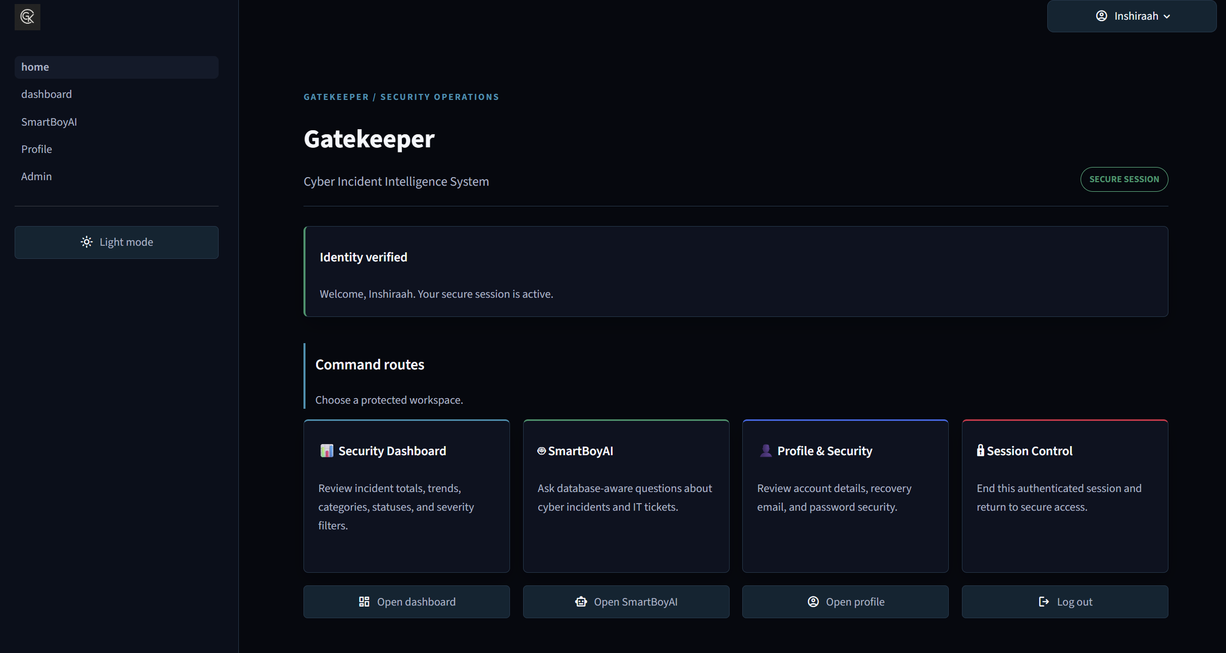
Figure 1. Login interface and successful authenticated access.
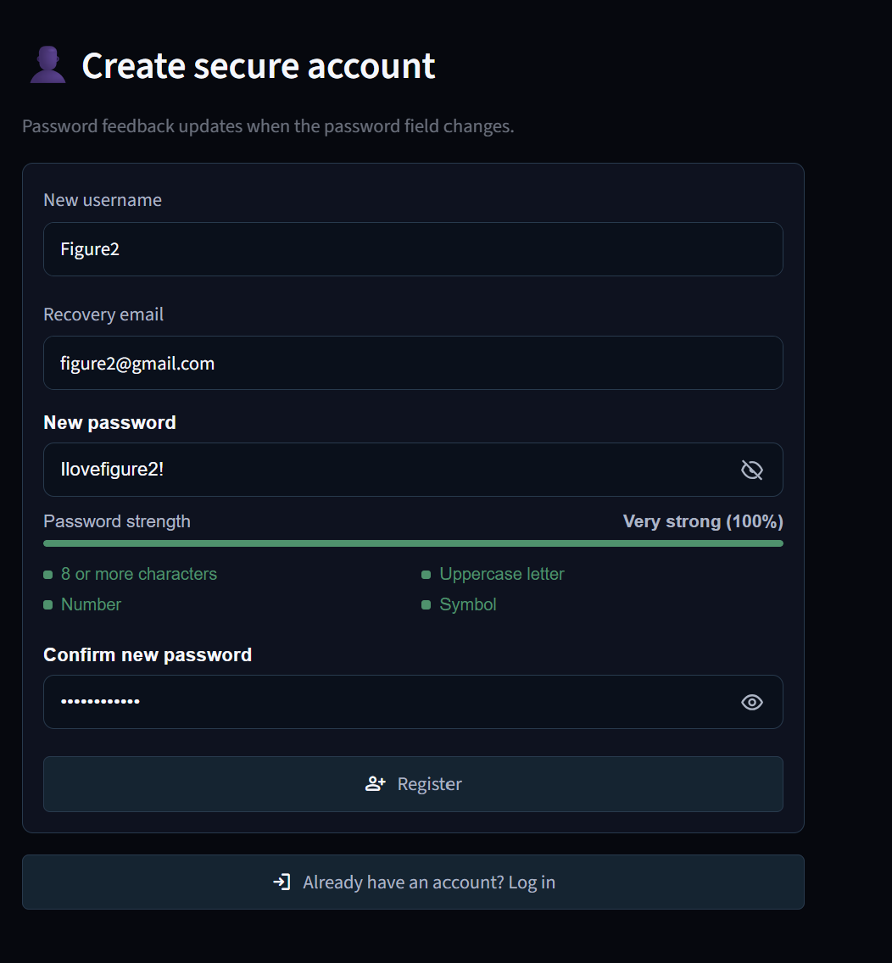
Figure 2. Registration form demonstrating password-strength feedback.

3.2 Cybersecurity Domain Dashboard
The main dashboard primarily presents the migrated cybersecurity incidents through summary metrics, filters, charts, a heatmap and a paginated table. Severity and other filters update the displayed records so users can focus on relevant incidents. The same dashboard also includes compact coursework dataset coverage for IT Operations and Dataset Metadata, so separate standalone Streamlit pages are not used for all three domains.
Users can save a dashboard summary to the saved_results table. The Saved Results viewer retrieves entries belonging to the logged-in user and opens a full saved result. Deletion is not exposed in the current dashboard UI. This feature uses reusable parameterised functions from export_service.py.
Figure 3. Cybersecurity dashboard showing incident metrics, visualisations and filtered data.
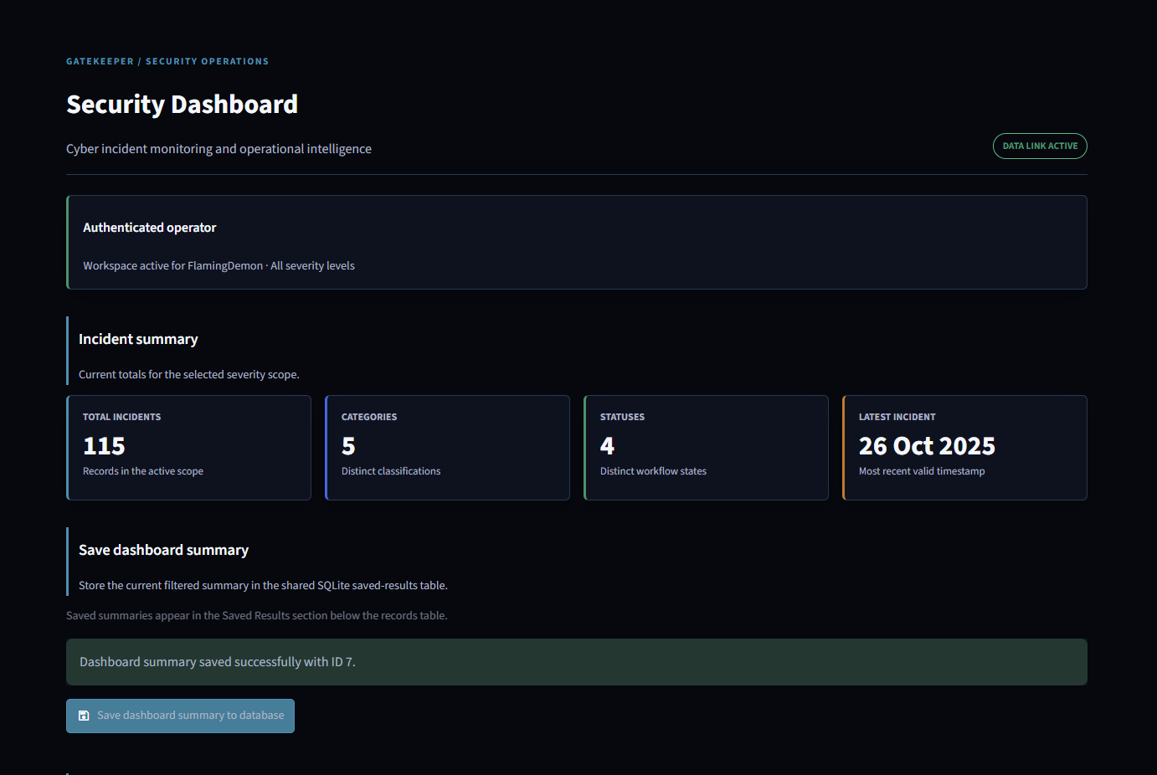
Figure 4. Heatmap and user-specific saved dashboard results.
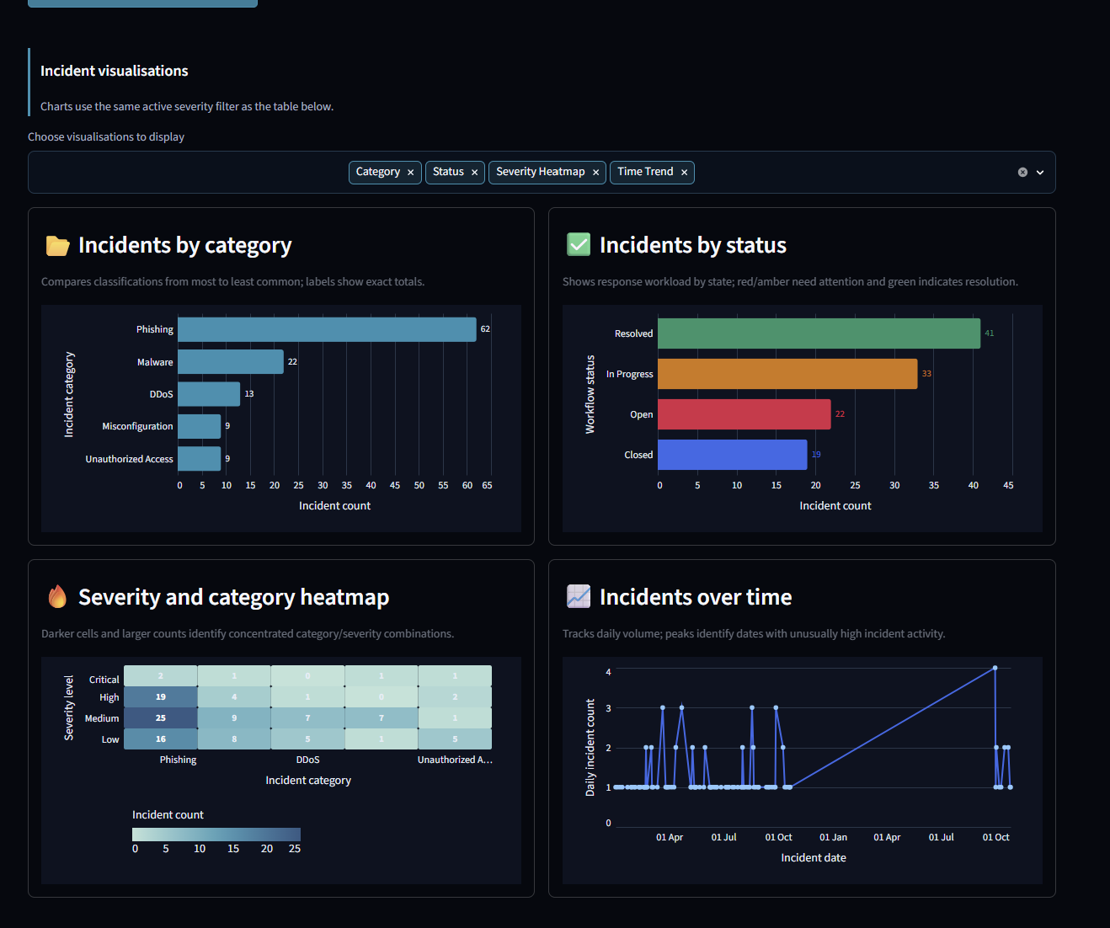

3.3 Data Science Domain
The datasets_metadata table stores five dataset records and describes each dataset using fields such as its name, row count, column count, uploader and upload date. This information is displayed in the Dataset Metadata tab within the main dashboard and is also included in SmartBoyAI's database context.
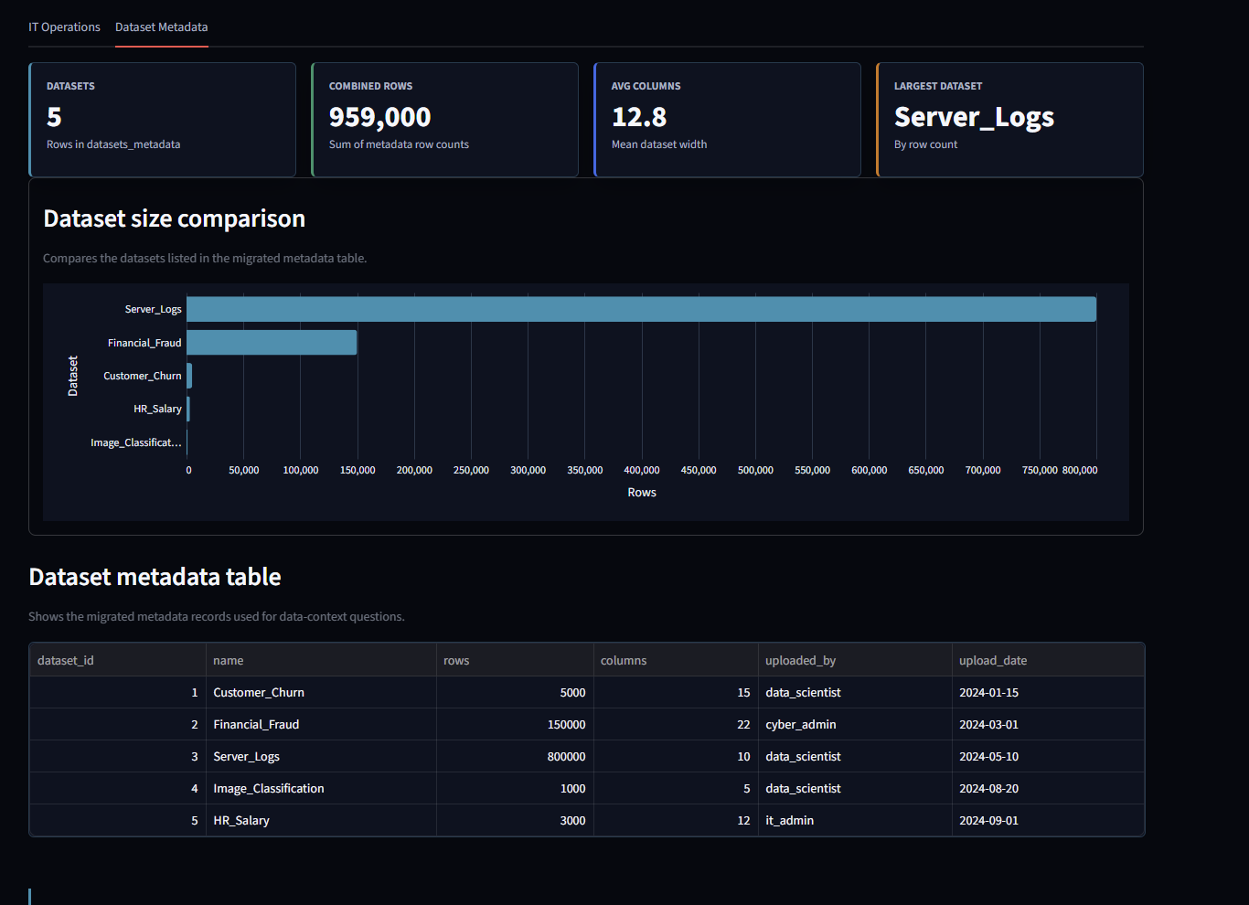
Figure 5. Dataset Metadata tab showing migrated dataset records and summary metrics.

3.4 IT Operations Domain
The it_tickets table contains 150 migrated support-ticket records. Ticket priority, status, assigned-staff and resolution-time information is displayed in the IT Operations tab within the same dashboard. The same data is also supplied to SmartBoyAI so the assistant can answer operational questions such as the number of open tickets or the distribution of priorities.
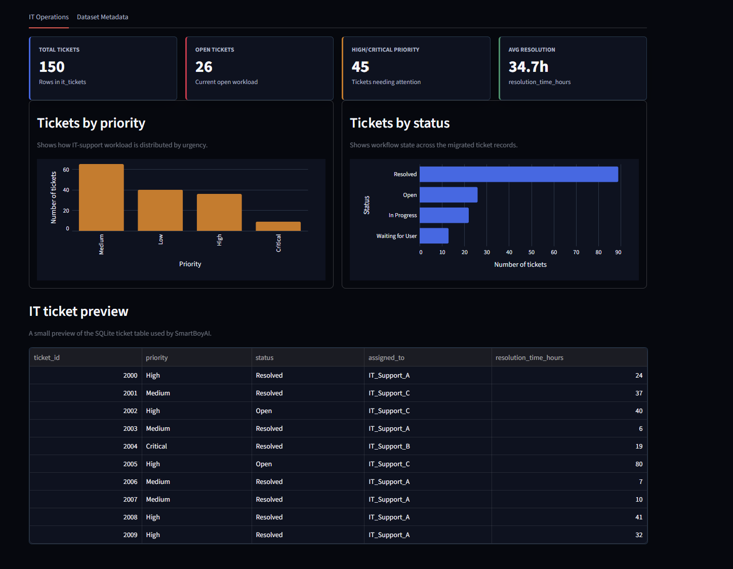
Figure 6. IT Operations tab showing ticket metrics, charts and a table preview.

3.5 SmartBoyAI Assistant
SmartBoyAI provides a protected chat interface for questions about cybersecurity incidents, IT tickets and dataset metadata. The assistant has been fine tuned to answer only dashboard related questions(like the CISA, cyber security incidents etc). It also reminds users no to input their passwords, API keys, or any other sensitive personal information.
The assistant combines conversational context with selected SQLite data. It refuses or redirects unrelated requests, does not claim access to unavailable data and streams the answer progressively. It declines/deflects questions out of the provided scope , does not disclose information that it does not have access to and streams the reply in a natural manner. Therefore, the chat interface helps to demonstrate both the API usage and the ability to combine the language model’s responses with the database content.
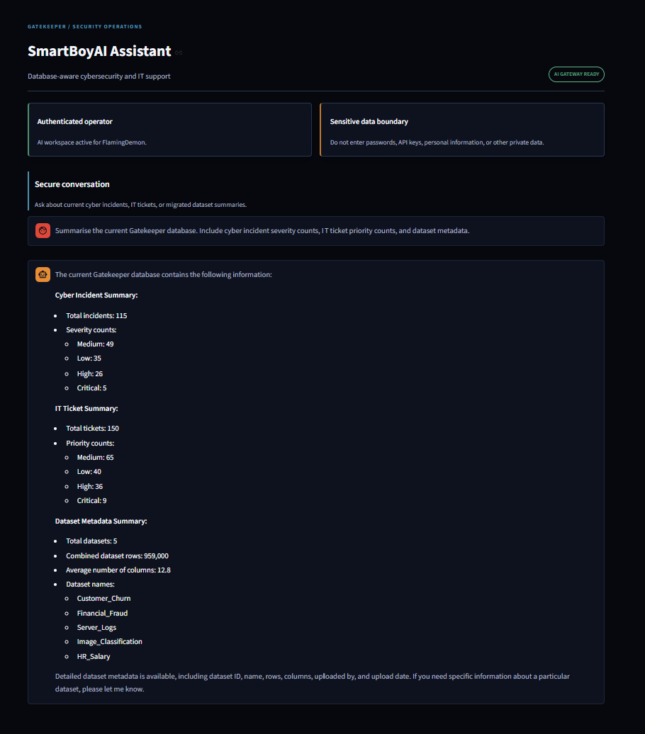
Figure 7. SmartBoyAI answering a database-aware cybersecurity or IT question while streaming the response.

3.6 Additional Extensions
Several extensions were added outside the core brief. These include a role-protected administrator page, a user profile page, SendGrid-assisted recovery, optional Twilio two-factor authentication, CISA Known Exploited Vulnerabilities data, and a Rich terminal interface.
The CLI supports account administration, CSV migration, data previews and exporting the most recent safe preview as a text file, CSV file or SQLite saved result. Sensitive account information such as hashes, recovery codes, phone numbers and secrets is excluded from export.

4. Testing & Validation
Testing combined syntax checks, simulated service tests, direct database queries and manual application checks. The table below records the main tests relevant to authentication, CRUD, session state, dashboards, exports and AI integration.
ID | Area | Input / steps | Expected result | Actual result | Status
T01 | Valid registration | Register with a unique username and strong password | Account is created and password is hashed | Passed during application testing | Pass
T02 | Duplicate username | Register using an existing username | Registration is rejected safely | Handled by uniqueness validation | Pass
T03 | Weak password | Submit a password below the strength rules | Validation feedback is shown; account is not created | Handled by registration validation | Pass
T04 | Valid and invalid login | Test correct credentials, then an incorrect password | Correct credentials authenticate; incorrect password is rejected | Application behaviour confirmed | Pass
T05 | Logout/protected page | Log out and navigate directly to a protected page | Authenticated state is cleared and access is blocked | Application behaviour confirmed | Pass
T06 | Role protection | Attempt to open Admin as a normal user | Access is denied; admin role is required | Role check present and tested | Pass
T07 | CSV migration | Migrate source CSV datasets into SQLite | Required tables are created/populated | 115 cyber incidents, 5 metadata records and 150 tickets present | Pass
T08 | Dashboard filtering | Apply a severity filter | Table, metrics and charts update to the filtered data | Manual dashboard check completed | Pass
T09 | Saved Results viewer | Save, list and open a dashboard result | User-specific entries are retrieved correctly | 3 results for Shihad1101, 1 for FlamingDemon; nonexistent user returned 0 | Pass
T10 | CLI text/CSV/SQLite export | Preview data, then use menu option 12 | Each supported export completes or errors safely | Simulated tests and manual flow completed | Pass
T11 | SmartBoyAI streaming | Ask a database-aware question with a valid Groq key | Response appears progressively and final reply enters history | Streaming implementation and manual application check completed | Pass
T12 | Missing key/API failure | Run without GROQ_API_KEY or simulate an API exception | Clear error shown without exposing secrets | Simulated error handling passed | Pass
Python syntax checks passed for the Streamlit pages, main.py and app_model modules. The final live demonstration should repeat the key tests using the exact submission copy so that screenshots and video evidence match the report.

5. Reflection & Conclusion

5.1 What I Learned
The project strengthened my understanding of secure authentication, especially why passwords should be salted and hashed instead of stored directly. I also gained practical experience with SQLite schemas, parameterised queries, CSV migration and sharing one database across two interfaces.
Streamlit introduced me to session state, protected multipage navigation, filters, charts and chat components. Integrating Groq showed how an API can be made more useful by combining conversation history with selected local database context. I also learnt how contextualising AI’s is really important for integrity and safety of data.The modular app_model structure also reinforced the value of separating interface code from reusable database and service functions.

5.2 Challenges Faced
One of the challenges was to ensure that authentication and permissions were consistent throughout the Streamlit app, as a page could not rely on its visibility in the navigation to determine whether it should be open or not. Each protected page had to check the session state, and the administrative functions additionally required a separate role check in SQLite.
Another challenge was the implementation of the Saved Results viewer. The dashboard called the get_saved_results() function, but the export service did not originally feature a list display. The service had a single-result export function, which was mistakenly implemented twice. The solution involved adding a parameterised list display to the service, refactoring the single-result export function, and testing the owner check against both test and production databases.
The final challenge was to enhance SmartBoyAI’s performance without eliminating its database awareness. The initial implementation of the API call did not utilise streaming and waited for the entire response before outputting anything. Streaming was implemented by iterating through the Groq response chunks, updating the Streamlit placeholder, and reconstructing the final response before saving it to the session history

5.3 Future Improvements
- Expand the IT Operations and Dataset Metadata dashboard tabs into fuller standalone dashboards later, with more filters and deeper visual analysis as they are currently in a single page which his more focused on cyber incidents.
- Add a larger automated test suite for authentication, migration, role protection, exports and Streamlit state.
- Move recovery and two-factor workflows(perhaps using Microsoft/google auth) to a production-ready server-side design with stronger expiry, auditing and rate limiting.
- Add more levels of administrator permissions and backend-level authorisation for every privileged service operation.
- Improve deployment support so the application can be hosted securely without depending on a local SQLite file.

5.4 Conclusion
The final version of the platform was created using the bcrypt authentication, SQLite database, pandas migration, Rich cli, protected Streamlit app, and Groq streaming based assistant. All the required data (users, cybersecurity, datasets, and tickets) were placed in the shared database, while multiple functions allowed account management, query dashboards, and result storage.
The project fulfilled the main objective of creating a secure integrated platform for multi-domain intelligence and included various additional features such as role-based administration, recovery options, two-factor authentication, CISA KEV tracking, cli exports, and others. The most interesting experience was the insight into the creation of the system, which includes multiple security, data, interface, and AI elements and successfully unites them into one whole.

6. AI Assistance Declaration
ChatGPT was used as an aid in development for planning, code reviews, debugging, validation, documentation organization, refactoring recommendations, and edge case consideration. Specific examples of this include reviewing the Saved Results service, implementing streamed Groq responses, exposing existing export helpers via the CLI, and auditing the project against the coursework requirements.
Any output generated with AI assistance was reviewed, adapted, and tested prior to being incorporated into the project. The final decisions, implementations, demonstrations, and submissions were all done by me.

7. References
Altair (2026) Altair documentation. Available at: https://altair-viz.github.io/ (Accessed: 18 July 2026).
CISA (2026) Known Exploited Vulnerabilities Catalog. Available at: https://www.cisa.gov/known-exploited-vulnerabilities-catalog (Accessed: 18 July 2026).
Groq (2026) Groq API documentation. Available at: https://console.groq.com/docs (Accessed: 18 July 2026).
OpenAI (2026) ChatGPT and Codex, used for development assistance and review.
Pallets Projects (2026) bcrypt package documentation. Available at: https://pypi.org/project/bcrypt/ (Accessed: 18 July 2026).
pandas development team (2026) pandas documentation. Available at: https://pandas.pydata.org/docs/ (Accessed: 18 July 2026).
Python Software Foundation (2026) sqlite3 — DB-API 2.0 interface for SQLite databases. Available at: https://docs.python.org/3/library/sqlite3.html (Accessed: 18 July 2026).
Streamlit (2026) Streamlit documentation. Available at: https://docs.streamlit.io/ (Accessed: 18 July 2026).
Streamlit (2026) Session State and secrets management documentation. Available at: https://docs.streamlit.io/develop/api-reference/caching-and-state/st.session_state and https://docs.streamlit.io/develop/concepts/connections/secrets-management (Accessed: 18 July 2026).
Textualize (2026) Rich documentation. Available at: https://rich.readthedocs.io/ (Accessed: 18 July 2026).
Twilio (2026) Twilio Verify documentation. Available at: https://www.twilio.com/docs/verify (Accessed: 18 July 2026).
Twilio SendGrid (2026) SendGrid documentation. Available at: https://docs.sendgrid.com/ (Accessed: 18 July 2026).
Middlesex University Mauritius (2026) CST1510 Coursework 2 materials and weekly lecture resources.

