UECS3253 WIRELESS APPLICATION DEVELOPMENT

QUIZ GENERATION APP

Group Name: G13
Student Name | Student ID | Practical Group | Programme (SE)
Leon Siow Yi Hong | 2204403 | P1 | SE
Quak Jing | 2205378 | P1 | SE
Koh Khai Jeck | 2304740 | P6 | SE
Chin We Jian | 2204263 | P4 | SE

Lee Kong Chian Faculty of Engineering and Science
Universiti Tunku Abdul Rahman

TABLE OF CONTENTS

PART
A SCREENS, COMPONENTS AND REACT-NAVIGATION 3
A.1 Screens & Layout 3
A.2 Use of Components 33
A.3 Reusability (Custom Components) 42
A.4 Implementation of React-Navigation 48
B DATA PERSISTENCE 52
B.1 Usage of Data Persistence 52
B.2 Implementation of Data Persistence 54
B.3 CRUD Operations & Input Validation 64
C CLOUD CONNECTIVITY 68
C.1 Usage of Cloud Connectivity 68
C.2 Implementation of Cloud Connectivity 69
REFERENCES 90

BRIEF SUMMARY
The wireless application developed for this assignment is a quiz generation app. This summary will briefly describe the implementation for each part of the application.
Part A - User Interfaces, the implementations are as the following:
- 30 screens
- 6 third party components
- 7 custom components
- React-navigation: Stack, Bottom-Tab, and Material-Top-Tab
Part B – Data Persistence, the implementations are as the following:
Database | Data Stored / Function
Text files | Quiz notes
AsyncStorage | Re-logs user after restarting application
SQLite | account, course, chapter, question, quiz history, and question history
Part C – Cloud Connectivity, the implementations are as the following:
API Server | Services
AppServer.py  (Web-based) | 6 services regarding account  5 services regarding course  5 services regarding chapter  5 services regarding question  2 services regarding quiz notes
History.py  (Web-based) | 5 services regarding quiz history and question history
Quiz.py  (WebSocket) | - Randomize quiz questions  - Validate quiz answer  - Record quiz attempt

KEY FEATURES
The quiz generation app has the following key features globally:
- Login for pre-existing account
- Sign up for creating new account
- Start Quiz
- Select course for Quiz
- Select chapter(s) to be included for Quiz
- Enter question amount for Quiz
- Select answer for questions in Quiz
- Check answers for Quiz
- Read and update personal account information
- Logout

The following key features are applicable for Admin accounts:
- Create, Read, Update, and Delete course
- Create, Read, Update, and Delete chapter
- Create, Read, Update, and Delete questions
- Read, and Update quiz note
- Create, Read, Update, and Delete accounts
- Read history and quesHistory

The following key features are applicable for Student accounts:
- Read course
- Read chapter
- Read quiz note
- Read history and quesHistory

SCREENS, COMPONENTS AND REACT-NAVIGATION

Screens & Layout
Every page will be explained using an admin account (username: kirito27, password: kirito) as student accounts have limited access.
- Login Screen
- The first page user sees when opening the application
- The user must enter their username and password to login.
- The user can click on the “Login” button to check the if username and password entered is correct an Alert will pop up if the credentials are incorrect.
- New users can create a new student account by clicking the “Sign Up” button. It will direct user to the Signup Page
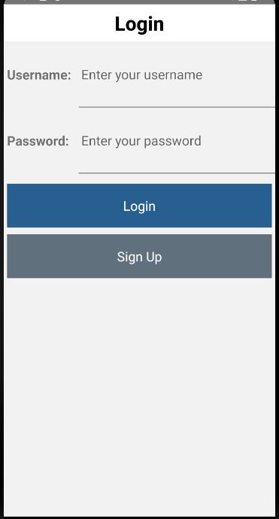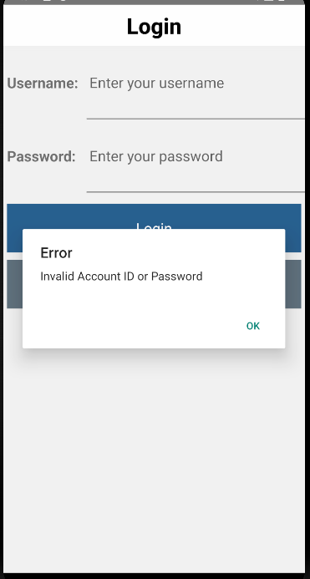

- Signup Page
- The user is required to enter their username, password and email to create a new account
- The user can click the “Create Account” button to create their account.
- An Alert will pop up if the fields are empty, or username already exists.
- Upon successful creation, the user will be directed back to the Login Screen
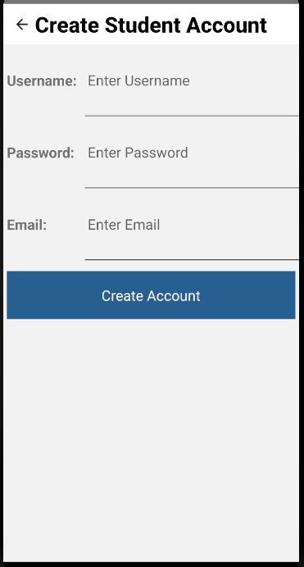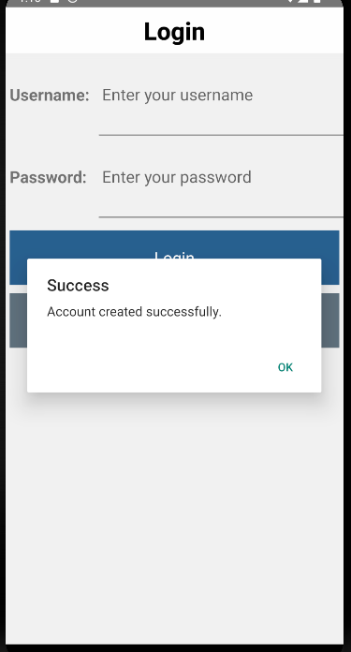
Alerts:
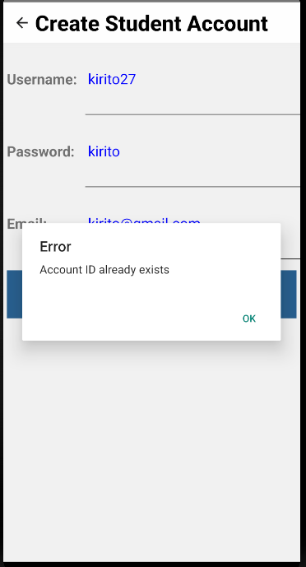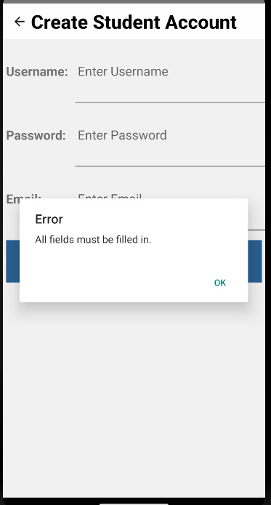

- Home Page
- After the user login, this is the home page of the application.
- There is a “Start Quiz:” Button in the middle to start a quiz which will direct the user to the Quiz Course Selection Screen.
- The bottom tab has 3 buttons:
  -  Left: Option Page
  -  Middle: Home Page
  -  Right: Profile Page
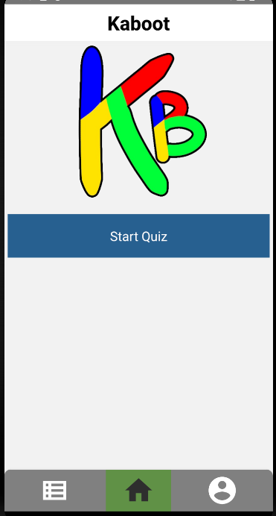

- Quiz Course Selection Screen
- After clicking “Start Quiz” button, user will be directed to this page to select which course to do the quiz with.
- Selecting on a course will direct the user to the Quiz Chapter Selection Screen.
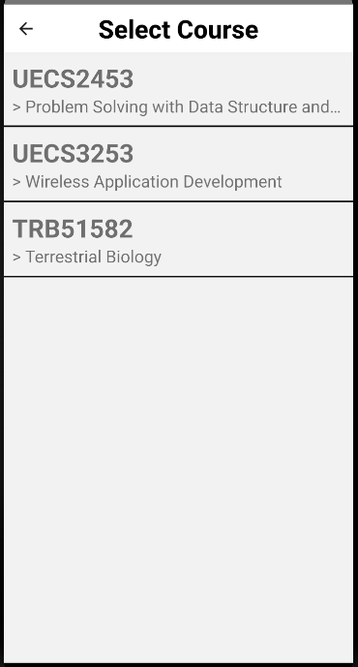

- Quiz Chapter Selection Screen
- Once users choose a course for the quiz, they are directed to the chapter selection page where users can select which chapter to include.
- After clicking on the checkboxes to choose the chapters, the user can continue to the next page by clicking on the “Continue” button and be directed to the Quiz Question Amount Screen.
- An alert will pop up if no chapters are selected.
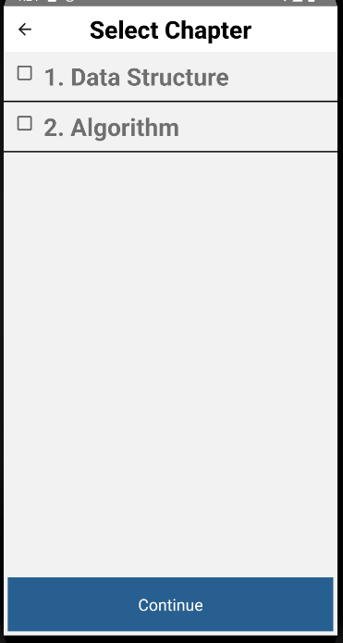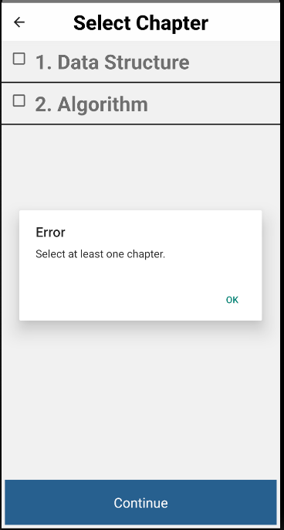

- Quiz Question Amount Screen
- In this page, it shows users how many questions are in the chapters.
- Users can enter how many questions they want to answer.
- Once entered the question amount, users can click “Start Quiz” button to start answering the quiz and be directed to the Quiz Start Screen.
- An Alert will pop up if the question amount is invalid.
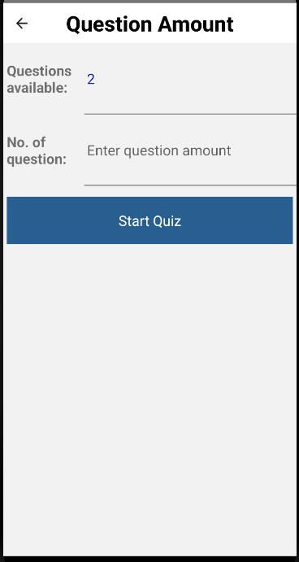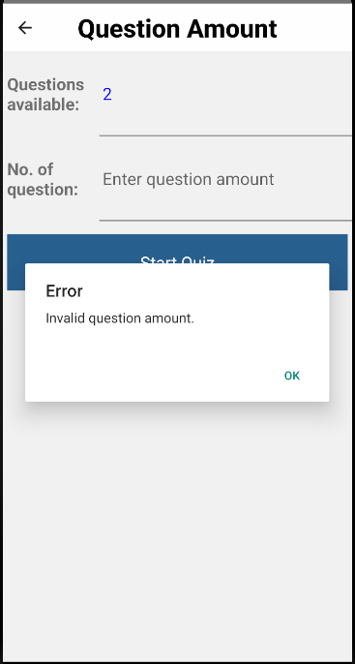

- Quiz Start Screen
- Users need to select an answer to the question before clicking next
- Users can swipe to view each question, left to view the last question and right to view the next question.
- In the last question it will have a “Submit” button. When the button is clicked it will give the user confirmation to finish the quiz and be directed to the Result Screen.
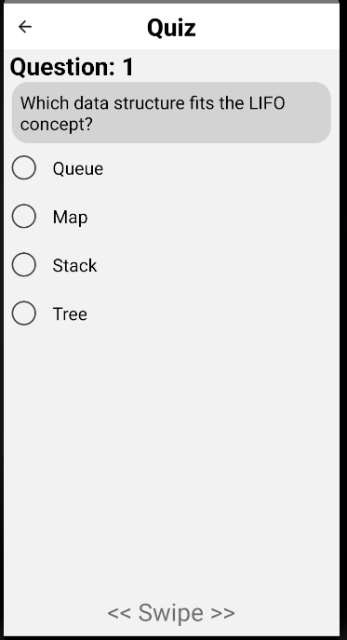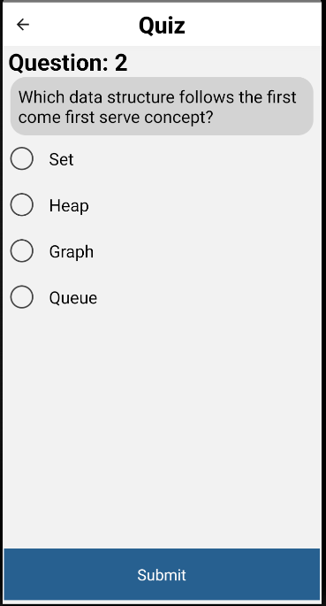
Submitting the Quiz:
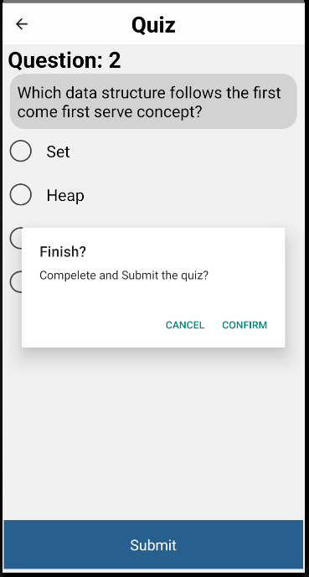

- Result Screen
- This page shows the user the results of the user's attempt at the quiz.
- It shows the date of the attempt, the number of correct and incorrect answers, and the marks of the quiz in %
- There are 2 buttons below
  - “Check Answers” button directs the users to the Quiz Answer Screen where the user can check the answer for each question.
  - “Back to Home Screen” button directs users back to the home page of the application.
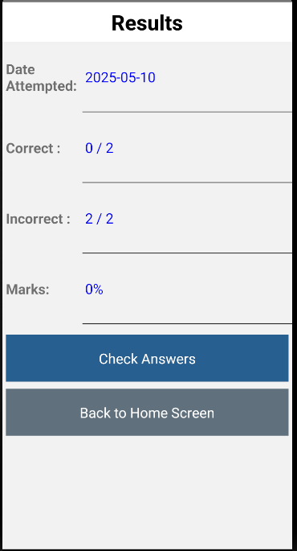

- Quiz Answer Screen
- This page allows the user to check the answer for each question in the quiz.
- The page allows swiping to swipe left to see the next question answer and right to see last question answer.
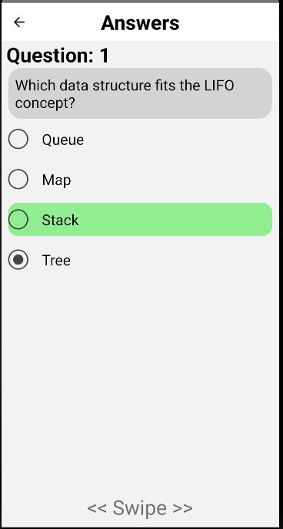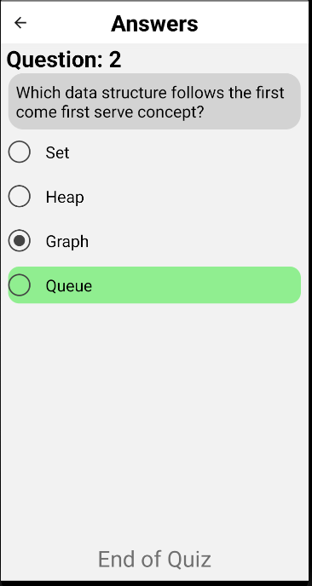

- Option Page
- This page allows the user to choose different options of the features of the application.
- There are 3 buttons:
  - “Course Select” Button direct user to Course Select Screen.
  - “Edit Accounts” Button direct user to Accounts Screen.
  - “Check History” Button direct user to History Date Screen.
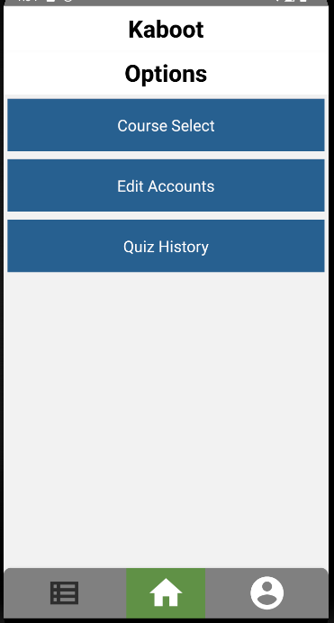

- Course Select Screen
- This screen shows the user the list of courses available in the application
- Each course can be pressed to View the chapters of the course
- When the button  is pressed, it will direct the user to Course Info Screen.
- When the button  is pressed it will show the user a tab with the following options:
  - Add Course, direct user to Create Course Screen.
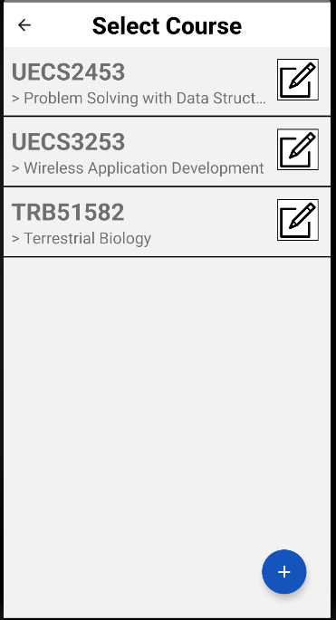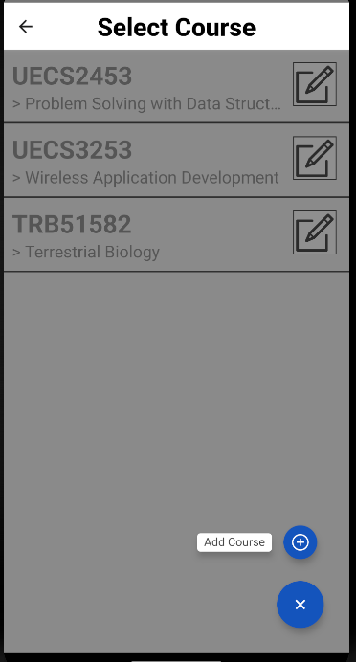

- Create Course Screen
- This page allows the user to create a new course in the application.
- The user is prompted to enter the course code (8 characters) and the course name.
- When “Create Course” button is pressed:
  - An Alert will pop up if there are empty fields or course code is of incorrect length.
  - If successful, the user will be directed back.
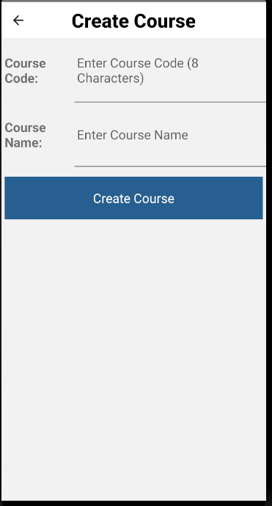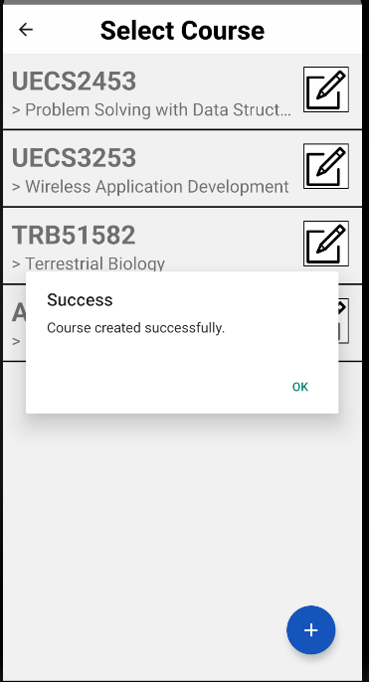
Alerts:
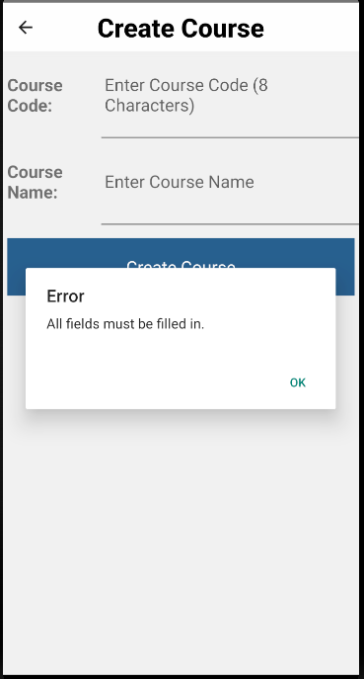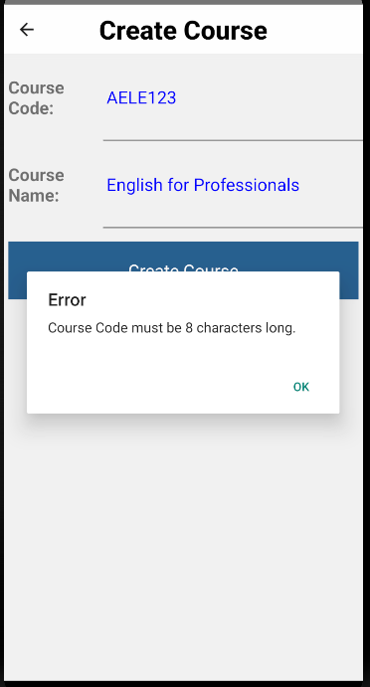
- Course info Screen
- This page shows the information about the course
- The button  will open a tab with 2 options:
  -  Edit Course will direct the user to Course Edit Screen.
  -  Delete course will ask user to confirm course deletion.
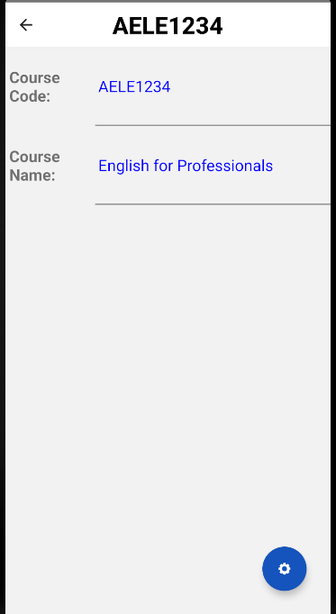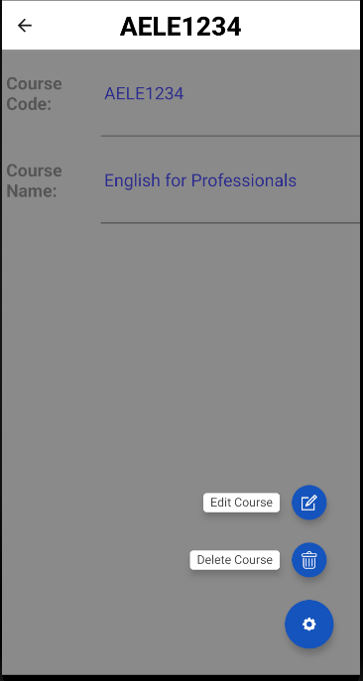
Deleting Course:
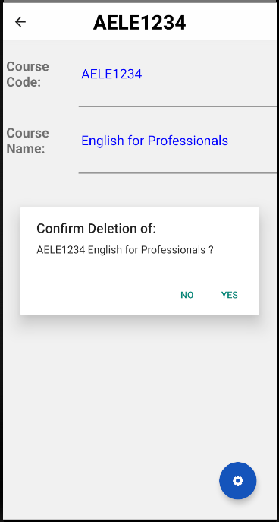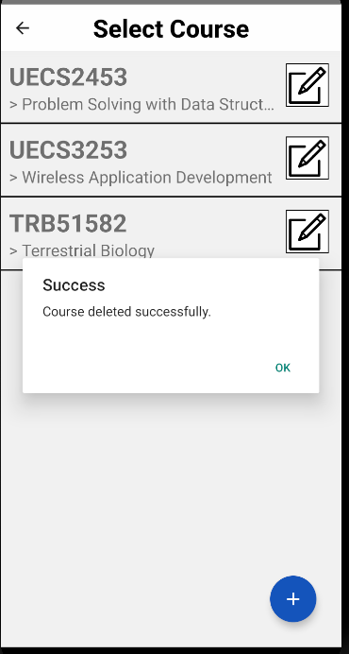
- Course Edit Screen
- This page allows the user to change the course code and name.
- When the “Save Changes” button is pressed it will update the course code and name. Then show “Course edited successfully” and redirect users back to Course Info Page.
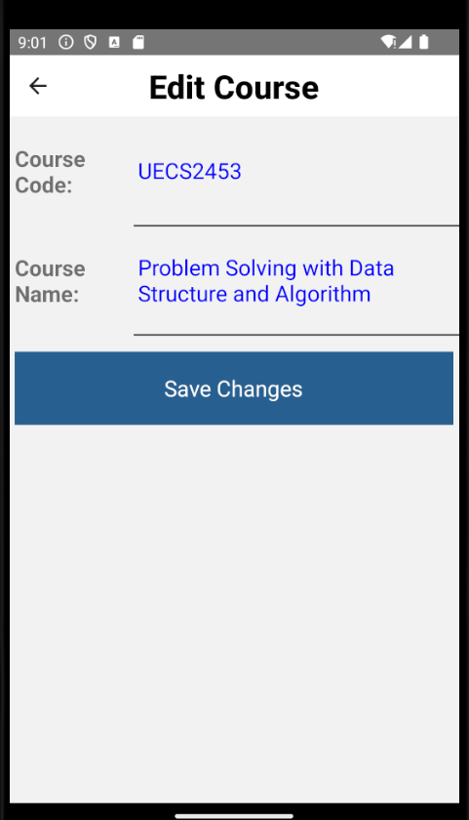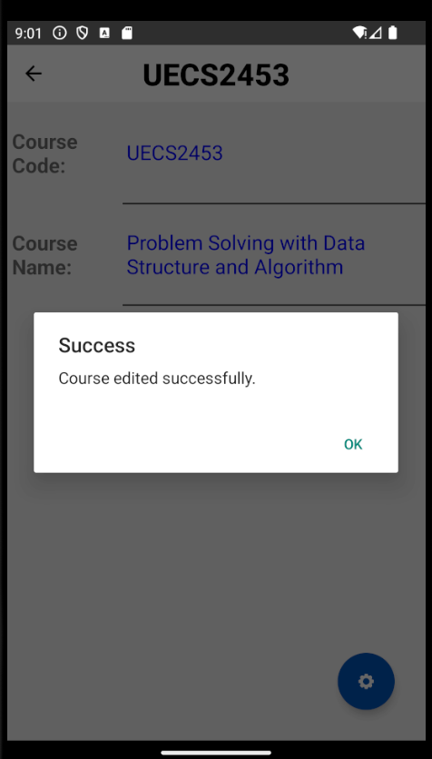

- Select Chapter Screen
- This page shows the user the chapters in the selected course.
- When the chapter is pressed it will direct users to the Questions/Notes Screen.
- The button  will direct the user to Chapter info Screen.
- The button will show a tab with 1 option:
  - Add Chapter, which will direct the user to Create Chapter Screen.
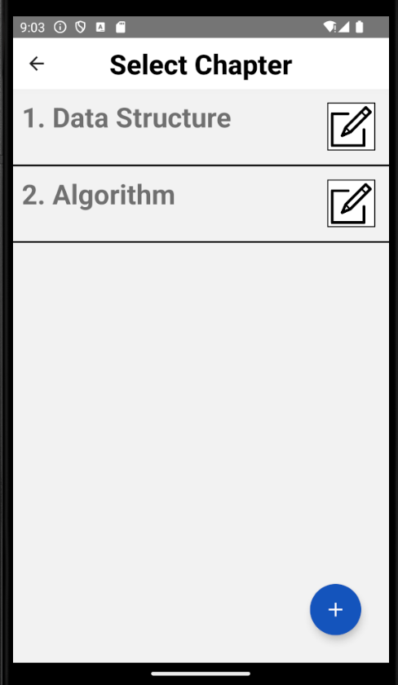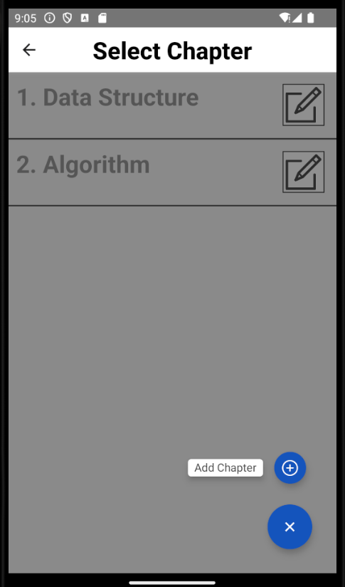

- Create Chapter Screen
- This page allows the user to create a new Chapter in the selected course
- Users need to enter Chapter No. and Chapter name.
- When “Create Course” button is pressed:
  - An Alert will pop up if Chapter No. is invalid or the fields are empty.
  - If successfully created, it will redirect users back to the Select Chapter Screen.
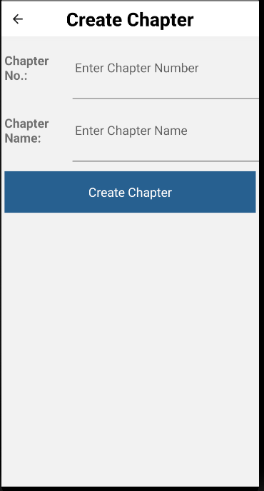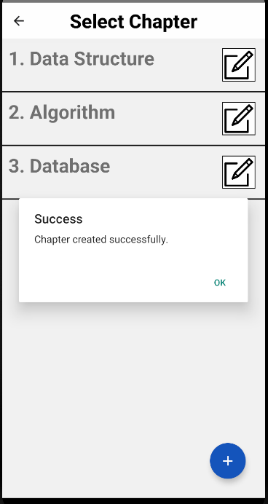
Alerts:
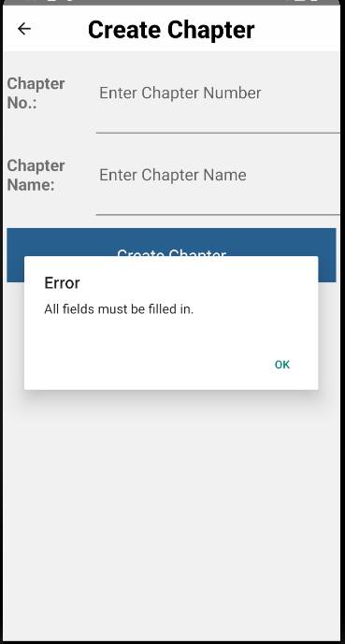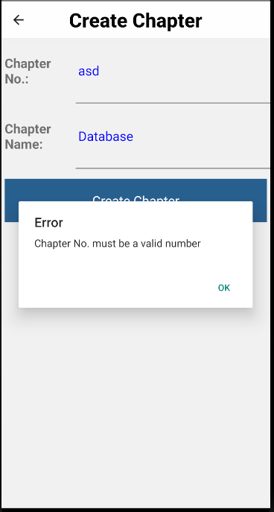
- Chapter Info Screen
- This page shows the information of the selected chapter
- This button will open a tab with 2 options:
  - Edit Chapter will direct the user to Edit Chapter Screen
  - Delete Chapter will ask user to confirm deletion of Chapter.
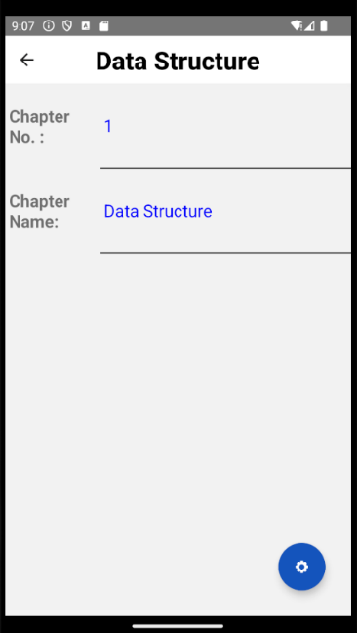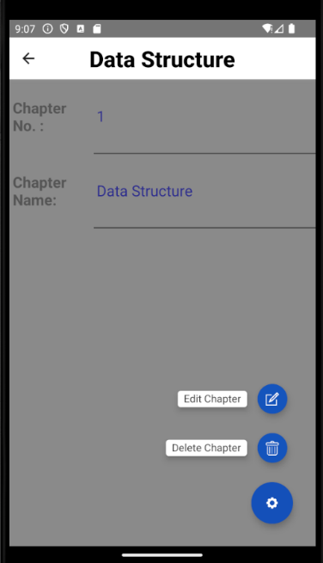
Deleting Chapter:
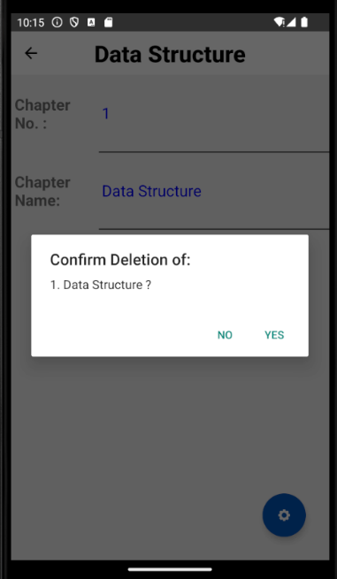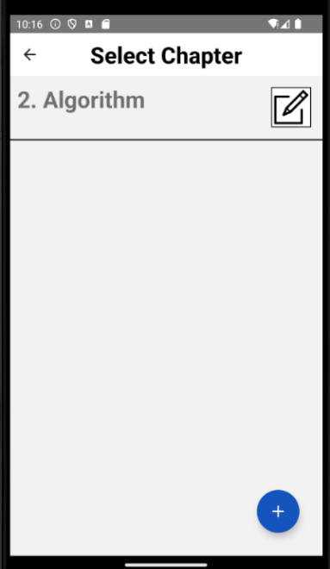

- Edit Chapter Screen
- This page allows the user to change the chapter number and name.
- When the “Save Changes” button is pressed it will update the chapter number and name. Then show “Chapter edited successfully” and redirect users back to Chapter Info Screen.
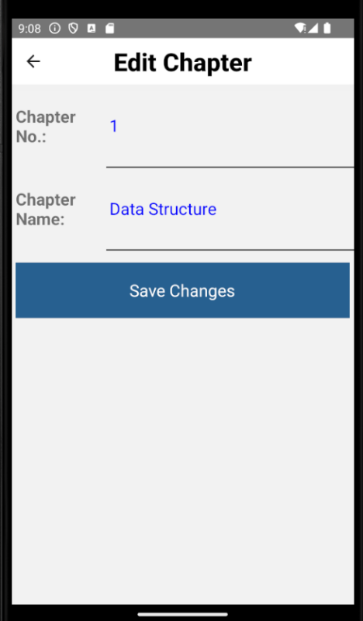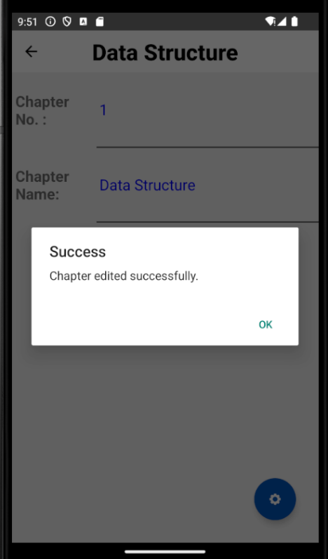

- Questions/Notes Screen
- This page show user the Questions in the selected course chapter
- There is a top bar with 2 options:
  - Question, show list of questions in the course
  - Note, shows the note of the chapter
- Each question can be clicked to view Question Info
- When this button is click in Question, it will show 1 option:
  - Add Question which directs the user to Create Question Screen.
- When this button is pressed in Note, it will show 1 option:
  - Edit notes, which direct the user to Edit Note Screen.
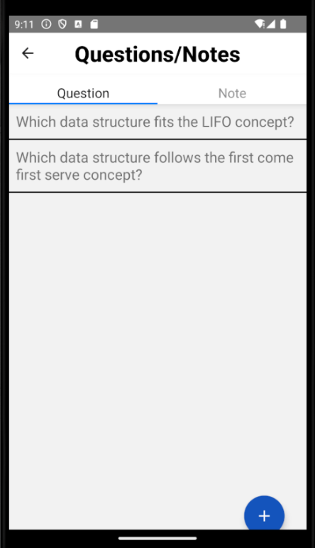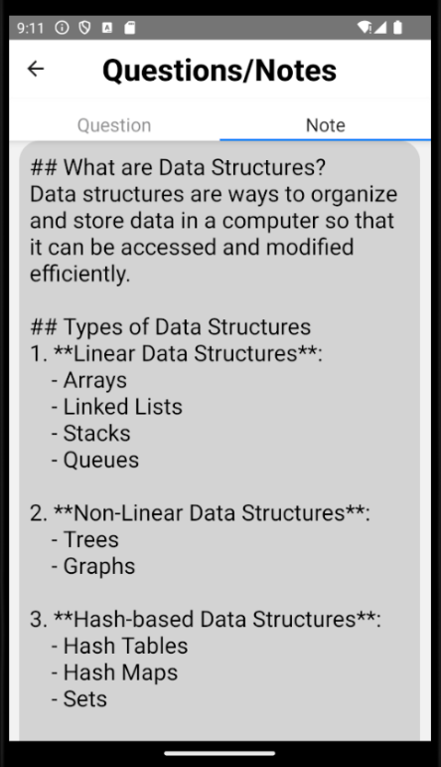

- Create Question Screen
- This page allows the user to create a question in the chapter.
- The user needs to enter the question, 4 different options for the answer and the correct answer.
- When create course button is pressed:
  - If a field is empty it will show “All fields must be put in”
  - Once everything is filled in and submitted it will show “Question created successfully” and redirect users back to the Questions/Notes Screen.
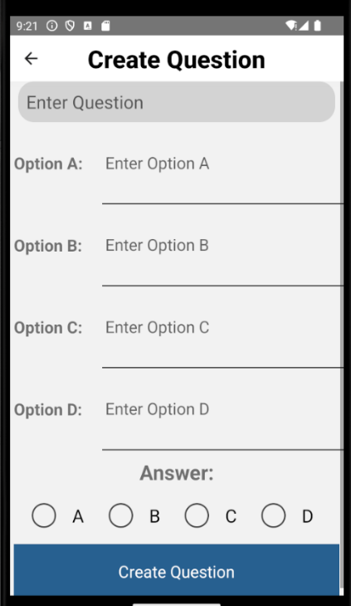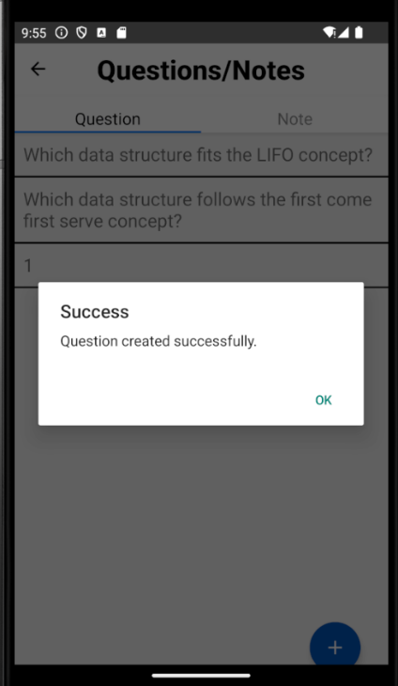
Alerts:
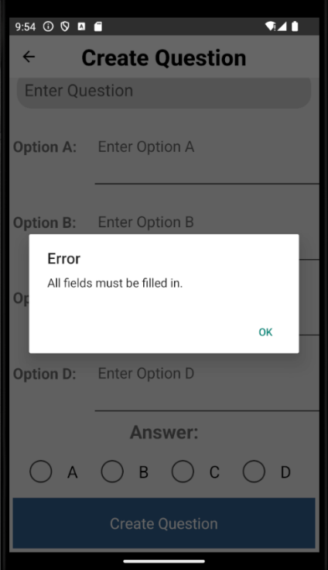
- Question Info Screen
- This page shows the user the selected question details
- When this button is click in Question, it will show 2 options:
  - Edit Question, which directs the user to Edit Question Screen.
  - Delete Question, when this button is pressed it will ask user confirmation of deletion and deletes the question if the user clicks yes.
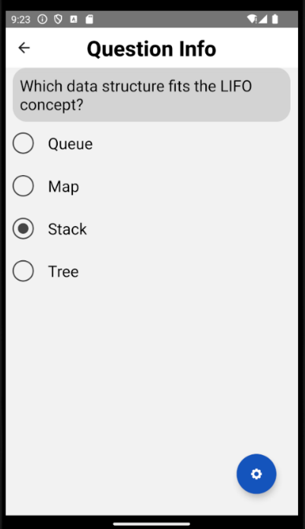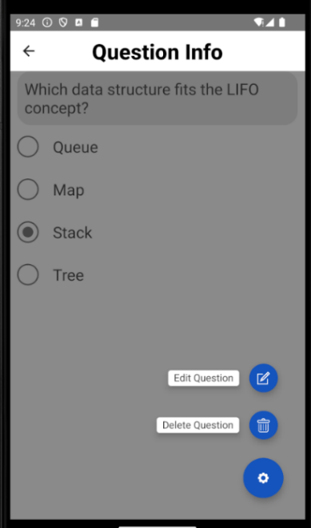
Deleting Question:
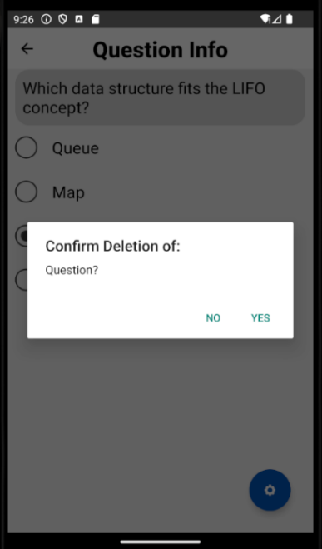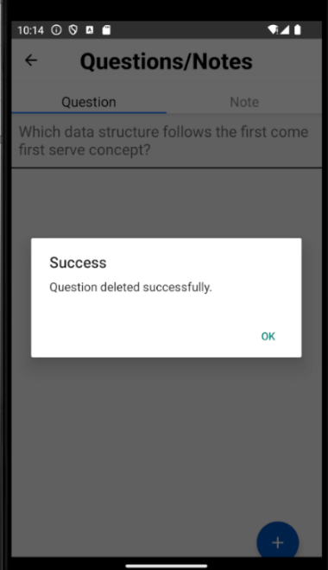

- Edit Question Screen
- Works the same as create question but the button is changed to “Save Changes”
- When the “Save Changes” button is pressed it will update the question information accordingly
- An Alert will pop up if the fields are empty.
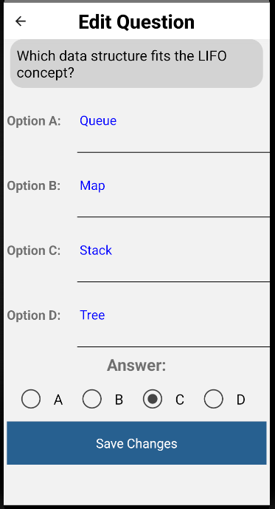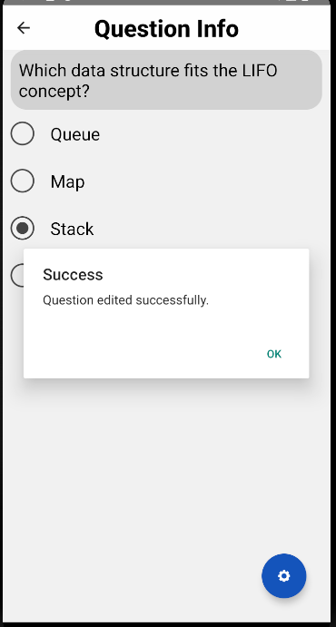
Alerts:
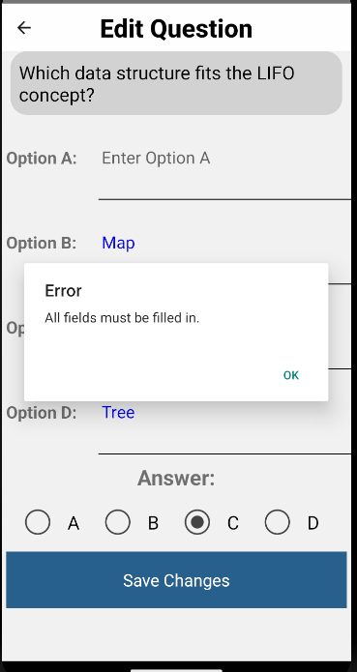

- Edit Note Screen
- This page allows the user to edit the notes of the chapter.
- When “Save Changes” button is pressed it will show “Note edited successfully” and update the notes
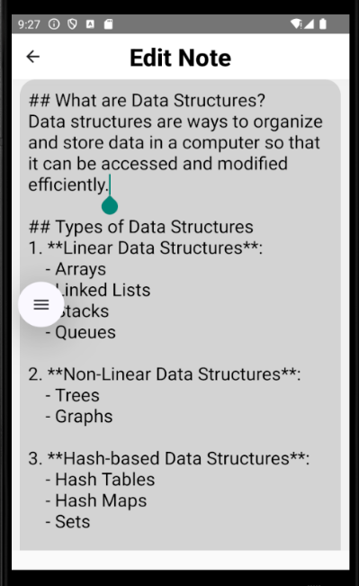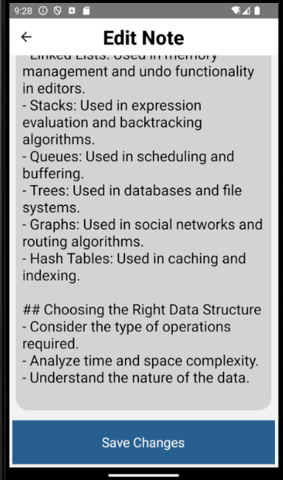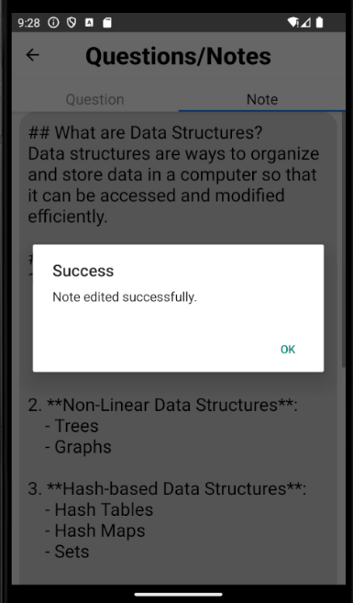

- Accounts Screen
- This page shows the list of accounts signed up in the application
- The top bar has 2 options:
  - Student, show list of student accounts
  - Admin, show list of admin accounts
- Each account can be pressed to see the account info
- When this button is pressed it will show a tab with 1 option:
  - Add Account, this button will direct user to Create Account Screen.
Student Accounts:
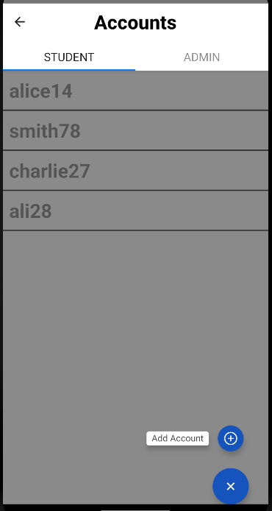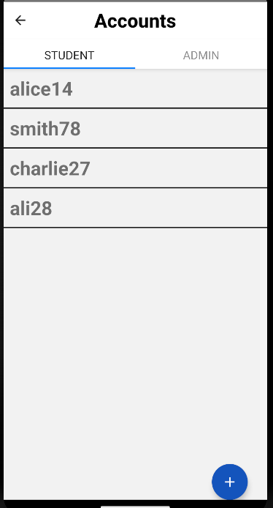
Admin Accounts:
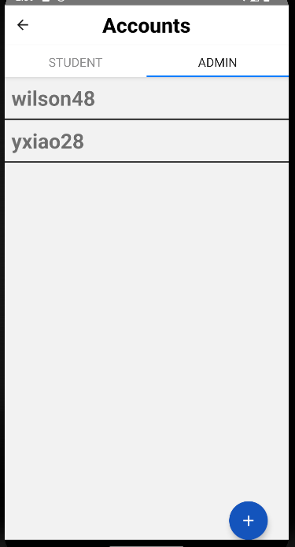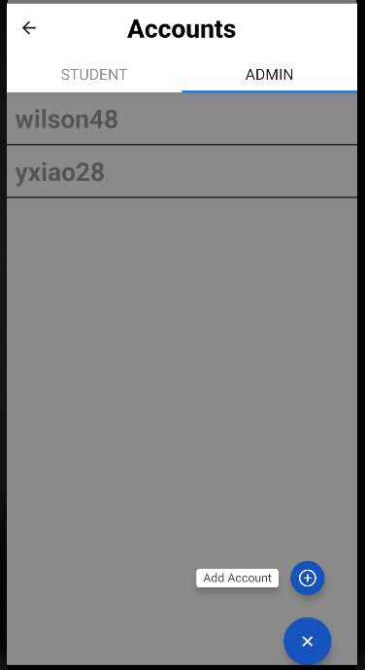
- Create Account Screen
- This page allows the user to create a new account.
- The Role allows the user to choose between admin or student account.
- When “Create Account” button is pressed:
  - An Alert will pop up if the fields are empty or username already exists.
  - If all field is filled up it will show “Account created successfully” and redirect user back to Accounts Screen.
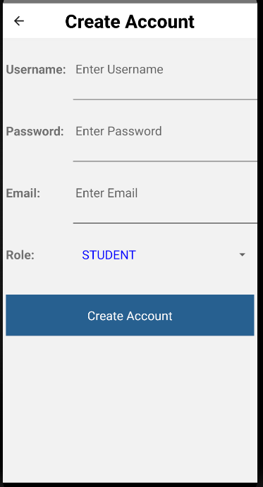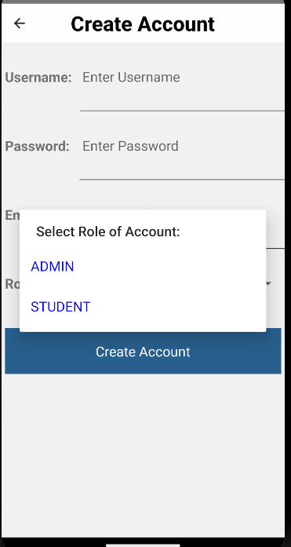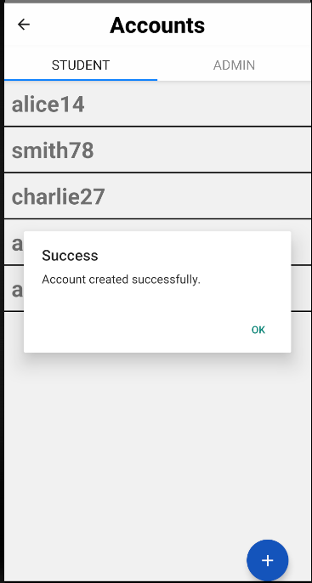
Alerts:
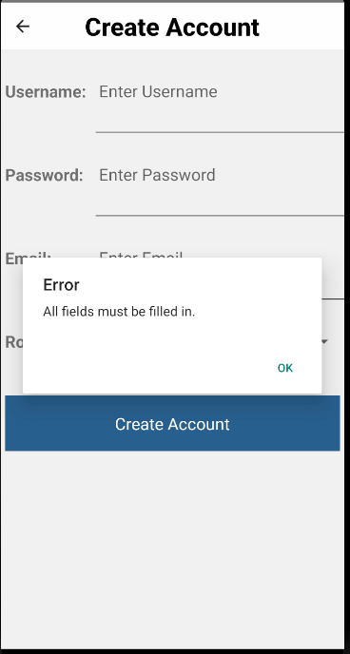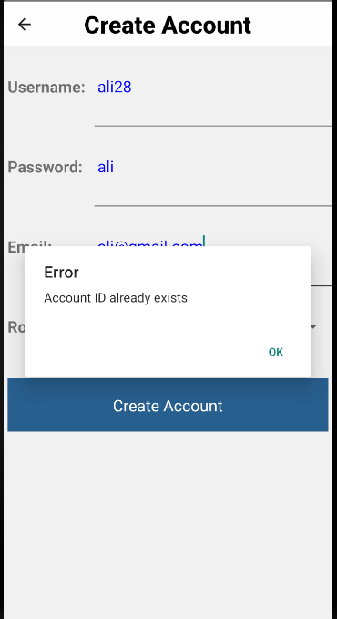

- Account Info Screen (Student)
- This page shows the information of the selected user account
- When this button is pressed it will show a tab with 2 options:
  - Edit Account, which will direct the user to the Edit Account Screen
  - Delete Account which will ask user for confirmation of deletion and delete the account if user pressed yes

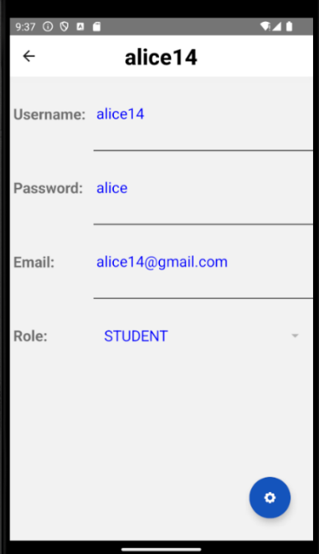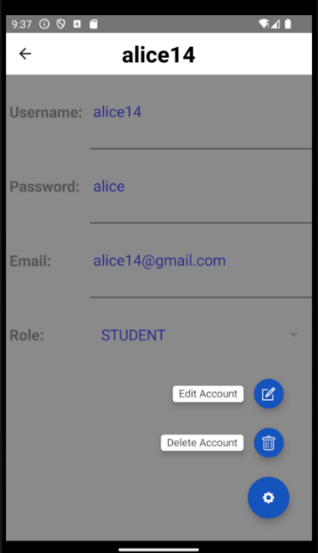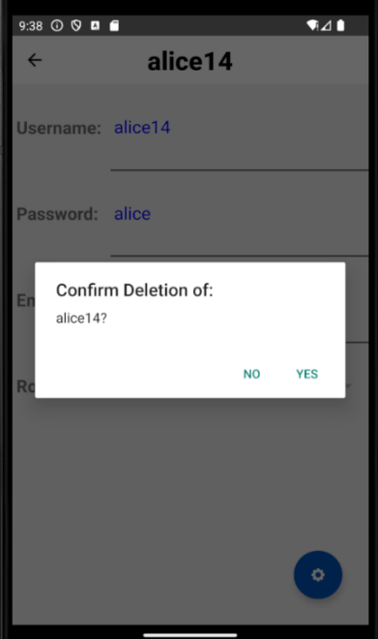

- Edit Account (Student)
- This page works the same as create account, but the button is changed to “Save Changes”
- When “Save Changes” is pressed it will show user “Account edited successfully” and update the account details
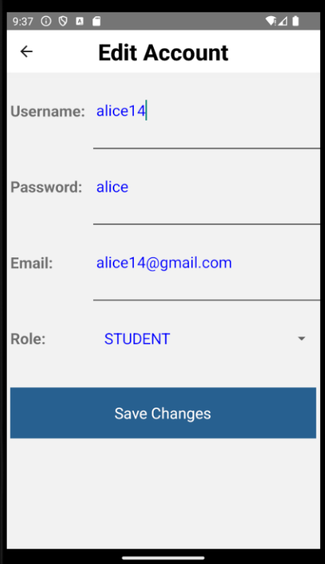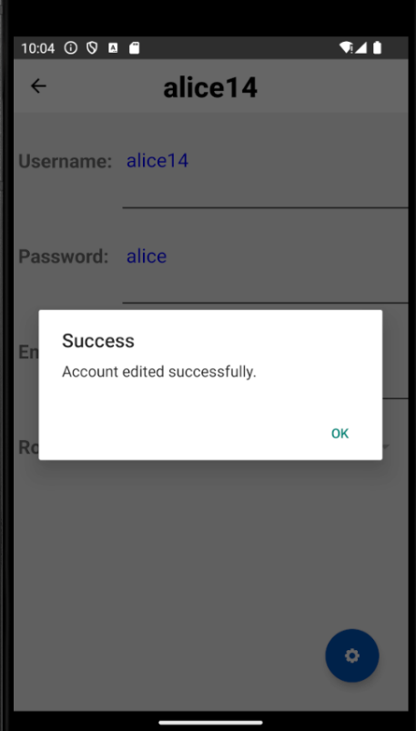

- Quiz History
- This allows users to see the history of attempted quizzes.
- User can choose the course, date of attempt and which account attempted the quiz to see the history of the quiz
- The quiz result shows the result of the attempted quiz by the chosen account and has 2 buttons:
  - “Check Answer” button to see the answer of the question and user
  - “Back” button to go back to the previous page
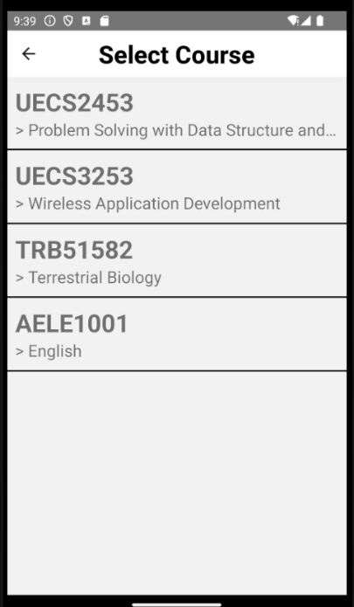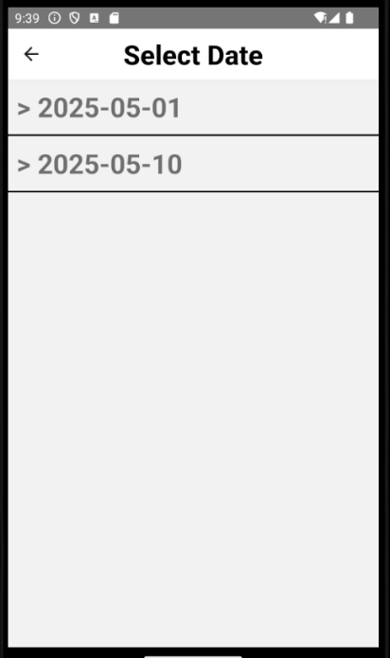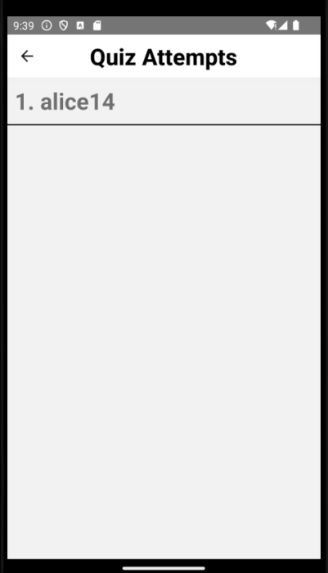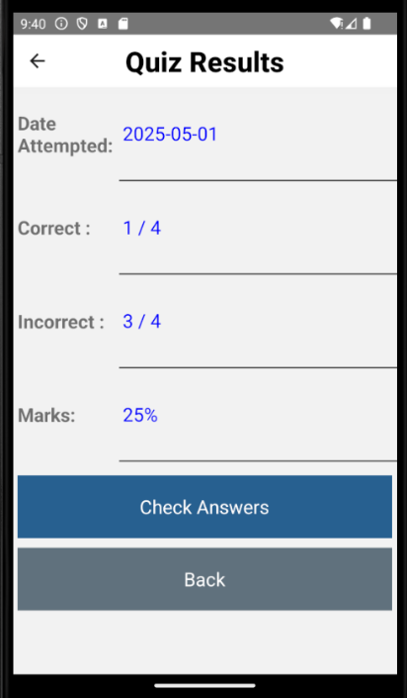

- Profile Page (Admin)
- This page is to show the information of user’s profile
- This button will open a tab with 2 options
  -  Edit Account, which directs the user to Edit Account Screen to change their account details, which the role of account cannot be changed.
  -  Log out, which logs the user out and redirect to login page
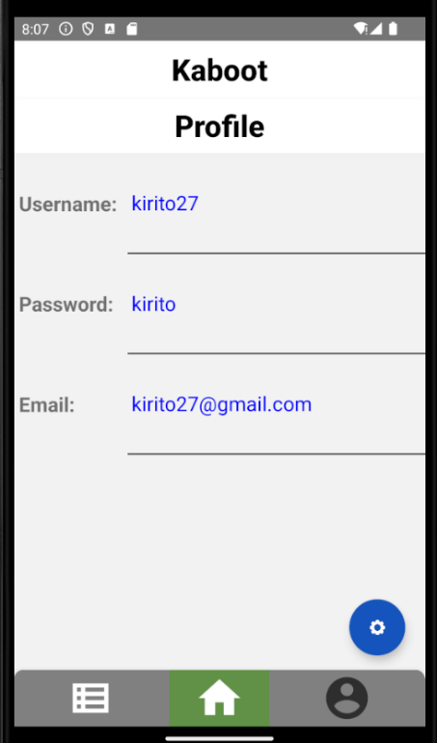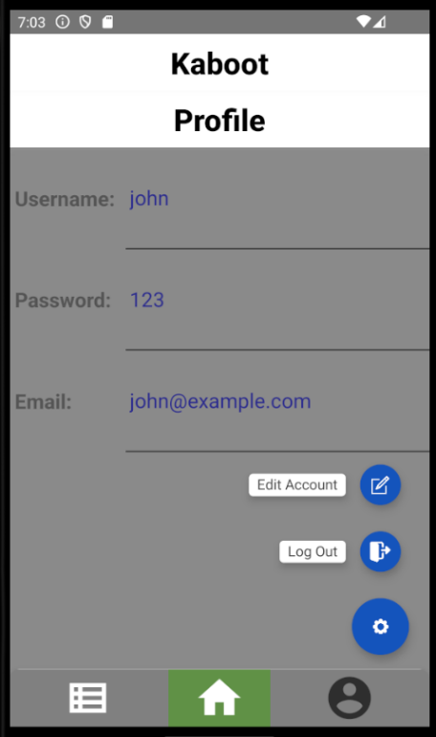

- Edit account (Admin)
- This allows the user to edit their info
- When “Save Changes” is pressed it will show user “Account edited successfully” and update the account details
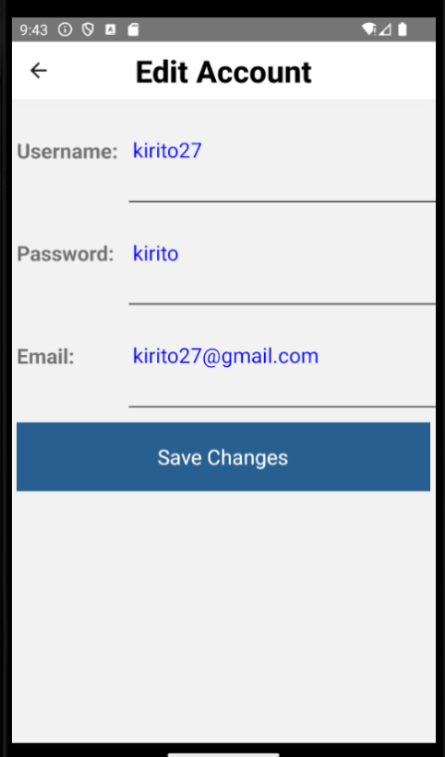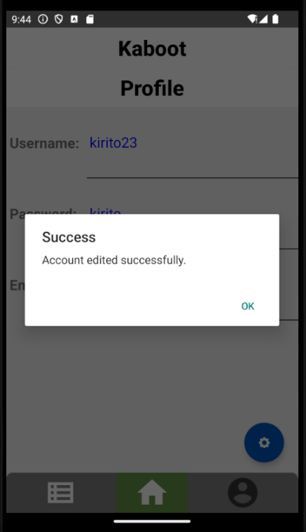

Use of Components
i. Mixing Internal Styles and StyleSheets
Styles can be applied directly in the component using inline styles or by utilizing stylesheets in React Native. Internal Styles are applied directly to JSX elements using style attributes. StyleSheets are created using StyleSheet.create() in which it allows for reusable and shareable styles across multiple components.
Example:
- Internal styles
  - The view applies the style that sets the layout direction to vertical or column and aligns items to centre directly in the component.
  - The image applies the style that sets the height and with of the image to 30% of the screen height directly within the component.
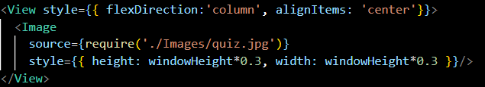
- StyleSheets
- The Text above AppButton uses the style timeout from the stylesheet infoStyles.
- This sets the text to have the font size of 30, bold font, red color and text aligned in center.
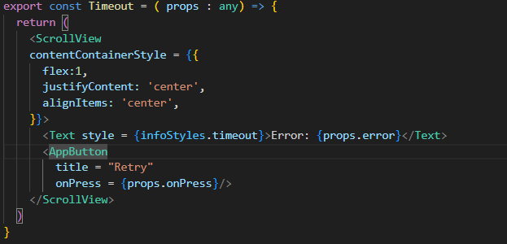

StyleSheet:
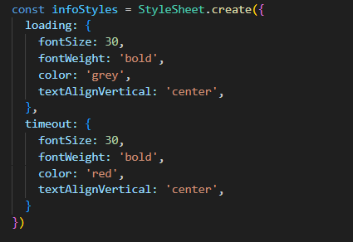

ii. StyleSheets Implemented in External Files
In a large application, one way to keep the components organized is by placing StyleSheets in separate files. By separating the styles from the main component file, the code becomes more readable
Example:
- AppButton component and style is written in ./UI and implemented in Options.tsx
- The code shows Appbutton style is written in the UI.tsx
- The Appbutton is used in Options.tsx
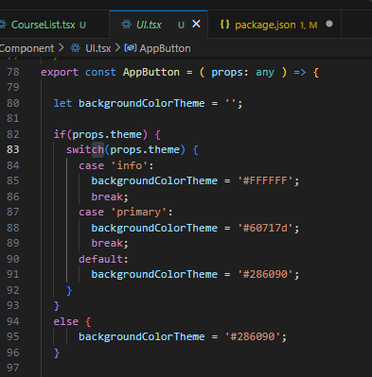

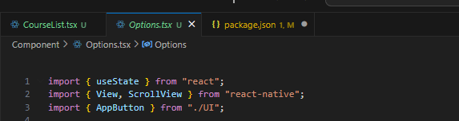
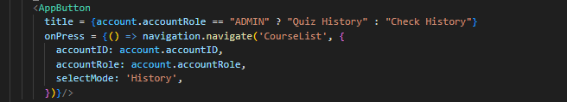

iii. Six Third-Party Components used
The application uses a systematic and careful approach to component utilization. Both Built-in and third-party components are used to develop the application. Below are examples of third-party components used.

- @react-native-picker/picker
- Picker is a drop-down list component
- In the example it loops through props.items and create a Picker.Item for each with a label, key and value.
- This allow for the implementation of selecting account role when creating accounts in which only one value is desired out of the multiple selections.
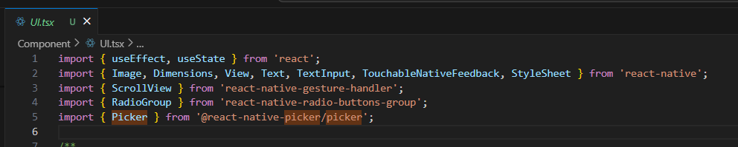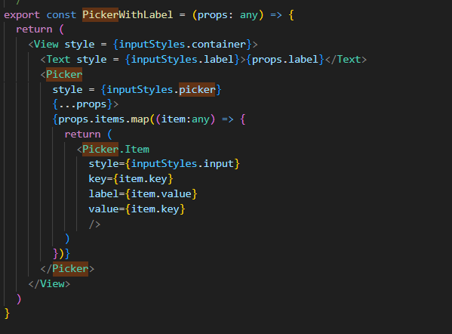

- react-native-floating-action/FloatingAction
- FloatingAction is used to show a floating button which can expand to multiple selection when tapped
- In the example the floating action used props:
  - Actions(defined in above code)
  - floatingIcon(options.jpg)
  - onPressItem, triggers when user taps one action items
- This floating acton allow users to edit or delete a course in the course info page
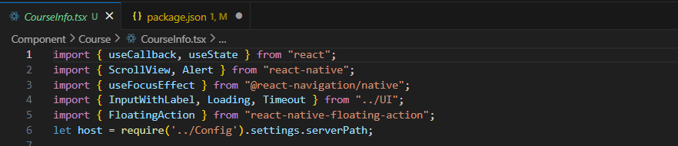
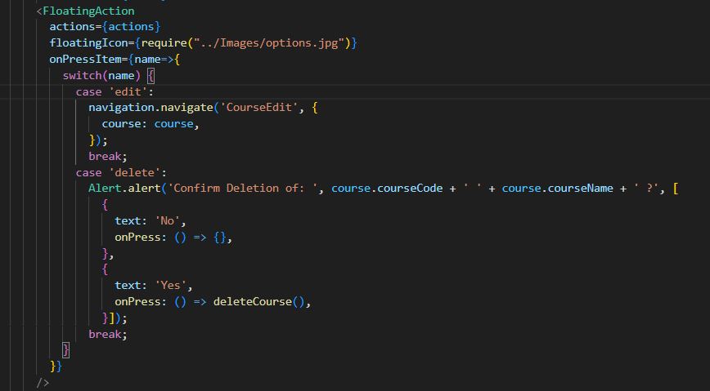

- @react-native-community/checkbox
- This is a customizable Checkbox component
- In this example the checkbox component allows the user to toggle selection and when the checkbox is pressed it will update the state
- This allows for the implementation of selecting multiple Chapters to be included in the quiz.
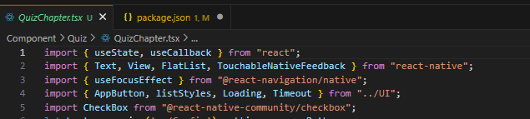
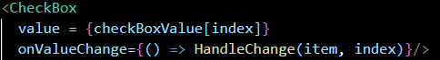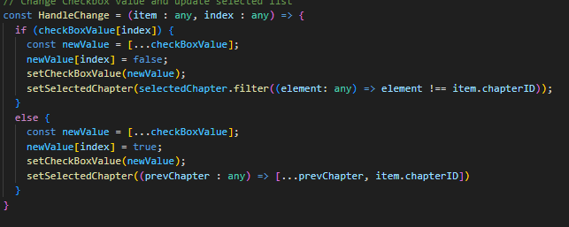

- react-native-vector-icons/MaterialCommunityIcons
- This component provides a large collection of customizable vector icons
- In this example the MaterialCommunity Icons is used to display an icon, and the icon changes color based on whether the tab is focused or not.
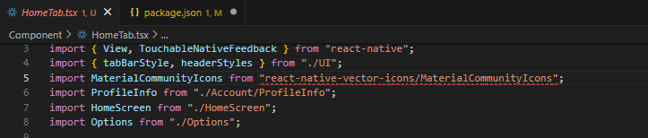
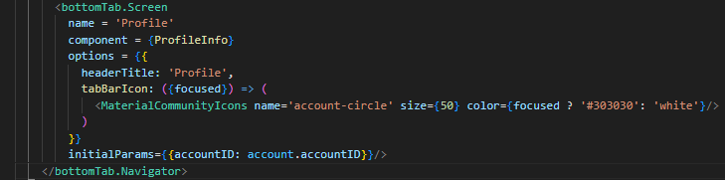

- react-native-radio-buttons-group/RadioGroup
- This is a customizable RadioGroup component
- In this example the RadioGroup component allows the user to select from a series of radio buttons in which only the most recent selected button will be marked as selected.
- This allows the implementation of selecting only one value as the answer for quiz system.
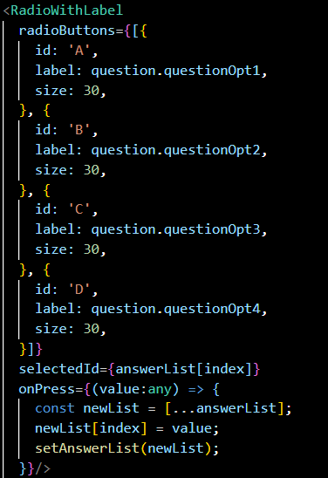
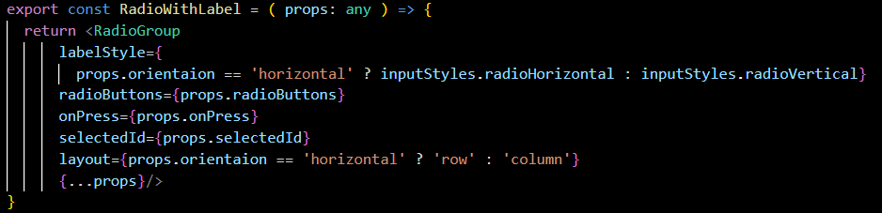

- react-native-pager-view/PagerView
- This is a component which allows for the swiping of pages.
- PagerView renders all sub child components as a series of pages in order, which can be accessed through the use of gestures such as swiping.
- This can be used in the implementation of displaying quiz questions where the user needs to swipe through a series of questions.
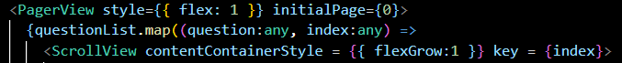

Reusability (Custom Components)
Several custom components are implemented in this project to maintain consistency across the user interface. The components used are InputWithLabel, RadioWithLabel, PickerWithLabel, AppButton, Timeout, and Loading.

- InputWithLabel
- This component renders a label and a multiline text input
- The props.label displays the label text beside the text input
- The props.style allows the change of the input style
- {...props} allow other TextInput props to the component
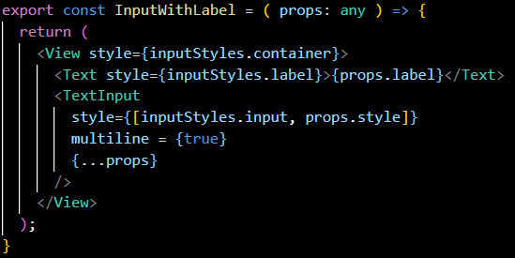

- RadioWithLabel
- Create RadioGroup with layout and styles
- LabelStyle depends on the layout, either horizontal or vertical
- radioButtons displays an array of radio buttons from the props
- onPress is a callback function which triggered when user selects different options
- selectedID indicates which button is selected
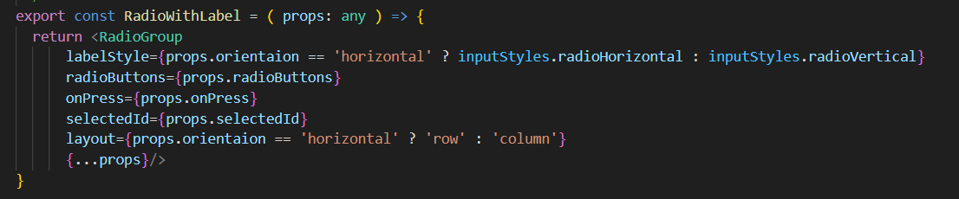

- QuestionField
- A custom component for entering and displaying multiple lines of text.
- It applies a style in a textinput
- inputStyles.questionFields is used as the style of the text input
- Multiline is set to true which allow user to write in multiple lines
- {...props} allow additional props to pass in
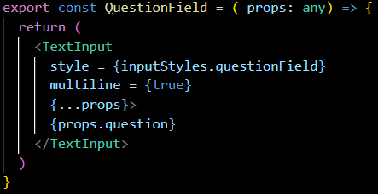

- PickerWithLabel
- A reusable custom component to show a dropdown menu to allow user to select a value from a list
- This component puts a style in the picker component to provide a consistent style
- A props.label is display beside the picker
- The component is styled with inputStyles.container
- Dropdown list is styled with inputStyles.picker
- Options are shown with Picker.Item and using props.items array
- Each item has a key and value.
- inputStyles.input is applied to each item
- {...props} allow additional props to pass in
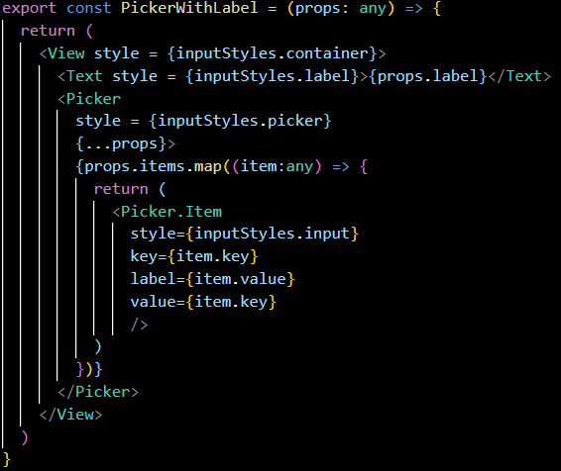

- AppButton
- A custom button component
- Use TouchableNativeFeedback to detect touch inputs
- The component allows 2 types of content, icon and text
- Icon button is used if props.icon is provided
- Text button is used if no icon is given then props.title is displayed.
- Press and long press are handled using props.onPress and props.onLongPress
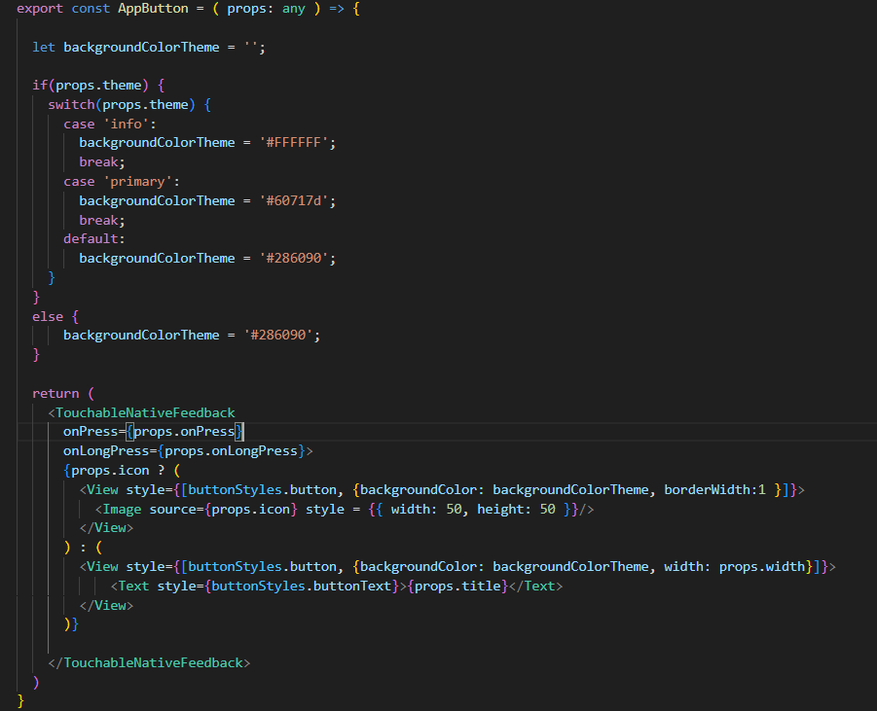

- Timeout Component
- A custom reusable component to show error message
- contentContainerStyle is used to center the content
- Display error message accordingly using props.error
- Include a AppButton labeled “Retry” and trigger props.onPress when pressed
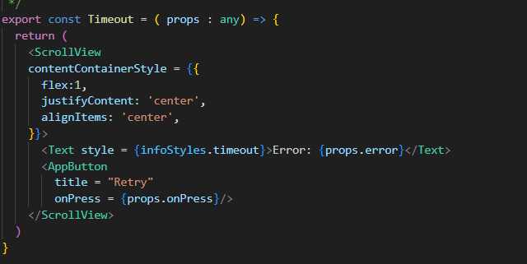

- Loading
- A custom reusable component to show loading text
- Use UseState to manage the loadingText
- useEffect sets up a timer using setInterval to update loadingText (‘.’) every 500 milliseconds
- Counter is used to track the number of dots and reset after 3 dots
- Use ScrollView
- contentContainerStyle centers the content
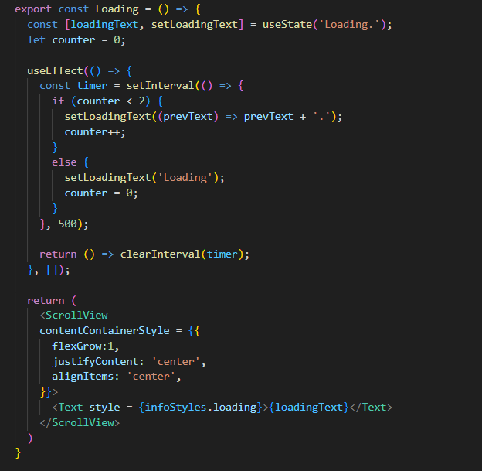

Implementation of React-Navigation
i. Navigating Between Screens with Variables and Functions
Transitioning between screens is done using the navigation.navigate method, which allows variables and functions to be passed as route parameters.
Example:
- Navigate from home screen to course list page
- The route is used to access navigation parameters
- Navigation enables navigation to other screens which are inserted into a Stack Navigator.
- When AppButton is pressed, it triggers navigation.navigate and pass the value accountId and selectMode to the Select Course Screen
- No functions are passed in the implementation as the react-navigation hook, “useFocusEffect” is used which run callbacks when the screen is focused and automatically cleans up when the screen is unfocused, making the app being updated in real time
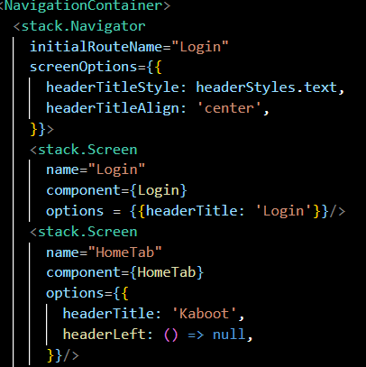
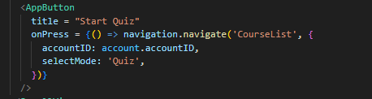

ii. Similar screens are combined and coded in the same file
Multiple screens applications often have similar screens grouped within the same file. This can help reduce the number of files, making it easier to manage
Example:
- Have 2 different screen displays for student and admin accounts
- Using accountRole and selectMode the application can show different screens to different types of users
- If user has the “ADMIN” role and is not in “History” an edit button is shown
- If user has the “ADMIN” role and is not in “History” a floating action button is shown
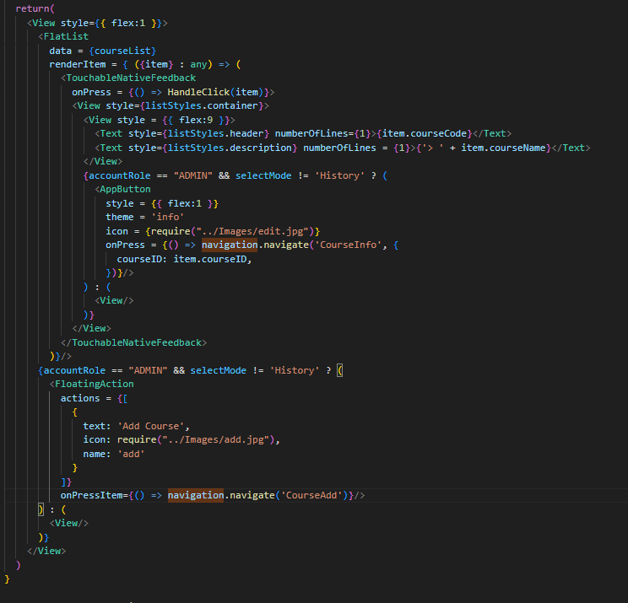

iii. Nesting Navigators
Nesting navigator is using one navigator inside another. This is useful to organize app flows.
Example:
- Bottom Tab
- Implemented in HomeScreen
- The bottomTab.Screen is used in bottomTab.Navigator
- Used to display different screens which are:
  - Options
  - Home
  - Profile
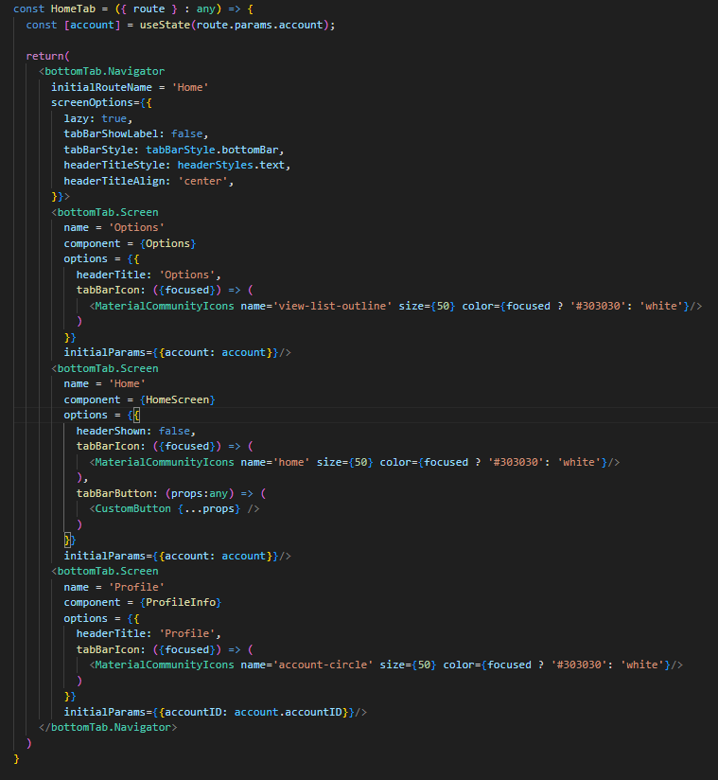

- Material Top Tab
- Implemented in AccountTab and QuestionTab
- The ‘lazy’ param is used to ensure that the screens inside the navigator are loaded only when they are focused, which compliments the use of ‘useFocusEffect’.
- Used to display multiple screens that have different parameters, such as AccountTab displaying accountList for both STUDENT and ADMIN account, or QuestionTab displaying both Questions and Notes tab.
AccountTab:
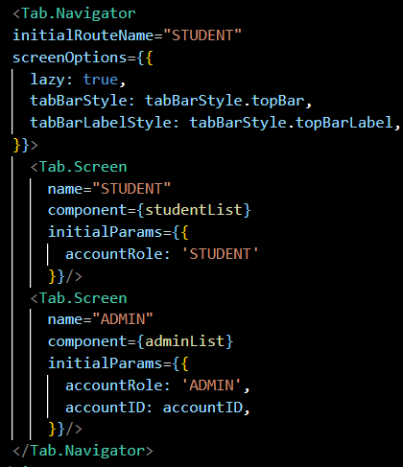
QuestionTab:
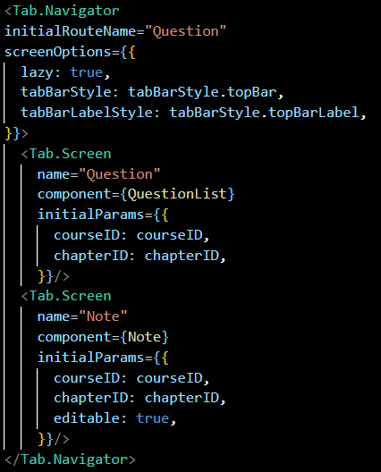

DATA PERSISTENCE

Usage of Data Persistence
The quiz generation app can access data stored in various databases even after the application’s process has ended. Three different databases were implemented to store different data. The implementations are as the following:
Database | Data Stored / Function
File system | Quiz notes (text files)
AsyncStorage | Re-logs user after restarting application
SQLite | account, course, chapter, question, quiz history, and question history
Text files are used for storing quiz notes for different chapters of courses. The notes can be lengthy and is not suitable for databases such as SQLite. Thus, .txt files serves as a more intuitive method to store data such as sentences and paragraphs. Text files will be read and updated when requested by the user.
AsyncStorage is used to keep the user logged in after the user exits and restarts the application. AsyncStorage will store, automatically enter, and forget the credentials of the current user depending on the action of the user.
SQLite serves as the standard database for storing relational tables. In this case, the entire application depends multiple inter-related tables to fulfil its services. The attributes of each table are as the following:
Table | Attributes
Account | accountID INTEGER PRIMARY KEY AUTOINCREMENT  accountName TEXT NOT NULL UNIQUE  accountPass TEXT NOT NULL  accountEmail TEXT NOT NULL  accountRole TEXT NOT NULL
Course | courseID INTEGER PRIMARY KEY AUTOINCREMENT  courseCode TEXT NOT NULL UNIQUE  courseName TEXT NOT NULL
Chapter | chapterID INTEGER PRIMARY KEY AUTOINCREMENT  courseID INTEGER NOT NULL REFERENCES course(courseID) ON DELETE CASCADE  chapterNo INTEGER NOT NULL  chapterName TEXT NOT NULL
Question | questionID INTEGER PRIMARY KEY AUTOINCREMENT  courseID INTEGER NOT NULL REFERENCES course(courseID) ON DELETE CASCADE  chapterID INTEGER NOT NULL REFERENCES chapter(chapterID) ON DELETE CASCADE  questionAsk TEXT NOT NULL  questionOpt1 TEXT NOT NULL  questionOpt2 TEXT NOT NULL  questionOpt3 TEXT NOT NULL  questionOpt4 TEXT NOT NULL  questionAns TEXT NOT NULL
History | historyID INTEGER PRIMARY KEY AUTOINCREMENT  accountID INTEGER NOT NULL REFERENCES account(accountID) ON DELETE CASCADE  courseID INTEGER NOT NULL REFERENCES course(courseID) ON DELETE CASCADE  quizDate DATETIME NOT NULL
quesHistory | quesHistoryID INTEGER PRIMARY KEY AUTOINCREMENT  historyID INTEGER NOT NULL REFERENCES history(historyID) ON DELETE CASCADE ON UPDATE CASCADE  questionID INTEGER NOT NULL REFERENCES question(questionID) ON DELETE CASCADE ON UPDATE CASCADE  answer TEXT NOT NULL

Implementation of Data Persistence
Text Files
- Reading Text Files
“AppServer.py” provides the service to read the note of a .txt file in the specified directory. A new directory will be created if the requested note does not exist.
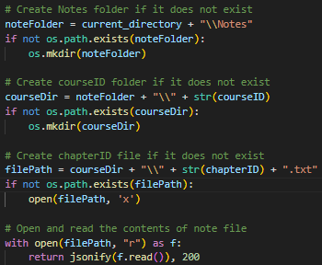
- Updating Text Files
“AppServer.py” provides the service to update the note of a .txt file in the specified directory according to the content in the request.
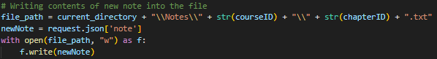

AsyncStorage
- Storing Credentials
When a successful login attempt is made, AsyncStorage will remember the credentials of the current user, namely the username and password.
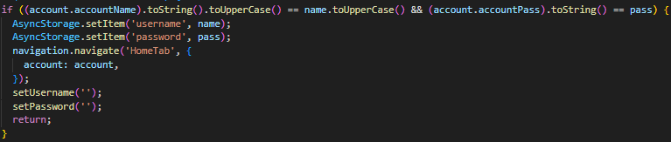
- Reading Credentials
When the application is restarted, AsyncStorage will read and enter the credentials of the last user logged in to attempt to login the user. This way, the user would not be required to re-enter their credentials on every startup.
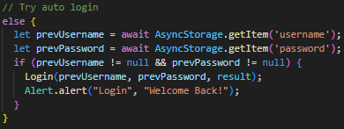
- Removing Credentials
When the user logouts, AsyncStorage will forget the saved credentials of the current user.
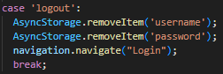

SQLite Queries
Account Queries
- Retrieve all accounts
“AppServer.py” provides the service to list all accounts from “account”.
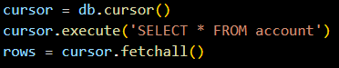
- Retrieve accounts based on Role
“AppServer.py” provides the service to list all accounts with the specified accountRole from “account”.
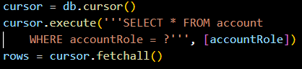
- Retrieve a specific account.
“AppServer.py” provides the service to get an account with the specified accountID from “account”.
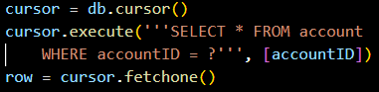
- Create a new account
“AppServer.py” provides the service to add a new account into “account”.
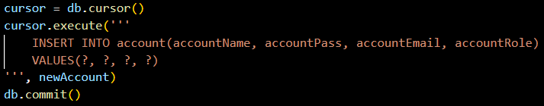

- Update an account
“AppServer.py” provides the service to update the details of an account with the specified accountID from “account”.
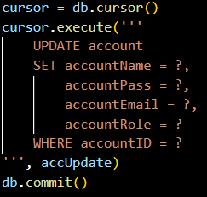
- Delete an account
“AppServer.py” provides the service to delete an account with the specified accountID from “account”.
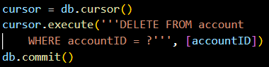
Course Queries
- Retrieve all courses
“AppServer.py” provides the service to list all courses from “course”.
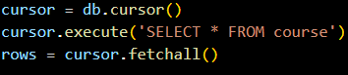
- Retrieve a specific course
“AppServer.py” provides the service to get a course with the specified courseID from “course”.
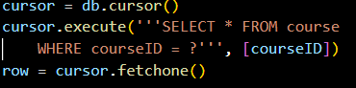

- Create a new course
“AppServer.py” provides the service to add a new course into “course”.
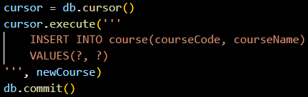
- Update a course
“AppServer.py” provides the service to update the details of a course with the specified courseID from “course”.
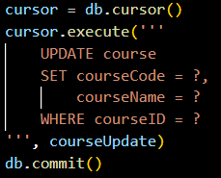
- Delete a course
“AppServer.py” provides the service to delete a course with the specified courseID from “course”.
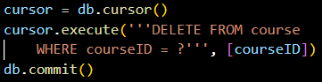
Chapter Queries
- Retrieve all chapters of a course
“AppServer.py” provides the service to list all chapters with the specified courseID from “chapter”.
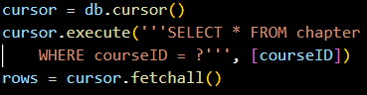

- Retrieve a specific chapter
“AppServer.py” provides the service to get a chapter with the specified chapterID from “chapter”.
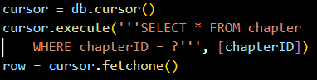
- Create new a chapter
“AppServer.py” provides the service to add a new chapter into “chapter”.
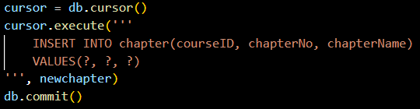
- Update a chapter
“AppServer.py” provides the service to update the details of a chapter with the specified chapterID from “chapter”.
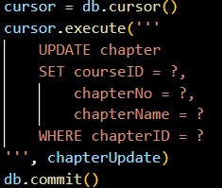
- Delete a chapter
“AppServer.py” provides the service to delete a chapter with the specified chapterID from “chapter”.
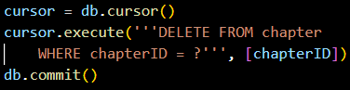

Question Queries
- Retrieve all questions of a chapter
“AppServer.py” provides the service to list all questions with the specified chapterID from “question”.
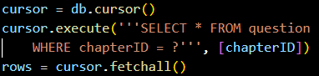
- Retrieve a specific question
“AppServer.py” provides the service to get a question with the specified questionID from “question”.
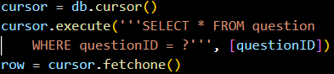
- Create a new question
“AppServer.py” provides the service to add a new question into “question”.
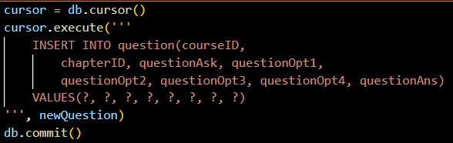

- Update a question
“AppServer.py” provides the service to update the details of a question with the specified questionID from “question”.
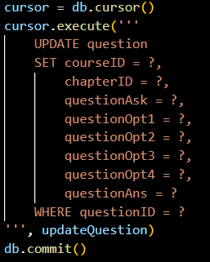
- Delete a question
“AppServer.py” provides the service to delete a question with the specified questionID from “question”.
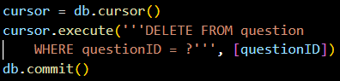
Quiz History Queries
- Retrieve unique quiz dates of course
“History.py” provides the service to list all quiz dates in descending order with the specified courseID from “history”.
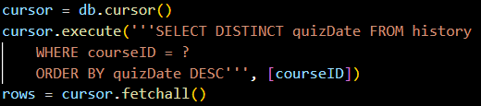

- Retrieve unique quiz dates of course and account
“History.py” provides the service to list all quiz dates in descending order with the specified courseID and accountID from “history”.
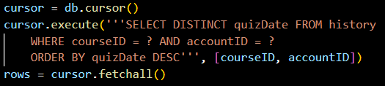
- Retrieve quiz attempts of course and quiz date
“History.py” provides the service to list all quiz attempts in descending order with the specified courseID and quizDate from “history”.
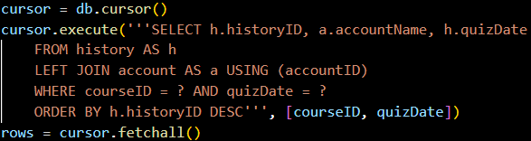
- Retrieve quiz attempts of course, account and quiz date
“History.py” provides the service to list all quiz attempts in descending order with the specified courseID, accountID, and quizDate from “history”.
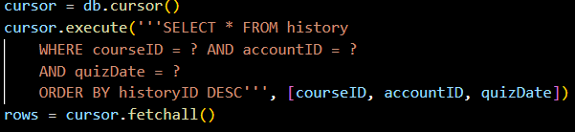
- Retrieve all questions attempted of specific quiz
“History.py” provides the service to list all questions attempted in a quiz with the specified historyID from “quesHistory”.
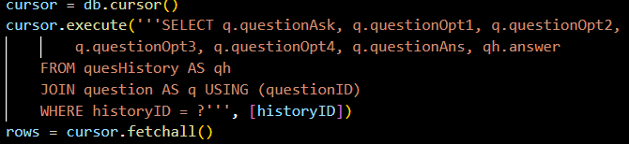

- Record quiz attempt
“Quiz.py” provides the service to add new quiz attempt and the questions in the quiz into “history” and “quesHistory” respectively.
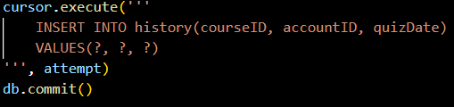
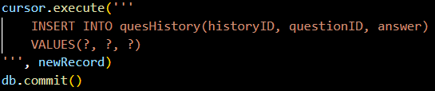

CRUD Operations & Input Validation
The CRUD Operations of each table/text file and input validation is implemented as the following:
Operation | Screen(s) | Input Validation
Create account | AccountAdd | Alerts for empty input, duplicate accountID
Create account process is used when:
New user signs up
Admin creates a new account
Read account | Login, AccountInfo, AccountList, ProfileInfo | -
Read account process is used when:
Loading all account to match the credentials when logging in
Admin views all existing account
User views personal account
Update account | AccountEdit | Alerts for empty input, duplicate accountID
Update account process is used when:
Admin updates other user’s account
User updates personal account
Delete account | AccountInfo | -
Delete account process is used when:
Admin deletes other user’s account
Create course | CourseAdd | Alerts for empty input, incorrect courseCode length, duplicate courseCode
Create course process is used when:
Admin creates a new course
Read course | CourseInfo, CourseList | -
Read course process is used when:
User views all existing courses
Update course | CourseEdit | Alerts for empty input, incorrect courseCode length, duplicate courseCode
Update course process is used when:
Admin updates a course
Delete course | CourseInfo | -
Delete course process is used when:
Admin deletes a course
Create chapter | ChapterAdd | Alerts for empty input, invalid chapterNo
Create chapter process is used when:
Admin creates a new chapter in a course
Read chapter | ChapterInfo, ChapterList, QuizChapter | -
Read chapter process is used when:
User views all existing chapter of a course
Update chapter | ChapterEdit | Alerts for empty input, valid number, invalid chapterNo
Update chapter process is used when:
Admin updates a chapter of a course
Delete chapter | ChapterInfo | -
Delete chapter process is used when:
Admin deletes a chapter of a course
Create question | QuestionAdd | Alerts for empty input
Create question process is used when:
Admin creates a new question in a chapter of a course
Read question | QuestionInfo, QuestionList, QuizQuestion | -
Read question process is used when:
User view all existing question in a chapter of a course
Update question | QuestionEdit | Alerts for empty input
Update question process is used when:
Admin updates a question in a chapter of a course
Delete question | QuestionInfo | -
Delete question process is used when:
Admin deletes a question in a chapter of a course
Create history | QuizResult | -
Create history process is used when:
User completes a quiz session
Read history | HistoryDate, HistoryList | -
Read history process is used when:
User views all existing quiz history
Create quesHistory | QuizResult | -
Create quesHistory process is used when:
User completes a quiz session
Read quesHistory | HistoryInfo, | -
Read quesHistory process is used when:
User views all existing question history in a quiz history
Read note | Note | -
Read note process is used when:
User views all existing notes in a chapter of a course
Update note | NoteEdit | -
Update note process is used when:
Admin updates the notes in a chapter of a course

CLOUD CONNECTIVITY

Usage of Cloud Connectivity
The quiz generation app runs all its CRUD process by requesting services from API servers. Three different API servers were implemented to handle different requests. The implementations are as the following:
API Server | Services
AppServer.py  (Web-based) | 6 services regarding account  5 services regarding course  5 services regarding chapter  5 services regarding question  2 services regarding quiz notes
History.py  (Web-based) | 5 services regarding quiz history and question history
Quiz.py  (WebSocket) | - Randomize quiz questions  - Validate quiz answer  - Record quiz attempt
The services of the application are separated into 3 different servers for the purpose of maintainability, scalability, and isolate responsibilities.
AppServer.py acts as the primary server for requesting CRUD on account, course, chapter, question, and quiz notes. AppServer.py runs on port 5000 and communicates over HTTP.
History.py is a server specialised in serving CRUD request on history and quesHistory. History.py runs on port 7000 and communicates over HTTP.
Quiz.py is a utility server for preparing, marking, and recording a quiz session. Quiz.py runs on port 6000 and supports real-time bidirectional communication, suitable for quiz sessions.

Implementation of Cloud Connectivity
AppServer.py
- AppServer.py utilizes Blueprints to segregate the services of each table into different files for the purpose of maintainability and readability.
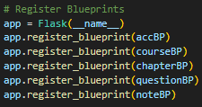
- All the services of each table use “database.sqlite” as the primary database.
- http://127.0.0.1:5000/account allows the application to retrieve all accounts from “account”.
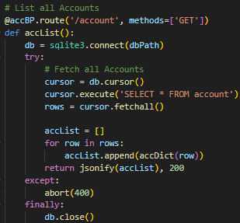

- http://127.0.0.1:5000/account/<accountRole> allows the application to retrieve all accounts with the specified accountRole from “account”.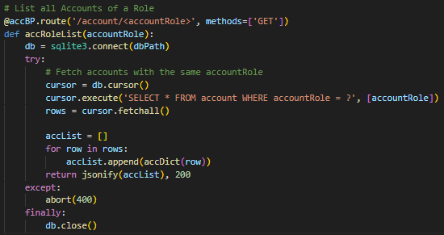
- http://127.0.0.1:5000/account/<int:accountID> allows the application to retrieve an account with the specified accountID from “account”.
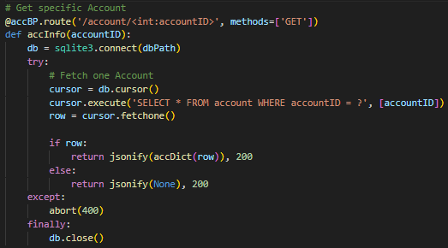

- http://127.0.0.1:5000/account allows the application to add a new account into “account”.
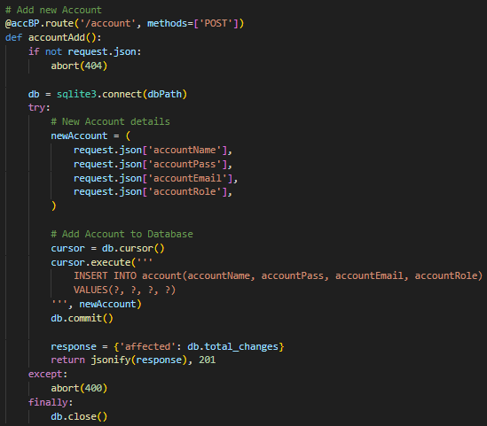.

- http://127.0.0.1:5000/account/<int:accountID> allows the application to update the details of an account with the specified accountID from “account”.
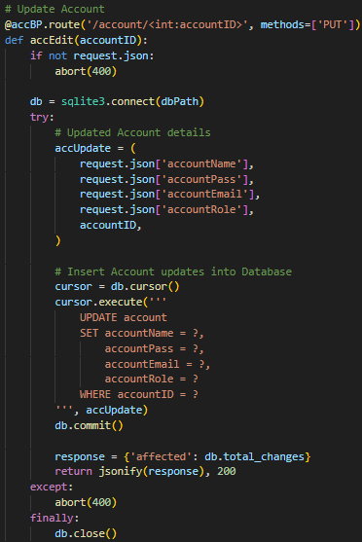

- http://127.0.0.1:5000/account/<int:accountID> allows the application to delete an account with the specified accountID from “account”.
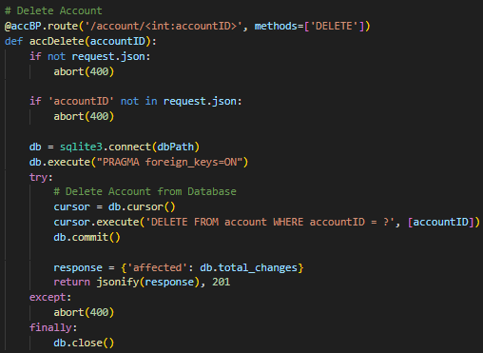
- http://127.0.0.1:5000/course allows the application to retrieve all courses from “course”.
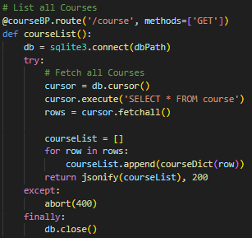

- http://127.0.0.1:5000/course/<int:courseID> allows the application to retrieve a course with the specified courseID from “course”.
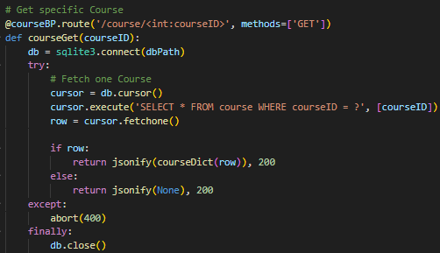

- http://127.0.0.1:5000/course allows the application to add a new course into “course”
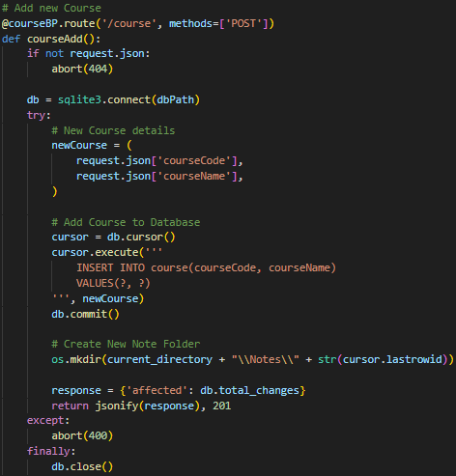

- http://127.0.0.1:5000/course/<int:courseID> allows the application to update the details of a course with the specified courseID from “course”.
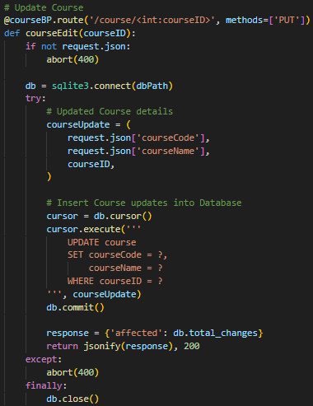

- http://127.0.0.1:5000/course/<int:courseID> allows the application to delete a course with the specified courseID from “course”.
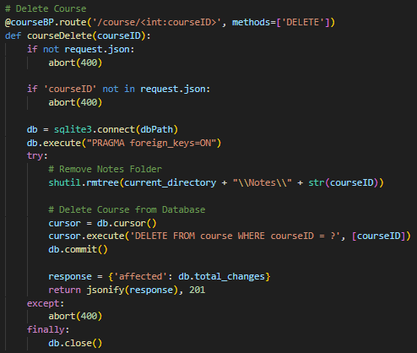
- http://127.0.0.1:5000/<int:courseID>/chapter allows the application to retrieve all chapters with the specified courseID from “chapter”.
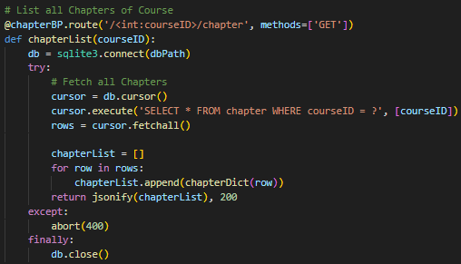
- http://127.0.0.1:5000/<int:courseID>/chapter/<int:chapterID> allows the application to retrieve a chapter with the specified courseID and chapterID from “chapter”.
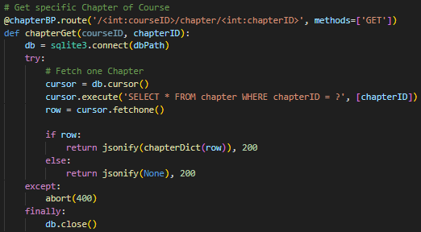
- http://127.0.0.1:5000/<int:courseID>/chapter allows the application to add a new chapter with the specified courseID into “chapter”.
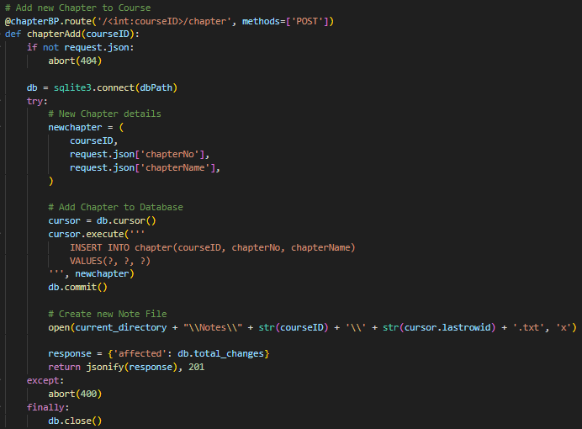
- http://127.0.0.1:5000/<int:courseID>/chapter/<int:chapterID> allows the application to update the details of a chapter with the specified courseID and chapterID from “chapter”.
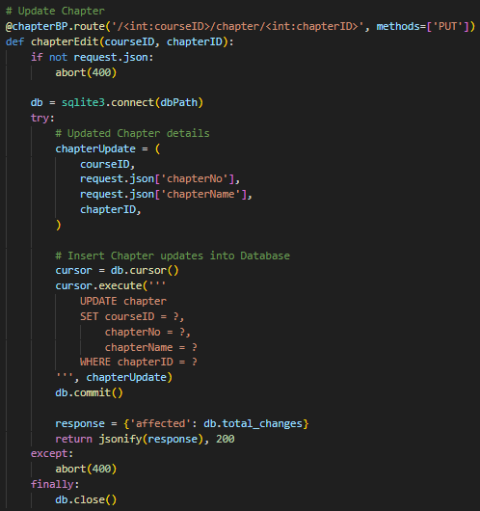

- http://127.0.0.1:5000/<int:courseID>/chapter/<int:chapterID> allows the application to delete a chapter with the specified courseID and chapterID from “chapter”.
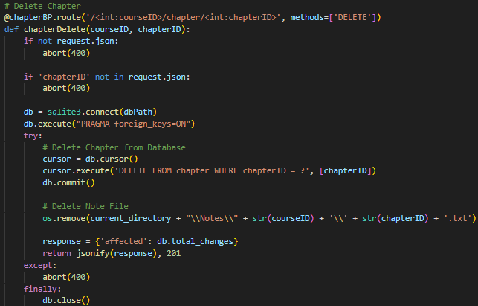
- http://127.0.0.1:5000/<int:courseID>/<int:chapterID>/question allows the application to retrieve all questions with the specified courseID and chapterID from “question”.
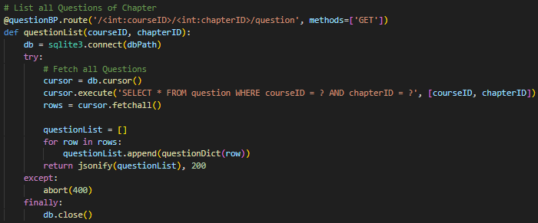

- http://127.0.0.1:5000/<int:courseID>/<int:chapterID>/question/<int:questionID> allows the application to retrieve a question with the specified courseID, chapterID, and questionID from “question”.
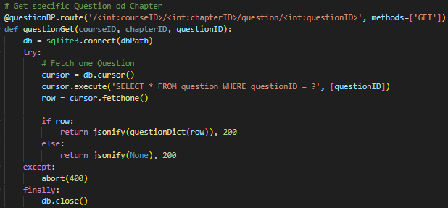
- http://127.0.0.1:5000/<int:courseID>/<int:chapterID>/question allows the application to add a new question with the specified courseID and chapterID into “question”.
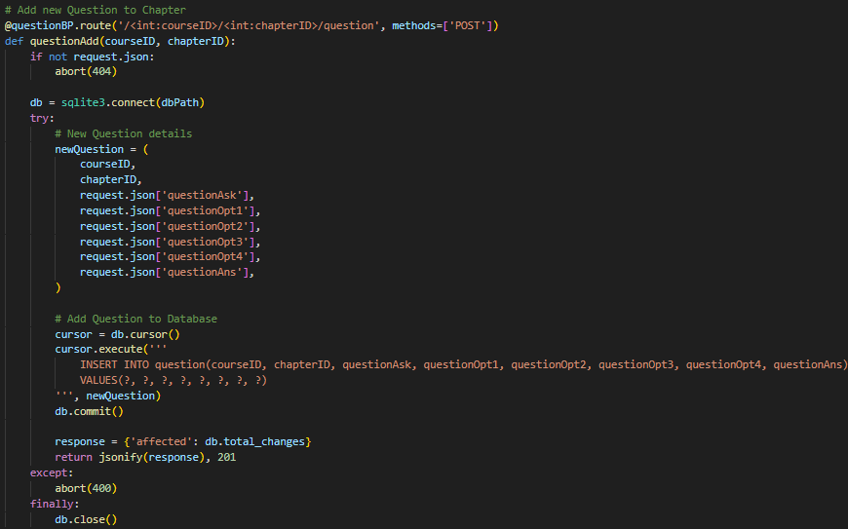

- http://127.0.0.1:5000/<int:courseID>/<int:chapterID>/question/<int:questionID> allows the application to update the details of a question with the specified courseID, chapterID, and questionID from “question”.
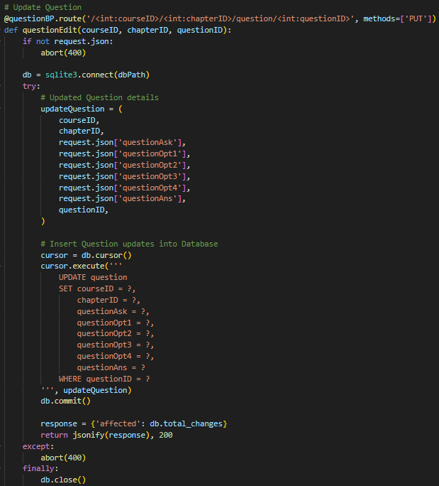

- http://127.0.0.1:5000/<int:courseID>/<int:chapterID>/question/<int:questionID> allows the application to delete a question with the specified courseID, chapterID, and questionID from “question”.
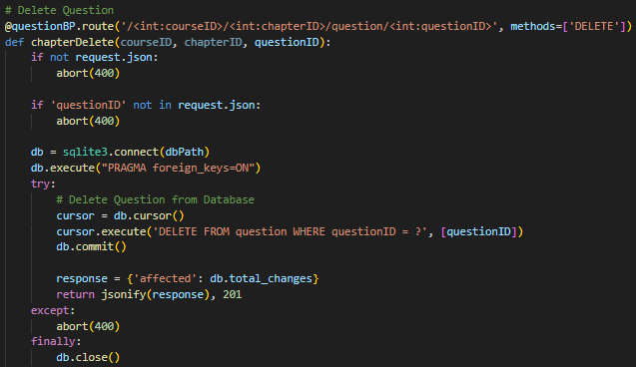
- http://127.0.0.1:5000/<int:courseID>/<int:chapterID>/note allows the application to retrieve the notes with the specified courseID and chapterID from the directory.
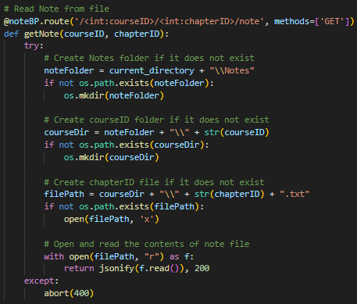

- http://127.0.0.1:5000/<int:courseID>/<int:chapterID>/note allows the application to update the notes specified courseID and chapterID from the directory.
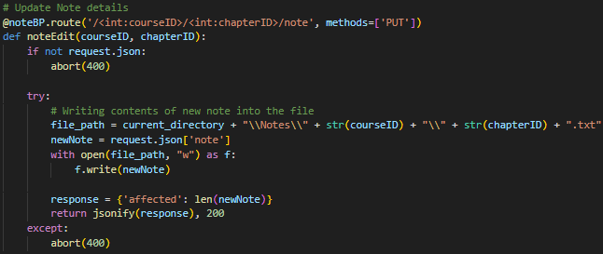
History.py
All the services regarding quiz history and question history uses “database.sqlite” as the primary database.
- http://127.0.0.1:5000/<int:courseID>/history allows the application to retrieve all quiz dates with the specified courseID from “history”.
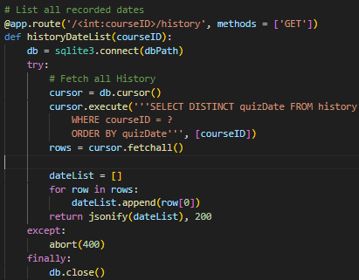
- http://127.0.0.1:5000/<int:courseID>/history/<int:accountID> allows the application to retrieve all quiz dates with the specified courseID and accountID from “history”.
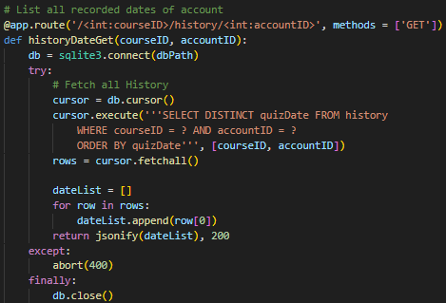
- http://127.0.0.1:5000/<int:courseID>/<string:quizDate>/history allows the application to retrieve all quiz attempts with the specified courseID and quizDate from “history”.
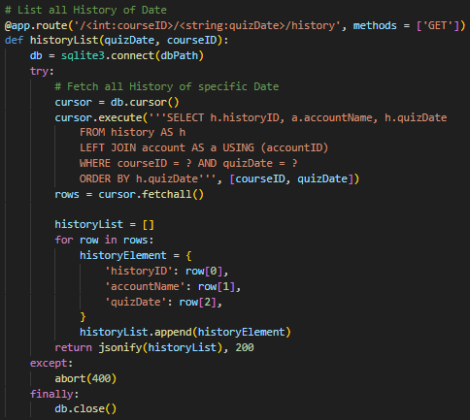

- http://127.0.0.1:5000/<int:courseID>/<string:quizDate>/history/<int:accountID> allows the application to retrieve all quiz attempts with the specified courseID, quizDate, and accountID from “history”.
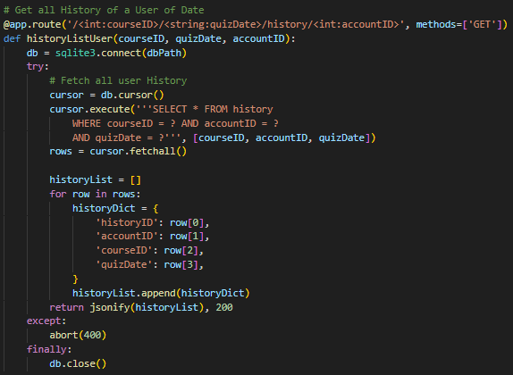
- http://127.0.0.1:5000/questionHistory/<int:historyID> allows the application to retrieve all question history with the specified historyID from “quesHistory”.
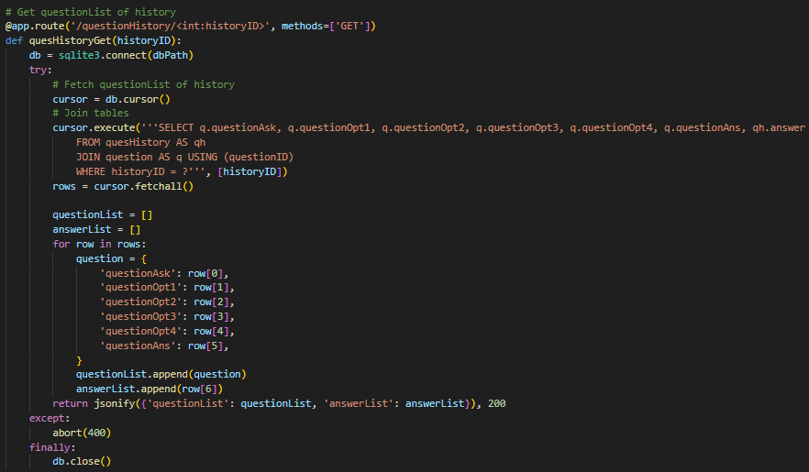
Quiz.py
All the services regarding quiz history and question history uses “database.sqlite” as the primary database.
- The application sends the list of questions and question number to the server. The server then randomizes the questions. Finally, the server sends the randomize list of question back to the application.
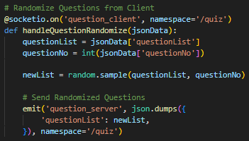
- The application sends the list of questions and list of answers to the server. The server then validates the list of answers with the correct answers of the list of questions. Finally, the server sends the number of correct answers, number of incorrect answers, and datetime of the quiz back to the application.
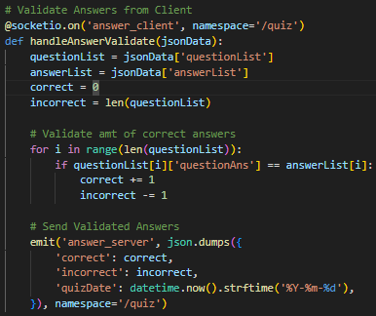

- The application sends the list of questions and list of answers to the server. The server then adds the new quiz attempt into “history” and “quesHistory”. The server does not return anything back to the application.
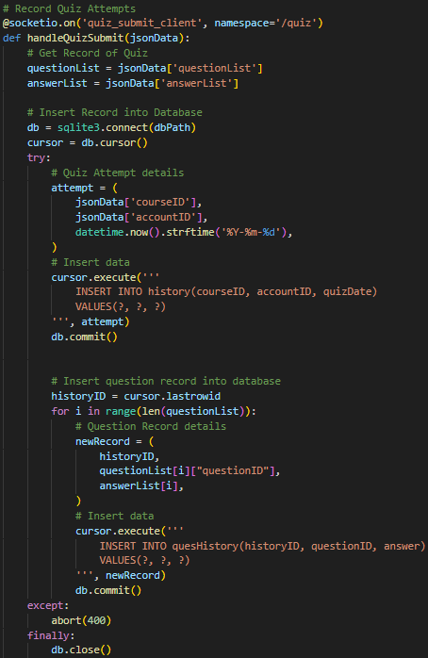

REFERENCES
npm. (2024). react-native-radio-buttons-group. [online] Available at: https://www.npmjs.com/package/react-native-radio-buttons-group.
npm. (2021). react-native-floating-action. [online] Available at: https://www.npmjs.com/package/react-native-floating-action.
npm. (2024). @react-native-community/checkbox. [online] Available at: https://www.npmjs.com/package/@react-native-community/checkbox.
npm. (2024). @react-native-picker/picker. [online] Available at: https://www.npmjs.com/package/@react-native-picker/picker.
npm. (2025). react-native-pager-view. [online] Available at: https://www.npmjs.com/package/react-native-pager-view.
npm. (2025). @react-native-vector-icons/material-icons. [online] Available at: https://www.npmjs.com/package/@react-native-vector-icons/material-icons.

‌

‌

END OF DOCUMENT

