UNIVERSITI TUNKU ABDUL RAHMAN

LEE KONG CHIAN FACULTY OF ENGINEERING AND SCIENCE

UECS2344 SOFTWARE DESIGN

ASSIGNMENTS

June 2025 Trimester

PEER FEEDBACK EVALUATION SYSTEM

NO. | STUDENT NAME | STUDENT ID | Practical Group
1. | QUAK JING | 2205378 | P3
2. | LEON SIOW YI HONG | 2204403 | P3
3. | NG ZONG HAO | 2302020 | P3
4. | KOH KHAI JECK | 2304740 | P2

Table of Contents
Part 1: Roles and Responsibilities of Team Members 1
Part 2: Software Requirement Design 2
2.1 Analysis Class Diagram 2
2.2 Use Case Diagram 3
2.3 Use Case Descriptions 4
2.4 Assumptions 13
Part 3(a): Software Design 14
3.1 Sequence Diagram 14
3.1.1 Login Account 14
3.1.2 Create Account 15
3.1.3 Manage Profile 16
3.1.4 Submit Peer Feedback 17
3.1.5 Update Feedback 18
3.1.6 View Feedback 19
3.1.7 Generate Feedback Report 20
3.1.8 Create Evaluation Activity 21
3.2 Design Class Diagram 22
3.3 Design Class Diagram (Modified) 23
3.4 Package Diagram 24
Part 4: Team Reflection 25

Part 1: Roles and Responsibilities of Team Members
Role | Responsibilities
Quak Jing
- Use Case Auditor  - UML Auditor  - Java Developer | - Use Case Diagram and Use Case Description modification and improvement  - Sequence Diagram auditing  - Design Class Diagram modification and improvement  - App Package development
Leon Siow Yi Hong
- Analysis Class Diagram Designer  - UML Auditor  - Java Developer | - Analysis Class Diagram design and development  - Use Case Diagram and Use Case Description modification and improvement  - Design Class Diagram auditing  - Domain Package Development
Ng Zong Hao
- Sequence Diagram Designer  - Design Class Diagram Designer  - Package Diagram Designer  - Software Reviewer | - Sequence Diagram design and development  - Design Class Diagram design and development  - Package Diagram design and development
Koh Khai Jeck
- Use Case Designer  - Sequence Diagram Designer  - Design Class Diagram Designer  - Software Reviewer | - Use Case Diagram and Use Case Description design  - Sequence Diagram design and development  - Design Class Diagram design and development

Part 2: Software Requirement Design

2.1 Analysis Class Diagram
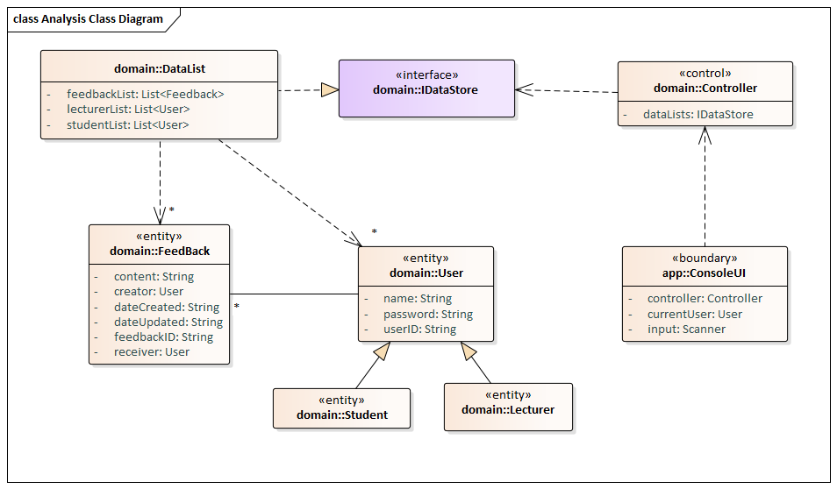

2.2 Use Case Diagram
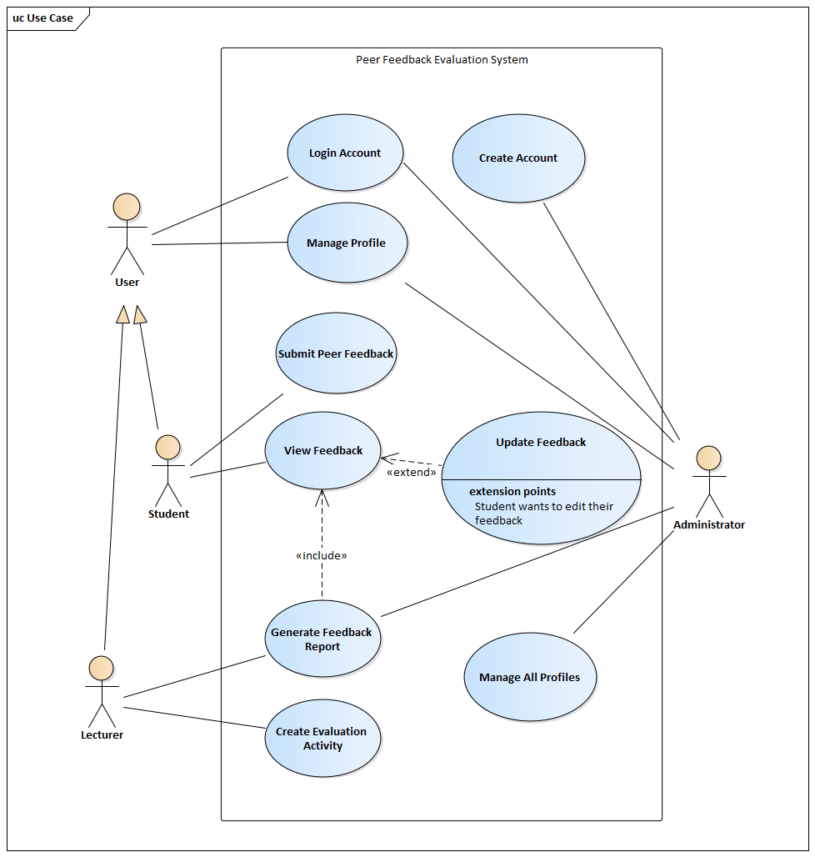

2.3 Use Case Descriptions
Use Case Name: LOGIN ACCOUNT |  | ID: C001 | Importance Level: High
Primary Actor: USER | Use Case Type: DETAILED, ESSENTIAL
Stakeholders and Interests:
Users – to access the peer feedback evaluation system using their personal account.

Brief Description:
This use case describes the process of login to pre-existing user accounts.

Trigger:
A user wants to access their account to use the peer feedback evaluation system.

Relationships:
Association : User
Include : N/A
Extend : N/A
Generalization: N/A

Normal Flow of Events:
- The user enters their user ID and password in the login interface.
- The user submits the login form.
- The peer feedback evaluation system searches for user ID and passwords of existing accounts. Perform 2.1, or 2.2.
  - If there are no records for the entered user ID and/or password, the user is prompted to re-enter their username and password. Continue to flow no. 1.
  - If there are records for entered user ID as well as password and both are correct, the user is granted access to the peer feedback evaluation system using their account.

Sub-flows:
N/A
Alternate/Exceptional Flows:
- The user must have a pre-existing account.

Use Case Name: CREATE ACCOUNT |  | ID: C002 | Importance Level: High
Primary Actor: ADMINISTRATOR | Use Case Type: DETAILED, ESSENTIAL
Stakeholders and Interests:
Administrator – to create an account using user ID and password of user.

Brief Description:
This use case describes the process of creating a new account.

Trigger:
An administrator wants to create a new account for new users of the peer feedback evaluation system who do not have an existing account.

Relationships:
Association : Administrator
Include : N/A
Extend : N/A
Generalization: N/A

Normal Flow of Events:
- The peer feedback evaluation system prompts the administrator to create a new account.
- The administrator enters the user ID and password of the user.
- The administrator enters the personal details of the user, including name, phone number, email address and role.
- The administrator reviews the account information that was entered.
- The administrator submits the sign-up form.
- The peer feedback evaluation system saves and creates a new user account based on the information given by the user.

Sub-flows:
N/A
Alternate/Exceptional Flows:
- The user must not have a pre-existing account.

Use Case Name: MANAGE PROFILE |  | ID: C003 | Importance Level: High
Primary Actor: USER | Use Case Type: DETAILED, ESSENTIAL
Stakeholders and Interests:
Users – to update the personal information of their accounts.

Brief Description:
This use case describes the process of updating the account information of a user.

Trigger:
A user wants to update their personal information of their account.

Relationships:
Association : USER
Include : N/A
Extend : N/A
Generalization: N/A

Normal Flow of Events:
- The peer feedback evaluation system displays the account information to the user.
- The user edits the account information.
- The user reviews the updates made to their account.
- The user submits the updates.
- The peer feedback evaluation system saves the updates made to the user account.

Sub-flows:
N/A
Alternate/Exceptional Flows:
- The user must have a valid login to access the peer feedback evaluation system.
- The updated account information must be valid
.

Use Case Name: SUBMIT PEER FEEDBACK |  | ID: C004 | Importance Level: High
Primary Actor: STUDENT | Use Case Type: DETAILED, ESSENTIAL
Stakeholders and Interests:
Students – to create and submit feedback of a selected peer in the selected evaluation activity.

Brief Description:
This use case describes the process of creating and submitting feedback of a peer in an evaluation activity using the peer feedback evaluation system.

Trigger:
A student wants to submit feedback of a peer in an evaluation activity.

Relationships:
Association : STUDENT
Include : N/A
Extend : N/A
Generalization: N/A

Normal Flow of Events:
- The student selects an evaluation activity. Perform 1.1 or 1.2
  - If the deadline for the evaluation activity has already passed, the peer feedback evaluation system displays a message “Deadline has passed, no changes allowed”. Continue to flow no. 1.
  - If the deadline for the evaluation activity has not passed, the peer feedback evaluation system displays a list of peers that are currently participating in the evaluation activity.
- The student selects a peer.
- The peer feedback evaluation system creates a feedback form.
- The student enters their feedback of the selected peer.
- The student submits the feedback form.
- The peer feedback evaluation system records the feedback form.

Sub-flows:
N/A
Alternate/Exceptional Flows:
- The student must have valid login to access the peer feedback evaluation system.
- The list of evaluation activities and peers must not be empty.

Use Case Name: UPDATE FEEDBACK |  | ID: C005 | Importance Level: High
Primary Actor: STUDENT | Use Case Type: DETAILED, ESSENTIAL
Stakeholders and Interests:
Students – to update the contents of the feedback that they have submitted.

Brief Description:
This case describes the process of updating feedback that was submitted by a student in an evaluation activity.

Trigger:
A student wants to edit the contents of the feedback they have submitted during the evaluation activity.

Relationships:
Association : Student
Include : N/A
Extend : View Feedback
Generalization: N/A

Normal Flow of Events:
- The peer feedback evaluation system displays the feedback form alongside its original contents to the user.
- The student edits the content of the feedback form.
- The student reviews the edits made to the feedback form.
- The student submits the feedback form.
- The peer feedback evaluation system saves the updates made to the feedback form.

Sub-flows:
N/A
Alternate/Exceptional Flows:
- The student must have valid login to access the peer feedback evaluation system.
- Once the student successfully updates the feedback, the student will be sent to the view feedback interface. Execute C006 View Feedback.

Use Case Name: VIEW FEEDBACK |  | ID: C006 | Importance Level: High
Primary Actor: USER | Use Case Type: DETAILED, ESSENTIAL
Stakeholders and Interests:
Users – to view the contents the feedback the has been selected.

Brief Description:
This use case describes the process of displaying the feedback that was submitted by students during a evaluation activity.

Trigger:
A user wants to view the contents of the selected feedback.

Relationships:
Association : User
Include : N/A
Extend : N/A
Generalization: N/A

Normal Flow of Events:
- The student selects an evaluation activity. Perform 1.1 or 1.2
  - If the deadline for the evaluation activity has already passed, the peer feedback evaluation system displays a message “Deadline has passed, no changes allowed”. Continue to flow no. 1.
  - If the deadline for the evaluation activity has not passed, the peer feedback evaluation system displays a list of all feedback submitted during the selected evaluation activity.
- The user reviews the list of feedback.
- The user selects a feedback from the list.
- The peer feedback evaluation system displays the contents of the selected feedback to the user.

Sub-flows:
N/A
Alternate/Exceptional Flows:
- The student must have valid login to access the peer feedback evaluation system.
- The list of evaluation activities and feedback must not be empty.

Use Case Name: GENERATE FEEDBACK REPORT |  | ID: C007 | Importance Level: High
Primary Actor: LECTURER, ADMINISTRATOR | Use Case Type: DETAILED, ESSENTIAL
Stakeholders and Interests:
Lecturer, Administrator – to generate a summary of the evaluation activity that was created in report format.

Brief Description:
This use case describes the process of generating a feedback report of a selected evaluation activity.

Trigger:
A lecturer or administrator wants to view a report of the feedback that was submitted by the students during an evaluation activity.

Relationships:
Association : Lecturer, Administrator
Include : View Feedback
Extend : N/A
Generalization: N/A

Normal Flow of Events:
- The lecturer or administrator selects an evaluation activity.
- The peer feedback evaluation system generates a summary of the feedback submitted during the selected evaluation activity in a report.
- The lecturer or administrator reviews the report generated.

Sub-flows:
N/A
Alternate/Exceptional Flows:
- The lecturer or administrator must have valid login to access the peer feedback evaluation system.
- The list of evaluation activities must not be empty.
- Once the lecturer or administrator reviewed the report generated, they may view the individual feedback submitted by the students. Execute C006 View Feedback.
Use Case Name: CREATE EVALUATION ACTIVITY |  | ID: C008 | Importance Level: High
Primary Actor: LECTURER | Use Case Type: DETAILED, ESSENTIAL
Stakeholders and Interests:
Lecturer – to create an evaluation activity to allow students to submit peer feedback.

Brief Description:
This use case describes the process of creating an evaluation activity.

Trigger:
A lecturer wants to create an evaluation activity to let students submit their peer feedback.

Relationships:
Association : Lecturer
Include : N/A
Extend : N/A
Generalization: N/A

Normal Flow of Events:
- The lecturer selects the course they are currently teaching.
- The peer feedback evaluation system prompts the lecturer to create a new evaluation activity.
- The lecturer enters the name and deadline for the evaluation activity.
- The lecturer reviews the details entered.
- The peer feedback evaluation system creates the evaluation activity and adds all students who are currently studying the course as participants.

Sub-flows:
N/A
Alternate/Exceptional Flows:
- The lecturer must have valid login to access the peer feedback evaluation system.
- The list of courses must not be empty.
- The deadline for the evaluation activity must be valid.
- The students who are enrolled in the course must not be empty.

Use Case Name: MANAGE ALL PROFILES |  | ID: C009 | Importance Level: High
Primary Actor: ADMINISTRATOR | Use Case Type: DETAILED, ESSENTIAL
Stakeholders and Interests:
Administrator – to perform update or delete actions towards all accounts of the peer feedback evaluation system.

Brief Description:
This use case describes the process of updating and deleting accounts in the peer feedback evaluation system.

Trigger:
The administrator wants to update or delete a specific account in the peer feedback evaluation system.

Relationships:
Association : Administrator
Include : N/A
Extend : N/A
Generalization: N/A

Normal Flow of Events:
- The administrator selects an account role.
- The peer feedback evaluation system displays a list of accounts based on the account role selected.
- The administrator selects an account from the list.
- The peer feedback evaluation system displays all the information of the selected account. Perform 4.1 or 4.2
  - If the administrator chooses to delete the account, the account is deleted and the use case ends.
  - If the administrator chooses to update the account, the peer feedback evaluation system displays a form with the current information of the account.
- The administrator edits the information of the account.
- The administrator reviews the new information.
- The administrator submits the form.
- The peer feedback evaluation system saves the changes made on the account.

Sub-flows:
N/A
Alternate/Exceptional Flows:
- The administrator must have valid login to access the peer feedback evaluation system.
- The list of accounts must not be empty.

2.4 Assumptions
- Lecturer and tutors are the same entity named as “Lecturer”.
- Student and lecturer accounts are provided by the administrator.
- Feedback records are only generated on demand when requested by lecturer or administrator.
- Students are only able to view the feedback they submitted.
- Lecturers are only able to view the submitted feedback of the evaluation activities they created.
- System administrators can view all submitted feedback.

Part 3(a): Software Design

3.1 Sequence Diagram

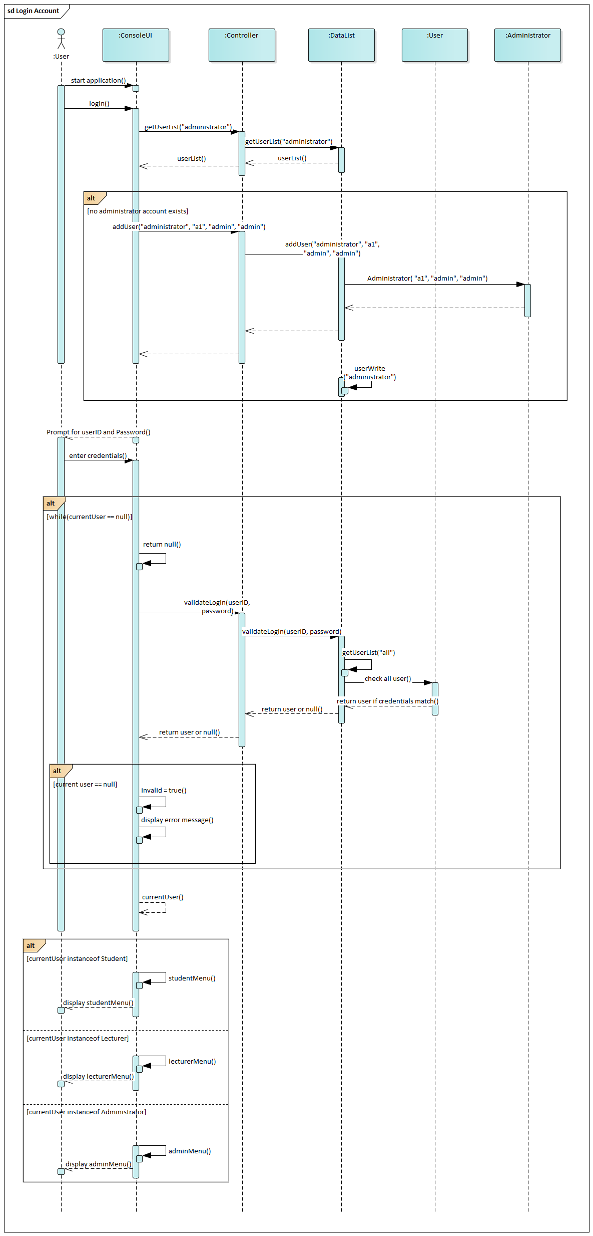
3.1.1 Login Account

3.1.2 Create Account
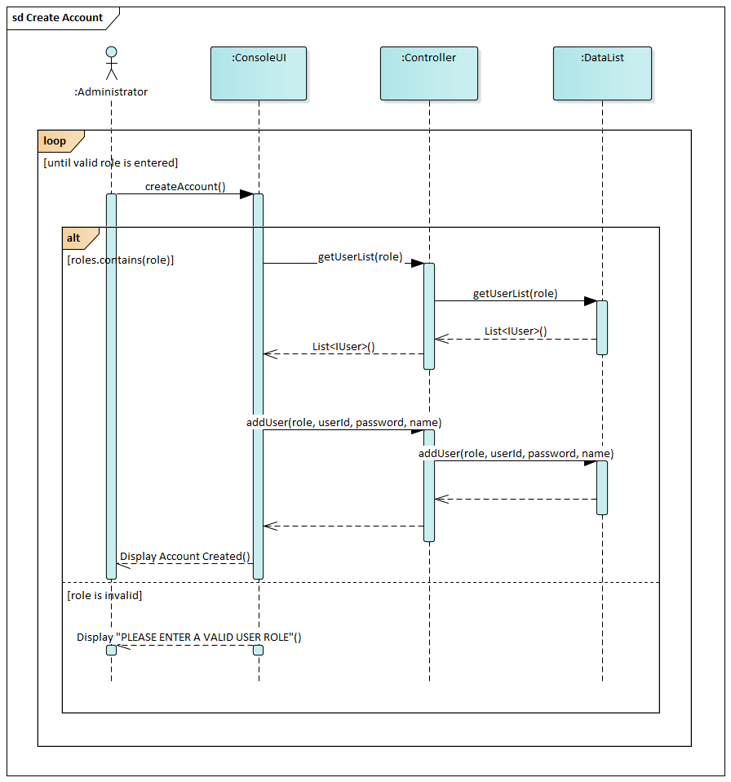

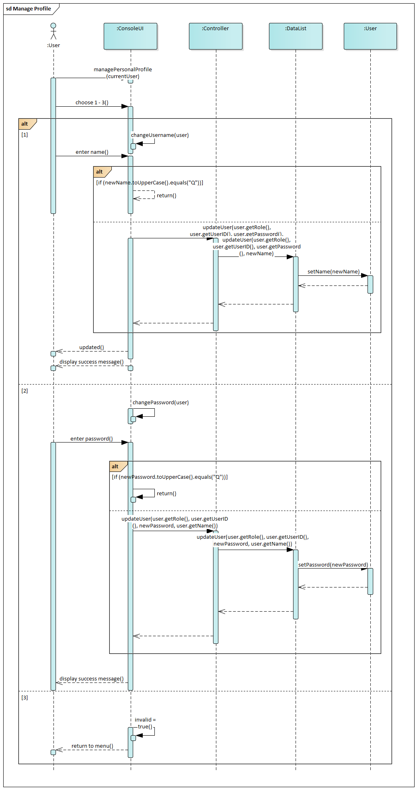
3.1.3 Manage Profile

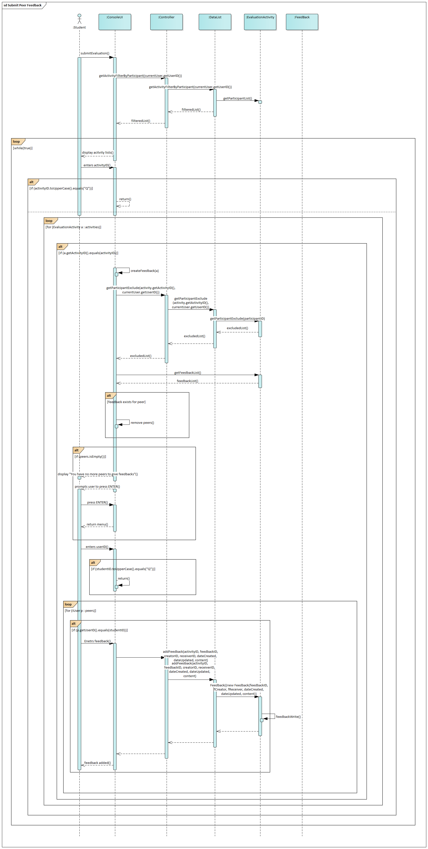
3.1.4 Submit Peer Feedback

3.1.5 Update Feedback
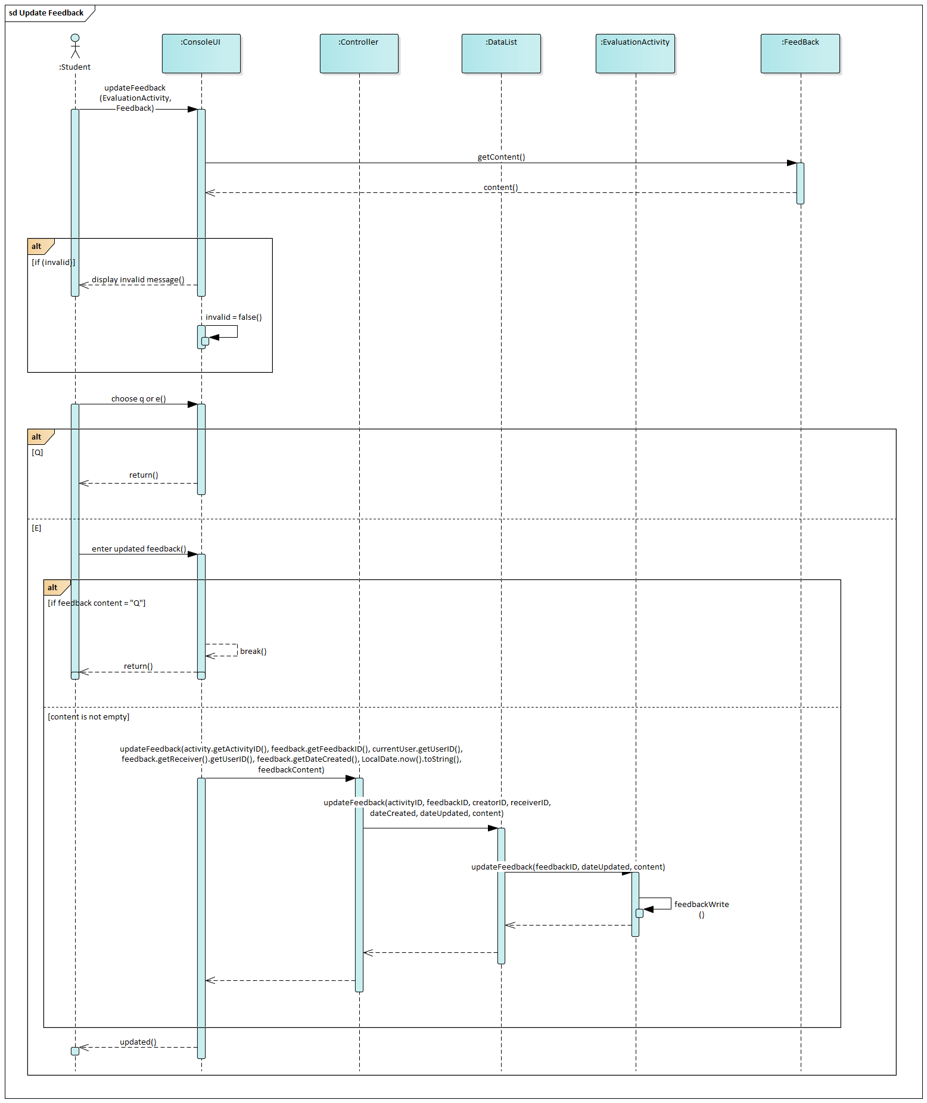

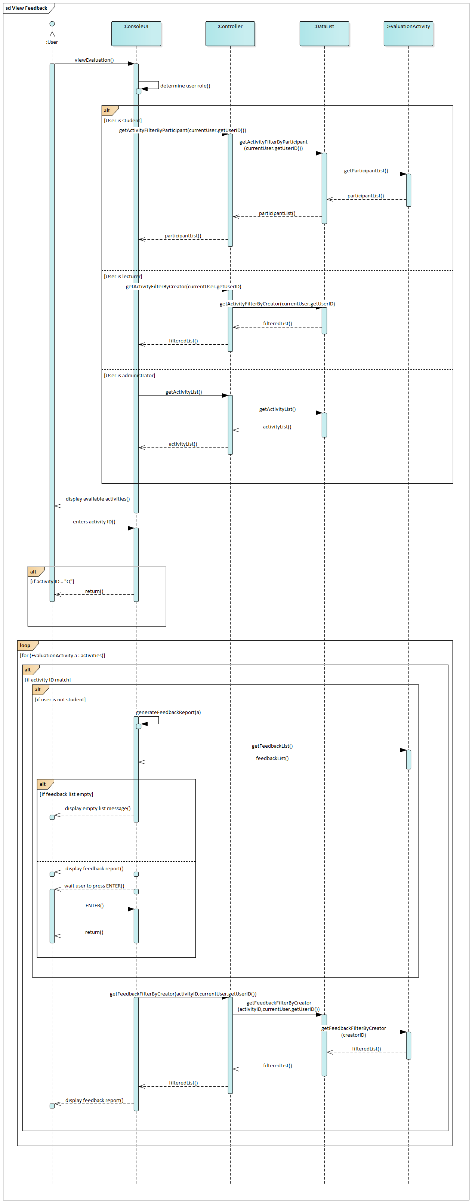
3.1.6 View Feedback

3.1.7 Generate Feedback Report
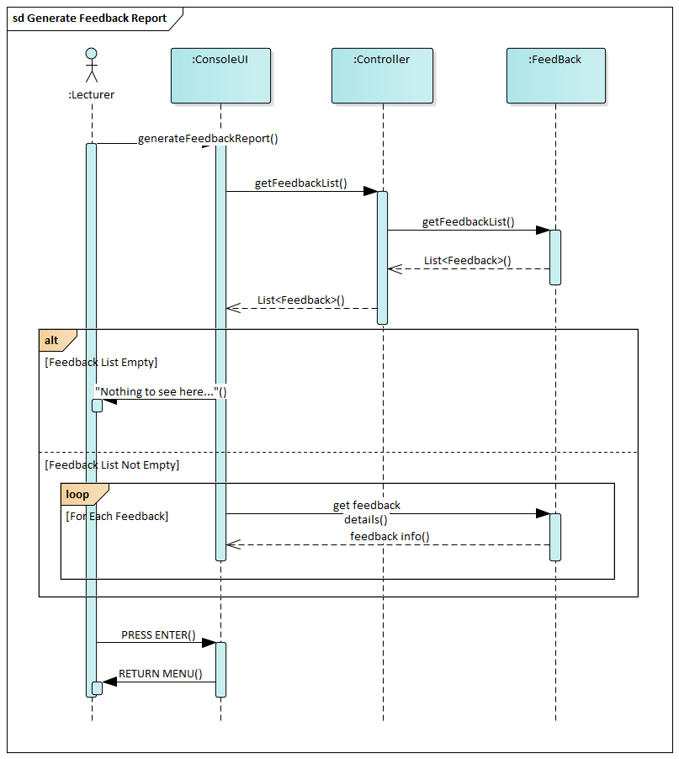

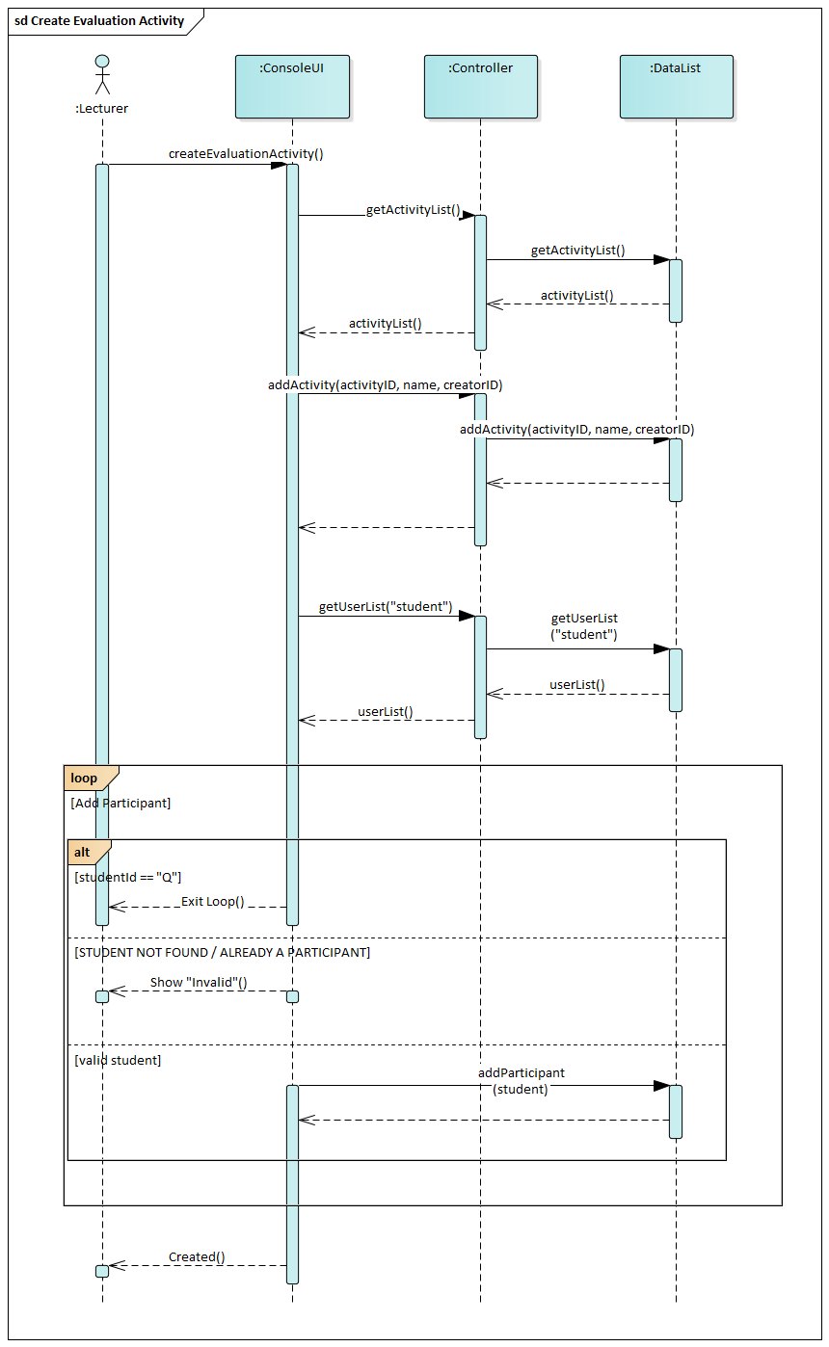
3.1.8 Create Evaluation Activity

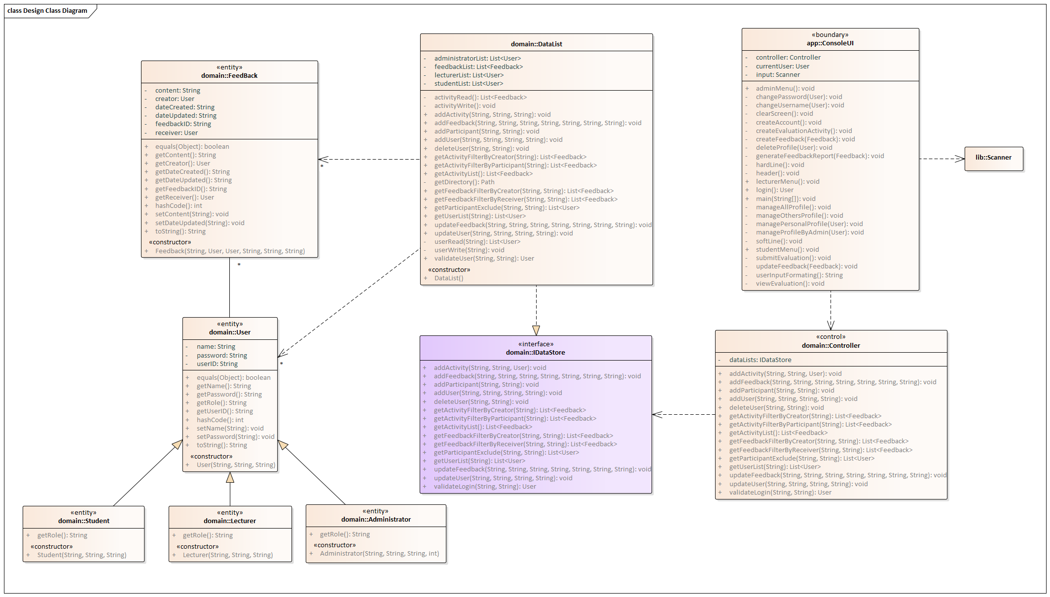
3.2 Design Class Diagram

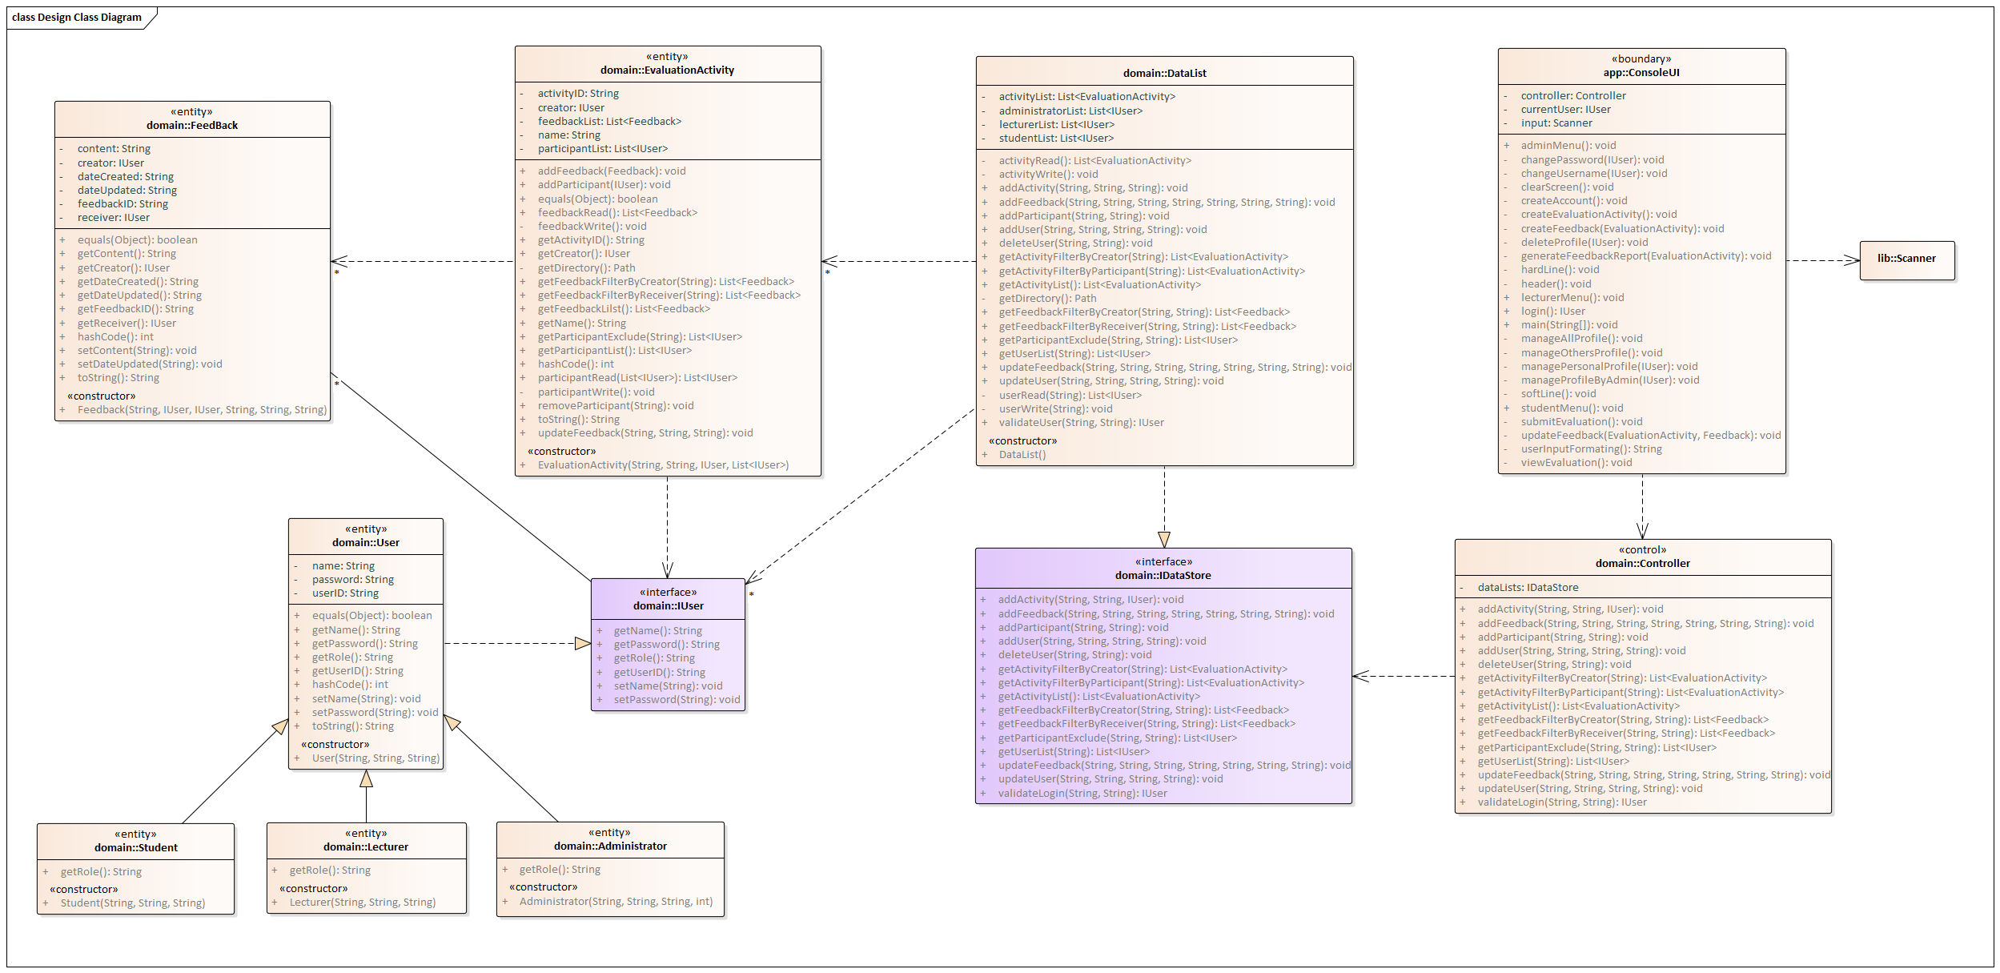
3.3 Design Class Diagram (Modified)

3.4 Package Diagram
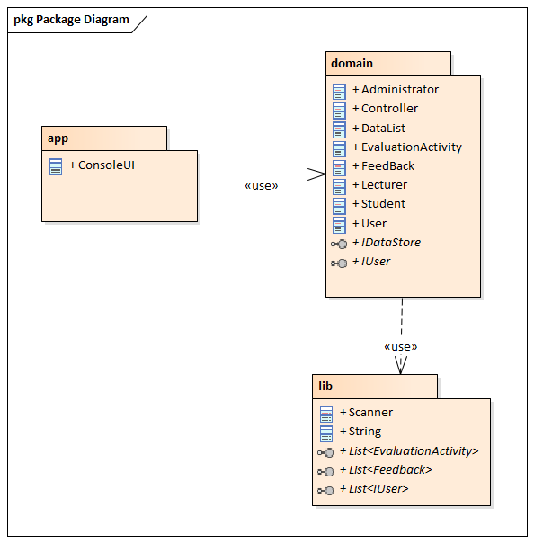

Part 4: Team Reflection
Each member fulfilled their roles across the design, development, and testing process. Koh Khai Jeck led the design of use cases, developed sequence diagrams, and conducted software review. Leon Siow Yi Hong designed the analysis class diagram, audited the UML diagrams, finalized the design class diagram, and developed the domain package of the software. Ng Zong Hao worked with Koh Khai Jeck to create sequence diagrams, updated the design class diagram, and reviewed the final software. Quak Jing audited the use cases and UML diagrams, finalized the design class diagram, and developed the app package of the software.
The distribution of tasks allowed members to streamline their part, which would then be reviewed by other members to catch inconsistencies and errors. The reviews improved design quality, such as Koh Khai Jeck suggestion to create evaluation activity to contain the feedback, and Leon Siow Yi Hong suggestion to create interface for users to improve compatibility.
The usage of high-level diagrams provided the design team with a structural view of the software, ensuring the app package and domain package would interact seamlessly. The low-level diagrams allowed team members to design, develop, and review the software to ensure all requirements are completely fulfilled.

