UNIVERSITI TUNKU ABDUL RAHMAN

LEE KONG CHIAN FACULTY OF ENGINEERING AND SCIENCE

UECS1144 OBJECT-ORIENTED APPLICATION DEVELOPMENT

GROUP ASSIGNMENT

June 2024 Trimester

No. | STUDENT NAME | PROGRAMME | Practical Group
1. | Leon Siow Yi Hong  (2204403) | SE | P3
2. | Quak Jing  (2205378) | SE | P3
3. | Koh Khai Jeck  (2304740) | SE | P3
4. | Loo Ting Hong  (2205184) | SE | P4

Table Of Contents:
Content | Page(s)
1.0 System Requirements | 3 - 4
2.0 UML | 5
3.0 Sample Accounts to Login | 6
4.0 Sample Inputs/Outputs  4.1 Login  4.2 Course Menu  4.3 Main Menu  4.4 Account Menu  4.5 Chapter Menu  4.6 Question Menu  4.7 Quiz Menu  4.8 Quiz Report Menu | 7 - 45  7 – 9  10 – 14  15 – 16  17 – 23  24 – 29  30 – 34  35 – 40  41 - 45
5.0 Appendix | 46 - 47

1.0 System Requirements:
ID | Requirements
SR001 | The Quiz Generator shall allow users and administrators to login to their personal accounts using their registered user ID and password.
SR002 | The Quiz Generator shall allow users to sign up for a new account.
SR003 | The Quiz Generator shall allow users and administrators to update the information of their personal accounts.
SR004 | The Quiz Generator shall allow users and administrators to view a list of existing courses.
SR005 | The Quiz Generator shall allow users and administrators to select their desired course from the list of existing courses.
SR006 | The Quiz Generator shall allow administrators to create new courses.
SR007 | The Quiz Generator shall allow administrators to update the information of existing courses.
SR008 | The Quiz Generator shall allow administrators to delete existing courses.
SR009 | The Quiz Generator shall allow administrators to view a list of existing chapters of the selected course.
SR010 | The Quiz Generator shall allow administrators to select their desired chapter from the list of existing chapters.
SR011 | The Quiz Generator shall allow administrators to create new chapters for the selected course.
SR012 | The Quiz Generator shall allow administrators to update the information of existing chapters.
SR013 | The Quiz Generator shall allow administrators to delete existing chapters.
SR014 | The Quiz Generator shall allow administrators to view a list of existing questions of the selected chapter.
SR015 | The Quiz Generator shall allow administrators to create new questions for the selected chapter.
SR016 | The Quiz Generator shall allow administrators to update the information of existing questions.
SR017 | The Quiz Generator shall allow administrators to delete existing questions.
SR018 | The Quiz Generator shall allow administrators to view a list of existing accounts.
SR019 | The Quiz Generator shall allow administrators to create new accounts.
SR020 | The Quiz Generator shall allow administrators to update the information of existing accounts.
SR021 | The Quiz Generator shall allow administrators to delete existing accounts.
SR022 | The Quiz Generator shall allow users to start a Quiz based on their selected course.
SR023 | The Quiz Generator shall allow users to view their results upon completion of the Quiz.
SR024 | The Quiz Generator shall allow users to view their selected answer and the correct answer to each question of the Quiz.
SR025 | The Quiz Generator shall allow the users to view the details of their past attempts on the Quiz of the selected course.
SR026 | The Quiz Generator shall allow the users to view a summary of their results of all Quiz attempts of the selected course.
SR027 | The Quiz Generator shall allow administrators to view all Quiz attempts of users for the selected course.
SR028 | The Quiz Generator shall allow administrators to view a summary of the results of all Quiz attempts of a selected user for the selected course.

2.0 UML
Class Diagram is included in the Class Diagram Folder as pdf format. A png format is also included as backup in case the pdf file is too blurry. The name of the file is:
- “Class Diagram – Final”

3.0 Sample Accounts to Login:
- User Accounts:
User ID : ALICE528
Password : 040528

User ID : SMITH478
Password : 472816

User ID : CHARLIE7
Password : CB5487

- Admin Accounts:
User ID : KIRITO27
Password : 181018

User ID : WLSON048
Password : 048048

User ID : YXIAO728
Password : yxiao17028

Note: If no administrator account is detected in the database, a default account is created:
User ID : ADMIN001
Password : admin001

4.0 Sample Inputs/Outputs

4.1 Login

4.1.1 Login Menu
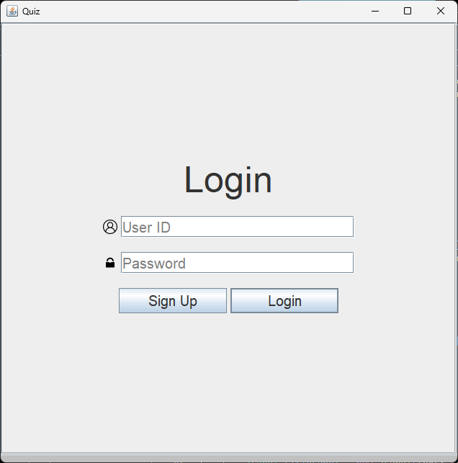
Figure 4.1.1(1) Login Menu
Input:
- Enter User ID and Password of either user or administrator accounts and click on the “Login” button to login to the Quiz Generator.
- Upon successful validation, the user will be redirected to the Course Select Menu.
- If the user clicks on the “Sign Up” button, they will be redirected to the Sign-Up Menu.

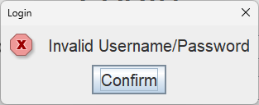
Figure 4.1.1(2) Error Message
- If the user enters a User ID and Password that does not match any accounts in the database, the error message above would be displayed, and the text fields would be cleared.

4.1.2 Sign-Up Menu
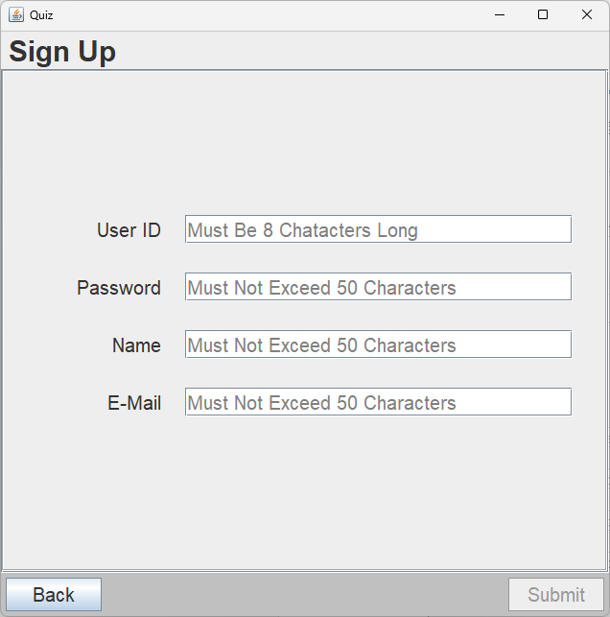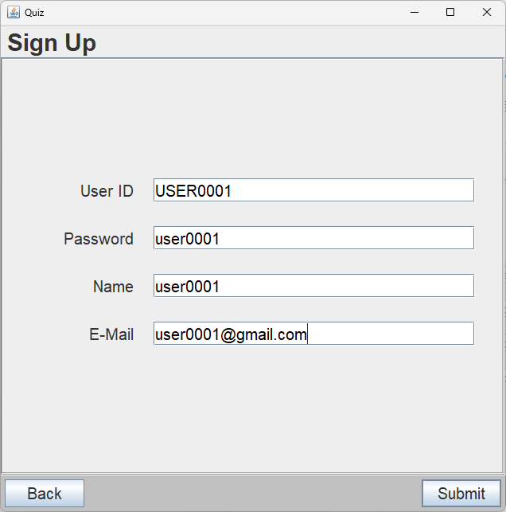
Figure 4.1.2(1) Sign-Up Menu
Inputs:
- Enter the text fields with relevant information and according to the constraints stated in the hint section and tooltip of each text field.
- Only when all constraints are satisfied shall the “Submit” button be enabled.
Buttons:
- Back : Returns the user back to the Login Menu.
- Submit : Displays the Sign-Up Confirmation Panel.
Constraints:
- User ID : Must be 8 characters long.
- Password : Must not exceed 50 characters.
- Name : Must not exceed 50 characters.
- E-Mail : Must not exceed 50 characters.

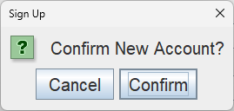
Figure 4.1.2(2) Sign-Up Confirmation Panel
Buttons:
- Cancel : Closes the confirmation panel.
- Confirm : Creates and writes the new account with the information entered and redirects the user to the Course Select Menu.

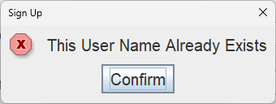
Figure 4.1.2(3) Error Messages
- If the user enters a User ID or Name that is not unique, the system will display an error message shown above according to the data that is repeated.

4.2 Course Menu

4.2.1 Course Select Menu
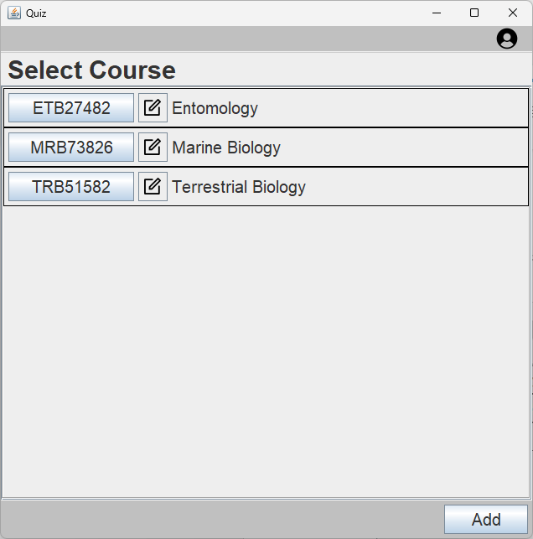 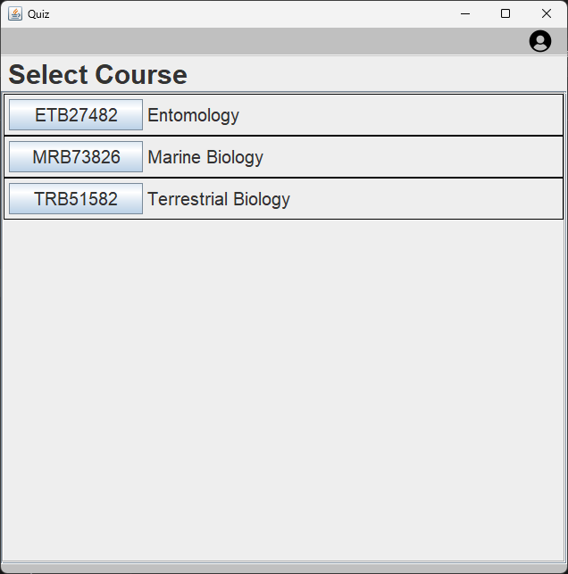 Figure 4.2.1(1) Course Menu (Admin) Figure 4.2.1(2) Course Menu (User)
Buttons:
- Each button in the list selects the corresponding course and redirects the user to the Main Menu.
- The edit button beside each button selects the corresponding course to be edited in the Course Edit/Delete Menu.
- Add : Redirects the user to the Course Create Menu.

4.2.2 Course Create Menu
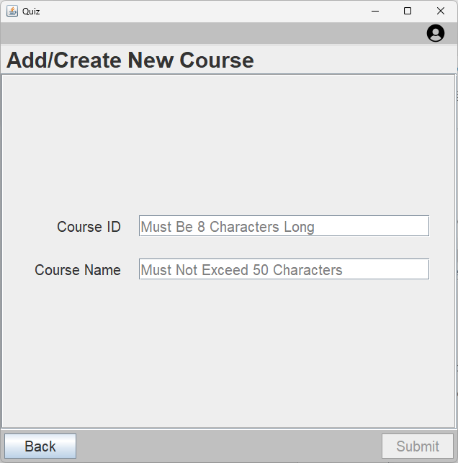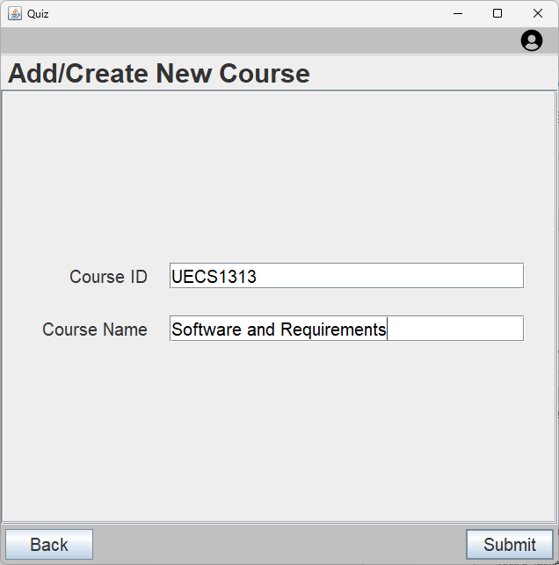
Figure 4.2.2(1) Course Create Menu
Inputs:
- Enter relevant information into each field according to the constraints stated in the hint/tooltip section of each text field.
- Only when all constraints are satisfied shall the “Submit” button be enabled.
Buttons:
- Back : Returns the user back to the Course Select Menu.
- Submit : Displays the Course Create Confirmation Panel.
Constraints:
- Course ID : Must be 8 characters long.
- Course Name : Must not exceed 50 characters.

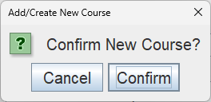
Figure 4.2.2(2) Course Create Confirmation Panel
Buttons:
- Cancel : Closes the confirmation panel.
- Confirm : Creates and writes the new course with the information entered and returns the user back to the Course Select Menu.

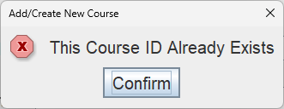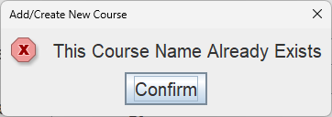
Figure 4.2.2(3) Error Messages
- If the data entered for Course ID or Course Name is not unique, the system will display an error message shown above according to the field that is repeated.

4.2.3 Course Edit/Delete Menu
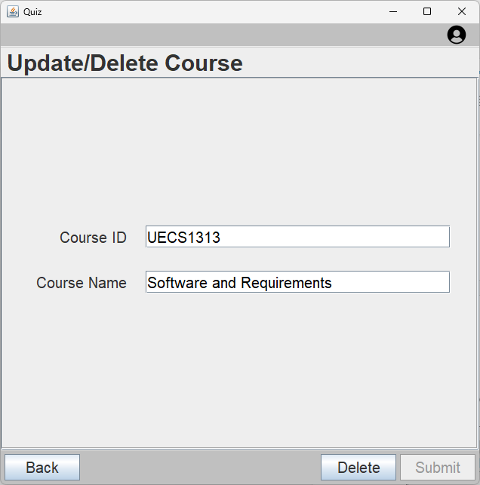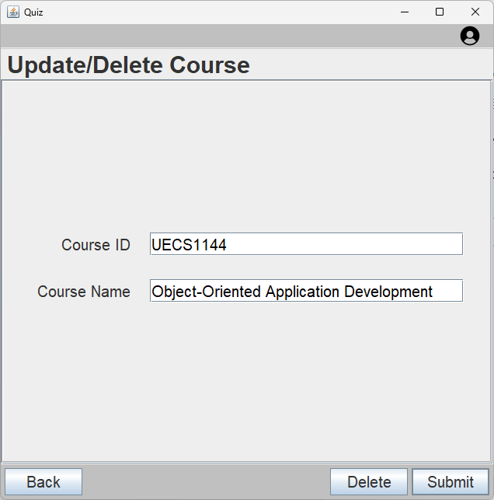
Figure 4.2.3(1) Course Edit/Delete Menu
Input:
- Edit the information in the desired field according to the constraints stated in the hint/tooltip section of the text field.
- Only when the constraints are met shall the submit button be enabled.
Buttons:
- Back : Returns the user back to the Course Select Menu.
- Delete : Displays the Course Delete Confirmation Panel.
- Submit : Displays the Course Edit Confirmation Panel.
Constraints:
- Course ID : Must be 8 characters long.
- Course Name : Must not exceed 50 characters.

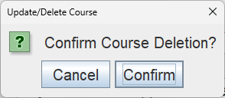
Figure 4.2.3(2) Course Delete Confirmation Panel
Buttons:
- Cancel : Closes the confirmation panel.
- Confirm : Deletes the course from the list and returns the user back to the Course Select Menu.

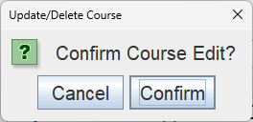
Figure 4.2.3(3) Course Edit Confirmation Panel
Buttons:
- Cancel : Closes the confirmation panel.
- Confirm : Edits and writes the new information of the course and returns the user back to the Course Select Menu.

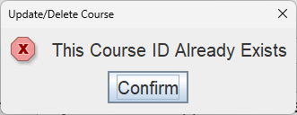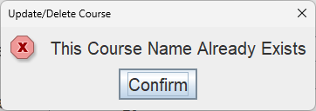
Figure 4.2.3(4) Error Messages
- If the data entered for Course ID or Course Name is not unique, the system will display an error message shown above according to the field that is repeated.

4.3 Main Menu
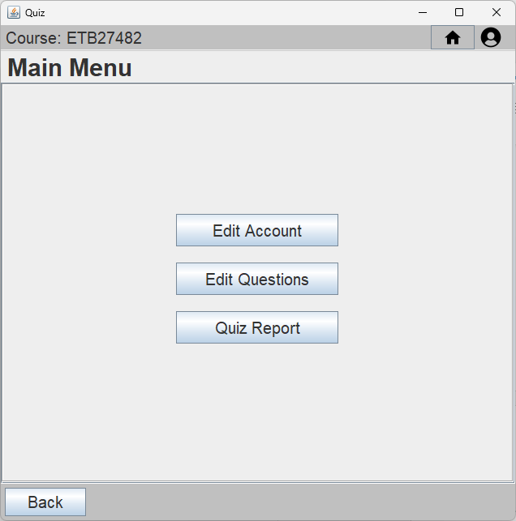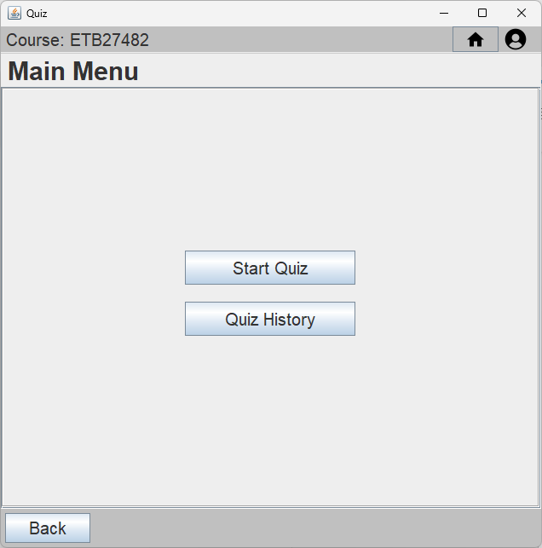
Figure 4.3(1) Main Menu (Admin) Figure 4.3(2) Main Menu (User)
Buttons:
- Home (Icon) : Returns the user back to the Main Menu.
- User (Icon) : Displays the Account Dropdown.
- Back : Returns the user back to the Course Select Menu.
- Admin
  - Edit Account : Redirects the user to the Account Type Select Menu.
  - Edit Questions: Redirects the user to the Chapter Select Menu.
  - Quiz Report : Redirects the user to the Quiz Report User Selection Menu.
- User
  - Start Quiz : Redirects the user to the Quiz Chapter Select Menu.
  - Quiz History : Redirects the user to the Quiz Report Attempt Select Menu.

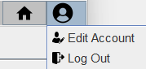
Figure 4.3(3) Account Dropdown
Buttons:
- Edit Account : Redirects the user to the Account Self Edit Menu.
- Log Out : Log the user out of the system and returns the user to the Login Menu.

4.4 Account Menu

4.4.1 Account Type Select Menu
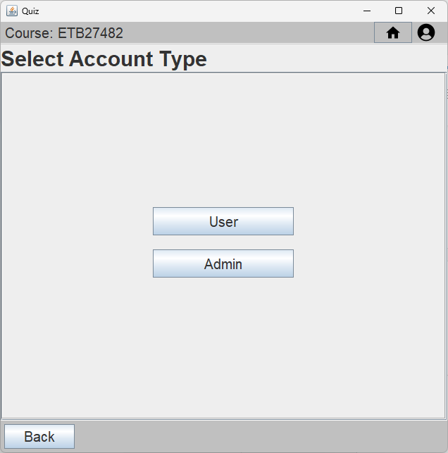
Figure 4.4.1 Account Type Select Menu
Buttons:
- Back : Returns the user back to the Main Menu.
- User : Redirects the user to the Account Select Menu with only User Accounts.
- Admin : Redirects the user to the Account Select Menu with only Admin Accounts.

4.4.2 Account Select Menu
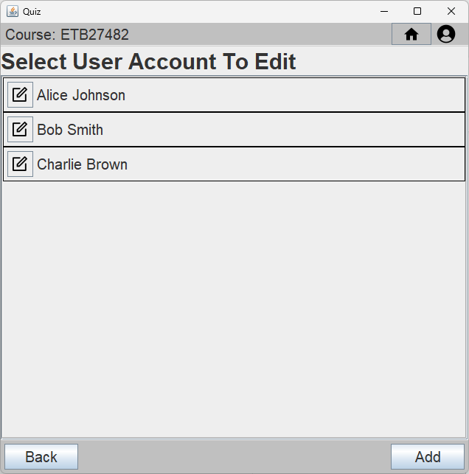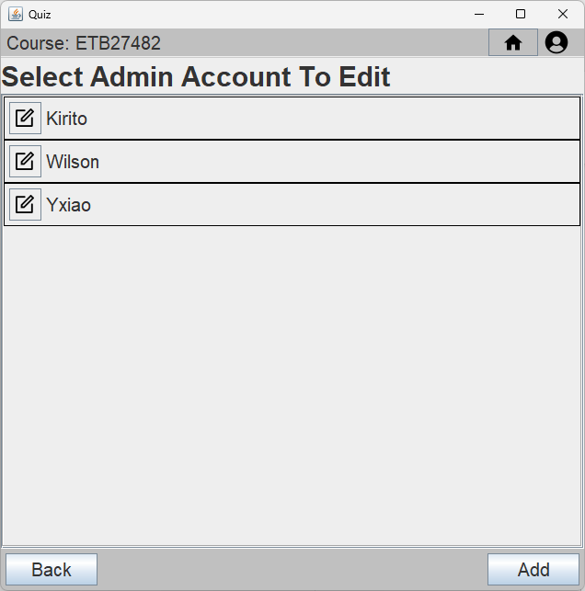
Figure 4.4.2(1) Account Select (User) Figure 4.4.2(2) Account Select (Admin)
Buttons:
- Each button in the list selects the corresponding account to be edited in the Account Edit/Update Menu.
- Back : Returns the user back to the Account Type Select Menu.
- Add : Redirects the user to the Account Create Menu.

4.4.3 Account Create Menu
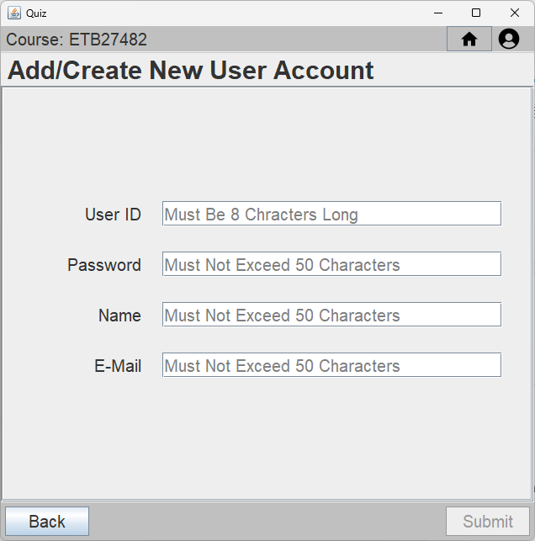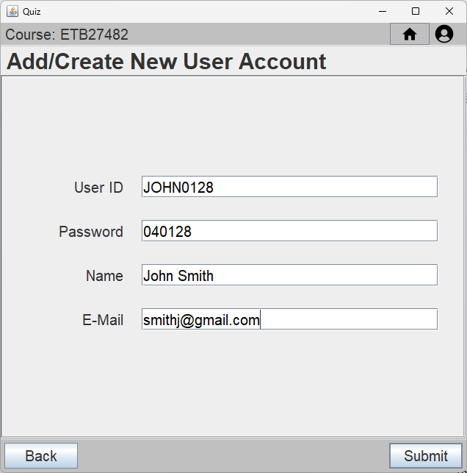
Figure 4.4.3(1) Account Create Menu
Input:
- Enter relevant information into each field according to the constraints stated in the hint/tooltip section of each text field.
- Only when the constraints are met shall the submit button be enabled.
Buttons:
- Back : Returns the user back to the Account Select Menu.
- Submit : Displays the Account Create Confirmation Panel.
Constraints:
- User ID : Must be 8 characters long.
- Password : Must not exceed 50 characters.
- Name : Must not exceed 50 characters.
- E-Mail : Must not exceed 50 characters.

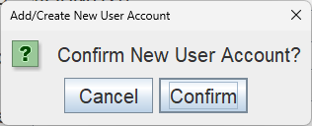
Figure 4.4.3(2) Account Create Confirmation Panel
Buttons:
- Cancel : Closes the confirmation panel.
- Confirm : Creates and writes the new account with the information entered and returns the user back to the Account Select Menu.

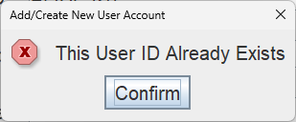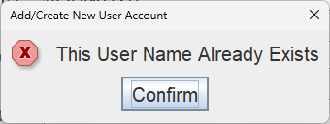
Figure 4.4.3(3) Error Messages
- If the data enetered for User ID or Name is not unique, the system will display an error message shown shown above according to the data that is repeated.

4.4.4 Account Edit/Delete Menu
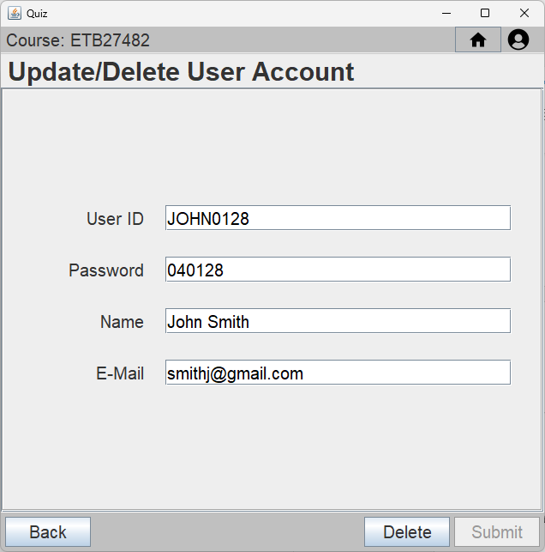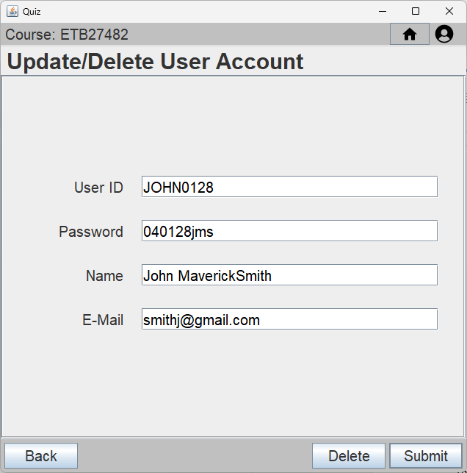
Figure 4.4.4(1) Account Edit/Delete Menu
Input:
- Edit the information in the desired field according to the constraints stated in the hint/tooltip section of the text field.
- Only when the constraints are met shall the submit button be enabled.
Buttons:
- Back : Returns the user back to the Account Select Menu.
- Delete : Displays the Account Delete Confirmation Panel.
- Submit : Displays the Account Create Confirmation Panel.
Constraints:
- User ID : Must be 8 characters long.
- Password : Must not exceed 50 characters.
- Name : Must not exceed 50 characters.
- E-Mail : Must not exceed 50 characters.

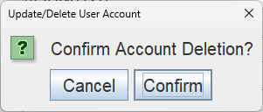
Figure 4.4.4(2) Account Delete Confirmation Panel
Buttons:
- Cancel : Closes the confirmation Panel.
- Confirm : Deletes the account from the list and returns the user back to the Account Select Menu.
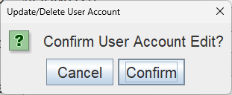
Figure 4.4.4(3) Account Edit Confirmation Panel
Buttons:
- Cancel : Closes the confirmation panel.
- Confirm : Edits and writes the new information of the account and returns the user back to the Account Select Menu.

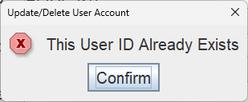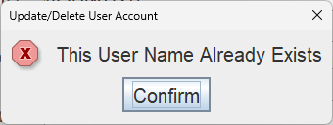
Figure 4.4.4(4) Error Messages
- If the data enetered for User ID or Name is not unique, the system will display an error message shown shown above according to the data that is repeated.

4.4.5 Account Self Edit Menu
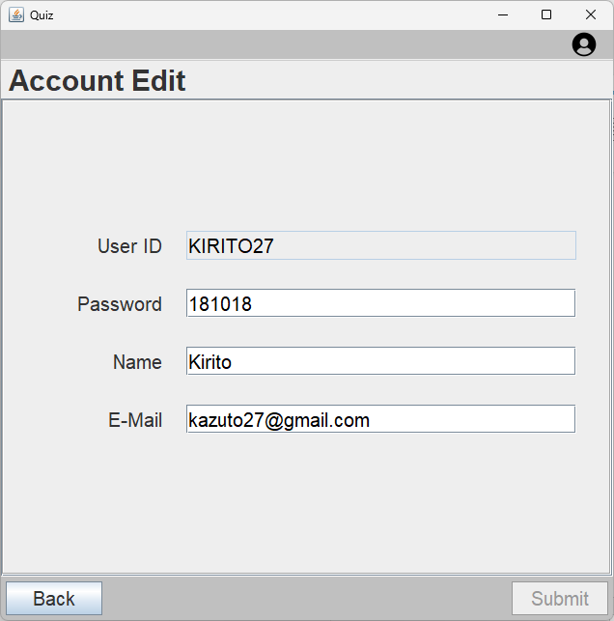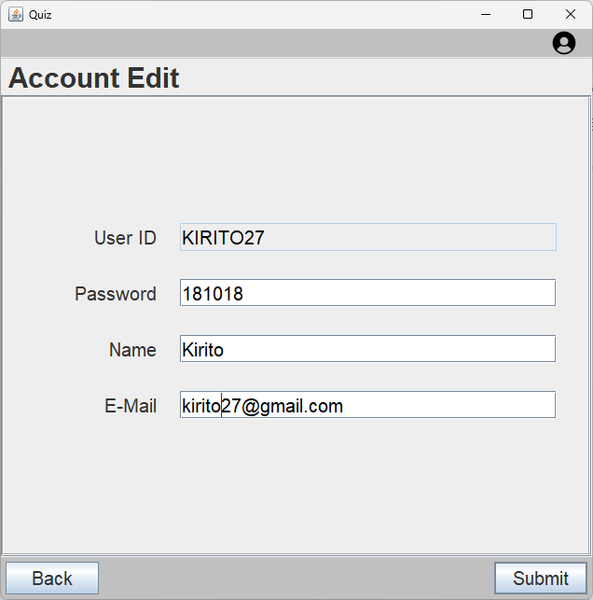
Figure 4.4.5(1) Account Self Edit Menu
Input:
- Edit the information in the desired field according to the constraints stated in the hint/tooltip section of the text field.
- Only when the constraints are met shall the submit button be enabled.
Buttons:
- Back : Returns the user back whatever page they were previously on.
- Submit : Displays the Account Self Edit Confirmation Panel.
Constraints:
- Password : Must not exceed 50 characters.
- Name : Must not exceed 50 characters.
- E-Mail : Must not exceed 50 characters.

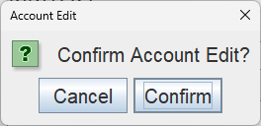
4.4.5(2) Account Self Edit Confirmation Panel
Buttons:
- Cancel : Closes the confirmation panel.
- Confirm : Edits and writes the new information of the account and returns the user back to whatever page they were previously on.

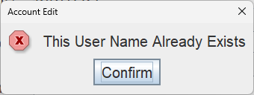
4.4.5(3) Error Messages
- If the data enetered for Name is not unique, the system will display an error message shown above.

4.5 Chapter Menu

4.5.1 Chapter Select Menu
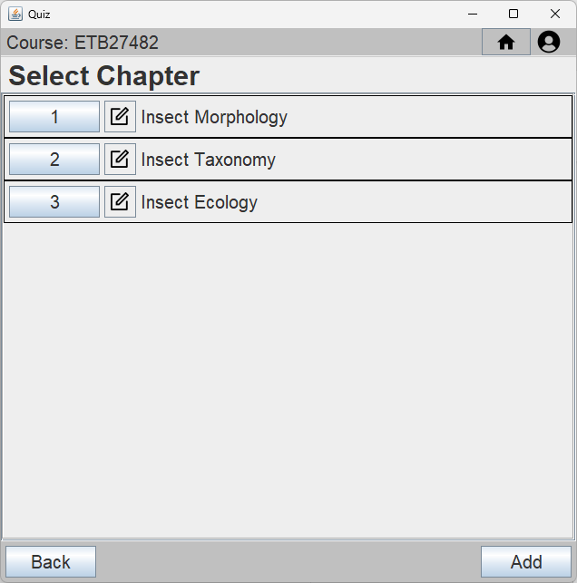
Figure 4.5.1 Chapter Select Menu
Buttons:
- Each button in the list selects the corresponding chapter and redirects the user to the Question Select Menu.
- The edit button beside each button selects the corresponding chapter to be edited in the Chapter Edit/Delete Menu.
- Back : Returns the user back to the Main Menu.
- Add : Redirects the user to the Chapter Create Menu.

4.5.2 Chapter Create Menu
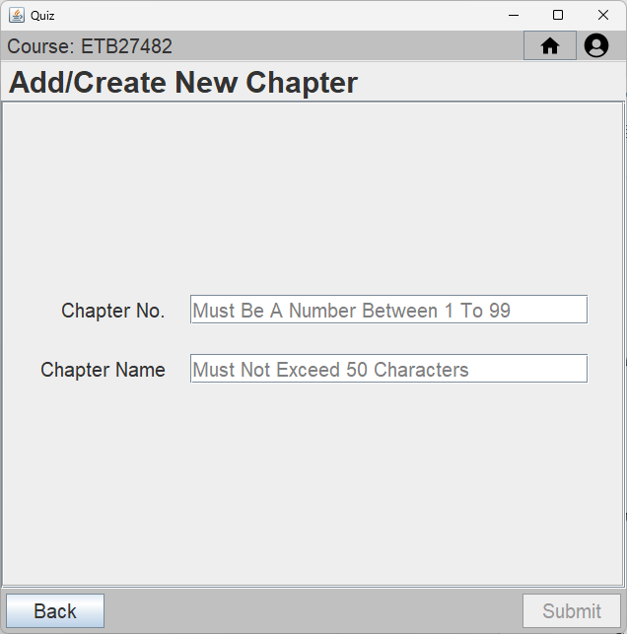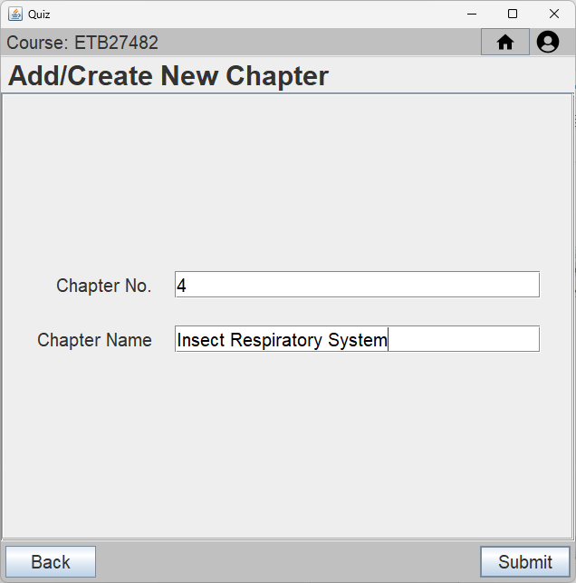
Figure 4.5.2(1) Chapter Create Menu
Input:
- Enter relevant information into each field according to the constraints stated in the hint/tooltip section of each text field.
- Only when the constraints are met shall the submit button be enabled.
Buttons:
- Back : Returns the user back to the Chapter Select Menu.
- Submit : Displays the Chapter Create Confirmation Panel.
Constraints:
- Chapter No : Must be 8 characters long.
- Chapter Name : Must not exceed 50 characters.

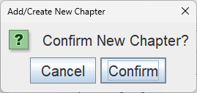
Figure 4.5.2(2) Chapter Create Confirmation Panel
Buttons:
- Cancel : Closes the confirmation panel.
- Confirm : Creates and writes the new chapter with the information entered and returns the user back to the Chapter Select Menu.

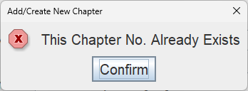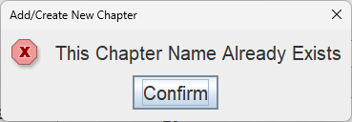
Figure 4.5.2(3) Error Messages
- If the data enetered for Chapter No or Chapter Name is not unique, the system will display an error message shown shown above according to the data that is repeated.

4.5.3 Chapter Edit/Delete Menu
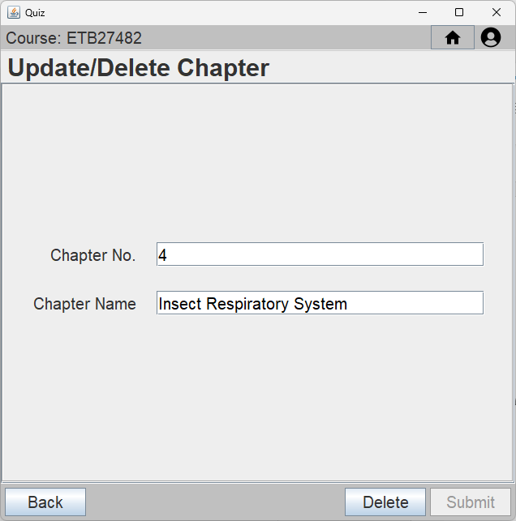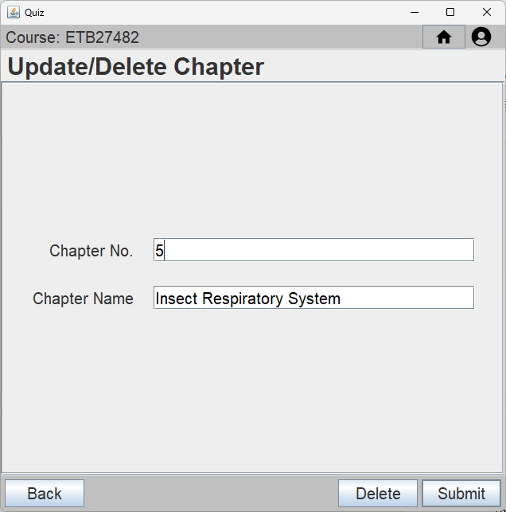
Figure 4.5.3(1) Chapter Edit/Delete Menu
Input:
- Edit the information in the desired field according to the constraints stated in the hint/tooltip section of the text field.
- Only when the constraints are met shall the submit button be enabled.
Buttons:
- Back : Returns the user back to the Chapter Select Menu.
- Delete : Displays the Chapter Delete Confirmation Panel.
- Submit : Displays the Chapter Edit Confirmation Panel.
Constraints:
- Chapter No. : Must be 8 characters long.
- Chapter Name : Must not exceed 50 characters.

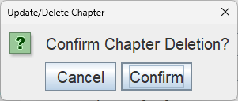
Figure 4.5.3(2) Chapter Delete Confirmation Panel
Buttons:
- Cancel : Closes the confirmation panel.
- Confirm : Deletes the chapter from the list and returns the user back to the Chapter Select Menu.

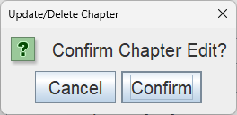
Figure 4.5.3(3) Chapter Edit Confirmation Panel
Buttons:
- Cancel : Closes the confirmation panel.
- Confirm : Edits and writes the new information of the chapter and returns the user back to the Chapter Select Menu.

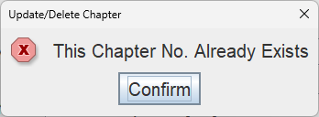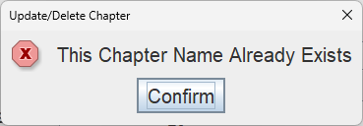
Figure 4.5.3(4) Error Messages
- If the data enetered for Chapter No. or Chapter Name is not unique, the system will display an error message shown shown above according to the data that is repeated.

4.6 Question Menu

4.6.1 Question Select Menu
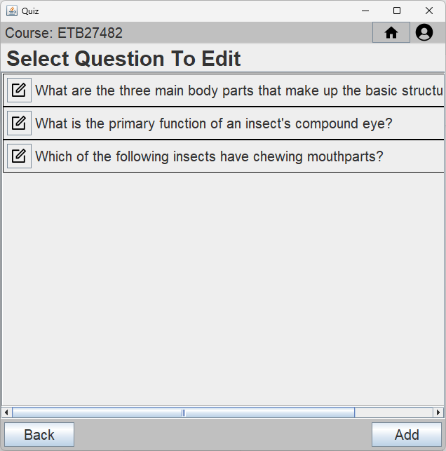
Figure 4.6.1 Question Select Menu
Buttons:
- Each button in the list selects the corresponding question to be edited in the Question Edit/Update Menu.
- Back : Returns the user back to the Chapter Select Menu.
- Add : Redirects the user to the Question Create Menu.

4.6.2 Question Create Menu
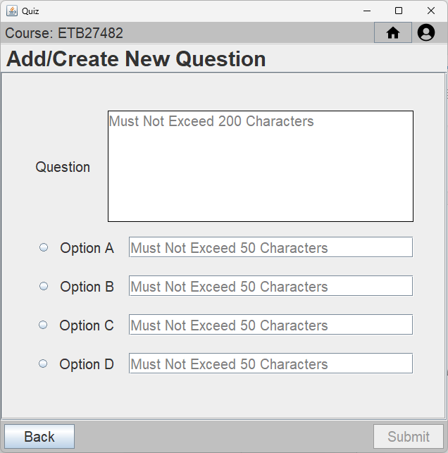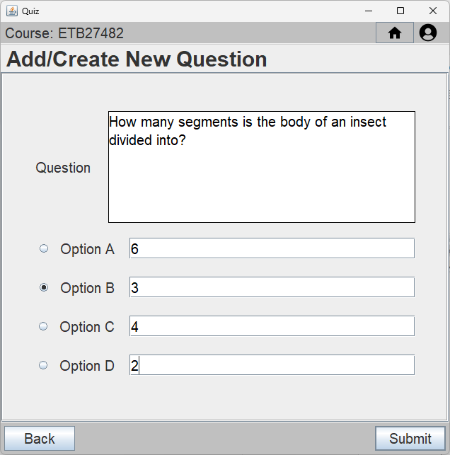
Figure 4.6.2(1) Question Create Menu
Input:
- Enter relevant information into each field according to the constraints stated in the hint/tooltip section of each text field.
- The answer to the question is indicated by which radio button is selected.
- Only when the constraints are met shall the submit button be enabled.
Buttons:
- Back : Returns the user back to the Question Select Menu.
- Submit : Displays the Question Create Confirmation Panel.
Constraints:
- Question : Must not exceed 200 characters.
- Option A : Must not exceed 50 characters.
- Option B : Must not exceed 50 characters.
- Option C : Must not exceed 50 characters.
- Option D : Must not exceed 50 characters.
- Answer : A radio button is selected.
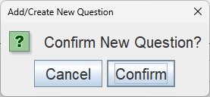
Figure 4.6.2(2) Question Create Confirmation Panel
Buttons:
- Cancel : Closes the confirmation panel.
- Confirm : Creates and writes the new question with the information entered and returns the user back to the Question Select Menu.

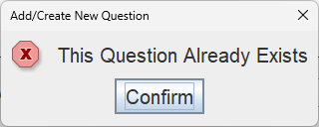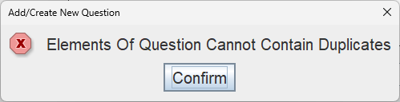
Figure 4.6.2(3) Error Messages
- If the data enetered for Question is not unique or the elements of the question contains duplicates, the system will display an error message shown shown above according to the data that is repeated.

4.6.3 Question Edit/Delete Menu
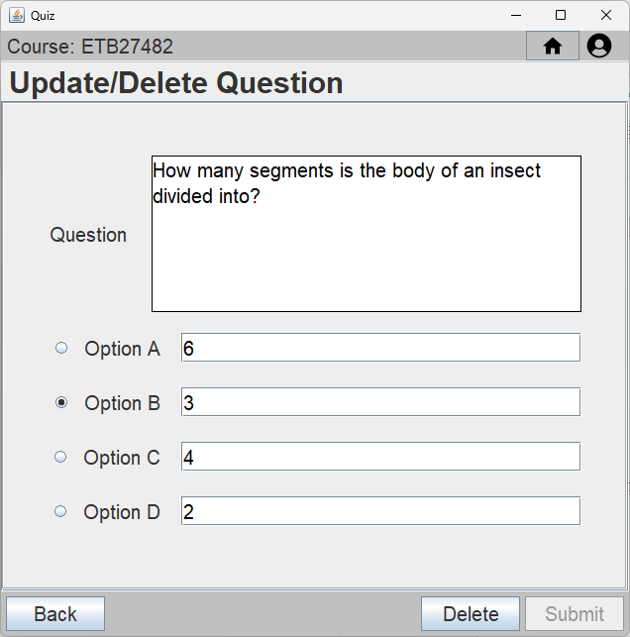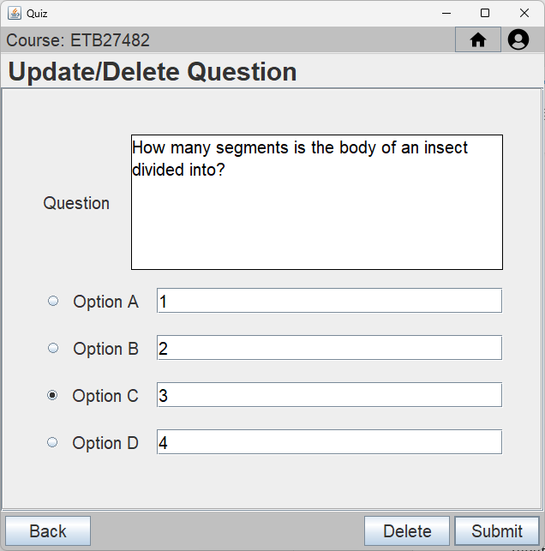
Figure 4.6.3(1) Question Edit/Delete Menu
Input:
- Edit the information in the desired field according to the constraints stated in the hint/tooltip section of the text field.
- Answer is edited through selecting a different radio button corresponding to the option.
- Only when the constraints are met shall the submit button be enabled.
Buttons:
- Back : Returns the user back to the Question Select Menu.
- Delete : Displays the Question Delete Confirmation Panel.
- Submit : Displays the Question Create Confirmation Panel.
Constraints:
- Question : Must not exceed 200 characters.
- Option A : Must not exceed 50 characters.
- Option B : Must not exceed 50 characters.
- Option C : Must not exceed 50 characters.
- Option D : Must not exceed 50 characters.
- Answer : A radio button is selected.
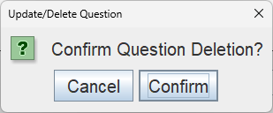
Figure 4.6.3(2) Question Delete Confirmation Panel
Buttons:
- Cancel : Closes the confirmation panel.
- Confirm : Deletes the question from the list and returns the user back to the Question Select Menu.

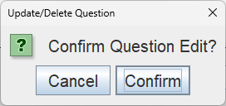
Figure 4.6.3(3) Question Edit Confirmation Panel
Buttons:
- Cancel : Closes the confirmation panel.
- Confirm : Edits and writes the new information of the question and returns the user back to the Question Select Menu.

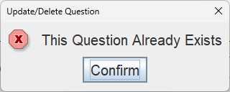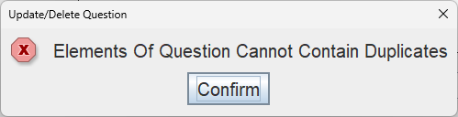
Figure 4.6.3(4) Error Messages
- If the data enetered for Question is not unique or the elements of the question contains duplicates, the system will display an error message shown shown above according to the data that is repeated.

4.7 Quiz Menu

4.7.1 Quiz Chapter Select Menu
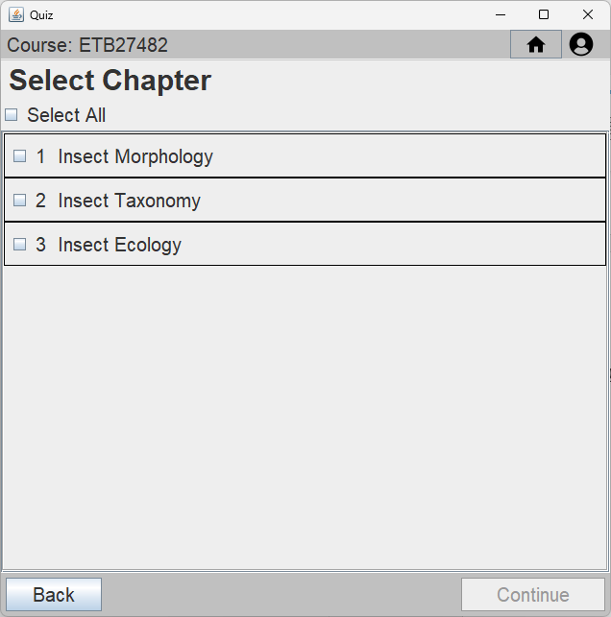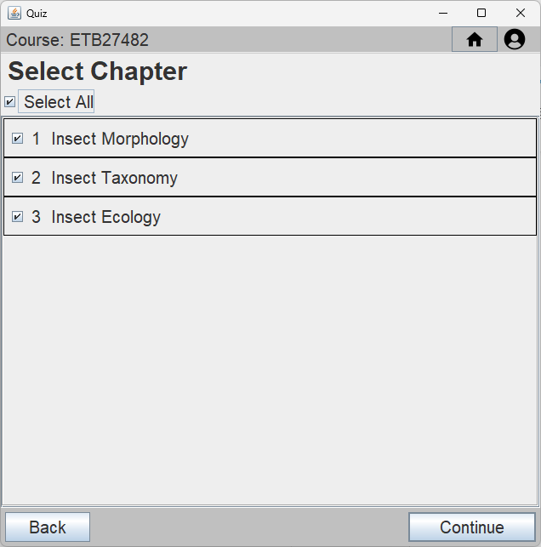
Figure 4.7.1 Chapter Select Menu
Buttons:
- Each check box in the list selects the corresponding chapter to be included in the Quiz.
- Back : Returns the user back to the Main Menu.
- Continue : Continue to Quiz Question Amount Menu.

4.7.2 Quiz Question Amount Menu
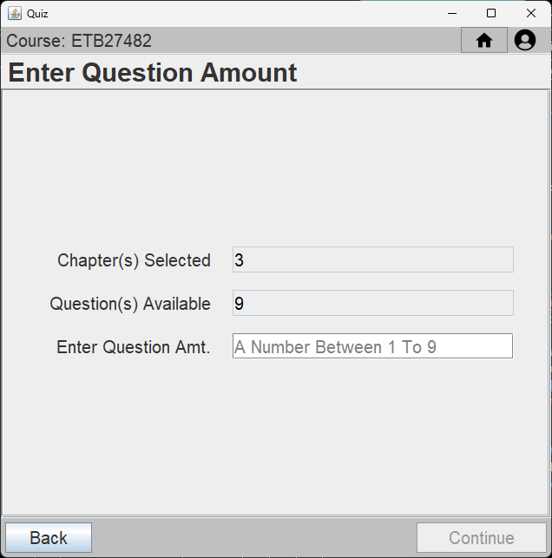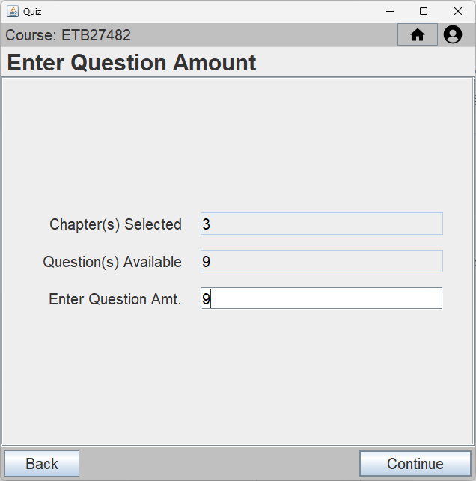
Figure 4.7.2(1) Quiz Question Amount Menu
Input:
- Enter the desired amount of questions in the “Enter Question Amt.” field.
- Only when the constraints are satisfied shall the “Continue” button be enabled.
Buttons:
- Back : Returns the user back to the Quiz Chapter Select Menu.
- Continue : Displays the Quiz Start Confirmation Panel.
Constraints:
- Question Amt. : Must be a number between 1 and the total amount of questions available.

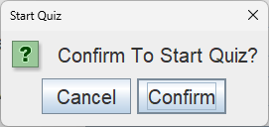
Figure 4.7.2(2) Quiz Start Confirmation Panel.
Buttons:
- Cancel : Closes the confirmation panel.
- Confirm : Starts the quiz and redirects the user to the Quiz Start Menu.

4.7.3 Quiz Start Menu
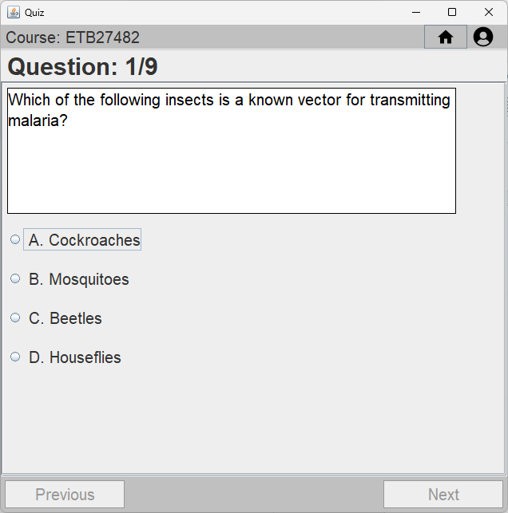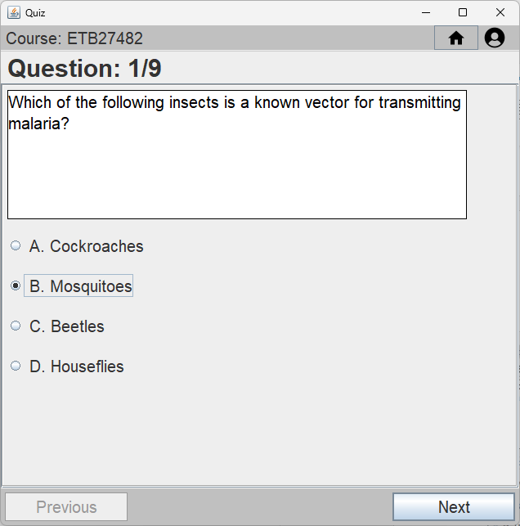
Figure 4.7.3(1) Quiz Start Menu (Beginning)

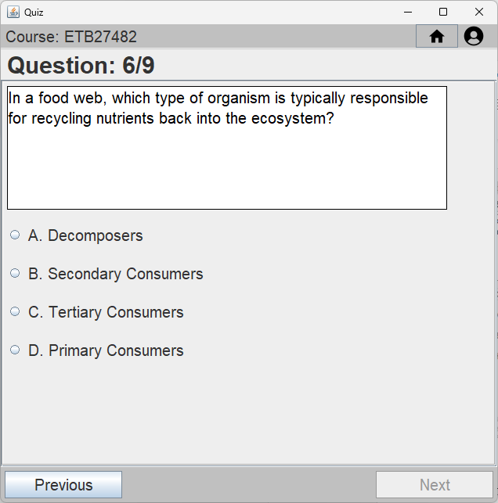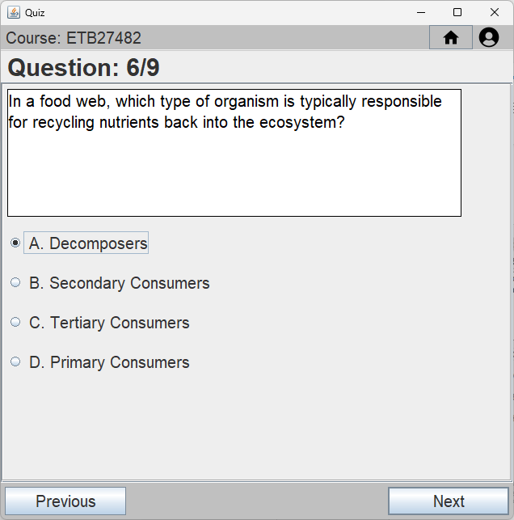
Figure 4.7.3(2) Quiz Start Menu (Middle)
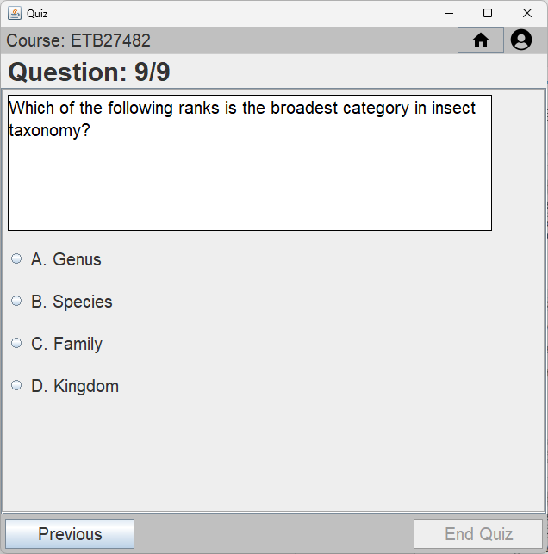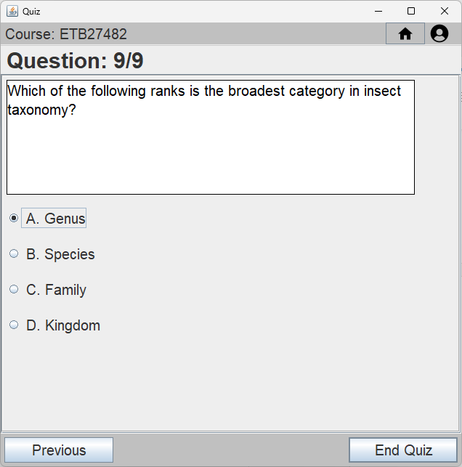
Figure 4.7.3(3) Quiz Start Menu (Ending)
Input:
- Select one radio button as the answer.
- Only when a radio button is selected the “Next” and “End Quiz” buttons shall be enabled.
Buttons:
- Previous : Returns to the previous question.
- Next : Proceeds to the next question.
- End Quiz : Displays the Quiz End Confirmation Panel.

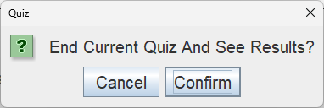
Figure 4.7.3(4) Quiz End Confirmation Panel
Buttons:
- Cancel : Closes the confirmation panel.
- Confirm : Ends the Quiz and redirects the user to the Quiz End Menu.

4.7.4 Quiz End Menu
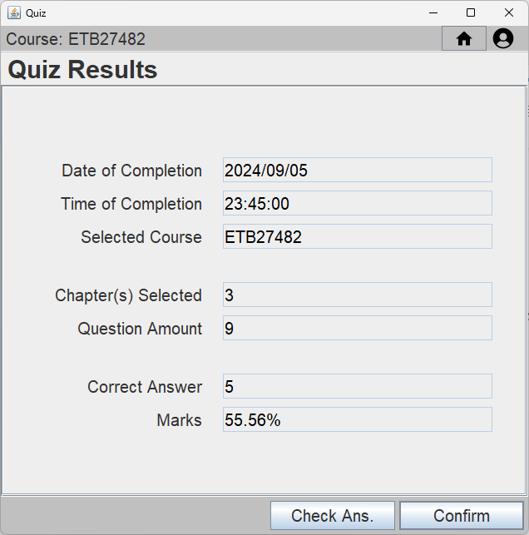
Figure 4.7.4 Quiz End Menu
Buttons:
- Check Ans. : Redirects the user to the Quiz Answers Menu.
- Confirm : Returns the user back to the Main Menu.

4.7.5 Quiz Answers Menu
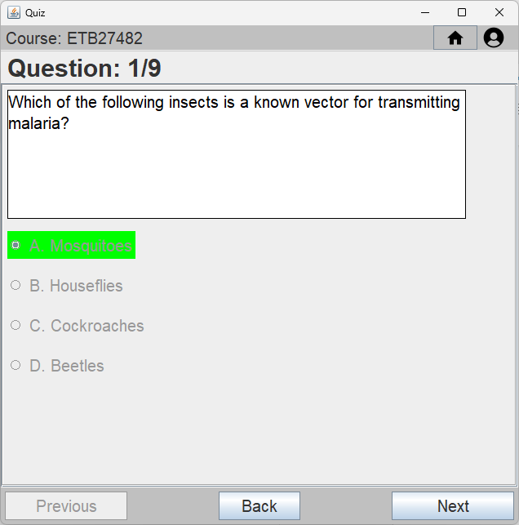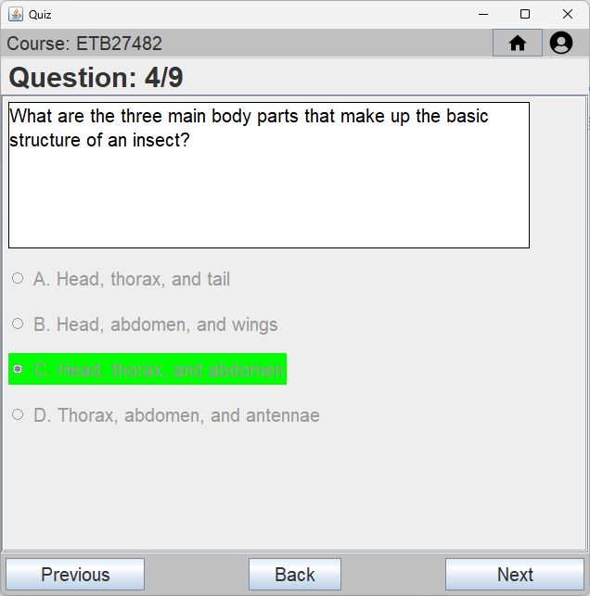
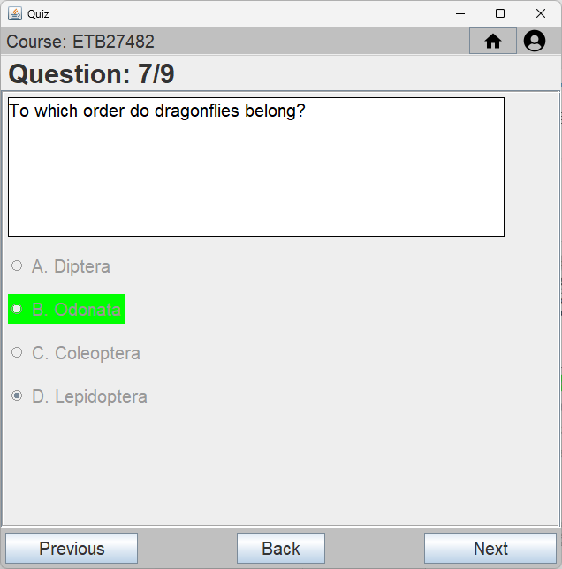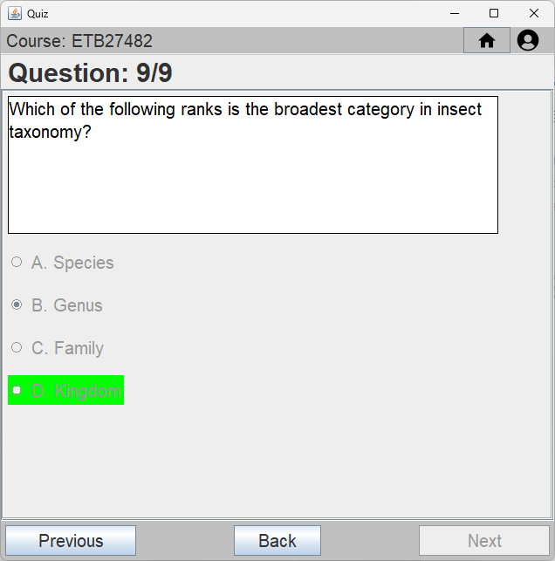
Figure 4.7.5 Quiz Answers Menu
Buttons:
- Previous : Returns to the previous question.
- Next : Proceeds to the next question.
- Back : Returns the user to the Quiz End Menu.
Info:
- The green highlighted text indicates the correct answer to that particular question.
- The selected radio button indicates the selected answer of the user for that particular question.

4.8 Quiz Report Menu

4.8.1 Quiz Report User Select Menu
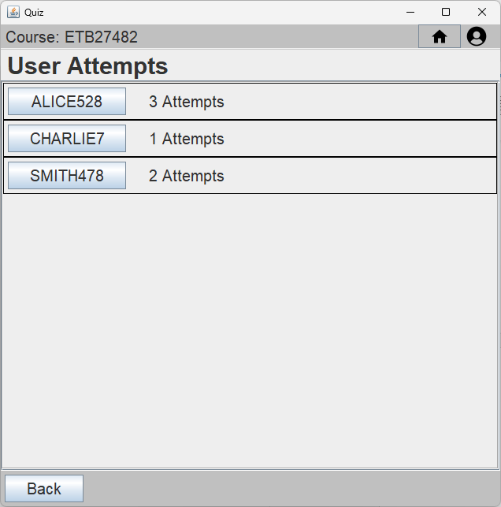
Figure 4.8.1 Quiz Report User Select Menu
Buttons:
- Each button in the list selects the corresponding account and redirects the user to the Quiz Report Attempt Select Menu.
- Back : Returns the user back to the Main Menu.

4.8.2 Quiz Report Attempt Select Menu
Figure 4.8.2 Quiz Report Attempt Select Menu
Buttons:
- The buttons in the list selects the corresponding Quiz Attempt and redirects the user to the Quiz Report Detail Menu.
- Back (User) : Returns the user back to the Main Menu.
- Back (Admin) : Return the admin back to the Quiz Report User Select Menu.
- Summary : Redirects the user to the Quiz Report Summary Menu.

4.8.3 Quiz Report Detail Menu
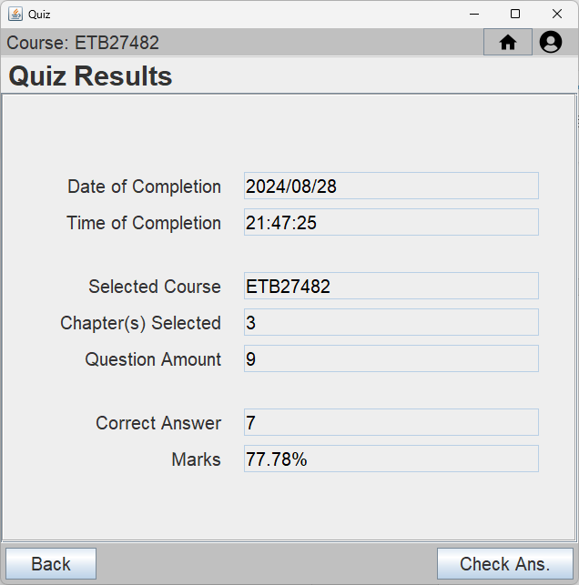
Figure 4.8.3 Quiz Report Detail Menu
Buttons:
- Back : Returns the user back to the Quiz Report Attempt Selection Menu.
- Check Ans. : Redirects the user to the Quiz Report Answers Menu.

4.8.4 Quiz Report Answers Menu
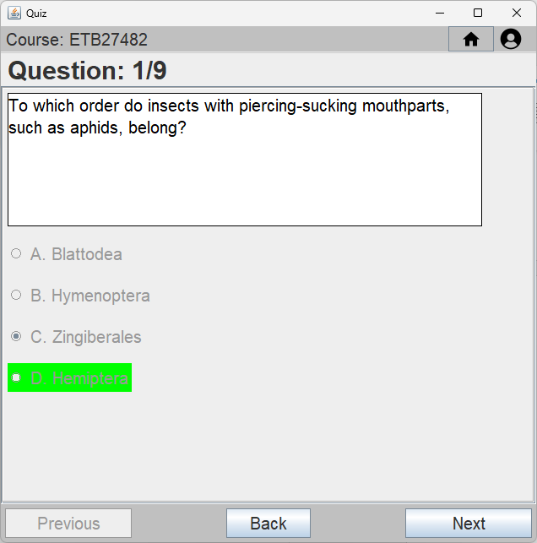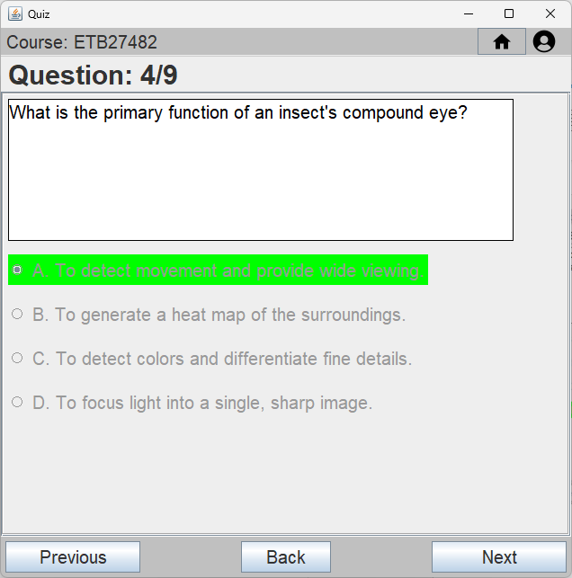
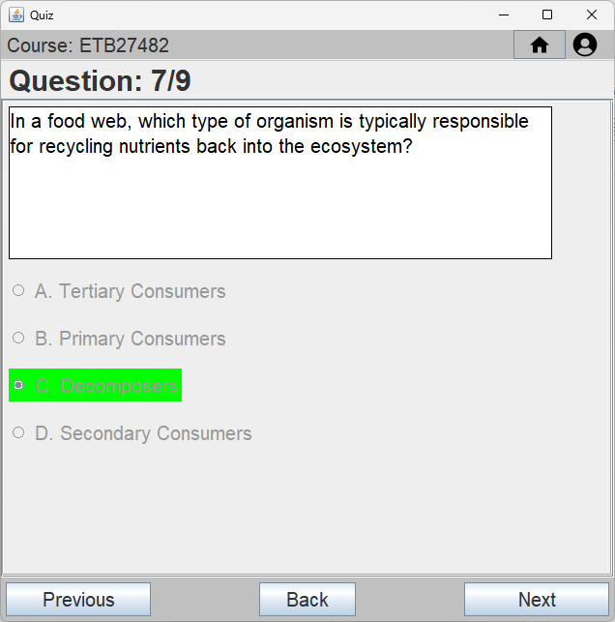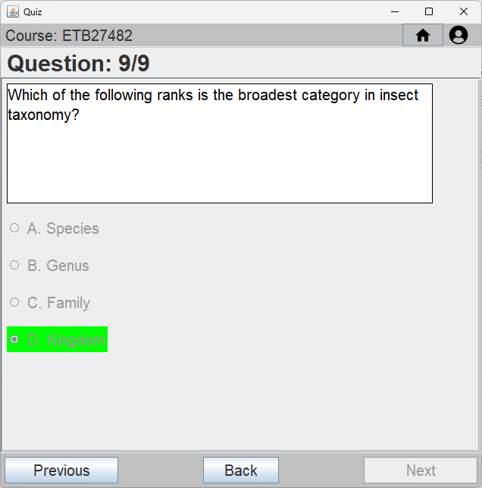
Figure 4.8.4 Quiz Report Answers Menu
Buttons:
- Previous : Returns to the previous question.
- Next : Proceeds to the next question.
- Back : Returns the user back to the Quiz Report Detail Menu.
Info:
- The green highlighted text indicates the correct answer to that particular question.
- The selected radio button indicates the selected answer of the user for that particular question.

4.8.5 Quiz Report Summary Menu
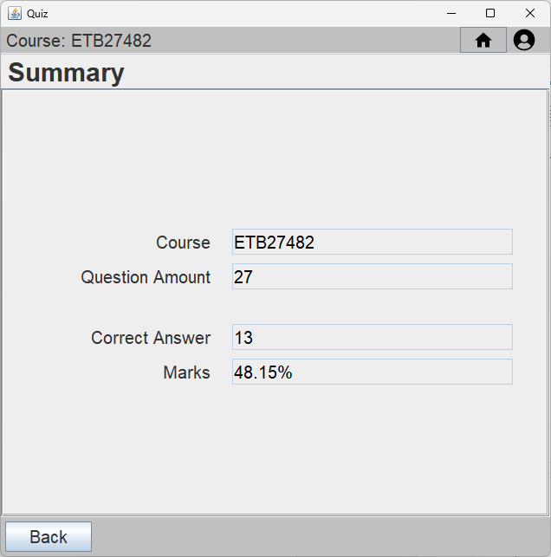
Figure 4.8.5 Quiz Report Summary
Button:
- Back : Returns the user back to the Quiz Report Attempt Selection Menu.

5.0 Appendix
Earlier Iterations of Class Diagrams are included in the Class Diaram Folder with the names:
- “Class Diagram v1.0”
- “Class Diagram v1.1”

GUI concept sketches:
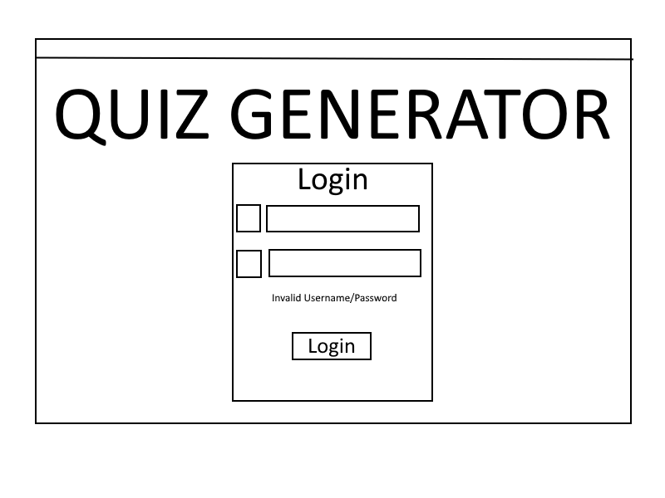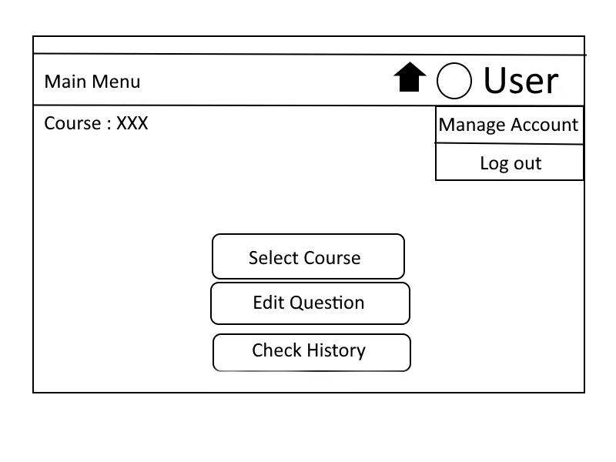
Login Menu Main Menu

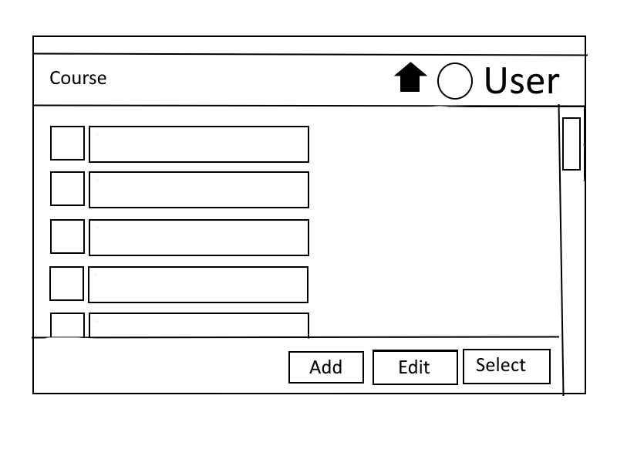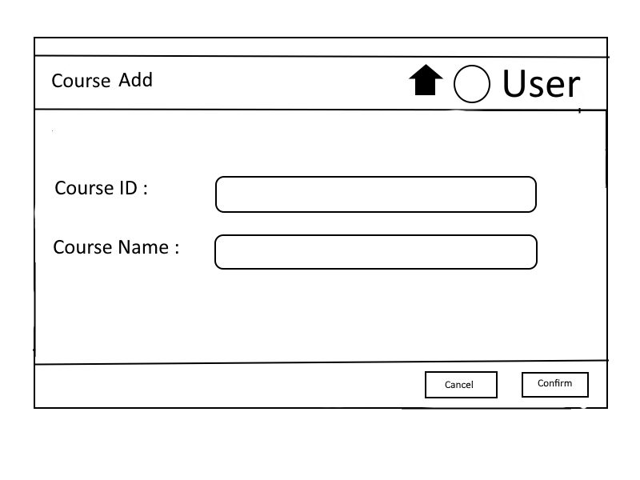
Lists Menu Create Menu
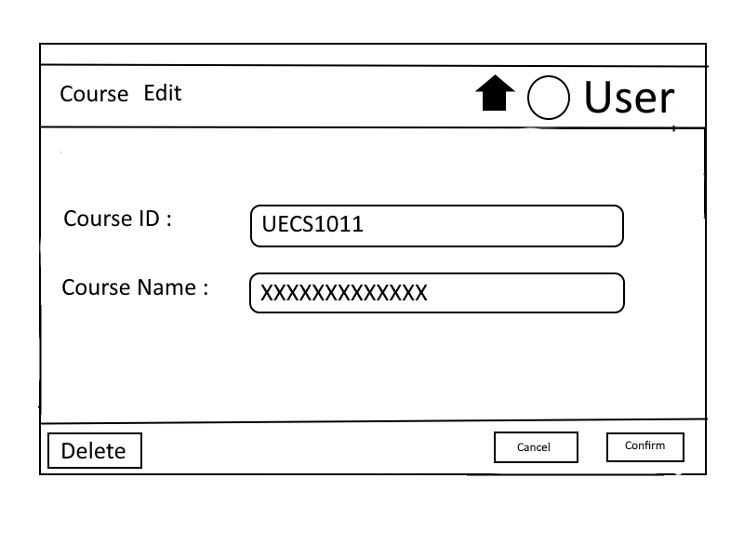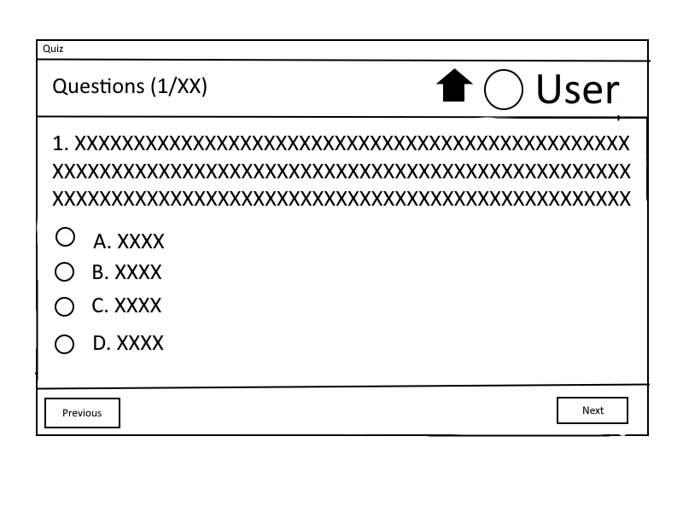
Edit Menu Quiz Start Menu

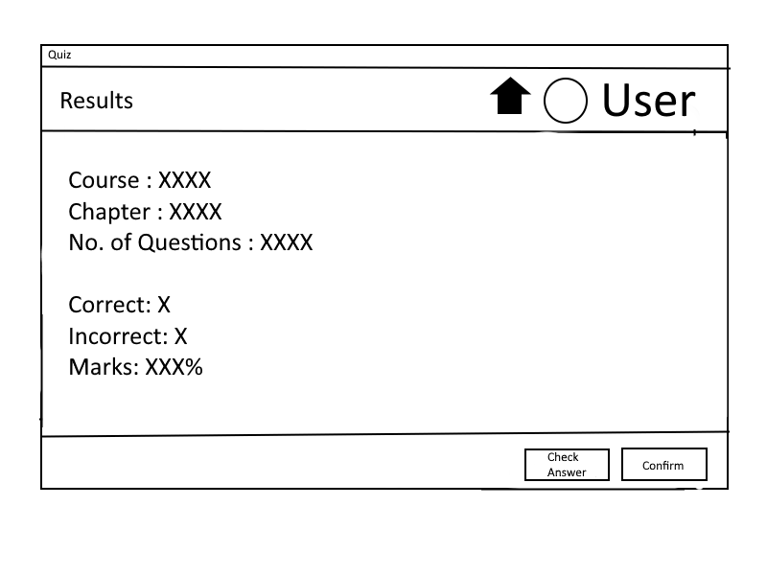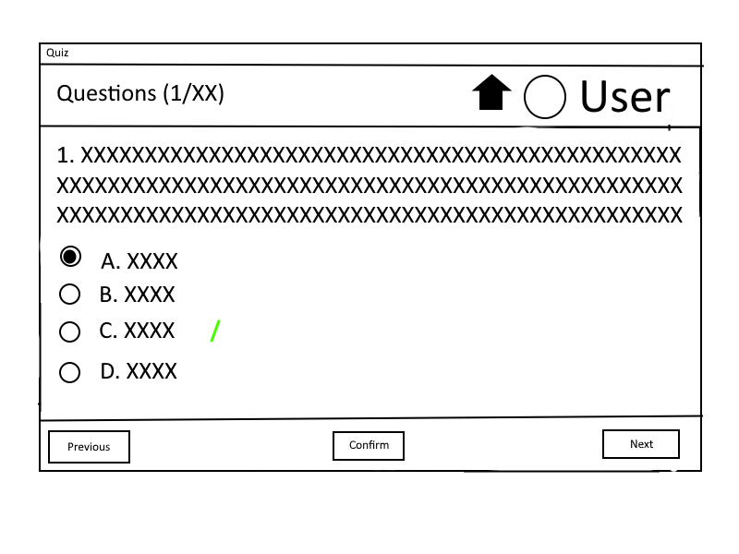
Quiz Result Menu Quiz Check Answer Menu

