|  |  |  |  |  |  |  |
| --- | --- | --- | --- | --- | --- | --- |
|  | **NA** | **1** | **2** | **3** | **4** | **5** |
| **HPI** | 0 | 1-3 | 1-3 | 1-3 | >3 | >3 |
| **ROS** | 0 | 0 | 1 | 2-9 | 2-9 | >9 |
| **PFSH** | 0 | 0 | 0 | 0 | 1 | >1 |
| **PE** | 0 | 1 | 1 | 2-5 | 6-7 | >7 |

**E/M Review**

|  |  |  |
| --- | --- | --- |
| **E/M Level**  (1/2/3/4/5) | **Elements** | **E/M Level** |
| **HPI**  ( 1/1/1/4/4) | 1 | 3 |
| **ROS**  (0/1/2/2/10) | 4 | 4 |
| **PFSH**  (0/0/0/1/2) | 1 | 4 |
| **PE**  (1/1/2/6/8) | 3 | 3 |
| **Potential E/M Level c/w Hx and PE** | | 3 |

Tool Tip: Actual E/M code should be assigned by billing professionals and based on medical necessity and is not necessarily based on levels supported by documentation.

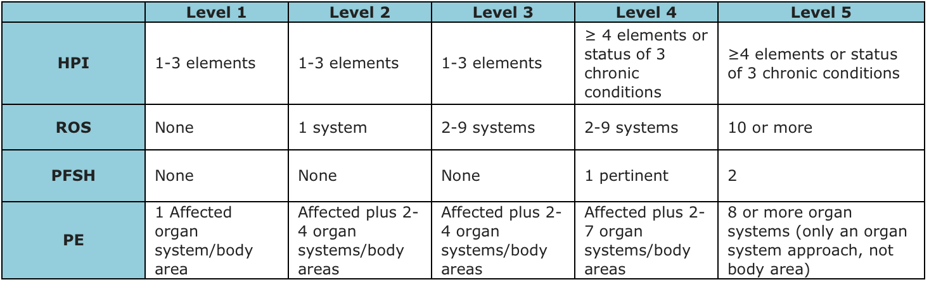

# Notes v3

First table: I changed some of the numbers internal to the first table.  Specifically, the HPI row has a >3 in the "4" column. Also, there are no x's. The table shows exactly what column you get to based on a given # of elements.  If you are in column "NA", that is what should be reported.

Second table: This shows how the layout should appear.  Notice the new column and row labels.  Notice the name of exam is now PE.  Notice there are now five numbers in the parentheses. Notice that the parentheses are below the labels and smaller in font.

Third table: this is the source we call the Hamilton table. Everything above should be consistent with this. One issue in the Hamilton table is that in Level 3 and Level 4 of exam he is overlapping. I consulted with Dan ad we made a decision reflected in the first table.

Notes V4

Changed EM to E/M