iPhone

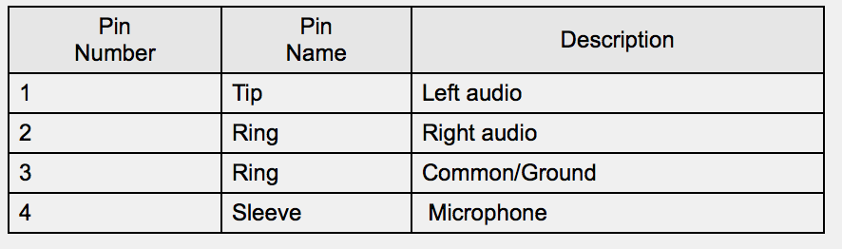

red to green

iPhone microphone (base4) (audio to phone)

* PMA (Ring/2) speaker audio (audio to phone)

White and green to white

iPhone audio (tip1/2) (audio from phone)

* PMA (tip) microphone out (audio from phone)

Black to black

iPhone ground (3)(ground phone)

<> PMA ground (base)

PMA8000B

