**Processing**

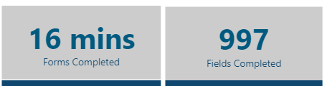

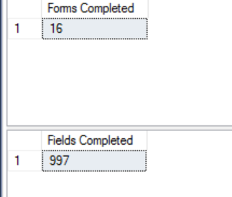

Query Used

----------------------Forms Completed---------------------------------------

select sum(FormCount) as [Forms Completed] from

(SELECT [Appointment ID],

CASE

WHEN [Form/Specialty] ='GP' and [Plan Type]='HMO' THEN 1

WHEN [Form/Specialty] ='GP, ORTHO' and [Plan Type]='HMO' THEN 2

WHEN [Form/Specialty] ='GP, PEDO' and [Plan Type]='HMO' THEN 2

WHEN [Form/Specialty] ='ORTHO' and [Plan Type]='HMO' THEN 1

WHEN [Form/Specialty] ='GP' and [Plan Type]='PPO' and Type='FULL' THEN 1

WHEN [Form/Specialty] ='GP' and [Plan Type]='PPO' and Type='PARTIAL' THEN 1

WHEN [Form/Specialty] ='GP, ORTHO' and [Plan Type]='PPO' and Type='FULL' THEN 2

WHEN [Form/Specialty] ='GP, ORTHO,PEDO' and [Plan Type]='PPO' and Type='FULL' THEN 3

WHEN [Form/Specialty] ='ORTHO' and [Plan Type]='PPO' and Type='FULL' THEN 1

END AS FormCount

FROM app.vwDimensionFilters

group by [Appointment ID],[Form/Specialty],[Plan Type],Type

)T1

left join

(select [Appointment ID],[Status] from app.vwDataAuditKPIReport

group by [Appointment ID],[Status])T2 on T1.[Appointment ID]=T2.[Appointment ID]

where t2.[Status]in ('Completed','Escalated')

---------------------Fields Completed------------------------------------------------------

select sum(FieldCount) as [Fields Completed] from

(SELECT [Appointment ID],

CASE

WHEN [Form/Specialty] ='GP' and [Plan Type]='HMO' THEN 16

WHEN [Form/Specialty] ='GP, ORTHO' and [Plan Type]='HMO' THEN 41

WHEN [Form/Specialty] ='GP, PEDO' and [Plan Type]='HMO' THEN 17

WHEN [Form/Specialty] ='ORTHO' and [Plan Type]='HMO' THEN 40

WHEN [Form/Specialty] ='GP' and [Plan Type]='PPO' and Type='FULL' THEN 141

WHEN [Form/Specialty] ='GP' and [Plan Type]='PPO' and Type='PARTIAL' THEN 50

WHEN [Form/Specialty] ='GP, ORTHO' and [Plan Type]='PPO' and Type='FULL' THEN 158

WHEN [Form/Specialty] ='GP, ORTHO,PEDO' and [Plan Type]='PPO' and Type='FULL' THEN 278

WHEN [Form/Specialty] ='ORTHO' and [Plan Type]='PPO' and Type='FULL' THEN 37

END AS FieldCount

FROM app.vwDimensionFilters

group by [Appointment ID],[Form/Specialty],[Plan Type],Type

)T1

left join

(select [Appointment ID],[Status] from app.vwDataAuditKPIReport

group by [Appointment ID],[Status])T2 on T1.[Appointment ID]=T2.[Appointment ID]

where t2.[Status] in ('Completed','Escalated')



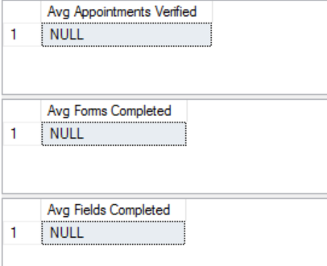

Query Used

-----------------------------------------Avg Appointments Verified----------------------------------

select Count(distinct T1.[Appointment ID])/nullif((count(T2.Workday)*8),0) as [Avg Appointments Verified]from

(SELECT [Appointment ID],[Status]

FROM app.vwDataAuditKPIReport

group by [Appointment ID],[Status]

)T1

left join

(select [Appointment ID],[Workday]

from app.vwDimensionFilters

group by [Appointment ID],Workday)T2 on T1.[Appointment ID]=T2.[Appointment ID]

where T1.[Status] in ('Completed','Escalated')and T2.Workday=1

-----------------------------------------Avg Forms Completed-------------------------------------

select sum(T1.[FormCount])/(count(T1.Workday)*8) as [Avg Forms Completed] from

(SELECT [Appointment ID],[Workday],

CASE

WHEN [Form/Specialty] ='GP' and [Plan Type]='HMO' THEN 1

WHEN [Form/Specialty] ='GP, ORTHO' and [Plan Type]='HMO' THEN 2

WHEN [Form/Specialty] ='GP, PEDO' and [Plan Type]='HMO' THEN 2

WHEN [Form/Specialty] ='ORTHO' and [Plan Type]='HMO' THEN 1

WHEN [Form/Specialty] ='GP' and [Plan Type]='PPO' and Type='FULL' THEN 1

WHEN [Form/Specialty] ='GP' and [Plan Type]='PPO' and Type='PARTIAL' THEN 1

WHEN [Form/Specialty] ='GP, ORTHO' and [Plan Type]='PPO' and Type='FULL' THEN 2

WHEN [Form/Specialty] ='GP, ORTHO,PEDO' and [Plan Type]='PPO' and Type='FULL' THEN 3

WHEN [Form/Specialty] ='ORTHO' and [Plan Type]='PPO' and Type='FULL' THEN 1

END AS FormCount

FROM app.vwDimensionFilters

group by [Appointment ID],[Form/Specialty],[Plan Type],[Type],[Workday]

)T1

left join

(select [Appointment ID],[Status] from app.vwDataAuditKPIReport

group by [Appointment ID],[Status])T2 on T1.[Appointment ID]=T2.[Appointment ID]

where t2.[Status]in ('Completed','Escalated') and

T1.[Workday]=1

-----------------------------------------Avg Fields Completed-------------------------------------

select sum(T1.[FieldCount])/(count(T1.Workday)*8) as [Avg Fields Completed] from

(SELECT [Appointment ID],[Workday],

CASE

WHEN [Form/Specialty] ='GP' and [Plan Type]='HMO' THEN 16

WHEN [Form/Specialty] ='GP, ORTHO' and [Plan Type]='HMO' THEN 41

WHEN [Form/Specialty] ='GP, PEDO' and [Plan Type]='HMO' THEN 17

WHEN [Form/Specialty] ='ORTHO' and [Plan Type]='HMO' THEN 40

WHEN [Form/Specialty] ='GP' and [Plan Type]='PPO' and Type='FULL' THEN 141

WHEN [Form/Specialty] ='GP' and [Plan Type]='PPO' and Type='PARTIAL' THEN 50

WHEN [Form/Specialty] ='GP, ORTHO' and [Plan Type]='PPO' and Type='FULL' THEN 158

WHEN [Form/Specialty] ='GP, ORTHO,PEDO' and [Plan Type]='PPO' and Type='FULL' THEN 278

WHEN [Form/Specialty] ='ORTHO' and [Plan Type]='PPO' and Type='FULL' THEN 37

END AS FieldCount

FROM app.vwDimensionFilters

group by [Appointment ID],[Form/Specialty],[Plan Type],[Type],[Workday]

)T1

left join

(select [Appointment ID],[Status]

from app.vwDataAuditKPIReport

group by [Appointment ID],[Status])T2 on T1.[Appointment ID]=T2.[Appointment ID]

where t2.[Status]in ('Completed','Escalated') and

T1.[Workday]=1

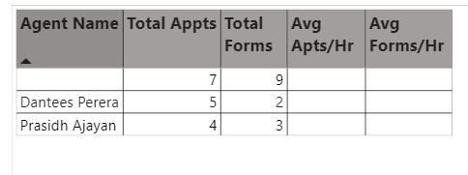

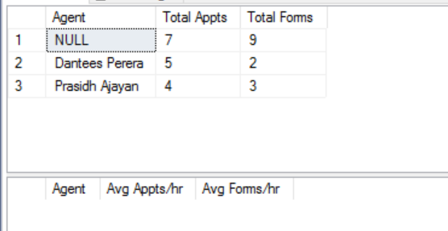

Query Used

-----------------------------------------Total Appts & Total Forms----------------------------------

select T2.Agent,Count(distinct T2.[Appointment ID]) as [Total Appts],sum(T2.[FormCount])as [Total Forms]from

(SELECT [Appointment ID],[Status]

FROM app.vwDataAuditKPIReport

group by [Appointment ID],[Status]

)T1

left join

(select [Appointment ID],[Agent],

CASE

WHEN [Form/Specialty] ='GP' and [Plan Type]='HMO' THEN 1

WHEN [Form/Specialty] ='GP, ORTHO' and [Plan Type]='HMO' THEN 2

WHEN [Form/Specialty] ='GP, PEDO' and [Plan Type]='HMO' THEN 2

WHEN [Form/Specialty] ='ORTHO' and [Plan Type]='HMO' THEN 1

WHEN [Form/Specialty] ='GP' and [Plan Type]='PPO' and Type='FULL' THEN 1

WHEN [Form/Specialty] ='GP' and [Plan Type]='PPO' and Type='PARTIAL' THEN 1

WHEN [Form/Specialty] ='GP, ORTHO' and [Plan Type]='PPO' and Type='FULL' THEN 2

WHEN [Form/Specialty] ='GP, ORTHO,PEDO' and [Plan Type]='PPO' and Type='FULL' THEN 3

WHEN [Form/Specialty] ='ORTHO' and [Plan Type]='PPO' and Type='FULL' THEN 1

END AS FormCount

FROM app.vwDimensionFilters

group by [Appointment ID],[Form/Specialty],[Plan Type],[Type],Agent)T2

on T1.[Appointment ID]=T2.[Appointment ID]

where T1.[Status] in ('Completed','Escalated')

group by T2.Agent

--------------------------------Avg Apts/Hr and Avg Forms/hr------------------------------------

select T2.[Agent],Count(distinct T2.[Appointment ID])/nullif((count(T2.Workday)*8),0) as [Avg Appts/hr],

sum(T2.FormCount)/nullif((count(T2.Workday)*8),0) as [Avg Forms/hr] from

(SELECT [Appointment ID],[Status]

FROM app.vwDataAuditKPIReport

group by [Appointment ID],[Status]

)T1

left join

(select [Appointment ID],[Agent],[Workday],CASE

WHEN [Form/Specialty] ='GP' and [Plan Type]='HMO' THEN 1

WHEN [Form/Specialty] ='GP, ORTHO' and [Plan Type]='HMO' THEN 2

WHEN [Form/Specialty] ='GP, PEDO' and [Plan Type]='HMO' THEN 2

WHEN [Form/Specialty] ='ORTHO' and [Plan Type]='HMO' THEN 1

WHEN [Form/Specialty] ='GP' and [Plan Type]='PPO' and Type='FULL' THEN 1

WHEN [Form/Specialty] ='GP' and [Plan Type]='PPO' and Type='PARTIAL' THEN 1

WHEN [Form/Specialty] ='GP, ORTHO' and [Plan Type]='PPO' and Type='FULL' THEN 2

WHEN [Form/Specialty] ='GP, ORTHO,PEDO' and [Plan Type]='PPO' and Type='FULL' THEN 3

WHEN [Form/Specialty] ='ORTHO' and [Plan Type]='PPO' and Type='FULL' THEN 1

END AS FormCount

from app.vwDimensionFilters

group by [Appointment ID],[Form/Specialty],[Plan Type],[Type],[Agent],[Workday])T2 on T1.[Appointment ID]=T2.[Appointment ID]

where T1.[Status] in ('Completed','Escalated')and T2.Workday=1

group by T2.Agent

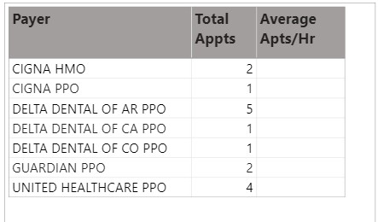

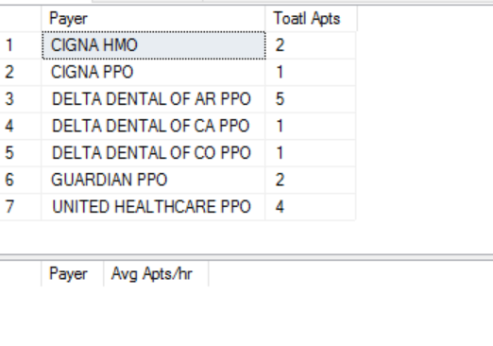

Query Used

-----------------------------------------Total Apts---------------------------------------------

select T2.[Payer],Count(distinct T2.[Appointment ID])as [Toatl Apts]from

(SELECT [Appointment ID],[Status]

FROM app.vwDataAuditKPIReport

group by [Appointment ID],[Status]

)T1

left join

(select [Appointment ID],[Payer]

from app.vwDimensionFilters

group by [Appointment ID],[Payer])T2 on T1.[Appointment ID]=T2.[Appointment ID]

where T1.[Status] in ('Completed','Escalated')

group by T2.[Payer]

-----------------------------------------Avg Apts/hr---------------------------------------------

select T2.[Payer],Count(distinct T2.[Appointment ID])/nullif((count(T2.Workday)*8),0) as [Avg Apts/hr]from

(SELECT [Appointment ID],[Status]

FROM app.vwDataAuditKPIReport

group by [Appointment ID],[Status]

)T1

left join

(select [Appointment ID],[Payer],[workday]

from app.vwDimensionFilters

group by [Appointment ID],[Payer],[Workday])T2 on T1.[Appointment ID]=T2.[Appointment ID]

where T1.[Status] in ('Completed','Escalated') and T2.Workday=1

group by T2.[Payer]

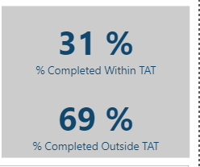

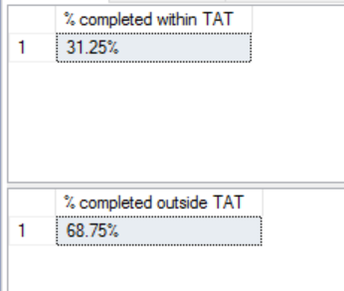

Query Used

-----------------% completed within TAT-----------------------------------

select concat((cast(sum(t1.AppntID) as float)/Count(distinct T1.[Appointment ID]))*100,'%')

as [% completed within TAT]from

(SELECT [Appointment ID],

CASE

WHEN [Priority] ='Same Day' and DATEDIFF(HOUR,[HSC Appointment Date],[Completion Date])<=2

THEN Count(distinct[Appointment ID])

WHEN [Priority] ='Next Day' and DATEDIFF(HOUR,[HSC Appointment Date],[Completion Date])<=24

THEN Count(distinct[Appointment ID])

WHEN [Priority] ='Future' and DATEDIFF(HOUR,[HSC Appointment Date],[Completion Date])<=72

THEN Count(distinct[Appointment ID])

END AS AppntID

FROM app.vwDimensionFilters

group by [Appointment ID],[Priority],DATEDIFF(HOUR,[HSC Appointment Date],[Completion Date])

)T1

left join

(select [Appointment ID],[Status]

from app.vwDataAuditKPIReport

group by [Appointment ID],[Status])T2 on T1.[Appointment ID]=T2.[Appointment ID]

where t2.[Status]in ('Completed','Escalated')

-----------------% completed outside TAT-----------------------------------

select concat((cast(sum(t1.AppntID) as float)/Count(distinct T1.[Appointment ID]))*100,'%')

as [% completed outside TAT]from

(SELECT [Appointment ID],

CASE

WHEN [Priority] ='Same Day' and DATEDIFF(HOUR,[HSC Appointment Date],[Completion Date])>2

THEN Count(distinct[Appointment ID])

WHEN [Priority] ='Next Day' and DATEDIFF(HOUR,[HSC Appointment Date],[Completion Date])>24

THEN Count(distinct[Appointment ID])

WHEN [Priority] ='Future' and DATEDIFF(HOUR,[HSC Appointment Date],[Completion Date])>72

THEN Count(distinct[Appointment ID])

END AS AppntID

FROM app.vwDimensionFilters

group by [Appointment ID],[Priority],DATEDIFF(HOUR,[HSC Appointment Date],[Completion Date])

)T1

left join

(select [Appointment ID],[Status]

from app.vwDataAuditKPIReport

group by [Appointment ID],[Status])T2 on T1.[Appointment ID]=T2.[Appointment ID]

where t2.[Status]in ('Completed','Escalated')

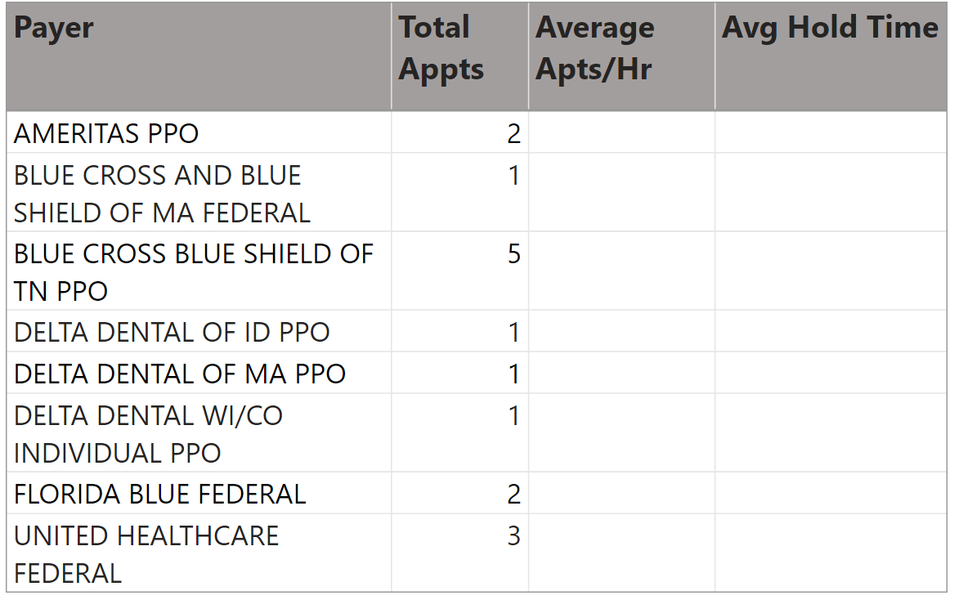

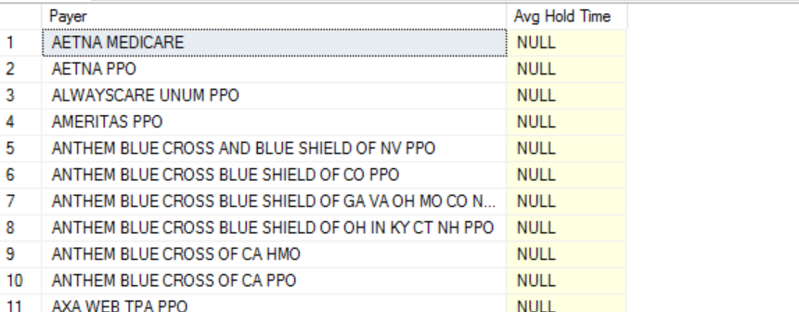

Query Used

select Payer,[Avg Hold Time]

from app.vwDimensionFilters

group by Payer,[Avg Hold Time]

**DATA AUDIT**

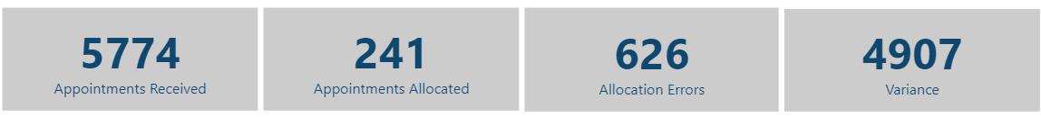

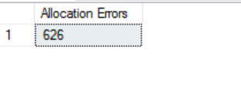

Query Used

select min([Allocation Errors]) as [Allocation Errors] from

app.vwDataAuditKPIReport

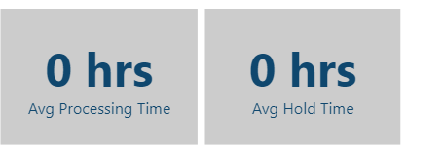

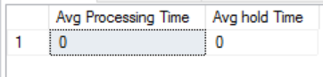

Query Used

select sum(DATEDIFF(DAY,[Processing Start Time],[Processing Stop Time]))/count([Appointment ID])

as [Avg Processing Time],sum(DATEDIFF(DAY,[Hold Start Time],[Hold Stop Time]))/count([Appointment ID])

as [Avg hold Time] from

app.vwDataAuditKPIReport