CS423 DevOps

Assignment 3

Abdur Rahman Goraya, 2022035
Ubaid ur Rehman, 2022599

About the assignment and project:
The project was cloned from https://github.com/eljamaki01/ReactNodeTesting, it contained a React + Express app that was a simple shopping cart application. Very basic, but contained a front-end and back-end part with tests written for both.
The assignment object was to setup CI/CD deployment of a given app. The app had tests written and used ESLint. These provided code structure and guidelines.
We set up the GitHub workflows, two separate ones for testing and staging. These workflows triggered with relevant triggers and updated their deployed code in their respective servers.
Both of these workflows also contained the integral CI part where we ran jest and eslint to ensure our code quality is up to standard.
They also included notification via emails.

Difficulties we faced:
1. After installing node via nvm, libatomic1 was missing for some reason from the default install of the linux OS. We thought I was an issue with node but the fix was as simple as
sudo apt install libatomic1
2. We both couldn’t remember the mail trapping service that Sir used in class and that took some time to remember (we asked chatgpt because 10 minutes of googling didn’t work, thanks AI). We used ethereal mail (mailtrap.io was not working)
3. When using the actions script appleboy/ssh-action@v1.0.3, it took us 30 minutes to figure out that the script does not source the .bashrc located in the user folder. We had to insert this at the start of it so it could find npm and pm2
source ~/.bashrc || source ~/.profile || true
[ -s "$HOME/.nvm/nvm.sh" ] && source "$HOME/.nvm/nvm.sh" || true

Flows:
Not sure if we are asked to present what we did, or what is the CI/CD process of the application after the assignment but here’s both.
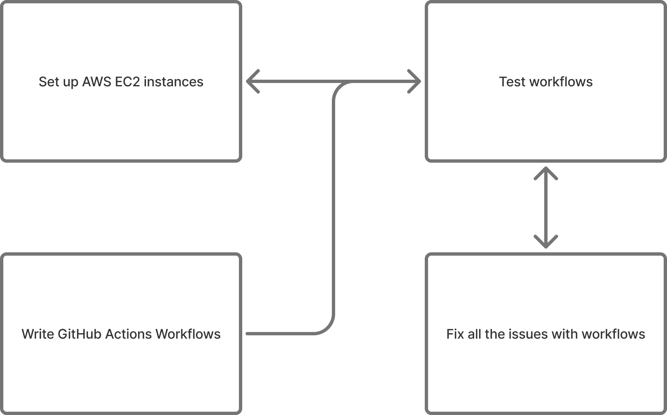

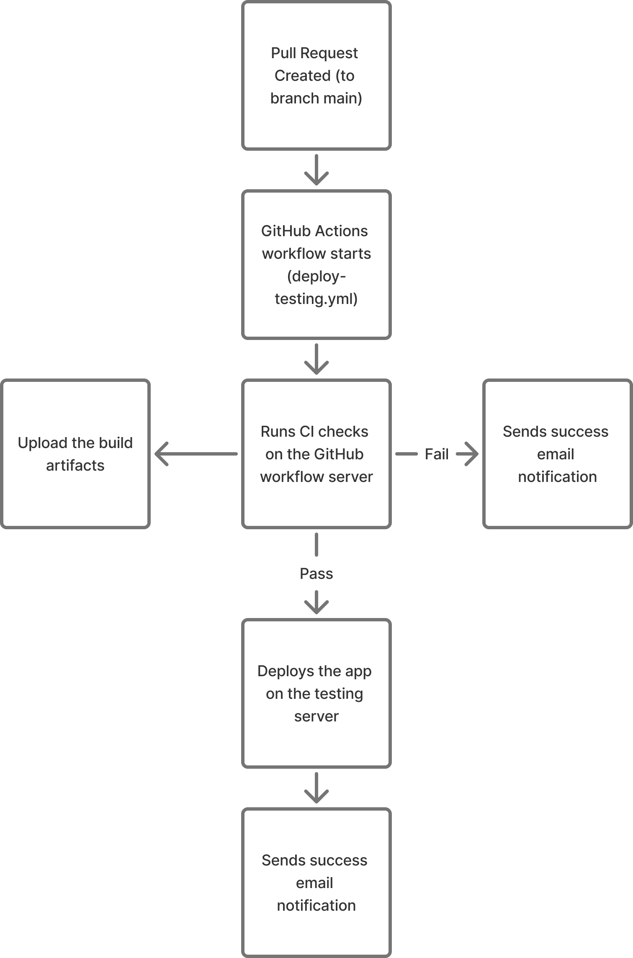

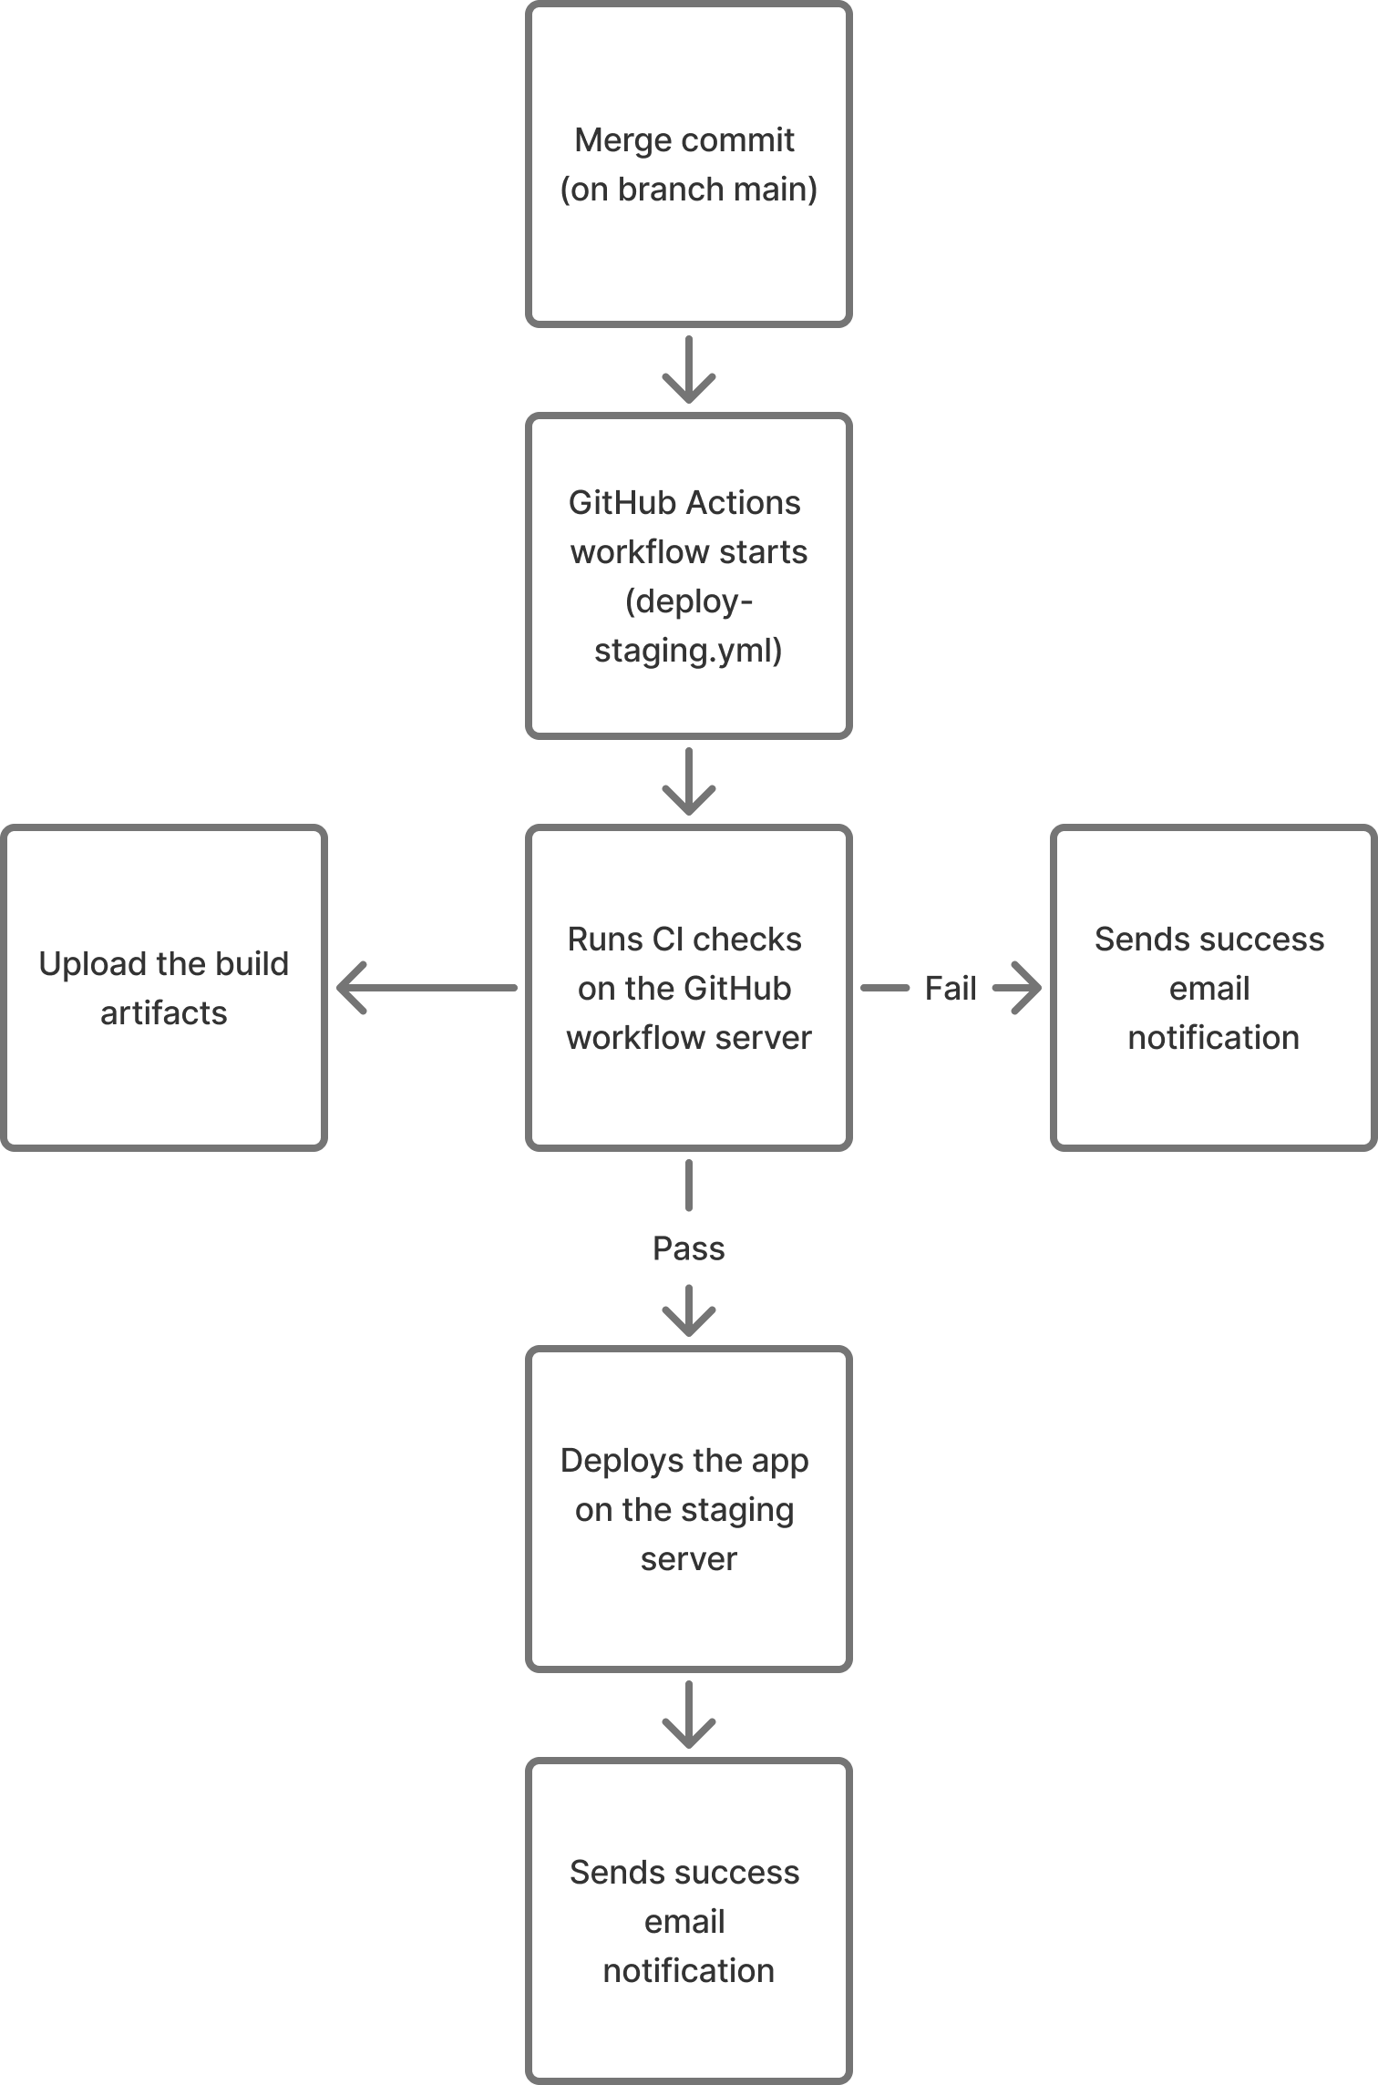

Screenshots:
1. Creating the instances
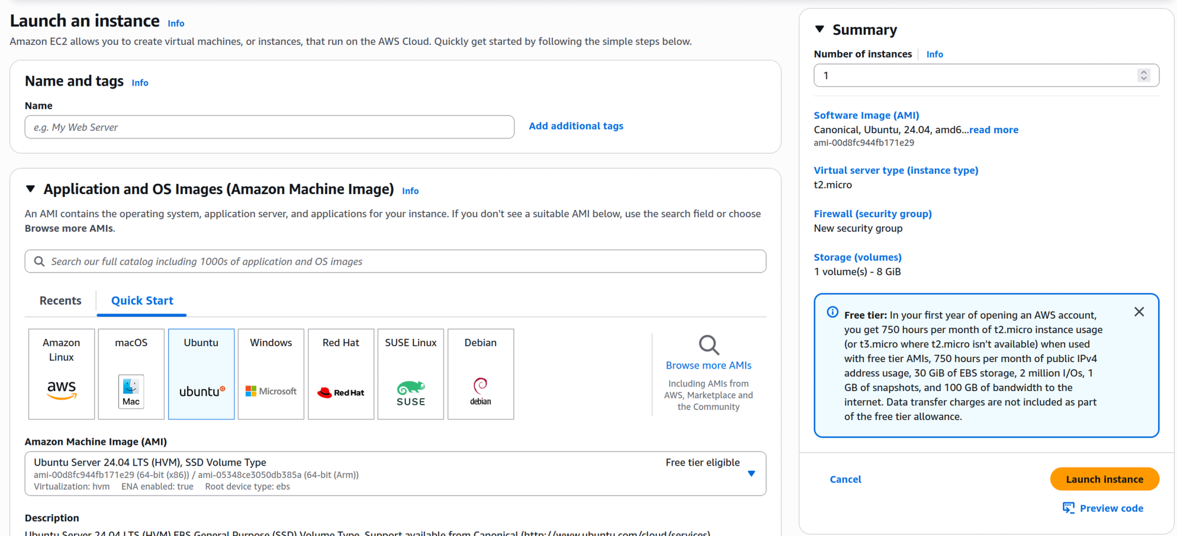
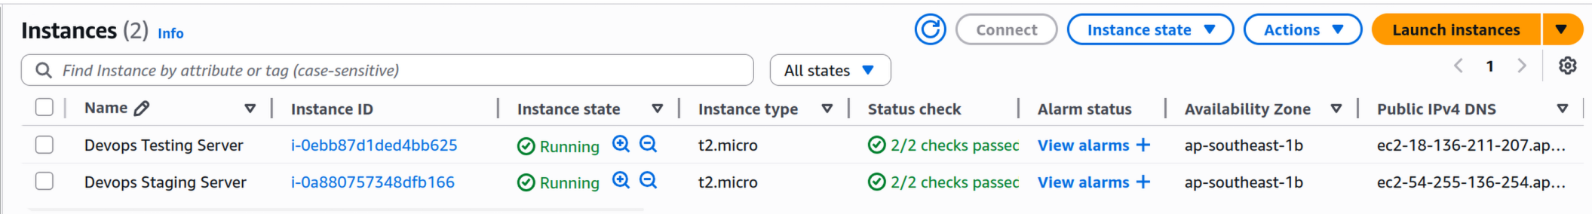
2. Writing and pushing the workflows
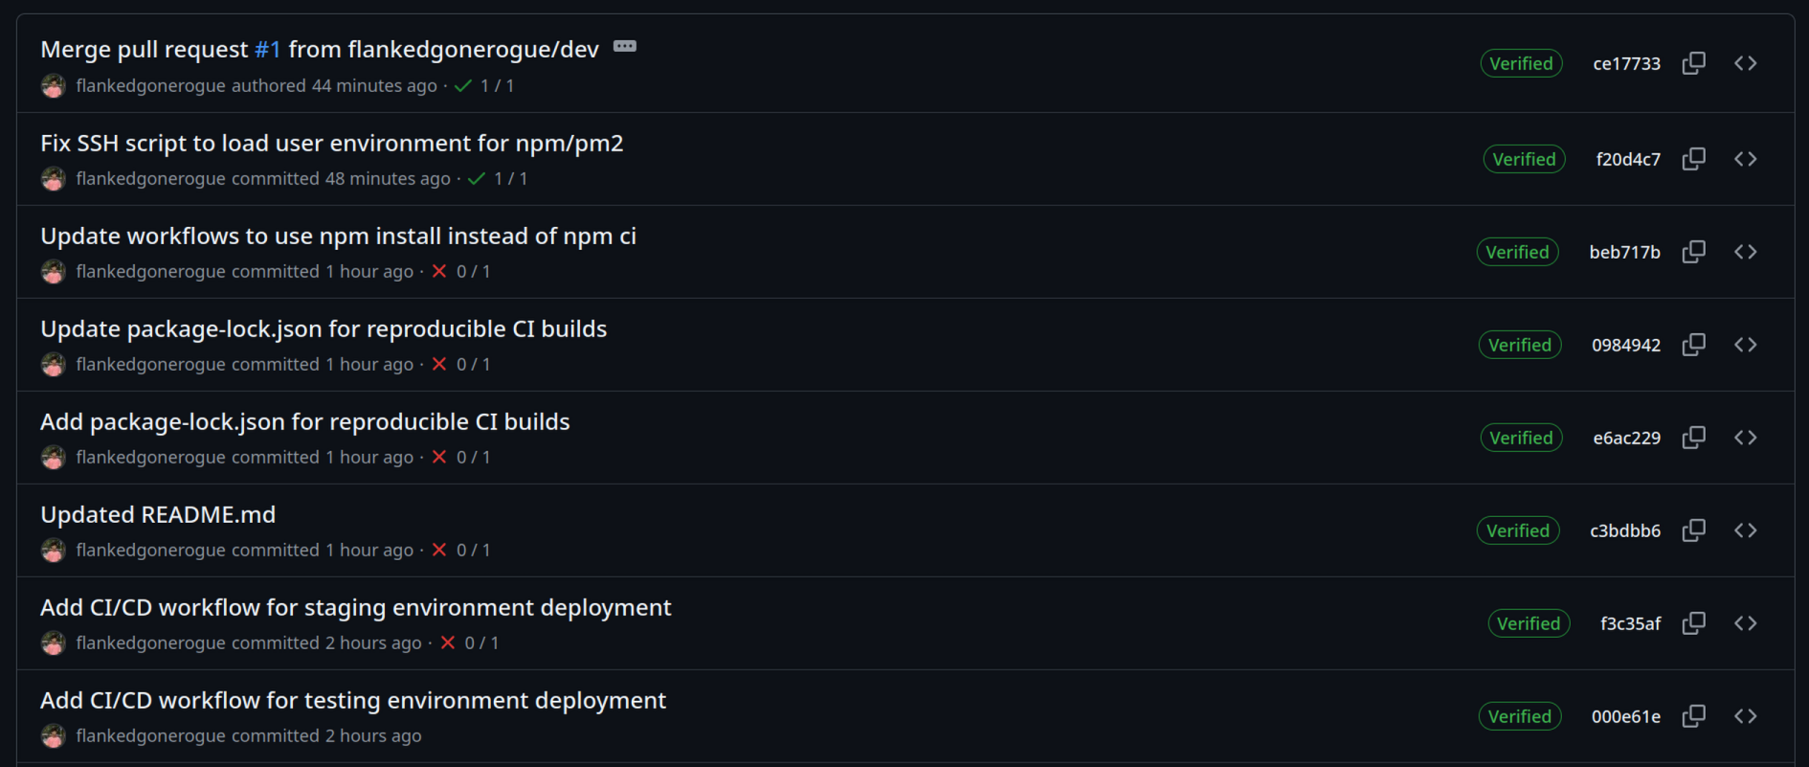
3. Storing the secrets

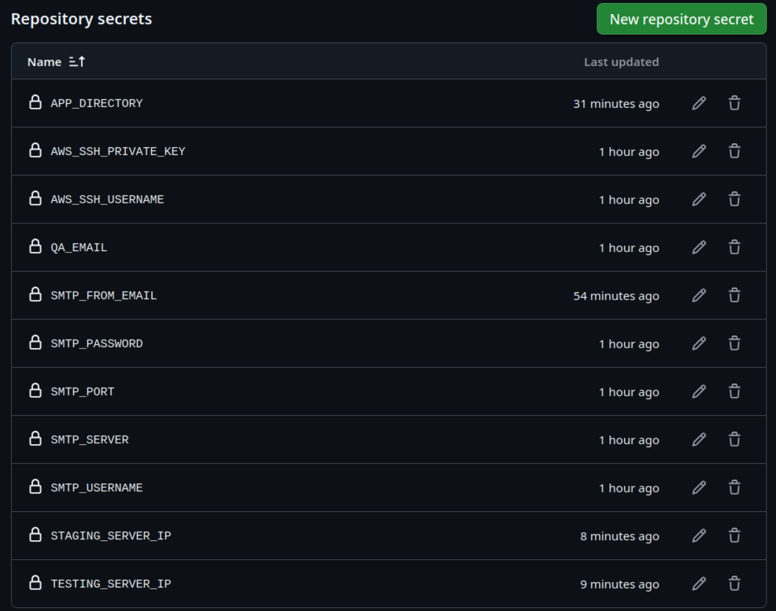
4. Setting up the instances
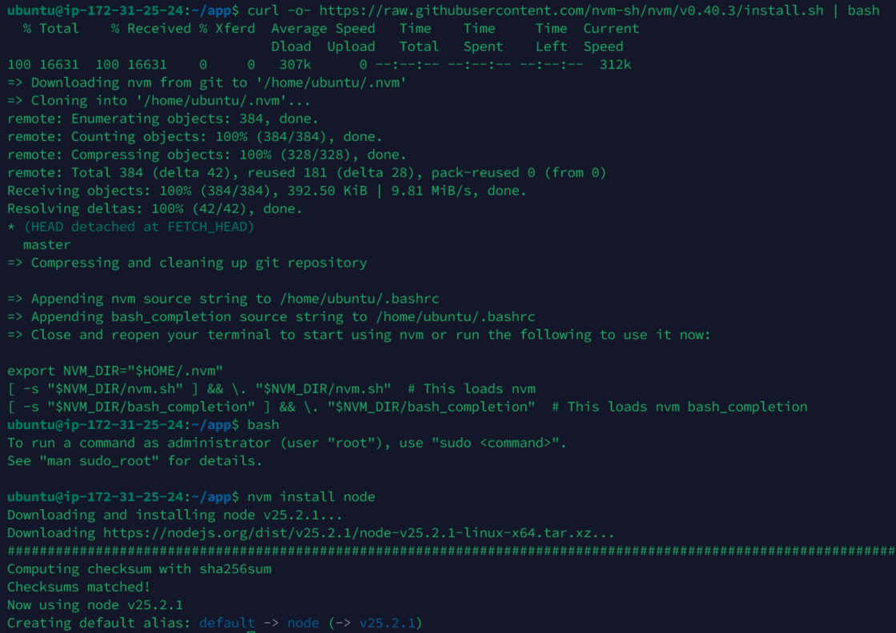

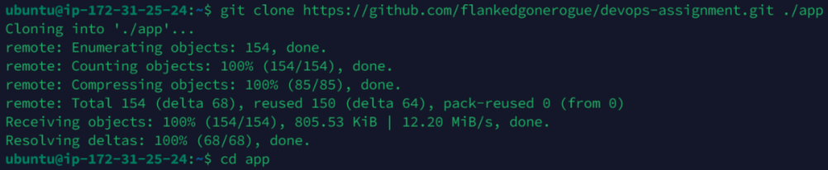
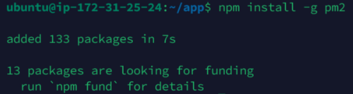
5. Testing the workflows
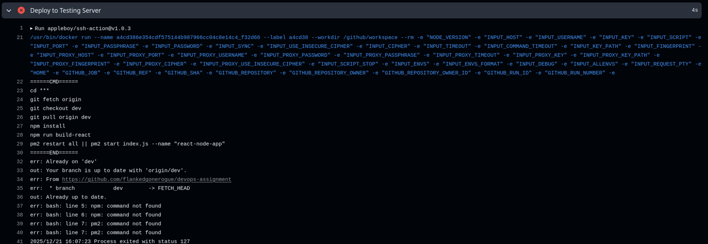
6. Ta-da apps running
