CS423 DevOps

Assignment 3

Abdur Rahman Goraya, 2022035
Ubaid ur Rehman, 2022599

About the assignment and project:
The project was cloned from https://github.com/eljamaki01/ReactNodeTesting, it contained a React + Express app that was a simple shopping cart application. Very basic, but contained a front-end and back-end part with tests written for both.
Now we set up the assignment with Docker containers, adding a dockerfile to build the images.
After this, I disabled both of the old GitHub Action workflows, and wrote new ones that had one major change. It builds a docker images, pushes it to ECR, then runs command on the EC2 to update the image and redeploy the container.

Difficulties we faced:
Not many difficulties were facing in this assignment. The experience from the first one carried over.

Flows:
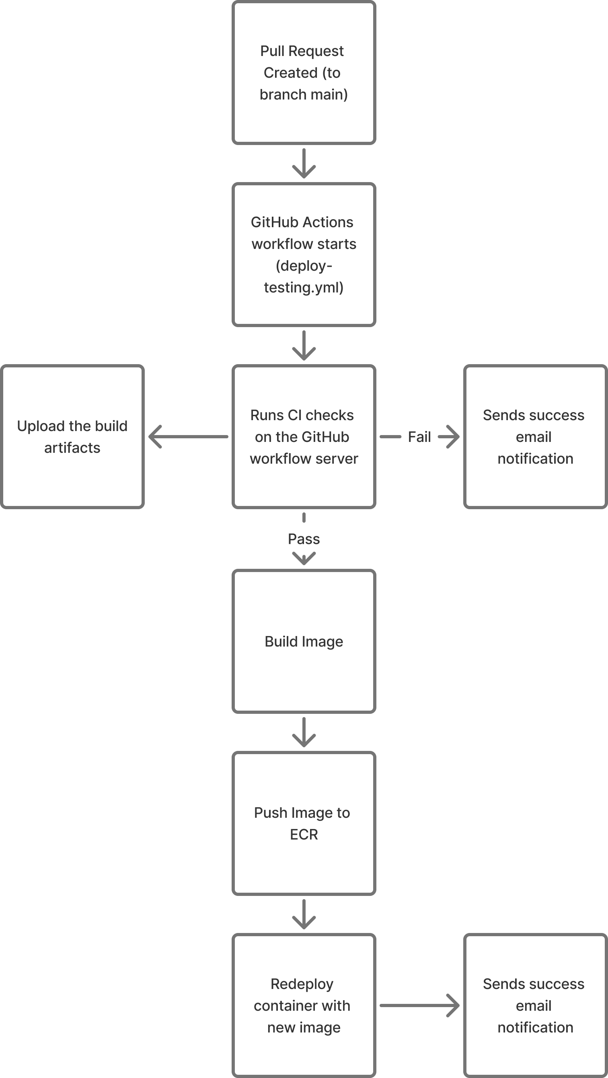

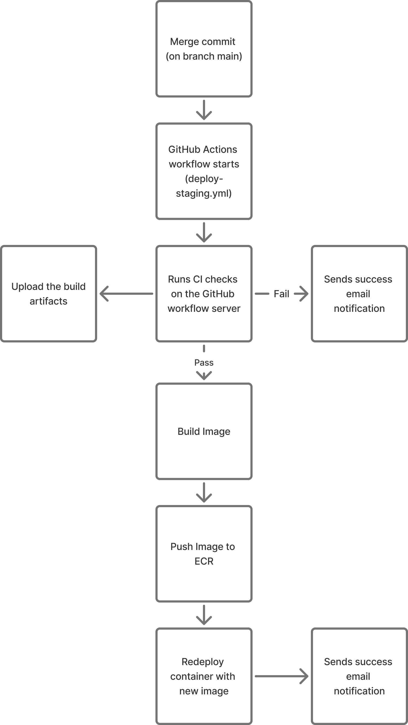

Screenshots:
1. Creating the instances
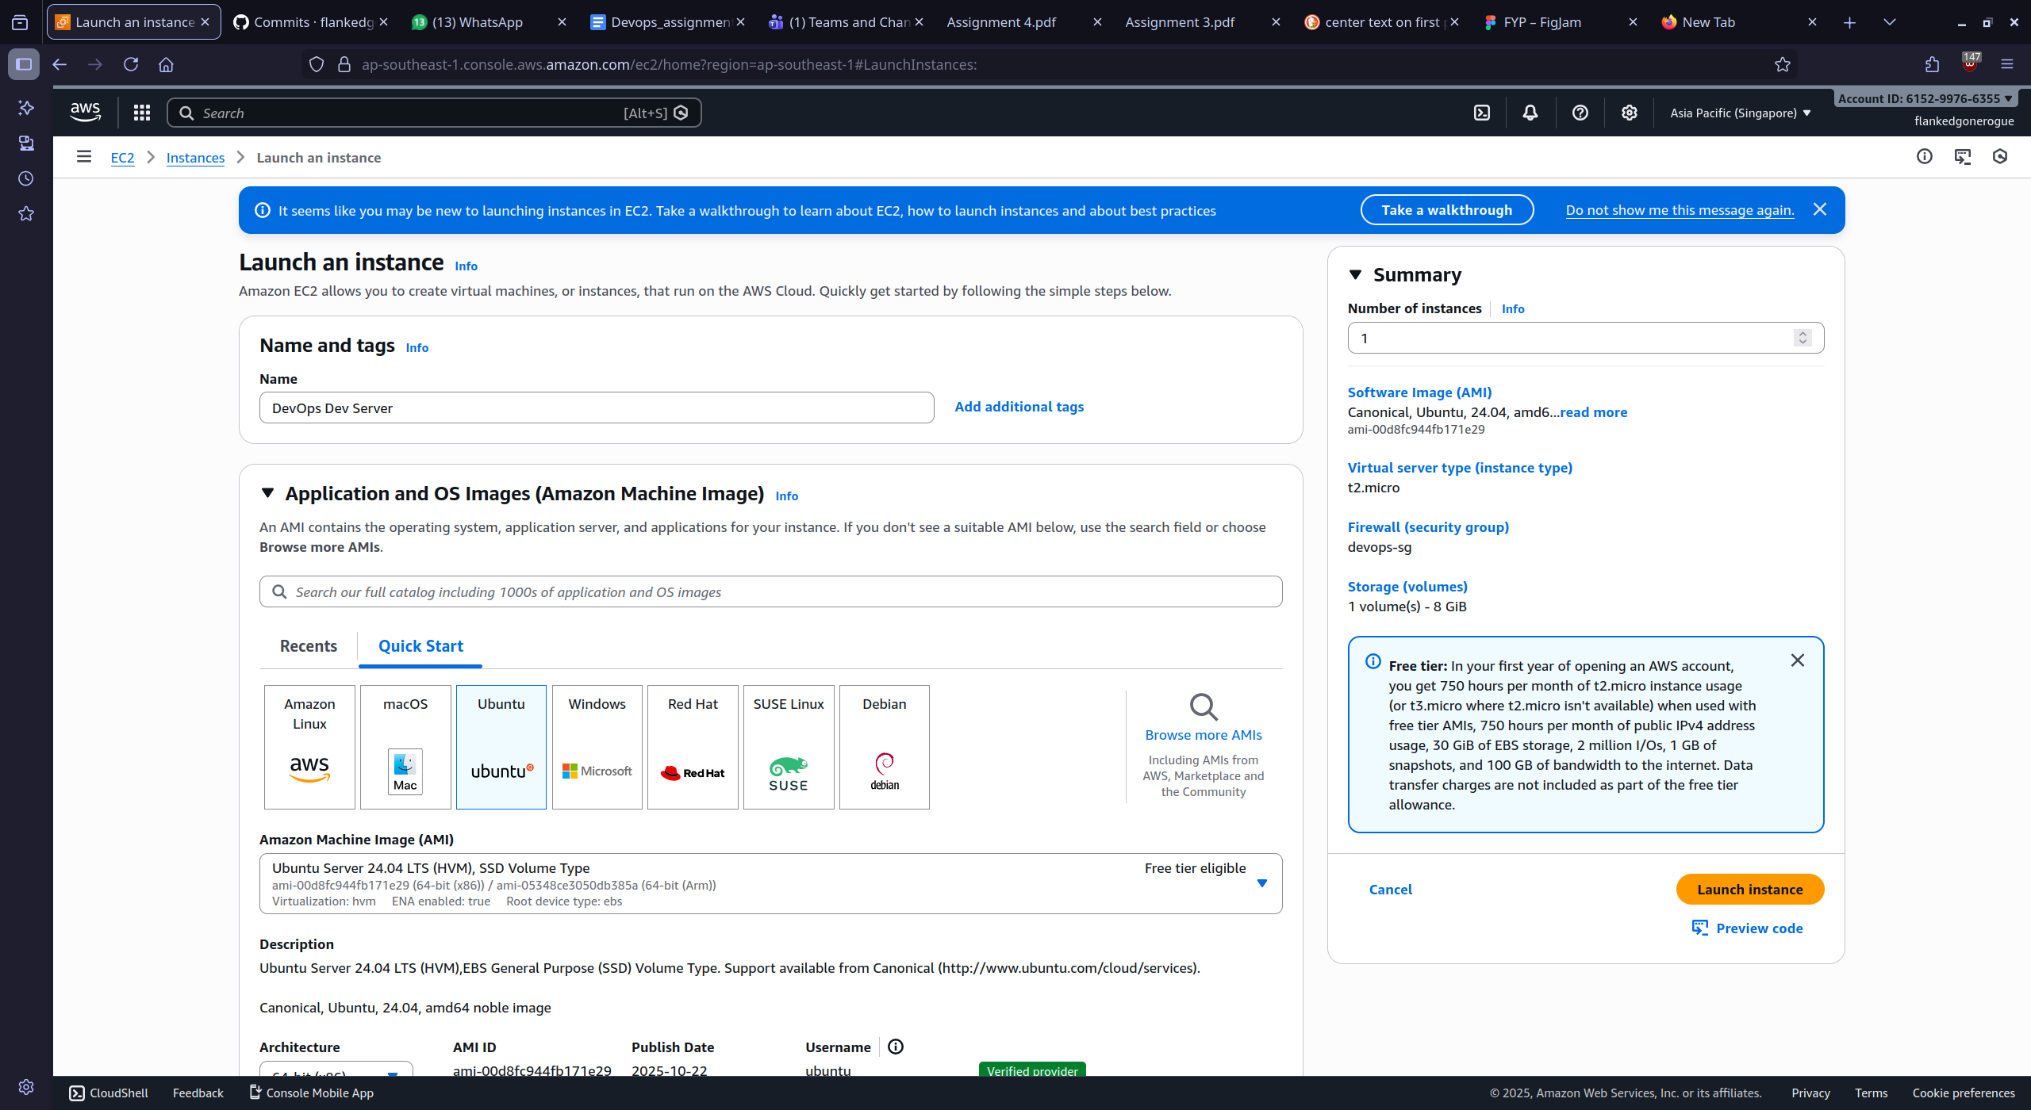
2. Creating the IAM role for EC2 instances
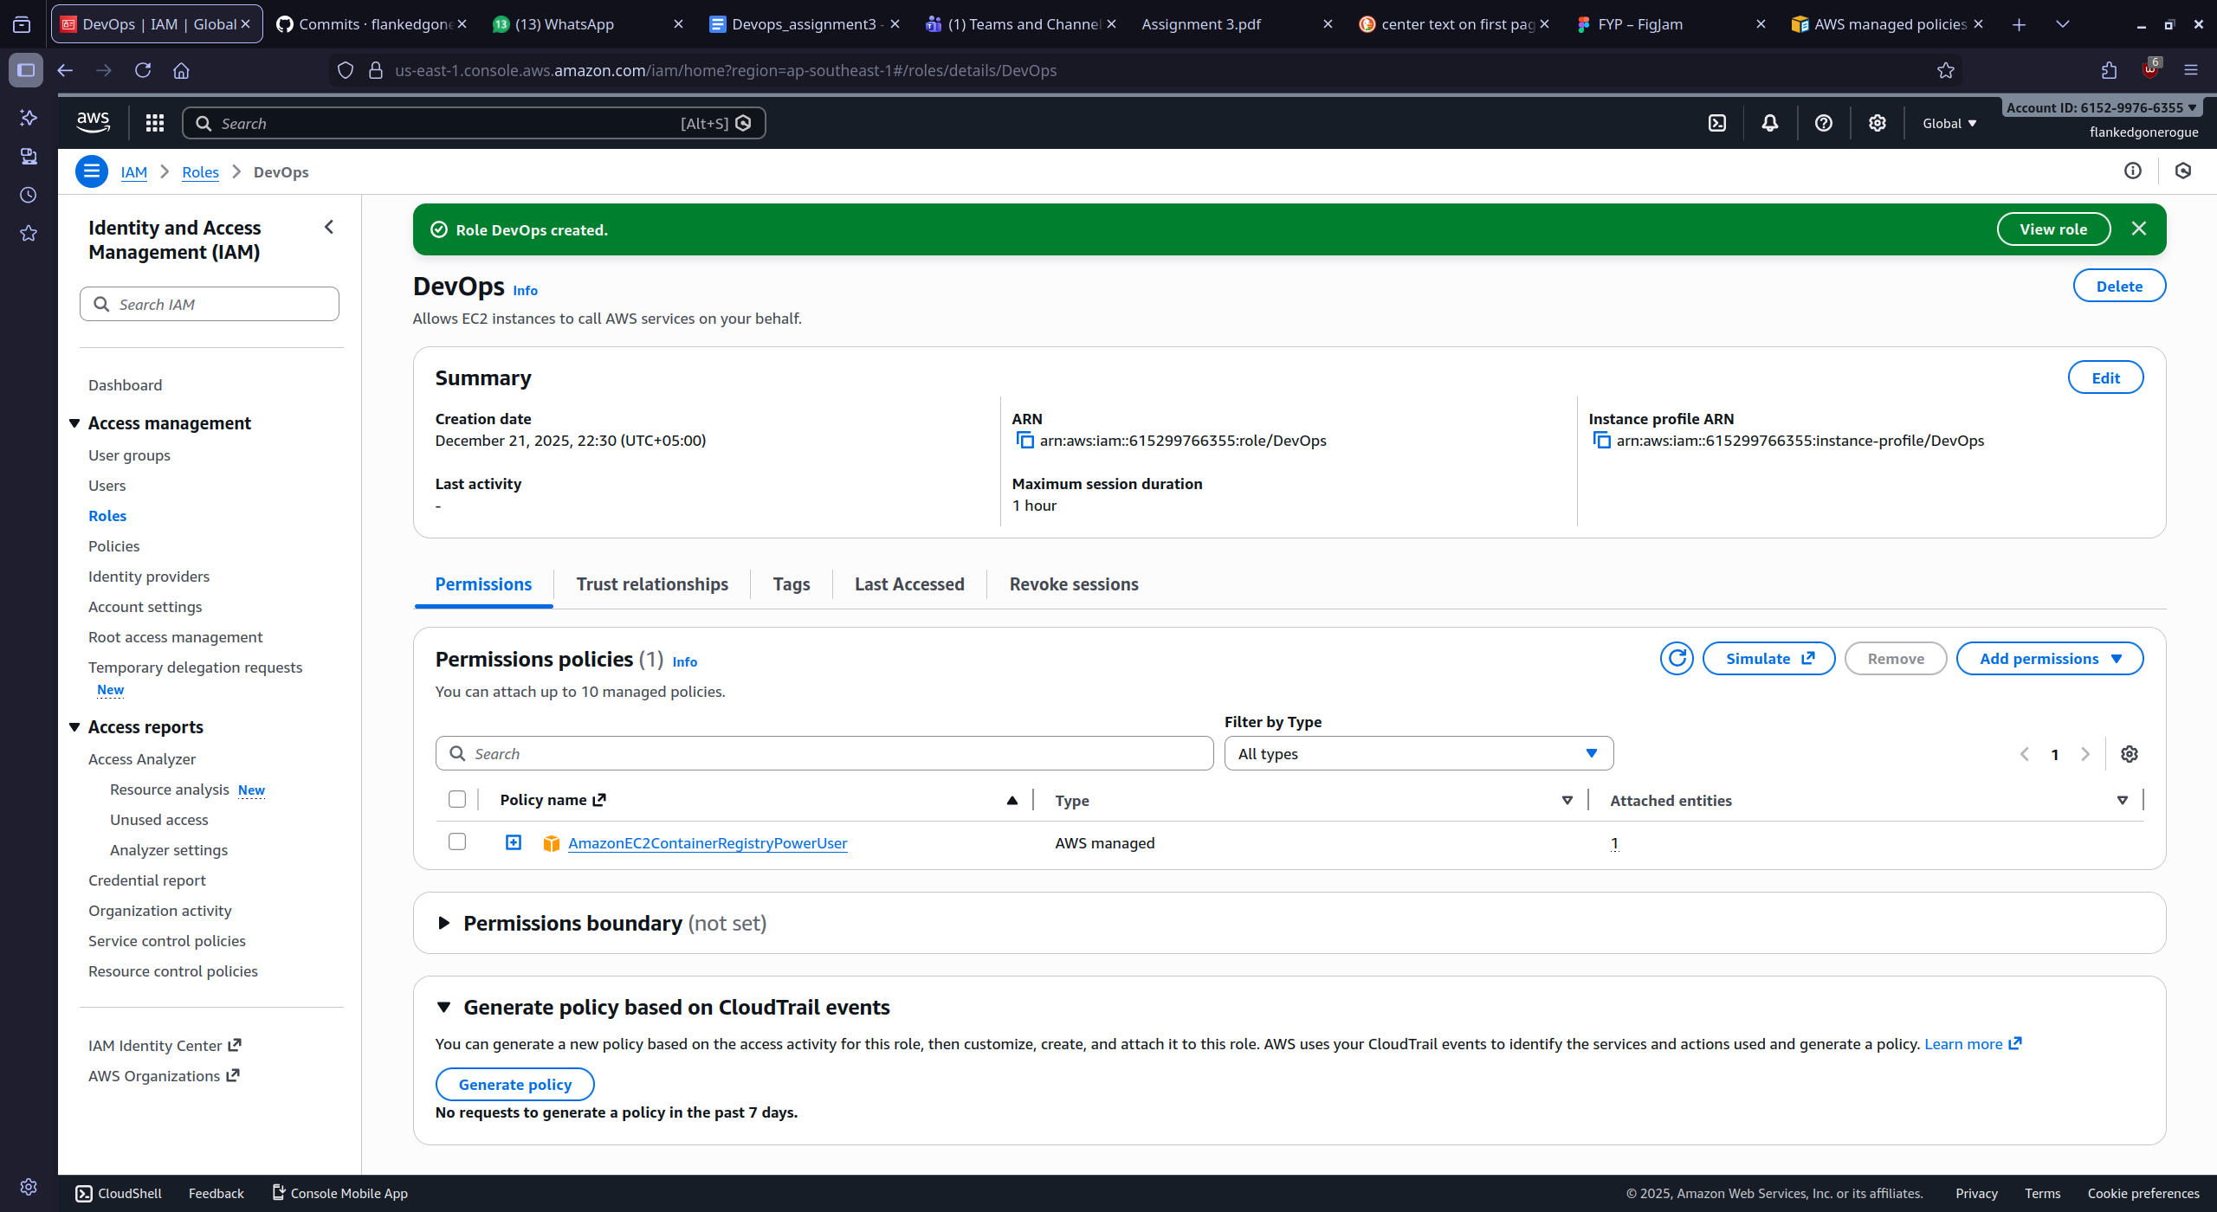
3. Assigning the IAM role

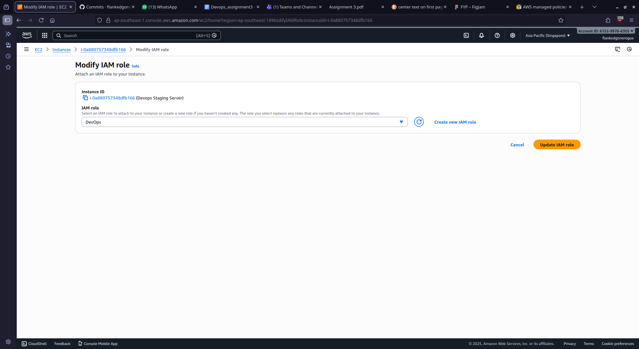
4. Setting up instances
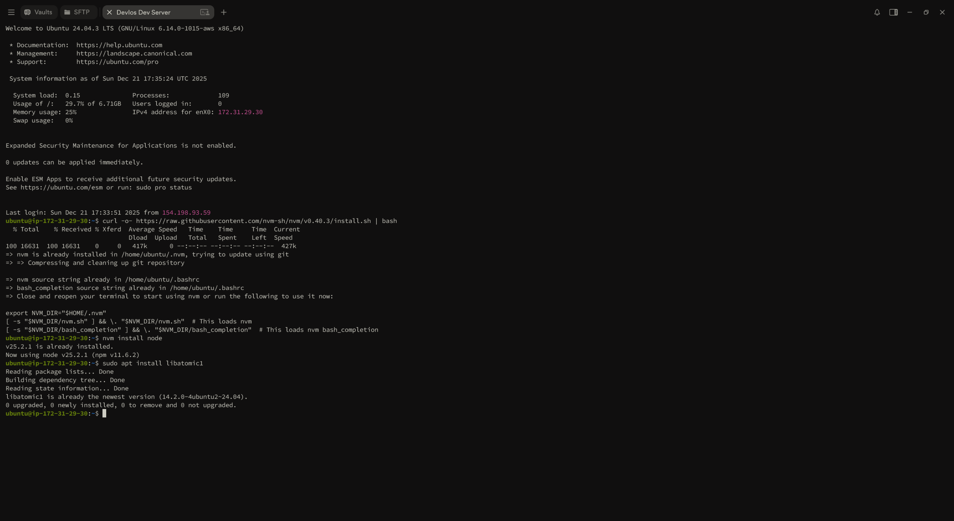
4. Create GitHub Actions User and then access token

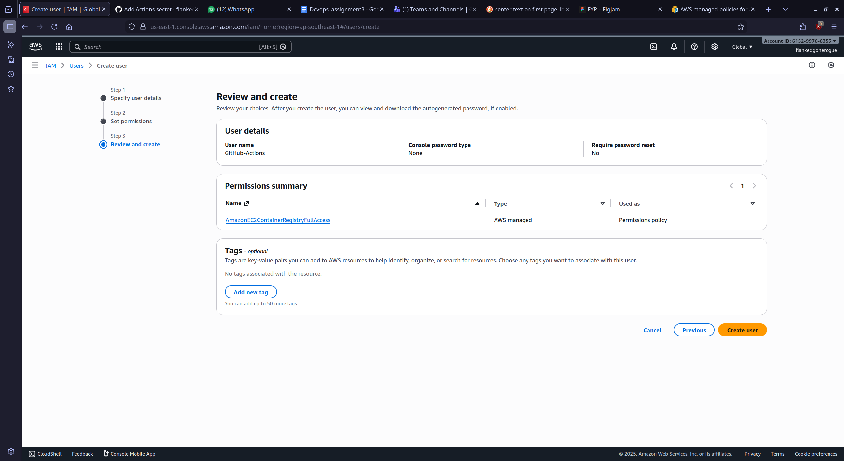

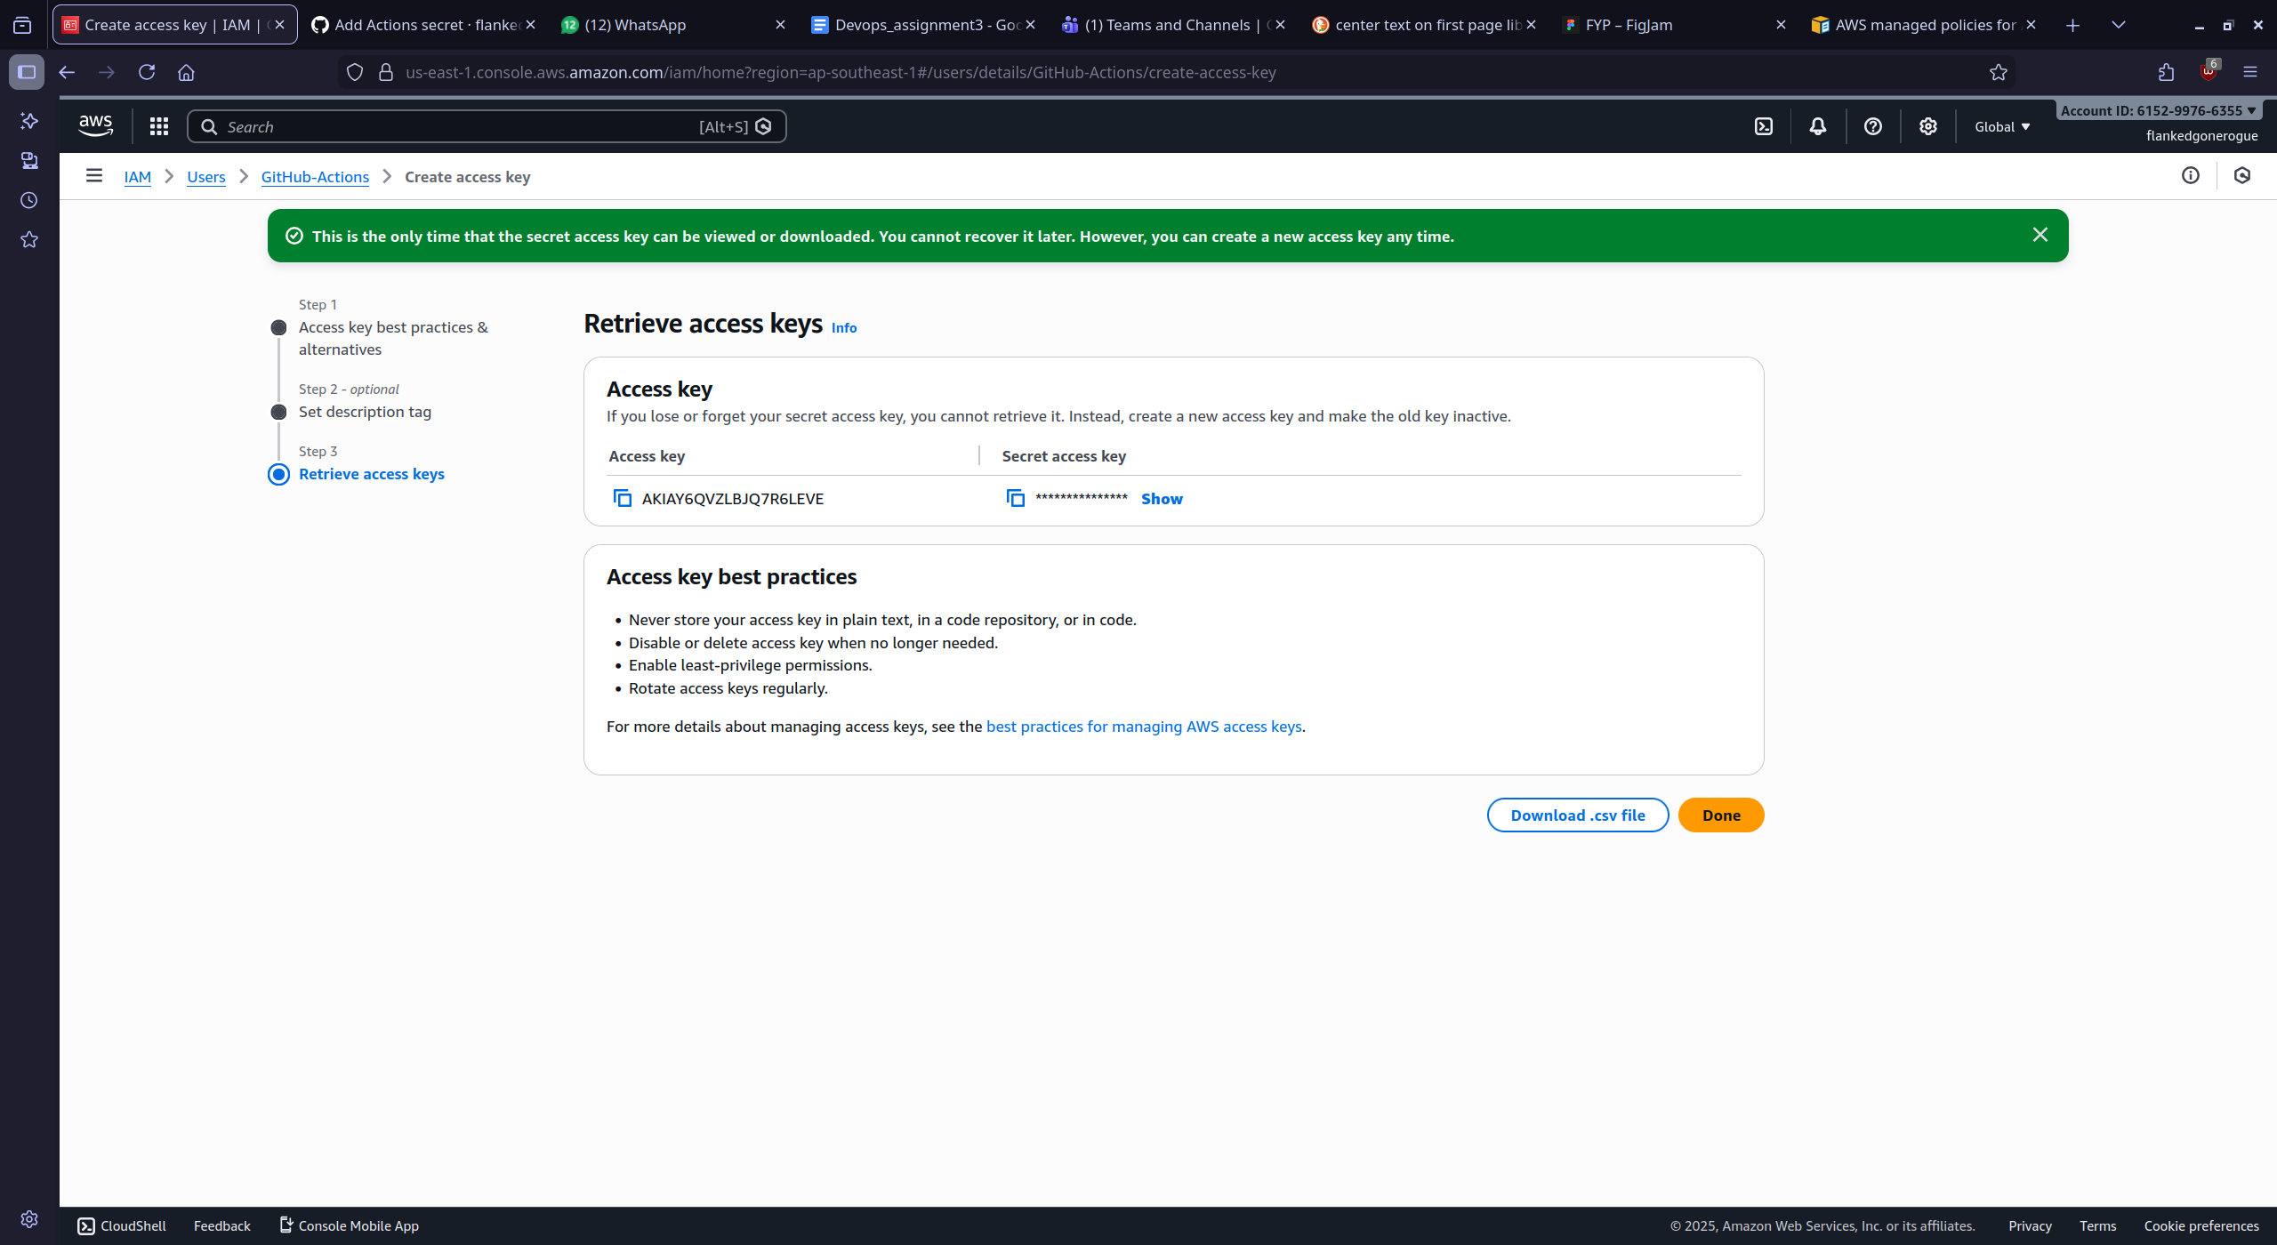
5. Setting up the new secrets and variables

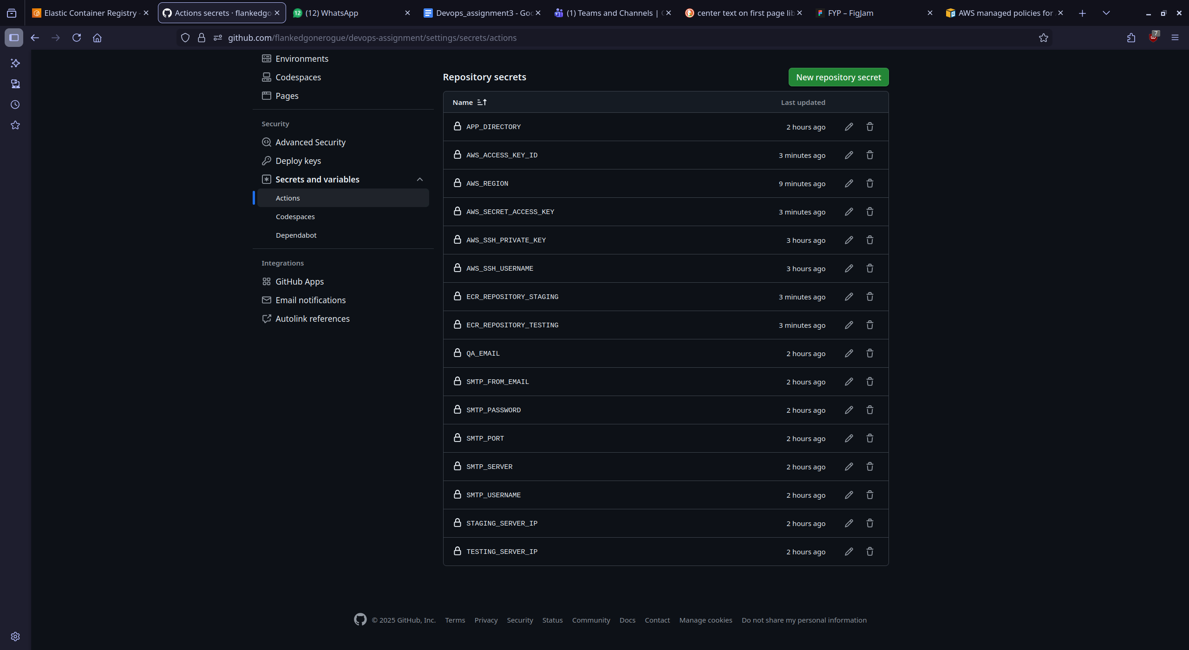
5. Viewing the success e-mails
