TDS Payout Integration for BB+ Platform
Technical Specification — Summary Document
Author: Prashant Chauhan · Version: 9.0 · February 2026

Table of Contents

Right-click the TOC above → Update Field to refresh page numbers.

This document presents a simplified overview of the TDS (Tax Deducted at Source) integration for BB+ payouts.
It focuses on the problem statement, three solution approaches, and the recommended approach.
Implementation details, code snippets, and detailed technical specifications have been minimized.

1.1. 1. Overview & Problem Statement

1.1.1. 1.1 Business Context: Why TDS Support?
BB+ merchants need to comply with Indian tax regulations when making vendor payments.
When TDS (Tax Deducted at Source) applies:
- Merchant enters a gross amount (e.g., ₹10,000)
- Selects a TDS category (e.g., Section 194J - Professional Services at 10%)
- Optionally applies Lower Deduction Certificate (LDC) for reduced rates
- System calculates TDS amount (₹1,000) and creates a payout for the net amount (₹9,000) to the vendor
- TDS amount is tracked for monthly filing and payment to the government

1.1.2. 1.2 Product Requirement
Seamless Merchant Experience
The product requirement is to provide a seamless experience for merchants using the Payouts API, where they can pass minimal details similar to what is currently passed to the compute API.
Key Requirements:
- Minimal Input: Merchants should provide basic payout details (gross amount, TDS category, contact, etc.) without needing to pre-calculate TDS values themselves
- Automatic Calculation: The system should automatically compute TDS amounts based on the provided inputs
- Persistence: All TDS-related data should be persisted correctly for compliance and reporting
- Unified Flow: The payout should be created seamlessly after TDS calculation
- Universal Applicability: This single approach should work consistently across all three payout types:
Single Payout (UI-based merchant-initiated payouts)
Bulk Payout (CSV file upload with multiple payout records)
API Payout (Programmatic payout creation via API integration)
This requirement drives the architectural decision to ensure merchants have a consistent, simple interface regardless of how they create payouts, while the system handles all complexity of TDS computation and compliance internally.

1.1.3. 1.3 The Problem
Current State
The existing Payouts service does not support BB+ TDS computation and tracking.
We need to integrate TDS functionality while:
- Not impacting existing Vendor-Payments flows (which have their own TDS handling)
- Supporting all payout types: Single Payout (UI), Bulk Payout (CSV), and API Payouts
- Maintaining clear separation of concerns between Payouts and Tax-Compliance services
- Ensuring data consistency between payout records and TDS filing records

1.1.4. 1.4 Services Involved
Service | Responsibility
Tax-Compliance | - Computes TDS based on category, rate, and LDC status  - Manages TDS Payment entities for compliance and filing  - Validates TDS categories and PAN details
Payouts | - Creates payout records for net amount to vendor  - Processes fund transfers  - Emits payout status updates  - Stores TDS information for audit trail
Tax-Compliance (BFF) | - Acts as BFF — the only backend the UI talks to for TDS flows  - Computes TDS, orchestrates payout creation, presents data to merchants

1.1.5. 1.4 Amount Relationship
Key Formula

1.1.6. 1.5 Key Entities
Entity | Service | Purpose
payout | Payouts | The payment to vendor (net amount after TDS deduction)
payout_details | Payouts | Extended TDS information (category, amounts, breakdown) stored as JSON
tds_payment | Tax-Compliance | TDS record for government filing (includes deductee PAN, amounts, category details)

1.1.7. 1.6 Coverage: All Payout Types
Payout Type | Description | TDS Handling
Single Payout (UI) | Merchant creates one payout via Tax-Compliance UI | Preview TDS breakdown before confirming; one compute call per payout
Bulk Payout (CSV) | Merchant uploads CSV with multiple payouts | Compute TDS for all rows upfront; generate preview file; user confirms before processing
API Payouts | Merchant integrates via API | Same pattern as UI - caller computes TDS first, then creates payout with pre-computed values

1.2. 2. Approach 1: Inline Compute Pattern
Not Recommended — Payout API accepts TDS inputs; Payouts calls Tax-Compliance internally (S2S); async TDS entity creation

1.2.1. 2.1 How It Works
In this approach, the Payouts service accepts TDS computation inputs (gross amount, category, contact details)
and internally calls the Tax-Compliance service to compute TDS before creating the payout.
Flow Summary
- Preview (UI only): Tax-Compliance (BFF) computes TDS to show breakdown to merchant
- Create Payout: Tax-Compliance sends TDS inputs to Payouts API with gross amount
- Inline Compute: Payouts makes S2S call to Tax-Compliance compute API
- Amount Derivation: Payouts derives net amount (gross - TDS) and stores payout with net amount
- Async TDS Entity: When payout reaches terminal state, Payouts publishes to Kafka; Tax-Compliance creates TDS Payment entity

1.2.2. 2.2 Flow Diagram (High-Level)
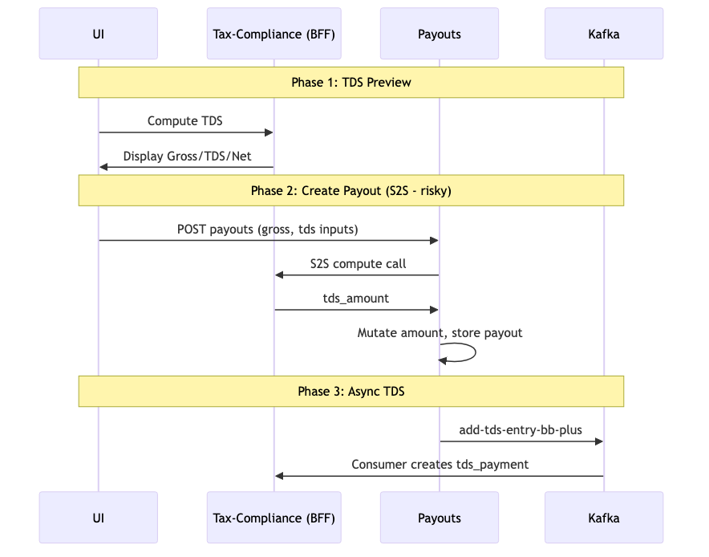

1.2.3. 2.3 Payout Type Considerations
Payout Type | Impact
Single Payout (UI) | One S2S call per payout (+50-200ms latency)
Bulk Payout (CSV) | S2S call for every row during payout creation (high latency for bulk operations)
API Payouts | External API users pay latency cost; service coupling creates reliability risk

1.2.4. 2.4 Pros and Cons
Pros | Cons
Single API call for merchant/caller | S2S call adds 50-200ms latency to every payout
Payout and TDS data stored atomically | Payouts fails if Tax-Compliance is down (tight coupling)
Simple integration for frontend | Domain leakage - Payouts must understand TDS computation
 | Amount mutation (gross→net) is risky and error-prone
 | TDS Payment entity created asynchronously (not in API response)
 | High testing complexity (must mock Tax-Compliance in all tests)

Why Not Recommended
This approach introduces significant technical debt: latency overhead, service coupling,
domain leakage, and risky amount mutation. The synchronous S2S call in the critical path
makes payouts dependent on Tax-Compliance availability.

1.3. 3. Approach 2: Tax-Compliance Orchestrated
Alternative — Tax-Compliance orchestrates both TDS computation and payout creation

1.3.1. 3.1 How It Works
In this approach, Tax-Compliance becomes the orchestrator. It exposes a single API endpoint
that creates both the TDS Payment entity and the payout.
Flow Summary
- Preview (UI only): Tax-Compliance (BFF) computes TDS to show breakdown
- Single API Call: UI calls Tax-Compliance payout creation API (not Payouts directly)
- Tax-Compliance Orchestration:
Computes TDS
Creates TDS Payment entity (synchronously)
Calls Payouts API (S2S) to create payout
Returns both TDS Payment ID and Payout ID in response
- Status Sync: Tax-Compliance listens to payout status updates via existing Kafka topic

1.3.2. 3.2 Flow Diagram (High-Level)
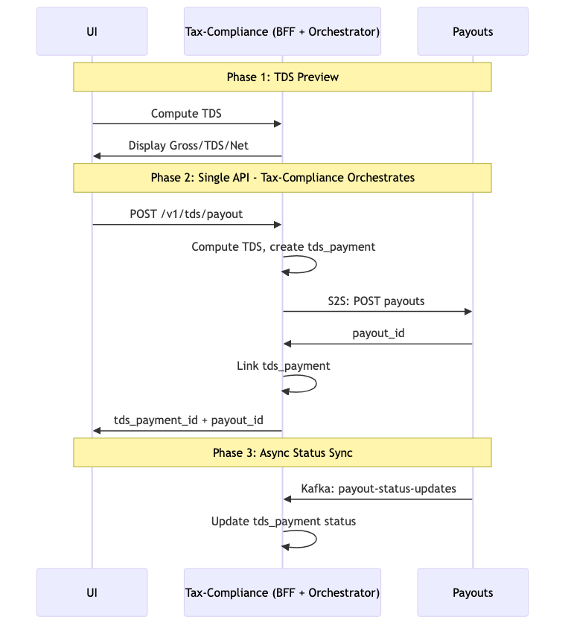

1.3.3. 3.3 Payout Type Considerations
Payout Type | Impact
Single Payout (UI) | One orchestrated call via Tax-Compliance
Bulk Payout (CSV) | Would require new bulk orchestration API in Tax-Compliance; complex error handling
API Payouts | External users call Tax-Compliance instead of Payouts (API surface change)

1.3.4. 3.4 Pros and Cons
Pros | Cons
Single API call returns both TDS Payment ID and Payout ID | Reversed S2S call (Tax-Compliance → Payouts adds latency)
TDS Payment entity available synchronously | Tax-Compliance depends on Payouts (tight coupling)
Tax-Compliance owns all TDS data | Domain leakage - Tax-Compliance must understand payout creation
No new Kafka topic needed | Complex orchestration logic in Tax-Compliance
Minimal Payouts changes | Bulk payout support requires significant Tax-Compliance work

When to Consider
This approach is viable if having the TDS Payment ID synchronously in the API response
is a hard requirement. However, it introduces orchestration complexity and reverses
the natural dependency direction (Tax-Compliance calling Payouts).

1.4. 4. Approach 3: Pre-Compute Pattern (RECOMMENDED)
RECOMMENDED - All Channels — Tax-Compliance (BFF) pre-computes TDS; Payouts receives pre-computed values; minimal changes
BFF = Tax-Compliance Only
In BB+ TDS flows, Tax-Compliance is the only BFF. There is no separate Dashboard/BFF service. The UI talks to Tax-Compliance; Tax-Compliance orchestrates compute and payout creation.
Core Principle: Keep Payouts Dumb About TDS Computation
Payouts should NOT call Tax-Compliance during payout creation.
Instead, the caller (Tax-Compliance for UI flows, or API client for programmatic) pre-computes TDS
by calling Tax-Compliance first, then passes the pre-computed values to Payouts.
Payouts simply stores these values and routes to the correct Kafka topic.

1.4.1. 4.1 How It Works
This approach separates TDS computation from payout creation, following the same pattern
already used by Vendor-Payments.
Flow Summary
- Compute TDS (Before Payout): Tax-Compliance (BFF) computes TDS internally; for API clients, they call Tax-Compliance compute API
- Display Preview: Tax-Compliance shows merchant the TDS breakdown (gross, TDS, net)
- Create Payout: Tax-Compliance (or API client) sends pre-computed values to Payouts API
amount: NET amount (e.g., 900000)
tds.amount: TDS amount (e.g., 100000)
tds.gross_amount: Gross amount (e.g., 1000000)
tds.source: "bb_plus" (routing indicator)
tds.breakdown: Full TDS calculation details
- Payouts Storage: Payouts stores payout (net amount) + all TDS fields in payout_details
- Kafka Routing: When payout reaches terminal state, Payouts checks source field:
If "bb_plus" → publish to add-tds-entry-bb-plus (Tax-Compliance consumer)
Otherwise → publish to add-tds-entry (Vendor-Payments consumer - existing)
- Async TDS Entity: Tax-Compliance consumer creates TDS Payment entity from Kafka message

1.4.2. 4.2 Flow Diagram (High-Level)
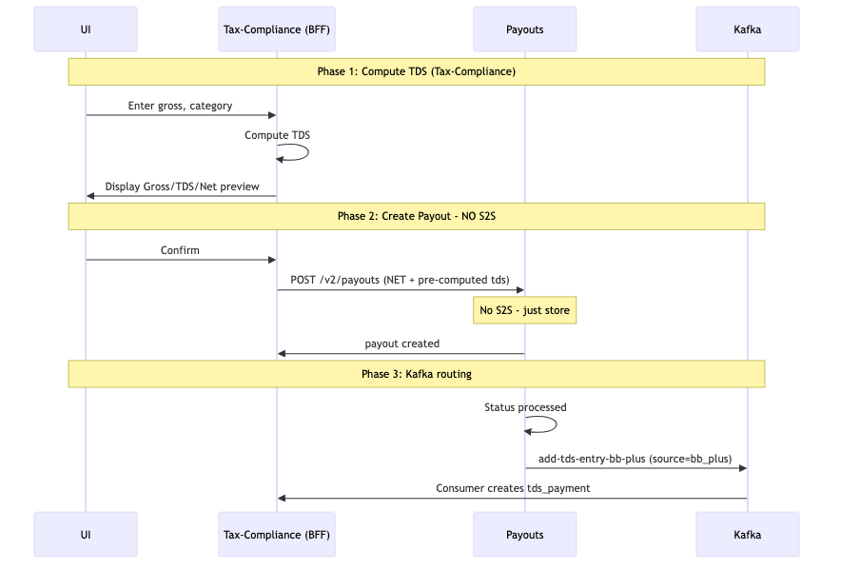

1.4.3. 4.3 Key Differences from Approach 1
Aspect | Approach 1 (Inline) | Approach 3 (Pre-Compute)
TDS Computation | Payouts calls Tax-Compliance (S2S) | Caller pre-computes before payout creation
S2S Call in Payout API | Yes - blocking (+50-200ms) | No - zero latency added
Amount Handling | Mutates params.Amount (gross→net) | Caller sends NET amount directly
Failure Coupling | Payouts fails if Tax-Compliance down | Compute separate from payout creation
Payouts Code Changes | High (client, compute logic) | Low (add fields + topic routing)
Domain Separation | Leaks to Payouts | Clean - Tax-Compliance owns compute

1.4.4. 4.4 Channel-by-Channel Flow
Core Design Tension — API Payouts
In Dashboard and Bulk flows, TDS compute values are known before the payout request is made
— Tax-Compliance (BFF) computes and passes them in. For direct API Payouts, the merchant only
has raw inputs (category, PAN, amount). TDS compute values are not yet available.
If Payouts calls Tax-Compliance synchronously for API payouts:
adds latency (+~200ms p95), creates availability coupling (Payouts fails if Tax-Compliance is down),
and increases Payouts blast radius (new S2S integration). This is rejected.
Resolution: Tax-Compliance exposes a public compute endpoint. API merchants make two calls
(compute → create payout), passing pre-computed values — identical to the Dashboard/Bulk pattern.
Payouts never calls Tax-Compliance.
Channel | TDS values available at payout time? | Who computes? | Payouts change
Dashboard (UI) | YES — user filled form, compute shown as preview | Tax-Compliance (BFF) | Accept + store 4 fields; route to Kafka topic
Bulk CSV | YES — computed row-by-row during parse, preview before confirm | Tax-Compliance (BFF)
API (direct merchant) | NO — merchant has only raw inputs (category, PAN, amount) | Merchant calls Tax-Compliance compute API first

1.4.5. Storage Decision
Payouts stores:
- Payouts stores: Primitive fields only — tds_amount, tds_rate, tds_category, payee_pan, source (new columns on payout row). No new entity, no Tax-Compliance integration.
- Tax-Compliance stores: Full tds_payments entity, created asynchronously from the Kafka event after payout completion. Kafka event carries the primitive fields.
The net payout amount is determined by the pre-computed tds_amount at creation time, so money routing is correct before the async entity creation.

1.4.6. Dashboard / Single Payout Flow
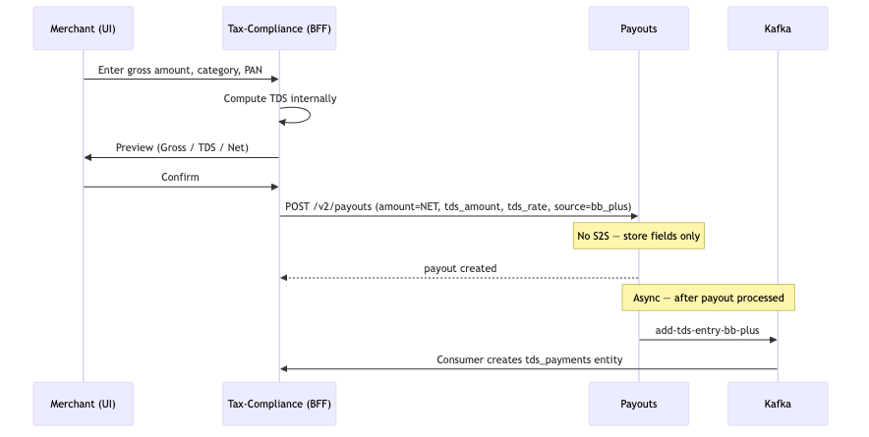

1.4.7. Bulk CSV Flow
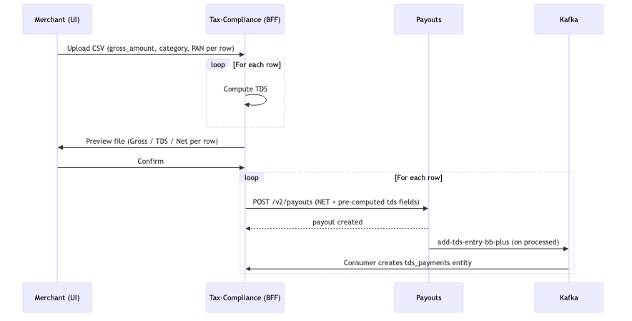

1.4.8. API Payout Flow (Direct Merchant Integration)
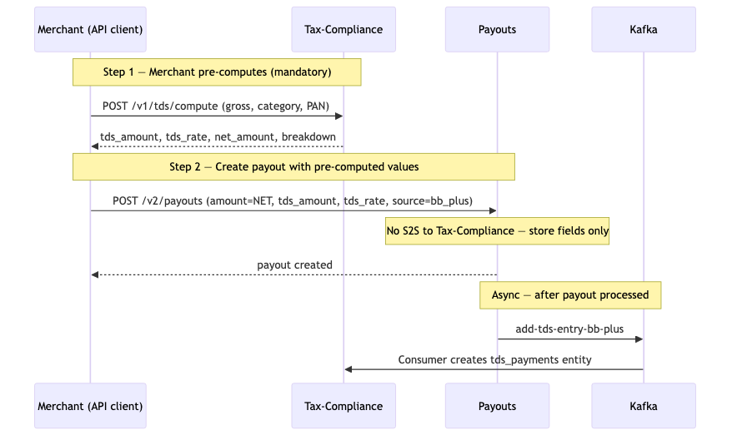

1.4.9. 4.5 Changes Required (High-Level)
Service | Changes | Effort
Payouts | - Add optional fields to TDSDetails struct: source, gross_amount, breakdown  - Add topic routing logic in ProcessTdsForPayout() based on source field  - Store BB+ fields in payout_details JSON | Low
Tax-Compliance | - Build/enhance compute API endpoint  - Build Kafka consumer for add-tds-entry-bb-plus topic  - Create TDS Payment entities from Kafka messages | Medium
Tax-Compliance (BFF) | - Compute TDS before payout creation  - Display TDS breakdown in preview to merchant  - Pass pre-computed values to Payouts API | Medium
Tax-Compliance (Bulk) | - Add TDS columns to CSV template  - Tax-Compliance computes TDS per row during parsing  - Generate preview file with TDS breakdown | Medium

1.4.10. 4.6 Pros and Cons
Pros | Cons
Zero latency added to payout API (no S2S call) | Two separate API calls (compute, then create payout)
Payouts decoupled from Tax-Compliance availability | LDC certificate could expire between compute and payout
Minimal Payouts changes (just fields + routing) | Tax-Compliance (BFF) must orchestrate two-step flow
No amount mutation - caller sends NET directly
Clean domain separation
Backward compatible - all new fields optional
Easy testing - no Tax-Compliance mock needed
Same pattern as existing Vendor-Payments flow
Works seamlessly for all payout types (single, bulk, API)

1.5. 5. Comparison of Approaches

1.5.1. 5.1 All Three Approaches
Criteria | Approach 1: Inline | Approach 2: Orchestrated | Approach 3: Pre-Compute ✓
S2S call in payout creation | Yes (Payouts→Tax) | Yes (Tax→Payouts) | No
Latency added to payout API | +50-200ms | +50-200ms | 0ms
Service coupling | Tight | Tight (reversed) | Loose
Amount mutation | Yes (risky) | No | No
Payouts code changes | High | Minimal | Low
Domain separation | Leaks to Payouts | Leaks to Tax | Clean
Testing complexity | High | High | Low
Bulk payouts support | Complex | Very complex | Simple
API version change | Maybe | No | No
TDS Payment ID in response | No (async) | Yes (sync) | No (async)

1.6. 6. Final Recommendation
RECOMMENDED: Approach 3 — Pre-Compute Pattern
Approach 3 is the recommended solution for all payout types (Single, Bulk, API).
- Zero latency overhead: No S2S call in payout creation critical path
- Failure isolation: Payouts doesn't fail if Tax-Compliance is down
- Minimal Payouts changes: Only add fields + topic routing (low risk, low effort)
- Clean domain separation: Tax-Compliance owns computation; Payouts owns payout processing
- No amount mutation: Caller sends NET amount directly (less error-prone)
- Easy testing: No need to mock Tax-Compliance in Payouts tests
- Proven pattern: Same approach used by existing Vendor-Payments flow
- Backward compatible: All new fields are optional; no API version change needed
- Scales to all channels: Works uniformly for UI, Bulk CSV, and API integrations

1.6.1. 6.1 Trade-offs Accepted
Trade-off | Mitigation
Two API calls required (compute, then create) | Tax-Compliance (BFF) handles orchestration; merchants see single flow in UI
TDS Payment ID not available in payout API response | Tax-Compliance creates entity asynchronously; ID available via query API if needed
LDC certificate could expire between compute and payout | Unlikely in practice (seconds between calls); can add staleness check if needed

1.6.2. 6.2 Implementation Priority
- Phase 1: Payouts service changes (fields + topic routing) - Low risk, high value
- Phase 2: Tax-Compliance compute API + Kafka consumer - Independent of Payouts
- Phase 3: Tax-Compliance UI flow (single payout) - First user-facing feature
- Phase 4: Bulk payout CSV integration - Reuses all prior work
- Phase 5: API documentation for external integrations - Completes all channels

1.7. 7. Non-Functional Requirements (Summary)

1.7.1. 7.1 Performance
Metric | Target
Tax-Compliance compute API latency | < 200ms (p95)
Payout creation latency (no change) | < 500ms (p95)
Kafka publish to TDS Payment creation | < 5 seconds

1.7.2. 7.2 Throughput
- Single Payouts: Support existing payout throughput (no degradation)
- Bulk Payouts: Support up to 10,000 rows per CSV file
- Compute API: Handle peak load during bulk processing

1.7.3. 7.3 Availability
- Tax-Compliance compute API: 99.9% uptime
- Kafka consumer: Automatic retry with DLQ for failed messages
- Graceful degradation: If compute API down, preview fails but old payouts (without TDS) continue to work

1.7.4. 7.4 Data Retention
- Payout details (TDS fields): Retained per existing payout retention policy (7+ years for compliance)
- TDS Payment entities: Retained indefinitely for tax filing and audit
- Kafka messages: 7 days retention minimum

1.8. 8. Security & Observability (Summary)

1.8.1. 8.1 Security
Aspect | Implementation
PII Handling | - Deductee PAN encrypted at rest in Tax-Compliance  - No PAN in Payouts service (only contact_id reference)  - No PII in logs or Kafka messages
Access Control | - Tax-Compliance compute API: Authenticated merchants only  - Payouts API: Existing authentication (no change)  - TDS Payment query API: Merchant can only access their own records
Kafka Security | - Use existing Kafka authentication and authorization  - Topic ACLs to restrict publisher/consumer access

1.8.2. 8.2 Observability
Component | Metrics & Monitoring
Tax-Compliance Compute API | - Request count, latency (p50, p95, p99)  - Error rate by error type  - LDC application rate
Payouts API | - TDS payout count (source = bb_plus)  - Kafka publish success/failure rate
Kafka Consumer | - Consumer lag  - Message processing rate  - DLQ message count  - TDS Payment creation success/failure rate
Alerting | - Compute API error rate > 5%  - Kafka consumer lag > 1000 messages  - DLQ messages present  - Payout-to-TDS-Payment reconciliation gaps

1.8.3. 8.3 Error Handling
- Compute API errors: Return clear error messages (e.g., invalid category, PAN not found, LDC expired)
- Payout creation errors: Same as existing payout errors (no change)
- Kafka publish failures: Use outbox pattern for at-least-once delivery
- Kafka consumer failures: Retry with exponential backoff; send to DLQ after max retries
- Reconciliation: Daily job to detect payouts with TDS but no TDS Payment entity (alert ops team)

Document Purpose
This summary document provides a high-level overview of the TDS integration problem and solution approaches.
For detailed implementation specifications, API contracts, struct definitions, SQL schemas, test plans,
and code examples, please refer to the full technical specification document.

