# Exercise

1.

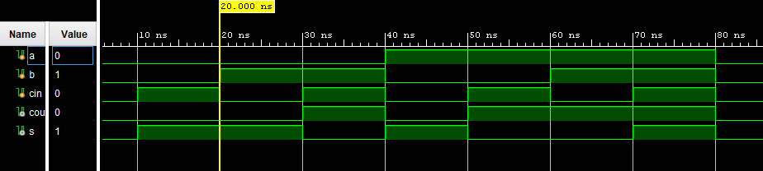

2. No difference, if gate have delay there should be difference in timing.

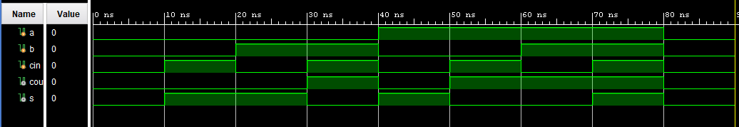

3. done

4. ShiftA use blocking, ShiftB use non-blocking which result in incorrect shift in ShiftA -> assign both reg to q.

5. in ipad