Activity XII : Computer Forensics

Instructors : Kunwadee Sripanidkulchai, Ph.D.

# Part II. Investigation

Answer these questions:

1. List all directories that were traversed in ‘RM#2’.   
   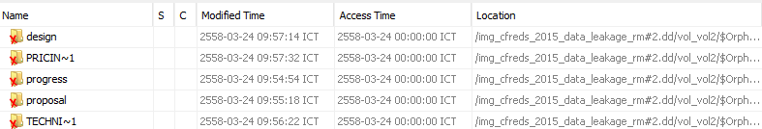  
   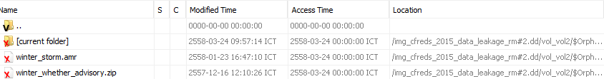  
   According to accessed time these are directories that were traversed in RM#2
2. List all files that were opened in 'RM#2’.   
   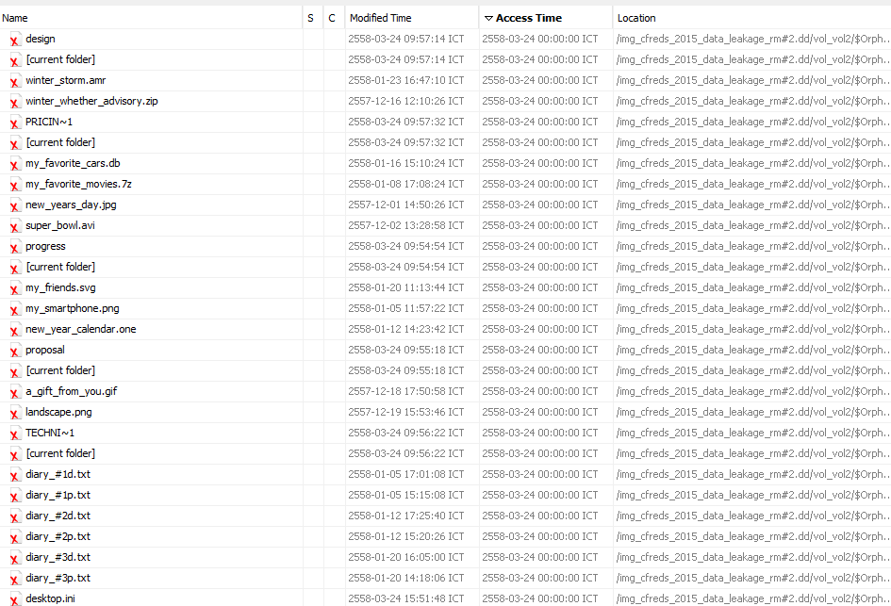  
   **Beside** [current folder] and other folder such as “design” these may be the files that were opened in ‘RM#2’ according to accessed time.
3. Recover deleted files from USB drive ‘RM#2’. What files were you able to recover?   
   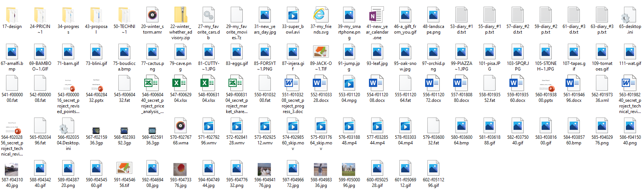  
   These are recovered files
4. What actions were performed for anti-forensics on USB drive ‘RM#2’? [Hint: this can be inferred from the results of the above question]   
   1. Format removable drive  
   2. Change file type / name  
     
   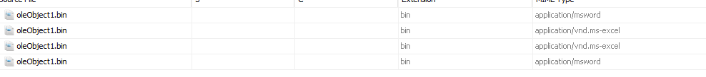  
   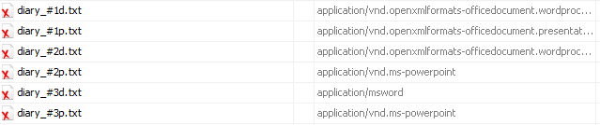

Examine media #3.

1. Recover hidden files from the CD-R ‘RM#3’. What files were you able to recover?  
   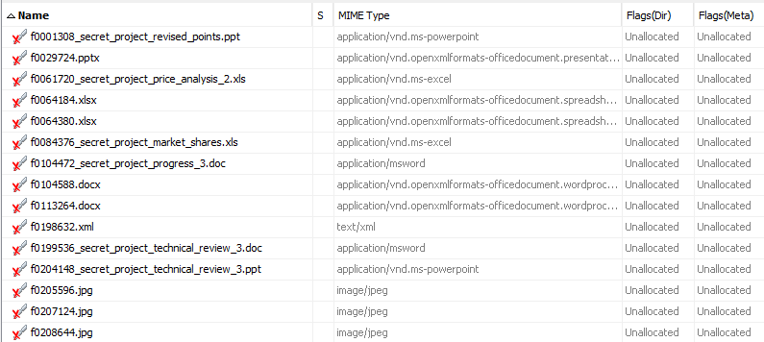   
   By carving unallocated space between partition the hidden files that stored there are retrieved
2. What actions were performed for anti-forensics on CD-R ‘RM#3’?   
   - format  
   - renaming  
   - hide files