# Part I

* 1. Roles
* Customer
  + Unauthorized customer
  + Authorized customer
* Employee
  + Trainee
  + Senior
  + Manager

*Part-time will have access role as Trainee

* 1. Services (Facilities)

I would like to partition zones for ease of access assigning

* Common facilities
  + Bathroom
  + Coffee service area
* Authorized customer facilities
  + Table and Chairs
* Unauthorized customer facilities
  + waiting chair
  + Front door
* Common employee facilities
  + Coffee service area (where staffs serve customer drinks)
  + Coffee making tools
  + Cashier + POS device
* Delicate employee facilities
  + Store room
  + Admin PC (monitor ERP, stock)
  1. access resource
* Customer: every customer enter coffee shop are Unauthorized customer until register with **CU student card** or **entering registration form**. After the registration customer will become Authorized customer by getting authorized by using face recognition system for Chula member type or authorized by using **face recognition** + entrance fee charging for Non-Chula member type. *I assume coffee member type is separate from high-level security policy
* Employee: every people occupying valid **(RFID) Employee badge** are Trainee, Senior, Manager depend on **Employee badge type**.
  1. ACL

Use ACL by

* for customer side: putting poster/sign to identify which facilities are only for Authorized customer.
* for employee side: Put color-coded sign to identify accessibility for each employee type on facilities + on IT device require RFID on employee badge to authorize.

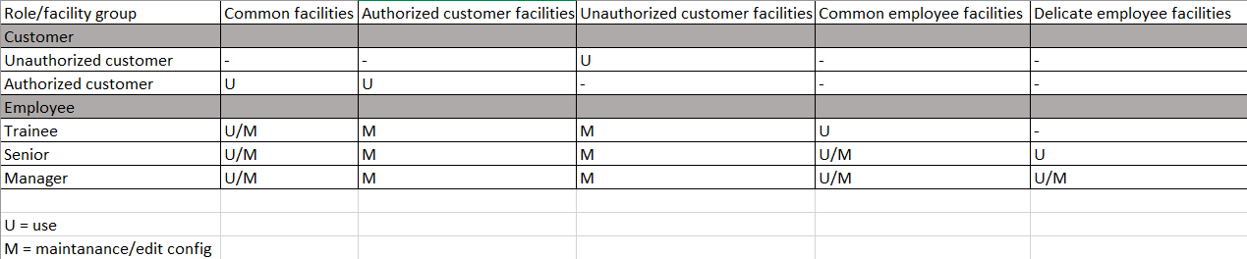

# Part II

1. Roles(User)
   * Academic
   * Student [S]
   * Graduated Student [S]
   * Instructor in charge of course [C]
   * Advisor in charge of student [S]

* Moderator
  + Registration staff of faculty [F]
  + Main Registration staff

*[] is variable

1. Objects

* Course
* Request enroll entry
* Enroll entry
* Request withdraw/cancel entry
* Withdraw/cancel entry on
* Grade for student
* Academic Account
* GPAX/GPA report

1. Functions
   * C/R/U/D for each objects

4.

