**COM FAB: Assignment 1 Report**

Krit Cholapand 6030070521

Voxelization image

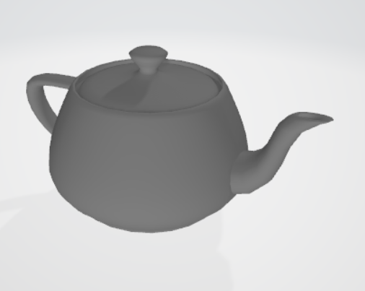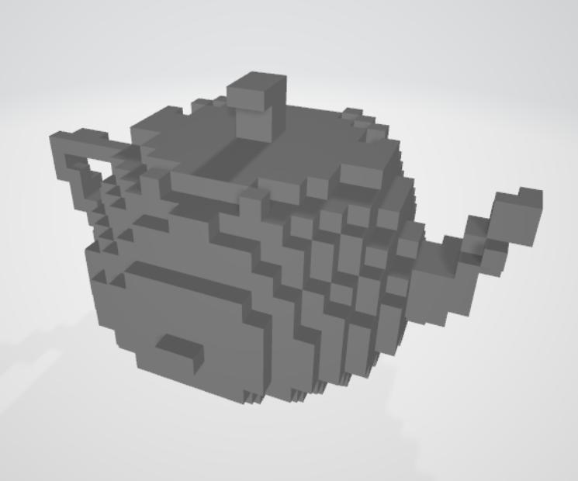

Reference

* Möller–Trumbore intersection algorithm https://en.wikipedia.org/wiki/M%C3%B6ller%E2%80%93Trumbore_intersection_algorithm

Problem and Improvement space

* Can’t save empty mesh.
* The ray cast sampling’s cast direction is not uniformly distribute
* Use accelerate structure as Extra credit suggest
* Add parameter to configure voxel size, voxel grid dimension etc.

Extra Credit

* Extra 2 Multi sampling rays for testing the code is here

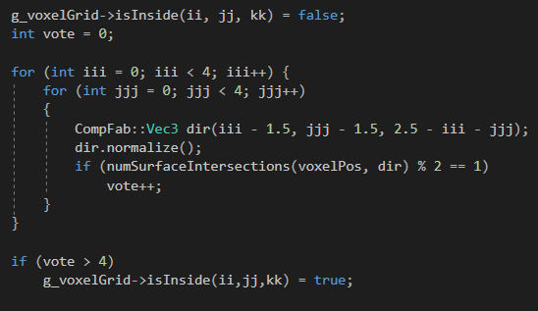

Comment

* Let me apologize for turn in this assignment late kub.