COM-FAB: HW2

KRIT CHOLAPAND

Procedural generated city

1. Image

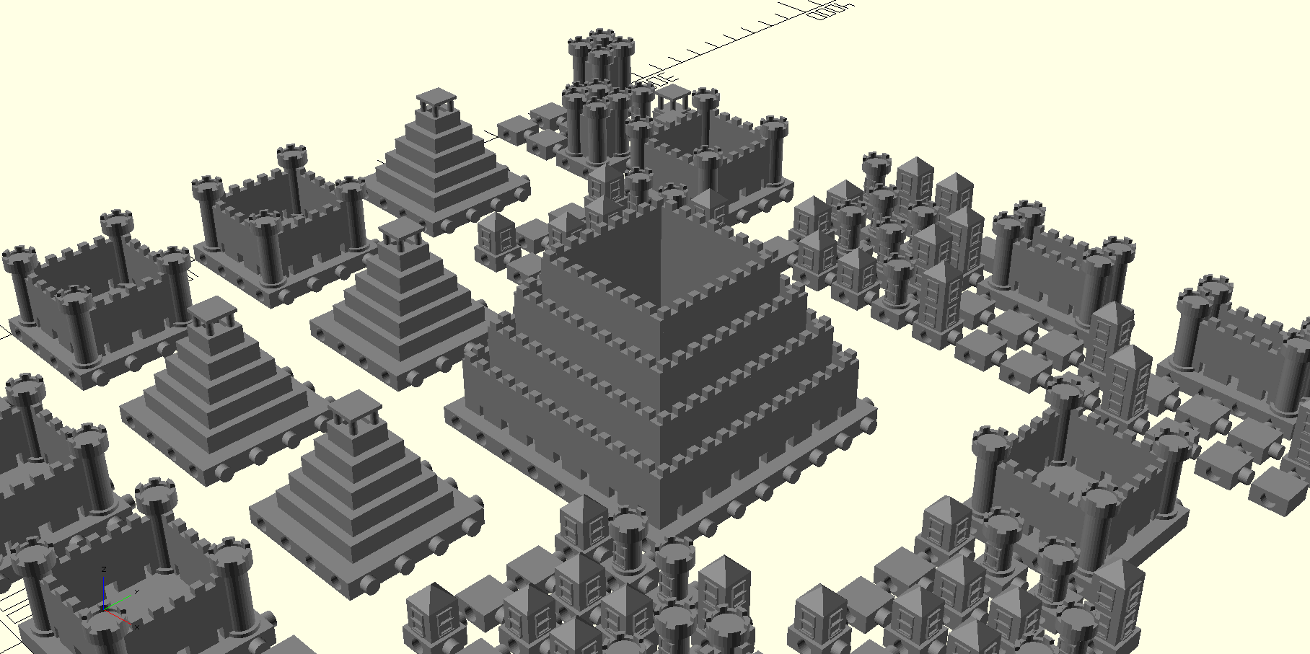

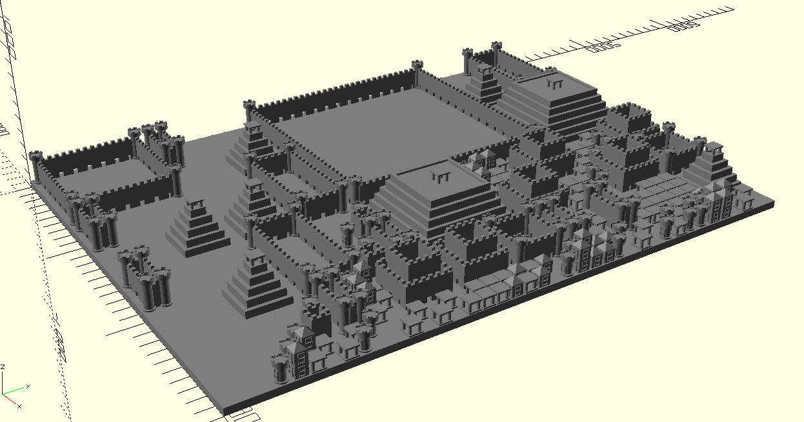

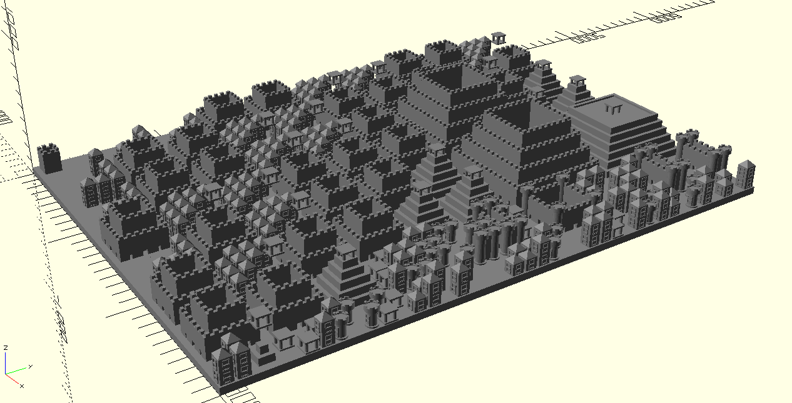

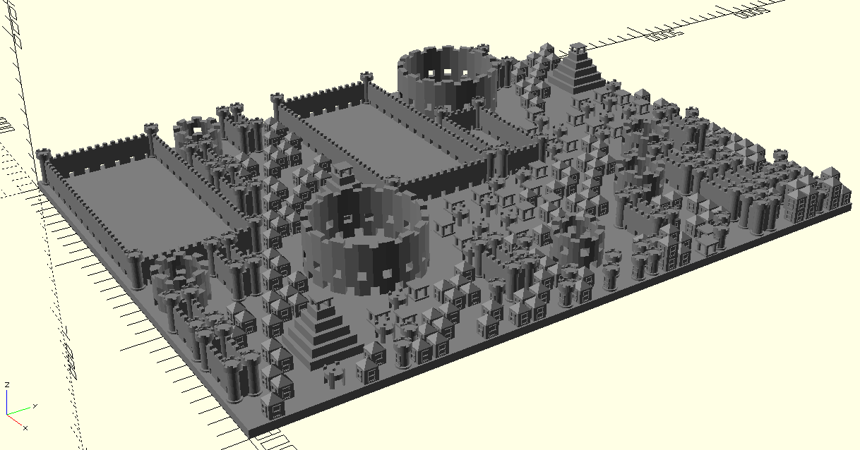

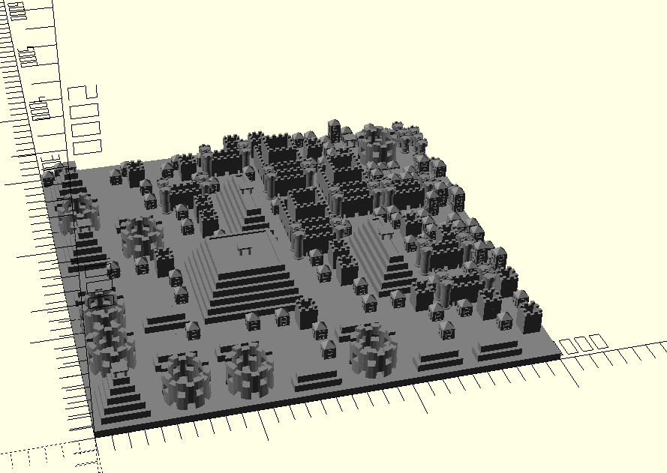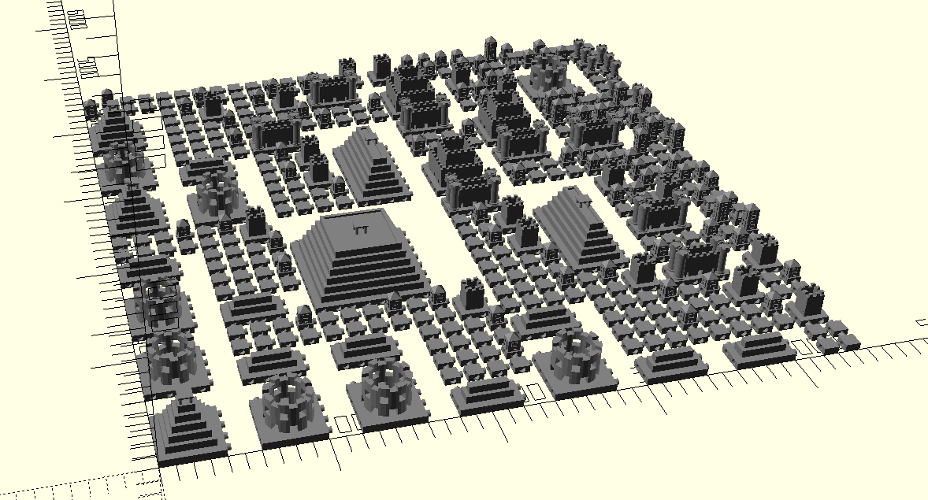

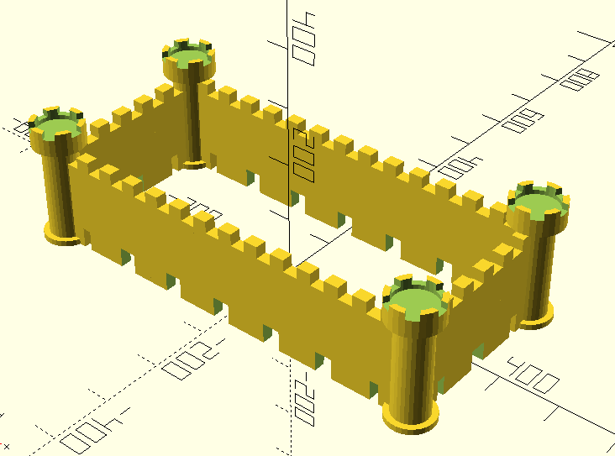 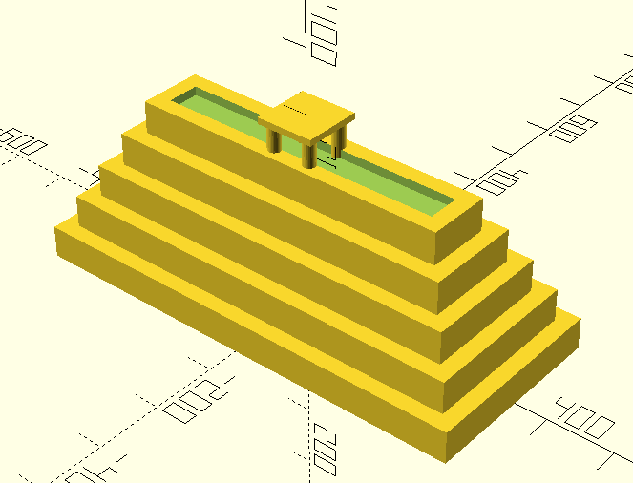

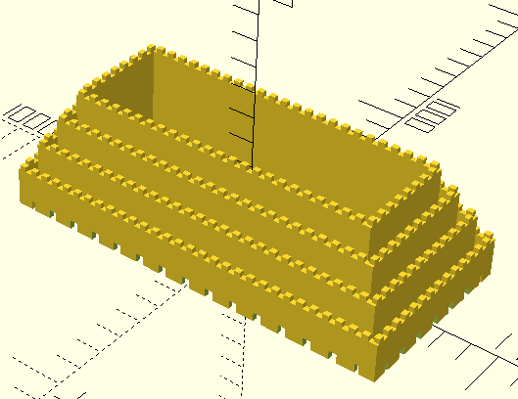 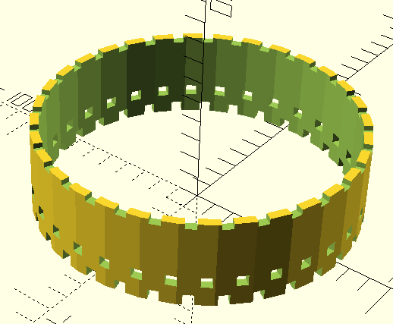

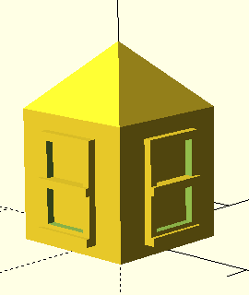 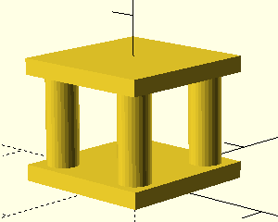 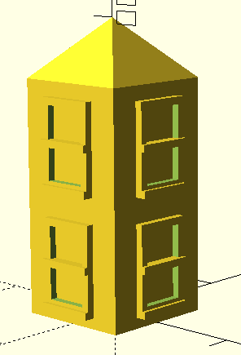 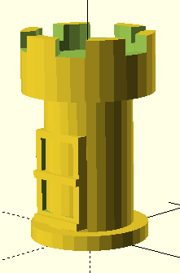

1. Reference

* <http://www.openscad.org/cheatsheet/index.html>
* <https://en.wikibooks.org/wiki/OpenSCAD_User_Manual>
* <https://www.browserling.com/tools/prime-numbers>

1. Problem
   1. Building generator not so balance.
   2. Random seed is not update to inspector view can only printed to console.
   3. Building is not much aesthetic.
   4. Hardcoding on some model.
2. Extra Credit
   1. . Create designs that include moving parts or parts that are closely linked to each other (e.g., a robotic finger shown above).
      1. Each component is like Lego brick can be connect or separated.

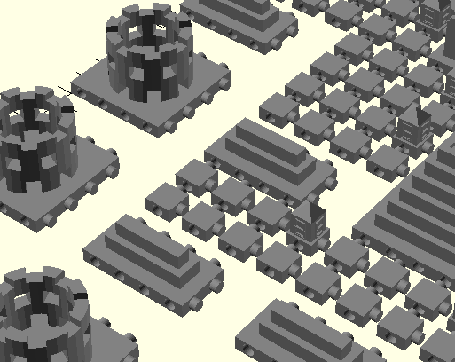

* 1. Using recursion
     1. The city generator itself using recursion
  2. Responsive model
     1. Some building can be resize

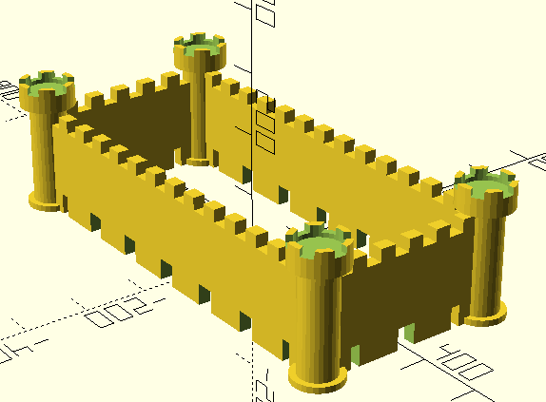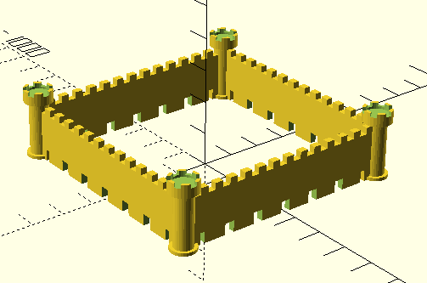

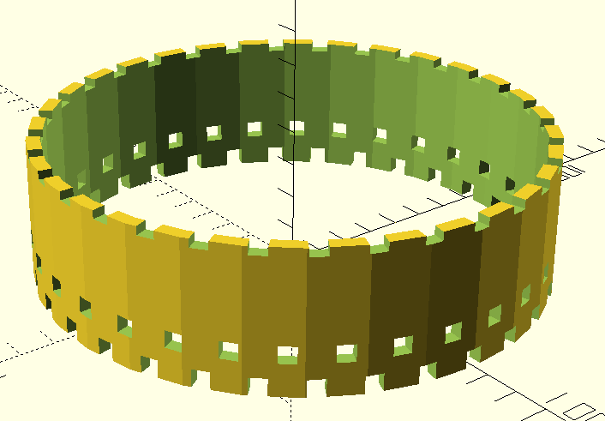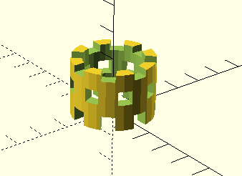

* 1. Generate using seed the randomly generated city can be later reproduce using same seed.

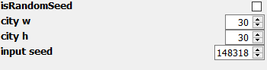

1. Comment
   1. So much fun !