COM-FAB: HW3

KRIT CHOLAPAND

1. Image

* Drag-Link

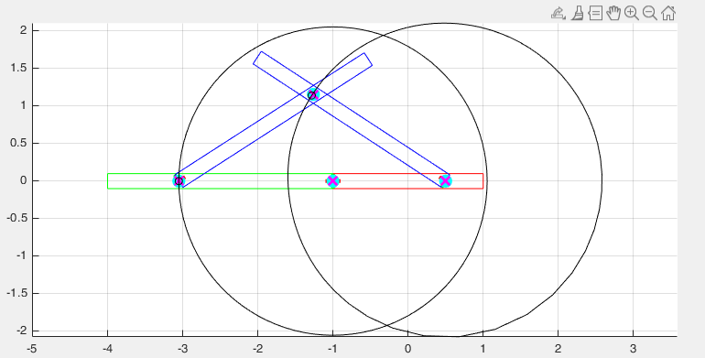

* Double-Rocker

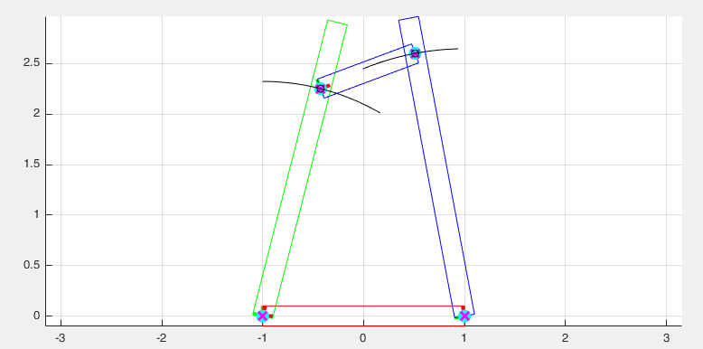

* Hoekens

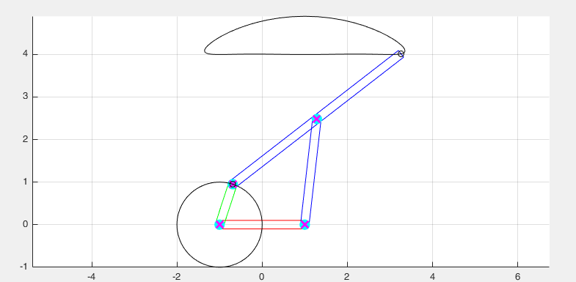

* Peaucellier-Lipkin

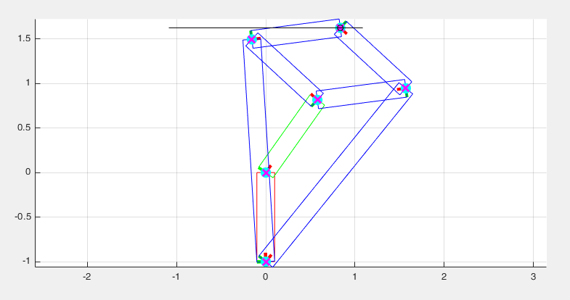

* Klann

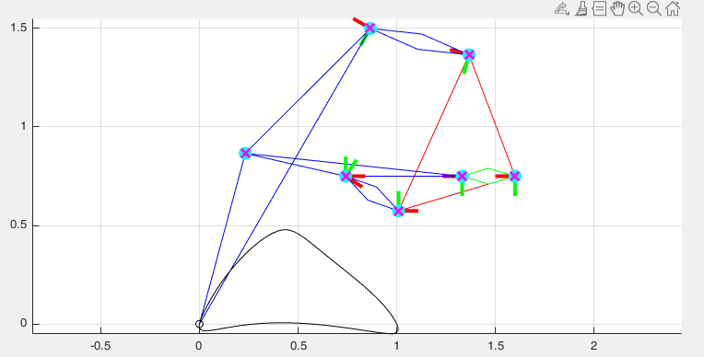

1. Reference

* <https://uk.mathworks.com/matlabcentral/answers/151246-how-to-install-global-optimization-toolbox>
* <http://eng.sut.ac.th/me/2014/document/MachanicsMachinery/CH%202%20Linkages%20and%20Mechanisms.pdf>
* All Wikipedia link in assignment

1. Problem
   1. Need Optimization Toolbox
   2. With little knowledge all design tend to overconstraint
   3. Difficulty in reading Klann diagram on wiki
2. Extra Credit
   1. None
3. Comment
   1. So much fun !