SALMONAN ARABIC ISLAMIC INSTITUTE

WEB-APPLICATION

An Undergraduate Proposal

presented to the Faculty of

Computer Science and Information Technology Department

AMA Computer College

123 Gen. Malvar St., Davao City

In Partial Fulfillment of the

Requirements for the Degree of

Bachelor of Science in Information Technology

By

Mylene D. Porol

Samera M. Bocay

**TABLE OF CONTENTS**

|  |  |
| --- | --- |
|  | **Page** |
| Title Page |  |
| Table of Contents | i |
| List of Tables | iv |
| List of Figures | vii |
|  |  |
| **CHAPTER 1 – INTRODUCTION** |  |
| Background of the Study | 1 |
| Statement of the Problem | 2 |
| Objectives of the Study  Scope and Limitations  Significance of the Study | 3  4  5 |
| Operational Definition of Terms | 6 |
|  |  |
| **CHAPTER 2 – REVIEW OF RELATED LITERATURE AND SYSTEMS** |  |
| Related Literature | 7 |
| Related Systems | 10 |
|  |  |
| **CHAPTER 3 – MATERIALS AND METHODOLOGY** |  |
| Research Design | 14 |
| Project Environment | 14 |
| Locale | 14 |
| Population of the Study | 15 |
| Research Instruments  Statistical Tools  Timetable | 15  15  16 |
| Data Gathering Instruments | 17 |
| Data Gathering Procedures | 17 |
| Methodology | 18 |
| Requirements Specification | 18 |
| Use Case Diagrams | 18 |
| Use Case Specifications | 19 |
| Design |  |
| Project Design | 31 |
| Output and User-Interface Design | 34 |
| Data Design | 45 |
| Development | 53 |
| Software Specification | 53 |
| Deployment Diagram | 54 |
| Test Plan | 55 |
| Test Cases | 55 |
| Verification, Validation and Testing | 67 |
| Unit Testing | 67 |
| Integration Testing | 67 |
| System Testing | 67 |
|  |  |
| **References** |  |
|  |  |
| **Appendices** |  |
| 1. Letter of Permission |  |
| 1. Interview Questionnaire |  |
| 1. Interview Transcription |  |

**LIST OF TABLES**

|  |  |
| --- | --- |
|  | **Page** |
| 1 Timeline Table | 16 |
| 1.1 Use Case (Login) | 19 |
| 1.2 Use Case (Add User) | 20 |
| 1.3 Use Case (Delete User) | 21 |
| 1.4 Use Case (Update Information) | 22 |
| 1.5 Use Case (Add Quiz, Assignment, Exam) | 23 |
| 1.6 Use Case (Edit Quiz, Assignment, Exam) | 24 |
| 1.7 Use Case (Delete Quiz, Assignment, Exam) | 25 |
| 1.8 Use Case (View Student Activities) | 26 |
| 1.9 Use Case (Record Grade) | 27 |
| 1.10 Use Case (Take Quiz, Assignment, Exam) | 28 |
| 1.11 Use Case (View Grade) | 29 |
| 1.12 Use Case (Learn Arabic) | 30 |
| 2Administrator Data | 45 |
| 2.1 Faculty Data | 46 |
| 2.2 Student Data | 47 |
| 2.3 Subject Data | 48 |
| 2.4 Quiz Data | 49 |
| 2.5 Assignment Data | 50 |
| 2.6 Exam Data | 51 |
| 2.7 Software Specification | 53 |
| 2.8 Program Specification | 53 |

**LIST OF FIGURES**

|  |  |
| --- | --- |
|  | **Page** |
| 1 Edmodo.com | 10 |
| 2 netacad.com | 11 |
| 3 khanacademy.org | 12 |
| 4 elerningforkids.org | 13 |
| 5 Use case models | 18 |
| 6 Context Flow Diagram | 31 |
| 7 Administrator Data Flow Diagram (level 0) | 32 |
| 8 Faculty Data Flow Diagram (level 0) | 32 |
| 9 Student Data Flow Diagram (level 0) | 33 |
| 10 Site Map | 33 |
| 11 Home | 34 |
| 12 Translator | 34 |
| 13 Madrasah | 35 |
| 14 Contact | 35 |
| 15 Log-in | 36 |
| 16 Administrator Home Page | 36 |
| 17 Settings | 37 |
| 18 Subject Data | 37 |
| 19 Inquire | 38 |
| 20 User Information | 40 |
| 21 Update User | 40 |
| 22 Events | 40 |
| 23 Add Activity | 41 |
| 24 Inquire Student | 42 |
| 25 Record Grade | 42 |
| 26 Take Activity | 43 |
| 27 Activities | 43 |
| 28 View Grades | 44 |
| 29 Entity Relation Diagram | 52 |
| 30 Deployment Diagram | 54 |

**CHAPTER 1**

**INTRODUCTION**

**Background of the Study**

The Islamic education in the Philippines can be traced back to the period of the Islamization of Sulu in the 13th century. It started first in the form of maktab or Qur’anic schools for young children to learn to read and recite the Qur’an. Later, a more formal structure known as the madrasah was established teaching the subjects of Theology, Arabic, Jurisprudence, and History. On December 12, 2005, the Madrasah Comprehensive Development and Promotion Program was created for Muslim communities committed to learning throughout life in a unified form in accordance with the government policy and the need for development not only in the City of Davao but in the whole of Mindanao. (Diatas, ‎2014)

Salmonan Arabic Islamic Institute was one of the oldest Madrasah in Davao City. The Madrasah had been an important educational institution for Muslims in providing young children with religious instruction. It had been responsible for transmitting Islamic knowledge, values and culture. Secular public education does not provide for this type of knowledge, so children who go to public schools were often ignorant about their religion. Muslim parents want their children to have employable skills and religious awareness at the same time, children began attending regular schools as well as attending the Madrasah on weekends. (Canacan, 2014)

The classes in Salmonan Arabic Islamic Institute was only on Saturday and Sunday, most of the students that enrolled in Madrasah had a limited time to learn Arabic language because of their busy schedules in their weekly class, this was the reason why the researchers came up with a research in creating a Web-application for the Madrasah in order for the faculty to be interactive to have a lesson for the students to provide more knowledge for the young generation who usually used the new technology to learn about Arabic language and lessons that related to the religion of Islam.

**Statement of the Problem**

The study aims to provide a Web-Application for Salmonan Arabic Islamic Institute to address the following problems:

1. The Salmonan Arabic Islamic Institute has limited means of advertising and promoting the Madrasah.
2. The teachers are having a hard time informing students about the activities and programs of the Salmonan Arabic Islamic Institute on time.
3. The Salmonan Arabic Islamic Institute has limited time in teaching because the class is only held on Saturday and Sunday.
4. Salmonan Arabic Islamic Institute guests are interested in learning the Arabic language and Islamic culture.

**Objective of the Study**

To develop a Web-Application that can help the Madrasah by making their weekend classes hassle-free and less time consuming for the students and teachers who have weekdays classes.

Specially, the proponents aim to develop the following:

1. To develop a Web-Application that provides an advertisement of Salmonan Arabic Islamic Institute about the important details of the Madrasah for the guest.
2. To develop a Web-Application that will notify the students using the Web-Application about the activities and programs of the Salmonan Arabic Islamic Institute.
3. To create a Web-Application that will provide an e-learning for the students of Salmonan Arabic Islamic Institute.
4. To create a Web-Application that provides a word translator of Arabic language and tutorials for the guest of the madrasah who wants to learn Islamic knowledge.

**Scope and Limitations**

The Salmonan Arabic Islamic Institute Web-Application aims to provide information about the Madrasah in Salmonan Arabic Islamic Institute.

The capacity of the system includes sending of notifications to students about recently uploaded activities by the faculty. The web application will provide English to Arabic word translation and vice versa. It will notify the faculty and the students if there is a due date in online activities. The teachers can encode grades of the students through the web application. The students can inquire grades by entering a verification code in the web application. The administrator has the authority to edit grades with the permission of the faculty. Only the administrator can manage the user’s important data.

On the other hand, only the administrator can register and give access to new users. The faculty and students cannot change any important details about their personal information. Students cannot edit their answers as soon as they submit during online exams. The web application does not support real time conversation or chatting. The system does not identify erroneous input of students’ grades. Thus, the faculty should ensure correct entry in the system. The web application process relies on Internet connection. Hence, all users should have internet connection

**Significance of the Study**

The significance of the study entitled “Salmonan Arabic Islamic Institute Web-Application” is to help give benefits to the concerned group below.

**Salmonan Arabic Islamic Institute** - The study will benefit the faculty members and students who are struggling in managing their learnings in Arabic and other lessons that related to the Islam. It also makes the faculty member to easily notify the students by using the Web-Application about the activities and programs of the Madrasah. By providing such study about the Web-Application, the faculty members, students and other individual who are managing in this project will experience new type of Web-Application in which the users can be able to translate the word from Arabic to English and the faculty can update new online activities such as quizzes and exams for the students to spend more time in doing their weekend and weekdays lesson at the same time.

**The Researchers** - The study is most significant with the proponents by overcoming the problems and analyzing things with the research information acquired. It feeds the proponents the experience and knowledge in which they can have a good practice on how to communicate the team properly to organize the work and they can apply for the future jobs they wanted.

**Future Researchers** - The study can help the future researchers as their basis for developing a Web-Application. It can also provide them broad ideas and knowledge to gather data about Islam and it can be a good source of information.

**Operational Definition of Terms**

**Advertisement -** Something important that is shown or presented to the public to make an announcement.

**Encode** -to convert (a message) from plain text into code.

**Grades** - an accepted level or standard.

**Inquiry** - a seeking for information by asking questions.

**Madrasah -** An educational institution, particularly for Islamic religious instruction.

**Web-Application** - An [application program](http://searchsoftwarequality.techtarget.com/definition/application-program) that is stored on a remote server and delivered over the Internet through a browser interface.

**CHAPTER 2**

**REVIEWS OF RELATED LITERATURE AND SYSTEMS**

**Related Literature**

The chapter presented some reliable works of different authors which helped in the conceptualization of the study**.**

**Arabic Language.** Arabic is one of the world’s major languages with over 300 million people in various Arab countries who used it as a mother tongue. It was also used extensively as the major language in a non-Arab country, the Central African Republic of Chad, and as a minority language in several other countries, including Afghanistan, Israel (where both Arabic and Hebrew are official languages), Iran, and Nigeria. In 1974, Arabic was adopted as one of the six United Nations official languages, joining Chinese, English, French, Russian and Spanish. Over one billion Muslims in places like India, Indonesia, Pakistan and Tanzania study Arabic as a foreign or second language for liturgical and scholarly use. In the United States, several Muslim and Arab communities employed Arabic in their daily interactions and for religious purposes. (Abu-Absi,2016)

**Machine Translator.** One of the great technologies invented, it contributed a lot of help to the people. The study focused in creating a system which computer software was used to translate one human language to another, it made our lives easier. There are a lot of benefits in this online service translation and you can quickly translate information in this service. Machine translator was not easy to create yet a very useful and practical system. Some machine translator was now implemented in the World Wide Web. Google translate in the best example which offered translation service.

After 10 years onwards, the machine translator can translate the same manner as human that is why many groups of translator were afraid that machine could be replaced in so many areas. In this article “Is Machine Translator a Threat to Human Translator?” (Vitek ,2000) it discussed how machine translator evolved in many areas, a bank teller was replaced by ATM’s, cashier was replaced by checked-out scanner and many mid-level managers replaced by a sophisticated software. (Carbonell,1994).

**Educational Software.** The advent of computers and multimedia technologies during the last years has led to a steadily growing support of the educational task by computers. Nowadays, educational software powered by information and communication technologies seemed to illustrate increased capabilities, relatively low cost as well as improved features with regards to the educational task. Along with these developments, there existed a vast increase in the number of educational software provided for use in a class. The term “Educational Software” was used to refer to software designed to support learning. Educational software differentiates to other application software to the fact that during the development of educational oriented software the way students learn should be taken into account. Moreover, the functional factor of the designed educational software must also be taken under consideration during the development phase since it was tightly connected with the learning process and played a very important role with regards to the acquisition of the educational software. (Lyras,2014)

**E-Learning.** In the era of information abundance, diversity and distribution was crucial for individuals and organizations to put things in order by defining standards for everything. Following the trend, the developers, vendors and users of e-learning systems develop, support and adopt standards for the overall learning process. As it happened with every community, e-learning was now shifting from the chaotic “no standards” stage, to the phase of rules’ and standards’ definition in an attempt to avoid the Babel syndrome. From the first moment of this phase, pioneers of the e-learning community cooperated in order to define standards, protocols and architectures for the development of e-learning content, services and products. International consortia comprising standardization organizations, institutes and software houses undertake the coordination of players in the e-learning market chain. They collect user requirements, issue specifications for e-learning systems, develop and test applications, which validated the user’s requirements and converted the approved specifications into standards. (Varlamis, ‎2006)

**Related Systems**

**Edmodo**

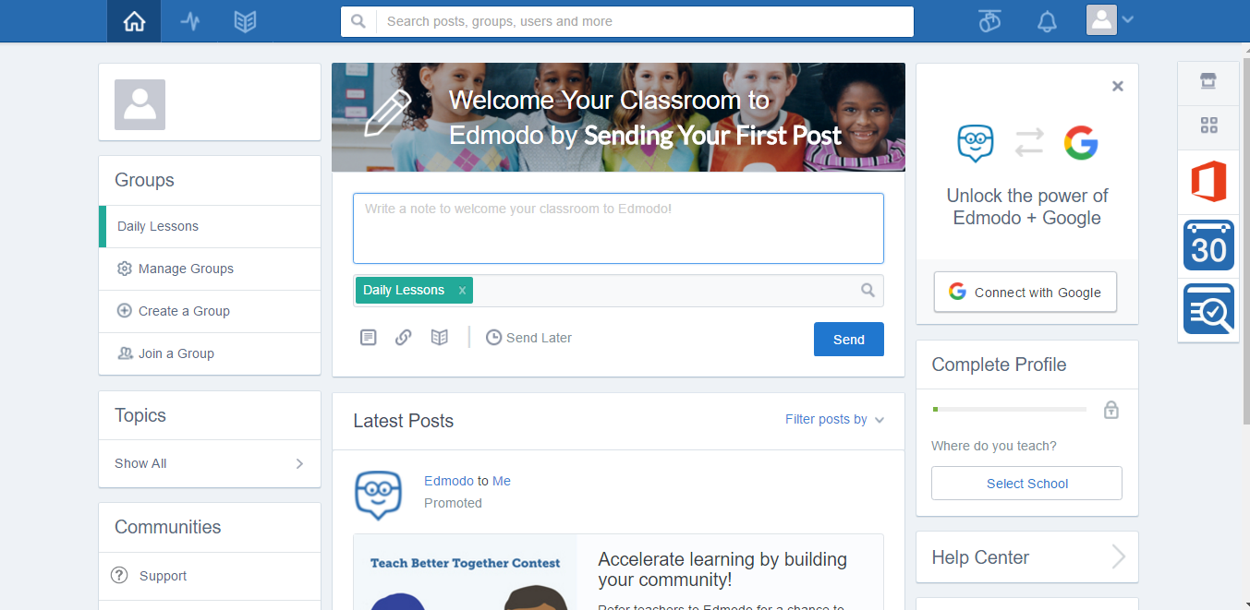

Figure 1 Edmodo.com

Edmodo is similar to the Salmonan Arabic Islamic Institute Web-Application that provides an e-Learning system for the online activities for the students and instructors, where the instructors can put a lesson for the students to read and also the faculty can also upload the quiz, assignment in exam for the students to answer the activity but the Samonan Araboc Islamic Institute Web-Application can’t use to communicate online to have a personal message and comments.

**NetAcad**



Figure 2 netacad.com

The NetAcad is similar to the Salmonan Arabic Islamic Institute Web Application and Edmodo that provide an E-learning system for the online activities for the students and instructors, this system also had grades overview for the students to see their grades, but it is different from Salmonan Arabic Islamic Institute Web Application because the application provides a translator to help the users understand the Arabic language and the Web-application cannot use to communicate online to have a personal message.

**Khan Academy**

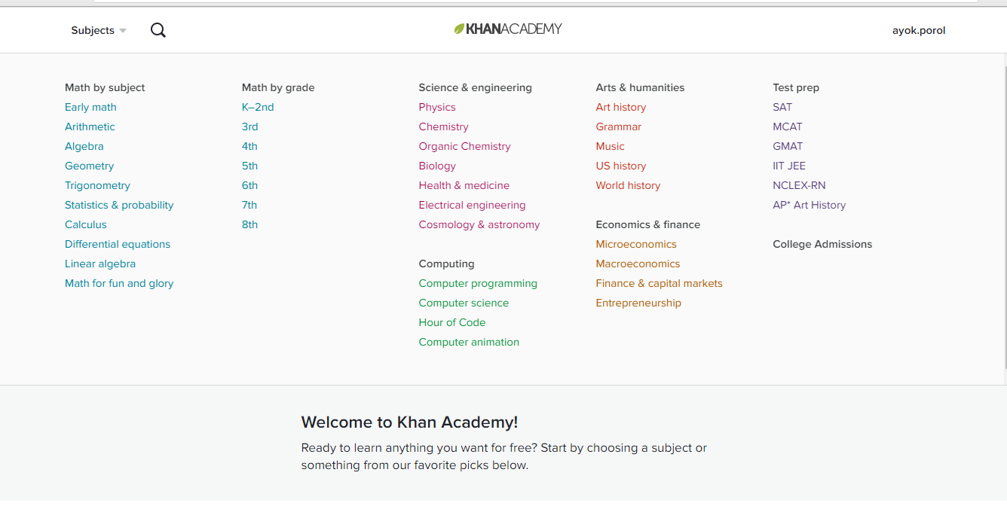

Figure 3 khanacademy.org

The system is related to Salmonan Arabic Islamic Institute Web-Application which

Offers subjects for learning online.

Khan Academy offers practice exercises, instructional videos, and a personalized learning dashboard that empower learners to study at their own pace inside and outside of the classroom. Leaning areas like math, science, computer programming, history, art history, economics, and more. Our math missions guide learners from kindergarten to calculus using state-of-the-art adaptive technology that identifies strengths and learning gaps.

**E-learning for kids**



Figure 4. elearningforkids.org

The E-learning for kids is a website that teaches children’s future to determine their ability to master the basics of learning Science, Math and Computer. It costs, class and sizes and other issues often to prevent children to access quality online learning that can support and reinforce their essential skills. Most of their students are 5-12 years old who are already active in using technology.

The system is similar to Salmonan Islamic Arabic Institute Web-Application that will teach children to learn about Arabic, Tawheed, Math and other subject in the Madrasah. The parents can also see the works of their children and they can teach their children.

**CHAPTER 3**

**MATERIALS AND METHODOLOGY**

**Research Design**

The descriptive research design for the Web-Application was dependent on the result of a case study of the researchers where they observed and surveyed as to the effectiveness of the study. The researchers used the validated survey questionnaires in gathering data for the proposed system in Salmonan Arabic Islamic Institute through interview and survey questionnaire. Researchers were able to study the specific areas where they must concentrate. The respondents of this study were the students and teachers of the Madrasah and the administrator who will manage the Web-Application.

**Project Environment**

**Locale**

The researchers conducted the research study at Salmonan Arabic Islamic Institute located in Boulevard, Davao City and the respondents were the students, teachers and faculty member of the Madrasah that were present on the days the researchers will conduct a survey.

**Population of the Study**

The researchers aimed to have a minimum of 100 respondents for the study. The main respondents were the students and teachers of Salamonan Arabic Islamic Institute and the chairman of the Madrasah.

**Research Instruments**

The study used a validated questionnaire to gather data from surveys that were be done with the respondents.

**Statistical Tools**

The researchers decided to use weighted mean in analyzing the results of the surveys because it referred to the over-all average of responses that helped the researchers to broadly understand and justify the needs of the user’s in-terms of what they need in a working system.

**Timetable**

Table 1. Timetable (September 2016 - April 2017)

|  |  |  |  |  |  |  |  |  |  |  |  |  |  |
| --- | --- | --- | --- | --- | --- | --- | --- | --- | --- | --- | --- | --- | --- |
| **Activities** | **Salmonan Arabic Islamic Institute Web-Application** | | | | | | | | | | | | |
| SEP | | | OCT | NOV | | | DEC | JAN | FEB | MAR | APR | |
| Research |  | | |  |  |  | |  |  |  |  |  |  |
| Planning |  |  | | | |  | |  |  |  |  |  |  |
| Documentation |  |  |  | | | | | | | | | |  |
| Design |  |  |  | |  | | | | | | | |  |
| Implementation |  |  |  | |  |  | | | | | | |  |
| Deployment |  |  |  | |  |  |  | |  |  |  | |  |

The table shows the progress of the research and implementation.

* Research – In this stage, researchers looked for the best subject to study and gather reliable information from the internet, books and tutorials for their Capstone project.
* Planning – After finding a subject, the researchers planned the steps to do and what to focus on to fulfill their Capstone Project.
* Documentation – Researchers documented the things gathered that were relevant in the study.
* Feature implementation – Researchers created a system for the research and implemented features to resolve the issue.
* Deployment – When the system was completed, the researchers set up for system deployment in the chosen school.

**Data Gathering Instruments**

The researchers conducted a personal visit to the Salmonan Arabic Islamic Institute to ask for permission for the system to be developed. The data for the research were collected using a validated survey questionnaire to gather the information of the Madrasah. The researchers gather information from the internet, books and tutorials that would be best served in helping the researchers in developing the Web-Application.

**Data Gathering Procedures**

1. Researchers conducted an interview.

Students, teachers, faculty members and the chairman of Salmonan Arabic Islamic Institute were the respondents of the interview.

2. Asked permission to conduct the study.

The researchers asked permission from the head of the Madrasah before conducting the study for the Web-Application.

3. Collected the questionnaire.

The entire questionnaires were collected on or before the given time for answering the questionnaire.

4. Analyzed and interpreted the data that has been collected.

After conducting the interview, the researchers gathered all the data and document analysis that was being used to identify the problems and formulate the specific objectives of the study.

## Methodology

**Requirement Specification**

**Use Case Diagram**



Figure 5: Use case models

The Figure 5, shows the interaction between the Students, Faculty and Administrator inside the system.

**Use Case Specification**

Table 1.1 Use Case (Login)

|  |  |
| --- | --- |
| **ID:** | **UC1** |
| **Title:** | Login |
| **Description:** | The users can log-in to the Web-Application. |
| **Primary Actor:** | Administrator, Faculty, Student |
| **Pre-Condition:** | 1. There must be an internet connection.  2. The users must be registered.  3. The username and password must be correct. |
| **Basic Flow of Events:** | 1. The user will enter username and password.  2. The user will click the login button.  3. The system will validate if the user exists in the database.  4. The system will display the main window. |
| **Alternative flows:** | 3.1. If the username or password are Incorrect  3.1.1. There will be an error message saying “Username/ Password are incorrect.”  3. 2.1 If the user not exist in the database, there will be a prompt message saying user is not registered in our database. |
| **Include/Extension Points:** | None |
| **Post-conditions:** | Successfully Login |
| **Status:** | In Progress |
| **Priority** | High |

Table 1.2 Use Case (Add User)

|  |  |
| --- | --- |
| **ID:** | **UC2** |
| **Title:** | Add User |
| **Description:** | The Administrator can add a user. |
| **Primary Actor:** | Administrator |
| **Pre-Condition:** | 1. There must be an internet connection.  2. The administrator must login to the system.  3. The administrator will add a user that registered to the Madrasah.  4. For adding a student user, the student must be enrolled. |
| **Basic Flow of Events:** | 1. The Administrator will click the user button on the user inquiry window.  2. The system will show the registration form.  3. The administrator will input the information of the user to register.  4. The Administrator will click the Submit button to save the user’s data.  5. The system will validate user’s registration information. |
| **Alternative flows:** | 5.1 If the users exist, there will be a prompt message saying user is already in a database. |
| **Include/Extension Points:** | None |
| **Post-conditions:** | User’s successfully added. |
| **Status:** | In Progress |
| **Priority** | High |

Table 1.3 Use Case (Delete User)

|  |  |
| --- | --- |
| **ID:** | **UC3** |
| **Title:** | Delete User |
| **Description:** | The Administrator can delete a user’s data. |
| **Primary Actor:** | Administrator |
| **Pre-Condition:** | 1. There must be an internet connection.  2. The administrator must login to the system. |
| **Basic Flow of Events:** | 1. The Administrator will click the user button on the main window.  2. The system will show the search bar.  3. The Administrator will enter the user id on the search bar.  4. The system will display the user information.  5. The administrator will click the delete button.  6. The system will delete the user information. |
| **Alternative flows:** | 5.1. If the Administrator will click the delete button  5.1.1 there will be a prompt message saying “do you want to delete user’s data? Yes, or No”.  5.1.2 if the Administrator will click the Yes button the system will show confirmation. |
| **Include/Extension Points:** | None |
| **Post-conditions:** | Delete user complete. |
| **Status:** | In Progress |
| **Priority** | Medium |

Table 1.4 Use Case (Update Information)

|  |  |
| --- | --- |
| **ID:** | **UC4** |
| **Title:** | Update Information |
| **Description:** | The Administrator can update the information of the user and the information of the Madrasah. |
| **Primary Actor:** | Administrator |
|  |  |
| **Pre-Condition:** | 1. There must be an internet connection.  2. The Administrator must login to the web-application. |
| **Basic Flow of Events:** | 1. The Administrator will click the user dropdown menu on the main window.  2. The system will show the search bar.  3. The Administrator will enter the user id on the search bar.  4. The system will display the user information.  5. The administrator will click the update button.  6. The administrator will input the information of the user to register  7. The Administrator will click the save button.  8. The system will validate the user information.  9. The Administrator will click the setting on main menu.  10. The system will show the display setting.  11. The Administrator will change the madrasah information.  12. The Administrator will the update button.  13. The system will validate the web-application changes. |
| **Alternative flows:** | 7.1.1 If the Administrator will click the save button. “there will be a prompt message saying Do you want to change the users Information? Yes, or cancel”  12.1.1 if the Administrator will click the update button, there will be a prompt message saying “Do you want to change the Madrasah information? Yes, or cancel.” |
| **Include/Extension Points:** | None. |
| **Post-conditions:** | Update Successfully. |
| **Status:** | In Progress |
| **Priority** | Medium |

Table 1.5 Use Case (Add Quiz, Assignment, Exam)

|  |  |
| --- | --- |
| **ID:** | **UC5** |
| **Title:** | Add Quiz, Assignment, Exam |
| **Description:** | The Faculty User can add an online activity such as Quiz, Assignment and Exam, |
| **Primary Actor:** | Faculty |
| **Pre-Condition:** | 1. There must be an internet connection.  2.The Faculty user must be logged in. |
| **Basic Flow of Events:** | 1. The Faculty will click the subject dropdown menu on the main window.  2. The system will show adding activity on the right side of the subjects.  3. The Faculty will input the instruction of the activity on the instruction text box.  4. The Faculty will choose the activity type.  5. The faculty will set a due date of the activity.  6. The Faculty will click the upload button to upload the PDF or doc. Format file.  7.The faculty will click the create button to create a document online.  8. The Faculty will click the send button to upload the PDF or .doc format file or sent the created document online.  9. The system will validate the activity. |
| **Alternative flows:** | 8.1.1 if the send button, the system will show the confirmation message. |
| **Include/Extension Points:** | None. |
| **Post-conditions:** | Faculty successfully added the add quiz, assignment, exam. |
| **Status:** | In Progress |
| **Priority** | High |

Table 1.6 Use Case (Edit Quiz, Assignment, Exam)

|  |  |
| --- | --- |
| **ID:** | **UC6** |
| **Title:** | Edit Quiz, Assignment, Exam |
| **Description:** | The Faculty user can Edit the prepared activity. |
| **Primary Actor:** | Faculty |
| **Pre-Condition:** | 1. There must be an internet connection.  2. The Faculty must be logged in. |
| **Basic Flow of Events:** | 1. The Faculty will click the subject dropdown menu.  2. The system will display the subject information and the activities.  3. The Faculty will click the activity to edit.  4. The System will show the activity information.  5. The faculty will click the edit button.  6. The Faculty will enter the new instruction of the activity on the instruction text box.  7. The Faculty will click the upload button to upload the PDF or doc. Format file.  8. The faculty will click the create button to create a document online.  9. The Faculty will click the send button to upload the edited activity.  10. The system will validate the activity |
| **Alternative flows:** | 9.1.1 if the send button, the system will show the confirmation message. |
| **Include/Extension Points:** | None. |
| **Post-conditions:** | Edit successfully. |
| **Status:** | In Progress |
| **Priority** | Medium |

Table 1.7 Use Case (Delete Quiz, Assignment, Exam)

|  |  |
| --- | --- |
| **ID:** | **UC7** |
| **Title:** | Delete Quiz, Assignment, Exam |
| **Description:** | The Faculty can delete an activity. |
| **Primary Actor:** | Faculty |
| **Pre-Condition:** | 1. There must be an internet connection.  2. Must be logged in to the web-application. |
| **Basic Flow of Events:** | 1. The Faculty will click the Activity dropdown menu on the main window.  2. The Faculty will click the subject.  3. The system will show the subject information and the activities.  5. The Faculty will click the activity to edit.  6. The System will show the activity information.  7. The faculty will click the edit button.  8. The system will validate the activity changes. |
| **Alternative flows:** | 7.1. If the Administrator will click the delete button there will be a prompt message saying “do you want to delete the file? Yes, or No”.  7.1.1 if the Administrator will click the Yes button the system will show a confirmation. |
| **Include/Extension Points:** | None. |
| **Post-conditions:** | Delete file complete |
| **Status:** | In Progress |
| **Priority** | Medium |

Table 1.8 Use Case (View Student Activities)

|  |  |
| --- | --- |
| **ID:** | **UC8** |
| **Title:** | View Student Activities |
| **Description:** | The Faculty can view the activities of the students. |
| **Primary Actor:** | Faculty |
| **Pre-Condition:** | 1. There must be an internet connection.  2. The Faculty must be logged in. |
| **Basic Flow of Events:** | 1. The Faculty will click the Student dropdown menu.  2. The system will show the Student inquiry form.  3. The Faculty will input the Student Id or the last name and first name of the Student.  4. The system will system will display the student information and activities. |
| **Alternative flows:** | None |
| **Include/Extension Points:** | None |
| **Post-conditions:** | View student’s activity. |
| **Status:** | In Progress |
| **Priority** | Medium |

Table 1.9 Use Case (Record Grade)

|  |  |
| --- | --- |
| **ID:** | **UC9** |
| **Title:** | Record Grade |
| **Description:** | The Faculty will record the activity of the student’s. |
| **Primary Actor:** | Faculty |
| **Pre-Condition:** | 1. There must be an internet connection.  2. The Faculty must be logged in |
| **Basic Flow of Events:** | 1. The Faculty will click the Student dropdown menu.  2. The system will show the Student inquiry form.  3. The Faculty will input the Student Id or the last name and first name of the Student.  4. The system will system will display the student information and activities.  5. The faculty will click the record grade button.  6. the system will show the grading form.  7. The Faculty will select a subject.  8. The Faculty will select an activity type.  9. The Faculty will enter the grade of the student on the grade textbox.  10. the Faculty will click the save button to record the student grade.  11. The system will display a confirmation. |
| **Alternative flows:** | None |
| **Include/Extension Points:** | None |
| **Post-conditions:** | Grade save successfully. |
| **Status:** | In Progress |
| **Priority** | High |

Table 1.10 Use Case (Take Quiz, Assignment, Exam)

|  |  |
| --- | --- |
| **ID:** | **UC10** |
| **Title:** | Take Quiz, Assignment, Exam |
| **Description:** | The Student can take the online Quiz, Assignment and Exam that sent by the faculty user. |
| **Primary Actor:** | Student |
| **Pre-Condition:** | 1. There must be an internet connection.  2. Student must be logged in. |
| **Basic Flow of Events:** | 1. The Student will click the subject dropdown menu on the main window.  2. The system will show the subject online activity.  3. The Student will click the available activity such as quiz, assignment and exam.  4. The system will show the activity information.  5. The Student will click the sent button.  6. The system will display a confirmation of the answered activity. |
| **Alternative flows:** | 5.1 If the Student will click the sent button, there will be a prompt message saying “do you want to send your work? Yes, or Cancel” |
| **Include/Extension Points:** | None. |
| **Post-conditions:** | Sent successfully |
| **Status:** | In Progress |
| **Priority** | High |

Table 1.11 Use Case (View Grade)

|  |  |
| --- | --- |
| **ID:** | **UC11** |
| **Title:** | View Grade |
| **Description:** | The student user can view their grades online. |
| **Primary Actor:** | Student |
| **Pre-Condition:** | 1. There must be an internet connection.  2.The Student must be logged in to the web-application. |
| **Basic Flow of Events:** | 1.The student user will click the Subject dropdown on the main window menu.  2. The system will show the grade button on the right side of the subject.  3. The Student will click the grade button.  4. The system will show the grade recorded. |
| **Alternative flows:** | none |
| **Include/Extension Points:** | None. |
| **Post-conditions:** | The student cannot edit grades. |
| **Status:** | In Progress |
| **Priority** | Medium |

Table 1.12 Use Case (Learn Arabic)

|  |  |
| --- | --- |
| **ID:** | **UC13** |
| **Title:** | Learn Arabic |
| **Description:** | The Guest can learn an Islamic lesson on the tutorial that shared on the web-application and learn a basic Arabic Word. |
| **Primary Actor:** | Guest, Student |
| **Pre-Condition:** | 1. There must be an internet connection. |
| **Basic Flow of Events:** | 1. The actor can view the Tutorials.  2. The actor can use the English to Arabic word translator and vice versa.  3. The actor will enter a word on the translator.  4. The system will translate the word from English to Arabic language and vice versa. |
| **Alternative flows:** | None. |
| **Include/Extension Points:** | None. |
| **Post-conditions:** | None. |
| **Status:** | In Progress |
| **Priority** | Medium |

**Design**

This section contains the following: project design, output and user-interface design and data design.

**Project Design**

This section includes the context flow diagram and data flow diagram.

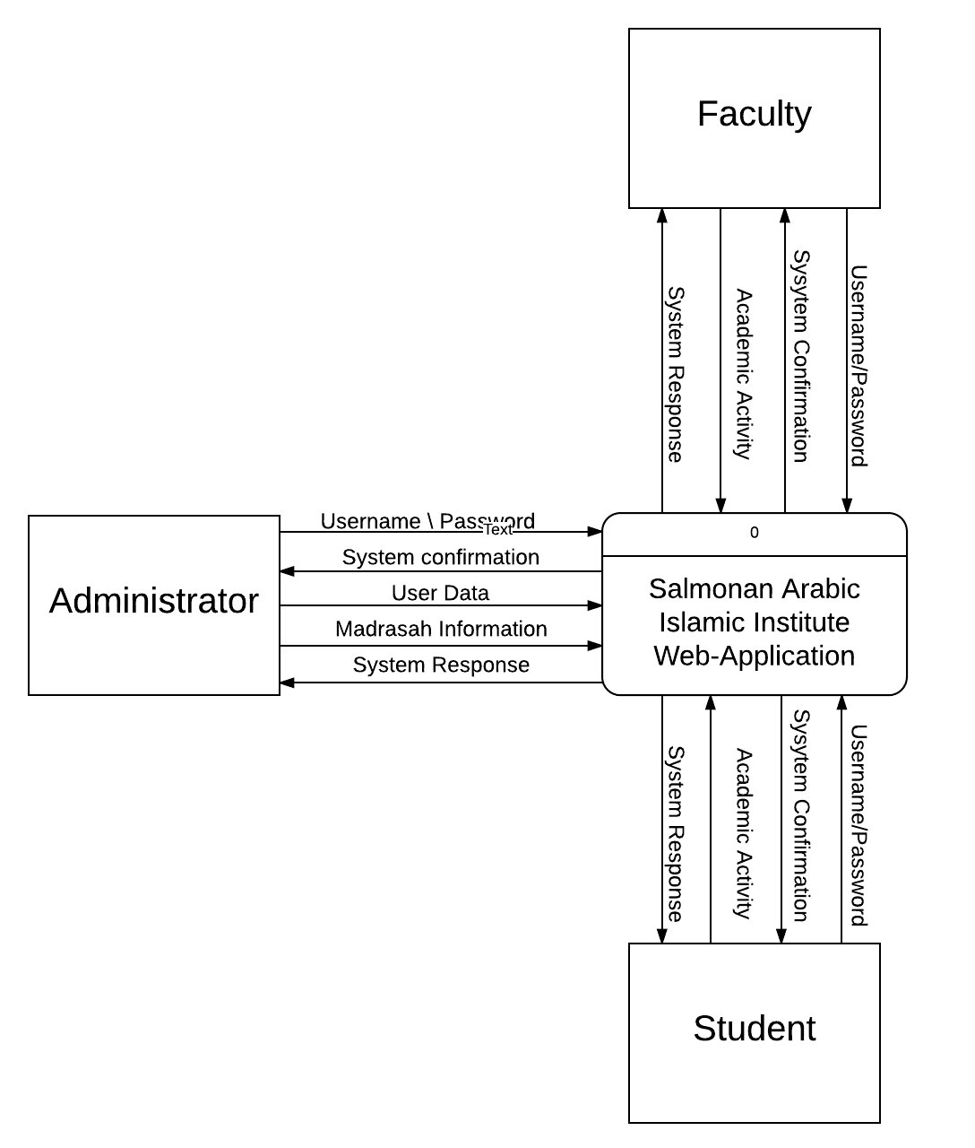

Figure 6. Context Flow Diagram

The Figure 6, shows the context diagram of the system. The user must have their account in order to logged in to the system so that they can view the information and activities and the administrator should be the one who will verify the user’s records and will manage the Web-Application. The coming and outgoing data flows linked to participating external entities like Project creator, manager and members.

## Data Flow Diagram

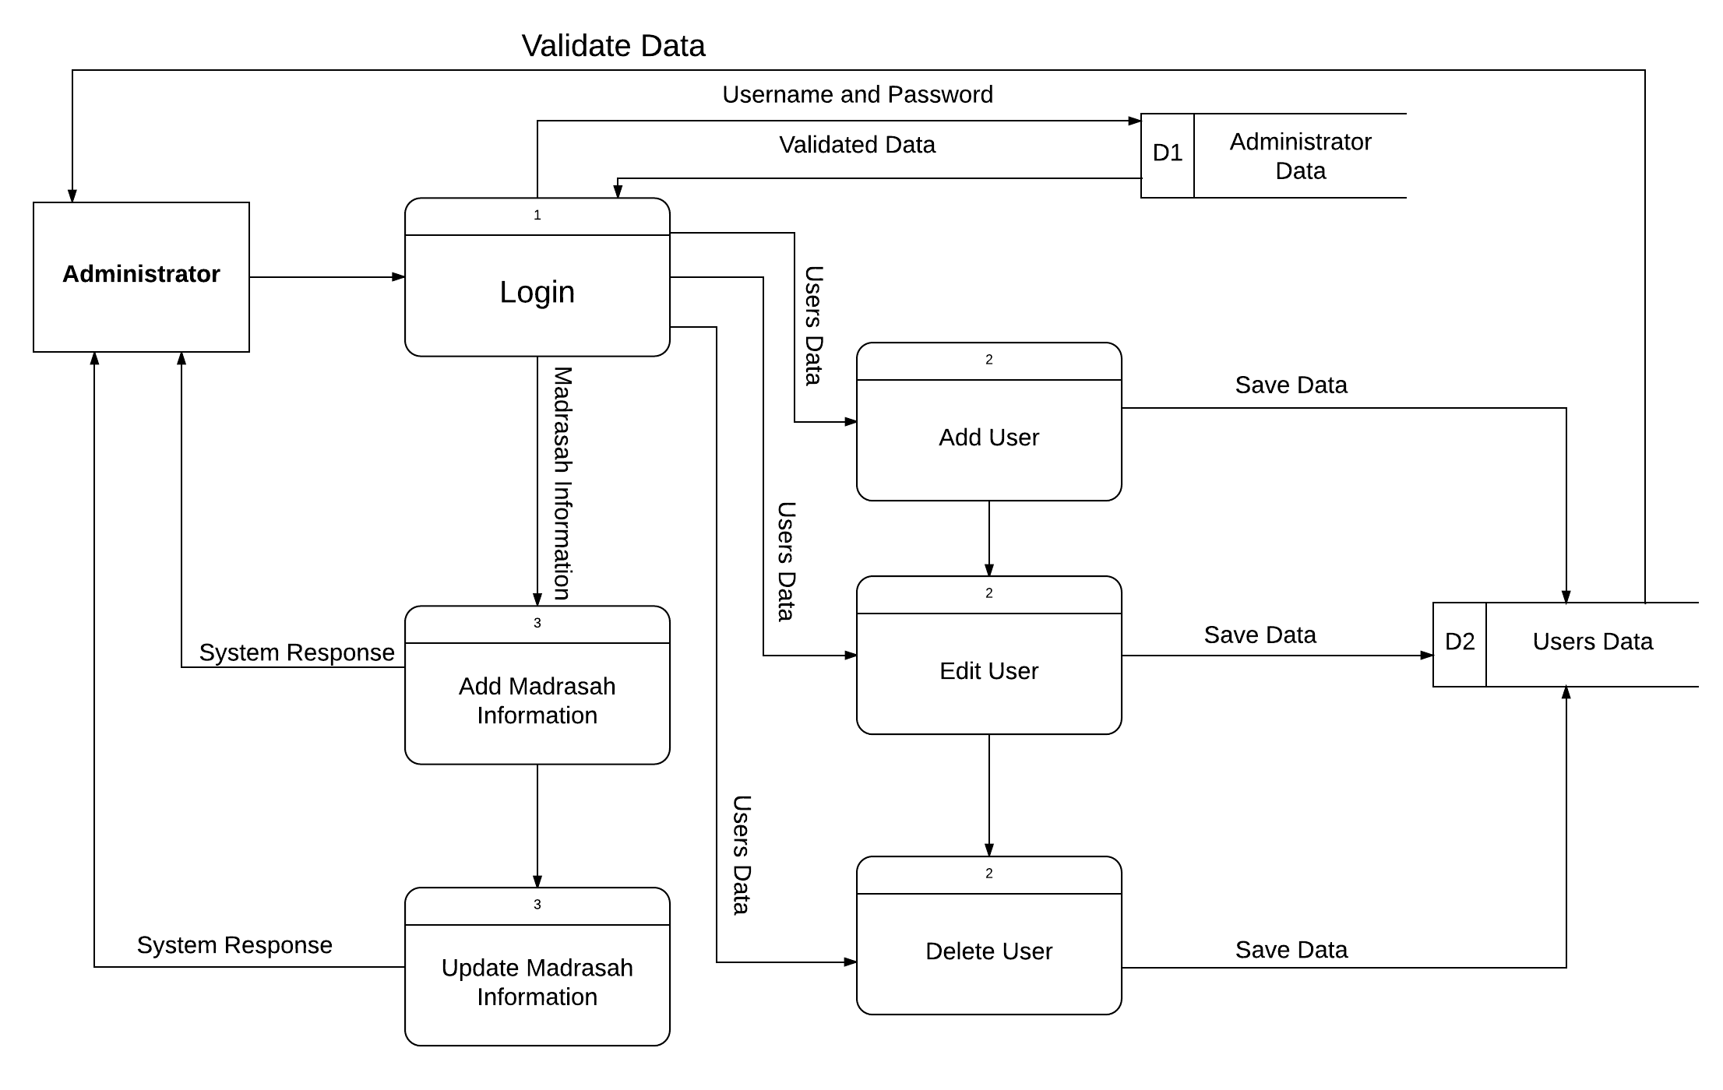

Figure 7. Administrator Data Flow Diagram

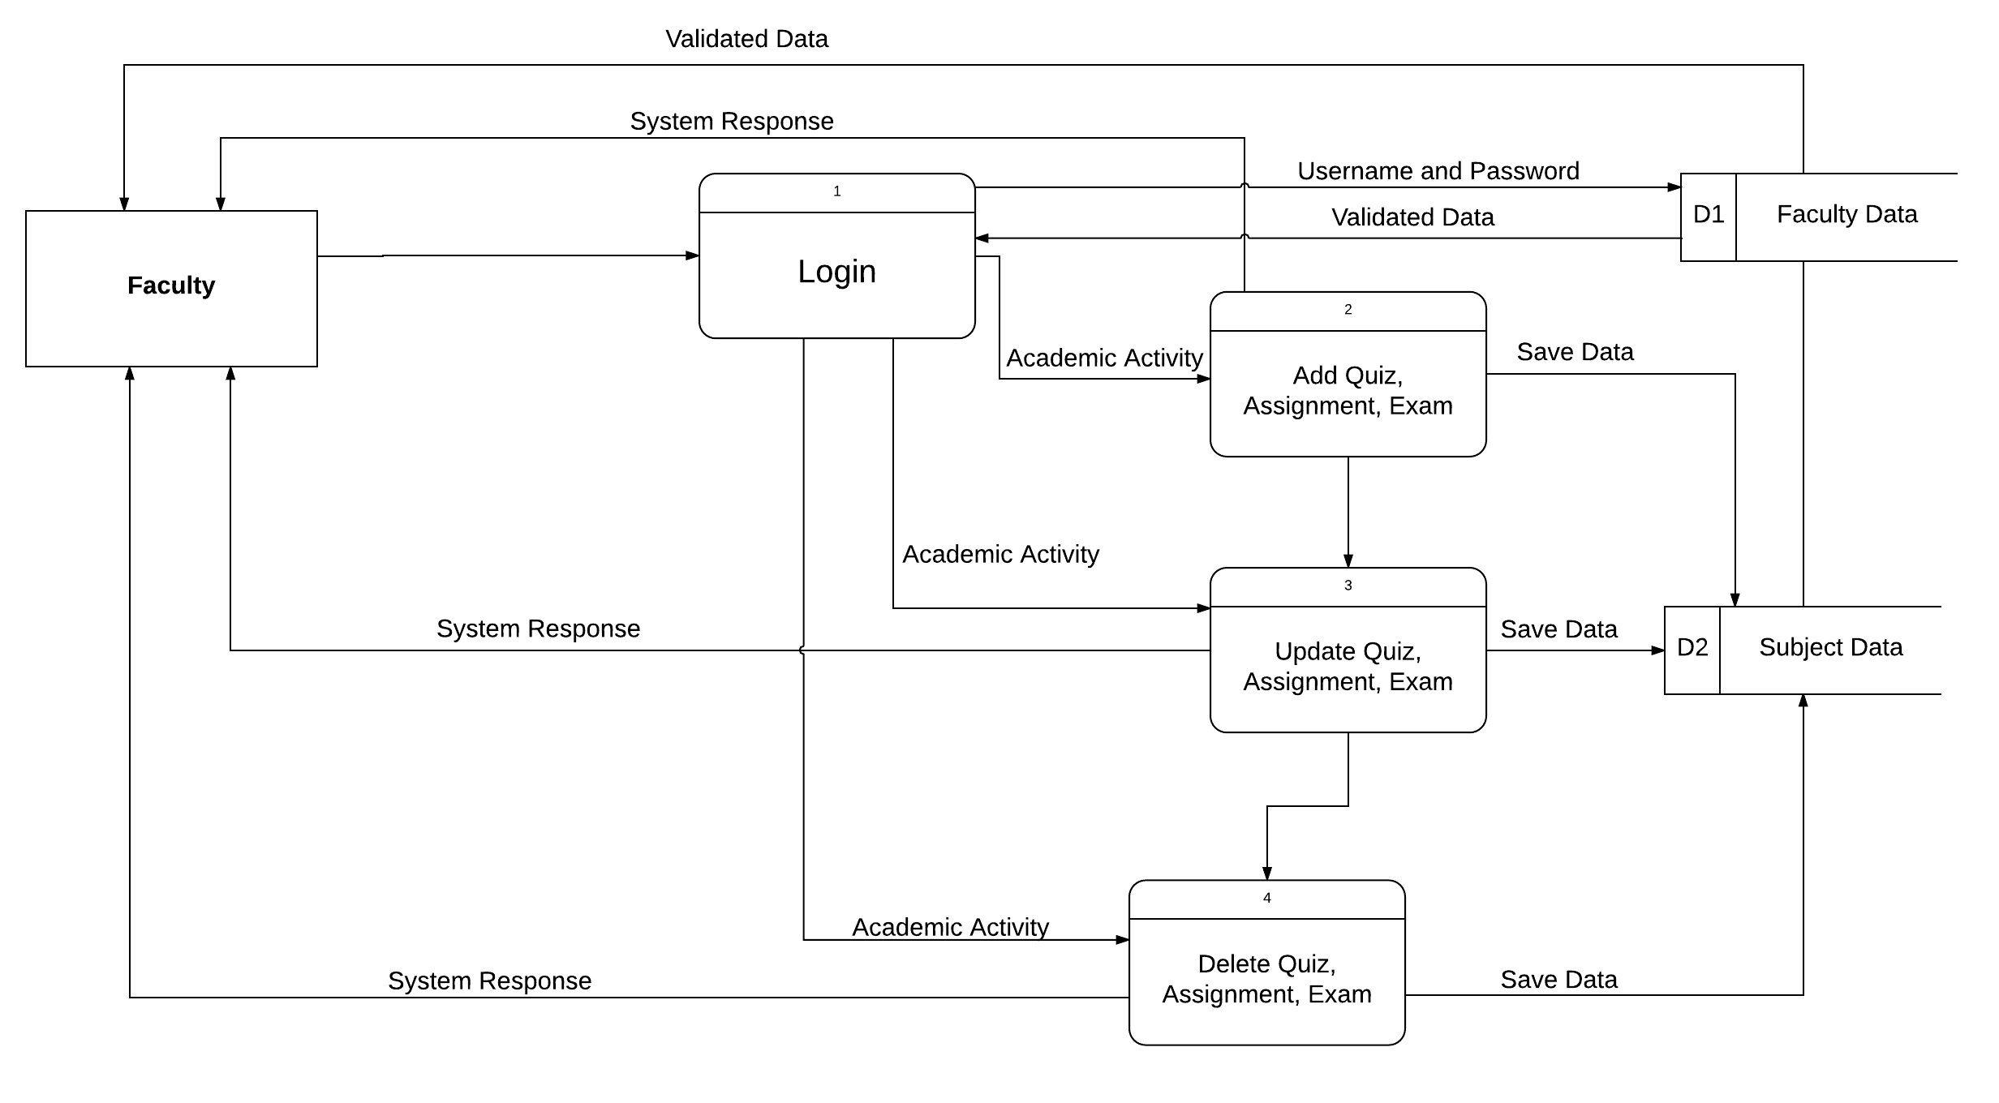

Figure 8. Faculty Data Flow Diagram

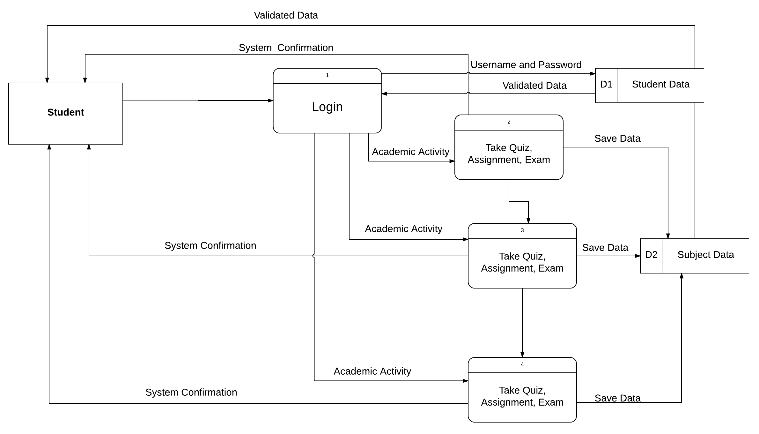

Figure 9. Student Data Flow Diagram

Figures 7, 8 and 9 show the data flow diagram of the system. The system provides the need information and needs of the users regarding their record. The system will keep the records of the users. The users’ record can verify and manage by the Administrator.

**Site Map**

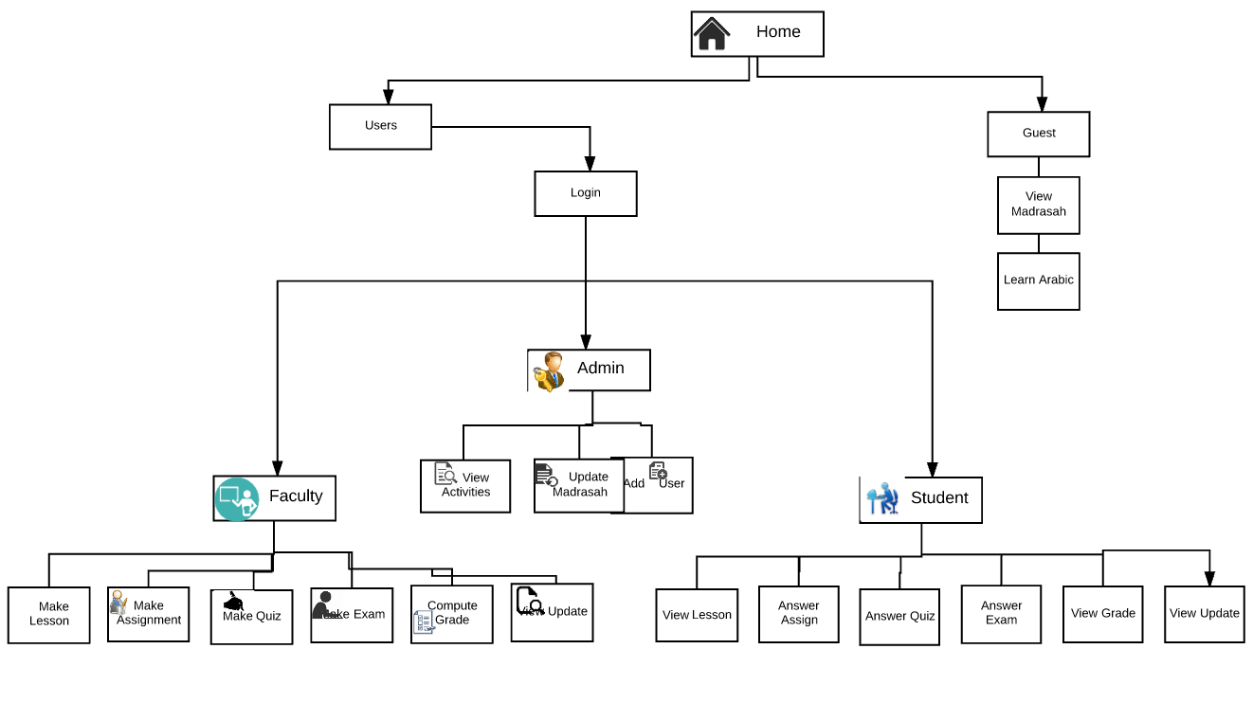

Figure 10 Site Map

The figure shows the list of pages inside the Salmonan Arabic Islamic Web-Application. It shows how the user can navigate and explore the website.

**Output and User-Interface Design**

It includes the wireframes of the system.

**Wireframes**

**Home**

Figure 11 Home

The figure shows the index of our Web-application**.**

**Translator**

Figure 12 Translator

The figure shows the English-Arabic Translator of the Web-Application.

**Madrasah**

Figure 13 Madrasah

The figure shows the information of the Madrasah.

**C:\Users\Mylene Porol\Documents\Capstone Final\CapstoneDocument\WireFrame\Contact.png**

Figure 14 Contact

The figure shows the contact details of the madrasah.

**C:\Users\Mylene Porol\Documents\Capstone Final\CapstoneDocument\WireFrame\Login.png**

Figure 15 Log-in

The figure shows the log-in page of the Web-Application.

**C:\Users\Mylene Porol\Documents\Capstone Final\CapstoneDocument\WireFrame\AdminHome.png**

Figure 16 Administrator Homepage

The figure shows that the administrator main window.

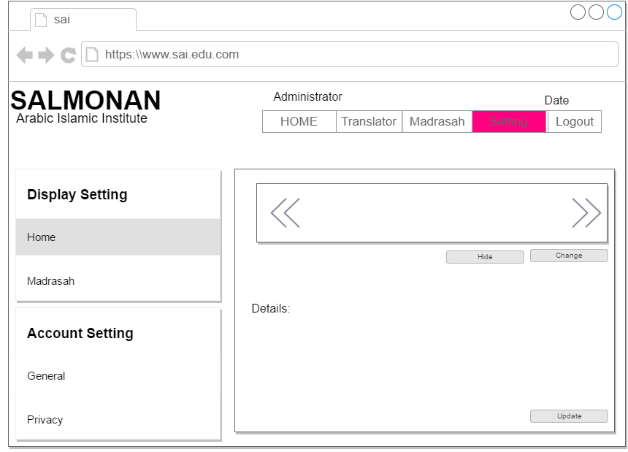

Figure 17 Settings

The figure shows that the Administrator can manage the application settings.

**C:\Users\Mylene Porol\Documents\Capstone Final\CapstoneDocument\WireFrame\AdminSubject.png**

Figure 18 Subject Data

The figure shows the subject data about the activities of the users.

**C:\Users\Mylene Porol\Documents\Capstone Final\CapstoneDocument\WireFrame\UserAdmin.png**

Figure 19 Inquiry

The figure shows that the Administrator ca inquire the user information.

**C:\Users\Mylene Porol\Documents\Capstone Final\CapstoneDocument\WireFrame\UserData.png**

Figure 20 User Information

The figure shows that the Administrator can update or delete the user information.

**C:\Users\Mylene Porol\Documents\Capstone Final\CapstoneDocument\WireFrame\UpdateUser.png**

Figure 21 Update User

The figure shows that the Administrator will update the users’ information.

**C:\Users\Mylene Porol\Documents\Capstone Final\CapstoneDocument\WireFrame\EventsAdmin.png**

Figure 22 Events

The figure shows the madrasah events.

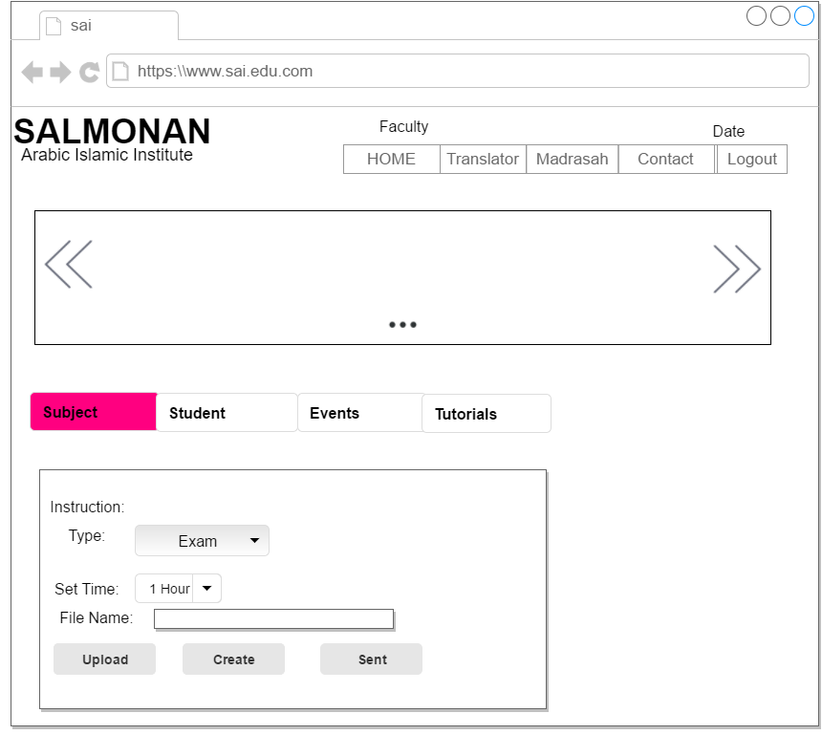

Figure 22 Add Activity

The figure shows that the faculty user can upload or create an activity.

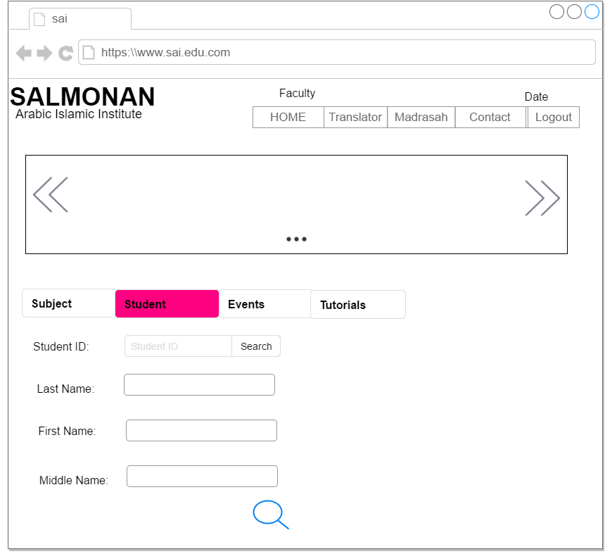

Figure 24 Inquire Student

The figure shows that the faculty can inquire the student information.

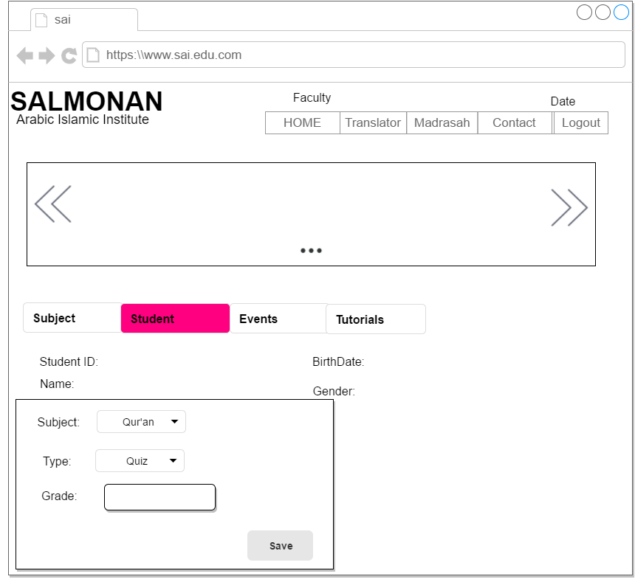

Figure 25 Record Grade

The figure shows that the faculty can record the student grade.

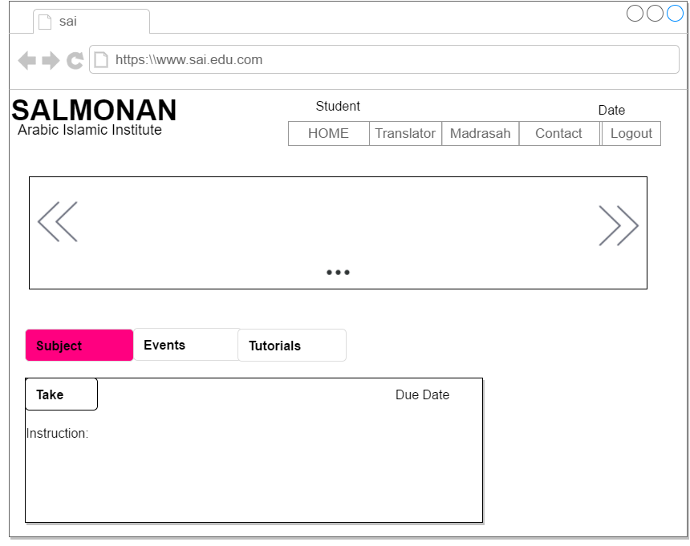

Figure 26 Take Activity

The figure shows that the student will take the activity that by the faculty.

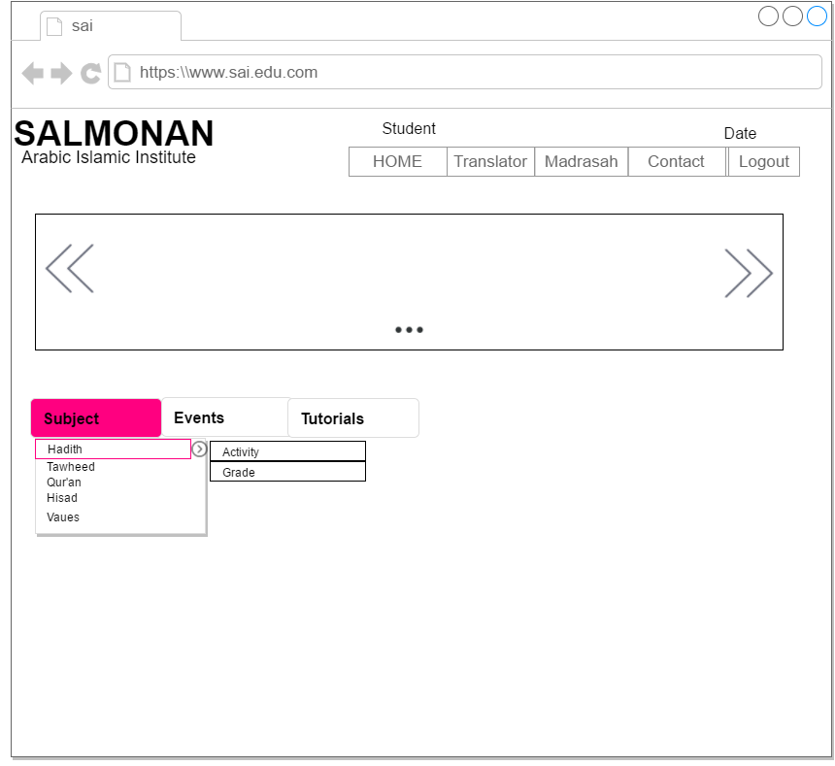

Figure 27 Activities

The figure shows that the student can view their online activity and the madrasah activity.

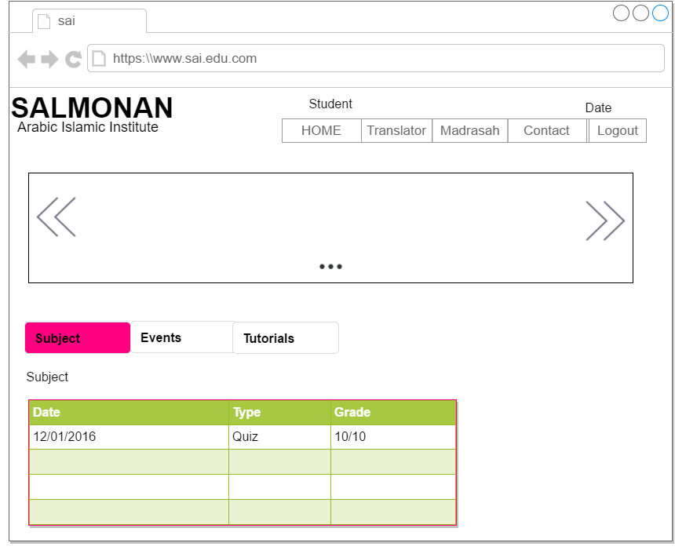

Figure 28 View Grades

The figure shows that the student can view their grades online.

**Data Design**

**Data Dictionary**

**Table 2** Administrator Data

|  |  |  |  |  |  |
| --- | --- | --- | --- | --- | --- |
| **Column Name** | **Column Description** | **Data Type** | **Length** | **Primary Key** | **Null** |
| AdminID | Identifier of the administrator | Integer | 12 | True | False |
| Fname | Administrator given name | Varchar | 50 | False | False |
| Lname | Administrator surname name | Varchar | 50 | False | False |
| ContactNo | Administrator contact number | Varchar | 15 | False | False |

**Table 2.1** Faculty Data

|  |  |  |  |  |  |
| --- | --- | --- | --- | --- | --- |
| **Column Name** | **Column Description** | **Data Type** | **Length** | **Primary Key** | **Null** |
| FacultyID | Unique identifier of the Instructor | Integer | 10 | True | False |
| Fname | Instructor’s given name | Varchar | 50 | False | False |
| Lname | Instructor’s surname name | Varchar | 50 | False | False |
| Address | Instructor’s address | Varchar | 50 | False | False |
| ContactNo | Instructor’s contact number | Varchar | 15 | False | False |

**Table 2.2** Student Data

|  |  |  |  |  |  |
| --- | --- | --- | --- | --- | --- |
| **Column Name** | **Column Description** | **Data Type** | **Length** | **Primary Key** | **Null** |
| StudentD | Identifier of the Student | Integer | 12 | True | False |
| Fname | Student’s given name | Varchar | 50 | False | False |
| Lname | Student’s surname name | Varchar | 50 | False | False |
| ContactNo | Student’s contact number | Varchar | 15 | False | False |

**Table 2.3** Subject Data

|  |  |  |  |  |  |
| --- | --- | --- | --- | --- | --- |
| **Column Name** | **Column Description** | **Data Type** | **Length** | **Primary Key** | **Null** |
| SubjectCode | Identifier for the Subject | Integer | 12 | True | False |
| Subname | Subject’s name | Varchar | 50 | False | False |
| SubDescription | Subject Description | Varchar | 50 | False | False |
| StudentId | Identifier of the Student | Integer | 12 | False | False |
| FacultyId | Identifier of the Faculty User | Integer | 10 | False | False |

**Table 2.4** Quiz Data

|  |  |  |  |  |  |
| --- | --- | --- | --- | --- | --- |
| **Column Name** | **Column Description** | **Data Type** | **Length** | **Primary Key** | **Null** |
| QuizCode | Identifier for the Quiz | Integer | 12 | True | False |
| QuizDescription | Quiz Description | Varchar | 50 | False | False |
| StudentId | Identifier of the Student | Integer | 12 | False | False |
| FacultyId | Identifier of the Faculty User | Integer | 10 | False | False |

**Table 2.5** Assignment Data

|  |  |  |  |  |  |
| --- | --- | --- | --- | --- | --- |
| **Column Name** | **Column Description** | **Data Type** | **Length** | **Primary Key** | **Null** |
| AssignmentCode | Identifier for the Assignment | Integer | 12 | True | False |
| AssignmentDescription | Assignment Description | Varchar | 50 | False | False |
| StudentId | Identifier of the Student | Integer | 12 | False | False |
| FacultyId | Identifier of the Faculty User | Integer | 10 | False | False |

**Table 2.6** Exam Data

|  |  |  |  |  |  |
| --- | --- | --- | --- | --- | --- |
| **Column Name** | **Column Description** | **Data Type** | **Length** | **Primary Key** | **Null** |
| Exam Code | Identifier for the Exam | Integer | 12 | True | False |
| Exam Description | Exam Description | Varchar | 50 | False | False |
| StudentId | Identifier of the Student | Integer | 12 | False | False |
| Faculty | Identifier of the Faculty User | Integer | 10 | False | False |

**Entity Relationship Diagram**

The Faculty can have one or more student that enrolled to the subject, but a student user can only enrolled in one faculty. A faculty can make one or more quizzes, assignment and exam at a time but quizzes, assignments and exams can only made by one Faculty. A student or group of the students can take one or more of the activities.



Figure 10.4 Entity Relationship Diagram

**Development**

**Software Specification**

**Table 2.7** Software Specification of Salmonan Arabic Islamic Web-Application.

|  |  |
| --- | --- |
| **Software Specification** | |
| **Operating System** | Windows 7 or higher version |
| **Database** | MySQL |
| **Server** |  |
| **Software** | Apache, PHP MyAdmin, Sublime text 2 and Bootstrap, XAMPP |
| **Programming language** | PHP |
| **Scripts** | HTML, CSS, JAVASCRIPT |

**Table 2.8** Program specification

|  |  |
| --- | --- |
| **Program Specification** | |
| **Programming Language** | PHP |
| **3rd Party Software** | Apache, Xampp, PHP MyAdmin, Sublime text 2, Bootstrap |
| **Database** | MySQL |
| **Scripts** | HTML, CSS, JAVASCRIPT |

Table 2.8 shows the programming languages, software and databases that was used by the researchers to meet the systems requirements.

**Deployment Diagram**



Figure 9.20 Deployment Diagram

**Test Plan**

**Test Case 1: Login**

|  |  |  |  |  |  |
| --- | --- | --- | --- | --- | --- |
| **Test Case #1 Test Case Name: Login** | | | | | |
| **Pre-Conditions:**  1. There must be an internet connection.  2. The users must be registered.  3. The username and password must be correct. | | | | | |
| Step | Action | Expected System | Pass | Fail | Comment |
| 1 | The user will click the “login” button in the homepage menu. | The system will display the form to log-in form. |  |  |  |
| 2 | The user will enter username and password | The system will if the user exists in the database |  |  |  |
| 3 | The user will click the login button | The system will display the homepage. |  |  |  |
| **Post-Conditions:**  Successfully Login | | | | | |

**Test Case 2: Add User**

|  |  |  |  |  |  |
| --- | --- | --- | --- | --- | --- |
| **Test Case #2 Test Case Name: Add User** | | | | | |
| Pre-Conditions:   1. There must be an internet connection. 2. The administrator must login to the system. 3. The administrator will add a user that registered to the Madrasah. 4. For adding a student user, the student must be enrolled. | | | | | |
| Step | Action | Expected System | Pass | Fail | Comment |
| 1 | The Administrator will click the user button on the user inquiry window. | The system will display the registration form. |  |  |  |
| 2 | The Administrator will input the user information. |  |  |  |  |
| 3 | The Administrator will click the submit button. | The system will show a prompt message for the confirmation. |  |  |  |
| **Post-Conditions:**  User’s successfully added. | | | | | |

**Test Case 3: Delete User**

|  |  |  |  |  |  |
| --- | --- | --- | --- | --- | --- |
| **Test Case #3 Test Case Name: Delete User** | | | | | |
| Pre-Conditions:   1. There must be an internet connection. 2. The administrator must login to the system. | | | | | |
| Step | Action | Expected System | Pass | Fail | Comment |
| 1 | The Administrator will click the user button on the main window. | The system will show the search bar. |  |  |  |
| 2 | The Administrator will enter the user id on the search bar. | The system will display the user’s information. |  |  |  |
| 3 | The Administrator will click the delete button. | The system will delete the user information |  |  |  |
| Post-Conditions:  Delete user complete. | | | | | |

**Test Case 4: Update Information**

|  |  |  |  |  |  |
| --- | --- | --- | --- | --- | --- |
| **Test Case #4 Test Case Name: Update Information** | | | | | |
| Pre-Conditions:   1. There must be an internet connection. 2. The administrator must login to the Web-Application. | | | | | |
| Step | Action | Expected System | Pass | Fail | Comment |
| 1 | The Administrator will click the user dropdown menu on the main window. | The system will show the search bar. |  |  |  |
| 2 | The Administrator will enter the user id on the search bar. | The system will display the user information. |  |  |  |
| 3 | The Administrator will click the update button. | The Administrator will input the information of the user. |  |  |  |
| 4 | The Administrator will click the save button. | The system will validate the user information |  |  |  |
| 5 | The Administrator will click the Setting menu on the main menu. | The system will display the setting information |  |  |  |
| 6 | The Administrator will change the madrasah information |  |  |  |  |
| 7 | The Administrator will click the update button | The system will validate the web-application changes. |  |  |  |
| Post-Conditions:  Update Successfully | | | | | |

**Test Case 5: Add Quiz, Assignment, Exam**

|  |  |  |  |  |  |
| --- | --- | --- | --- | --- | --- |
| **Test Case #5 Test Case Name: Add Quiz, Assignment, Exam** | | | | | |
| Pre-Conditions: The Faculty must login to the web-application. | | | | | |
| Step | Action | Expected System | Pass | Fail | Comment |
| 1 | The Faculty will click the subject dropdown menu on the main window. | The system will show the adding activity on the right side of the subject. |  |  |  |
| 2 | The Faculty will click the upload button. | The system only allows pdf and doc. File format |  |  |  |
| 3 | The Faculty will click the create button. | The system will a blank document. |  |  |  |
| Post-Conditions:  Faculty successfully added the add quiz, assignment, exam. | | | | | |

**Test Case 6: Edit Quiz, Assignment, Exam**

|  |  |  |  |  |  |
| --- | --- | --- | --- | --- | --- |
| **Test Case #6 Test Case Name: Edit Quiz, Assignment, Exam** | | | | | |
| Pre-Conditions:  1. There must be an internet connection.  2. The Faculty must be login. | | | | | |
| Step | Action | Expected System | Pass | Fail | Comment |
| 1 | The Faculty will click the subject dropdown menu. | The system will display the subject information and the activities. |  |  |  |
| 2 | The Faculty will click the subject. | The system will show the subject information and the activities. |  |  |  |
| 3 | The faculty will click the create button to create a document online. | The system will show the blank document. |  |  |  |
| 4 | The Faculty will click the send button. | The system will validate the the activity. |  |  |  |
| Post-Conditions:  Edit Successfully. | | | | | |

**Test Case 7: Delete Quiz, Assignment, Exam**

|  |  |  |  |  |  |
| --- | --- | --- | --- | --- | --- |
| **Test Case #7 Test Case Name: Delete Quiz, Assignment, Exam** | | | | | |
| Pre-Conditions:  1. There must be an internet connection.  2. The Faculty must be login to the web-application. | | | | | |
| Step | Action | Expected System | Pass | Fail | Comment |
| 1 | The Faculty will click the subject. | The system will show the subject information and the activities. |  |  |  |
| 2 | The Faculty will click the activity to edit. | The System will show the activity information. |  |  |  |
| 3 | The faculty will click the edit button. | The system will validate the activity changes. |  |  |  |
| Post-Conditions:  Delete File Complete | | | | | |

**Test Case 8: View Student Activities**

|  |  |  |  |  |  |
| --- | --- | --- | --- | --- | --- |
| **Test Case #8 Test Case Name: View Student Activities** | | | | | |
| Pre-Conditions:  1. There must be an internet connection.  2. The Faculty must be login. | | | | | |
| Step | Action | Expected System | Pass | Fail | Comment |
| 1 | The Faculty will click Academic button on the Student dropdown menu. | The system will display the student inquiry form. |  |  |  |
| 2 | The Faculty will input the student id or the student last name and first name. | The system will system will display the student information and activities. |  |  |  |
| Post-Conditions:  View student’s activity | | | | | |

**Test Case 9: Record Grade**

|  |  |  |  |  |  |
| --- | --- | --- | --- | --- | --- |
| **Test Case #9 Test Case Name: Record Grade** | | | | | |
| Pre-Conditions:  1. There must be an internet connection.  2. The Faculty must be login. | | | | | |
| Step | Action | Expected System | Pass | Fail | Comment |
| 1 | The Faculty will click the subject dropdown. | The system will show the Student inquiry form. |  |  |  |
| 2 | The Faculty will click the Student dropdown menu. | The system will display the student Last name and First name. |  |  |  |
| 3 | The Faculty will input the Student Id or the last name and first name of the Student. | The system will system will display the student information and activities. |  |  |  |
| 4 | The faculty will click the record grade button. | the system will show the grading form. |  |  |  |
| 5 | The faculty will click the save button. | The system will send a conformation. |  |  |  |
| Post-Conditions:  Grade save successfully. | | | | | |

**Test Case 10: Take Quiz, Assignment, Exam**

|  |  |  |  |  |  |
| --- | --- | --- | --- | --- | --- |
| **Test Case #10 Test Case Name: Take Quiz, Assignment, Exam** | | | | | |
| Pre-Conditions:  1. There must be an internet connection.  2. Student must be login. | | | | | |
| Step | Action | Expected System | Pass | Fail | Comment |
| 1 | The Student will click the subject dropdown menu on the main window | The system will show the subject online activity. |  |  |  |
| 2 | The Student will click the available activity such as quiz, assignment and exam. | The system will show the activity information. |  |  |  |
| 3 | The Student will click the sent button. | The system will display a confirmation of the answered activity. |  |  |  |
| Post-Conditions:  Sent successfully | | | | | |

**Test Case 12: View Grade**

|  |  |  |  |  |  |
| --- | --- | --- | --- | --- | --- |
| **Test Case #12 Test Case Name: View Grade** | | | | | |
| Pre-Conditions:  1. There must be an internet connection.  2.The Student must be logged in to the web-application. | | | | | |
| Step | Action | Expected System | Pass | Fail | Comment |
| 1 | The student user will click the Subject dropdown on the main window menu. | The system will show the grade button on the right side of the subject. |  |  |  |
| 2 | The Student will click the grade button | The system will show the grade recorded |  |  |  |
| Post-Conditions:  The student cannot edit grades. | | | | | |

**Test Case 13: Learn Arabic**

|  |  |  |  |  |  |
| --- | --- | --- | --- | --- | --- |
| **Test Case #13 Test Case Name: Learn Arabic** | | | | | |
| Pre-Conditions:  The guest must have an internet connection. | | | | | |
| Step | Action | Expected System | Pass | Fail | Comment |
| 1 | The guest will click the “Translator” button in the menu. | The web-application will display Translator form. |  |  |  |
| 2 | The guest can use the English to Arabic and vice versa word translator. | The web-application will translate the word that the guest chooses. |  |  |  |
| 3 | The guest can click the tutorials. | The web-application will display the shared tutorial for Arabic language and some basic information about Islamic studies. |  |  |  |
| Post-Conditions:  The system cannot translate multiple word. | | | | | |

**Verification, Validation and Testing**

**Unit Testing**

The researchers tested the program code separately. Each functional and non-functional requirement were tested to ensure that the system met the objective and specification and delivered functionalities without any errors. After all the verification and validation testing were approved by the researchers. It tested the system’s overall functionalities and defined the system behavior if it is working completely stable and well maintained.

**Integration testing**

The researchers tested the program codes to make sure that it worked online, the researchers used a testing tool in order to check the bugs and system failures.

**System Testing**

The researchers tested the Web-Application to ensure the behavior of the whole system. It was tested and defined the scope development. Each functional and non-functional requirement were tested to ensure that the system met the objective and specification and delivered functionalities without any errors. It included testing based on the requirements, specification, test cases, behavior of the system, and interaction with the operating system and system resources.

**References**

(Diatas, ‎2014) Islamic Education from http://eprints.ums.ac.id/31516/2/2._CHAPTER_I.pdf

(Canacan, 2014) Islamic Studies and Education from http://eprints.ums.ac.id/31516/2/2._CHAPTER_I.pdf

(Abu-Absi, 2016) The Arabic Language from https://historyofislam.com/contents/the-modern-age/the-arabic-language/

(Carbonell,1994) Context Based Machine Translator from https://www.cs.cmu.edu/~jgc/publication/Context_Based_Machine_AMTA_2006.pdf

(Lyras,2014) Educational Software Evaluation from http://www.academia.edu/18419630/Educational_Software_Evaluation_A_Study_from_an_Educational_Data_Mining_Perspective

(Varlamis, ‎2006) The Present and Future of Standards for E-Learning Technologies from http://ijklo.org/Volume2/v2p059-076Varlamis.pdf