**USE CASES for Maschem Inventory System**

**1. Raw Material Stock Tracking**

* Track inventory levels of raw materials like ethanol, solvents, acids, etc.
* Log materials as they are received from suppliers (Purchase Orders).
* Track batch numbers, expiration dates, and storage location (bins, shelves, etc.).

**2. Production Consumption Tracking**

* Track how much of each raw material is consumed in each batch/process.
* Record when raw materials are moved to the production area.
* Support "work orders" to start a manufacturing job that automatically deducts raw materials.

**3. Low Stock Alerts**

* Generate alerts when material stock falls below minimum threshold levels.
* Trigger email/SMS/web notifications via Flask API or React UI.

**4. Finished Goods Tracking**

* After production, record how much of the finished product (e.g., chemical compound) is available.
* Track batch numbers, quality checks, and packaging.

**5. Audit and Compliance**

* Maintain history logs of stock movements (who did what and when).
* Generate reports for traceability (e.g., which raw material went into which batch of product).

**6. Analytics and Dashboard**

* Daily/weekly usage summary.
* Most consumed raw materials.
* Inventory forecasting (e.g., raw material will last X days at current usage rate).

**Use Case Narratives**

**Use Case Title: Monitor Raw Material Inventory**

* **Primary Actor**: Inventory Manager
* **Stakeholders**:
  + Inventory Manager (ensures stock availability)
  + Procurement Officer (gets notified of low stock)
  + Production Manager (needs raw materials for planning)

**Use Case ID: UC-01**

**Brief Description:**

This use case describes how the system tracks raw materials, notifies when stock levels fall below thresholds, and supports the procurement process.

**Preconditions:**

* The raw material products are already registered in the system.
* Threshold values for minimum stock are configured.
* Users have appropriate access rights (via Odoo or Flask API).

**Basic Flow (Main Scenario):**

1. **Inventory Manager** logs in through React frontend.
2. The system displays current stock levels of all raw materials.
3. A scheduled task or real-time trigger checks stock levels.
4. If any material quantity is below threshold:
   * The system highlights it in red.
   * Sends notification (via email/API) to the Procurement Officer.
5. Procurement Officer initiates a restock request.
6. The system logs the request and updates status when fulfilled.

**Alternate Flow (Stock Replenishment Already in Progress):**

* If a material is already being restocked (i.e., has a pending order), the system does not raise a new alert unless the order is overdue.

**Postconditions:**

* The alert is logged.
* The inventory dashboard is updated.
* The restock order is tracked until completion.

**Exceptions:**

* If the API fails or cannot fetch stock data, show a system error.
* If user has no permissions, deny access to sensitive operations.

**Use Case 2: Track Usage in Production**

* **Use Case ID**: UC-02
* **Primary Actor**: Production Operator
* **Stakeholders**:
  + Production Manager
  + Inventory Manager
  + Quality Assurance Team

**Brief Description:**

The system records the raw materials consumed during each production batch, updates the stock in real-time, and maintains traceability for quality control.

**Preconditions:**

* A production order is active in the system.
* Raw materials are available in sufficient quantity.

**Basic Flow:**

1. Production Operator initiates a batch process using the Odoo frontend or custom React dashboard.
2. Operator selects the Bill of Materials (BOM) for the product.
3. The system deducts the required quantities from the raw material stock.
4. Logs the consumption with timestamp and batch ID.
5. Generates a production log report accessible to QA and management.

**Alternate Flow:**

* If there is insufficient stock, the system halts the process and alerts the Inventory Manager.

**Postconditions:**

* Stock levels are updated.
* Usage history is stored for compliance and analysis.

**Exceptions:**

* Manual override is required if sensor-based tracking fails (e.g., in automated plants).

**Use Case 3: Generate Inventory Reports**

* **Use Case ID**: UC-03
* **Primary Actor**: Inventory Manager
* **Stakeholders**:
  + Financial Team
  + Plant Manager

**Brief Description:**

Enables users to generate reports on stock levels, movements, low stock items, and forecasted requirements.

**Preconditions:**

* The system contains up-to-date stock movement data.

**Basic Flow:**

1. Inventory Manager selects the type of report via the frontend (React).
2. Chooses filters like date range, location, product category.
3. System queries the data and generates a PDF or dashboard view.
4. Report is downloadable or can be emailed.

**Postconditions:**

* Reports are stored or exported.
* Can be used for audits and planning.

**Exceptions:**

* Data access is limited by user role permissions.

**Use Case 4: Add New Raw Materials**

* **Use Case ID**: UC-04
* **Primary Actor**: Inventory Staff
* **Stakeholders**:
  + Procurement Officer
  + Quality Control

**Brief Description:**

Allows staff to register new raw materials into the system with necessary attributes like safety data, unit of measure, and reorder point.

**Preconditions:**

* User has appropriate permissions.
* The new material is validated by QC.

**Basic Flow:**

1. Staff opens the "Add Material" form in React frontend.
2. Inputs material name, UoM, storage location, safety info, reorder threshold.
3. Selects the appropriate tax and accounting settings.
4. System creates a new record in the product.template model.
5. Material is now available for use in procurement and production.

**Postconditions:**

* New material is active in the system.
* Included in reports and alerts.

**Exceptions:**

* Duplicate material names trigger a warning.

*Nb: UML DIAGRAMS BELOW*

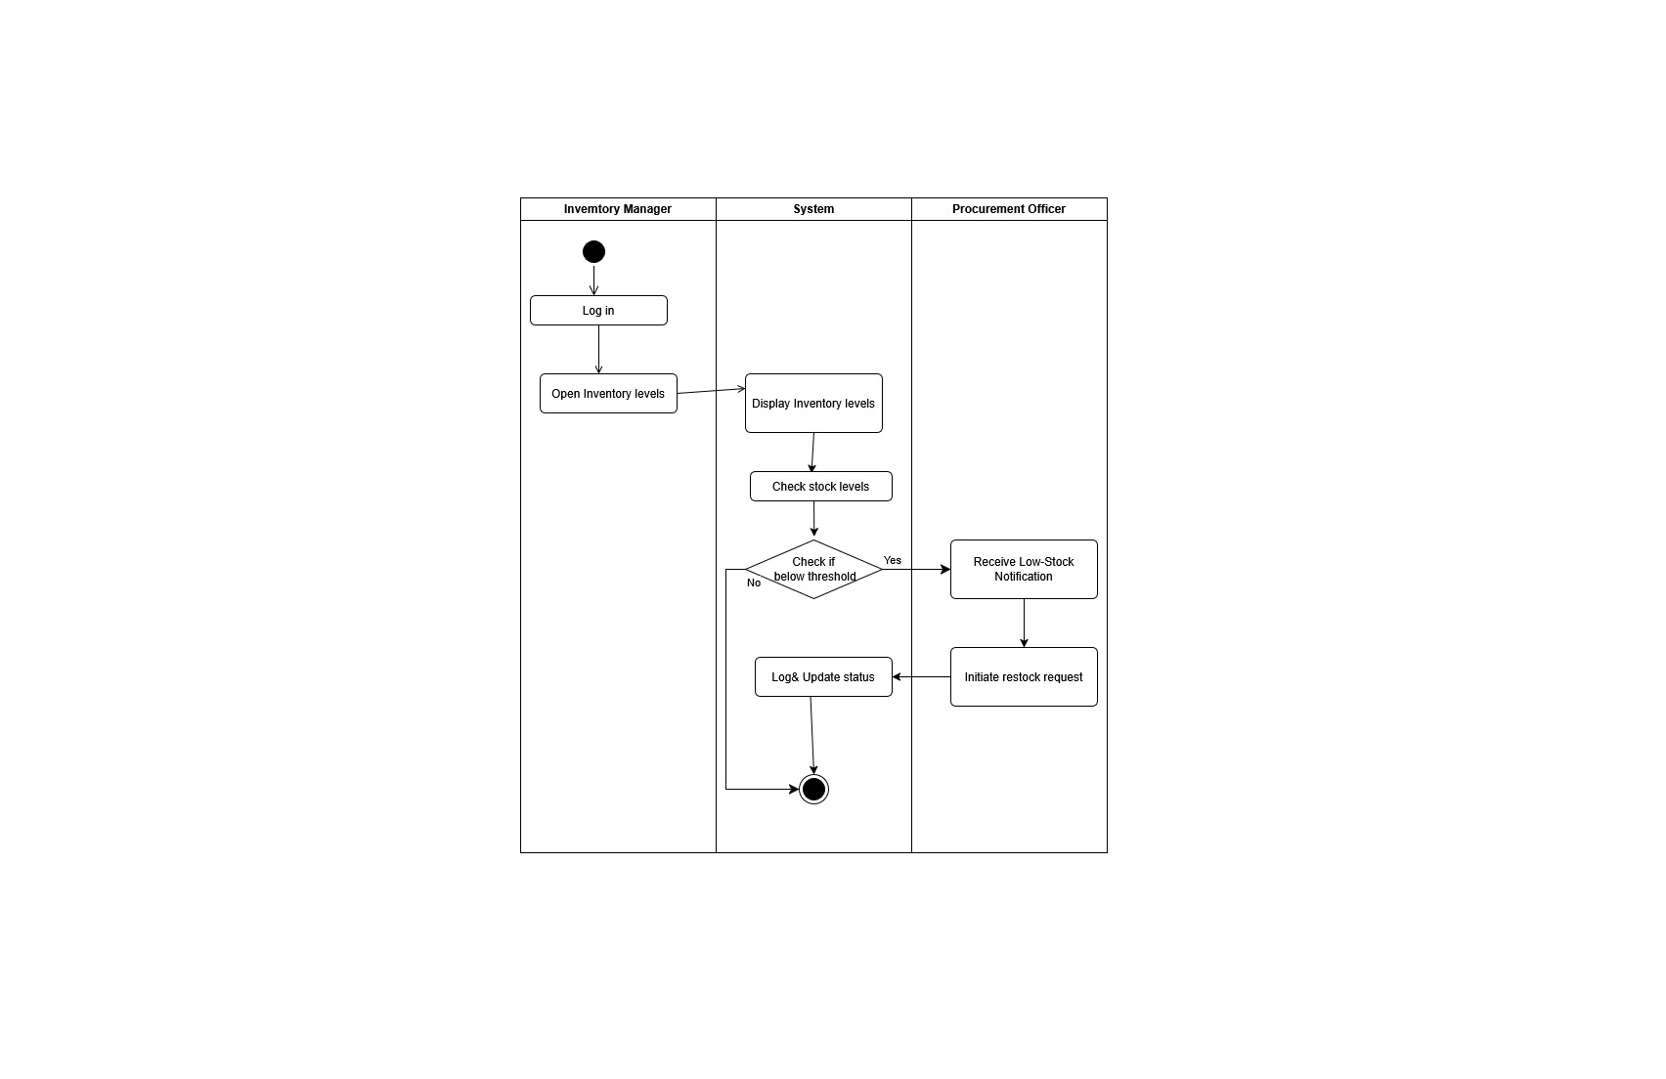

Figure 1-Activity Diagram

Package Diagram

