Software Requirements and Specification

for a

Social Media Collective Feed Chrome Extension

Version 1.0

Prepared by:

Tanner Burns  
Brett Estep  
Minh Nguyen  
Ben Vineyard

Brandon Yates

CS 4398

Spring Semester 2016

Table of Contents

1. Introduction
   1. Purpose
   2. Problem Statement
2. Functional Requirements
   1. General Functionality
   2. User Tasks
      1. Login to Accounts
      2. Open Feedbar
      3. Hide Feedbar
      4. Change Settings
      5. Social Media Specific Functions
         1. Post
         2. Like
         3. Follow/Unfollow
         4. Repost/Retweet
   3. System Functions
      1. Refresh Data
3. Non-Functional Requirements
   1. Secure Data
   2. Services
   3. Response Time
   4. Navigation
   5. Capacity
   6. Availability
   7. Readability
   8. Connection
   9. Content
4. Design/Implementation Constraints
   1. Standards Compliance
   2. Development Constraints
5. References and Sources

1. Introduction

1.1 Purpose:

Our project consists of a social media extension for the Google Chrome web browser. The extension will display one or many social media feeds based on the user’s choice of social media accounts. The user can be logged in to multiple social media accounts to view all feeds in one location.

1.2 Problem Statement:

**Vision** – We want a Google Chrome Extension that allows us to view all social media feeds in a single location.

**Issue Statement** – There are too many social media sites being widely used. It is hard to view all of your active social media feeds at once without viewing them separately on their corresponding web page.

**Method** – We will create a Google Chrome Extensions using html, JavaScript, and CSS to create a single news feed that will display all your social media sites in a single location.

2. Functional Requirements

2.1 General Functionality:

This project will be built using the Chrome Extension tool in the Google Chrome browser. This will implement html, css, and javascript code to create an “activated” module that adds to the functionality of the Chrome browser. This extension will add an additional toolbar underneath the URL bar that contains a row of icons representing multiple major social media sites (i.e. Facebook, Twitter, Instagram, etc.). The user will login to each of these social media accounts without leaving their current browsing session. The user has the option of displaying a feed containing the data pulled from each of these sites by clicking on their respective icons in the toolbar. The user can hide this feed by re-clicking each previously activated icon. Included on the toolbar is a ‘Settings’ button and a ‘Refresh’ button. The ‘Settings” button will provide additional functionality to customize the behavior of the toolbar, while the ‘Refresh’ button will allow the users to pull new data from each of the selected social media sites. The user will have the ability to scroll through the content if it exceeds screen size.

2.2 User Tasks:

2.2.1 Login to Accounts - The user shall be able to log into accounts for multiple social media sites.

This is an image of the toolbar created by the Chrome extension set underneath the URL bar on the webpage. The Toolbar contains 3 icons representing 3 social media sites: Facebook, Twitter, and Instagram, respectively, as well as an ‘Accounts’ button and a settings button represented by a grey gear icon. The user will press the ‘Accounts’ button to display a list of social media sites that may be activated. The user can then choose which sites to login. After entering the correct account login information, an icon will be displayed on the toolbar for the corresponding social media site.

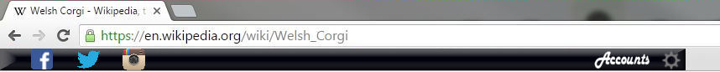

2.2.2 Open Feedbar - The user shall be able to open the feedbar to display selected social media feeds.

By clicking the icons on the toolbar, the user can open a feed containing the information pulled from the social media account currently logged in. Clicking on another icon will add that account’s feed to the feedbar. An arrow will appear below the icon to show that it is being displayed in the feedbar. The image below illustrates an open feedbar with 3 accounts activated.

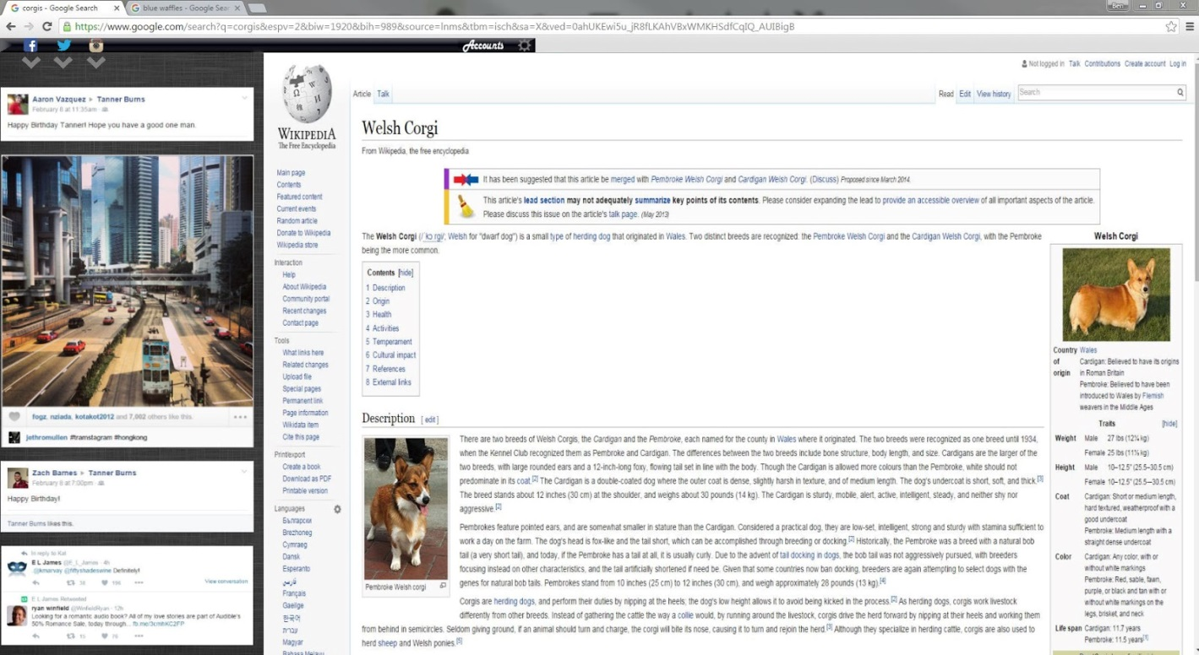

2.2.3 Hide Feedbar - The user shall be able to hide the feedbar.

Once the feedbar is opened, the user can click the icons on the toolbar again to hide them from the feed. If no icons are currently selected, the feedbar will minimize and no longer display anything.

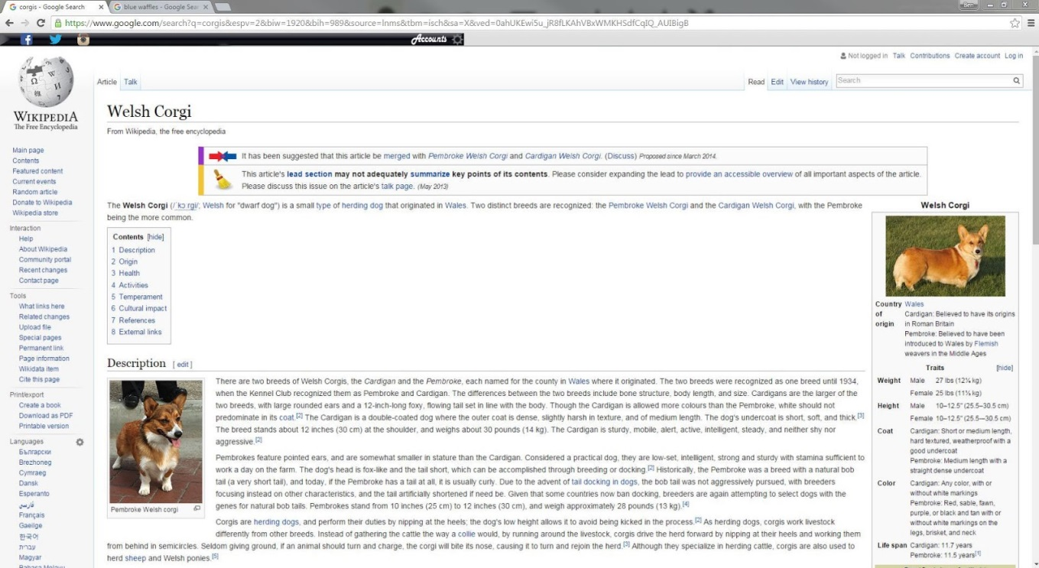

2.2.4 Change Settings - The user shall be able to change a variety of settings to affect certain toolbar functionality.

2.2.4.1 The user can click on the settings button (the grey gear icon) to change a number of settings including the below.

2.2.4.1.1 Showing or hiding account icons on the toolbar.

2.2.4.1.2 Adjusting the size of the feedbar within the browser.

2.2.4.1.3 Rearranging the order that feeds are displayed from each account.

2.2.4.1.4 Changing the frequency that feed is displayed from each account.

2.2.5 Social Media Specific Functions - The user shall be able to perform normal tasks that are associated with each social media account

2.2.5.1 Post - The user shall be able to Post from each account directly through the feedbar.

2.2.5.2 Like - The user shall be able to Like posts from other users through the feedbar.

2.2.5.3 Follow/Unfollow - The user shall be able to Follow or Unfollow any user, consequently adding or removing their posts from the feed.

2.2.5.4 Repost/Retweet - The user shall be able to Repost or Retweet a post that was posted from another user.

2.3 System Functions:

2.3.1 Refresh Data

2.3.2 Application will inform the user which social media site is having difficulty reaching the network

2.3.3 Maximize battery life for laptops/tablets.

3. Non-Functional Requirements

3.1 Secure access of user’s data:

3.1.1 User’s info should never be at risk.

    3.1.2 User’s info can be remembered for quicker login

3.2 Services widely available:

3.2.1 24/7 access.

3.3 Updating should be quick:

3.3.1 Quick response from social media servers.

3.4 Fast navigation:

3.4.1 User interface is easy to use.

3.5 Flexibility of being able to use multiple sites at a time:

3.5.1 Wide range of social media sites need to be available.

3.6 A large amount of post should be able to be viewed:

3.6.1 Can go back at least 30 minutes.

3.7 Text should be viewable at any resolution:

3.7.1 Flexibility of the size of text/image for the best visibility.

3.8 Able to reach the social media sites quickly to be able to make comments:

3.8.1 Should be able to make a status from the application in real time.

3.9 Social media content will remain where the user left-off:

3.9.1 Feed activity will remain where it was when tabs are created/deleted.

4. Design/Implementation Constraints

4.1 Standards compliance:

IEEE 1074 - Standard for Developing Software Life Cycle Processes

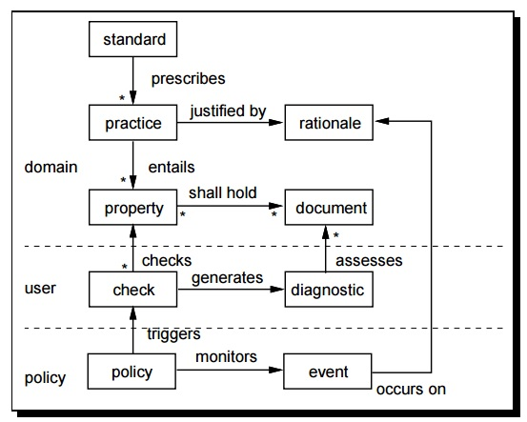

Standard and Compliance Model

4.2 Development constraints:

4.2.1 Programming Language: This project is to be done using JavaScript, CSS and HTML.

4.2.2 Platform Support: Since the extension is built to fully function on Google Chrome Web Browser on Windows, it does not guarantee the same results if it is run on Linux or MacOS.

4.2.3 Use of API’s: The extension relies on data from the API’s provided by social media companies. A change or an update in the API means that the extension has to adapt in order to continue serving users.

4.2.4 Deploying Schedule: Timetable deliverables must be agreed and followed by all members.

4.2.5 Software licensing: Should it be needed, the extension must be registered and accepted by Google Chrome Web Store.

4.2.6 User’s Data: Since the extension requires user’s data to sign in and retrieve social media feeds, it is important for the extension to protect user’s data.

4.2.7 Legal: The extension shall follow legal guidelines provided by social media companies.

5. References and Sources

* IEEE. IEEE Std 830-1998 IEEE Recommended Practice for Software Requirements Specifications. IEEE Computer Society, 1998.
* IEEE Std 1074-1997 Documentation: <http://goo.gl/e2ORYz>
* Images borrowed from Instagram, Facebook, Twitter, and Wikipedia
* Facebook’s API: <https://developers.facebook.com/docs/apis-and-sdks>
* Instagram’s API: <https://www.instagram.com/developer/>
* Twitter’s API: <https://dev.twitter.com/overview/documentation>