

**"AutoSense" – Social Sentiment Intelligence SaaS for Automotive Industry**

A Comprehensive Study Report on the Development of AI-Powered Social Sentiment Analytics Platform for Automotive Manufacturers and Dealers

Submitted by

Abhishek Sarangi

Program Name

NPDMS 2

Mentored by

Prof. Sushil Kumar – Program Director, IIM Visakhapatnam Prof. Amit Shankar – Program Co-director, IIM Visakhapatnam

**ACKNOWLEDGEMENT**

The authors of this report wish to extend their sincere appreciation to

Professor Sushil Kumar, the course instructor, for his invaluable guidance, unwavering support, and insightful feedback throughout this project. His expertise and encouragement have been instrumental in shaping the direction and outcome of our work.

We are also grateful to IIM Visakhapatnam for providing the conducive

environment and resources necessary for the successful completion of this project. The opportunities and learning experiences offered by the institute have been instrumental in our academic and personal growth.

Finally, we would like to express our appreciation to our peers and colleagues who have contributed to this project in various ways, enriching the collaborative process and enhancing the quality of our work. Their contributions have been vital to the accomplishment of this report.

We recognise the importance of acknowledging and appreciating the support and resources that make projects like this possible.

Therefore, we extend our heartfelt gratitude to all who have contributed to the successful completion of this project.

- Group 3 team members

Senior Management Program – Batch 2

CONTENT

1. Product Vision & Mission 4
2. Competitive Analysis 5
3. Segmentation, Targeting and Positioning 11
4. Product Development 16
5. Go-to-market Strategy 24
6. Team Management 30
7. Financial feasibility 32
8. References 35

CHAPTER – 1

# PRODUCT VISION & MISSION

## Product Vision:

AutoSense aspires to revolutionize automotive market intelligence by creating the industry's most comprehensive social sentiment analytics platform. We envision a future where automotive manufacturers and dealers make data-driven decisions based on real-time consumer insights, transforming how the industry understands and responds to customer preferences, pain points, and emerging trends across all digital touchpoints.

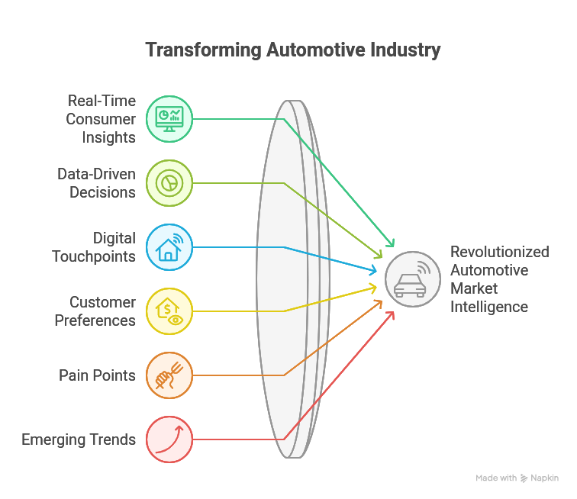

## Product Mission:

Our mission is to bridge the gap between consumer voice and automotive industry decision-making by delivering a sophisticated AI-powered SaaS platform that transforms unstructured social media conversations into actionable business intelligence. Through advanced sentiment analysis, competitive benchmarking, and predictive analytics, AutoSense empowers automotive stakeholders to enhance product development, optimize marketing strategies, and ultimately deliver vehicles that truly resonate with consumer expectations.

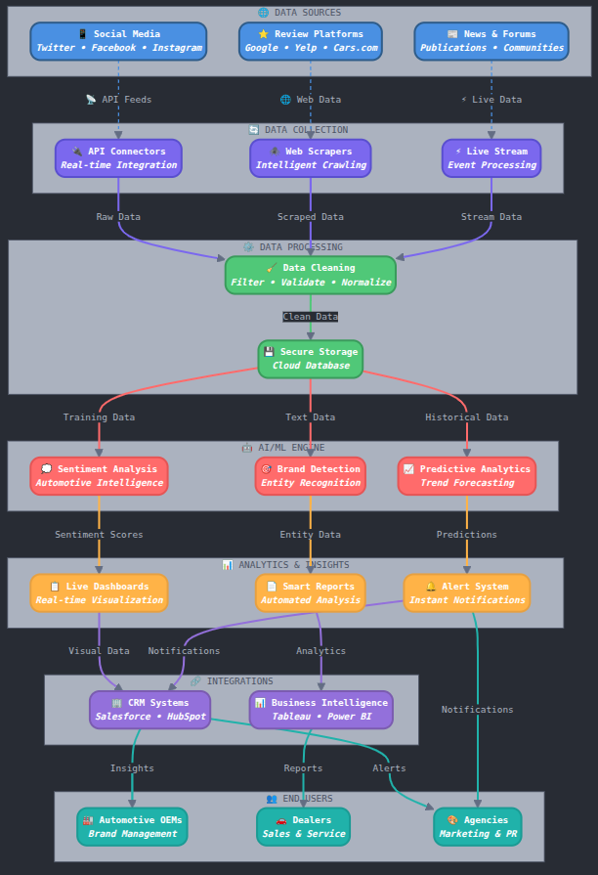

CHAPTER – 2

# COMPETITIVE ANALYSIS

## Market Overview

**Market Size & Growth:** The global automotive analytics market was valued at USD 3.2 billion in 2024 and is expected to reach USD 9.8 billion by 2032, growing at a CAGR of 15.2%. The social listening and sentiment analysis market specifically is projected to grow at 17.8% CAGR.

**Key Drivers:**

* Increasing importance of customer experience in automotive industry
* Growing volume of social media discussions about automotive brands
* Rising need for competitive intelligence and market positioning
* Digital transformation initiatives across automotive sector
* Regulatory requirements for customer feedback monitoring

**Challenges:**

* Data privacy and compliance concerns
* Integration complexity with existing enterprise systems
* High implementation costs for comprehensive solutions
* Skilled personnel shortage for data interpretation
* Fragmented data sources across multiple platforms

## Identification of Key Competitors

**Direct Competitors:**

* Brandwatch (Now Cision)
* Sprout Social
* Hootsuite Insights
* Mention
* Talkwalker

**Indirect Competitors:**

* Traditional market research firms (Nielsen, Ipsos)
* Business intelligence platforms (Tableau, PowerBI)
* Social media management tools
* Automotive-specific research companies (J.D. Power, Cox Automotive)

## Features and technical comparison:

We've studied several market models to identify key features for our new product. Here's a quick comparison of our findings:

| **Feature** | **Brandwatch** | **Sprout Social** | **Hootsuite** | **Mention** | **AutoSense** |
| --- | --- | --- | --- | --- | --- |
| Real-time Sentiment Analysis | Yes | Yes | Limited | Yes | Advanced AI-powered |
| Automotive-specific Tagging | No | No | No | No | Yes |
| Multi-language Support | Yes | Limited | Limited | Yes | Yes (15+ languages) |
| Competitive Benchmarking | Basic | Basic | No | Yes | Advanced |
| Custom Dashboard | Yes | Yes | Yes | Yes | Industry-specific |
| API Integration | Yes | Yes | Yes | Yes | Comprehensive |
| Predictive Analytics | Limited | No | No | Limited | Advanced ML models |
| Pricing (Starting) | $800/month | $249/month | $49/month | $29/month | $599/month |

## Market positioning:

AutoSense is strategically positioned as the specialized, AI-driven social sentiment intelligence solution exclusively designed for the automotive industry. Unlike generic social listening tools, we focus specifically on automotive manufacturers, dealers, and related stakeholders who require deep, industry-specific insights to drive product development, marketing strategies, and customer experience improvements.

## Distribution channels:

**Primary Channels:**

* **Direct Sales (B2B):** Enterprise sales team targeting automotive OEMs and large dealer networks
* **Partner Channel:** Integration partnerships with automotive technology providers and consultants
* **Digital Marketing:** Industry-specific content marketing and thought leadership
* **Trade Shows:** Automotive industry conferences and exhibitions

**Secondary Channels:**

**Referral Programs:** Incentivized referrals from existing customers

**Freemium Model:** Limited free trial to demonstrate value proposition

**Channel Partners:** Reseller partnerships with automotive business solution providers

* 1. **Unique Selling Proposition**

**"AutoSense: The Only Social Intelligence Platform Built Exclusively for Automotive Success"**

**Key Differentiators:**

* **Automotive-Specific AI Models:** Trained specifically on automotive terminology, features, and consumer behavior patterns
* **Real-time Competitive Intelligence:** Instant benchmarking against competitors with automotive-specific metrics
* **Feature-Level Sentiment Analysis:** Deep dive into specific car features (mileage, safety, design, etc.)
* **Predictive Trend Analysis:** Forecast emerging consumer preferences and market shifts
* **Integration Ready:** Seamless integration with existing automotive CRM and marketing platforms

CHAPTER – 3

# SEGMENTATION, TARGETING & POSITIONING

## Market Overview

The global automotive social listening market is experiencing rapid growth, driven by increasing digitalization and the critical importance of customer voice in automotive decision-making. With 4.8 billion social media users globally generating 2.5 quintillion bytes of data daily, the automotive industry faces both an opportunity and a challenge in extracting meaningful insights from this vast information ecosystem.

## Segmentation

#### 3.2.1 By Company Size

* **Enterprise (500+ employees):** Large automotive manufacturers (Ford, Toyota, BMW)
* **Mid-Market (50-500 employees):** Regional automotive manufacturers and large dealer groups
* **Small Business (<50 employees):** Independent dealers and specialized automotive service providers

#### 3.2.2 By Industry Vertical

* **Original Equipment Manufacturers (OEMs):** Global and regional car manufacturers
* **Automotive Dealers:** Multi-brand dealerships and single-brand dealers
* **Automotive Services:** Insurance companies, financing companies, aftermarket services
* **Automotive Technology:** Tier 1 suppliers, automotive software companies

#### 3.2.3 By Use Case

* **Product Development:** R&D teams seeking consumer feedback on features
* **Marketing & Brand Management:** Marketing teams monitoring brand perception
* **Customer Experience:** Customer service teams tracking satisfaction and issues
* **Competitive Intelligence:** Strategy teams monitoring competitor performance

#### 3.2.4 By Geographic Region

* **North America:** Mature market with high digital adoption
* **Europe:** Strict data privacy regulations, premium automotive focus
* **Asia-Pacific:** Rapid growth, diverse market conditions
* **Emerging Markets:** Cost-sensitive, mobile-first consumers

## Targeting:

## **3.3.1 Primary Target Segment**

**Automotive OEMs and Large Dealer Networks**

* Annual Revenue: $500M+
* Employees: 1000+
* Digital Maturity: Advanced
* Pain Points: Need for real-time consumer insights, competitive intelligence
* Budget: $50K-$500K annually for analytics solutions

#### 3.3.2 Secondary Target Segment

**Mid-Market Automotive Companies**

* Annual Revenue: $50M-$500M
* Employees: 100-1000
* Digital Maturity: Developing
* Pain Points: Limited resources for comprehensive market research
* Budget: $10K-$50K annually

## Positioning:

For automotive industry leaders who need to understand consumer sentiment and competitive dynamics, AutoSense is the only social intelligence platform that provides real-time, AI-powered insights specifically designed for automotive decision-making, enabling faster, more informed strategic decisions that drive market success.

CHAPTER – 4

# PRODUCT DEVELOPMENT

## Objective:

To develop a comprehensive AI-powered social sentiment intelligence platform that transforms unstructured social media data into actionable insights for automotive industry stakeholders. The platform will provide real-time sentiment analysis, competitive benchmarking, and predictive analytics specifically tailored for automotive applications.

## Product Summary:

AutoSense is a cloud-based SaaS platform that leverages advanced natural language processing, machine learning, and automotive domain expertise to analyze social media conversations, reviews, and discussions about automotive brands, models, and features. The platform provides dashboard-driven insights that enable data-driven decision-making across product development, marketing, and customer experience functions.

## Development plan:

#### Phase 1: Research & Validation (8-10 weeks)

**Goals:**

* Validate market demand and customer pain points
* Define technical requirements and platform architecture
* Establish partnerships with data providers

**Activities:**

* Customer discovery interviews with 50+ automotive industry professionals
* Competitor analysis and feature gap identification
* Technical feasibility assessment for AI models
* Data source evaluation and partnership discussions

**Expected Outcomes:**

* Validated product-market fit
* Technical architecture blueprint
* Initial customer commitments

#### Phase 2: MVP Development (12-16 weeks)

**Goals:**

* Build core sentiment analysis engine
* Develop basic dashboard and reporting features
* Establish data ingestion pipeline

**Activities:**

* Develop NLP models trained on automotive terminology
* Build data collection and processing infrastructure
* Create initial dashboard interface
* Implement basic sentiment analysis algorithms

**Expected Outcomes:**

* Functional MVP with core features
* Beta testing capability
* Initial AI model accuracy of 80%+

#### Phase 3: Beta Testing & Iteration (6-8 weeks)

**Goals:**

* Test platform with select customers
* Refine AI models based on real-world data
* Optimize user experience and interface

**Activities:**

* Deploy MVP to 5-10 beta customers
* Collect feedback and usage analytics
* Iterate on features and functionality
* Improve AI model accuracy

**Expected Outcomes:**

* Validated product features
* Improved AI accuracy (85%+)
* Customer testimonials and case studies

#### Phase 4: Full Platform Development (16-20 weeks)

**Goals:**

* Build comprehensive feature set
* Implement advanced analytics and predictive capabilities
* Develop enterprise-grade security and scalability

**Activities:**

* Advanced AI model development
* Competitive benchmarking features
* Predictive analytics implementation
* Enterprise integration capabilities

**Expected Outcomes:**

* Production-ready platform
* Comprehensive feature set
* Enterprise-grade security and compliance

#### Phase 5: Market Launch Preparation (4-6 weeks)

**Goals:**

* Finalize go-to-market strategy
* Prepare marketing materials and sales tools
* Establish customer support infrastructure

**Activities:**

* Sales team training and enablement
* Marketing campaign development
* Customer support process establishment
* Partner channel development

### 4.4 Technical Architecture

**Core Components:**

* **Data Ingestion Layer:** APIs to collect data from social media platforms
* **AI/ML Engine:** Natural language processing and sentiment analysis
* **Analytics Engine:** Statistical analysis and trend identification
* **Dashboard Layer:** User interface and visualization components
* **Integration Layer:** APIs for third-party system integration

**Technology Stack:**

* **Cloud Infrastructure:** AWS/Azure
* **Programming Languages:** Python, JavaScript, SQL
* **AI/ML Frameworks:** TensorFlow, PyTorch, scikit-learn
* **Database:** PostgreSQL, MongoDB
* **Frontend:** React.js, D3.js for visualizations

CHAPTER – 5

# GO-TO-MARKET (GTM) STRATEGY

### 5.1 Market Entry Strategy

AutoSense will employ a focused B2B enterprise sales approach, targeting automotive OEMs and large dealer networks with a consultative sales model that emphasizes value demonstration and ROI quantification.

### 5.2 Customer Acquisition Strategy

#### 5.2.1 Direct Sales Approach

* **Enterprise Sales Team:** Dedicated account executives for major automotive OEMs
* **Inside Sales Team:** Phone and video-based sales for mid-market segments
* **Customer Success Team:** Ensuring adoption and expansion within existing accounts

#### 5.2.2 Channel Partnerships

* **System Integrators:** Partnerships with automotive technology consultants
* **Technology Partners:** Integration with existing automotive software platforms
* **Reseller Network:** Authorized partners for specific geographic markets

### 5.3 Pricing Strategy

#### 5.3.1 Tiered Pricing Model

**Starter Plan - $2,999/month**

* Up to 5 brands monitoring
* 10,000 mentions per month
* Basic sentiment analysis
* Standard dashboard
* Email support

**Professional Plan - $7,999/month**

* Up to 15 brands monitoring
* 50,000 mentions per month
* Advanced sentiment analysis
* Custom dashboards
* Competitive benchmarking
* Phone and email support

**Enterprise Plan - $19,999/month**

* Unlimited brand monitoring
* Unlimited mentions
* Predictive analytics
* Custom AI model training
* API access
* Dedicated customer success manager
* 24/7 priority support

#### 5.3.2 Value-Based Pricing Justification

* Average cost savings: $500K annually through improved market intelligence
* Revenue impact: 15-25% improvement in marketing ROI
* Time savings: 70% reduction in manual market research activities

### 5.4 Marketing Strategy

#### 5.4.1 Digital Marketing

* **Content Marketing:** Industry-specific whitepapers, case studies, and research reports
* **SEO/SEM:** Targeted keywords for automotive analytics and social listening
* **Social Media:** LinkedIn thought leadership and industry engagement
* **Email Marketing:** Nurture campaigns for prospects and customers

#### 5.4.2 Traditional Marketing

* **Trade Shows:** Automotive industry conferences (NADA, SEMA, Auto Retail Summit)
* **Industry Publications:** Advertising in Automotive News, Wards Auto, etc.
* **Webinars:** Educational content on social sentiment analysis
* **PR:** Thought leadership and industry recognition

### 5.5 Launch Timeline

**Pre-Launch (Months 1-2):**

* Beta customer onboarding
* Sales team training
* Marketing material development
* Partnership establishment

**Launch (Month 3):**

* Official product launch
* Press release and media coverage
* Customer success stories
* Trade show presence

**Post-Launch (Months 4-6):**

* Customer acquisition acceleration
* Product iteration based on feedback
* Market expansion preparation
* Partnership program expansion

CHAPTER – 6

# TEAM MANAGEMENT

## Organisational Structure:

CEO

├── CTO (Chief Technology Officer)

│ ├── VP Engineering

│ │ ├── Backend Development Team (5)

│ │ ├── Frontend Development Team (3)

│ │ └── DevOps Team (2)

│ ├── VP Data Science

│ │ ├── Data Scientists (4)

│ │ ├── ML Engineers (3)

│ │ └── Data Engineers (2)

│ └── VP Product

│ ├── Product Managers (2)

│ └── UX/UI Designers (2)

├── CMO (Chief Marketing Officer)

│ ├── Marketing Manager

│ ├── Content Marketing Specialist

│ └── Digital Marketing Specialist

├── Chief Revenue Officer

│ ├── VP Sales

│ │ ├── Enterprise Sales Reps (3)

│ │ └── Inside Sales Reps (2)

│ └── VP Customer Success

│ ├── Customer Success Managers (3)

│ └── Support Specialists (2)

└── CFO/COO

├── Finance Manager

├── HR Manager

└── Operations Manager

* 1. **Roles and responsibilities:**

#### 6.2.1 Executive Team

* **CEO:** Strategic vision, investor relations, overall company leadership
* **CTO:** Technology strategy, product architecture, technical team leadership
* **CMO:** Brand positioning, marketing strategy, demand generation
* **Chief Revenue Officer:** Sales strategy, revenue growth, customer retention
* **CFO/COO:** Financial management, operations, legal and compliance

#### 6.2.2 Core Team Functions

* **Engineering:** Platform development, maintenance, and scaling
* **Data Science:** AI model development, analytics, and insights generation
* **Product:** Feature prioritization, user experience, product roadmap
* **Sales:** Customer acquisition, relationship management, revenue generation
* **Marketing:** Brand awareness, lead generation, content creation
* **Customer Success:** Customer onboarding, retention, and expansion

### 6.3 Hiring Plan

**Year 1 Priority Hires:**

* Senior Data Scientists (2)
* Enterprise Sales Representatives (2)
* Product Manager (1)
* Customer Success Manager (1)

**Year 2 Expansion:**

* Additional Engineering Resources (3)
* Marketing Specialists (2)
* International Sales Team (2)
* Customer Support Team (2)

CHAPTER – 7

# FINANCIAL FEASIBILITY

### 7.1 Revenue Model

AutoSense operates on a SaaS subscription model with tiered pricing based on usage and features. Additional revenue streams include professional services, custom development, and training programs.

### 7.2 Revenue Projections (5-Year Forecast)

| **Year** | **Customers** | **Average ACU** | **Total Revenue** | **Growth Rate** |
| --- | --- | --- | --- | --- |
| 1 | 25 | $96,000 | $2,400,000 | - |
| 2 | 65 | $108,000 | $7,020,000 | 192% |
| 3 | 150 | $120,000 | $18,000,000 | 156% |
| 4 | 275 | $132,000 | $36,300,000 | 102% |
| 5 | 450 | $144,000 | $64,800,000 | 78% |

### 7.3 Cost Structure

#### 7.3.1 Operating Expenses (Year 1)

* **Personnel Costs:** $1,800,000 (75% of expenses)
* **Technology Infrastructure:** $240,000 (10% of expenses)
* **Sales & Marketing:** $240,000 (10% of expenses)
* **General & Administrative:** $120,000 (5% of expenses)
* **Total OpEx:** $2,400,000

#### 7.3.2 Cost of Goods Sold

* **Data Acquisition:** $50 per customer per month
* **Cloud Infrastructure:** $25 per customer per month
* **Third-party Services:** $15 per customer per month
* **Total COGS:** $90 per customer per month

### 7.4 Profitability Analysis

#### 7.4.1 Unit Economics

* **Average Revenue Per User (ARPU):** $8,000/month
* **Customer Acquisition Cost (CAC):** $12,000
* **Customer Lifetime Value (LTV):** $288,000
* **LTV/CAC Ratio:** 24:1
* **Gross Margin:** 86%

#### 7.4.2 Break-even Analysis

* **Break-even Point:** Month 18
* **Monthly Recurring Revenue at Break-even:** $1,200,000
* **Customers at Break-even:** 150

### 7.5 Funding Requirements

#### 7.5.1 Initial Investment Needs

* **Seed Round:** $2,000,000
  + Product development: $800,000
  + Team building: $600,000
  + Marketing & sales: $400,000
  + Operations & working capital: $200,000

#### 7.5.2 Series A Funding

* **Series A:** $8,000,000 (Month 18)
  + Market expansion: $3,000,000
  + Product enhancement: $2,000,000
  + Sales team scaling: $2,000,000
  + International expansion: $1,000,000

### 7.6 Financial Metrics and KPIs

| **Metric** | **Year 1 Target** | **Year 2 Target** | **Year 3 Target** |
| --- | --- | --- | --- |
| Monthly Recurring Revenue | $200K | $585K | $1,500K |
| Annual Recurring Revenue | $2.4M | $7.0M | $18.0M |
| Gross Revenue Retention | 95% | 97% | 98% |
| Net Revenue Retention | 110% | 120% | 125% |
| Customer Acquisition Cost | $12K | $10K | $8K |
| Customer Lifetime Value | $288K | $324K | $360K |

### 7.7 Risk Assessment

#### 7.7.1 Market Risks

* **Competition:** Increasing competition from established players
* **Market Adoption:** Slower than expected adoption of AI analytics
* **Economic Downturn:** Reduced IT spending in automotive sector

#### 7.7.2 Mitigation Strategies

* **Differentiation:** Focus on automotive-specific features and expertise
* **Customer Success:** Ensure high retention through value demonstration
* **Diversification:** Expand to adjacent markets and use cases

# REFERENCES

The following sources and links have been used for collecting data:

1. Grand View Research. (2024). "Automotive Analytics Market Size, Share & Trends Analysis Report."
2. Mordor Intelligence. (2024). "Social Media Analytics Market - Growth, Trends, and Forecasts."
3. McKinsey & Company. (2023). "The Future of Automotive Data and Analytics."
4. Deloitte. (2024). "Global Automotive Consumer Study."
5. PwC. (2023). "Connected Car Report: Opportunities, Risk, and Turmoil on the Road to Autonomous Vehicles."
6. Accenture. (2024). "Automotive Digital Transformation: From Connected Cars to Autonomous Mobility."
7. Boston Consulting Group. (2023). "The Automotive Software and Electronics Market."
8. Capgemini. (2024). "Automotive Retail Revolution: How Digital is Transforming the Industry."
9. KPMG. (2023). "Global Automotive Executive Survey."
10. EY. (2024). "Mobility Consumer Index: Automotive Industry Trends and Insights."