NL2 Track Designer
Instruction Manual
A drag-and-drop coaster track designer for NoLimits 2

Contents

1. What Is This Program
NL2 Track Designer is an alternative to FVD++ for designing custom NoLimits 2 (NL2) roller coaster track. Instead of writing force-vector formulas, you build a ride by dragging named elements - Straight, Banked Turn, Hill Arc, Loop, Helix, and more - into an ordered list, adjusting a handful of plain-number parameters on each, and watching the track update live in a 3D preview. When you're happy with it, you export a file that NoLimits 2 can import directly as real, rideable track.
The goal is the same versatility FVD++ offers, without needing to learn a formula language first.
Before you rely on this tool, please check one thing in NoLimits 2:
Track Spline import (Coaster tab → Import → Track Spline) appears to be a NoLimits 2 Professional-license feature, not available in the standard/Steam version. If that menu item is missing or grayed out for you, the export this program produces may not be usable in your copy of NL2.

2. Installation
You have three ways to get this running, from easiest to most involved:

2.1 Option A — One-click launcher (easiest)
Double-click “Start NL2 Track Designer.bat” in the project folder.
1. If Python isn't already installed on your PC, it installs it automatically.
2. The first time, you may need to run the file a second time after Python finishes installing, so Windows picks up the new install.
3. After that, it sets up the app and launches it — no typing required.
Note: this isn't a standalone .exe — it's still Python underneath, just fully automated so you never see it.

2.2 Option B — Build a real standalone .exe (via GitHub, free)
GitHub gives everyone free access to real Windows build machines in the cloud (“Actions”). Full walkthrough is in BUILD_EXE_GUIDE.md, summarized here:
1. Create a free account at github.com/signup.
2. Create a new repository (Private is fine) and upload the entire project folder to it, including the hidden .github folder (GitHub Desktop handles this automatically if drag-and-drop hides it).
3. Open the “Actions” tab — a build starts automatically.
4. Wait 2–5 minutes, then download the finished .exe from the “Artifacts” section of that build.
The result is a genuine standalone Windows program — no Python required to run it, on this PC or any other Windows PC.

2.3 Option C — Manual setup (if you're comfortable with a terminal)
1. Install Python 3.10+ from python.org, checking “Add python.exe to PATH” during install.
2. Open a command prompt in the project folder.
3. Run: pip install -r requirements.txt
4. Run: python run_gui.py

3. Interface Tour
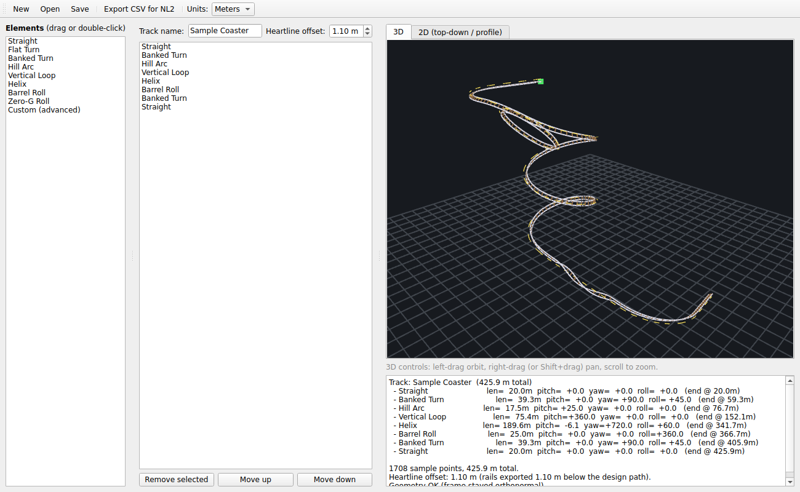
The main window, with a sample track loaded.
- Elements panel (far left) — the palette of available track pieces. Drag one onto the track list, or double-click to append it to the end.
- Track list (middle) — the ordered sequence of elements making up your ride. Drag to reorder; double-click an item to edit its numbers; Delete key or “Remove selected” to remove it.
- Track name / Heartline offset / Units (top of the middle column) — name your ride, set how far the physical rails sit below your design path, and choose meters or feet for entering numbers.
- Preview tabs (top right) — “3D” and “2D (top-down / profile)” views of the track, updating live as you edit.
- Summary panel (bottom right) — a plain-text readout of every element's length and angles, the total track length, and any geometry warnings.
- Toolbar (very top) — New / Open / Save a project, Export CSV for NL2, and the Units switch.

4. Building Your First Track
1. Add elements: drag a piece from the Elements panel onto the track list, or double-click it to add it at the end. Start simple — a Straight is a safe first piece.
2. Reorder: drag any item up or down within the track list, or select it and use the “Move up” / “Move down” buttons.
3. Edit parameters: double-click any item in the track list to open its parameter dialog (shown below). Change the numbers, give it a memorable name if you like, and click OK.
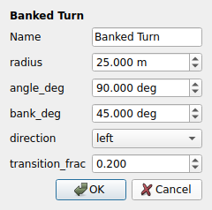
Editing a Banked Turn: plain number fields, no formulas.
1. Watch the preview: both the 3D and 2D tabs update immediately after every change, so you can see the effect of each element as you build.
2. Remove a piece: select it in the track list and press Delete, or click “Remove selected.”

5. Element Reference
Every element in the palette, what it takes, and what it does:
Element | Parameters | What it does
Straight | length | A flat, unbanked, straight section.
Flat Turn | radius, angle, direction | A turn with no banking — flat left or right.
Banked Turn | radius, angle, bank angle, direction, transition | A turn that rolls into a bank, holds it, at a chosen radius and angle.
Hill Arc | radius, angle | A vertical arc — positive angle crests upward, negative dips down. Chain two together (e.g. +20 then –20) for a classic airtime hill.
Vertical Loop | radius | A full 360° vertical loop.
Helix | radius, turns, height change, bank angle, direction | A banked spiral that climbs or descends over a chosen number of turns.
Barrel Roll | length, number of rolls, direction | An inline roll along an otherwise straight, flat section.
Zero-G Roll | radius, angle, number of rolls | A hill arc combined with a roll — the classic floater-airtime-plus-roll element.
Custom (advanced) | length, pitch/yaw/roll totals, easing | Full raw control — the same primitives FVD++ exposes, for anything the named elements don't cover.

6. Understanding the Heartline Offset
You design along the “heartline” — the path a rider's center of mass follows. All the roll, pitch, and turn math is defined relative to this path, which is also why rolls feel right: rotating around the exact point you're standing on is what a proper heartline roll is.
The “Heartline offset” field controls how far below that path the physical rails sit when exported — typically 1.0–1.2 m for a sit-down coaster. Set it to 0 to export the heartline itself with no offset.
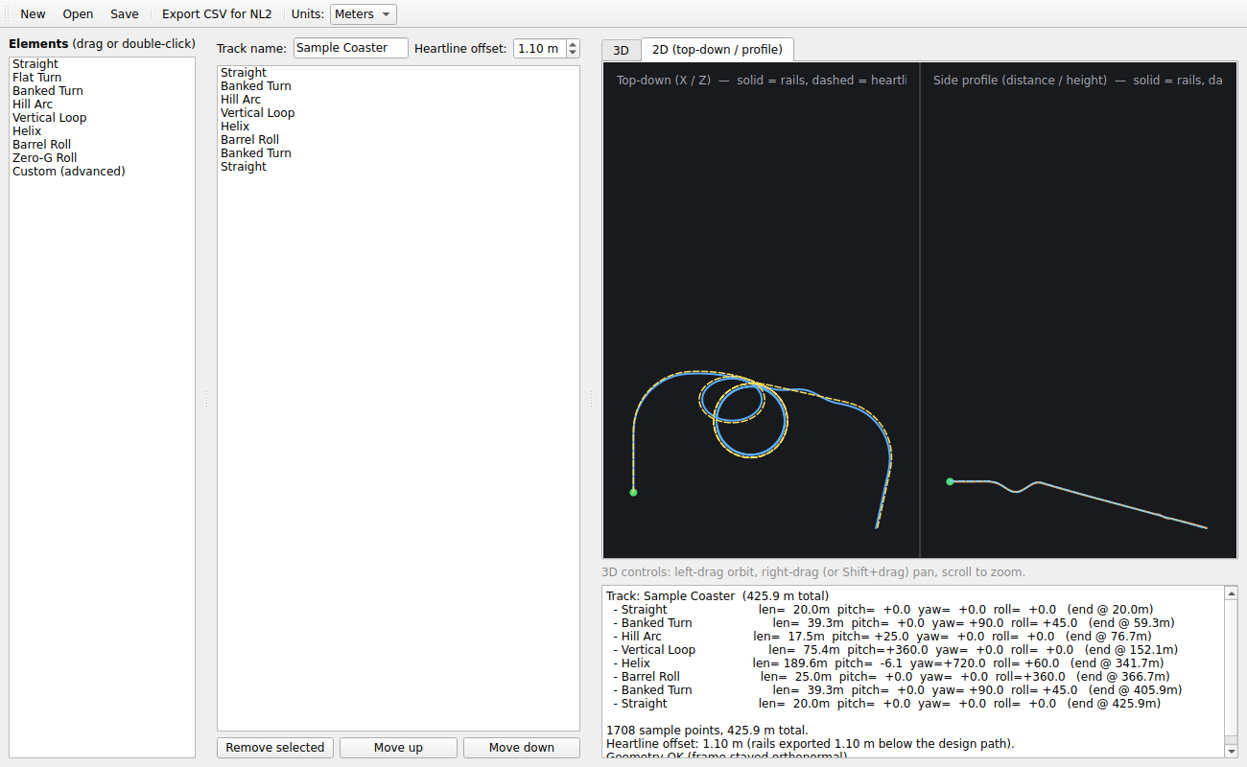
Both previews show the heartline as a dashed line next to the solid rails, so you can see what the offset is doing.
One detail worth knowing: at the inverted top of a loop, the rails correctly render above the heartline in world space — exactly like a real coaster, where the rail holds the car up from above while it's upside down.

7. Units Toggle
The “Units” dropdown in the toolbar switches every length, radius, and height field — including the Heartline offset — between meters and feet for display and entry. Angles and turn counts are unaffected, since they don't have a metric/imperial distinction.
Underneath, everything is always stored, computed, and exported in meters — NoLimits 2's file format is metric regardless of what units NL2 itself displays, so this toggle only changes what's comfortable to type, never the actual track.

8. The 3D and 2D Previews

3D view
- Left-drag: orbit the camera around the track.
- Right-drag (or Shift+drag): pan.
- Scroll wheel: zoom in/out.
Rails are drawn at the true track gauge with cross-ties between them — the ties are the clearest visual read on banking. The dashed yellow line is the heartline reference; the green dot marks the start.

2D view
Two panes: a top-down view (looking straight down) and a side profile (distance along the track vs. height). Useful for checking overall layout and height changes at a glance.

9. Saving and Loading Projects
Use “Save...” in the toolbar to save your track (all elements, parameters, name, and heartline offset) to a project file you can reopen later with “Open....” Project files always store values in meters regardless of which display units you had selected, so they're portable between sessions no matter what.

10. Exporting to NoLimits 2
1. Click “Export CSV for NL2...” in the toolbar.
2. Choose where to save the file.
3. In NoLimits 2: go to the Coaster tab → Import → Track Spline, and select the file you just exported.
4. Your track appears as real, rideable NL2 track.
The exported file is the rail path (heartline offset already applied) — not the raw heartline — so it's ready to import as-is.

11. Troubleshooting

The .bat launcher says Python wasn't found, even after it “installed” it
Close the window completely and double-click the .bat file again — Windows sometimes needs a fresh process to pick up a PATH change from an install that just finished.

The GitHub Actions build failed (red X instead of green check)
Click into the failed run and open the failing step's log — the error message is usually specific enough to fix directly. Share it and it can be debugged from there.

“Import → Track Spline” isn't in my NL2 menu
This is very likely the Professional-license limitation mentioned at the start of this manual — check your NL2 license tier.

The summary panel shows geometry warnings
This means the track's internal orientation math drifted slightly out of true (very rare, and automatically checked on every build). Try adjusting the element just before the warning first.

12. Known Limitations
- Loops and helices are circular, not clothoid — real comfortable loops taper their radius; this is a planned improvement.
- No visual authoring tool yet for creating brand-new named elements — the “Custom (advanced)” palette entry covers this with raw number fields in the meantime.
- The 3D preview is wireframe-style (rails + ties), not a shaded/solid render.
- Heartline offset is a single constant per track, not adjustable along the ride.

13. Where to Look for More
- README.md — full technical notes, what's been fixed each milestone, and the fuller limitations list.
- BUILD_EXE_GUIDE.md — the complete step-by-step for building a standalone .exe via GitHub.

