# FlashPay payment module for Joomla 4.x and JoomShopping 5.x

## Installation

1. Download the repository
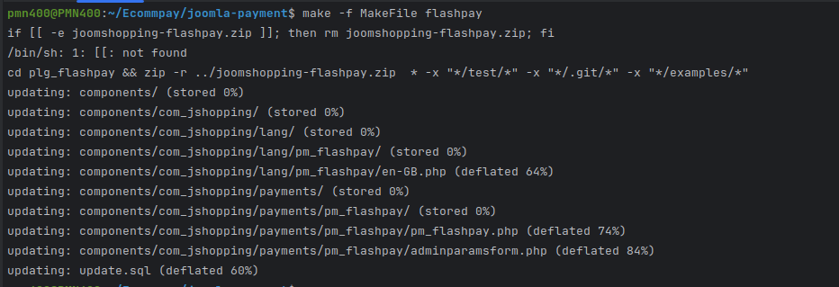
2. Run the command `make -f MakeFile flashpay`, as a result a zip file will be generated
3. Login to your Joomla admin panel
4. From the Components menu, go to JoomShopping Installation and Updates (arrow #1)

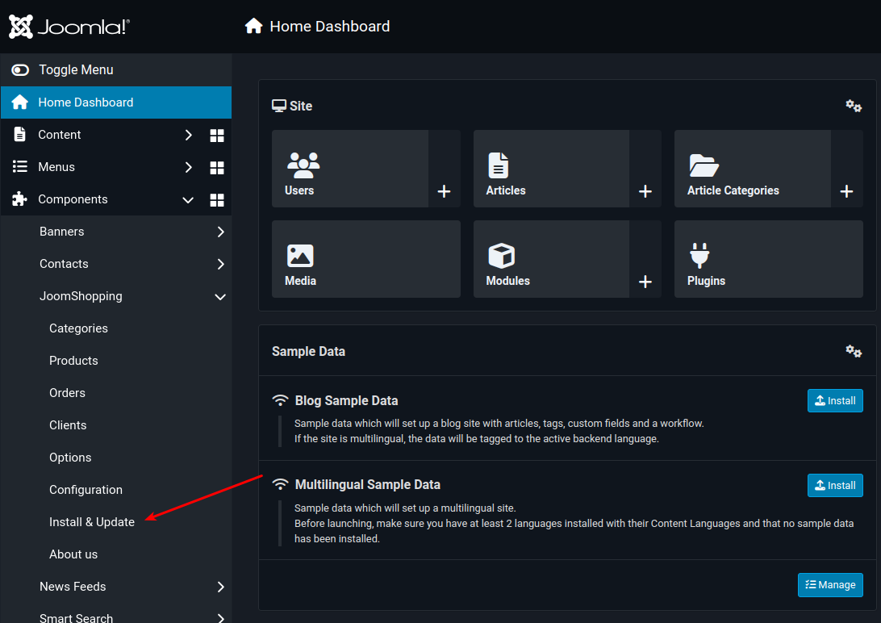
5. Install the package
6. Open the Upload package file page (arrow #1)
7. Select the module archive file downloaded in step 1
8. Download and install the module (arrow #2)

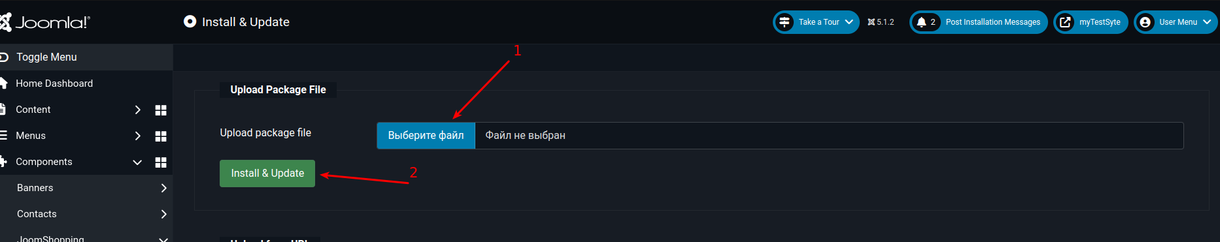

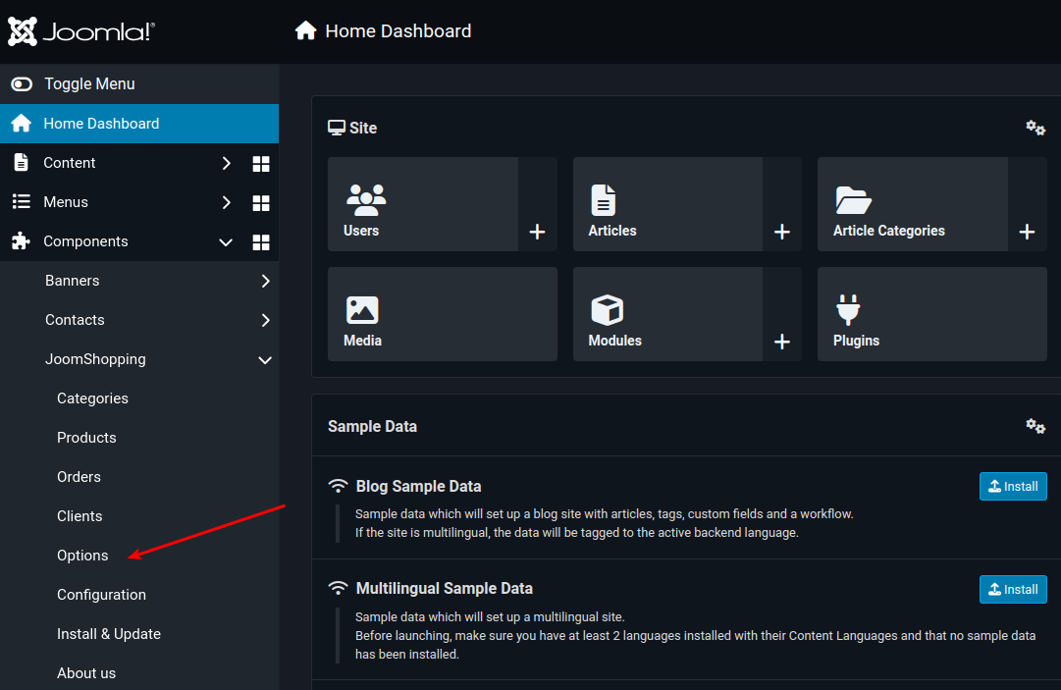
## Module setup

1. Login to Joomla admin panel
2. Go to JoomShopping Options panel (arrow #1)

3. Go to Payment Method (arrow #1)

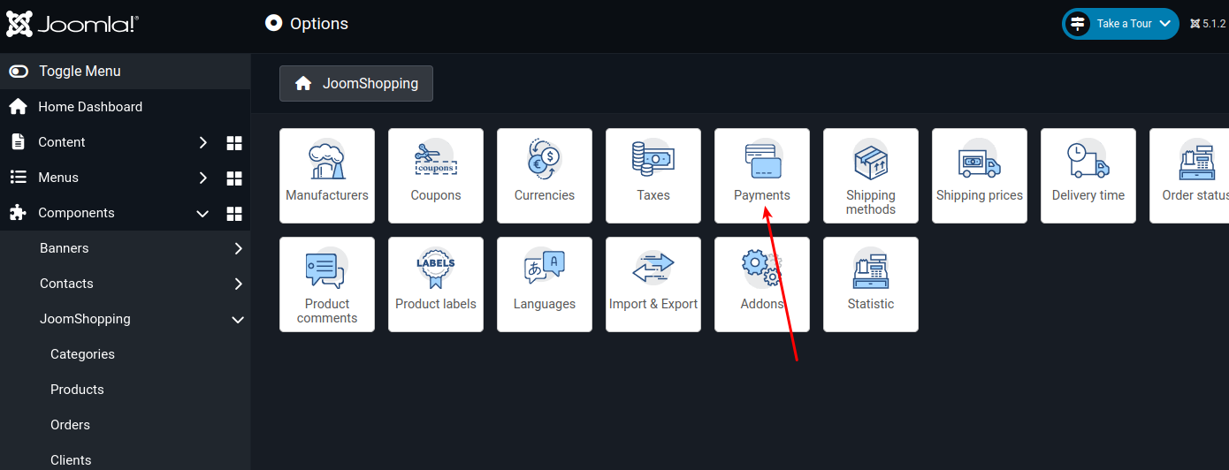
!

4. Click the Edit button (arrow #1)
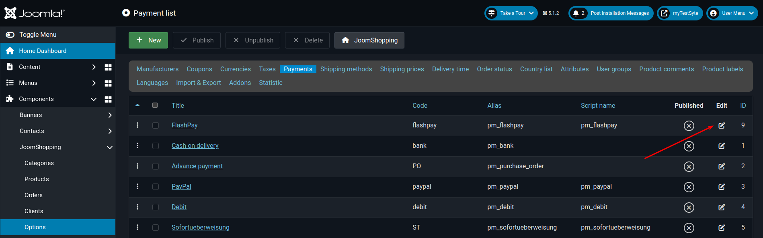

## Configure the module
1. Select the Configuration tab (arrow #1)
2. Enter the module settings
4. Click Save and Close (arrow #2)

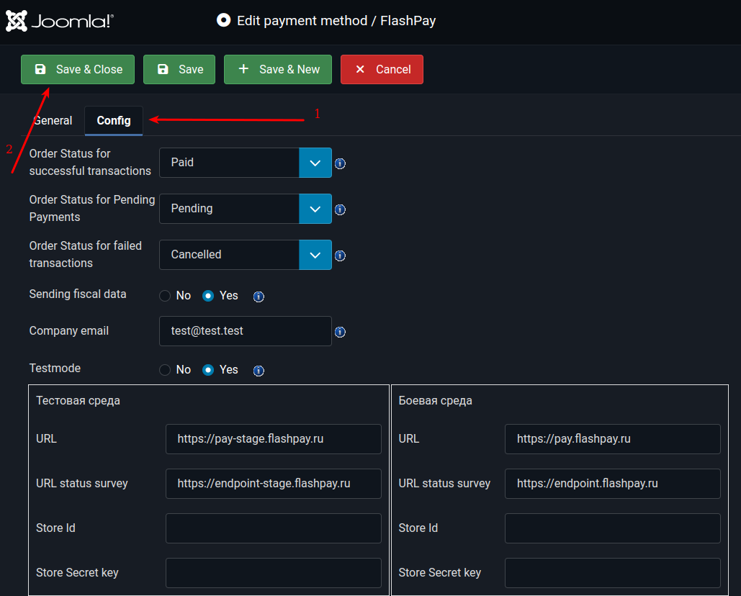

## Publish the payment method
1. Select the configured payment method from the list of available payment methods (arrow #1)
2. Publish it (arrow #2)

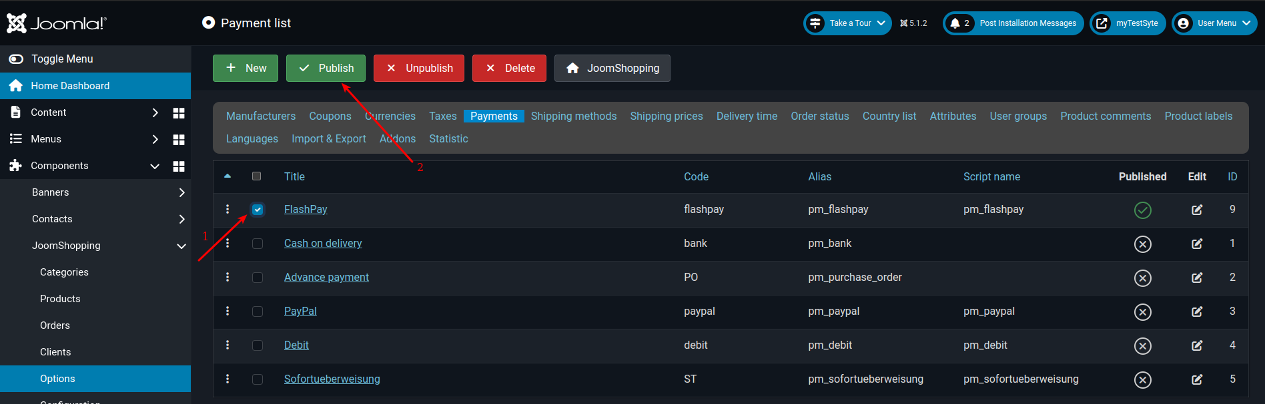

## Delete module

1. Login to Joomla admin panel
2. Go to JoomShopping Options panel (arrow #1)

3. Go to Payment Method (arrow #1)

## Delete a payment method
1. Select the configured payment method from the list of available payment methods (arrow #1)
2. Delete the selected payment method (arrow #2)

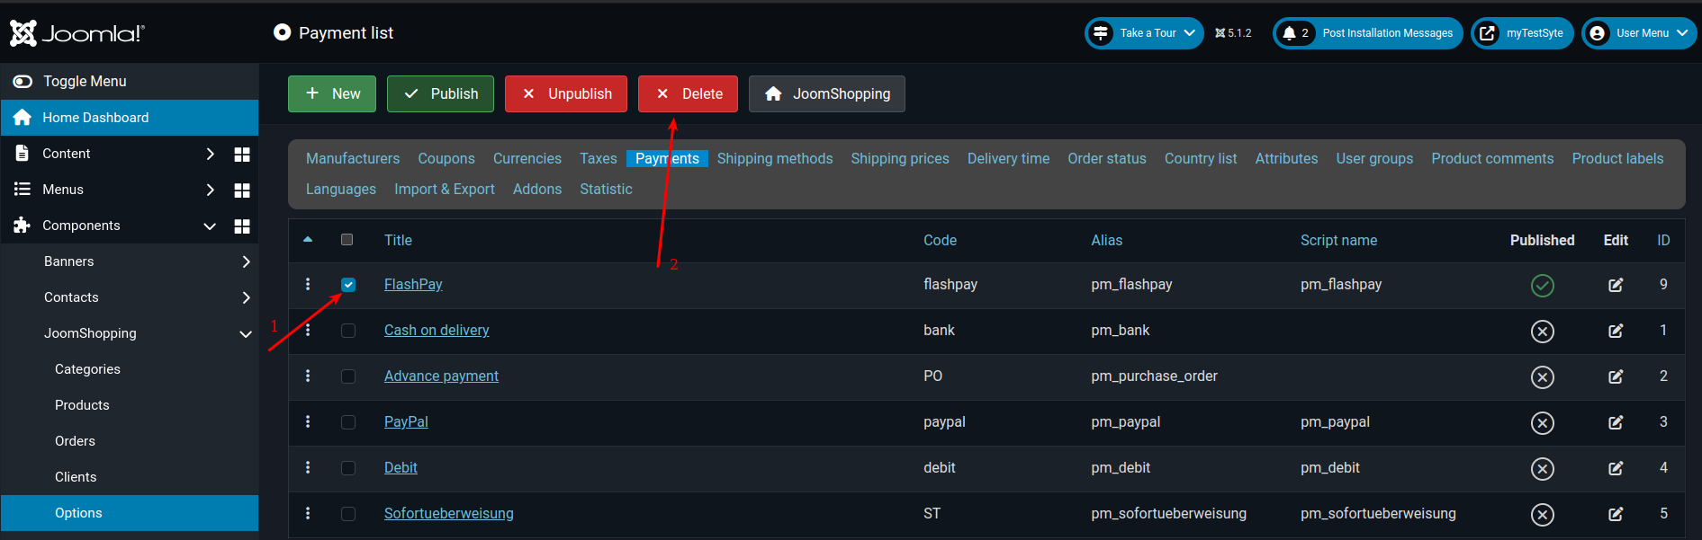
3. To completely remove the module, delete the following files and directories in the Joomla directory:
* `components/vendor`
* `components/comjshopping/payments/pm_flashpay`
* `components/comjshopping/lang/pm_flashpay`

