Source code:

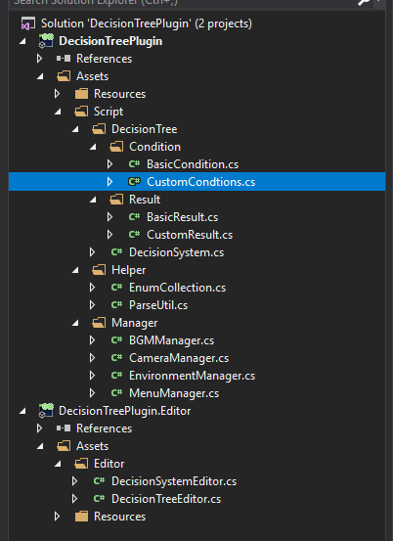

This is an example project for my decision tree system and its editor:

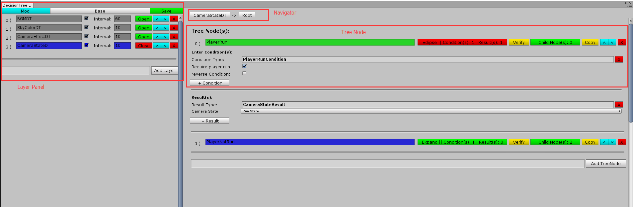

You can define more classes and assign its required data. Currently I support nearly all basic types, arrays, enums and so on.

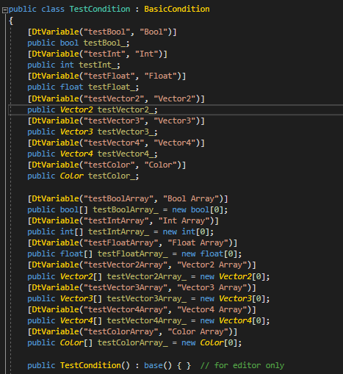

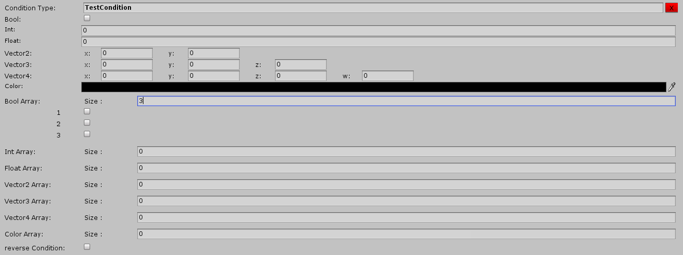

You can add any Condition and Result class. As long as they are inherited from BasicCondition or BasicResult class. You can select and added it here.

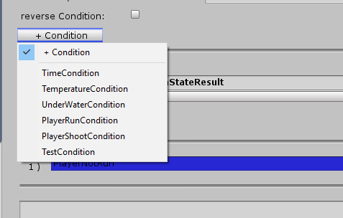

After configuration and save (Each save will give you a backup file):

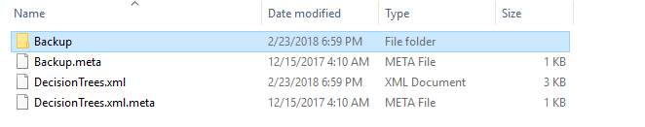

When running the game, I will load this xml file and use its data to build a decision tree.

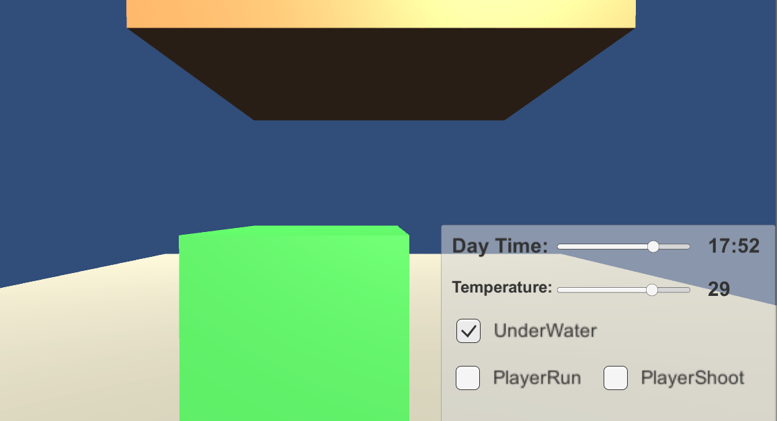

Then you can use the conditions(where the UI shows) to control other systems such as visual effect, camera effect, camera distance, BGM and so on.