One R Markdown Document, Fourteen Demos

Yihui Xie

2020-01-30 @ rstudio::conf

# Introduction

* This is an **R Markdown** document (Allaire et al. 2020).
* Markdown is a simple formatting syntax for authoring HTML, PDF, and MS Word documents, etc.
* For more details on using R Markdown, see <https://rmarkdown.rstudio.com>.

# R Markdown

## Embed R code

### Data

You can embed an R code chunk like this:

dat <- iris[, 1:2]  
names(dat) <- c('x', 'y')  
str(dat)

## 'data.frame': 150 obs. of 2 variables:  
## $ x: num 5.1 4.9 4.7 4.6 5 5.4 4.6 5 4.4 4.9 ...  
## $ y: num 3.5 3 3.2 3.1 3.6 3.9 3.4 3.4 2.9 3.1 ...

## Draw plots

### Starry night

par(mar = c(4, 4, .1, .2))  
smoothScatter(dat)  
sunflowerplot(dat, pch = 20, col = 7, seg.col = 7, size = .1, add = TRUE)

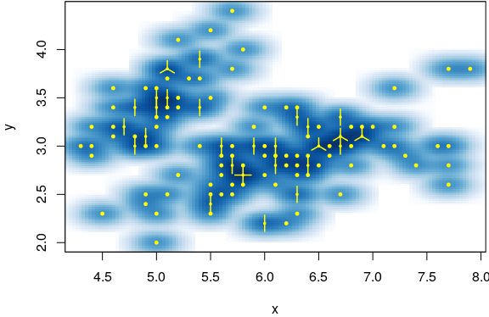

## Create tables

### A simple table

fit <- lm(y ~ x, data = dat)  
tab <- coef(summary(fit)) # regression coefficients  
knitr::kable(tab, caption = 'A simple table.')

A simple table.

|  |  |  |  |  |
| --- | --- | --- | --- | --- |
|  | Estimate | Std. Error | t value | Pr(>|t|) |
| (Intercept) | 3.419 | 0.254 | 13.48 | 0.000 |
| x | -0.062 | 0.043 | -1.44 | 0.152 |

## Inline code

### The model

The fitted model is:

$$Y=3.419+−0.062X$$

# Other features

## Figure caption

You can also add captions and numbers to figures. See Figure @ref(fig:pie) for example.

par(mar = c(0, 1, 0, 1))  
pie(  
 c(280, 60, 20),  
 c('Sky', 'Sunny side of pyramid', 'Shady side of pyramid'),  
 col = c('#0292D8', '#F7EA39', '#C4B632'),  
 init.angle = -50, border = NA  
)

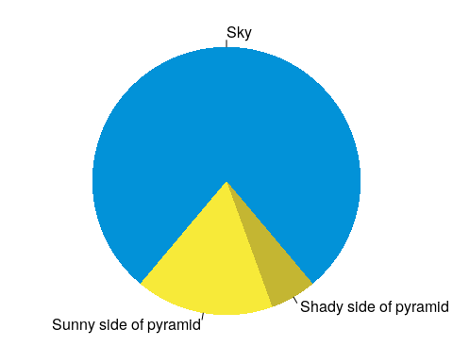

My favorite pie chart.

## Dynamic content

### Animation

par(mar = c(0, 1, 0, 1))  
a = sample(0:359, 1)  
for (i in 1:2) {  
 pie(c(i %% 2, 6), col = c('red', 'yellow'), labels = NA,  
 init.angle = a)  
}



### Leaflet maps

library(leaflet)  
leaflet() %>% addTiles() %>% setView(-122.410951, 37.7858188, zoom = 19)

### DataTables

DT::datatable(iris)

Allaire, JJ, Yihui Xie, Jonathan McPherson, Javier Luraschi, Kevin Ushey, Aron Atkins, Hadley Wickham, Joe Cheng, Winston Chang, and Richard Iannone. 2020. *Rmarkdown: Dynamic Documents for R*. <https://CRAN.R-project.org/package=rmarkdown>.