INSTRUCTIONS TO CREATE A CUSTOMIZED GOOGLE FORM

By Dan Menashi E-mail: d_menashi@yahoo.com

What is the purpose of this document? Provide step by step instructions to create a simple customized form as shown below. Once the data is entered in this form and submitted, it would feed into your Google sheet.

NOTE : You will need a general Google account to follow this document. If you don’t have one , you can create it for FREE at <https://account.google.com/>

SNAPSHOT OF THE CUSTOMIZED FORM THAT WE WILL CREATE

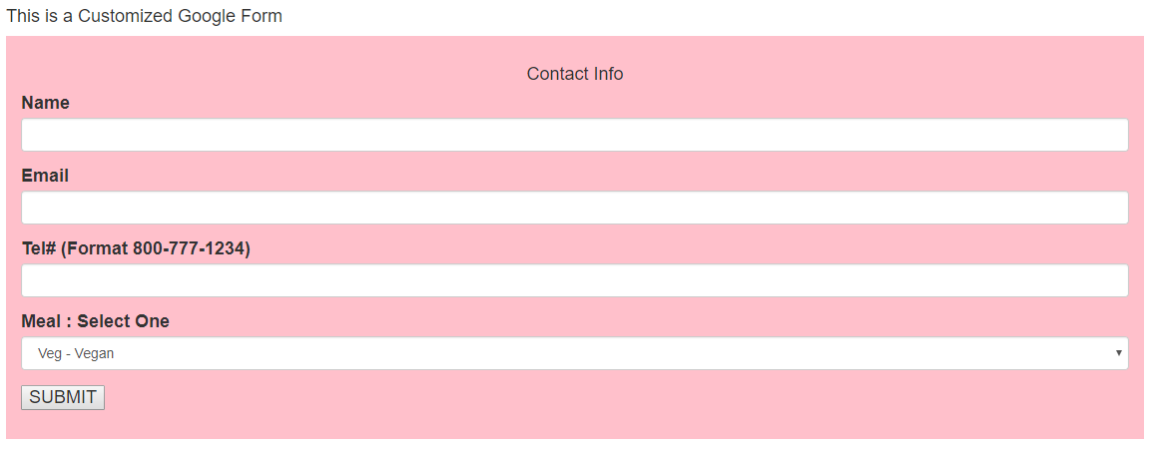

STEP-1 : Create a new Google sheet.

Sign in to your Google account and Login to Google drive <https://drive.google.com/> . You should see a screen as follows.

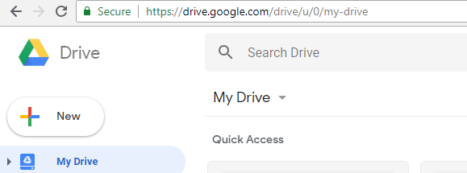

Click on the button 

After clicking on new button, a pull-down menu on left would be displayed as shown below. Click on the link Google Sheets.

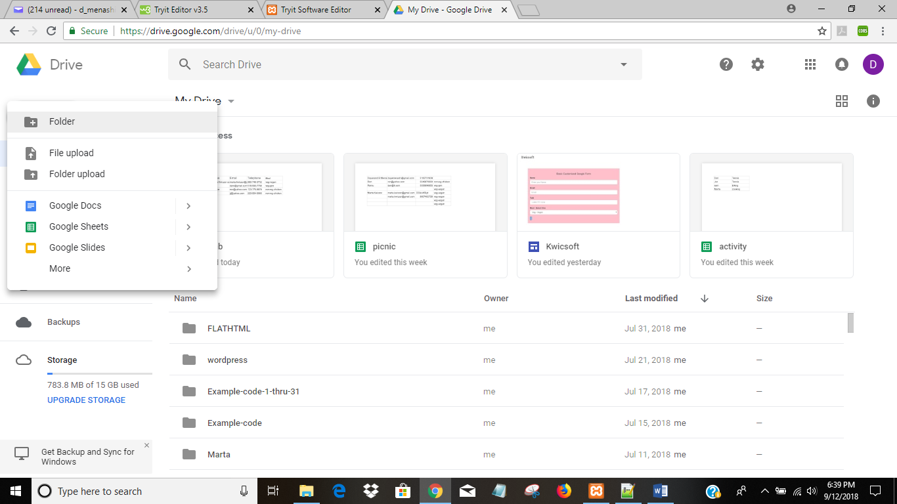

A new blank Google sheet would open as shown below.

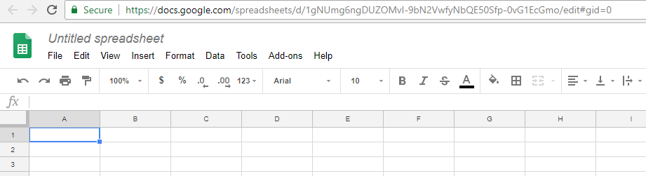

Please rename the sheet to any name of your choice. You can do that by clicking on Untitled spreadsheet

as shown below.

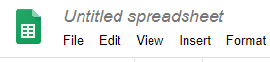

For the purpose of this tutorial we would rename the document as **picnicinfo.** The document would like this.

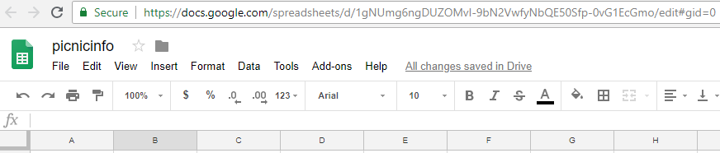

STEP-2 : Create a header record in the Google sheet.

Type in a header record . It should exactly look as shown below.



STEP-3 : Update the Google Script :

Click on Tools tab and from the pull down menu click on <>Script editor.

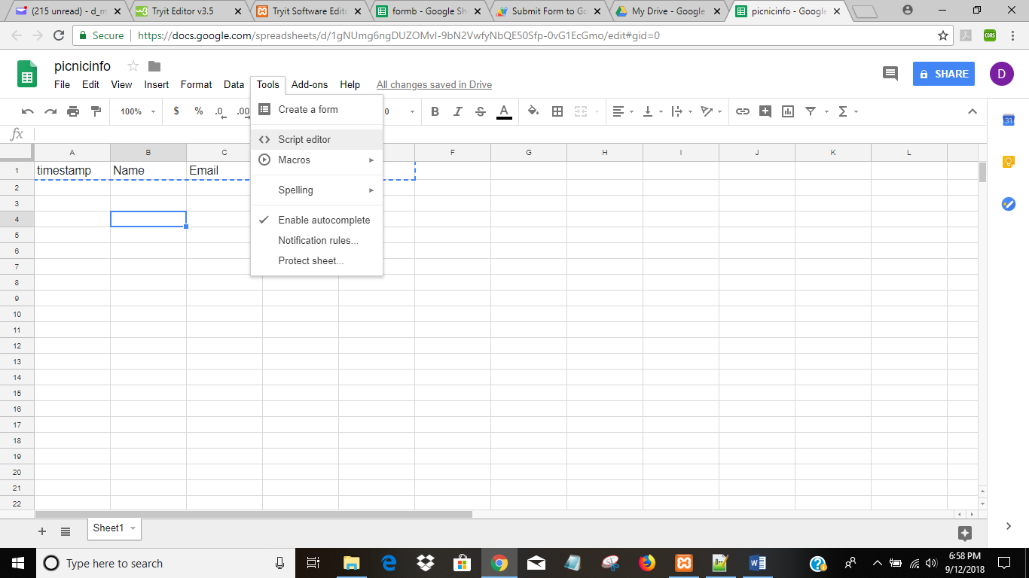

You will see the following screen that has two lines of code. Remove those lines of code.

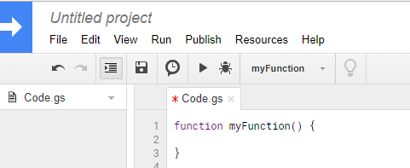

After removing the code your screen should look like this

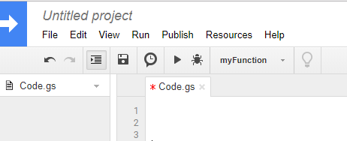

Now Click on the top left next to blue arrow where it says *Untitled project* . Following screen will popup

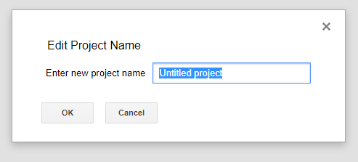

Enter **picnicinfo** in the box and click OK. As shown belo.

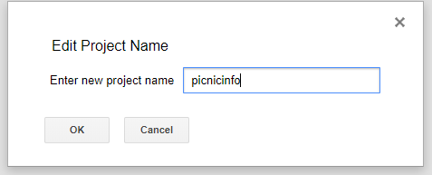

Now put your cursor on the line one as shown below. Copy paste all the code in red as shown below.



var sheetName = 'Sheet1'

var scriptProp = PropertiesService.getScriptProperties()

function intialSetup () {

var activeSpreadsheet = SpreadsheetApp.getActiveSpreadsheet()

scriptProp.setProperty('key', activeSpreadsheet.getId())

}

function doPost (e) {

var lock = LockService.getScriptLock()

lock.tryLock(10000)

try {

var doc = SpreadsheetApp.openById(scriptProp.getProperty('key'))

var sheet = doc.getSheetByName(sheetName)

var headers = sheet.getRange(1, 1, 1, sheet.getLastColumn()).getValues()[0]

var nextRow = sheet.getLastRow() + 1

var newRow = headers.map(function(header) {

return header === 'timestamp' ? new Date() : e.parameter[header]

})

sheet.getRange(nextRow, 1, 1, newRow.length).setValues([newRow])

return ContentService

.createTextOutput(JSON.stringify({ 'result': 'success', 'row': nextRow }))

.setMimeType(ContentService.MimeType.JSON)

}

catch (e) {

return ContentService

.createTextOutput(JSON.stringify({ 'result': 'error', 'error': e }))

.setMimeType(ContentService.MimeType.JSON)

}

finally {

lock.releaseLock()

}

}

After copy pasting , your screen should look as follows. The last line of code should end in line 31.

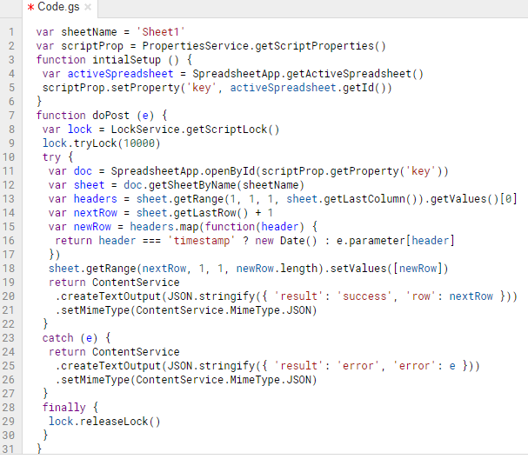

STEP-4 : Save the Google script.

Click on the File tab , next to blue arrow and below picnic as shown below and highlighted in yellow. A pull down menu will appear and click on save.

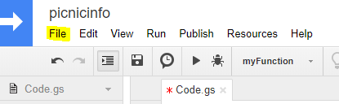

STEP-5 : Intial Setup

Click on the Run tab as highlighted in yellow. From the pulldown menu click on Run function and then from sub menu click on initialSetup

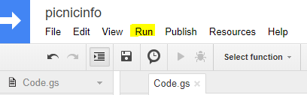

Following box will comeup.

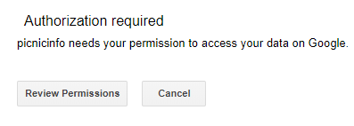

Click on Review Permissions

Following box will pop up. Click on your account.

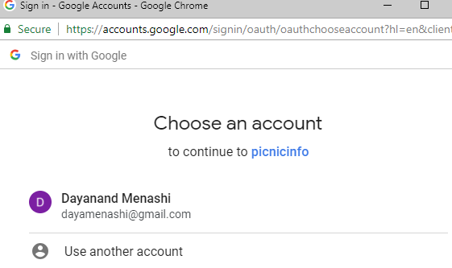

Following box will pop up. Now click where it says Advanced as highlighted in yellow below.

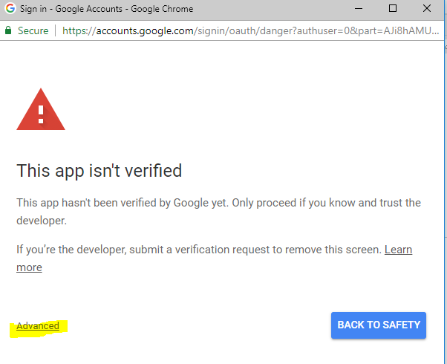

Following box will now popup. Click on the bottom left link Go to picnicinfo (unsafe) as highlighted in yellow below

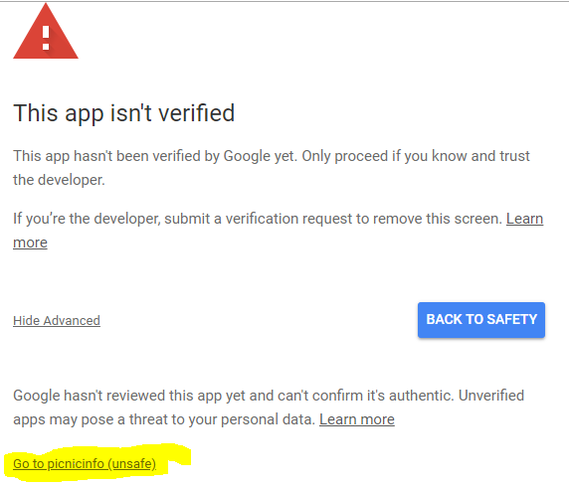

Following Box will popup. Now click on the button that says 

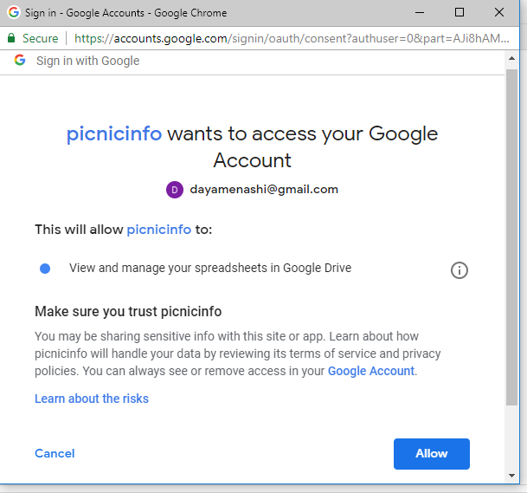

After clicking on the Allow button that box will be closed and you will be back to the script screen.

STEP-6 : Create Trigger

Click on Edit tab as shown below, a pull down menu will appear.

Click where it says **Current project’s triggers**

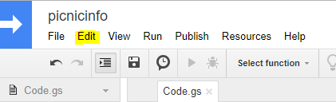

The following box will appear.

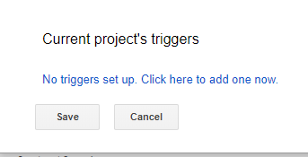

As we can see that there are no triggers, hence we will add one. Click on where it says Click here

Once we click, then following box will appear.

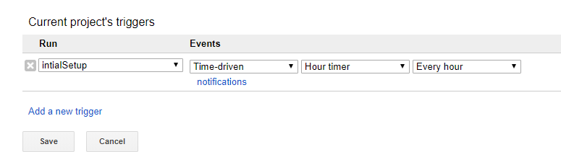

Change the dropdown values to the following

Run : doPost

Events : From spreadsheet Onform submit.

After changing the values your box should look as follows. Now click Save.

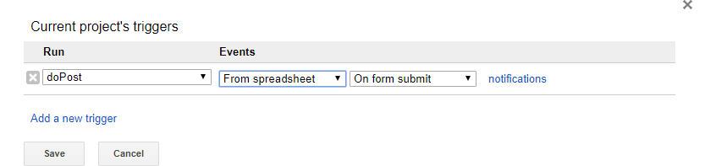

STEP-7 : Publish your script

Click on the Publish tab as highlighted in yellow below. In the pulldown menu click on the first item that says **Deploy as web app**

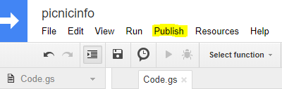

Following box should pop up. Change the following :

1. In the box under New, type **Initial version**

2. In the bottom where it say **Who has access to the app** select **Anyone, even anonymous**

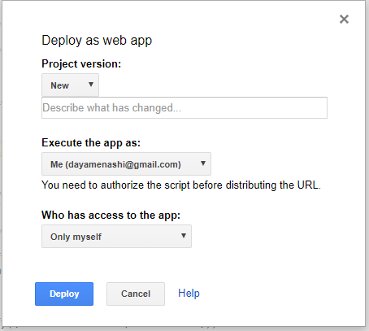

Your box should look as follows

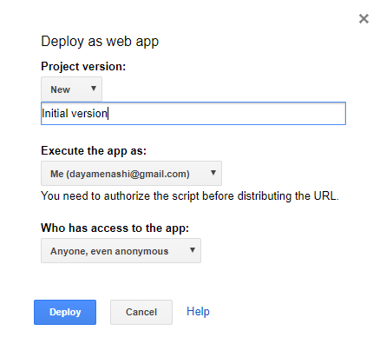

Now click on the blue button that says Deploy. Following box should pop up.

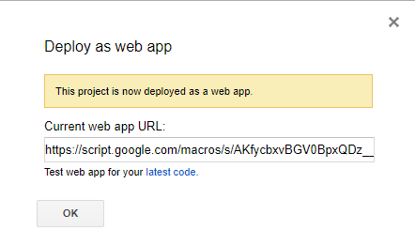

**CAUTION : Don’t Click OK now.**

First copy paste the Current web app URL in a notepad.

It should look something like this, ending with exec.

https://script.google.com/macros/s/AKfycbxvBGV0BpxQDz__UXl2dd0VRIwCzqF8PVEzoe13xv34itxVWHv8/exec

This is a very important piece of information as we will use URL in the Form web page that will be shown in next step.

Now click OK box.

The popup should disappear.

STEP-8 : Create Form web page.

Open a New Notepad file in your PC. Copy paste the code shown in red below. **Replace the yellow highlighted part with your web app URL that we created in STEP-7**. Make sure that after replacing the URL in your code . the URL is still enclosed within single quotes.

<!DOCTYPE html>

<html lang="en">

<head>

<title>Basic Customized Google Form</title>

<meta charset="utf-8">

<meta name="viewport" content="width=device-width, initial-scale=1">

<link rel="stylesheet" href="https://maxcdn.bootstrapcdn.com/bootstrap/3.3.7/css/bootstrap.min.css">

<script src="https://ajax.googleapis.com/ajax/libs/jquery/3.3.1/jquery.min.js"></script>

<script src="https://maxcdn.bootstrapcdn.com/bootstrap/3.3.7/js/bootstrap.min.js"></script>

</head>

<body>

<div class="container">

<h4>This is a Customized Google Form

<p>

<div class="col-md-12 shadow p-4 mb-4 border border-primary" style="background-color:pink">

<p> </p>

<h4 align="center">Contact Info</h4>

<form name="contact">

<div class="form-group">

<label for="Name">Name</label>

<input type="text" name="Name" class="form-control" id="Name" required>

</div>

<div class="form-group">

<label for="Email">Email</label>

<input type="email" name="Email" class="form-control" id="Email" pattern="[^@\s]+@[^@\s]+\.[^@\s]+" required>

</div>

<div class="form-group">

<label for="Telephone">Tel# (Format 800-777-1234)</label>

<input type="text" name="Telephone" class="form-control" id="Telephone" pattern="^\d{3}-\d{3}-\d{4}$" required>

</div>

<div class="form-group">

<label for="Meal">Meal : Select One</label>

<select class="form-control" name="Meal" id="Meal">

<option value="veg-vegan">Veg - Vegan</option>

<option value="veg-gen">Veg - eggsok</option>

<option value="nonveg-chicken">Non Veg-Only Chicken</option>

<option value="nonveg-red-meat">Non Veg-Red Meat</option>

</select>

</div>

<button type="submit">SUBMIT</button>

<p> </p>

</form>

<script>

const scriptURL = 'https://script.google.com/macros/s/AKfycbxvBGV0BpxQDz__UXl2dd0VRIwCzqF8PVEzoe13xv34itxVWHv8/exec'

const form = document.forms['contact']

form.addEventListener('submit', e => {

e.preventDefault()

fetch(scriptURL, { method: 'POST', body: new FormData(form)})

// .then(response => console.log('Successmmm!', response))

// .catch(error => console.error('Error!', error.message))

.then(response => success())

.catch(error => console.error('Error!', error.message))

})

function success() {

document.getElementById("status").innerHTML = "Form Submitted to Google sheet.";

clear();

}

function clear () {

document.contact.Name.value='';

document.contact.Email.value='';

document.contact.Telephone.value='';

}

$(document).ready(function(){

$("input").focus(function(){

$(this).css("background-color", "#cccccc");

});

$("input").blur(function(){

$(this).css("background-color", "#ffffff");

});

});

</script>

</div>

<p> </p>

<p id="status"></p>

</div>

</body>

</html>

Create a new folder called Form-code in the C:\ drive of your machine *(assuming you are using Windows)* Save this file as **Form-picnicinfo.html** in your machine as shown below.

NOTE : While saving the file Save as type dropdown field should have All types(*.*)

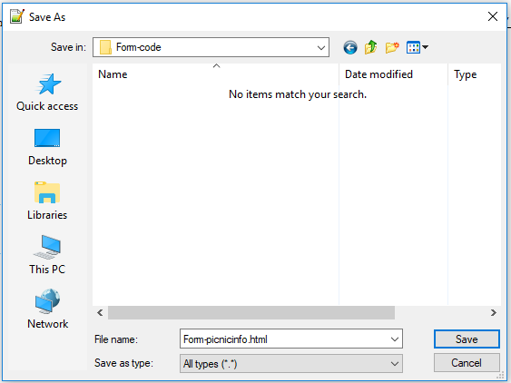

STEP-9 : Test the Form

Go to the Form-code folder that we created in STEP-8. It should look as below.

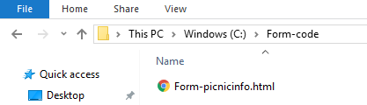

Double click and open the file Form-picnicinfo.html. The form should appear as shown below.

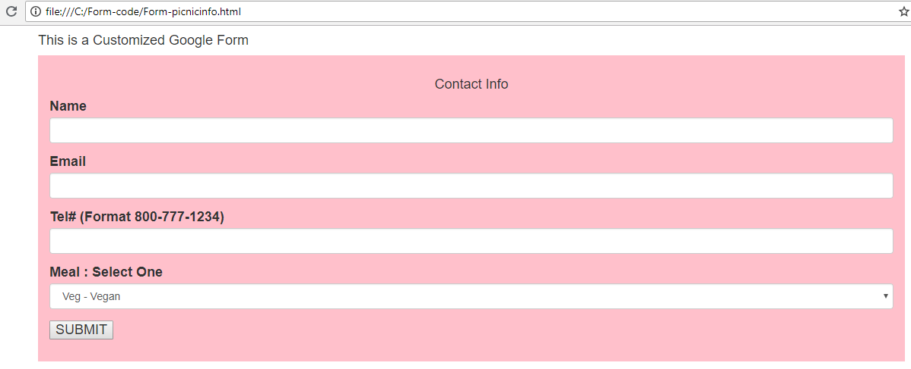

Let us input the following test data and click on the SUBMIT button

Name : James Bond

Email : bond@yahoo.com

Tel# 888-007-1234

Meal : Non Veg-Red Meat

After you hit SUBMIT button, in about 5 seconds you will see the message **Form Submitted to Google sheet** as shown below

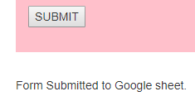

The data entered in the form should have fed the Google Sheet Picnicinfo that we created in STEP-1

So let us open the Google Sheet. Following is the snapshot of the Google Sheet, we can see that the info entered in the Form has fed to the Google Sheet. As shown below.

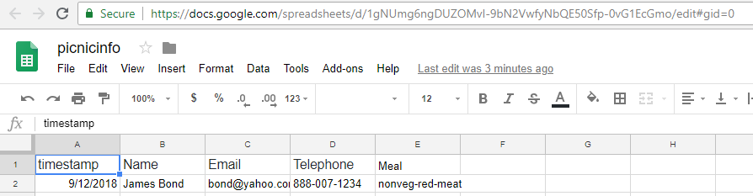

CONGRATULATIONS !!! you have successfully created a Customized Google Form that you can deploy in your web site and share it with others to get your required data.

If you don’t have a website, you can create a simple one for FREE at <http://sites.google.com> Within 5 minutes you should have a basic website like the following that I created for demo of this tutorial <https://sites.google.com/view/kwicsoft>

Once the basic website is ready then we will insert the Form code as shown below.

STEP-1 : In the right bar you will see the < > Embed button as shown below. Click on that.

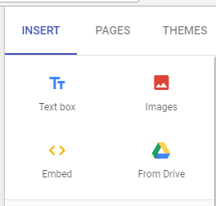

It will pop up the following box. Click on thesecond tab that says EMBED CODE

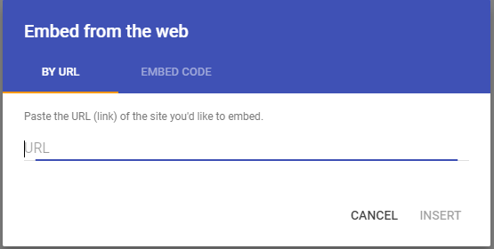

You should now see the following box

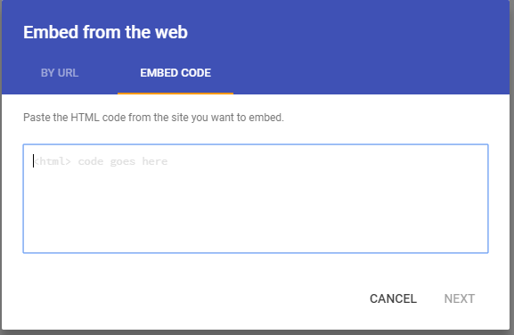

Now copy paste all code for Form-picnicinfo.html (Red code from STEP-8). Once you have copy pasted all the code then the NEXT button should become active and look as shown below.

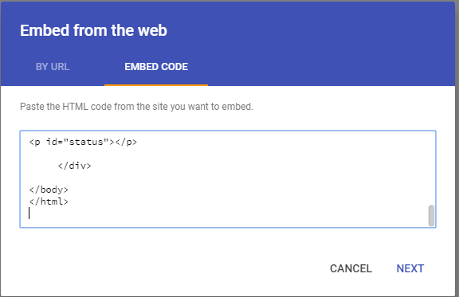

Click on the NEXT button now. You should see the following box popup.

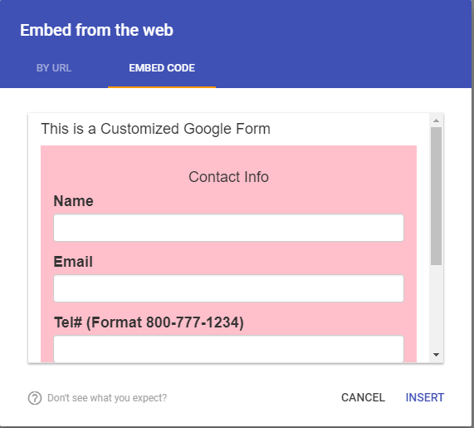

Click on INSERT button. You would see the following kind of box appear. This shows that the code was inserted properly.

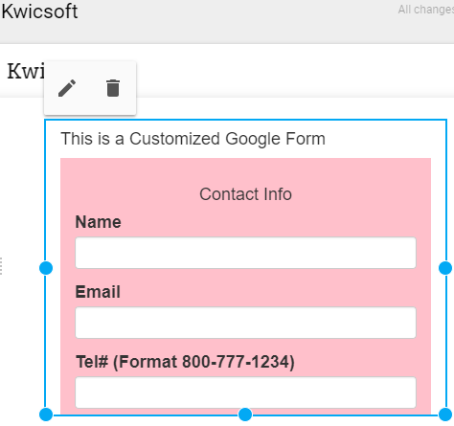

Now we need to drag the blew dotted box from the bottom to enlarge it so that all the form is visible. This we are doing because Google site has inserted the code in a Frame and we are increasing the size of the Frame so that the users don’t have to scroll down to view the entire form.

Drag the blue box enough so that there is enough space at the bottom for the Form output message to appear. You might have to drag in two steps as the initial dragging might stop after the end of form. You can release the cursor and then continue dragging. The Blue box should look as follows

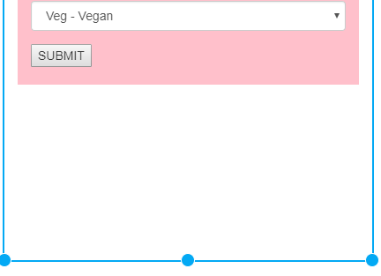

Once dragging is complete Click on the blue PUBLISH button as shown below

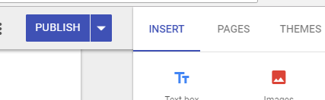

In few seconds a message at the bottom should pop as shown below



Click on the down arrow button next to publish and click on the link View published site

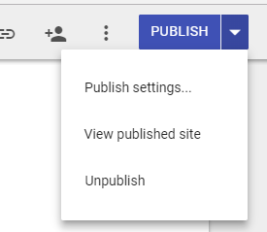

In our case the following URL is opened <https://sites.google.com/view/kwicsoft/home> in the new tab. In your case it will be similar URL. Instead of Kwicsoft it would have your websites’s name.

Your Google website should now have your customized Google Form ready to use and should look as follows.

NOTE : If you are accessing your Google site on the phone and submitting the form, then you might not see the Form message right away. You will need to scroll down to see the message.

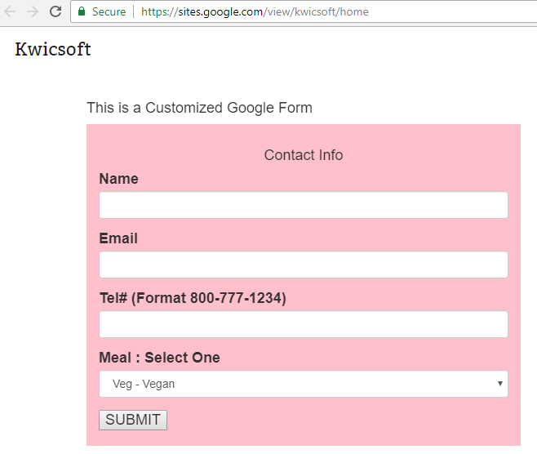

Hope this tutorial was helpful in achieving your goal. If you have any questions then please E-mail me with the subject :Question on Google Form .

My name is Dan and my E-mail is d_menashi@yahoo.com

*****