Visit http://www.formrecorder.com/formbuilder.html

STEPS TO CREATE GOOGLE SHEET WEB API

AND GOOGLE SHEET SHAREABLE LINK

STEP-1 : Create a new Google sheet.

Sign in to your Google account and Login to Google drive <https://drive.google.com/> . You should see a screen as follows.

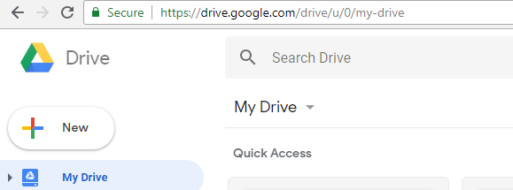

Click on the button 

After clicking on new button, a pull-down menu on left would be displayed as shown below. Click on the link Google Sheets.

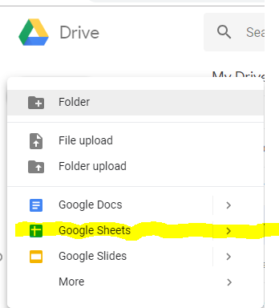

A new blank Google sheet would open as shown below.

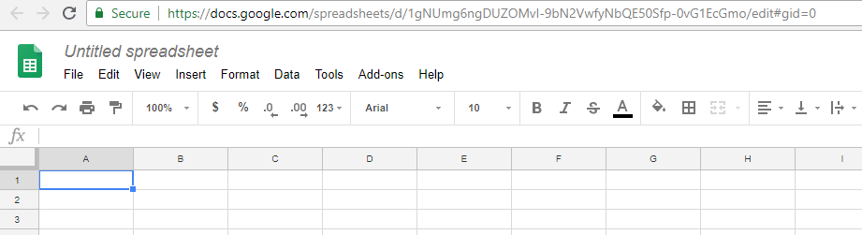

Please rename the sheet to any name of your choice. You can do that by clicking on Untitled spreadsheet

as shown below.

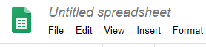

For the purpose of this tutorial we would rename the document as **formrecorder1.** The document would like this.

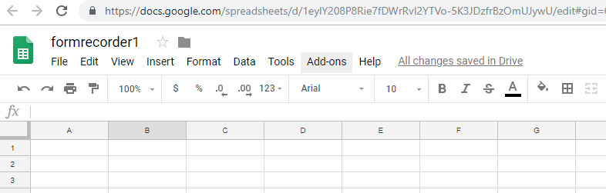

STEP-2 : Create a header record in the Google sheet.

Type in a header record . It should exactly look as shown below.

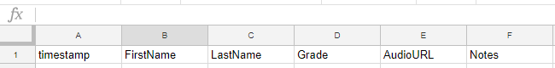

STEP-3 : Update the Google Script :

Click on Tools tab and from the pull down menu click on <>Script editor.

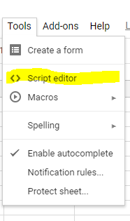

You will see the following screen that has two lines of code. Remove those lines of code.

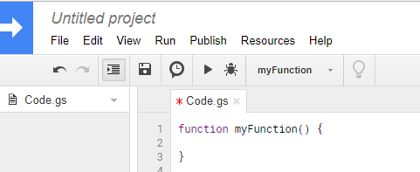

After removing the code your screen should look like this

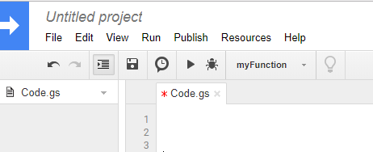

Now Click on the top left next to blue arrow where it says *Untitled project* . Following screen will popup

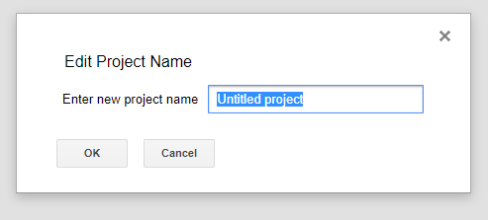

Enter **formrecorder1** in the box and click OK. As shown below.

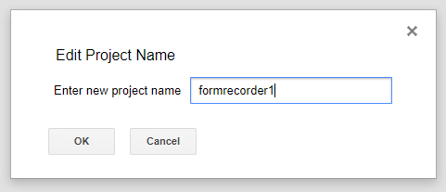

Now put your cursor on the line one as shown below. Copy paste all the code in red as shown below.



var sheetName = 'Sheet1'

var scriptProp = PropertiesService.getScriptProperties()

function intialSetup () {

var activeSpreadsheet = SpreadsheetApp.getActiveSpreadsheet()

scriptProp.setProperty('key', activeSpreadsheet.getId())

}

function doPost (e) {

var lock = LockService.getScriptLock()

lock.tryLock(10000)

try {

var doc = SpreadsheetApp.openById(scriptProp.getProperty('key'))

var sheet = doc.getSheetByName(sheetName)

var headers = sheet.getRange(1, 1, 1, sheet.getLastColumn()).getValues()[0]

var nextRow = sheet.getLastRow() + 1

var newRow = headers.map(function(header) {

return header === 'timestamp' ? new Date() : e.parameter[header]

})

sheet.getRange(nextRow, 1, 1, newRow.length).setValues([newRow])

return ContentService

.createTextOutput(JSON.stringify({ 'result': 'success', 'row': nextRow }))

.setMimeType(ContentService.MimeType.JSON)

}

catch (e) {

return ContentService

.createTextOutput(JSON.stringify({ 'result': 'error', 'error': e }))

.setMimeType(ContentService.MimeType.JSON)

}

finally {

lock.releaseLock()

}

}

After copy pasting , your screen should look as follows. The last line of code should end in line 31.

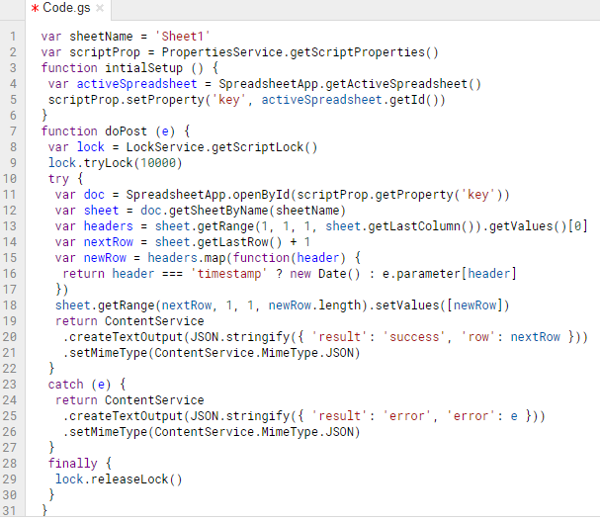

STEP-4 : Save the Google script.

Click on the File tab , as shown below and highlighted in yellow. A pull down menu will appear and click on save.

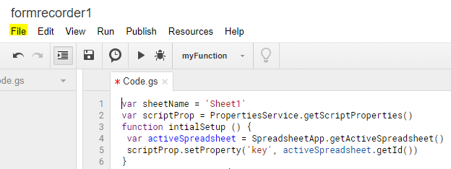

STEP-5 : Initial Setup

Click on the Run tab as highlighted in yellow. From the pulldown menu click on Run function and then from sub menu click on initialSetup

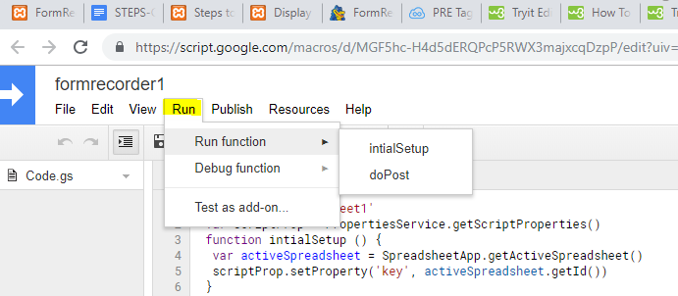

Following box will come up.

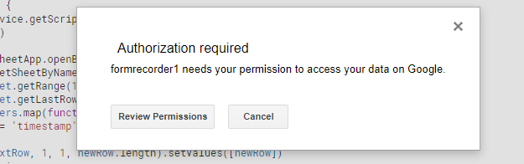

Click on Review Permissions

Following box will pop up. Click on your account.

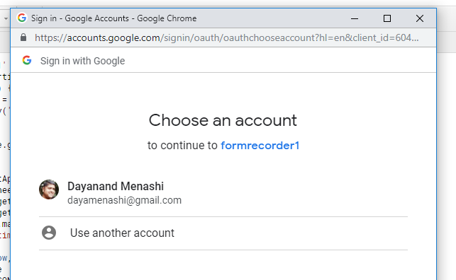

Following box will pop up. Now click where it says Advanced as highlighted in yellow below.

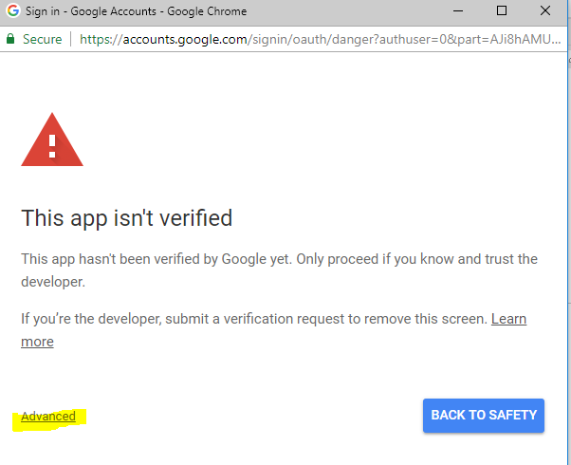

Following box will now popup. Click on the bottom left link Go to formrecorder1 (unsafe) as highlighted in yellow below

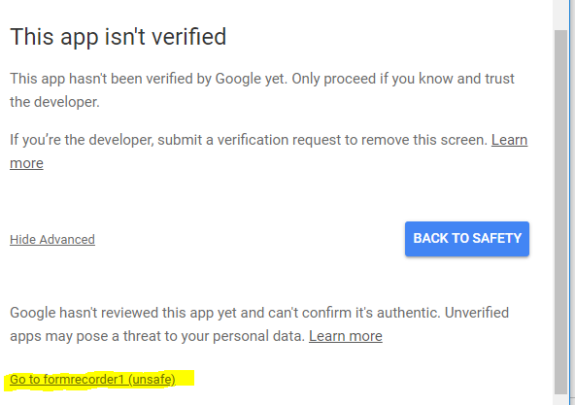

Following Box will popup. Now click on the button that says 

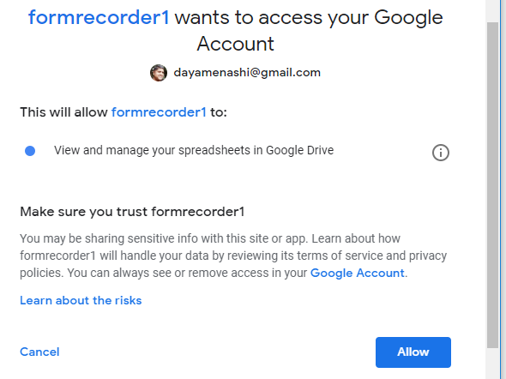

After clicking on the Allow button that box will be closed and you will be back to the script screen.

STEP-6 : Create Trigger

Click on Edit tab as shown below, a pull down menu will appear.

Click where it says **Current project’s triggers**

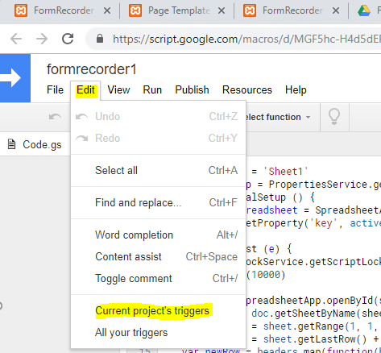

The following box will appear.

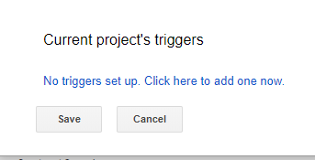

As we can see that there are no triggers, hence we will add one.

Click on where it says 

Once we click, then following box will appear.

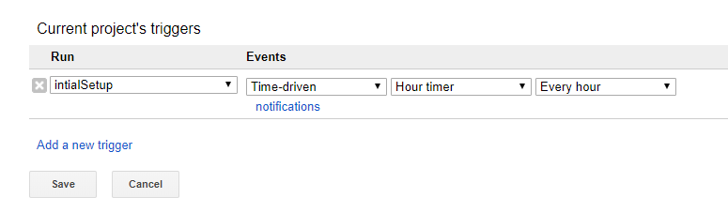

Change the dropdown values to the following

Run : doPost

Events : From spreadsheet Onform submit.

After changing the values your box should look as follows. Now click Save.

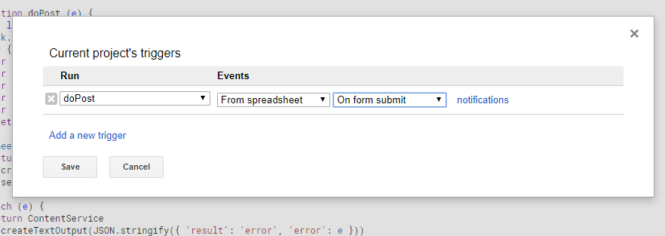

STEP-7 : Publish your script

Click on the Publish tab as highlighted in yellow below.

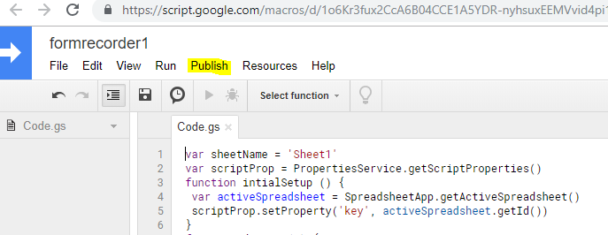

A pulldown menu will show up, click on the first item that says **Deploy as web app**

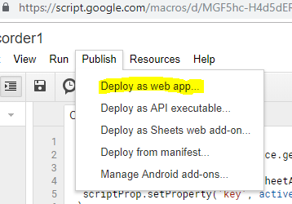

Following box would pop up. Change the following :

1. In the box under New, type **Initial version**

2. In the bottom where it say **Who has access to the app** select **Anyone, even anonymous**

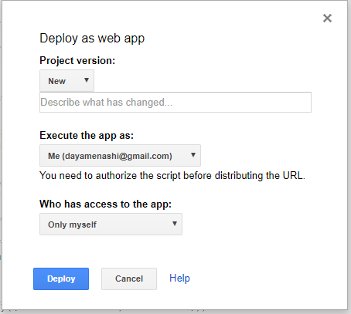

Your box should look as follows

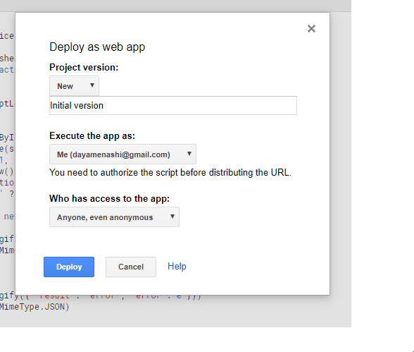

Now click on the blue button that says Deploy. Following box should pop up.

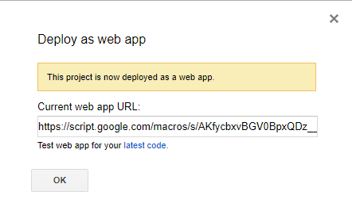

**CAUTION : Don’t Click OK now.**

Copy paste the Current web app URL in a notepad.

It should look something like this, ending with exec. This is the Google Sheet web API URL.

<https://script.google.com/macros/s/AKfycbxOH0dVRhlemE2mWoVHo0yYKKw3MOS5O69CG6P5vesw8gI4gLE1/exec>

Once you have copy pasted the Web API URL, click OK box. The popup should disappear.

STEP-8 : Get the Google sheet shareable link for formrecorder1:

Click on the tab for the google sheet as highlighted in yellow below.

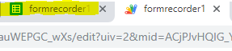

Click on the File menu as shown in yellow below.

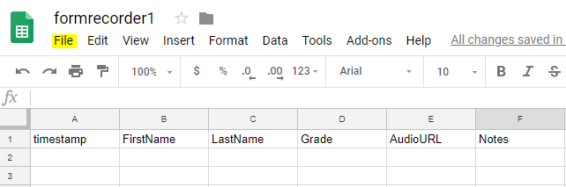

From the File pull down menu click on the link Publish to the web as shown in yellow below.

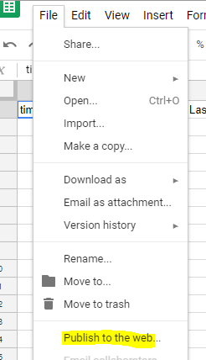

following popup box would appear. Click on the blue publish button.

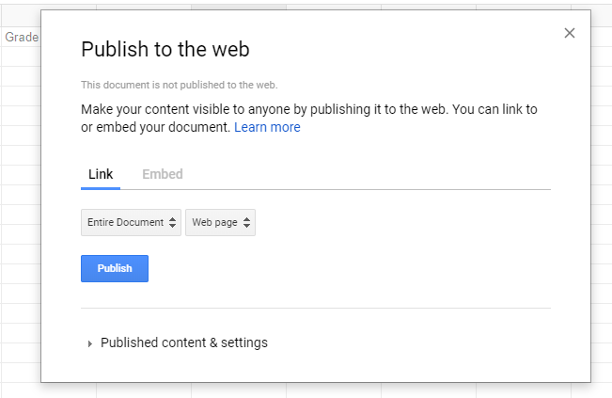

The following popup box would apear, click OK button.

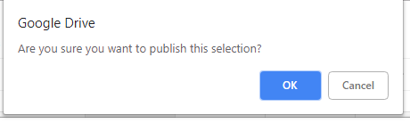

You would see the following popup box. It will have the shareable link in the tex box. Copy paste the link in a document.

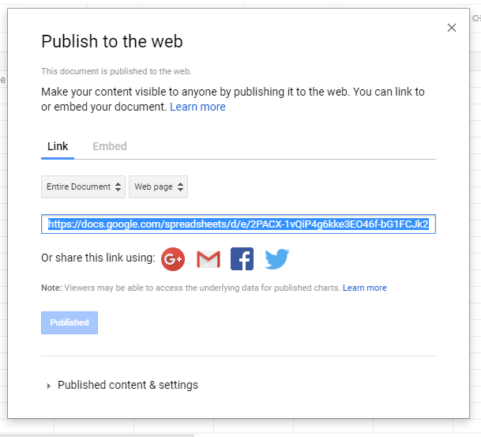

Your Google sheet link should look something similar.

<https://docs.google.com/spreadsheets/d/e/2PACX-1vQiP4g6kke3EO46f-bG1FCJk2MOY15S75peJ7B7GhgG0roosp3Ec7Gg4RgX-SG37_Hzyg0GtFVeHO_d/pubhtml>

Once you have the :

1. Google Web API URL . (obtained in STEP-7)
2. Google Sheet shareable link (obtained in STEP-8)

then you can close the Google sheet and proceed to FormBuilder <http://www.formrecorder.com/formbuilder.html>

and enter the above two pieces of information along with your Form name to generate your Customized Google Audio Form.

*****