I am creating a website using the starter template from Vite with react and typescript. The website will be a user interface to control and esp32. I will connect using BLE to the esp32 to send it commands and request status. The project needs to be highly module to allow expanding later as needed. There will be multiple menus.

1. The first menu will be the loading menu where the website tries to establish a connection to the esp32. See figure 1 in the appendix for a template. It will automatically move to the next menu when connected. There is also an error console that will show error messages when failing to connect.
2. It will then move to the main menu. This will have buttons to go to the start batch menu and the settings menu. There will be an info panel below that will show if an active recipe is selected and the LBS of the recipe. It will also show the current grain bin if one is active. See figure 2 in the appendix for a template.
3. The third menu is the start batch menu. It will have a drop down to select from a list of predefined recipes. It will also have an input box to input the quantity in lbs for the recipe. It will have a confirm button below to finalize the recipe. See figure 3 in the appendix for a template.
4. The fourth menu is the settings menu. For now it will have two buttons to go to a manage recipes and a manage bins menus that will not be created for now. The menu system must be modular so that new menus can easily be added. See figure 4 in the appendix for a template.

Appendix:

Figure 1:

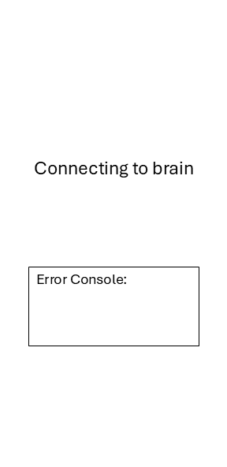

Figure

Figure 2:

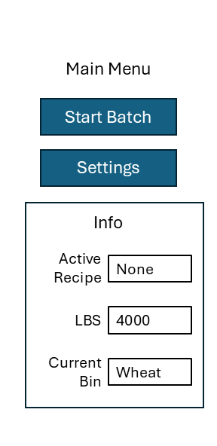

Figure

Figure 3:

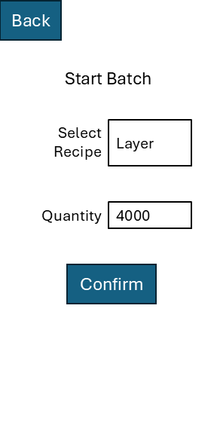

Figure

Figure 4:

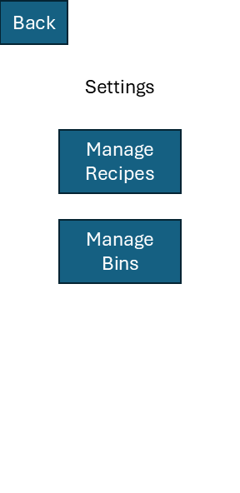

Figure