**Sentiments Analysis on New Tweets**

1. The sentiment results shows disparity of news topic between what CBS and BBC presented vs that of CNN and NYT. At the time of analysis, CBS news contents were more on Emmy Awards updates while CNN were mostly on Political event at the UN convention and the disaster in Mexico.

[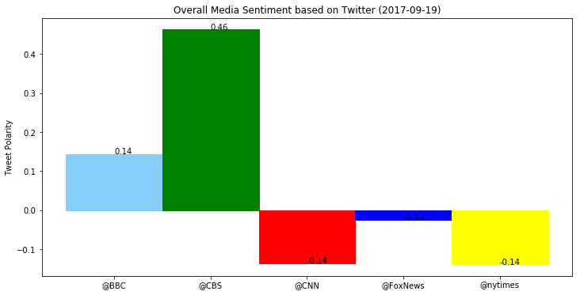](https://github.com/flauan/SentimentAnalysis/blob/master/output_8_0.png)

1. Fox shows a more diverse topic, delivering what seems to be balance notes on UN General convention.
2. Approximately 60%-70% of CBS’ positive sentiments were dominated by Emmy’s news and updates while surprisingly tweeted only four news with negative sentiments.