DOCUMENTATION

ASSIGNMENT 2

STUDENT NAME: Marincău Flavia-Maria
GROUP: e_30422

CONTENTS

1. Assignment Objective 3
2. Problem Analysis, Modeling, Scenarios, Use Cases 4
3. Design 7
4. Implementation 12
5. Conclusions 18
6. Bibliography 18

Assignment Objective

Main Objective
Design and implement an application aiming to analyze queuing-based systems by (1) simulating a series of N clients arriving for service, entering Q queues, waiting, being served and finally leaving the queues, and (2) computing the average waiting time, average service time and peak hour.
Sub-Objectives

Name | Description | Section adressed
Analyze the problem and identify requirements | Understanding the problem domain and the requirements of implementing the simulation application. | Introduction - analysis
Design the simulation application | Create a design for the simulation application, including an interface which makes the interaction between the user and the program easier, input methods, packages, classes etc. | Design
Implement the simulation application | Developing the application according to the specifications and using the design implemented. This includes the server and task data modeling, parsing the inputs from GUI and the implementation of the queue management. | Implementation
Test the simulation application | Ensure functionality, reliability and accuracy of results of the simulation application. | Testing

Problem Analysis, Modeling, Scenarios, Use Cases

Functional requirements – the desired behavior of the application
- The simulation application should allow users to setup the simulation.
- The simulation application should enable users to start the simulation.
- The simulation application should display the real-time queues evolution.
- The simulation application should allow users to clear input data.
- The simulation application should allow users to validate their data.
- The simulation application should display the accurate result.
- The simulation application should handle errors, providing informative messages to the user in case of invalid input.

Non-functional requirements – how the application must perform
- The simulation application should have minimal response time when performing operations desired by user.
- The simulation application should have an interface that is easy to use by anyone, even with users of little to no mathematical knowledge.
- The simulation application should clearly state an error when a mistake or an unexpected event occurs and it should not interrupt user navigating experience.
- The simulation application should have a clean design and should use a color pallete that makes the user experience more enjoyable.

Use case diagram
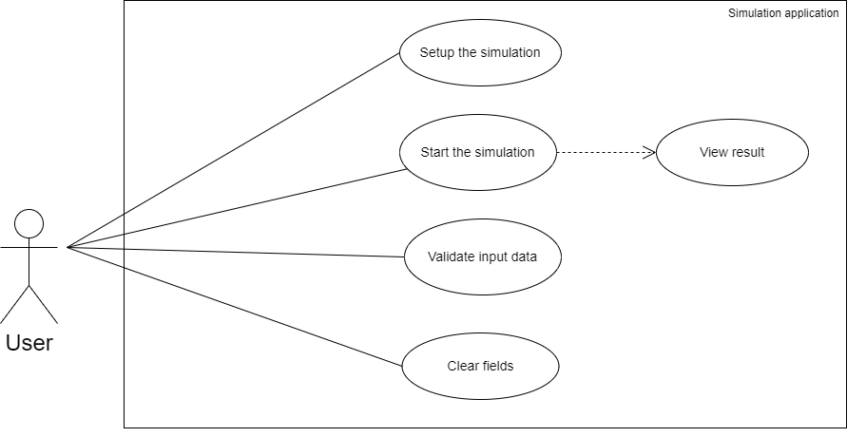

Use Case 1: setup the simulation
Primary Actor: user
Main Success Scenario:
- The user enters the simulation input data, respecting the correct format.
- The user clicks on one of the buttons “Validate input data” or “Start simulation”.
Alternative Sequence 1.1: incorrect input data
- If one or more fields were empty or were not introduced correctly, an error message will appear on the screen, indicating the problem.
- The scenario returns to step 1.

Use Case 2: start the simulation and view the result
Primary Actor: user
Main Success Scenario:
- The user enters the simulation input data, respecting the correct format.
- The user clicks on the button “Start simulation”.
- The simulation will start and the log of events will appear on the right side of the frame.
- The simulation results (avg waiting, service time and peak hour) will be displayed in the bottom part of the screen.
Alternative Sequence 2.1: incorrect input data
- If one or more fields were empty or were not introduced correctly, an error message will appear on the screen, indicating the problem and the simulation will not be started until the errors are corrected.
- The scenario returns to step 1.

Use Case 3: validate input data
Primary Actor: user
Main Success Scenario:
- The user enters the simulation input data, respecting the correct format.
- The user clicks on the button “Validate input data”.
- The program will show a message in the bottom part of the screen “Validation successful!”.
Alternative Sequence 3.1: incorrect input data
- If one or more fields were empty or were not introduced correctly, an error message will appear on the screen, indicating the problem.

Use Case 4: clear fields
Primary Actor: user
Main Success Scenario:
- The user enters the simulation input data, respecting the correct format.
- The user may or may not click on one of the buttons representing a desired operation to be perfomed.
- The user clicks on the “Reset input” button.
- The simulation fields are cleared and the user can enter a new set of input data.
Alternative Sequence 4.1: the “Clear fields” button is not clicked
- The fields will not be cleared until the button is clicked.
- The scenario returns to step 3.

Design
OOP design of the application
- Encapsulation
The SimulationFrameController encapsulates GUI-related logic, hiding implementation details of GUI components and interactions. Similarly, the SimulationManager encapsulates simulation management logic, including task generation, server setup, and result calculation.
- Abstraction
Abstraction is achieved through the use of abstract data types and interfaces. In the SimulationFrameController, abstraction is achieved by abstracting the concept of a simulation frame in the GUI, providing methods for updating results and handling user input. The SimulationManager abstracts the concept of a simulation manager, offering methods to control the simulation process and access results.
- Polymorphism
Polymorphism is demonstrated through overriding and overloading. For instance, this is demonstrated in the Scheduler class through different strategies for task dispatching, allowing the simulation to operate based on various policies. Additionally, the SelectionPolicy class defines different selection policies (e.g., shortest queue, shortest time) used by the Scheduler class.
- Composition
Composition is used to create complex objects by combining smaller objects as components. The SimulationManager composes Scheduler objects to manage task assignment to servers, enhancing flexibility in simulation management. Moreover, the Server class composes Task objects in a queue, forming the structure for handling tasks in the simulation.
- Modularity
The Scheduler class manages task distribution among servers independently, enhancing code organization and allowing for modular extension. Likewise, the Task class represents individual tasks in the simulation, providing a modular unit for task management and processing. Finally, the Server class represents servers handling tasks, contributing to modularity by encapsulating server-specific functionality.

UML Package Diagram

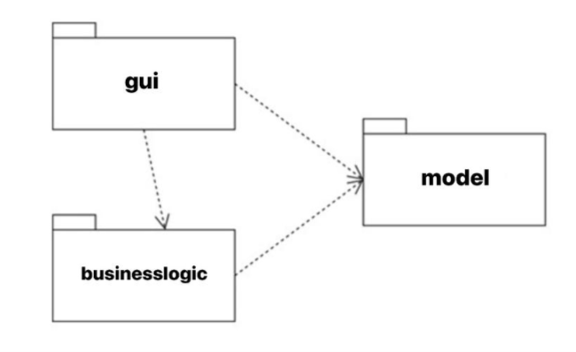

gui package – contains the classes implementing the graphical user interface: SimulationApp, SimulationFrameController
model package – contains the classes modeling the application data: Server, Task
businesslogic package – contains the classes implementing the mathematical operations functionality: ConcreteStrategyQueue, ConcreteStrategyTime, Scheduler, SimulationManager

UML Class Diagram

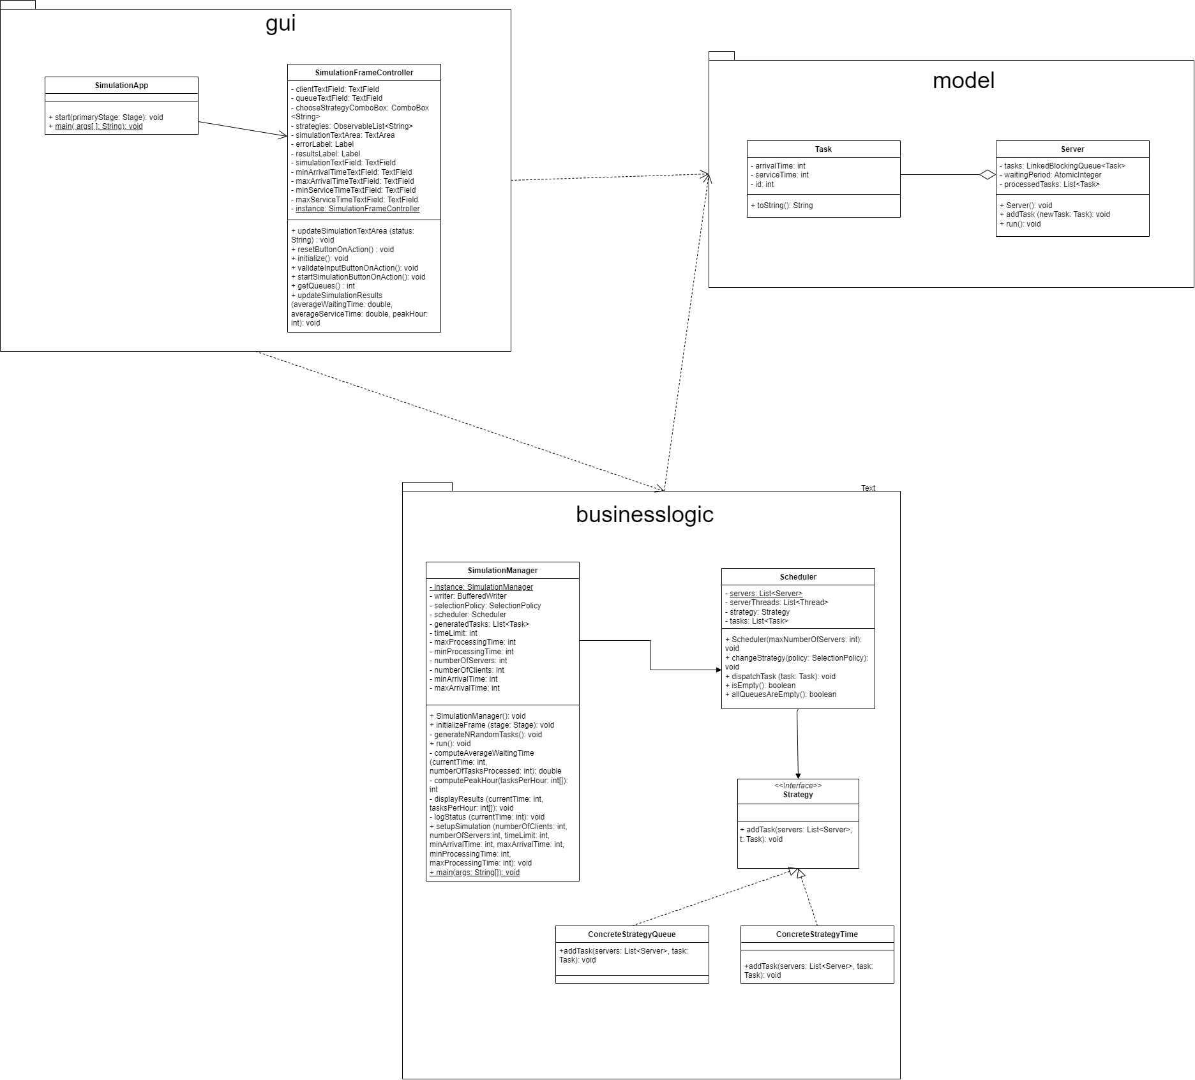
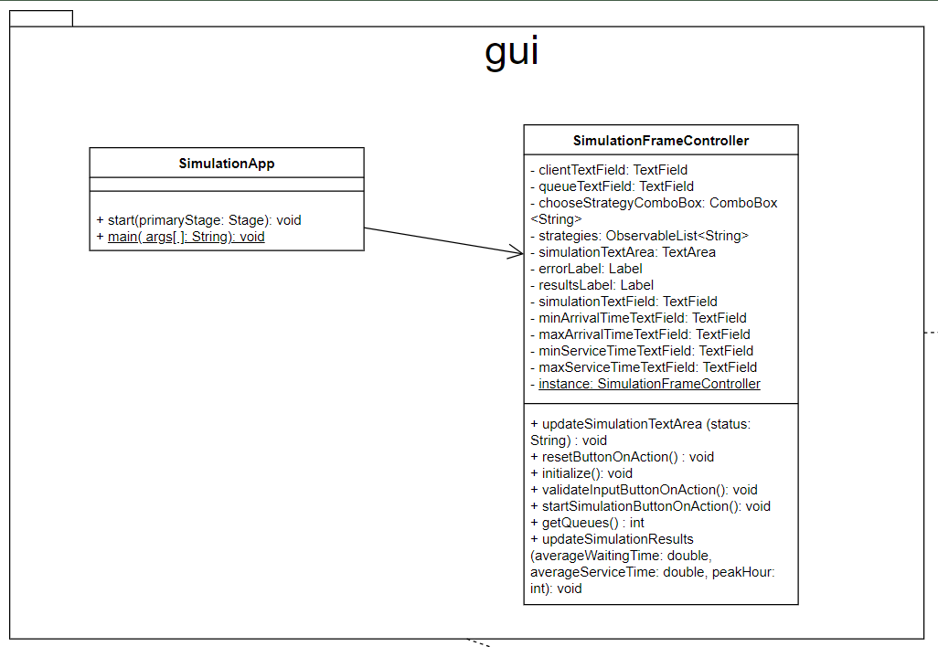
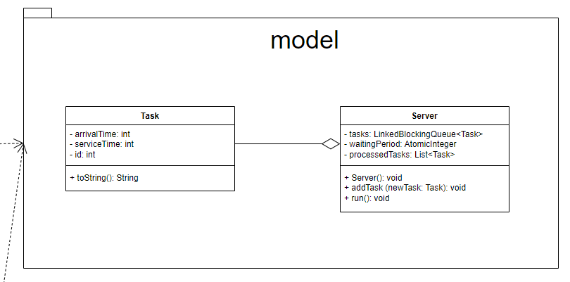

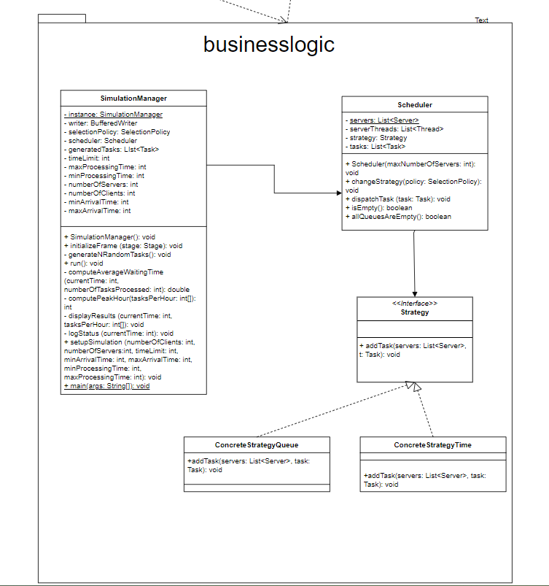

Used data structures
- List: This is a fundamental data structure in Java, used in my project in several places such as storing servers in the Scheduler class and storing tasks in the SimulationManager class. It provides methods to insert, update, delete and search for elements.
- LinkedBlockingQueue: This is a thread-safe queue based on linked nodes. It's used in the Server class to manage tasks. The queue orders elements FIFO (first-in-first-out). This data structure is ideal for concurrent applications as it supports operations that wait for the queue to become non-empty when retrieving an element, and wait for space to become available in the queue when storing an element.
- AtomicInteger: This data structure provides an int value that can be updated atomically. It's used in the Server class for managing the waiting period. The methods of this class offer atomic operations, which are useful in multithreaded applications. For example, the getAndAdd method atomically adds a given value to the current value, which is used in my project to update the waiting period.
- ObservableList: This is a list that allows listeners to track changes when they occur. In SimulationFrameController class, an ObservableList is used to hold the strategies. Listeners can be added to react when items are added or removed from the list.

Implementation

Implemented classes
- Task
The Task class represents a task that needs to be processed by a server. Each task has an arrival time, a service time, and an ID.
setServiceTime(int serviceTime): This method sets the service time for the task. The service time is the amount of time it takes for the task to be processed by a server.
setArrivalTime(int arrivalTime): This method sets the arrival time for the task. The arrival time is the time at which the task arrives and needs to be processed.
toString(): This method returns a string representation of the task. The string includes the task's ID, arrival time, and service time.
getWaitingTime(int currentTime): This method calculates the waiting time for the task. The waiting time is the difference between the current time and the task's arrival time. This method is used to calculate the total waiting time for all tasks, which is used to compute the average waiting time.
- Server
The Server class represents a server that can process tasks. Each server has a queue of tasks to process and a waiting period that represents the total time it will take to process all tasks in the queue. The server runs in its own thread, processing tasks one by one.
Server(): This is the constructor of the Server class. It initializes the queue of tasks, the waiting period, and the list of processed tasks.
addTask(Task newTask): This method adds a new task to the server's queue and updates the waiting period.
run(): This method is the entry point for the server's thread. It continuously processes tasks from the queue until the thread is interrupted.
getTasks(): This method returns an array of the tasks currently in the server's queue.
getQueueSize(): This method returns the number of tasks currently in the server's queue.
getTotalProcessingTime(): This method returns the total time it will take to process all tasks currently in the server's queue.
getProcessedTasks(): This method returns a list of all tasks that have been processed by the server.
- Scheduler
The Scheduler class is responsible for managing the servers and dispatching tasks to them based on a specified strategy. It can change the strategy at runtime, which allows for flexibility in task distribution.
Scheduler(int maxNumberOfServers): This is the constructor of the Scheduler class. It initializes the list of servers and starts a new thread for each server.
changeStrategy(SelectionPolicy policy): This method changes the strategy used to dispatch tasks to servers. The strategy can be either SHORTEST_QUEUE or SHORTEST_TIME.
dispatchTask(Task task): This method dispatches a task to a server based on the current strategy. The task is removed from the list of tasks after it is dispatched.
getServers(): This method returns the list of servers.
isEmpty(): This method checks if all servers are empty (i.e., they have no tasks to process).
allQueuesAreEmpty(): This method checks if all servers are empty and if there are no tasks left to be dispatched.
- Strategy, ConcreteStrategyTime, ConcreteStrategyQueue
The Strategy interface is a part of the Strategy design pattern used in my project. This pattern is used when we have multiple algorithms (strategies) for a specific task and the right one is chosen at runtime. The task is to add a new task to a server, and the strategies are based on either the shortest queue or the shortest time.
addTask(List<Server> servers, Task t): This method is used to add a new task to a server. The specific server is chosen based on the strategy implemented. The method takes a list of servers and a task as parameters. The list of servers represents all the available servers, and the task is the task to be added. The specific implementation of how the task is added to a server is done in the classes that implement this interface (ConcreteStrategyQueue and ConcreteStrategyTime).
In ConcreteStrategyQueue, the task is added to the server with the shortest queue (i.e., the server that is currently processing the least number of tasks).
In ConcreteStrategyTime, the task is added to the server that will finish its current tasks the earliest (i.e., the server with the shortest total processing time).
- SimulationManager
The SimulationManager class is the main class that manages the simulation. It is responsible for setting up the simulation, running it, and displaying the results. It uses the Scheduler class to manage the servers and dispatch tasks to them.
SimulationManager(): This is the constructor of the SimulationManager class. It initializes the writer for logging, the scheduler with the number of servers, and generates the tasks for the simulation.
initializeFrame(Stage stage): This method initializes the simulation frame using JavaFX. It loads the FXML file for the simulation frame and sets the scene on the provided stage.
generateNRandomTasks(): This method generates a specified number of random tasks. Each task has a random arrival time and processing time.
run(): This method is the entry point for the simulation. It runs the simulation for a specified time limit, dispatching tasks to servers and logging the status of the simulation at each time step.
displayResults(int currentTime, int[] tasksPerHour): This method displays the results of the simulation. It calculates the average waiting time, average service time, and peak hour, and updates the simulation results in the GUI.
logStatus(int currentTime): This method logs the status of the simulation at the current time. It writes the current time, waiting clients, and the state of each queue to the log file and updates the simulation text area in the GUI.
setupSimulation(int numberOfClients, int numberOfServers, int timeLimit, int minArrivalTime, int maxArrivalTime, int minProcessingTime, int maxProcessingTime): This method sets up the simulation with the provided parameters. It sets the number of clients, servers, time limit, and the range of arrival and processing times for the tasks. Then it generates the tasks and initializes the scheduler with the number of servers.
main(String[] args): This is the main method that starts the simulation. It creates an instance of SimulationManager and starts a new thread for the simulation.
- SimulationFrameController
The SimulationFrameController class is the controller for the GUI of the simulation. It handles user interactions with the GUI and updates the GUI based on the state of the simulation.
- initialize(): This method is called after all the @FXML annotated members have been loaded. It sets the instance of this class and initializes the chooseStrategyComboBox with the available strategies. It also adds a listener to the chooseStrategyComboBox to change the selection policy in the SimulationManager when a new strategy is selected.
- resetButtonOnAction(): This method is called when the reset button is clicked. It clears all the text fields and labels in the GUI.
- validateInputButtonOnAction(): This method is called when the validate input button is clicked. It validates the input from the user and displays an error message if the input is invalid.
- startSimulationButtonOnAction(): This method is called when the start simulation button is clicked. It validates the input, sets up the simulation with the input parameters, and starts the simulation.
- updateSimulationTextArea(String status): This method updates the simulation text area with the provided status.
- updateSimulationResults(double averageWaitingTime, double averageServiceTime, int peakHour): This method updates the results label with the average waiting time, average service time, and peak hour.

- getClients(), getQueues(), getSimulationTime(), getMinArrivalTime(), getMaxArrivalTime(), getMinServiceTime(), getMaxServiceTime(): These methods retrieve the input from the corresponding text fields.
- getInstance(): This method returns the instance of this class. It is used to update the GUI from other classes.
- SimulationApp
The SimulationApp class is the entry point of my JavaFX application. It extends the Application class from JavaFX and overrides the start method. This class is responsible for setting up the primary stage of the application and initializing the SimulationManager.
start(Stage primaryStage): This is the main entry point for all JavaFX applications. The start method is called after the init method has returned, and after the system is ready for the application to begin running. In this method, an instance of SimulationManager is created and the initializeFrame method is called with the primaryStage as an argument.
main(String[] args): This is the main method that launches the application. The launch method does not return until the application has finished running. It is typically the last line of the main method. It can be followed by system cleanup code if needed.

The graphical user interface (GUI)
The GUI was designed using JavaFX framework and SceneBuilder. Scene Builder is a visual layout tool that allows to design JavaFX user apps using a drag-and-drop interface, simplifying the UI design process. During the development of the GUI for this assignment, I incorporated several buttons, anchor panes, border panes, text fields, buttons and labels, ensuring an intuitive and user-friendly interface.
The interface is a .fxml file that is linked to its controller, i.e. SimulationFrameController class. The buttons were assigned an action that performs a specified operation described in the controller class and the text fields and labels have an fx:id which links the actual code to the visual part.

The layout of the polynomial calculator is presented below.
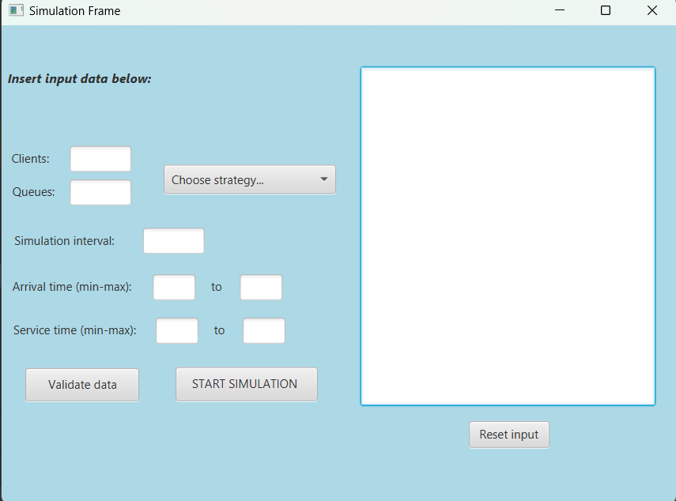

Moreover, an example of how multiple JavaFX components were put together is shown below.

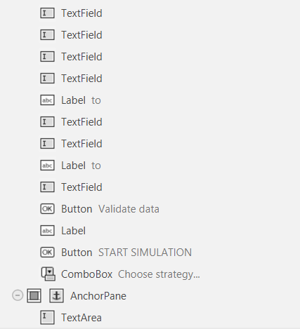

Conclusions
In the development of this project I have re-inforced my Java knowledge and OOP paradigms and I have gained valuable experience in making Use Case Diagrams and UML Package and Class Diagrams. Moreover, during the development of this application, I gained valuable insights regarding the usage of JavaFX framework and it became easier to handle and model small desktop applications using SceneBuilder. Additionally, terms like concurrency, threads, parallelism and synchronization became more clear to me through the developing of this application.
Future developments would include more advanced scheduling strategies beyond the shortest queue and shortest time. For example, it can be considered strategies that take into account the priority of tasks or the load on the servers. Another future development would be to enhance the GUI to provide real-time updates on the status of the simulation. This could include visual representations of the servers and tasks, and live statistics about the simulation, even integrating a database to store the results and create a history of simulations.

Bibliography
- Support courses and presentations
- Modeling the diagrams – draw.io
- https://www.w3schools.com/java/java_threads.asp
- https://www.geeksforgeeks.org/multithreading-in-java/
- https://www.geeksforgeeks.org/synchronization-in-java/
- https://www.simplilearn.com/tutorials/java-tutorial/synchronization-in-java

