DOCUMENTATION

ASSIGNMENT 3

STUDENT NAME: Marincău Flavia-Maria
GROUP: e_30422

CONTENTS

1. Assignment Objective 3
2. Problem Analysis, Modeling, Scenarios, Use Cases 4
3. Design 7
4. Implementation 13
5. Conclusions 18
6. Bibliography 18

Assignment Objective
Main Objective
Design and implement anpplication Orders Management for processing client orders for a warehouse.

Sub-Objectives

Name | Description | Section adressed
Analyze the problem and identify requirements | Understanding the problem domain and the requirements of implementing the orders management application. | Introduction - analysis
Design the orders management application | Create a design for the orders management application, including an interface which makes the interaction between the user and the program easier, input methods, packages, classes etc. | Design
Implement the orders management application | Developing the application according to the specifications and using the design implemented. This includes data modeling, parsing the inputs from GUI and the implementation of the orders management. | Implementation
Test the orders management application | Ensure functionality, reliability and accuracy of results of the application. | Testing

Problem Analysis, Modeling, Scenarios, Use Cases

Functional requirements – the desired behavior of the application
- The application should allow the user to add, edit and delete a client
- The application should allow the user to add, edit and delete a product
- The application should allow the user to add an order, selecting the product, client and desired quantity
- The application should display the accurate result.
- The application should handle errors, providing informative messages to the user in case of invalid input.
- The application should allow users to select their desired action to be performed.

Non-functional requirements – how the application must perform
- The application should have minimal response time when performing operations desired by user.
- The application should have an interface that is easy to use by anyone, even with users of little to no knowledge.
- The application should clearly state an error when a mistake or an unexpected event occurs and it should not interrupt user navigating experience.
- The application should have a clean design and should use a color pallete that makes the user experience more enjoyable.

Use case diagram
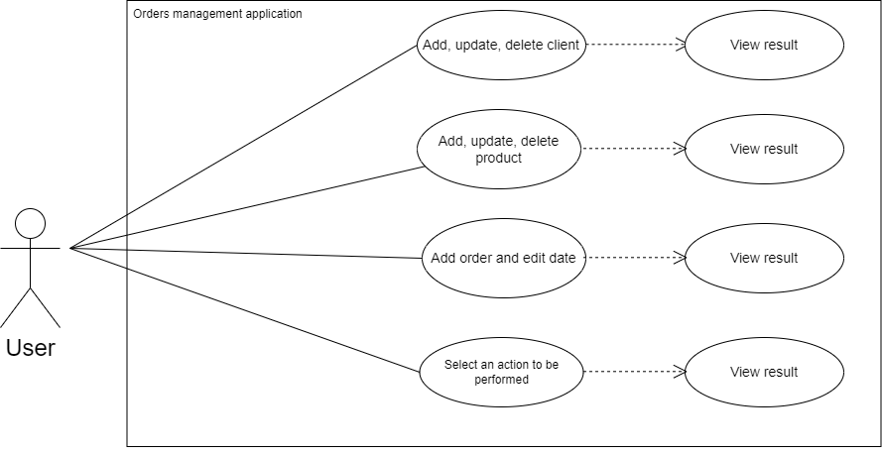

Use Case 1: select an action to be performed
Primary Actor: user
Main Success Scenario:
- The user selects an action to be performed.
- The user clicks on one of the buttons “Client operations”, “Product Operations” or “Create Order”.
Alternative Sequence 1.1: user does not click on any of the buttons
- The program will wait for the user to click on one of the buttons.
- The scenario returns to step 1.

Use Case 2: add, update, delete client
Primary Actor: user
Main Success Scenario:
- The user selects a field in the table and an action to be performed.
- The user clicks on one of the buttons “Add client”, “Update client” or “Delete client”.
- The action is performed and the field in the table is updated.
Alternative Sequence 1.1: incorrect input data
- If one or more fields were empty or were not introduced correctly, an error message will appear on the screen, indicating the problem and the program will not be started until the errors are corrected.
- The scenario returns to step 1.

Use Case 3: add, update, delete product
Primary Actor: user
Main Success Scenario:
- The user selects a field in the table and an action to be performed.
- The user clicks on one of the buttons “Add product”, “Update product” or “Delete product”.
- The action is performed and the field in the table is updated.
Alternative Sequence 1.1: incorrect input data
- If one or more fields were empty or were not introduced correctly, an error message will appear on the screen, indicating the problem and the program will not be started until the errors are corrected.
- The scenario returns to step 1.

Use Case 4: add order
Primary Actor: user
Main Success Scenario:
- The user selects the values for the client, user and the desired quantity.
- The user clicks on the button “Finalize order”.
- The action is performed and the field in the table is updated.
Alternative Sequence 1.1: incorrect input data
- If one or more fields were empty or were not introduced correctly, an error message will appear on the screen, indicating the problem and the program will not be started until the errors are corrected.
- The scenario returns to step 1.

Use Case 4: edit order date, delete date
Primary Actor: user
Main Success Scenario:
- The user selects the desired order date or the corresponding field he wants to delete.
- The user clicks on the button “Update order” or “Delete order”.
- The action is performed and the field in the table is updated.
Alternative Sequence 1.1: incorrect input data
- If the date was not introduced correctly, an error message will appear on the screen, indicating the problem and the program will not be started until the error is corrected.
- The scenario returns to step 1.

Design
OOP design of the application
• Encapsulation
The `ClientBLL` and `OrderBLL` classes encapsulate the business logic for operations on `Client` and `Orders` objects respectively. They hide the implementation details of the validation logic for these objects. Similarly, the `AbstractDAO`, `ClientDAO`, and `ProductDAO` classes encapsulate the data access logic, hiding the details of database operations.
• Abstraction
Abstraction is achieved through the use of abstract data types and interfaces. For instance, the `AbstractDAO` class provides a generic data access object implementation, abstracting the concept of a data access object and providing methods for common database operations such as insert, update, delete, and find.
• Polymorphism
Polymorphism is demonstrated through overriding. For example, the `ClientDAO` and `ProductDAO` classes extend the `AbstractDAO` class and override its methods to provide specific implementations for `Client` and `Product` objects respectively.
• Composition
Composition is used to create complex objects by combining simpler objects. For instance, the `Orders` class is composed of `Client` and `Product` objects, representing an order made by a client for a product. Similarly, the `ClientDAO` and `ProductDAO` classes are composed of an `AbstractDAO` object, using its methods to perform database operations.
• Modularity
The `ClientBLL`, `OrderBLL`, `AbstractDAO`, `ClientDAO`, and `ProductDAO` classes each manage a specific aspect of the application, enhancing code organization and allowing for modular extension. For example, the `ClientBLL` class is responsible for business logic related to `Client` objects, the `OrderBLL` class is responsible for business logic related to `Orders` objects, and the `AbstractDAO`, `ClientDAO`, and `ProductDAO` classes are responsible for data access logic.

UML Package Diagram
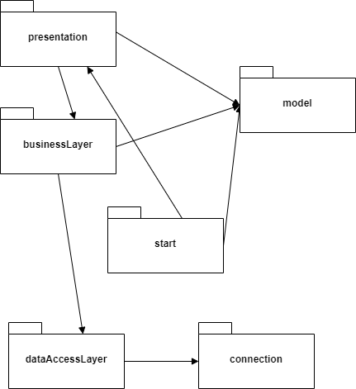

start package – contains the main class `Start` which is the entry point of the application. It also contains the main method used to launch the JavaFX application.
businessLayer package – contains the classes `ClientBLL` and `OrderBLL` which provide business logic for operations on `Client` and `Orders` objects respectively. These classes include methods for validating the fields of a `Client` or `Orders` object.
dataAcessLayer package – contains the classes `AbstractDAO`, `ClientDAO`, `ProductDAO` which provide a generic data access object implementation. These classes include methods for common database operations such as insert, update, delete, and find.
model package – contains the classes `Client`, `Product`, `Orders` which represent a client, a product, and an order in the system respectively. These classes hold information about the client, product, and order such as their id, name, email, phone number, address, description, price, stock quantity, and order date.
presentation package – contains the classes `ControllerClientOperations`, `ControllerCreateOrder`, `ControllerIntro`, `ControllerOrderOperations` which are controllers for the client operations view, create order view, intro view, and order operations view respectively. These classes include methods for initializing the view, handling button actions, and changing scenes.
connection package – contains the class `ConnectionFactory` which manages the database connection. It provides methods for creating and closing the connection, statement, and result set.

UML Class Diagram
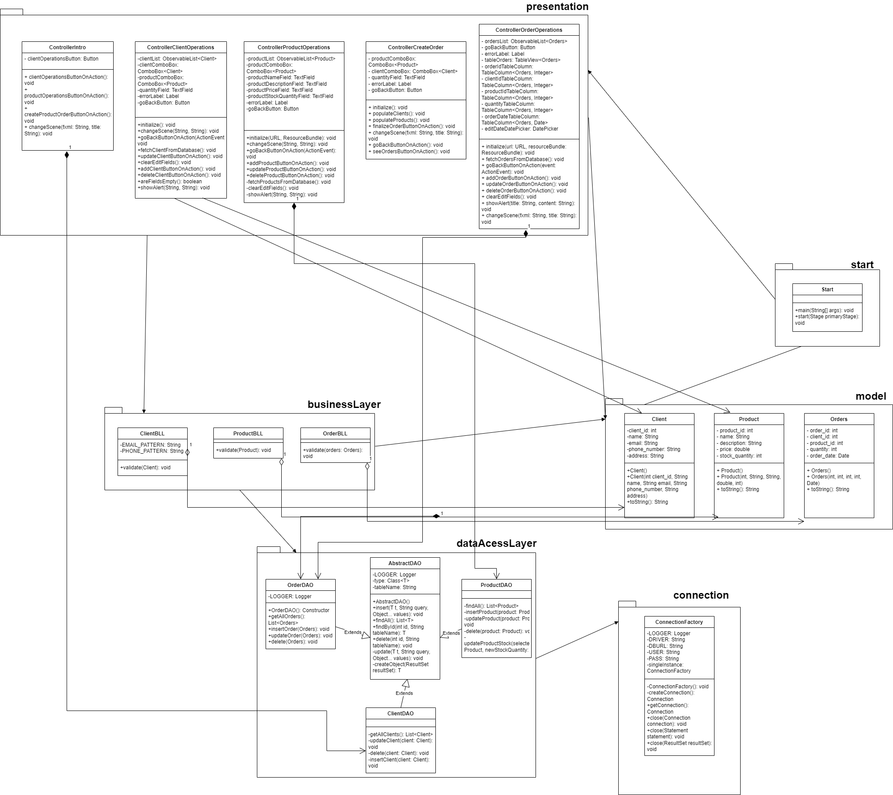

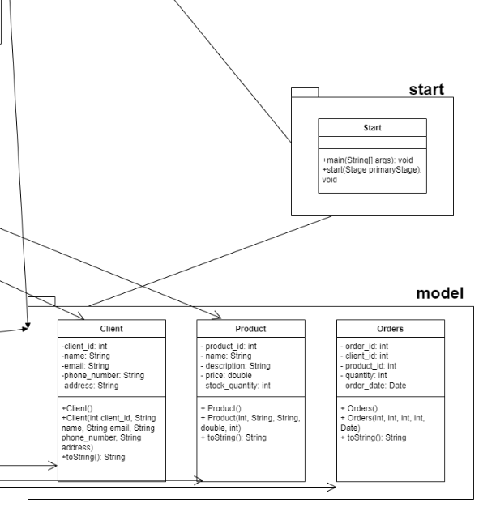

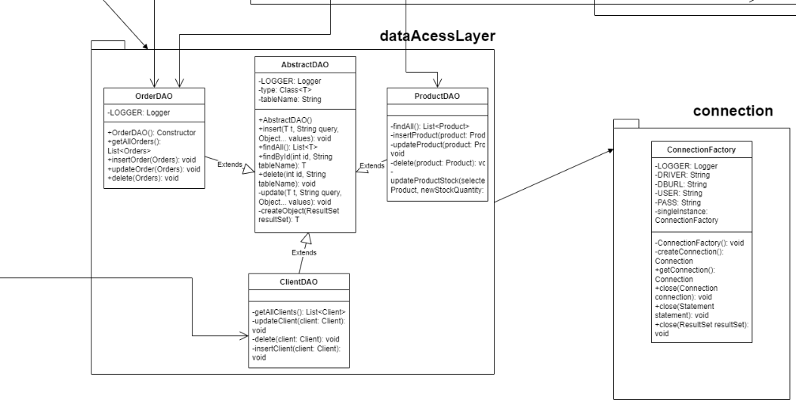

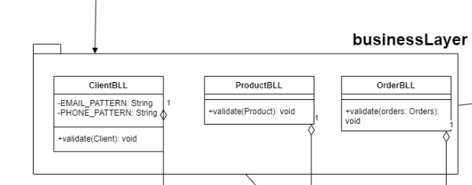

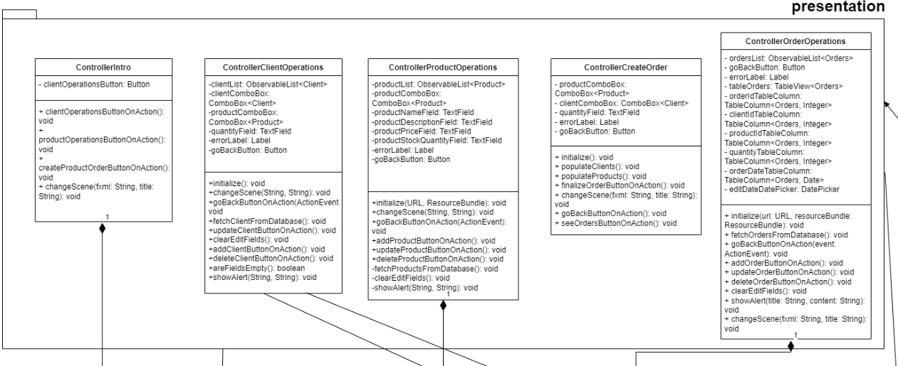

Used data structures
• List: This data structure is used in several places such as retrieving all records from the database in the `findAll` method of the `AbstractDAO` class. It provides methods to insert, update, delete and search for elements.
• ObservableList: This is a list that allows listeners to track changes when they occur. ObservableList is used in the `ControllerClientOperations` and `ControllerOrderOperations` classes to hold the clients and orders respectively.
• Exception: This is a type of class used for exceptional conditions that a program might encounter during execution. In my project, exceptions are used in the `ClientBLL` and `OrderBLL` classes to validate the fields of a `Client` or `Orders` object.
• ResultSet: This is a data structure used to store the result of a SQL query. In my project, it is used in the `AbstractDAO` class to retrieve data from the database. It provides methods to iterate over the data and get the values of the columns.

Implementation
Implemented classes
• AbstractDAO
The AbstractDAO class is a generic class that provides the basic CRUD operations for a database. It uses Java's Reflection API to dynamically access and manipulate data. It includes methods for inserting, finding, deleting, and updating records in the database, as well as creating an object from a ResultSet.

• Product
The Product class represents a product in the system. It holds information about the product such as its id, name, description, price, and stock quantity. This class is used to create and manipulate Product objects.

• ProductDAO, ClientDAO, OrderDAO
The DAO classes provide data access object implementation for Product, Client and Order objects. It includes methods for common database operations such as insert, update, delete, and find (CRUD operations).

• Orders
The Orders class represents an order in the database. It includes fields for the order id, client id, product id, quantity, and order date.

• Client
The Client class represents a client in the system. It holds information about the client such as their id, name, email, phone number, and address. This class is used to create and manipulate Client objects.

• ControllerClientOperations
The ControllerClientOperations class is a controller for the client operations view. It includes methods for initializing the view, handling button actions, and changing scenes.

• ConnectionFactory
The ConnectionFactory class manages the database connection. It provides methods for creating and closing the connection, statement, and result set.

• ControllerCreateOrder
The ControllerCreateOrder class is a controller for the create order view. It includes methods for initializing the view, handling button actions, and changing scenes.

• ControllerIntro
The ControllerIntro class is a controller for the intro view. It includes methods for handling button actions and changing scenes.

• ControllerOrderOperations
The ControllerOrderOperations class is a controller for the order operations view. It includes methods for handling button actions, changing scenes, and interacting with the Orders table in the database.

• ClientBLL, ProductBLL, OrderBLL
The Business Logic Layer (BLL) classes in this project are responsible for implementing the business rules and logic of the application. They interact with the Data Access Layer to retrieve and manipulate data, and ensure that the data is valid and consistent with the business rules.

• Start
The Start class is the entry point of the JavaFX application. It extends the Application class from JavaFX, which is an abstract class whose implementation represents a JavaFX application.

The graphical user interface (GUI)
The GUI of this project is indeed designed using the JavaFX framework. JavaFX is a software platform for creating and delivering desktop applications, as well as rich internet applications that can run across a wide variety of devices.

The GUI is defined in .fxml files, which are XML files that describe the user interface. These .fxml files are linked to controller classes, which handle user interactions and update the view accordingly. The controller classes in this project include `ControllerIntro`, `ControllerClientOperations`, `ControllerCreateOrder`, `ControllerOrderOperations`, and `ControllerProductOperations`.

The use of JavaFX and .fxml files allows for a clear separation of the UI design and the application logic. This makes the code easier to maintain and modify, as changes to the UI do not affect the application logic and vice versa.

The layout of the Orders Management Application is presented below.
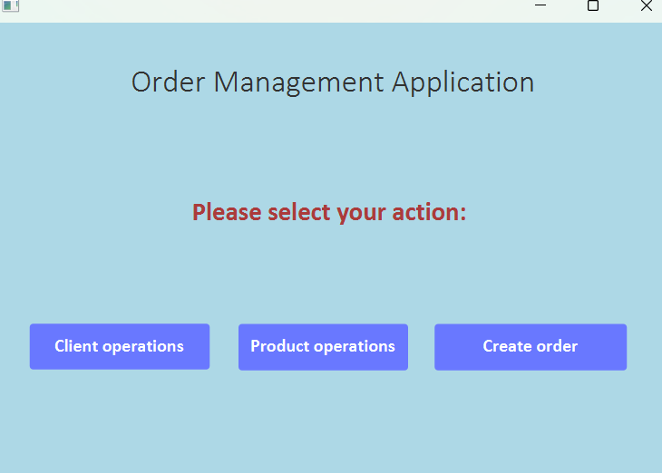

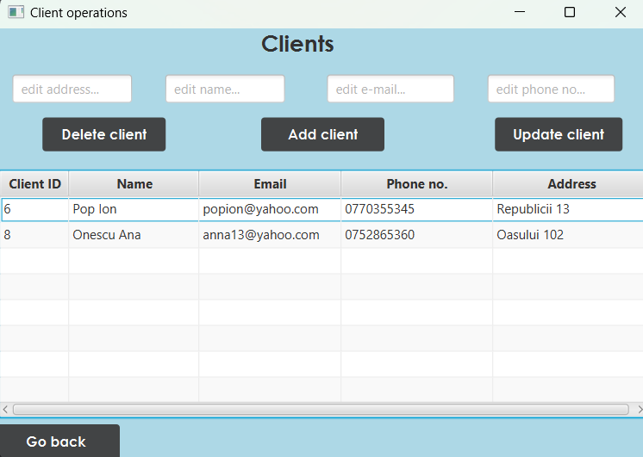

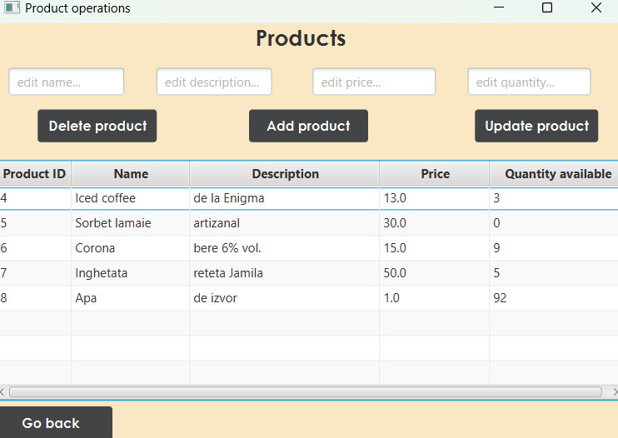

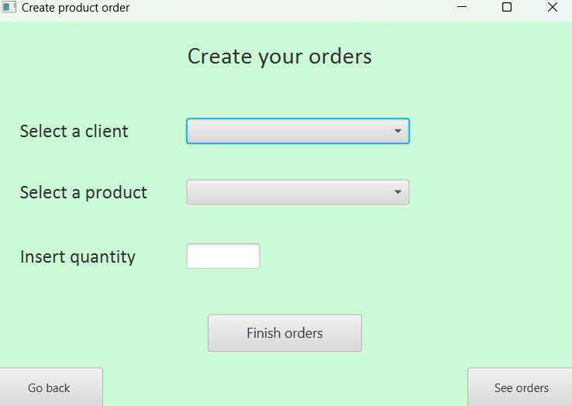

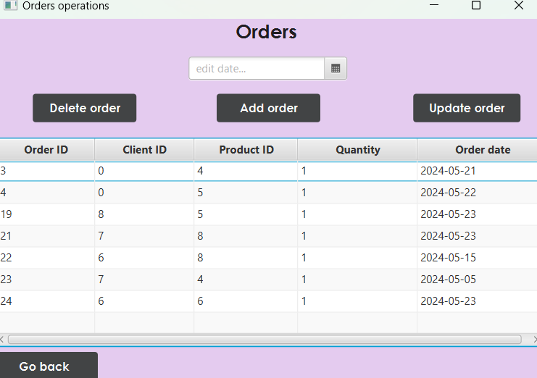

Conclusions
In the process of developing this project, I have significantly deepened my understanding of Java, particularly in the context of object-oriented programming. The project has also provided me with valuable experience in creating Use Case Diagrams and UML Package and Class Diagrams, which are essential tools for visualizing and planning software development projects.
Also, I have interacted with MySQL database framework that has allowed me to interconnect and store multiple objects.

Looking forward, there are several potential avenues for further development. One possibility would be to extend the database and create more tables that hold more significant details. Another possibility is providing more information to the users about the names of the products and clients instead of simply displaying their id’s in the orders table.

The project has also given me the opportunity to work extensively with the JavaFX framework and SceneBuilder. This has greatly enhanced my ability to develop and model small desktop applications, and has given me a deeper understanding of the practical applications of these tools.

Bibliography
- Support courses and presentations
- Modeling the diagrams – draw.io
- https://www.javatpoint.com/example-to-connect-to-the-mysql-database
- https://www.jetbrains.com/help/idea/javadocs.html
- https://dev.mysql.com/doc/refman/8.0/en/mysqldump-sql-format.html

