DOCUMENTATION

ASSIGNMENT 1

STUDENT NAME: Marincău Flavia-Maria
GROUP: e_30422

CONTENTS

1. Assignment Objective 3
2. Problem Analysis, Modeling, Scenarios, Use Cases 3
3. Design 6
4. Implementation 10
5. Results 16
6. Conclusions 17
7. Bibliography 18

Assignment Objective

Main Objective
Design and implement a polynomial calculator with a dedicated graphical interface through which the user can insert polynomials, select the mathematical operation to be performed and view the result.

Sub-Objectives

Name | Description | Section adressed
Analyze the problem and identify requirements | Understanding the problem domain and the requirements of implementing the polynomial calculator | Introduction - analysis
Design the polynomial calculator | Create a design for the polynomial calculator, including an interface which makes the interaction between the user and the program easier, input methods, packages, classes etc. | Design
Implement the polynomial calculator | Developing the application according to the specifications and using the design implemented. This includes the polynomial modeling which was done using a Map data structure, parsing the inputs using regular expressions and pattern matching and implementation of the arithmetic operations. | Implementation
Test the polynomial calculator | Ensure functionality, reliability and accuracy of results of the polynomial calculator using JUnit testing. | Testing

Problem Analysis, Modeling, Scenarios, Use Cases

Functional requirements – the desired behavior of the application
- The polynomial calculator should allow users to insert polynomials.
- The polynomial calculator should enable users to select mathematical operat ions.
- The polynomial calculator should add, subtract, multiply, divide two polynomials.
- The polynomial calculator should differentiate, integrate a polynomial selected by the user.
- The polynomial calculator should clear the input fields.
- The polynomial calculator should display the accurate result of the operation.
- The polynomial calculator should handle errors, providing informative messages to the user in case of invalid input or mathematical errors.

Use case diagram
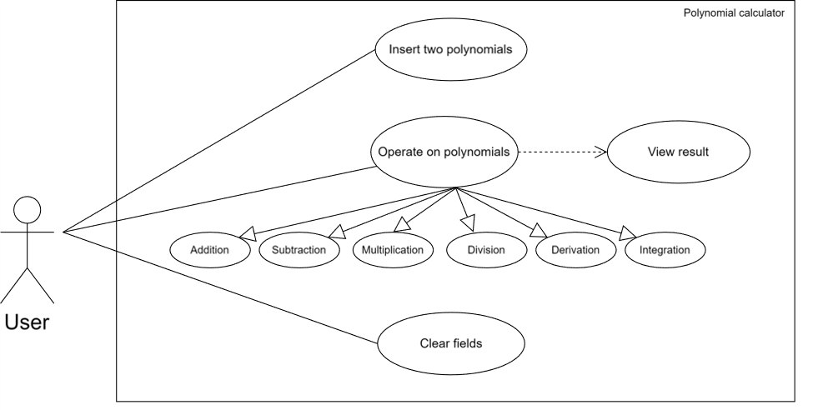

Use Case 1: insert two polynomials
Primary Actor: user
Main Success Scenario:
- The user enters the polynomials, respecting the correct format.
- The user clicks on one of the buttons representing a desired operation to be perfomed.
Alternative Sequence 1.1: incorrect polynomials
- One or both polynomials are empty => an error message will appear on the screen.
- One or both polynomials were not respecting the format imposed => an error message will appear on the screen, indicating the correct output.
- The scenario returns to step 1.
Note: the polynomial format accepted by the polynomial calculator is:
coeffNx^degreeN + coeffN-1x^degreeN-1 + … + coeff1x^degree1 + coeff0x^0

Use Case 2: operate on polynomials and view the result.
Primary Actor: user
Main Success Scenario:
- The user enters the polynomials, respecting the correct format.
- The user clicks on one of the buttons representing the symbol of the desired operation to be perfomed: addition, subtraction, multiplication, division or on one of the buttons “Derivate P1”, “Derivate P2”, “Integrate P1”, “Integrate P2”.
- The user views the output of the operation selected.
Alternative Sequence 2.1: user does not select an operation
- The system will wait for the user to click on a specified button
- The scenario returns to step 2.
Alternative Sequence 2.2: incorrect polynomials were entered and the user clicks on a specified button
- One or both polynomials are empty => an error message will appear on the screen, result will not be shown.
- One or both polynomials were not respecting the format imposed => an error message will appear on the screen, indicating the correct output, result will not be shown.
- The scenario returns to step 1.
Use Case 3: clear fields
Primary Actor: user
Main Success Scenario:
- The user enters the polynomials, respecting the correct format.
- The user may or may not click on one of the buttons representing a desired operation to be perfomed.
- The user clicks on the “Clear fields” button.
- The polynomial fields are cleared and the user can enter a new set of polynomials.
Alternative Sequence 3.1: the “Clear fields” button is not clicked
- The fields will not be cleared until the button is clicked.
- The scenario returns to step 3.

Design
OOP design of the application
- Encapsulation
The Polynomial class encapsulates the polynomial data structure and related methods, hiding the implementation details from other classes. For example, the internal representation of polynomials and the logic for manipulating them are hidden and well kept within this class.
- Abstraction
Abstraction is achieved through the use of abstract data types and interfaces. For instance, the Polynomial class abstracts the concept of a polynomial, providing methods to interact with polynomials without exposing their complexity behind.
- Polymorphism
Polymorphism is demonstrated through overriding and overloading. For instance, the Operations class contains static methods for performing polynomial operations such as addition, subtraction, multiplication, etc. These methods accept instances of the Polynomial class as arguments, allowing different polynomial objects to be operated on polymorphically.
- Composition
Composition is used to create complex objects by combining smaller objects as components. For example, the UserAppController class contains the graphical user interface components from JavaFX such as text fields, buttons, and labels. They create altogether an user-friendly interface for interacting with the polynomial calculator.

- Modularity
The project is modular because of the classes that are responsible for particular tasks such as polynomial manipulation, mathematical operations and GUI handling. Each class serves a well-defined purpose and can be modified or extended independentlly, enhancing code organization.

UML Package Diagram

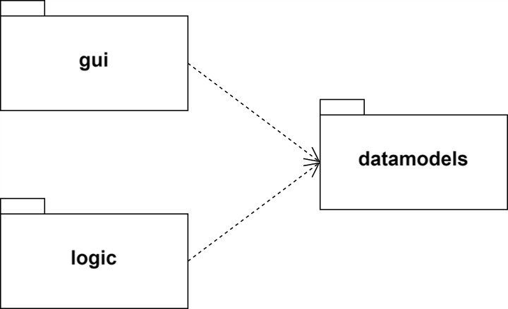
gui package – contains the classes implementing the graphical user interface: Main, UserAppController
datamodels package – contains the classes modeling the application data: Polynomial
logic package – contains the classes implementing the mathematical operations functionality: Operations

UML Class Diagram
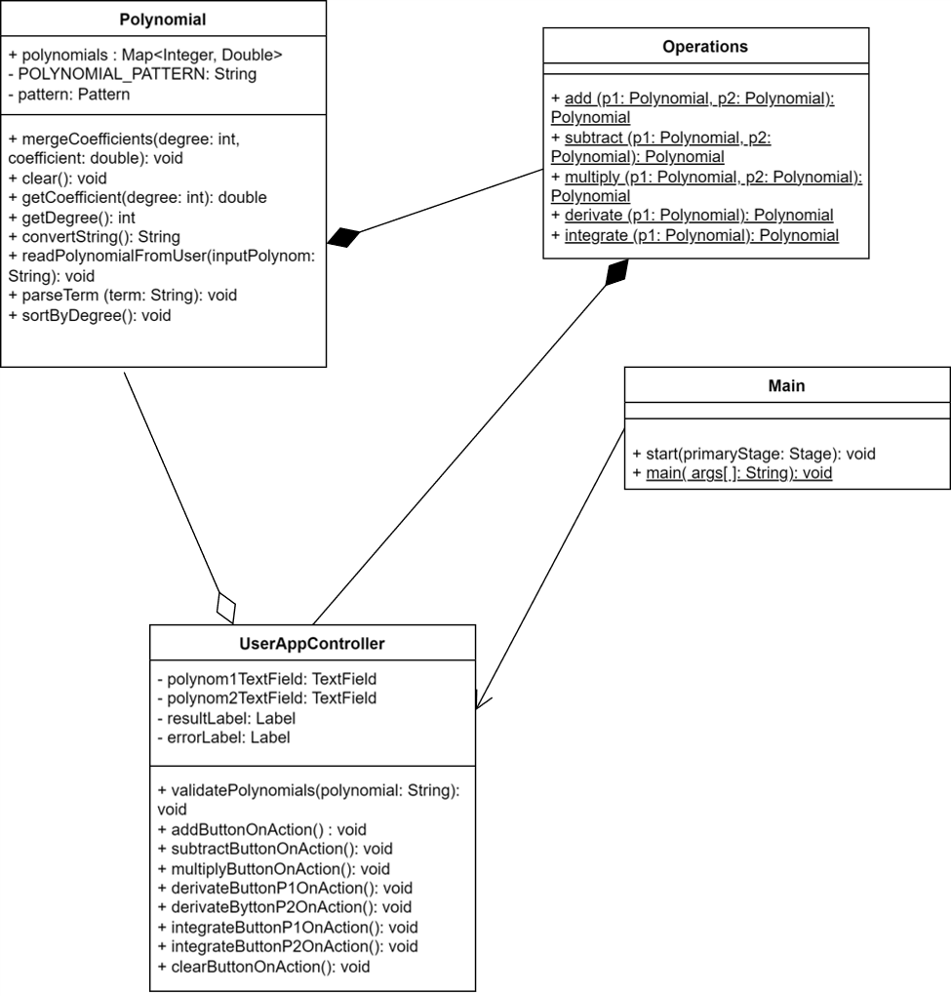

Used data structures
- Map Data Structure: Map<Integer, Double> data structure is used to represent polynomials. In the Polynomial class, a HashMap is being implemented to store the coefficients of each term, where the keys are the degrees of the terms and the values represent their coefficients. This data structure works on the principle of hashing, i.e. assigning an unique code for any variable/object after applying any formula/algorithm on its properties. The hash function should return the same code every time the function is applied on same/equal objects. This allows efficient storage of the polynomials.
- Regular Expressions (Regex) + pattern matching: Regular expressions are being used for parsing polynomial expressions introduced by the user. The Pattern and Matcher classes extract coefficient and degree data from an enterred polynomial in string format.

Implementation
Implemented classes
- Polynomial
This class is modeling a polynomial. It contains all the necessary methods and fields that make possible the conversion from the polynomial data structure to a polynomial string that the user enters.
Fields:
- polynomials: a map representing the polynomial, key=>degree, value=>coefficient
- POLYNOMIAL_PATTERN: a regex for parsing the polynomial terms
- pattern: a pattern used to compile the polynomial pattern

Relevant methods:
-convertString : this method converts a polynomial into a string for the output to be loaded with the value of that string, i.e. the converted polynomial, by appending certain symbols after several conditions have been met. It is used to output the result of an operation into a Label (resultLabel). It checks the polynomial not to be empty and it also verifies the coefficients to be integers.

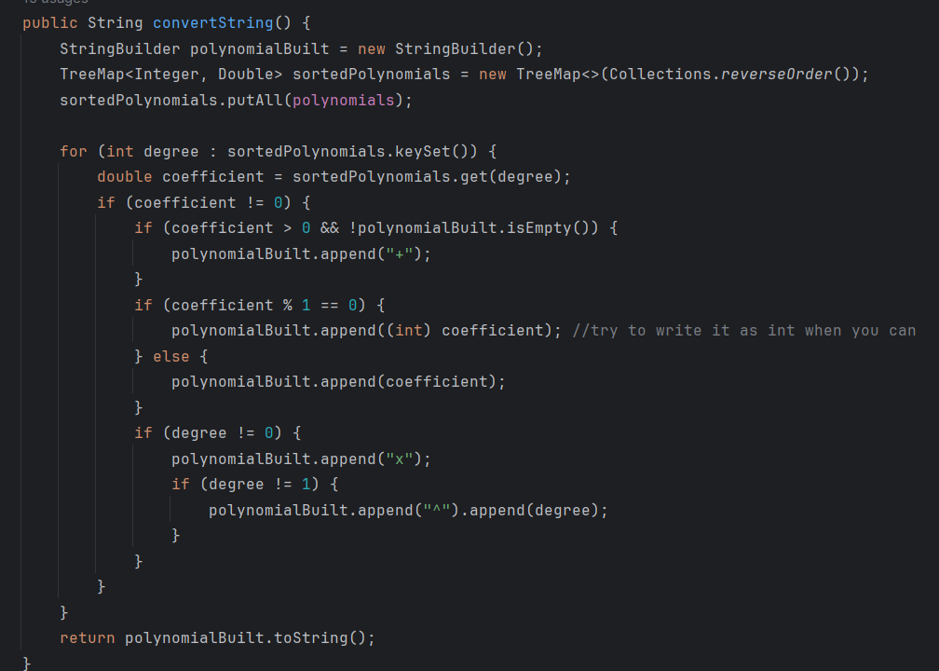
- readPolynomialFromUser: this method uses a predefined regex (POLYNOMIAL_PATTERN) to check the correctness of the input entered by the user. If the introduced expression was valid, it further calls the parseTerm method and catches the exception raised by it.
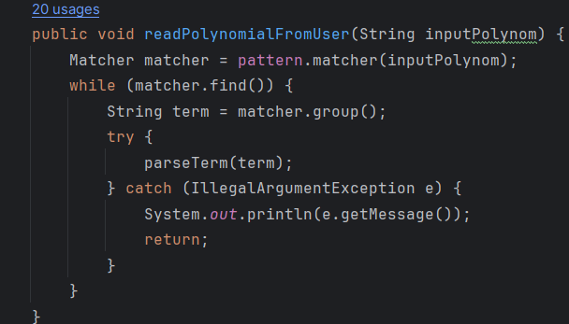

-parseTerm: this method constructs the polynomial from the valid string input by splitting the terms into degrees and coefficients. It later checks on several conditions to ensure the coefficients are positive or negative, integers or doubles. It also raises an exception if the input was not valid.
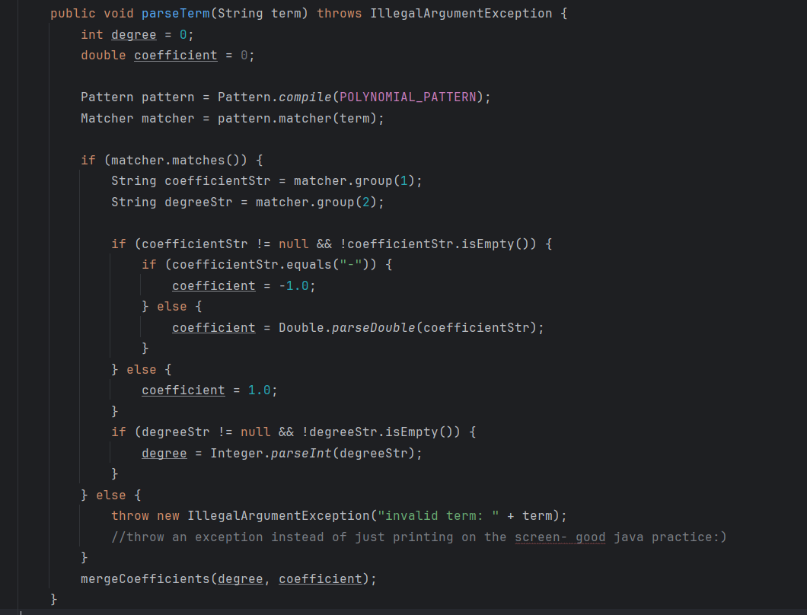

- Operations
This class implements the arithmetical operations on polynomials: addition, subtraction, multiplication, division, derivation, integration. It is called from the UserAppController Class and each operation is linked to a specific button.
Relevant methods:
-integrate: this method integrates a polynomial and rounds the result with maximum 3 decimals
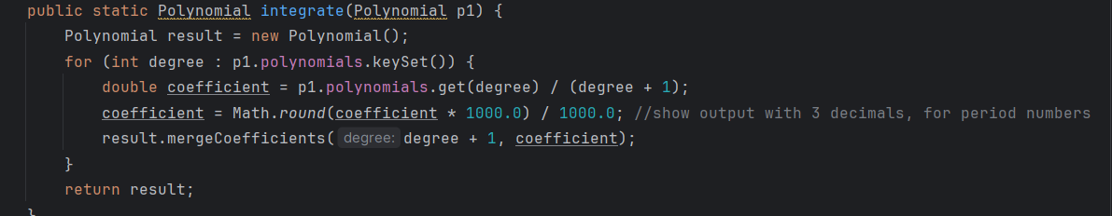
-other methods regarding the operations were done in a similar way.

- UserAppController
This class represents the user interface. It is the layer between the code and the user. More explicitly, it assigns actions to buttons, it takes the data from the text fields and it outputs the result of an operation. Without this class, users could not interact with the polynomial calculator.
Fields:
-polynom1TextField, polynom2TestField, resultLabel, errorLabel: JavaFX elements that allows the user to enter an input, see the output and see an error message if something did not work as expected.
Relevant methods:
-validatePolynomial: checks that the entered polynomials are respecting the format and are not empty. In case of a conflict, it sets a text to the error label.
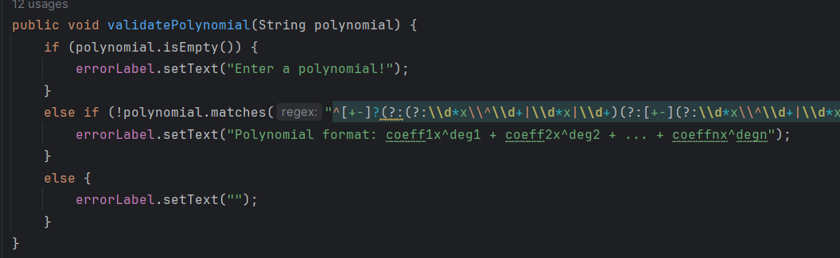
-addButtonOnAction: it checks the validity of the entered polynomials by the users and, if no problems were met, the polynomials are parsed and transformed into the format that the Operations class can handle them accordingly. The result of the operation will be loaded in the resultLabel.
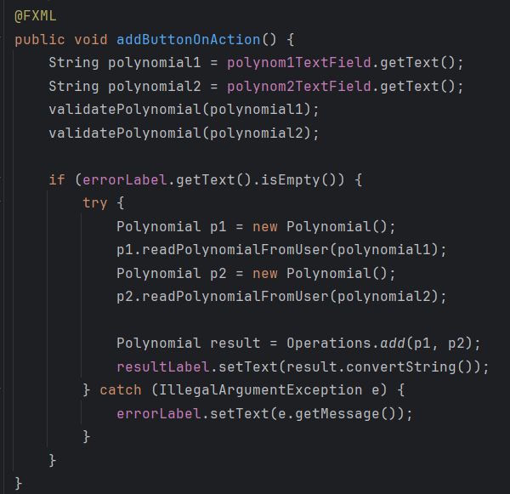
-other methods were done similarly.
- Main
This class launches the application using JavaFX concepts such as Stage, Scene and FXML Loader. It is loading the .fxml file into the FXML Loader and it starts running when the launch method is called.
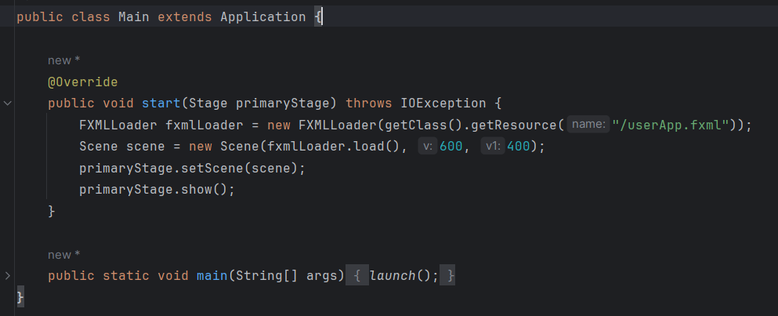

The graphical user interface (GUI)
The GUI was designed using JavaFX framework and SceneBuilder. Scene Builder is a visual layout tool that allows to design JavaFX user apps using a drag-and-drop interface, simplifying the UI design process. During the development of the GUI for this assignment, I incorporated several buttons, anchor panes, border panes, text fields, buttons and labels, ensuring an intuitive and user-friendly interface.
The interface is a .fxml file that is linked to its controller, i.e. UserAppController class. The buttons were assigned an action that performs a specified operation described in the controller class and the text fields and labels have an fx:id which links the actual code to the visual part.

The layout of the polynomial calculator is presented below.
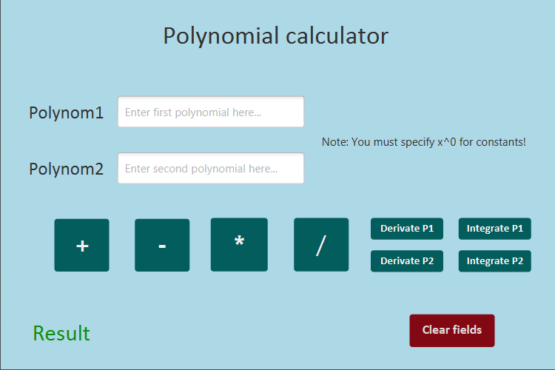

Moreover, an example of how multiple JavaFX components were put together is shown below.
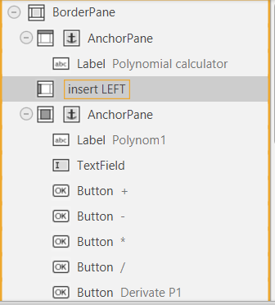

Results
JUnit is a widely used testing framework for Java programming language. It provides a simple and efficient way to write and execute unit tests for any Java code. This homework required unit testing with Junit, more specifically the correctness of the operations implemented by the polynomial calculator were tested.
All Junit test cases passed successfully. The tests were done by giving two polynomials as an input and writing the expecting output using the assertEquals method.
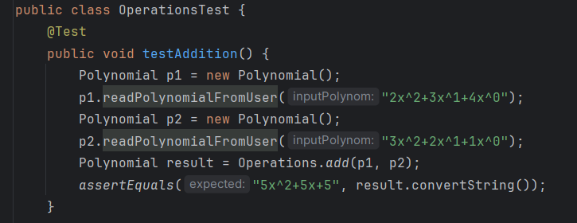
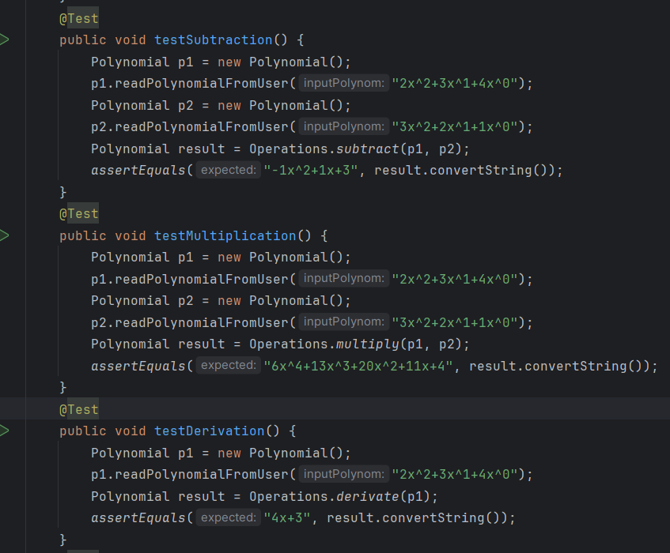
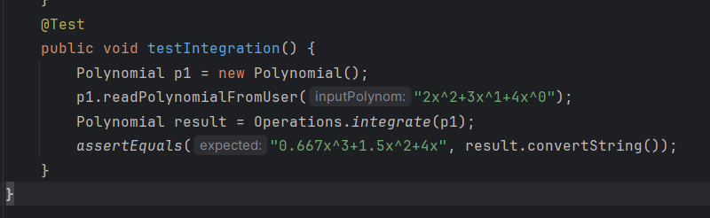

The validation of the tests is presented below.
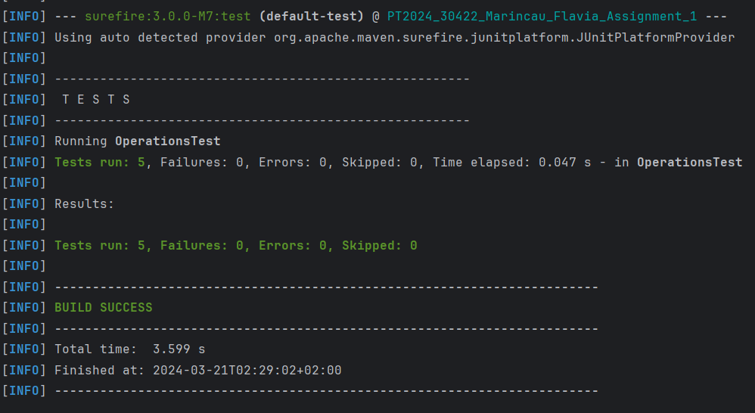

Conclusions
In the development of this project I have re-inforced my Java knowledge and OOP paradigms and I have gained valuable experience in making Use Case Diagrams and UML Package and Class Diagrams. Moreover, during the development of this application, I gained valuable insights regarding the usage of JavaFX framework and it became easier to handle and model small desktop applications using SceneBuilder.
Future developments would include designing a better interface for the polynomial calculator or adding a number desired by the user of polynomials to be added/subtracted etc. Also, a future improvement could be to design the polynomial calculator with floating point coefficients or having no format restrictions on the input polynomial (any format should be accepted, as long as it is still a polynomial).

Bibliography
- Support courses and presentations
- https://www.javatpoint.com/uml-class-diagram
- https://www.javatpoint.com/exception-handling-in-java
- Modeling the diagrams – draw.io
- https://www.baeldung.com/regular-expressions-java
- For testing my regex - https://regexr.com/

