**Framework Based Programming – Flavien Geoffray – 5999222008**

**App 2: Create a Tab navigation.**

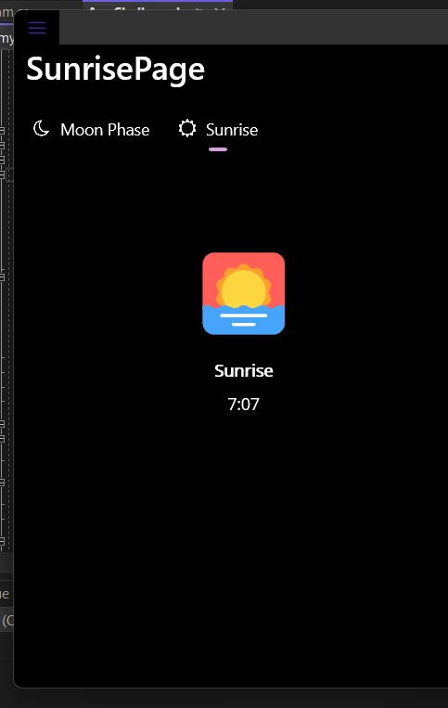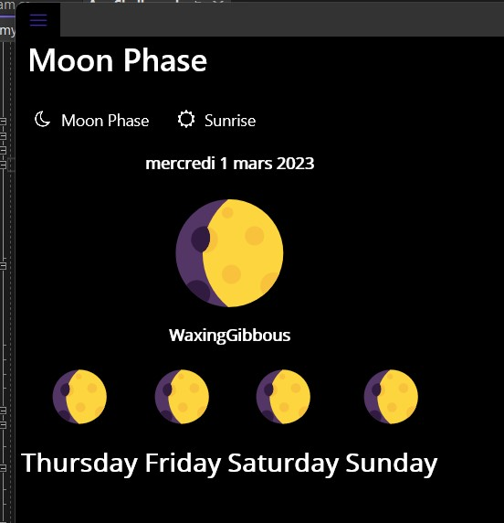

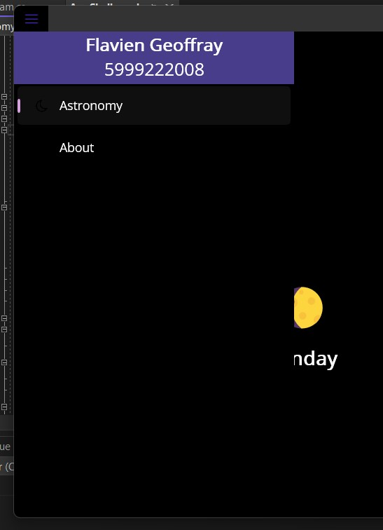On launch: the App opens on the moon phase. The user can click on “Sunrise” to switch page thanks to the tab navigation.