**Framework Based Programming – Flavien Geoffray – 5999222008**

**App 3: Use tabbed pages with navigation pages.**

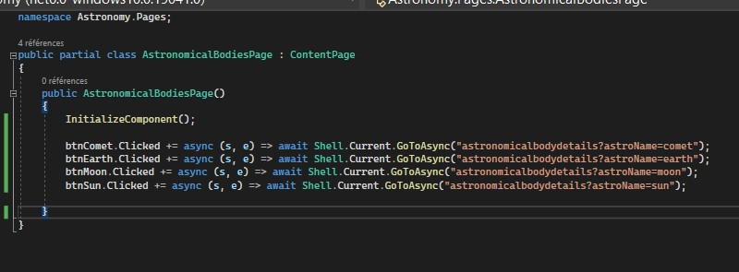**AstronomicalBodiesPage.xml.cs**

**AstronomicalBodyPage.xml.c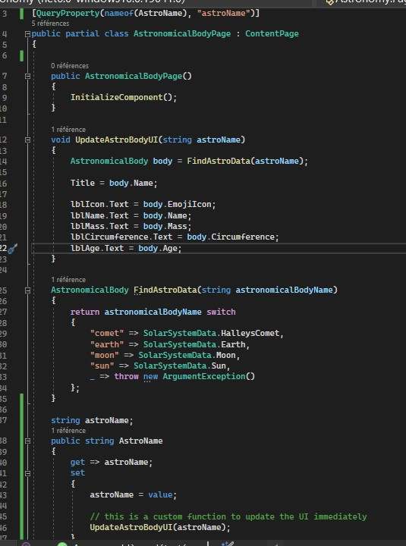s**

