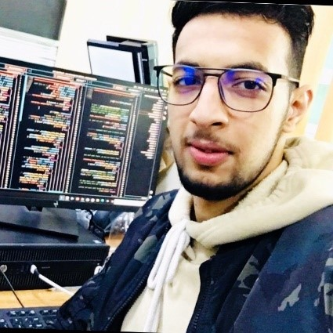

(Casablanca-Marocco)

**PROFILE**

**CHAABA**

**Web Developer**

**Work EXPERIENCE**

**SKILLS**

**LANGUAGES**

**education**

06 33 04 34 00

Web developer for several years, I have developed advanced technical skills, I am passionate that I will be able to put at the service of your company

Cree WEB Marocco

Web Developer

**Flash Web**

Web Developer

HTML/CSS

Web Developer

Voyages

Pratique régulière du judo et FOOTBALL

Création d’un blog personnel

Cinéma

Lecture

Francais

Anglais

Arabe

Lunix

Odoo

GIT/GITHUP

JS/Ajax

PYTHON/C++

SQL/MYSQL/JSON

PHP/LARAVEL/API

Mohamedchaaba7@gmail.com

Casablanca - Marocco

**mohamed**

Backend development in php Laravel.

Maintenance on different projects.

Advice and realization of projects in autonomy.

**DIPLOMAS Y HOBBIES**

**Formaciones :** Diplomados, Congresos, xxxxxxxxxx xxxxxx xxxxxxxxx xxxxxxxxxxxxxxxxx

**Hobbies:** xxxxxxxxxxxxxxxxxxxxxxxxxxxxxx



https://www.linkedin.com/in/mohamed-chaaba-23a1a5201/

(Casablanca-)

Marocco

**Freelancer**

*ISTA Casablanca*

***Software development technician***

***Scientific baccalaureate option SVT***

Casablanca-Marocco

Casablanca-Marocco

Development of a furnished rental website, on behalf of holiday accommodation

Working environment :

PHP, APACHE, MYSQL, JS, AJAX, JQUERY

**Pulm Indus(Dolidol)**

Developer (internship)

Development of a configurable ERP application using (ODOO), postgreSQL to relaunch tasks

(Casablanca-Marocco)

Dar Bouazza,-Marocco

Web developer for several years, I have developed advanced technical skills, I am passionate that I will be able to put at the service of your company

**Hobbies**

Moulay Smail

©AZURIUS – Modeles-de-cv,com